|  |  |
| --- | --- |
|  | **Fakulti Teknologi Kejuruteraan Kelautan dan Informatik, Universiti Malaysia Terengganu** |

**Lab Manual Week 6**

**Web Programming**



|  |  |  |
| --- | --- | --- |
| **Name** | **:** | **ARUN MUGILAN** |
| **Matric Num** | **:** | **S63746** |
| **Semester** | **:** | **3** |
| **Lab** | **:** | **6** |
| **Demonstrator** | **:** | **MR. ARIZAL** |

**Instructions**

This lab manual is for used by students at the School of Informatics and Applied Mathematics, Universiti Malaysia Terengganu (UMT) only. Not allowed to print and distribute this manual without official permission of the author.

Please follow the step by step as described in the manual. Tick (√) each step has been created and write the conclusion of each activity has been completed.

Conclusion or result of each activity must be written in a file named according to the following format:

[nomatrik] _ [LabX]. docx. Replace the 'X' with your lab session. Examples of correct file name is 'UK12345_Lab1.docx'.

Please prepare the assignments with your individual effort without any 'copy-paste' from other parties.

Best of luck!

**JAVASCRIPT**

**Objective:**

* Develop familiarity with the JavaScript language.
* Learn to use best-practice idioms and patterns.
* Understand concepts commonly used in dynamic language programming

**Explanation:**

Why need to study JavaScript?

* JavaScript is one of the 3 languages all web developers must learn.
* JavaScript is the world's most popular programming language.
* JavaScript is the programming language of the Web.

JavaScript is easy to learn.

In HTML file, JavaScript code is inserted between <script> and </script> tags.

Old JavaScript examples may use a type attribute: <script type="text/javascript">.

The type attribute is not required. JavaScript is the default scripting language in HTML.

**Activity 1**

Write down this html page, and name it as firstjs.html

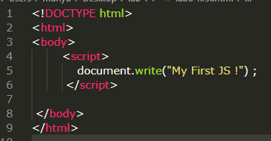

Try to call file firstjs.html on your browser.

After that, change the statement “document.write(“My First JS !”) into :

document.write("<b> My First </b> " + " <i>Java Script</i> " ) ;

**Conclusion and Result: ….**

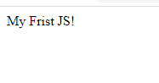

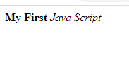

**Activity 2**

Write down this html page, and name it as datetimejs.html

Display date and time from computer.

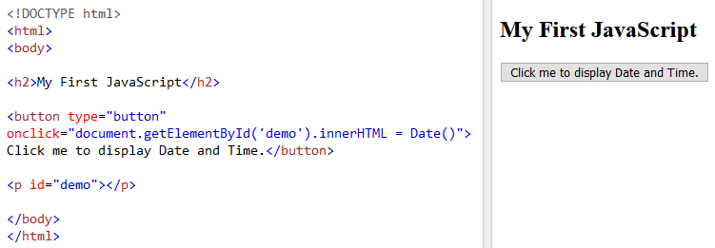

After you try to display date/time and get the result, now add these scripts to change the style of variable (demo)

document.getElementById("demo").style.fontSize = "25px";

document.getElementById("demo").style.color = "red";

document.getElementById("demo").style.backgroundColor = "yellow";

**Conclusion and Result: ….**

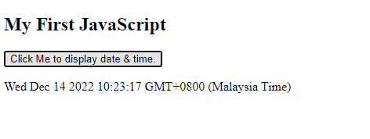

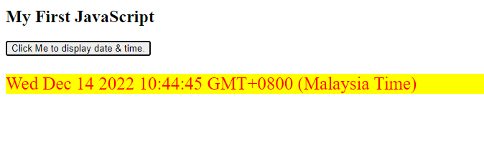

One of many JavaScript HTML methods is getElementById().

The example below "finds" an HTML element (with id="demo"), and changes the element content (innerHTML) to "Hello JavaScript"

Example:

document.getElementById("demo").innerHTML = "Hello JavaScript";

**Activity 3**

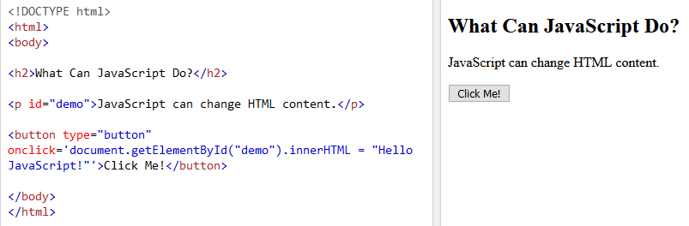

**Conclusion and Result: ….**

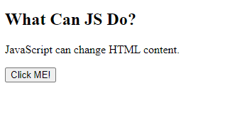

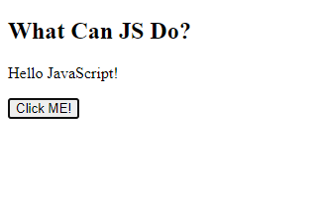

Note : JavaScript accepts both double and single quotes

document.getElementById("demo").innerHTML = "Hello JavaScript";

document.getElementById("demo").innerHTML = ‘Hello JavaScript’;

**Activity 4**

JavaScript Can Change HTML Attribute Values

In this example JavaScript changes the value of the src (source) attribute of an <img> tag:

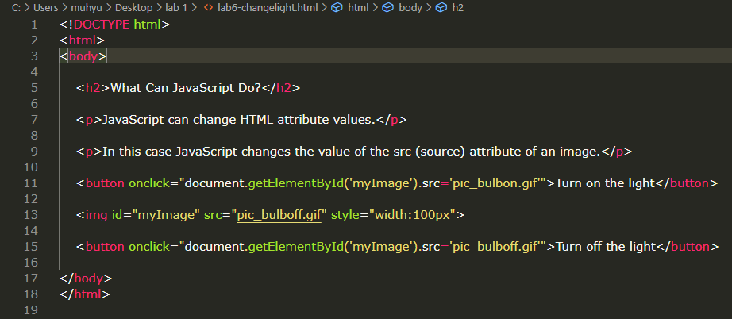

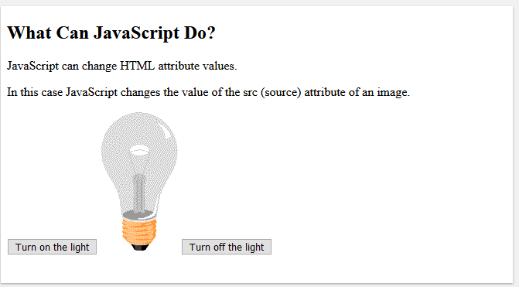

into the same folder of the html file.

The pictures of the ON and OFF bulb can be downloaded from: <https://bit.ly/37ltRvs>

**Conclusion and Result: ….**

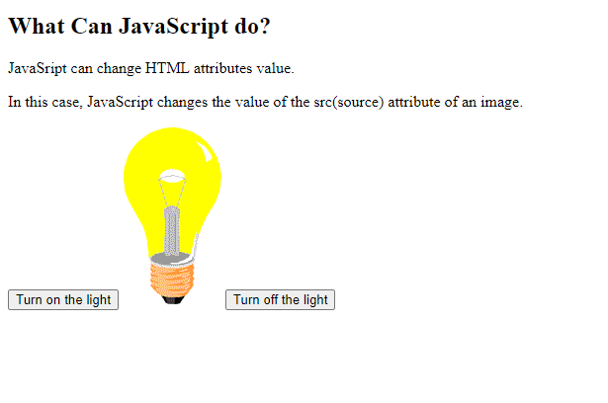

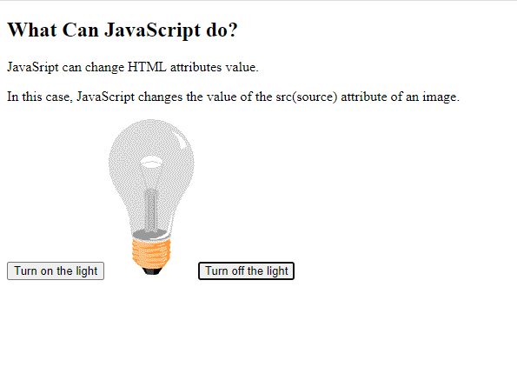

**JavaScript in <head> or <body> ?**

You can place any number of scripts in an HTML document.

Scripts can be placed in the <body>, or in the <head> section of an HTML page, or in both.

JavaScript in <head>

In this example, a JavaScript function is placed in the <head> section of an HTML page.

**External JavaScript Advantages**

Placing scripts in external files has some advantages:

* It separates HTML and code
* It makes HTML and JavaScript easier to read and maintain
* Cached JavaScript files can speed up page loads

To add several script files to one page - use several script tags:



**External References**

External scripts can be referenced with a full URL or with a path relative to the current web page.

This example uses a full URL to link to a script:



This example uses a script located in a specified folder on the current web site:



**Activity 5**

Link to file Javascript (*.js)

We can create external JavaScript file and embed it in many html page.

It provides code re usability because single JavaScript file can be used in several html pages.

An external JavaScript file must be saved by .js extension. It is recommended to embed all JavaScript files into a single file. It increases the speed of the webpage.

Let's create an external JavaScript file that prints Hello UMT students in a alert dialog box.

Name : message.js

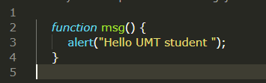

Let's include the JavaScript file into html page. It calls the JavaScript function on button click.

Name : extjavascript.html

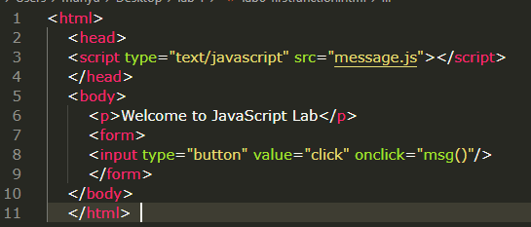

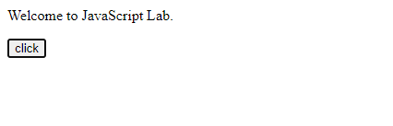

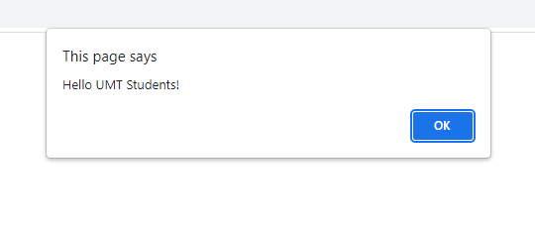

**Working with events**

**Activity 6**

**Script to Avoid the right click**

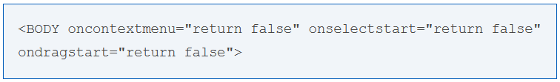

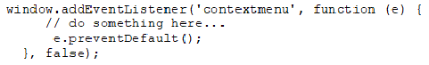

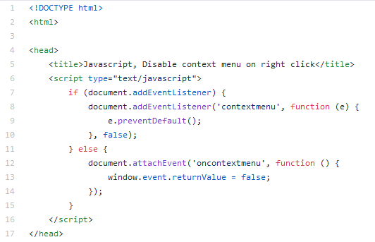

**Conclusion and Result:**

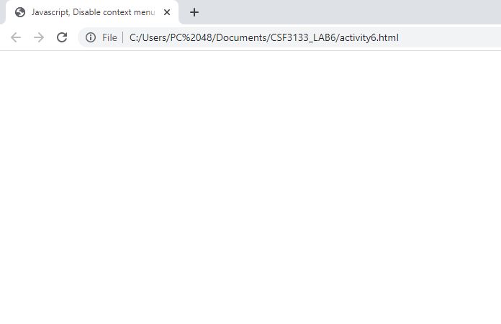

**Activity 7**

Multiplication Table

Create a simple multiplication table asking the user the number of rows and columns

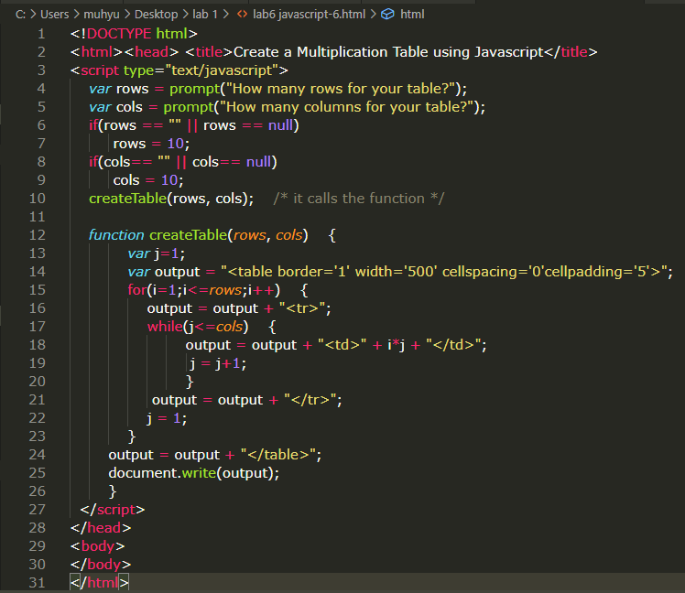



**Conclusion and Result: …..**

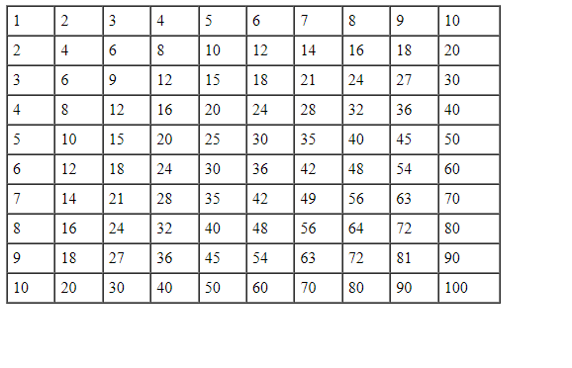

**• Client-side validation**

Validation can be defined by many different methods and deployed in many different ways.

* Server-side validation is performed by a web server, after input has been sent to the server.
* Client-side validation is performed by a web-browser, before the input is sent to a server.

**Activity 8**

HTML form validation can be done by JavaScript.

If a form field (fname) is empty, this function alerts a message, and returns false, to prevent the form from being submitted:

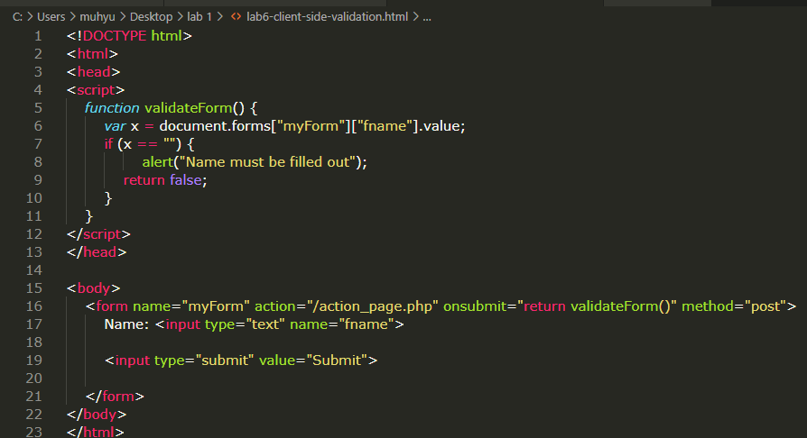

**Conclusion and Result: …..**

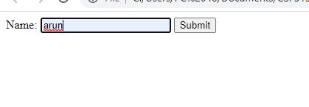

**Activity 9**

JavaScript Can Validate Numeric Input.

JavaScript is often used to validate numeric input:

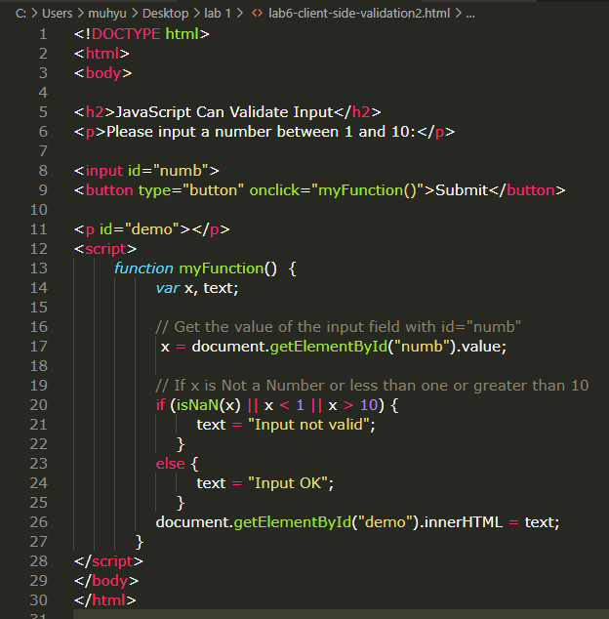



**Conclusion and Result: …..**

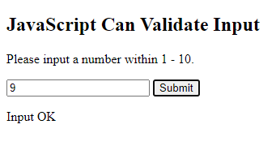

**Activity 10**

Write a JavaScript program where the program takes a random integer between 1 to 10, the user is then prompted to input a guess number. If the user input matches with guess number, the program will display a message "Good Work" otherwise display a message "Not matched"

File Guessing.html

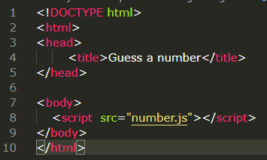

Number.js

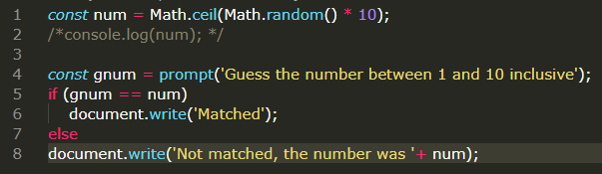

**Explanation:**

The Math.ceil() function is used to get the smallest integer greater than or equal to a given number.

The Math.random() function is used to get a floating-point, pseudo-random number in the range [0, 1) that is, from 0 (inclusive) up to but not including 1 (exclusive), which you can then scale to your desired range.

**Lab 5 Exercise**

1. Create file html and javascript, to make a greeting “good morning” or “good evening”. The input is number of hour.

if (hour < 18) {

greeting = "Good day"; }

else {

greeting = "Good evening";

}