|  |  |
| --- | --- |
|  | **Fakulti Teknologi Kejuruteraan Kelautan dan Informatik, Universiti Malaysia Terengganu** |

**Lab Manual Week 5**

**Web Programming**

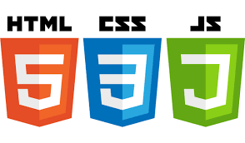

|  |  |  |
| --- | --- | --- |
| **Name** | **:** | **Arun Mugilan** |
| **Matric Num** | **:** | **S63746** |
| **Semester** | **:** | **3** |
| **Lab** | **:** | **MP3** |
| **Demonstrator** | **:** | **Mr.Arizal** |

**Instructions**

This lab manual is for used by students at the School of Informatics and Applied Mathematics, Universiti Malaysia Terengganu (UMT) only. Not allowed to print and distribute this manual without official permission of the author.

Please follow the step by step as described in the manual. Tick (√) each step has been created and write the conclusion of each activity has been completed.

Conclusion or result of each activity must be written in a file named according to the following format:

[nomatrik] _ [LabX]. docx. Replace the 'X' with your lab session. Examples of correct file name is 'UK12345_Lab1.docx'.

Please prepare the assignments with your individual effort without any 'copy-paste' from other parties.

Best of luck!

**CSS AND HTML**

**Objective:** The goal here is to start thinking of websites as systems rather than individual pages, and the code architecture should reflect this mindset.

**Explanation:**

**What is CSS?**

CSS is the language for describing the presentation of Web pages, including colors, layout, and fonts. It allows one to adapt the presentation to different types of devices, such as large screens, small screens, or printers. CSS is independent of HTML and can be used with any XML-based markup language. The separation of HTML from CSS makes it easier to maintain sites, share style sheets across pages, and tailor pages to different environments. This is referred to as the separation of structure (or: content) from presentation.

Style Sheets can format the HTML document. HTML documents may contain style sheet rules directly in them or they may import style sheets. There are three ways of providing styling information for the Web browsers.

**Using CSS**

CSS can be added to HTML documents in 3 ways:

* Inline - by using the style attribute inside HTML elements
* Internal - by using a <style> element in the <head> section
* External - by using a <link> element to link to an external CSS file

The most common way to add CSS, is to keep the styles in external CSS files.

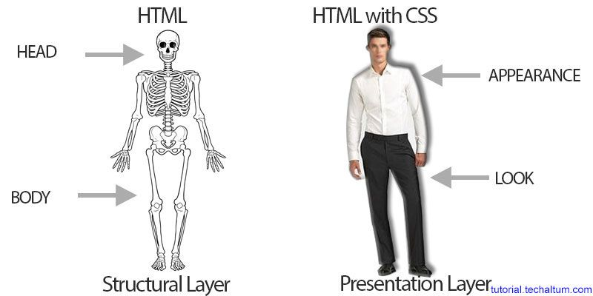

A CSS comprises of style rules that are interpreted by the browser and then applied to the corresponding elements in your document. A style rule is made of three parts −

* Selector − A selector is an HTML tag at which a style will be applied. This could be any tag like <h1> or <table> etc.
* Property − A property is a type of attribute of HTML tag. Put simply, all the HTML attributes are converted into CSS properties. They could be color, border etc.
* Value − Values are assigned to properties. For example, color property can have value either red or #F1F1F1 etc.

You can put CSS Style Rule Syntax as follows −

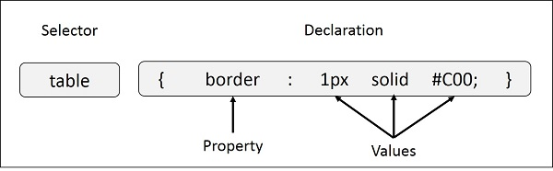

**ACTIVITY 1**

**Inline CSS**

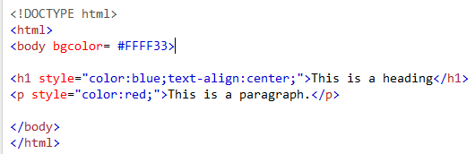



**ACTIVITY 2**

**Internal CSS**

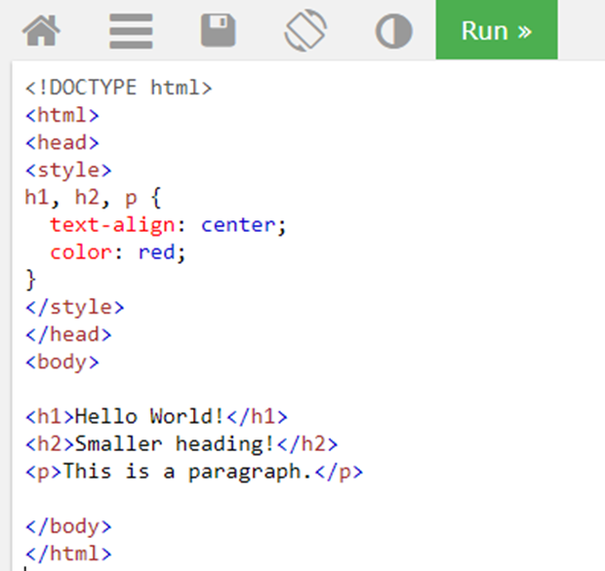

**Lab’s Exercise:**

1. Use internal css, to set the background color for the page to "linen" and the background color for <h1> to "lightblue".
2. Add an image, use it as a link to another page, and then set the border’s size around of the image equals to 1, when it’s hovered.

**Conclusion and Result:**





**ACTIVITY 3**

**External CSS**

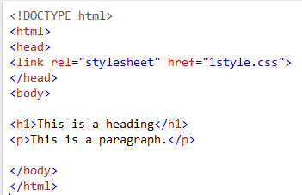

**Content of file 1style.css**

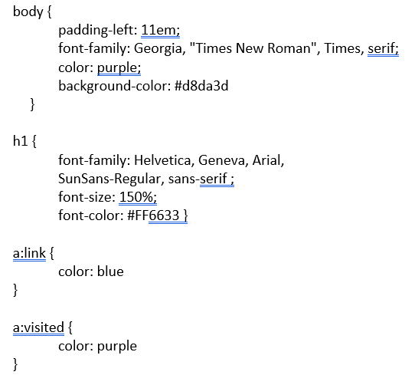

Conclusion:



**Lab’s Exercise:**

1. From this page, convert it into 2 pages, html and external css.

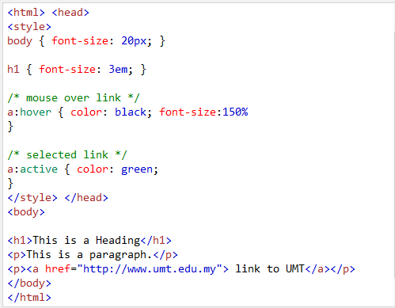

Write the css code into file “newstyle.css”, and then link it to the html page.

**Link to file css (from another website)**

This example uses a font from the Googleapis.com (font’s name: Tangerine)

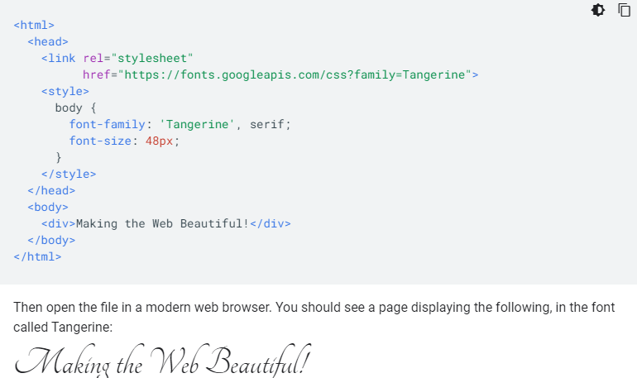

Google APIs (www.googleapis.com) are application programming interfaces (APIs) developed by Google which allow communication with Google Services and their integration to other services. Examples of these include Search, Gmail, Translate or Google Maps. Third-party apps can use these APIs to take advantage of or extend the functionality of the existing services.

In the css example above, we used one of the font libraries in Googleapis.

**CSS for Backgrounds**

Single background

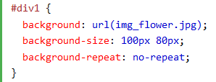

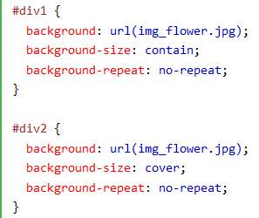

Example:

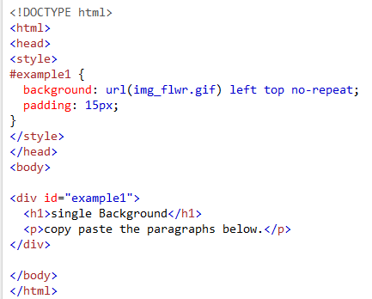

Multiple background

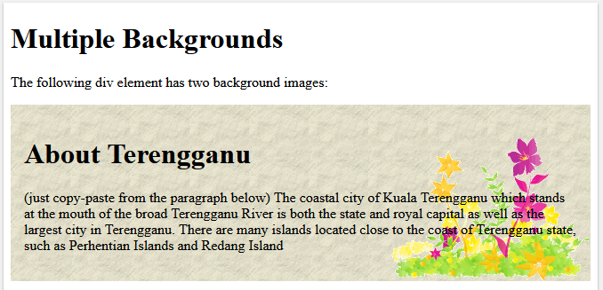

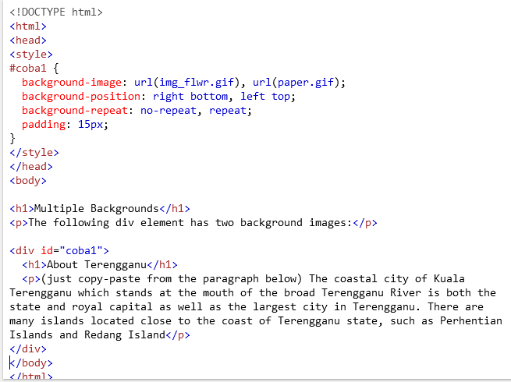

Download the background images : paper.gif and img_flwr.gif from <https://bit.ly/37ltRvs>

Use/copy this paragraph:

Terengganu formerly spelled Trengganu or Tringganu, is a sultanate and constitutive state of federal Malaysia. The state is also known by its Arabic honorific, Darul Iman ("Abode of Faith"). The coastal city of Kuala Terengganu which stands at the mouth of the broad Terengganu River is both the state and royal capital as well as the largest city in Terengganu. There are many islands located close to the coast of Terengganu state, such as Perhentian Islands and Redang Island

**CSS for TABLE**

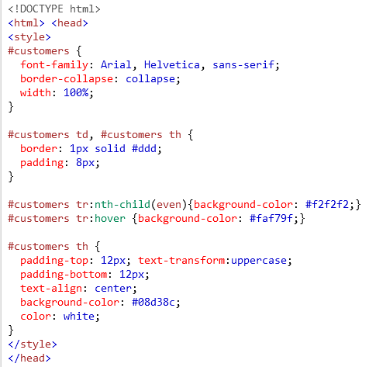

<body>

<table id="customers">

<tr>

<th>Company</th>

<th>Contact</th>

<th>Country</th>

</tr>

<tr>

<td>Alfreds Futterkiste</td>

<td>Maria Anders</td>

<td>Germany</td>

</tr>

<tr>

<td>Ernst Handel</td>

<td>Roland Mendel</td>

<td>Austria</td>

</tr>

<tr>

<td>Island Trading</td>

<td>Helen Bennett</td>

<td>UK</td>

</tr>

<tr>

<td>Magazzini Riuniti</td>

<td>Giovanni Rovelli</td>

<td>Italy</td>

</tr>

</table> </body>

</html>

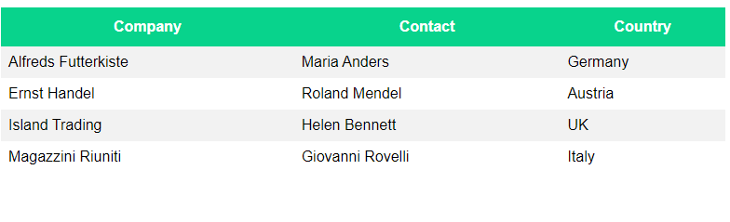

**CSS for Navigation Bar**

* Having easy-to-use navigation is important for any web site.
* With CSS you can transform boring HTML menus into good-looking navigation bars.
* Vertical bar or horizontal bar

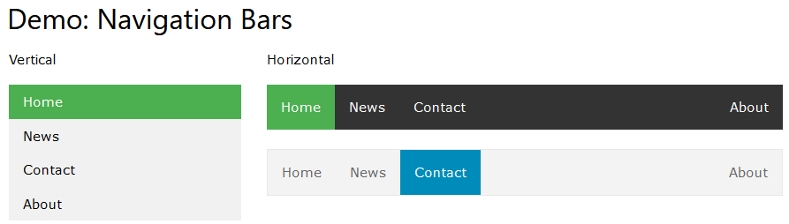

* A navigation bar is basically a list of links, so using the <ul> and <li> elements makes perfect sense:

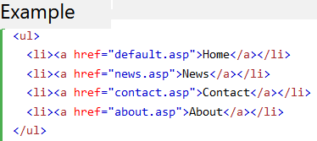

The complete html for vertical navigation bar : Result:

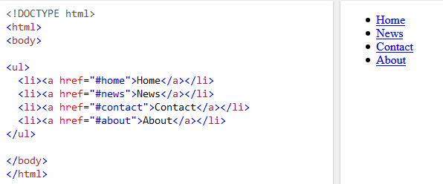

Now let's remove the bullets and the margins and padding from the list:

Add this inside <head>

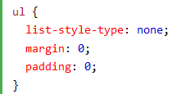

Change the style to create a basic vertical navigation bar with a gray background color and change the background color of the links when the user moves the mouse over them:

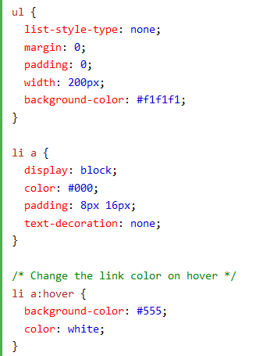 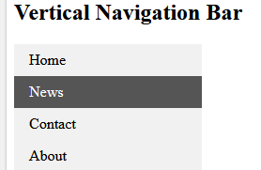

The style for vertical navigation bar

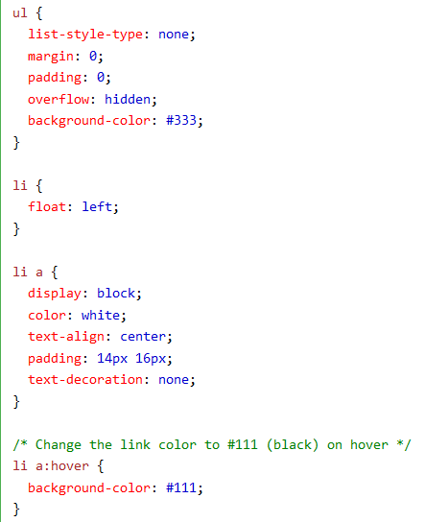

**Lab’s Exercise**

1. Create a css link access font Sofia from the Google APIs to make html page like this below.

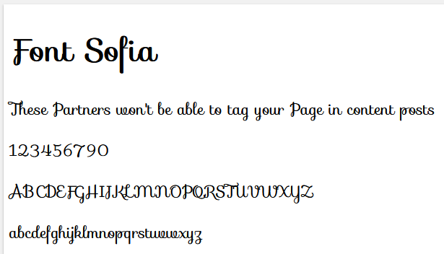

1. Create a horizonal navigation bar

Home, History, Attractions, Map, Gallery, Contact

**Conclusion and Result:**

….

**Lab 5’s Project**

1. **Copy these paragraphs**

(source: https://en.wikipedia.org/wiki/Universiti_Malaysia_Terengganu)

The Universiti Malaysia Terengganu (University of Malaysia, Terengganu) or UMT, formerly known as Kolej Universiti Sains dan Teknologi Malaysia (University College of Science and Technology Malaysia) or KUSTEM, is a university in Kuala Nerus District, Terengganu, Malaysia. It was officially chartered on 1 February 2007.

**HISTORY** of Universiti Malaysia Terengganu (UMT)

Universiti Malaysia Terengganu began as Universiti Pertanian Malaysia's Centre for Fisheries and Marine Science, located at Mengabang Telipot, Kuala Terengganu. It provided facilities for both students and lecturers from the Fisheries and Marine Science programmes to conduct their practical sessions and also researches.

Eventually, the Faculty of Fisheries and Marine Science of Universiti Pertanian Malaysia (UPM) in Serdang was transferred to Kuala Terengganu, and the Centre transformed into a branch campus, being renamed Universiti Pertanian Malaysia Terengganu (UPMT) in June 1996. The name of the faculty was also changed to the Faculty of Applied Sciences and Technology. Also formed were the Faculty of Science and Professional Literature and the Matriculation Centre.

Later on, the Cabinet of Malaysia had approved the establishment of Terengganu University College (KUT) on 5 May 1999 as an associate campus of UPM. Then Terengganu Universiti College was given autonomy on 1 May 2001 and was renamed the Malaysian Science and Technology University College (KUSTEM) on 20 June 2001.

On 1 February 2007, KUSTEM was given the status of a full-fledged university, and with that elevation, it was renamed again and remain to this very day as Universiti Malaysia Terengganu.

**VISION, MISSION, Function & Objective**

PHILOSOPHY

The Integration of Knowledge and Practice based on the Faith in Allah is Fundamental to the University's Endeavour in Preparing Competent Human Capital for Global Prosperity

VISION

Becoming The Country's Leading and Globally Respected Marine-Focused University

MISSION

Generating Knowledge for the Community's Affluence and Environmental Sustainability.

SLOGAN

Ocean of Discoveries, for Global Sustainability

NICHE AREA

Marine Science and Aquatic Resources

FUNCTIONS

* Supports the mission of the university to become the premier centre of learning and research by contributing to the progress of humankind and exploration of knowledge and also to the creation of wealth and national development.
* Provides trained manpower with professional skills, high self-discipline and positive work ethics.
* Produces graduates who are sensitive to management ideas, responsive to change and become a role-model for students and community.
* Serves society through the dissemination of ideas and new practices and seek solutions to current problems in society.
* Establishes relationships with other universities, institutions and the industry for mutual benefit and the national development.
* Supports the mission of the university to become an organised centre of research and learning as well as providing good services and exploring in a new technologies.

OBJECTIVES

* Explores all areas related to Science, Technology and Natural Resource Management through research.
* Provides the latest facilities (laboratories, libraries, computing and environment) to support the development of knowledge, learning and scholarship.
* Offers excellent programmes of study that meet current and future needs. Produces graduates who are responsible, knowledgeable, confident and competent.
* Plays an active role in the development of social, economic and education through the expansion services specifically to the local community of the East Coast Peninsular and to the Malaysians, in general.

1. **Create and design webpage**

* Follow this design below

|  |  |  |
| --- | --- | --- |
| Universiti Malaysia Terengganu | | |
| Menus : | Contents | Logo |
| History |
| Philosophy |
| Vission |
| Mission |
| Slogan |
| Niche area |
| Functions |
| Objectives |
|  | Footer  Copyright:  Date/year |  |

* Use section (such as: left, right, footer, header)
* Use internal and external css
* Create a navigation bar
* Be more creative. For all types of designers, inspiration and creativity are vital to success.