**Day4_Task**

let resumeDetailsOfArun = [

{

name:"Arun N",

college:"Nandha Engineering college",

Batch:"2015-2019",

Department:"EEE",

Experience:{

Years:"2 years",

First_company:"Cognizant",

Location:"Chennai",

Second_comapny:"Natwest",

Location:"Chennai",

Designation:"Software Test Engineer"

},

Project:{

In_Coginizant:"Liberty Mutual",

Doamain:"Insurance",

In_Natwest:"OBAO-Customer Onboarding",

Domain:"Banking"

},

skills:[

"Automation Testing",

"Selenium Webdriver",

"Java",

"API",

"Postman",

"Cucumber framework",

"Functional Testing",

"Jira",

"Agile"

],

Bio_data:{

Father_name:"Nagaraj K",

Mother_name:"Malathi N",

DOB:"10-03-1998",

City:"Erode"

}

}

]

**For loop:**

for(let i=0; i<resumeDetailsOfArun.length; i++){

console.log(resumeDetailsOfArun[i])

}

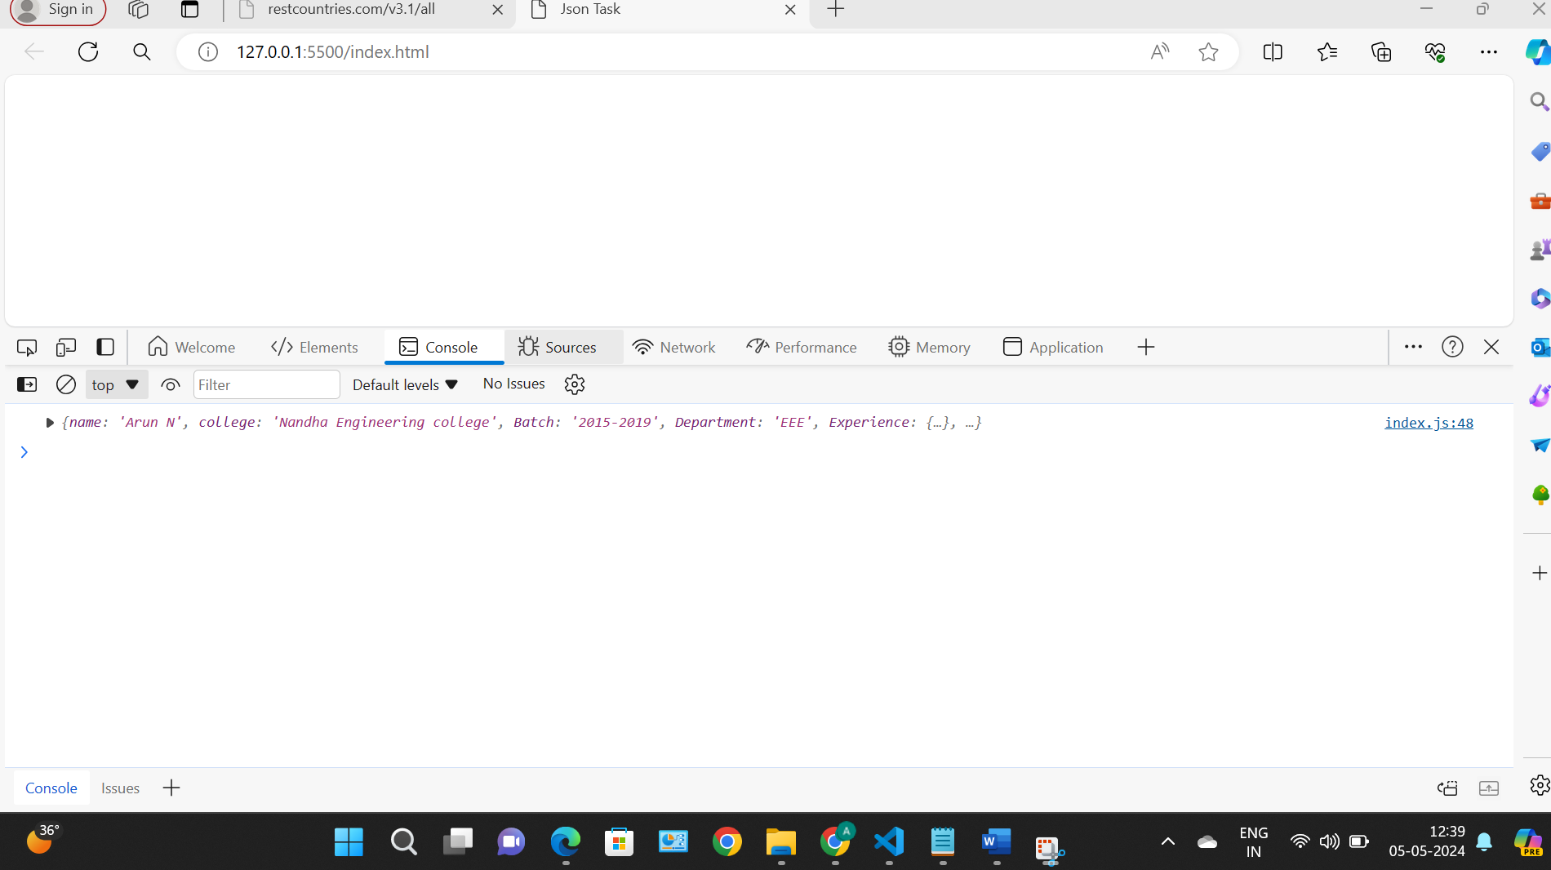

**For in Loop:**

for(let i in resumeDetailsOfArun){

console.log(resumeDetailsOfArun[i])

}

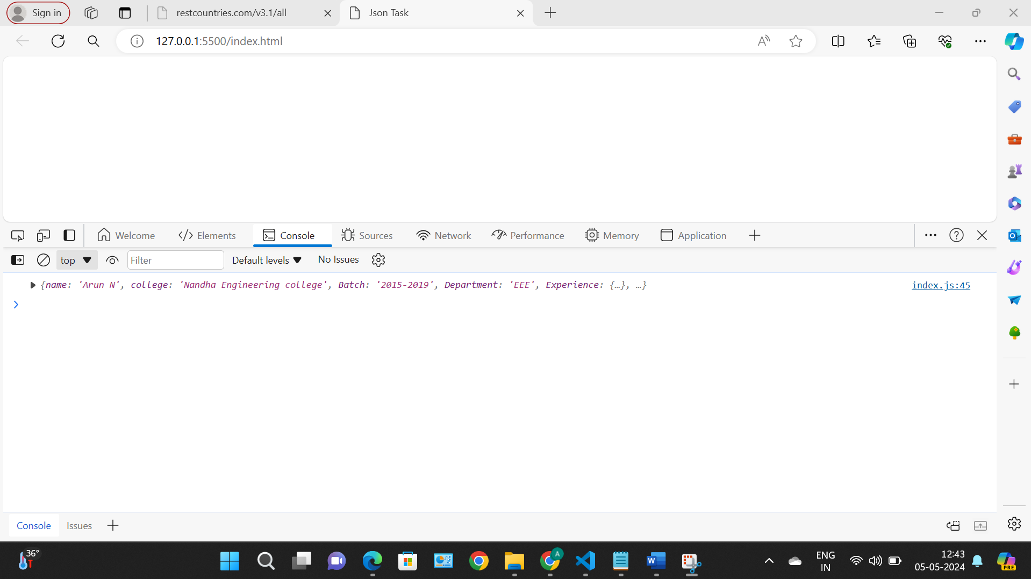

**For each loop:**

resumeDetailsOfArun.forEach((e)=>{

console.log(e)

})

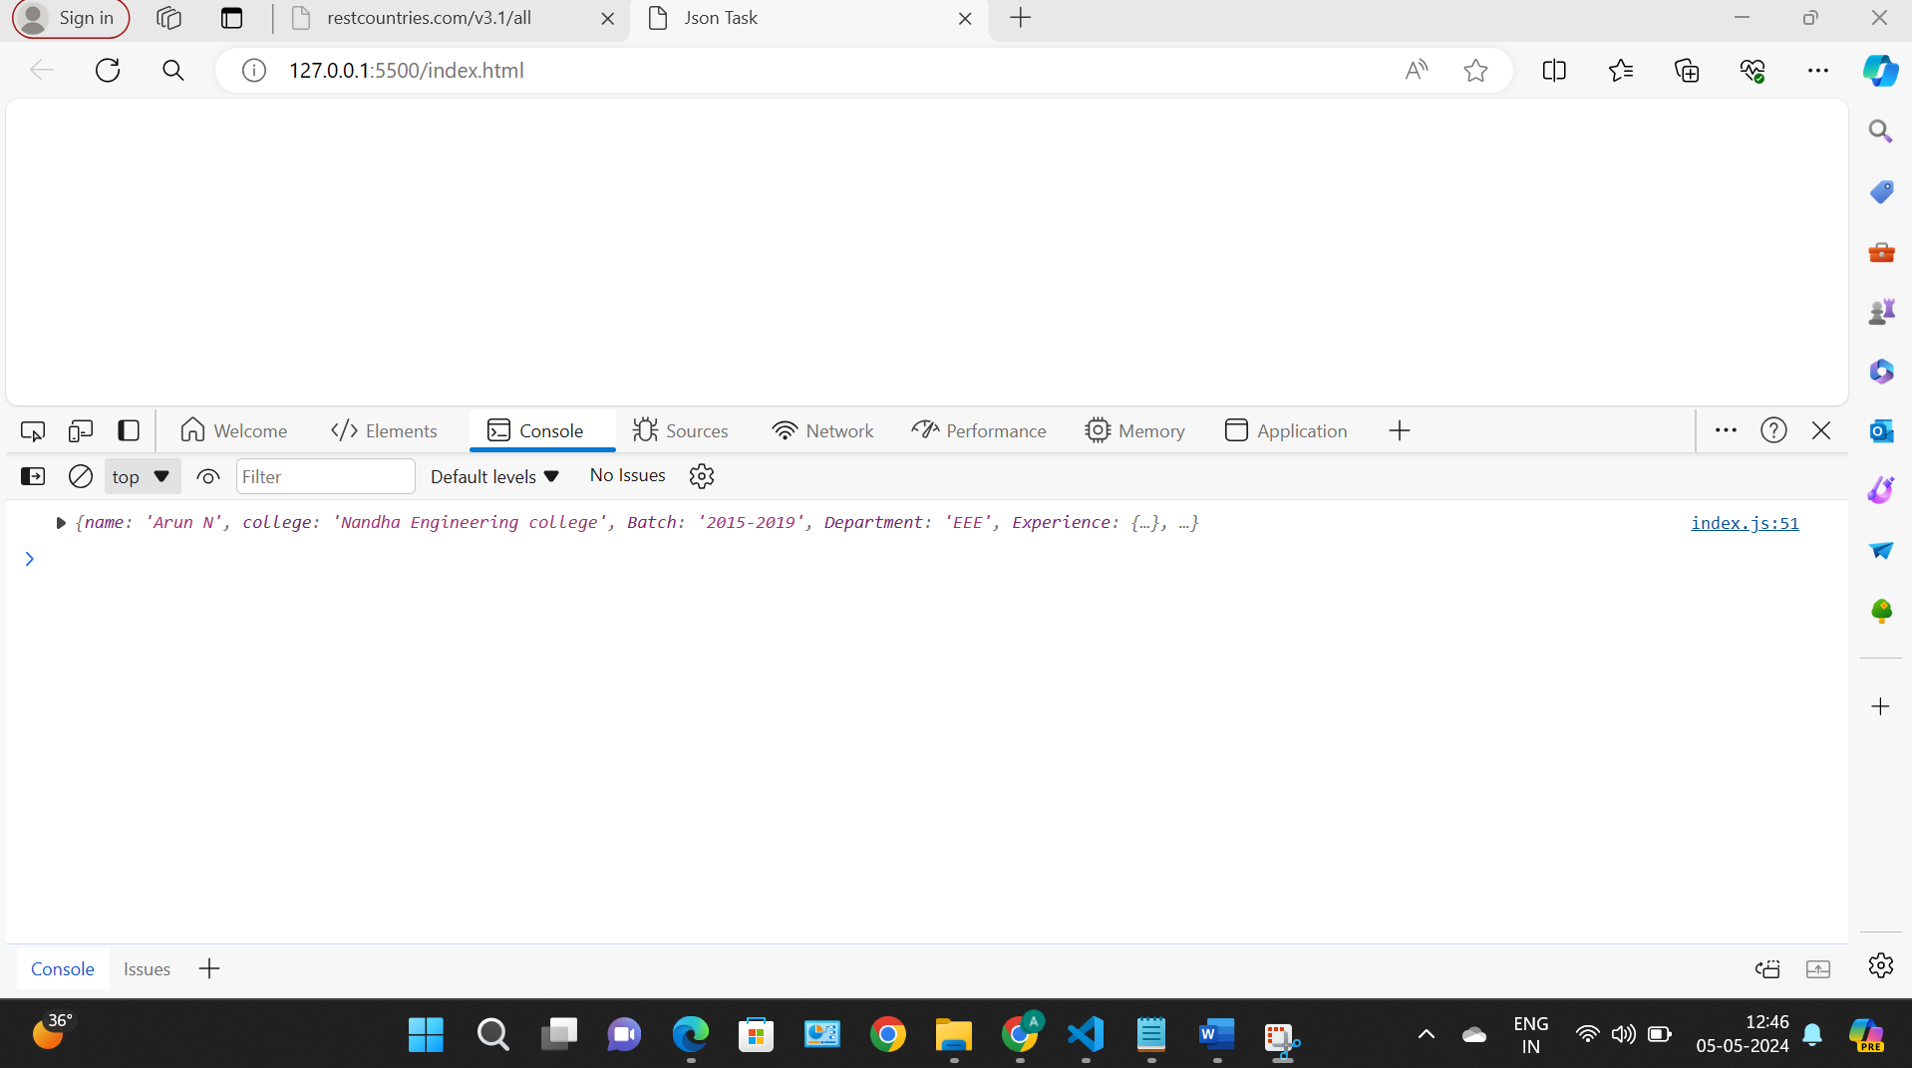

**For of loop:**

for(let i of resumeDetailsOfArun){

console.log(i)

}

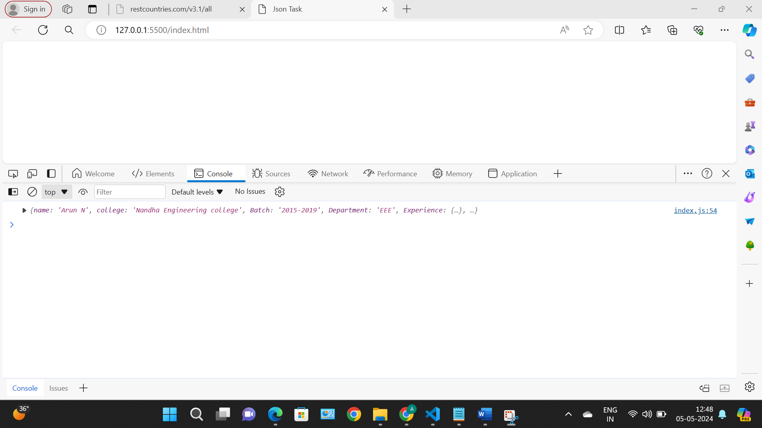

**Iterate using nested for loop:**

for(let i of resumeDetailsOfArun){

for(let e in i){

console.log(e,i[e])

}

}

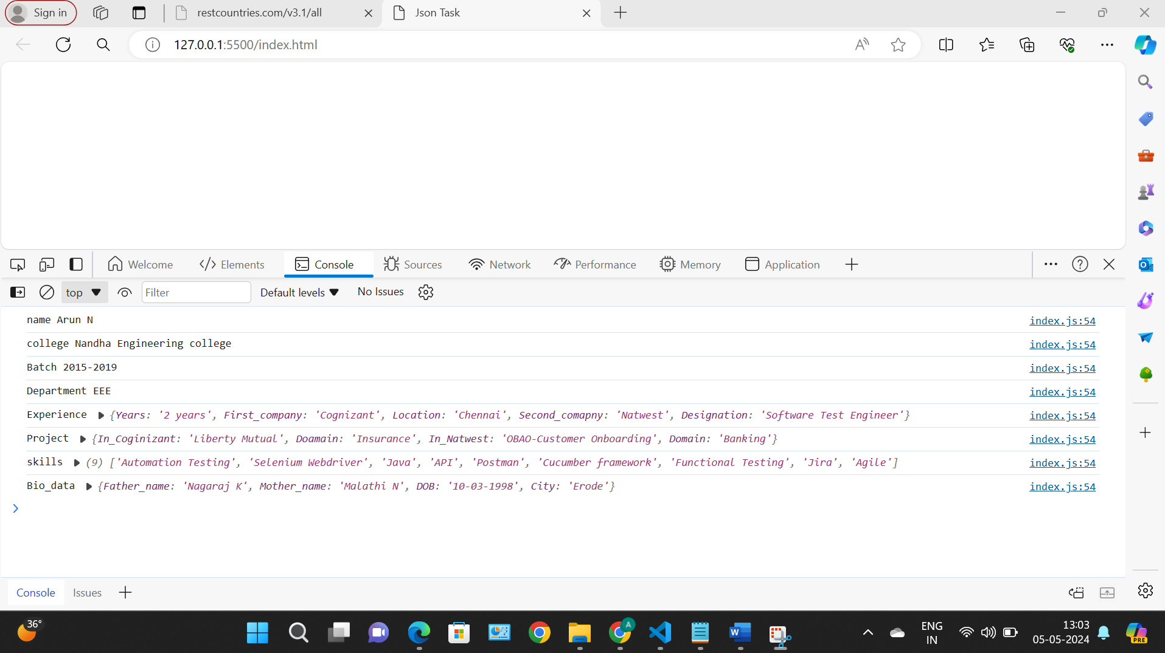

for(let i of resumeDetailsOfArun){

Object.keys(i).forEach((e)=>{

console.log(e,i[e])

})

}

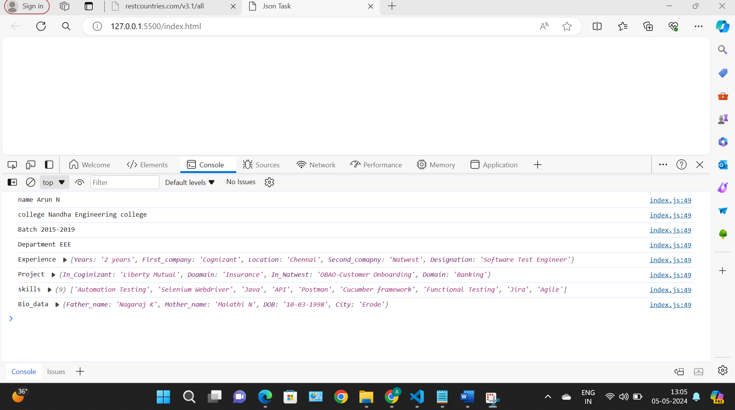s