**Introduction :**

The strength and vitality of the many neighbourhoods that make up Toronto, Ontario, Canada has earned the city its unofficial nickname of "the city of neighbourhoods." There are 140 neighbourhoods officially recognized by the City of Toronto and upwards of 240 official and unofficial neighbourhoods within the city's boundaries. Before 1998, Toronto was a much smaller municipality and formed part of Metropolitan Toronto. When the city amalgamated that year, Toronto grew to encompass the former municipalities of York, East York, North York, Etobicoke, and Scarborough. Each of these former municipalities still maintains, to a certain degree, its own distinct identity, and the names of these municipalities are still used by their residents, sometimes for disambiguation purposes as amalgamation resulted in duplicated street names. The area known as Toronto before the amalgamation is sometimes called the "old" City of Toronto, the Central District or simply "Downtown".

The "former" City of Toronto is, by far, the most populous and densest part of the city. It is also the business and administrative centre of the city. The uniquely Torontonian bay-and-gable housing style is common throughout the former city.

The "inner ring" suburbs of York and East York are older, predominantly middle-income areas, and ethnically diverse. Much of the housing stock in these areas consists of pre-World War II single-family houses and post-war high-rises. Many of the neighbourhoods in these areas were built up as streetcar suburbs and contain many dense and mixed-use streets, some of which are one-way. They share many characteristics with sections of the "old" city, outside the downtown core.

The "outer ring" suburbs of Etobicoke, Scarborough, and North York are much more suburban in nature (although these boroughs are developing urban centres of their own, such as North York City Centre around Mel Lastman Square). The following is a list of the more notable neighbourhoods, divided by the neighbourhoods' location based on the former municipalities, the names of which are still known and commonly used by Torontonians (and are necessary for disambiguating duplicate street names).

Toronto has many groups and associations to deal with neighbourhood issues, and larger umbrella organizations organize events to deal with broader issues.

**Data acquisition and cleaning :**

This is a list of postal codes in Canada where the first letter is M. Postal codes beginning with M are located within the city of Toronto in the province of Ontario. Only the first three characters are listed, corresponding to the Forward Sortation Area.

Canada Post provides a free postal code look-up tool on its website, via its applications for such smartphones as the iPhone and BlackBerry, and sells hard-copy directories and CD-ROMs. Many vendors also sell validation tools, which allow customers to properly match addresses and postal codes. Hard-copy directories can also be consulted in all post offices, and some libraries.

Toronto - 103 FSAs

Note: There are no rural FSAs in Toronto, hence no postal codes should start with M0, however, the postal code M0R 8T0 is assigned to an Amazon warehouse in Mississauga, suggesting that Canada Post may be allocating the M0 FSA for high volume addresses.

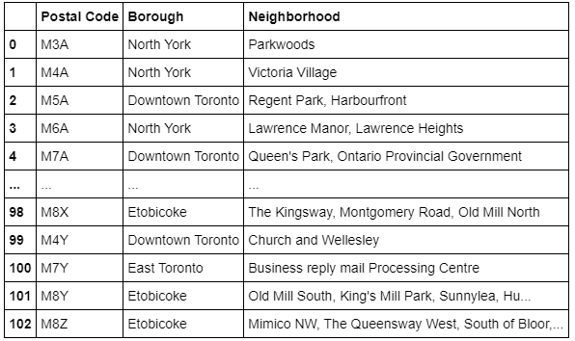

**Exploratory Data Analysis :**

Joining Two Data Sets Containing information about Boroughs its respective neighborhoods and postal code latitudes and longitudes respectively.

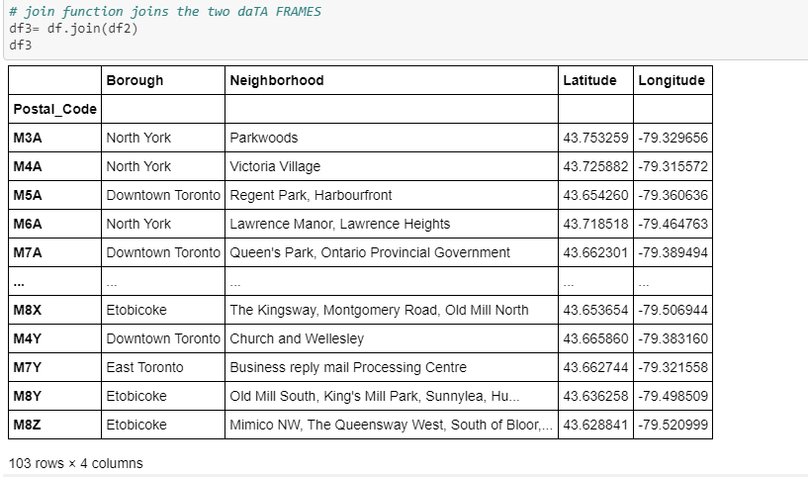

I’ve imported some libraries to perform some actions.

1. NumPy 🡪 Library to handle data in vectorized manner
2. Pandas 🡪 Library for Data Analysis
3. json 🡪 Library to handle JSON Files
4. Nominatim 🡪 Library that converts an Address to Latitudes and Longitudes
5. json_normalize 🡪 Library that transforms JSON Files into Pandas Data Frame
6. Folium 🡪 Library that renderes Maps

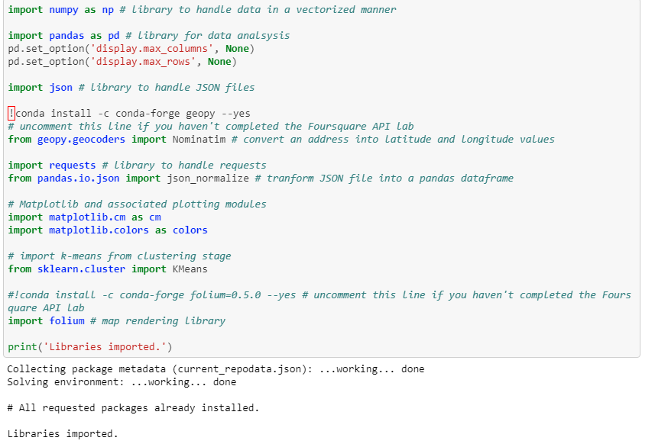

***Calculating a city Latitudes and Longitudes :***

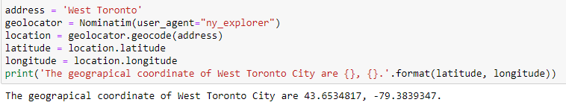

***Creating a Folium Map of selected City :***

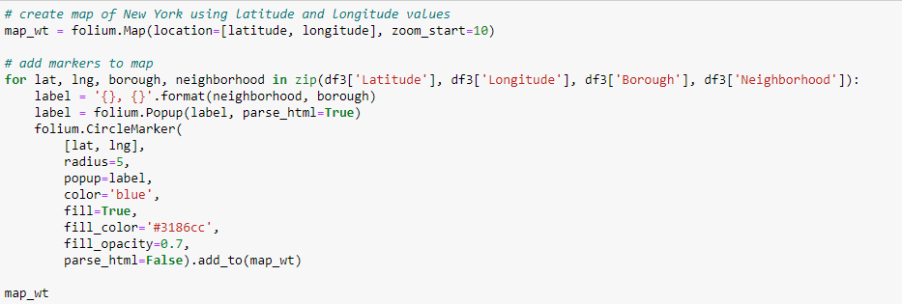

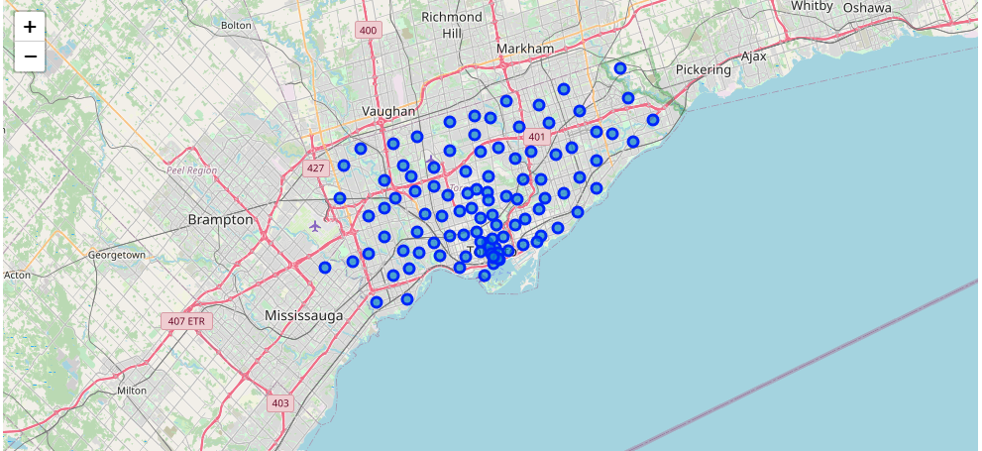

***Function that creates a Data Frame with all Boroughs and their respective neighbor hoods with nearby venues :***

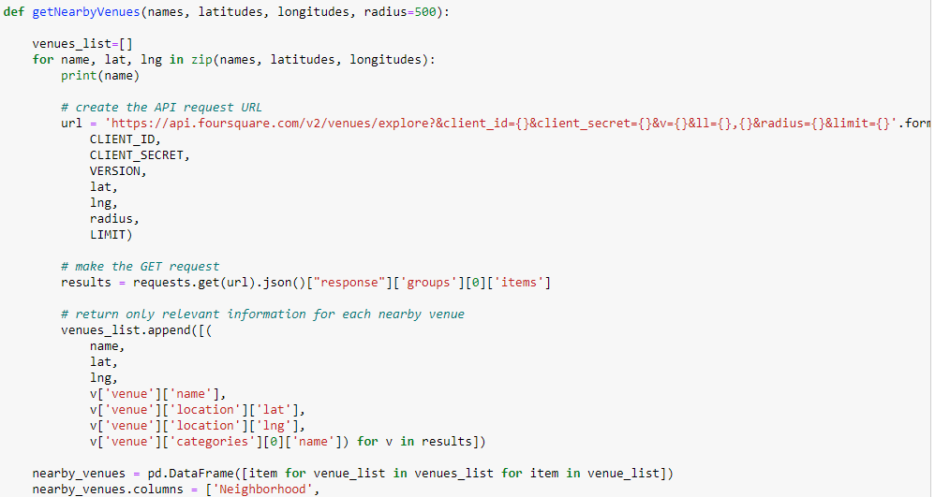

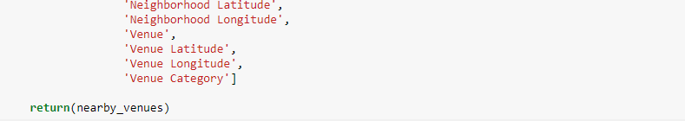

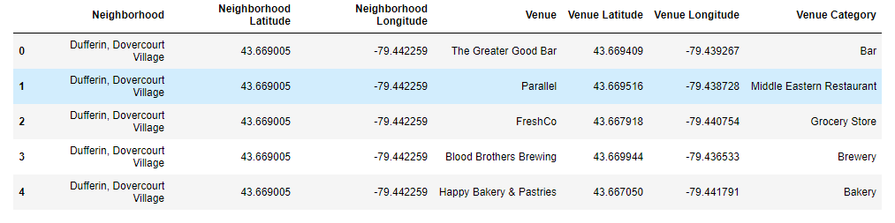

***One – hot Encoding on the resulting Data Frame :***

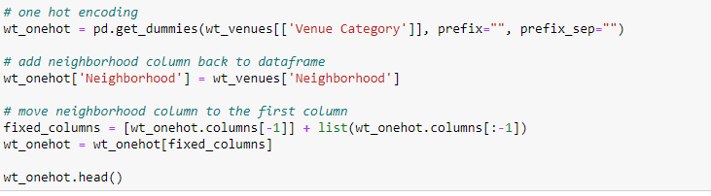

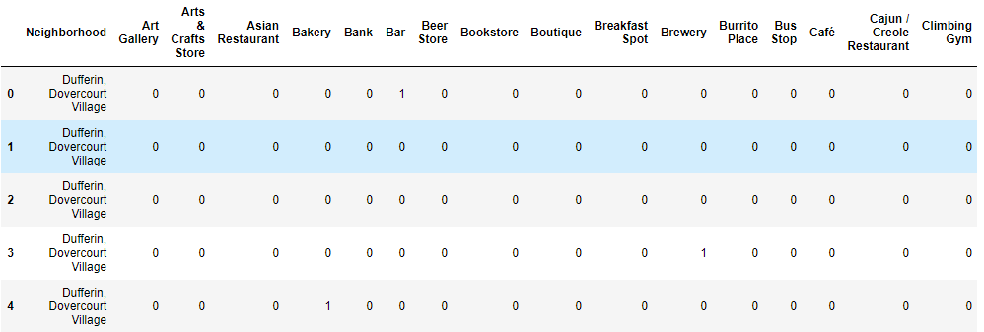

***Function that returns top 10 venues near each neighborhood of each borough :***

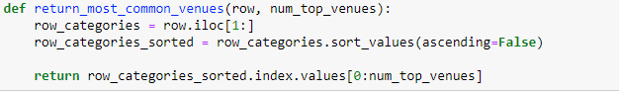

***CODE :***

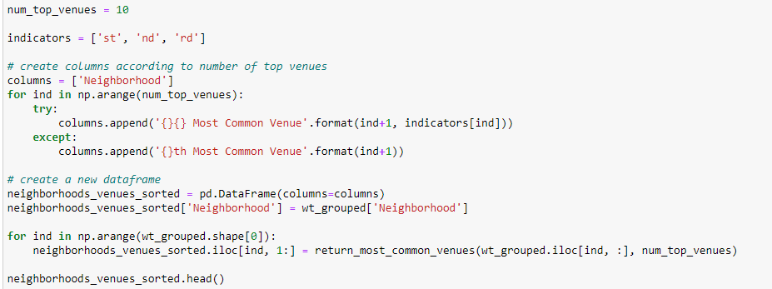

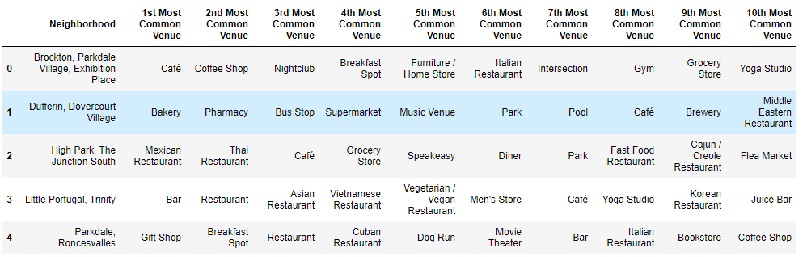

***K-MEANS CLUSTERING :***

To create 5 clusters :

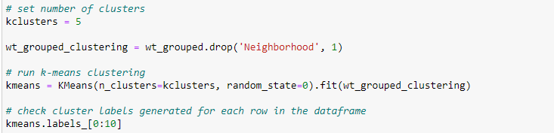

***REMODELING DATAFRAME AFTER CLUSTERING :-***

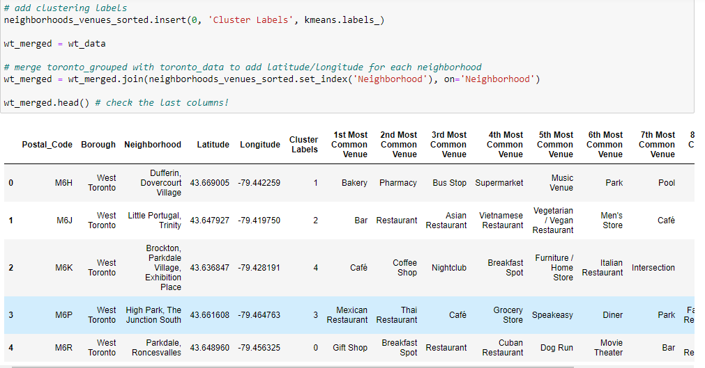

***Code for visualizing the clusters on the West Toronto Map :***

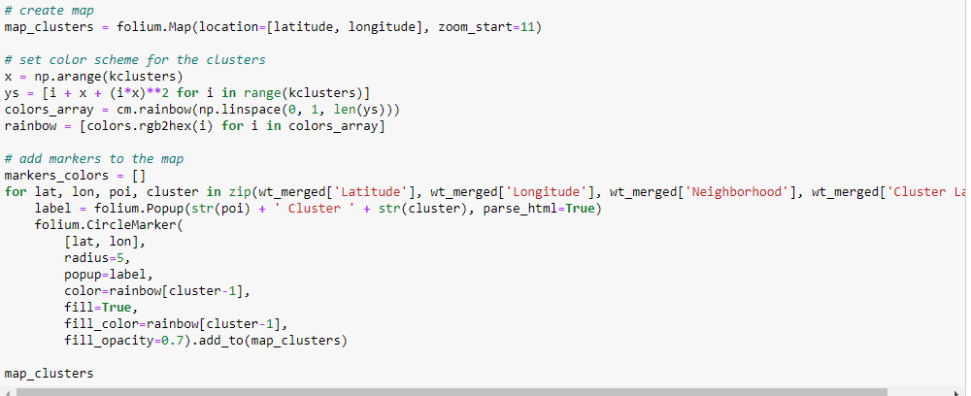

***Visualization :***

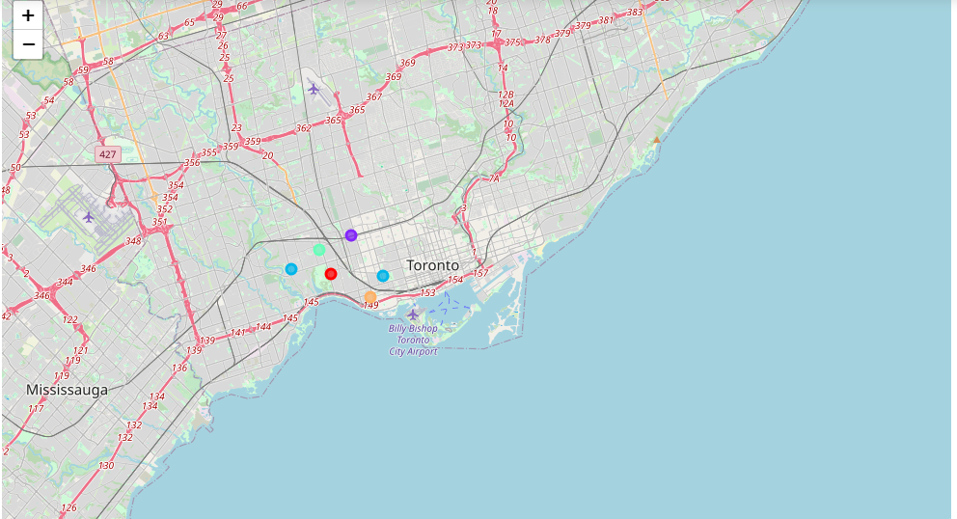

***Checking clusters :***

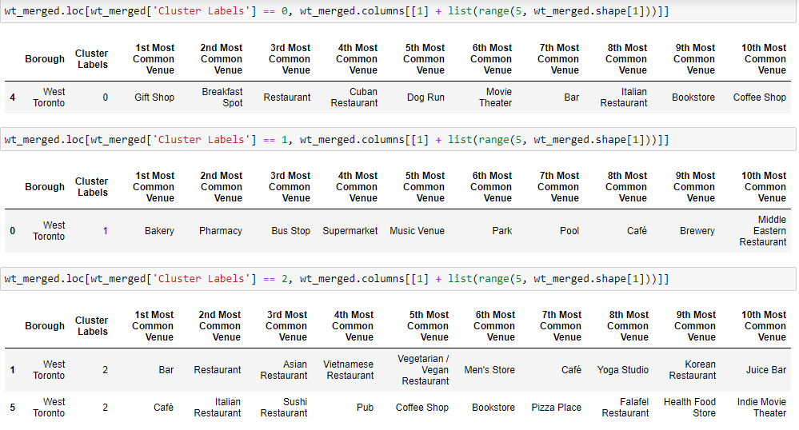

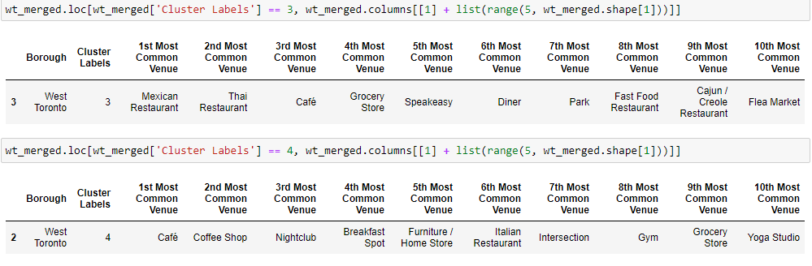

**Conclusions :**

From this Project, we can cluster the neighborhoods and their nearby venues and we cluster them according to top 10 most trending ones because their frequency of visiting by people is very high.

So if you want to start any kind of business like Cinema Theatres, Restaurants, etc… you can select the better the neighborhood.

And if you want to visit any tourists spots or hangout in the city you selected you can explore so many venues nearby.