**Tutorial 1:**

1. Write a program to determine the ranges of *char*, *short int*, *int* and *long int*, both *signed* and *unsigned*, by printing appropriate values from standard headers (standard library) and direct computations.
2. Write a program to determine the ranges of *float* and *double*. (An exercise in your resourcefulness in finding the correct functions)
3. Write a program which prints the character code of lowercase a-z and uppercase A-Z. E.g for the first few characters are shown below.

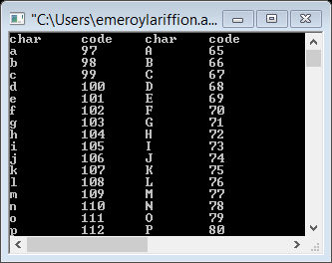

1. Write a program that request the number of seconds from the keyboard, convert it into hours, minutes & second and then, display it on the screen.
2. Write a program that request the length and width of a rectangle from the keyboard, and then output the area and perimeter of the rectangle
3. Extend the program in question 5, to make it into a menu-driven software (whereby the program gives choices 1-5 to find the area and perimeter of rectangle, square, circle, triangle and trapezium). Once the user choose (1)-(5), the program shall ask the relevant information to find and output the area and perimeter of the shapes. (e.g. for circle, input the radius of the circle).
4. Write a program that request two Cartesian points (x,y) and then compute the slope of the straight line between these points and their midpoint. Output your result.
5. Write a program that request temperature in Celsius and Fahrenheit and then convert it, and display the result. The conversion equation is:
$$T_{F}=\left({9.0}/{5.0}\right)T_{C}+32$$

6. Write a menu-driven program that request the type of cars from a limited list of at least 5 cars that you obtained from the [www.fueleconomy.gov](http://www.fueleconomy.gov) website. It would then request the distance of travel and the current price of gas per gallon, to calculate and output the total cost of the travel.
7. The Income Tax rate and bands for the UK are as given:

|  |  |  |
| --- | --- | --- |
| **Band** | **Taxable income** | **Tax rate** |
| Personal Allowance | Up to £11,000 | 0% |
| Basic rate | £11,001 to £43,000 | 20% |
| Higher rate | £43,001 to £150,000 | 40% |
| Additional rate | over £150,000 | 45% |

Write a program that request the taxable income of an individual, and then output the amount of tax and its effective tax rate.