**Tutorial 2:**

1. Create a printing program that print 1 to 100 in increment of 5, and then back from 100 to 1, in decrement of 5. Print the output on the screen.
2. Write a program that request the user to enter 1) beginning number to start counting, 2) ending number to start counting, and 3) Increment number used. Then, use the numbers to build a counting program (that counts the number between the start and ending number with the increment) and display the result.
3. Write a program that prints the Celsius to Fahrenheit conversion between 0 degree celsius to 300 degree Celsius, at increment of 5 celsius, using formulae given at tutorial 1.
4. Write a program that prints a table with each line giving an integer, its square and its cube. Request the user for the lower and upper limit, and ensure that the lower limit is smaller than the upper limit, by means of a do.. while loop.
5. The table below is sequence of Fibonacci numbers. The first two numbers in Fibonacci sequence are 0 and 1, and each subsequent number is the sum of the previous two numbers, according to the following equation:

$$F_{n}=F_{n-1}+F_{n-2}$$

Create a program that allow user to determine what the integer is at specific term.

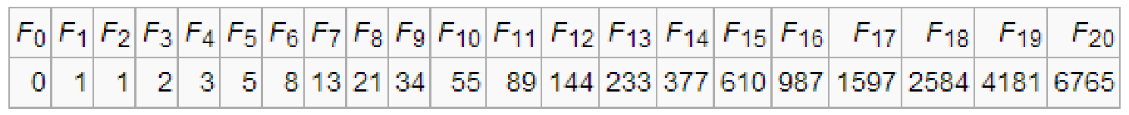

1. Have a program request the use to enter and uppercase letter. Use nested loops to produce a pyramid pattern like the figure below, where the pattern should extend to the character entered. For example, an input value of E is entered to produce the pattern in the figure below. Hint: Multiple loop is needed for the exercise.

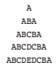

1. Write a program for the concentration game. For this program, you need to learn and use the following functions:
2. *rand ()* function : generates and return a whole number between 0 to a library-defined number
3. *time(NULL)* function : return the current time
4. *system(“clear”)* : a system command which can be executed from your C program in order to clear the display of previous value

Concentration game:

1. Ask the player if he wants to play concentration game
2. If No, exit the program. If yes, start playing
3. To play, generate three random integer numbers between 1-100 and print on the screen
4. The program shall give the user a 5 seconds to memorize the 3 numbers
5. Clear the screen from previously displayed numbers
6. Request the three numbers from the user
7. If all 3 numbers are correct, print congratulation, otherwise, correct the user by giving the three correct numbers.
8. Request the user if he wants to continue playing
9. Modify the concentration game to use main menu. The menu should allow the user to select a level of difficulty and/or quit the game. Each time the user completes a single game, the menu should reappear allowing the user to continue at the same level, at a new level, of simply quit the game
10. Easy (remember 3 numbers in 5 seconds)
11. Intermediate (remember 5 numbers in 5 seconds)
12. Difficult (remember 5 numbers in 2 seconds)
13. Quit