**COVID-19 USING COGNOS**

**Phase 3:DEVELOPMENT PART 1**

* **Project definition:**

The project we aim to address is the need for timely and insightful reporting on the COVID-19 pandemic’s impact on European union(EU) countries. This project involves analyzing COVID-19 cases and deaths data using IBM cognos. The objective is to compare and contrast the mean values and standard deviations of cases and associated deaths per day and by country in the EU/EEA. This project encompasses defining analysis objectives,collecting COVID-19 data,designing relevant visualizations in IBM cognos, and deriving insights from the data.

**Dataset Link:**[**https://www.kaggle.com/datasets/chakradharmattapalli/covid-19-cases**](https://www.kaggle.com/datasets/chakradharmattapalli/covid-19-cases)

* Project objectives:
* Loading and preprocessing the dataset.
* Start building the COVID-19 cases analysis using IBM Cognos for visualization.
* Define the analysis objectives and obtain the COVID-19 cases and deaths data file.
* Process and clean the data to ensure its accuracy and reliability.
* Given dataset:

|  |  |  |  |  |  |  |  |  |
| --- | --- | --- | --- | --- | --- | --- | --- | --- |
| dateRep | day | month | year | cases | deaths | countriesAndTerritories | | |
| 31-05-2021 | 31 | 5 | 2021 | 366 | 5 | Austria |  |  |
| 30-05-2021 | 30 | 5 | 2021 | 570 | 6 | Austria |  |  |
| 29-05-2021 | 29 | 5 | 2021 | 538 | 11 | Austria |  |  |
| 28-05-2021 | 28 | 5 | 2021 | 639 | 4 | Austria |  |  |
| 27-05-2021 | 27 | 5 | 2021 | 405 | 19 | Austria |  |  |
| 26-05-2021 | 26 | 5 | 2021 | 287 | 8 | Austria |  |  |
| 25-05-2021 | 25 | 5 | 2021 | 342 | 3 | Austria |  |  |
| 24-05-2021 | 24 | 5 | 2021 | 520 | 3 | Austria |  |  |
| 23-05-2021 | 23 | 5 | 2021 | 626 | 8 | Austria |  |  |
| 22-05-2021 | 22 | 5 | 2021 | 671 | 12 | Austria |  |  |
| 21-05-2021 | 21 | 5 | 2021 | 603 | 8 | Austria |  |  |
| 20-05-2021 | 20 | 5 | 2021 | 866 | 13 | Austria |  |  |
| 19-05-2021 | 19 | 5 | 2021 | 630 | 11 | Austria |  |  |
| 18-05-2021 | 18 | 5 | 2021 | 391 | 15 | Austria |  |  |
| 17-05-2021 | 17 | 5 | 2021 | 676 | 6 | Austria |  |  |
| 16-05-2021 | 16 | 5 | 2021 | 684 | 12 | Austria |  |  |
| 15-05-2021 | 15 | 5 | 2021 | 721 | 14 | Austria |  |  |
| 14-05-2021 | 14 | 5 | 2021 | 1100 | 11 | Austria |  |  |

Necessary step to follow:

**1.Import Libraries:**

Start by importing the necessary libraries:

Program:

Import os

import pandas as pd

import numpy as np

import matplotlib.pyplot as plt

import seaborn as sns

2.Load the Dataset:

Load your dataset into a Pandas DataFrame. You can typically find COVID-19 datasets in CSV format, but you can adapt this code to other formats as needed

Program:

os.chdir("C:\\Users\ELCOT\Downloads")

df=pd.read_csv("Covid_19_cases4.csv")

3. Exploratory Data Analysis (EDA):

Perform EDA to understand your data better. This includes checking for missing values, exploring the data's statistics, and visualizing it to identify patterns.

Program:

# Check for missing values

print(df.isnull().sum())

# Explore statistics

print(df.describe())

# Visualize the data (e.g., histograms, scatter plots, etc.)

4. Feature Engineering:

Depending on your dataset, you may need to create new features or transform existing ones. This can involve one-hot encoding categorical variables, handling date/time data, or scaling numerical features.

Program:

# Example: One-hot encoding for categorical variables

df = pd.get_dummies(df, columns=[' Avg. cases ', ' Avg. deaths'])

* Loading the dataset:
* Loading the dataset using machine learning is the process of bringing the data into the machine learning environment so that it can be used to train and evaluate a model.
* The specific steps involved in loading the dataset will vary depending on the machine learning library or framework that is being used. However, there are some general steps that are common to most machine learning frameworks:

**a.Identify the dataset:**

The first step is to identify the dataset that you want to load. This dataset may be stored in a local file, in a database, or in a cloud storage service.

**b.Load the dataset:**

Once you have identified the dataset, you need to load it into the machine learning environment. This may involve using a built-in function in the machine learning library, or it may involve writing your own code.

**c.Preprocess the dataset:**

Once the dataset is loaded into the machine learning environment, you may need to preprocess it before you can start training and evaluating your model. This may involve cleaning the data, transforming the data into suitable format, and splitting the data into training and test sets.

Program:

import os

import pandas as pd

import matplotlib.pyplot as plt

import numpy as np

import seaborn as sns

os.chdir("C:\\Users\ELCOT\Downloads")

df=pd.read_csv("Covid_19_cases4.csv")

print(df)

Output:

dateRep day month year cases deaths countriesAndTerritories

0 31-05-2021 31 5 2021 366 5 Austria

1 30-05-2021 30 5 2021 570 6 Austria

2 29-05-2021 29 5 2021 538 11 Austria

3 28-05-2021 28 5 2021 639 4 Austria

4 27-05-2021 27 5 2021 405 19 Austria

... ... ... ... ... ... ... ...

2725 06-03-2021 6 3 2021 3455 17 Sweden

2726 05-03-2021 5 3 2021 4069 12 Sweden

2727 04-03-2021 4 3 2021 4884 14 Sweden

2728 03-03-2021 3 3 2021 4876 19 Sweden

2729 02-03-2021 2 3 2021 6191 19 Sweden

[2730 rows x 7 columns]

* Exploratory Data Analysis(EDA):

**Some common data preprocessing tasks include:**

* **Data cleaning:**

This involves identifying and correcting errors and inconsistencies in the data. For example, this may involve removing duplicate records, correcting typos, and filling in missing values.

* **Data transformation:**

This involves converting the data into a format that is suitable for the analysis task. For example, this may involve converting categorical data to numerical data, or scaling the data to a suitable range.

* **Feature engineering:**

This involves creating new features from the existing data. For example, this may involve creating features that represent interactions between variables, or features that represent summary statistics of the data.

* **Data integration**:

This involves combining data from multiple sources into a single dataset. This may involve resolving in consistencies in the data, such as different data formats or different variable names .Data preprocessing is an essential step in many data science projects. By carefully preprocessing the data, data scientists can improve the accuracy and reliability of their results.

**#information about the dataset**

print(df.info)

**output:**

<class 'pandas.core.frame.DataFrame'>

RangeIndex: 2730 entries, 0 to 2729

Data columns (total 7 columns):

# Column Non-Null Count Dtype

--- ------ -------------- -----

0 dateRep 2730 non-null object

1 day 2730 non-null int64

2 month 2730 non-null int64

3 year 2730 non-null int64

4 cases 2730 non-null int64

5 deaths 2730 non-null int64

6 countriesAndTerritories 2730 non-null object

dtypes: int64(5), object(2)

memory usage: 149.4+ KB

#some basic techniques

print(df.head(4))

**output:**

|  |  |  |  |  |  |  |  |  |
| --- | --- | --- | --- | --- | --- | --- | --- | --- |
| dateRep | day | month | year | cases | deaths | countriesAndTerritories | | |
| 31-05-2021 | 31 | 5 | 2021 | 366 | 5 | Austria |  |  |
| 30-05-2021 | 30 | 5 | 2021 | 570 | 6 | Austria |  |  |
| 29-05-2021 | 29 | 5 | 2021 | 538 | 11 | Austria |  |  |
| 28-05-2021 | 28 | 5 | 2021 | 639 | 4 | Austria |  |  |

print(df.tail())

**output:**

|  |  |  |  |  |  |  |  |  |
| --- | --- | --- | --- | --- | --- | --- | --- | --- |
| 06-03-2021 | 6 | 3 | 2021 | 3455 | 17 | Sweden |  |  |
| 05-03-2021 | 5 | 3 | 2021 | 4069 | 12 | Sweden |  |  |
| 04-03-2021 | 4 | 3 | 2021 | 4884 | 14 | Sweden |  |  |
| 03-03-2021 | 3 | 3 | 2021 | 4876 | 19 | Sweden |  |  |
| 02-03-2021 | 2 | 3 | 2021 | 6191 | 19 | Sweden |  |  |

print(df.countriesAndTerritories.value_counts())

**output:**

Austria 91

Belgium 91

Spain 91

Slovenia 91

Slovakia 91

Romania 91

Portugal 91

Poland 91

Norway 91

Netherlands 91

Malta 91

Luxembourg 91

Lithuania 91

Liechtenstein 91

Latvia 91

Italy 91

Ireland 91

Iceland 91

Hungary 91

Greece 91

Germany 91

France 91

Finland 91

Estonia 91

Denmark 91

Czechia 91

Cyprus 91

Croatia 91

Bulgaria 91

Sweden 91

Name: countriesAndTerritories, dtype: int64

print(df.dtypes)

**output:**

dateRep object

day int64

month int64

year int64

cases int64

deaths int64

countriesAndTerritories object

dtype: object

#missing value find out

print(df.isnull().sum())

**output:**

dateRep 0

day 0

month 0

year 0

cases 0

deaths 0

countriesAndTerritories 0

dtype: int64

print(df.shape)

**output:**

(2730, 7)

print(df.columns)

**output:**

Index(['dateRep', 'day', 'month', 'year', 'cases', 'deaths',

'countriesAndTerritories'],

dtype='object')

print(df.groupby(['countriesAndTerritories','cases']).size())

**output:**

countriesAndTerritories cases

Austria 287 1

342 1

366 1

391 1

405 1

..

Sweden 7757 1

7832 1

8293 1

8468 1

8872 1

Length: 2424, dtype: int64

print(df.groupby(['countriesAndTerritories','deaths']).size())

**output:**

countriesAndTerritories deaths

Austria 3 2

4 1

5 1

6 2

8 4

..

Sweden 22 7

23 3

24 4

25 4

28 1

Length: 1161, dtype: int64

print(df['deaths'].sum())

**output:**

178247

print(df['cases'].sum())

**output:**

9994560

grouped=df.groupby('countriesAndTerritories')

print(grouped['cases'].agg([np.sum,np.mean,np.min,np.max,np.std]))

**output:**

sum mean amin amax std

countriesAndTerritories

Austria 184416 2026.549451 287 4051 995.569254

Belgium 288119 3166.142857 589 6285 1489.367499

Bulgaria 171236 1881.714286 53 5176 1492.096052

Croatia 113168 1243.604396 74 3217 891.781561

Cyprus 37700 414.285714 44 941 232.107987

Czechia 421221 4628.802198 6 16816 4568.044868

Denmark 69188 760.307692 -2001 2007 379.739609

Estonia 62916 691.384615 58 1956 512.714514

Finland 34760 381.978022 0 863 229.646442

France 2020808 22206.681319 2229 53843 13071.979649

Germany 1234058 13561.076923 1911 29518 7094.986871

Greece 210201 2309.901099 0 4322 848.995944

Hungary 371613 4083.659341 156 11265 3320.112746

Iceland 527 5.791209 0 43 8.003494

Ireland 42057 462.164835 270 768 100.813057

Italy 1290738 14183.934066 2489 26790 7041.661404

Latvia 46912 515.516484 119 1036 212.667940

Liechtenstein 437 4.802198 0 18 4.536812

Lithuania 77040 846.593407 184 2055 365.604643

Luxembourg 14464 158.945055 0 461 102.413797

Malta 7586 83.362637 0 501 106.804548

Netherlands 557983 6131.681319 2457 9587 1753.827097

Norway 53995 593.351648 0 2400 550.922386

Poland 1164964 12801.802198 559 35253 10077.117328

Portugal 44096 484.571429 158 1007 180.257602

Romania 275590 3028.461538 158 6651 2039.807678

Slovakia 178475 1961.263736 19 6107 1590.997715

Slovenia 63550 698.351648 0 1802 396.183329

Spain 552723 6073.879121 0 22744 5228.258973

Sweden 404019 4439.769231 90 8872 2291.974835

grouped=df.groupby('countriesAndTerritories')

print(grouped['deaths'].agg([np.sum,np.mean,np.min,np.max,np.std]))

**output:**

sum mean amin amax std

countriesAndTerritories

Austria 1925 21.153846 3 51 9.946438

Belgium 2696 29.626374 6 50 10.526842

Bulgaria 7471 82.098901 5 217 52.742573

Croatia 2488 27.340659 4 52 13.689590

Cyprus 129 1.417582 0 7 1.445806

Czechia 9639 105.923077 3 278 79.977390

Denmark 155 1.703297 0 5 1.269247

Estonia 654 7.186813 0 24 5.462828

Finland 177 1.945055 0 9 1.753489

France 22977 252.494505 44 897 122.023347

Germany 18337 201.505495 33 418 98.548846

Greece 5550 60.989011 0 134 19.821142

Hungary 14675 161.263736 5 311 80.336492

Iceland 1 0.010989 0 1 0.104828

Ireland 622 6.835165 -3 47 9.080215

Italy 28347 311.505495 44 718 128.946016

Latvia 752 8.263736 0 21 4.813950

Liechtenstein 4 0.043956 0 1 0.206133

Lithuania 1022 11.230769 4 24 4.187486

Luxembourg 176 1.934066 0 10 2.360801

Malta 104 1.142857 0 5 1.410842

Netherlands 2055 22.582418 3 65 12.061017

Norway 161 1.769231 0 25 4.107113

Poland 29969 329.329670 11 956 226.820539

Portugal 706 7.758242 0 41 9.337309

Romania 9926 109.076923 29 237 44.712720

Slovakia 5150 56.593407 0 149 32.456117

Slovenia 582 6.395604 0 39 6.858699

Spain 10344 113.670330 0 637 131.547039

Sweden 1453 15.967033 1 28 5.762813

#histogram

df.hist(figsize=(15,15), layout=(4,4), bins=20)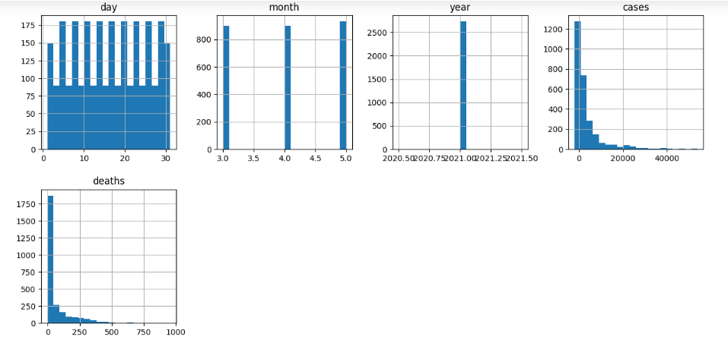

#checking outliers using box plot

df.plot(kind="box",subplots=True,layout=(5,5),figsize=(15,15))

**output:**

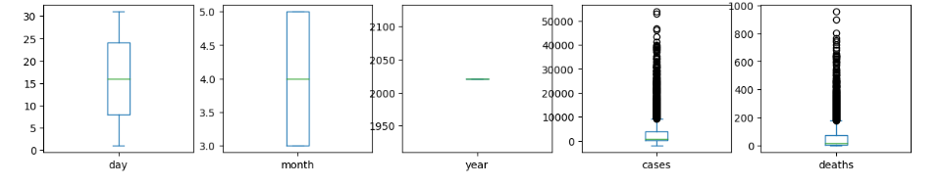

**#barplot**

x=df['countriesAndTerritories']

y=df['deaths']

plt.bar(x,y)

plt.xlabel('countries')

plt.ylabel('deaths')

plt.show()

**output:**

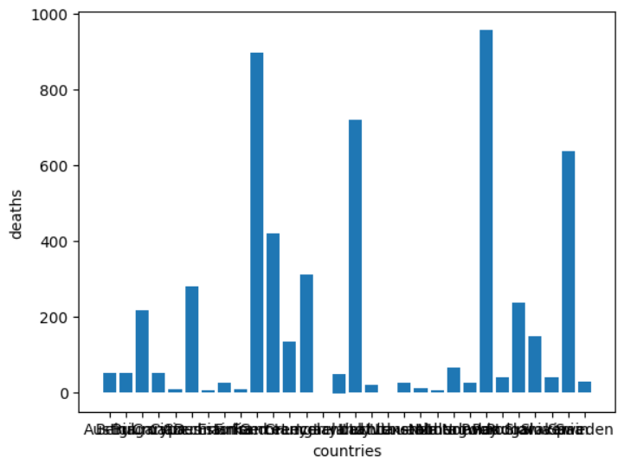

#heatmap

plt.figure(figsize=[14,6])

sns.heatmap(df.corr(), annot = True,cmap = 'coolwarm')

**output:**

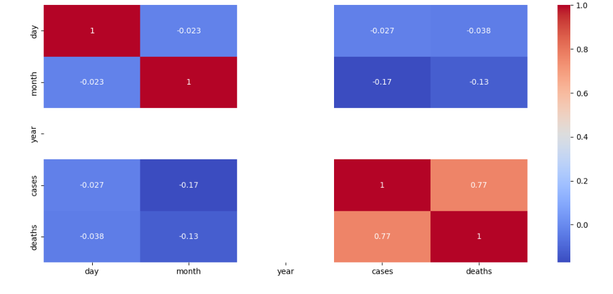

**#barplot**

x=df['countriesAndTerritories']

y=df['cases']

plt.bar(x,y)

plt.xlabel('countries')

plt.ylabel('cases')

plt.show()

**output:**

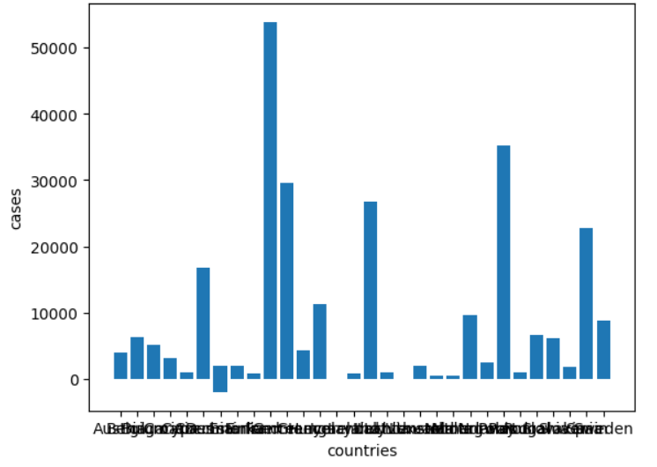

**Conclusion:**

The visualizations created for this assignment have played a crucial role in making these insights accessible and understandable. Visual aids such as bar charts, scatter plots, and heatmaps have not only made the data more approachable but have also allowed us to identify trends and patterns that might have otherwise gone unnoticed.

It is important to note that the choice of visualization techniques was instrumental in our ability to answer the assignment's questions effectively.

In the end we find the France country is most covid-19 cases(2020808) and Liechtenstein is the least covid-19 cases(437) occur. Poland country is the most death cases(29969) and Iceland is least death cases in(1) European union(EU) countries.

The heatmap says covid19 cases highly correlated to death cases and also histogram says the covid-19 cases and deaths is right skewed in the form for mode<median<mean.