[**https://tradingbot123.herokuapp.com**](https://tradingbot123.herokuapp.com)

1. **go to tradingview and select the crypto in view charts.**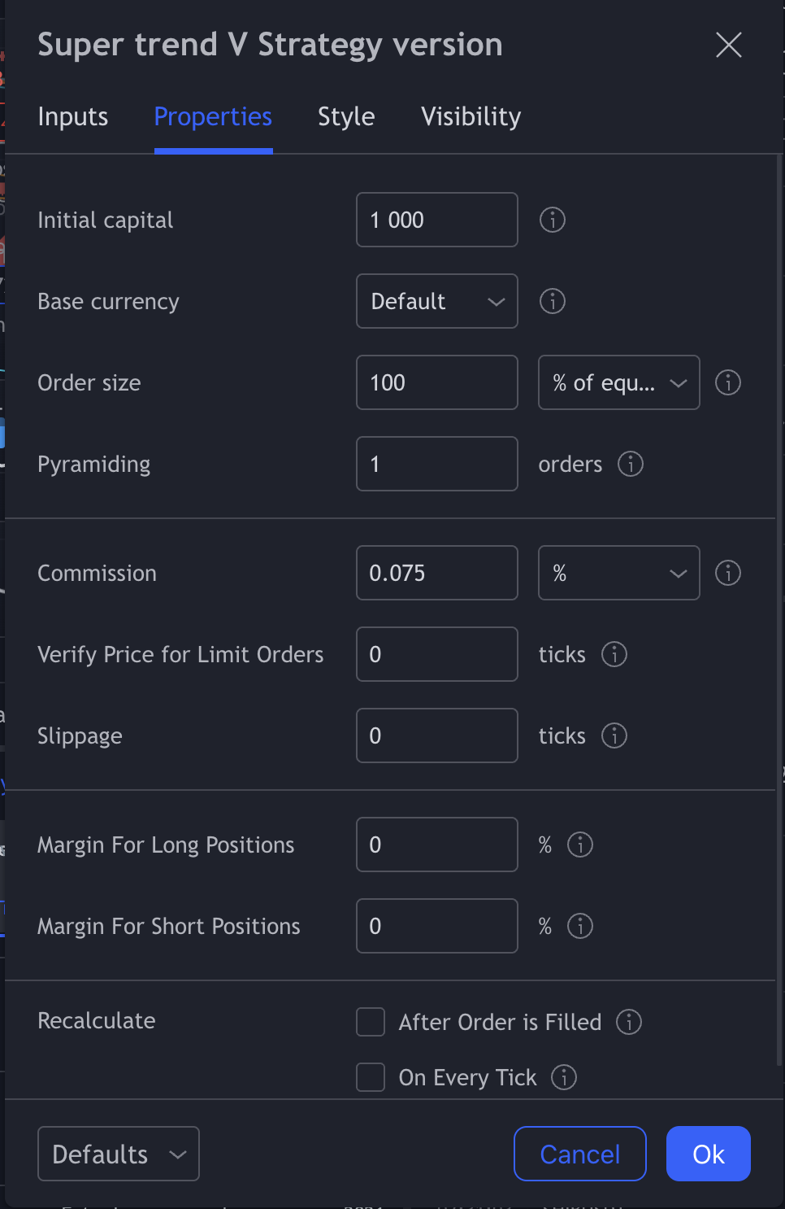
2. **Go to indicators and strategies -> my scripts and then select super trend v strategy version**
3. **Go to settings of the indicator and set your initial capital. Insert the capital a fraction less than your actual capital so that it covers up the trading cost/commission etc. For eg. if your capital is 100, you can insert something like 99.5 or 99.6.**
4. **Now go to create alert on trading view, select condition as super trend v strategy. select web hook url and insert this url**

**"**[**https://tradingbot123.herokuapp.com**](https://tradingbot123.herokuapp.com)**/webhook"**

**5) in the Message section add this and create alert:**

**{**

**"passphrase": "bot123",**

**"time": "{{timenow}}",**

**"exchange": "{{exchange}}",**

**"ticker": "{{ticker}}",**

**"bar": {**

**"time": "{{time}}",**

**"open": {{open}},**

**"high": {{high}},**

**"low": {{low}},**

**"close": {{close}},**

**"volume": {{volume}}**

**},**

**"strategy": {**

**"position_size": {{strategy.position_size}},**

**"order_action": "{{strategy.order.action}}",**

**"order_contracts": {{strategy.order.contracts}},**

**"order_price": {{strategy.order.price}},**

**"order_id": "{{strategy.order.id}}",**

**"market_position": "{{strategy.market_position}}",**

**"market_position_size": {{strategy.market_position_size}},**

**"prev_market_position": "{{strategy.prev_market_position}}",**

**"prev_market_position_size": {{strategy.prev_market_position_size}}**

**}**

**}**

**IMPORTANT**

**You need to create alert only after a sell signal is shown on the chart so that when the alert triggers it goes as buy signal. Since buy and sell signals are alternative. Once the alert is created, it will automatically trigger when buy and signals are shown henceforth so create only one alert.**

**This message is also located in the txt file in the folder.**

**6) in order to update the python file for leverage or api keys you will need to update the deployed app on heroku.**

**Download python -** [**https://www.python.org/downloads/**](https://www.python.org/downloads/)

**Download pip-** [**https://www.geeksforgeeks.org/how-to-install-pip-on-windows/**](https://www.geeksforgeeks.org/how-to-install-pip-on-windows/)

**Download https://git-scm.com/downloads**

**Download heroku cli -** [**https://devcenter.heroku.com/articles/heroku-cli#download-and-install**](https://devcenter.heroku.com/articles/heroku-cli%23download-and-install)

**Open command prompt/terminal in the folder and run :**

**pip install -r requirements.txt**

**Now make changes accordingly and deploy**

heroku login

Clone the repository

Use Git to clone tradingbot123's source code to your local machine.

heroku git:clone -a tradingbot123

cd tradingbot123

Deploy your changes

Make some changes to the code you just cloned and deploy them to Heroku using Git.

git add .

git commit -am "make it better"

git push heroku master

**Text highlighted in red is the code you need to run in terminal or cmd prompt.**

**To generate api keys on binance:**

[**https://www.binance.com/en/support/faq/360002502072**](https://www.binance.com/en/support/faq/360002502072)

**To check the logs if order was executed or if there was any error you can login to your heroku account and check app logs.**