DESIGN AND DEVELOPMENT OF BASIC HEALTH MONITORING STATION

Project report submitted in partial fulfillment of the requirements for the award of the degree of Bachelor Engineering in Instrumentation and Control Engineering
By
Mr. Arun Sanyasi
Ms. Sherab Zangmo
Ms. Tashi Chozom

Under the guidance of:
Mrs. Karma Kelzang Eudon (Guide)
Mr. Kinley Penjor (External Guide)

ELECTRICAL AND ELECTRONIC ENGINEERING DEPARTMENT
COLLEGE OF SCIENCE AND TECNOLOGY
RINCHENDING: PHUENTSHONLING
CHHUKHA DZONGKHAG: BHUTAN
June 2026

ROYAL UNIVERSITY OF BHUTAN
COLLEGE OF SCIENCE AND TEHNOLOGY
INSTRUMENTATION AND CONTROL ENGINEERING PROGRAMME



CERTIFICATE
This is to certify that the B.E. project titled “Basic Health Monitoring System”, which is being submitted by Mr. Arun Sanyasi(02220230), Ms. Tashi Chozom(02220244), and Ms. Sherab Zangmo (02220238) in partial fulfillment of the requirement for the award of the degree of Bachelor of Engineering in Instrumentation and Control

Mr. Kinley Penjor Ms. Karma Kelzang Eudon
External Guide Project Guide

ACKNOWLEGEMENT

We acknowledge guidance and support of each other at every stage of the development of our project “Basic Health Monitoring Station”. First, we would like to thank the College of Science and Technology, and Instrumentation and Control Engineering program which provided the facilities, resources and conducive working environment needed to successfully conclude this project.
We are grateful to our guide, Ms. Karma Kelzang Eudon, as she has been with us during project development as well. In this regard, she supported us with wisdom and encouragement with no delay. Her suggestions and technical knowledge have made us able to finish this task successfully.
Finally, we would like to extend our heartfelt appreciation to our external guide Mr. Kinley Penjor for taking the time required to peruse our work and providing us guidance, with positive comments, suggestions and continued assistance throughout the work process.
We would also like to thank Ms. Deepa Sharma who’s currently pursuing Bachelor of Nursing at Royal Academy of Thimphu who helped us understand the linkages between each parameter and help us understand the core concept of providing diagnoses and health tips for our applications.
We would like to express our gratitude to Chief Medical Officer and the staff of Phuentsholing General Hospital for providing the working space and access to all the clinical devices we needed to calibrate and test our system. They were generous enough to let us calibrate our device when necessary. We appreciate the team at Fab-Lab CST and their support to us in using their 3D printing capabilities while doing our project. Timber Lab staff, Mr.Vijay, helped us during the fabrication of the physical body of our system, therefore, we would like to thank him for his support. Finally, we would like to thank our fellow classmates, friends and family members for the encouragement, and support throughout this process.
Arun Sanyasi
Tashi Chozom
Sherab Zangmo

ABSTRACT

As the importance of preventative healthcare and early diagnosis of medical conditions continues to grow, there is an urgent need for effective methods of testing for health issues. In most establishments, pulse rate, respiratory rate, SpO2, body temperature, body height, and body weight must be measured individually through different pieces of equipment, making the process longer and necessitating manual recording. The purpose of this research project is to develop a prototype of a Basic Health Monitoring Station.The system utilizes the ESP32 microcontroller for live acquisition of the sensor data and Raspberry Pi 4B for data processing, graphical interface management, and report generation. The system incorporates sensors like MAX30102 for measuring pulse rate and SpO₂, MLX90614 for non-contact measurement of body temperature, VL53L0X for calculating body height, and a load cell sensor with the HX711 amplifier for body weight calculation. The BMI is automatically calculated using height and weight measurements. The output is categorized as low, normal, or high. The output is presented on the touch screen display. Finally, the QR code is generated to produce the health report. Thus, the total cost of building this device is Nu. 20,813, making it economical and feasible for colleges, rural hospitals, community centers, and offices.

List of Abbreviations

Abbreviation | Full Form
BMI | Body Mass Index
SpO₂ | Blood Oxygen Saturation
BPM | Beats Per Minute
°C | Degree Celsius
ESP32 | Espressif 32-bit Microcontroller
GPIO | General Purpose Input/Output
LCD | Liquid Crystal Display
GUI | Graphical User Interface
QR | Quick Response
IoT | Internet of Things
ToF | Time of Flight
ADC | Analog-to-Digital Converter
I²C | Inter-Integrated Circuit
IDE | Integrated Development Environment
USB | Universal Serial Bus

List of Figures
Figure 1 : Methodology 8
Figure 2 : System Overview 9
Figure 3 : System Flow Chart 10
Figure 4 : Schematic Diagram 15
Figure 5 : Simulation Circuit 16
Figure 6 : Communication Process Flow of the System 18
Figure 7 : User Interface Home Screen 23
Figure 8 : User Interface Measurement Screen 23
Figure 9 : User Interface Result Display Screen 23
Figure 10 : QR Code Process 24
Figure 11 : System Model 26
Figure 12 : Views of 3D Design 27
Figure 13 : Woodwork 31
Figure 14 : Integration of Load Cells and HX711 33
Figure 15 : Integration of Sensors in Sensor Box 33
Figure 16 : Mounting the temperature sensor 33
Figure 17 : Final Assembly of Basic Health Monitoring Station 34
Figure 18 : Testing of ESP32 38
Figure 19 : Testing of LCD and Raspberry pi 4 with Raspberry pi 38
Figure 20 : Testing of HX711 with load cell 38
Figure 21 : Testing of MLX90614ESF-DCI 39
Figure 22 : Testing of VLX5L0X 39
Figure 23 : Testing of Pulse rate sensor 39
Figure 24 : Testing of MAX301202 39
Figure 25 : Integrated System Testing 47
Figure 25 .1: Uploading of APPLICATIONS 48
TABLE OF CONTENT

ACKNOWLEGEMENT I
ABSTRACT II
List of Abbreviations III
List of Figures IV
CHAPTER 1: INTRODUCTION 1
1.1 Background 1
1.2 Problem statement 2
1.3 Motivation 3
1.4 Expected Outcomes 4
1.5 Aim and Objectives 4
1.6 Literature Review 4
CHAPTER 2: SYSTEM DESIGN 8
2.1 Methodology 8
2.2 System Overview 9
2.3 System Flow Chart 10
Figure 3: System Flow Chart 10
2.4 Voice-Assisted User Flow 11
CHAPTER 3: HARDWARE AND SOFTWARE DESIGN 12
3.1 Component Requirement 12
3.1.1 Hardware Components 12
3.1.2 Software Components 14
3.2 Schematic Diagram 15
3.3 Simulation Circuit 16
3.4 Software Architecture and System Implementation 17
3.5 Data Acquisition Using ESP32 17
3.6 Communication Between ESP32 and Raspberry Pi 17
3.7 Feeding Data Using Sensors 19
3.7.3 SpO₂ and Pulse Rate Data 20
3.7.5 Temperature Data 20
3.8 Back-end Processing in Raspberry Pi 21
3.9 BMI Calculation 22
3.10 Classification of Health Status Parameters 22
3.11 User Interface Design 23
3.12 QR Code and Health Report Creation 24
CHAPTER 4: MECHANICAL, DESIGN AND FABRICATION 25
4.1 Mechanical Design Overview 25
4.2 3D Model of the System Body 26
4.3 Dimensions of Components of the System Body 28
4.5 Modification of Body Frame 32
4.7 Assembly of the System 33
4.7 Material Selection 35
4.8 Planning for the College Infirmary and User Guidance 35
CHAPTER 5: TESTING AND CALIBRATION 38
5.1 Individual component testing 38
5.2 Integrated testing 44
5.4 Uploading of APP to the Capacitive Touch Display Screen. 47
6.1 Introduction 48
6.2 ESP32 and Raspberry Pi Programming 48
6.3 GUI Design 49
6.5.1 Saved Reports Screen 66
6.5.2 Storage Maintenance Screen 68
6.5.3 Settings Screen 69
6.5.4 Admin Panel 70
6.5.5 Admin Login Screen 70
6.5.6 Instruction and Mode Selection Screen 71
6.5.7 Welcome Screen 72
6.5.8 Measurement Result Screen 72
6.5.9 Health Diagnosis Screen 73
6.5.10 Consultation Guidance Screen 73
6.5.11 Temperature Detail Screen 74
6.5.12 Blood Oxygen Detail Screen 75
6.5.13 Pulse Rate Detail Screen 75
6.5.14 BMI Detail Screen 76
6.6 Voice Assistance Module 77
6.7 Serial Communication 78
6.8 Data Processing Algorithm 79
6.9 BMI Calculation 79
6.10 Health Classification Logic 80
6.11 QR Report Generation 80
CHAPTER 7: TESTING WITH NUMBER OF SAMPLES 84
7.1 Introduction 84
7.2 Individual Component Testing 84
7.3 Calibration Procedures 85
7.3.1 MAX30102 Calibration 85
7.3.2 MLX90614 Calibration 86
7.3.3 Pulse Sensor Calibration 86
7.3.4 VL53L0X Calibration 86
7.3.5 Load Cell Calibration 87
CHAPTER 8: RESULTS AND DISCUSSION 88
8.1 Introduction 88
8.2 Integrated System Testing 88
8.3 Data Collection 88
8.4 Comparison with Medical Devices 90
8.5 Error Analysis 94
8.6 Time Efficiency Analysis 99
8.7 Performance Evaluation 102
8.8 Trend Analysis 103
8.9 Feasibility Analysis 105
8.10 Cost Analysis 105
CHAPTER 9: CHALLENGES AND LIMITATIONS 107
9.1 Challenges Faced 107
9.2 System Limitations 107
CHAPTER 10: CONCLUSION AND FUTURE SCOPE 108
10.1 Conclusion 108
10.2 Contributions of the Project 108
10.3 Future Scope 109
REFERENCES 110
APPENDICES 112
Appendix A: Complete BHMS Data Analysis Graphs 112
Appendix B: Additional Notes on Voice Assistance 118
Appendix C: Detailed Gui Screen Functional Documentation 120
Appendix D: Consolidated Data Interpretation And Workflow Notes 135
Appendix F: Source Code Summary And Key Program Excerpts 136

CHAPTER 1: INTRODUCTION

1.1 Background
Countries around the world are now prioritizing preventive care over reactive management. Detection of any unusual health condition at an early stage is very important to decrease the disease burden as well as reduce medical expenses and enhance patient’s health. Periodic observation on vital parameters (pulse rate, respiratory rate, blood oxygen saturation (SpO₂), body temperature, height, weight and Body Mass Index (BMI)) is of significant interest for understanding the health conditions of a patient. These measurements are important for determining cardiovascular health, respiratory efficiency, metabolic performance and well-being. Vital signs measurements based on independent devices are also carried out in most institutions such as colleges, offices, and smaller nursing clinics. For instance, temperature can be obtained by thermometer, SpO₂ by a pulse oximeter, weight by digital weighing-scale, height by a hand measuring scale. Then BMI is calculated by manually calculating height and weight values. This stepwise approach results in unnecessary screening time, cumbersome workflow, manual records of data, and human error. Moreover, it gets tedious to maintain organized digital health records when measurements are taken separately. The rapid progress of embedded systems and microcontrollers, coupled with biomedical sensors, allows the integration of multiple functions like health monitoring to create a single automated platform. Microcontrollers like ESP32 enable real-time acquisition of data, while single-board computers such as Raspberry Pi enable advanced processing, graphical interface development, and data management capabilities. These modern biomedical sensors offer precise, small-volume, and budget-friendly methods for physiological measurement This Basic Health Monitoring Station aims to replace the drawbacks of mainstream health screening techniques by establishing an integrated, automated health kiosk integrated together with the capabilities to measure several crucial parameters in one system. It incorporates hardware integration, embedded programming, and graphical user interface development to design an intuitive and compact health monitoring solution. Pulse rate and SpO₂ are measured with MAX30102, body temperature with MLX90614 non-contact sensor, height with VL53L0X time-of-flight sensor, and weight with load cell with HX711 amplifier. BMI is calculated automatically from measurements of height and weight. The collected sensor data are processed and divided into health categories defined as low, normal, or high. The results are displayed on screen through a touchscreen, while a QR code function allows users to access a detailed digital self-report. This seamless strategy decreases screening time, increases operational effectiveness and facilitates systematic documentation of digital health management. The system is a portable, affordable, and deployable tool suitable in not only college infirmaries but also rural health centers, community centers, corporate offices and public health camps. At a design cost of Nu. 24,143, this project is affordability and scalability based and can be used in Bhutanese setting. In solving this project, one can use their practical knowledge with embedded systems, biomedical devices, circuit design, software development, system implementation, and testing methods to solve a real-world problem. The Basic Health Monitoring Station showcases an undergraduate education for engineering in technology-based solution that integrates creativity, pragmatism, and social impact to help in preventive healthcare, and this is the main objective to be met with the project.

1.2 Problem statement
Monitoring vital signs is one of the most basic components of primary care. Pulse rate, respiratory rate, blood oxygen saturation (SpO₂), body temperature, height, weight, and Body Mass Index (BMI) can also provide useful data about a person’s physiological condition. These parameters are measured on separate and independent devices that do not correlate with one another in many institutional settings, like college infirmaries, community health centers, and small medical units. The piecemeal approach to health screening poses several operational as well as technological hurdles. Firstly, using multiple standalone instruments makes one health check-up take longer. Every parameter needs to be measured individually, recorded manually, and interpreted. Due to that, the process becomes inefficient, particularly during health camps, peak hours, or emergency situations where multiple people need screening. Screening time is also negatively impacted in the sense that it becomes time-consuming and creates extra work burden among healthcare professionals. Second, human error is involved in noting the manual data of recording and computation. For example, BMI is a value that must be calculated manually using measured height and weight. Any flaw in recording or calculation can lead to misrepresentation of health status. The same goes for paper-based data, which can be misplaced, damaged, and are not consistent. Lack of a digital recording system eliminates the ability to keep an organized and reliable system for health data collection.
The other problem is that measurement and reporting systems lack integration. Conventional systems offer individual measurements and do not provide a summative summary of health status. There is no comprehensive system that combines different parameters and makes them into clear indicators, such as low, normal, or high state. As a result, preliminary screening of this sort may well be less organized and less informative. Additionally, many existing integrated health monitoring systems are quite pricey and are largely for use at hospital levels. These systems may not be cost-effective for Bhutanese micro-institutions, health systems in rural areas, or schools and communities. This lack of a cheap, locally designed approach creates a disconnect between technology and practical availability.
Also, given the increasing importance of preventive healthcare and digital transformation, there is demand for automated, technology-enabled health solutions. Institutions cannot promote self-assessment, digital record keeping, or structured health monitoring without a well-integrated system. Thus, the fundamental issue identified in this project is the absence of an inexpensive, automated, and integrated health monitoring system able to acquire numerous key parameters that are tracked in a singular compact device, providing real-time digital results and reporting in a defined way. This problem is addressed in the introduction of the Basic Health Monitoring Station, which seeks to provide a unique system for comprehensive biomedical sensors, embedded systems, automated data processing, and digital reporting as a low-cost and comprehensive solution for institutional and community distribution.

1.3 Motivation
The inspiration behind this project is to design an inexpensive and comprehensive health screening device for basic health screening purposes. Many universities have their own clinics, while many others use community health clinics. All of them employ individual equipment to screen vital parameters like heart rate, SpO₂, body temperature, height, weight, and BMI.
The motivation behind the implementation of the project lies in the requirement for an effective yet simple and economical health monitoring system used in basic health screenings. For instance, in college infirmaries, community health centers, and small medical facilities, vital signs such as pulse rate, SpO₂, body temperature, body height, weight, and BMI are monitored using individual devices. As a result, the whole process becomes quite cumbersome, which may lead to errors when documenting the data manually. To address this issue in Bhutan, there is a need for a system capable of calculating various health parameters, generating real-time results, determining BMI automatically, and providing digital documentation capabilities.
This project will also allow me to utilize the knowledge I gained about embedded systems, biomedical sensors, electronic circuitry, programming skills, and other techniques in solving a real-world problem in the field of health care.

1.4 Expected Outcomes
The BMI, pulse rate, SpO₂, breathing rate, and body temperature will be measured using the proposed system. The values will be provided through an intuitive display system, along with a health index that determines whether the individual is healthy or requires any medical help.

1.5 Aim and Objectives
1.5.1 Aim: To design a health monitoring system that measures four vital signs and BMI for basic check up.
1.5.2 Objectives:
- To design an integrated system for the measurement of pulse rate, respiratory rate, SpO₂ ,temperature, and BMI.
- To publish vital signs and health insights using ESP32 and Raspberry Pi.
- To install the system in the infirmary for quick and easy health check-ups.
Together, these objectives ensure that the project is technically feasible, practically applicable, and academically aligned with undergraduate engineering learning outcomes. The defined objectives also provide a structured road map for successful implementation and evaluation of the Basic Health Monitoring Station.

1.6 Literature Review
The literature review includes previous research on health monitoring systems, biomedical sensors, healthcare kiosks, and Internet-of-Things (IoT) based health care. The emphasis will be made on measuring pulse rate, respiration rate, SpO₂, body temperature, and Body Mass Index (BMI) in an automated manner.

1.6.1 Real Time Vital Sign Monitoring System
In this research paper, Dhingra & Sharma (2019), designed a real-time vital sign monitoring system with the help of microcontroller-based sensors. This paper was based on the development of an embedded system for real-time measurements of pulse rate and temperature, which are important health parameters. Thus, it can be said that embedded systems can be effectively used to perform real time monitoring of fundamental human health conditions.
This paper had a limitation in that their work was only based on certain health parameters; there was no measure of BMI and reporting was absent from the system. Thus, this research paper is relevant to the proposed project as this research paper provides the basis for the proposed Basic Health Monitoring Station. The major difference between the two projects is that the proposed Basic Health Monitoring Station will include all the mentioned parameters of this project along with BMI, height, and weight.

1.6.2 Automated Body Mass Index System
Patrick O. and Kazeem A. (2020) developed an Automated Body Mass Index system to reduce manual errors in BMI calculation. Their system used load cell and height measurement technology to calculate BMI automatically. The main advantage of this system was that it reduced the need for manual measurement and manual calculation. It also improved accuracy and made BMI assessment faster and more convenient.
Although the system was useful for BMI measurement, it was limited only to one health parameter. It did not measure pulse rate, respiratory rate, oxygen saturation, or body temperature. Therefore, it could not provide a broader health condition assessment. This work is important for the present project because BMI is one of the main parameters measured by the proposed station. The present project improves this by integrating BMI measurement with other vital signs in a single health monitoring station.

1.6.3 Guidelines for Recording Vital Signs
The Cleveland Clinic (2025) was the source that supplied information related to the documentation of vital signs including the pulse rate, respiration rate, temperature, and oxygen saturation levels. The source highlights the normal ranges for vital signs and aids in distinguishing between various readings to know whether they fall within the acceptable health range. Standard values of health parameters are significant when designing the health monitoring system because the system will compare readings with health parameters.
This source cannot serve as a hardware implementation study because it does not contain details regarding the development of the monitoring system or the design process. The source contains information concerning standard reference values for different health parameters. For the current project, the guideline will help in specifying the classification values for parameters like the pulse rate, respiratory rate, temperature, and SpO₂.

1.6.4 Healthcare Kiosk Systems Utilizing Vital Signs
The Bhutani et al. study from 2025 analyzed 36 papers on healthcare kiosks for vital sign measurements such as heart rate, oxygen saturation, temperature, and body mass index (BMI). Healthcare kiosks have many benefits but also some problems like technology and cost constraints. The relevance of the study lies in the fact that the suggested Basic Health Monitoring Station kiosk is of the same kind.
eMedicineHealth provides information about determining the normal SpO₂ level according to age in order to distinguish between normal and critical values of oxygen saturation. Although there are no technical features described, it can be useful for recognizing user oxygen saturation levels.

1.6.5 Patient Evaluation and Measurement of Vital Signs
According to the AAST Technical Guideline (2022), patient evaluation and measurement of vital signs were mentioned in the document. The document stresses that it is important to ensure accuracy in measuring, documenting, and recording the measured vital signs properly. Reliable patient evaluation is not only connected with measurement but also needs correct documentation for the future evaluation process.
The limitation in this case is the lack of attention to the use of hardware equipment in order to automate and digitize the measurement process. The technical guidelines provided clinical protocols in the procedure of vital signs measurement. The current research is related to the project as it includes development of hardware for structured and digitized presentation of data collected.
1.6.6 Integrated Biomedical Sensor Systems
In their research on integrated biomedical sensor systems based on microcontrollers, Sharma and Singh (2021) revealed that the combination of various sensors into one system increases the effectiveness of health monitoring. Multisensor systems are valuable since they make it possible to measure a variety of health indicators simultaneously, instead of requiring numerous standalone tools. Thus, the time and convenience of users are improved.
Unfortunately, the above-mentioned paper did not pay sufficient attention to the cost of development, portability, and ease of installation in organizations. Such aspects are critical when creating a device for a college infirmary or health screening zone. In contrast, the current project involves the application of this idea of multisensor integration in a real-life health monitoring station powered by ESP32, Raspberry Pi, and a touchscreen display.

1.6.7 Preventive Health Monitoring System Using IoT
According to Chen et al. (2019), IoT can be used remotely to monitor people’s health, which offers many advantages, including data sharing and accessibility and prolonged life. However, using IoT may increase costs and complexity, as well as pose serious problems related to privacy. Institutional systems require reliability and easy use. This paper contributes to the current research by recommending specific aspects of IoT that should be improved, although IoT is not used at present.

1.6.8 Summary of Literature Review
In most cases, current systems deal with either vital signs monitoring or body mass index computation but not both at the same time. While some previous studies have made measurements such as pulse rate and temperature using microcontrollers, and other studies solely concentrated on BMI computation, there is yet to be seen a combination of all these features along with medically accepted limits within the same hardware system. Thus, an existing gap within the body of knowledge is that there is no device which acts as a health monitoring station and can measure body mass index, pulse rate, breathing rate, oxygen saturation, and body temperature together.

CHAPTER 2: SYSTEM DESIGN

This chapter presents the overall design logic of the Basic Health Monitoring Station. The system design was prepared before fabrication and programming so that the hardware arrangement, software workflow, user interaction, voice guidance, report generation and data flow could work as one complete system. The design stage was important because the project combines biomedical sensors, embedded control, Raspberry Pi processing, touchscreen interaction and QR-based report access in a single station.
The system was designed with three main requirements. First, the station should measure multiple health parameters in one guided sequence. Second, the interface should be simple enough for users without technical knowledge. Third, the measured data should be stored and presented as a clear health report. These requirements guided the selection of sensors, controller, display, mechanical structure and software architecture.

2.1 Methodology
Methodology followed the step-by-step engineering design process. It began with the identification of the problem in basic health screening, selecting measurable parameters, reviewing literature, choosing appropriate sensors, designing circuits and mechanics, developing software, testing, calibration, and finally installation. Each of the steps was performed successfully before proceeding to the next step so that problems would be identified and rectified.
The suggested methodology also takes into account usability. As the proposed health station is meant to be used in an infirmary setting, the user needs to be capable of conducting measurements almost without any help. That is why such aspects as GUI development, button functionality, voice assistance, report creation and accessing QR code became an integral part of the development rather than add-on features.
Testing and calibration took place prior to the installation of the system in the college infirmary. That allowed ensuring that all components including sensors, ESP32 communication, Raspberry Pi application, touchscreen, report creation, and voice assistance have been properly tested.
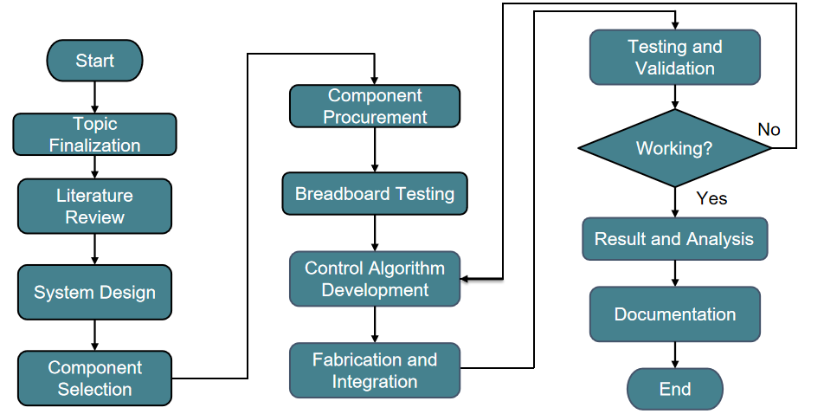
Figure 1: Methodology

2.2 System Overview
The Basic Health Monitoring Station consists of four layers: sensing layer, controller layer, processing and interface layer, and reporting layer. In the sensing layer, there is the MAX30102, MLX90614, VL53L0X, pulse sensor, and load-cell assembly. The controller layer uses ESP32 to read sensor values and prepare labeled packets of data. In the processing and interface layer, the Raspberry Pi 4B operates the PyQt software, calculates BMI, makes readings classification, and provides control of the touchscreen. In the reporting layer, there is the generation of a PDF health report and a QR code.
The station is able to monitor height, weight, BMI, body temperature, SpO2 level, pulse rate, and respiratory rate. Height and weight parameters are used for automatic calculation of the BMI. Other parameters are displayed as health indicators and used for the diagnosis logic. The results will appear on the results screen and can be opened as a PDF report via the QR code viewer.
The voice assistant is part of the system overview since it is a component within the measurement process. Through the DFPlayer Mini and speaker, verbal instructions will be delivered telling the user when to turn the temperature screw, put the left finger, put the right finger, remain steady during weight measurement, stand up for height, and see the results.
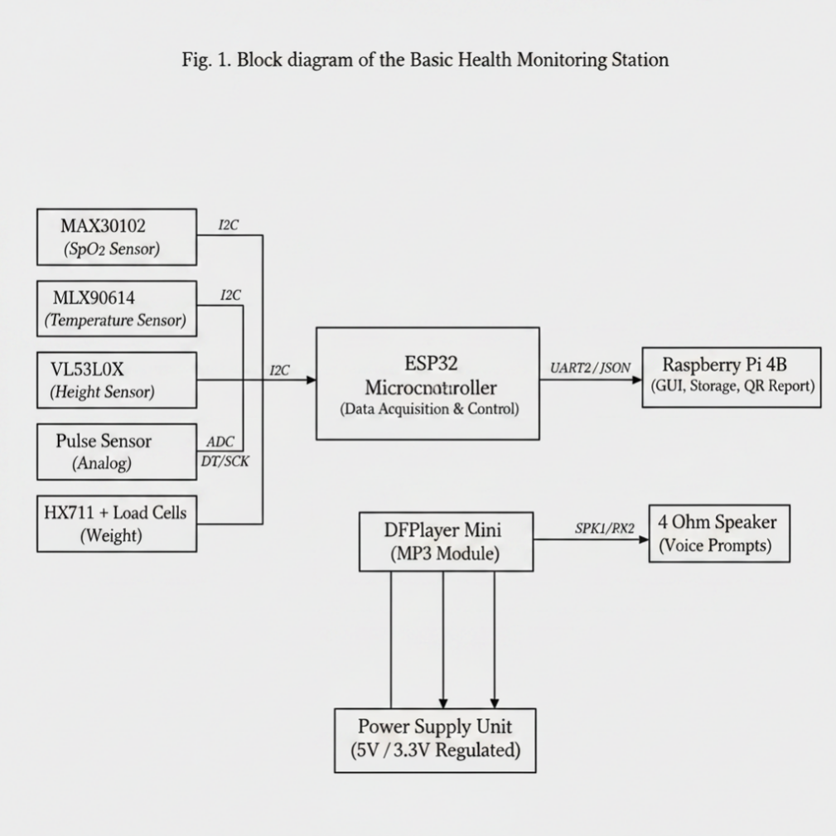
Figure 2: System Overview

2.3 System Flow Chart
The system flow starts when the user launches the application from the welcome screen. After the instruction screen, the user starts the check-up in hardware mode. The station then guides the user through each measurement stage in a fixed order. The chosen order is temperature measurement, SpO2 and respiratory-rate measurement, pulse measurement, weight measurement, height measurement, BMI calculation, result display, diagnosis and report generation.
The flow is arranged in this order to improve usability and reduce movement during measurement. The upper-body sensors are used first, followed by weight and height measurement. After all readings are captured, the Raspberry Pi verifies and displays the final values. The user can then select Report, Open QR, Diagnosis, Consult, Retake or Refresh depending on the need.
The final flow of the system is therefore not only a sensor-reading sequence but a complete user-service sequence. It includes measurement, processing, classification, report generation, QR access and storage. This makes the BHMS suitable for a self-service screening environment.
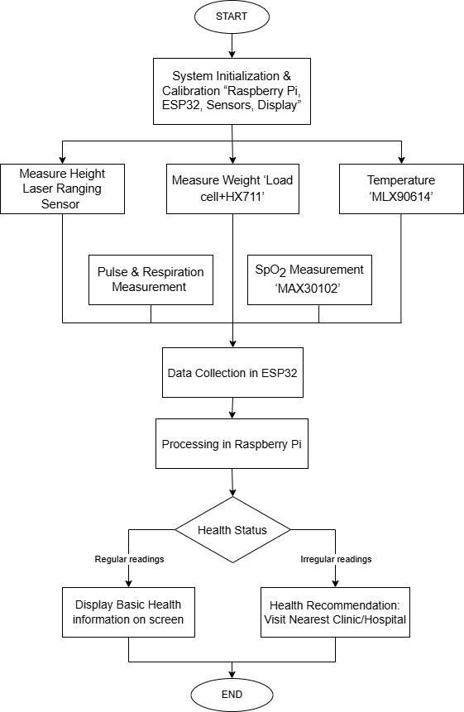

Figure 3: System Flow Chart

2.4 Voice-Assisted User Flow
The voice-assisted flow was added to reduce user confusion and to make the station easier to operate without continuous staff supervision. The voice prompts are synchronized with the measurement stages. The prompts do not replace the GUI; instead, they support the GUI by giving spoken instructions at the exact time when the user needs to move to the next action.

Table 2.1: Voice-assisted measurement flow used in the BHMS.
Stage | User Action | System Response
Welcome | User enters the kiosk interface | Plays welcome prompt and opens the instruction screen
Temperature | User adjusts temperature screw over the head | Records non-contact temperature using MLX90614
SpO2 and RR | User places left index finger in the sensor box | Records oxygen saturation and respiratory rate
Pulse | User places right index finger in the pulse sensor hole | Records BPM and confirms reading
Weight | User stands still on the platform | Records stabilized load-cell value
Height | User stands straight under the height sensor | Records height and calculates BMI
Result and Report | User views result, opens diagnosis or scans QR | Generates PDF report and QR viewer page

CHAPTER 3: HARDWARE AND SOFTWARE DESIGN

3.1 Component Requirement

3.1.1 Hardware Components
Sl.No | Name | Voltage (V) | Current (mA) | Image
 | Raspberry Pi 4 | 5 | 3000 | 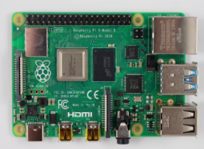
 | Capacitive Touchscreen LCD DIsplay | 5 | 1500-2000 | 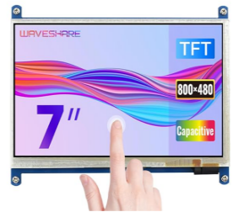
 | ESP32 WROOM-32 | 3 | 500 | 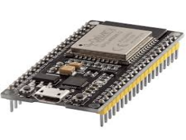
 | 4PCS 50KG Load Cell | 2.6-5.5 | 1.5 | 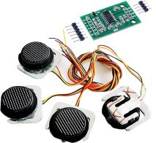
 | Vl53L0X- Laser ranging sensor | 2.6-5.5 | 5 | 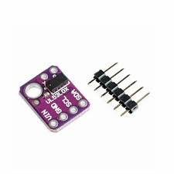
 | MAX30102 | 3.3-5 | 0.6 | 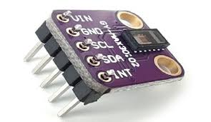
 | MLX90614ESF-DCI | 3.3 | 1.5 | 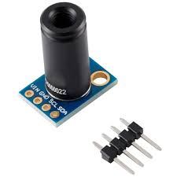
 | Mini UPS Power Bank | 5 | 3000 | 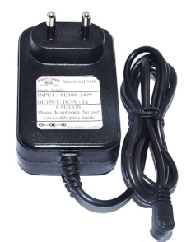
 | Jumper wire |  |  | 
10. | 15m electric wire |  |  | 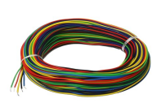

3.1.2 Software Components
Sl.No | Software | Description | Logo
 | Arduino IDE | An open-source software used to write, compile, and upload code to Arduino boards and other compatible microcontrollers. It provides a simple interface for programming and debugging embedded systems. | 
 | AutodeskFusion 360 | Cloud-based CAD, CAM, and CAE software used for 3D modeling, product design, simulation, and manufacturing. | 
 | Proteus 9 | Electronic design automation (EDA) software used for circuit design, simulation, and PCB layout. It allows users to simulate microcontroller-based circuits before hardware implementation. | 
 | Fritzing | Open-source electronics design tool that helps users create circuit diagrams, breadboard layouts, and PCB designs, making it easier to document and prototype electronic projects. | 
 | Easy EDA | Web-based electronic design automation tool used for schematic capture, circuit simulation, and PCB design. It allows users to design and order PCBs directly from the platform. | 
 | VS code studio | A powerful integrated development environment (IDE) used for developing software applications, debugging code, and building programs in various programming languages. | 
 | Cursor IDE | A IDE that enables the usage of the PyQt6 with the ability to correct and remove the delays in full functionality of the APP, | 

3.2 Schematic Diagram
The ESP32 acts as the main acquisition controller and communicates with the Raspberry Pi through UART to transfer processed sensor readings. The MAX30102, MLX90614, and VL53L0X sensors communicate over the I²C bus, while the pulse sensor uses an analog input and the HX711 amplifier receives the load cell signals.

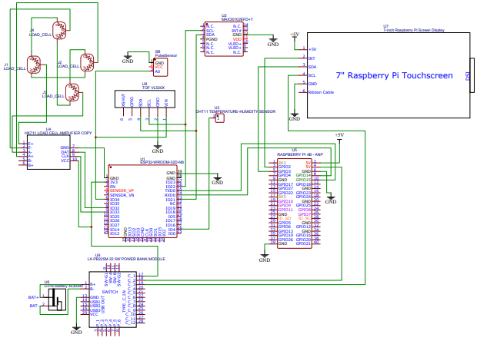
Figure 4: Schematic Diagram

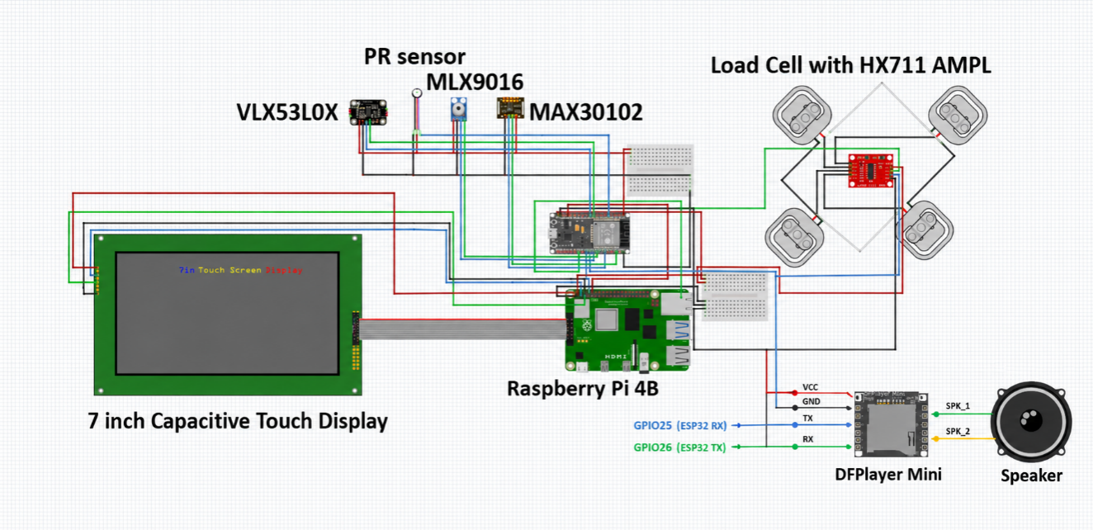
Figure 4.1: Circuit diagram showing capacitive touch display, Raspberry Pi 4B, ESP32, sensors, and load cell with HX711 amplifier connections.

3.3 Simulation Circuit
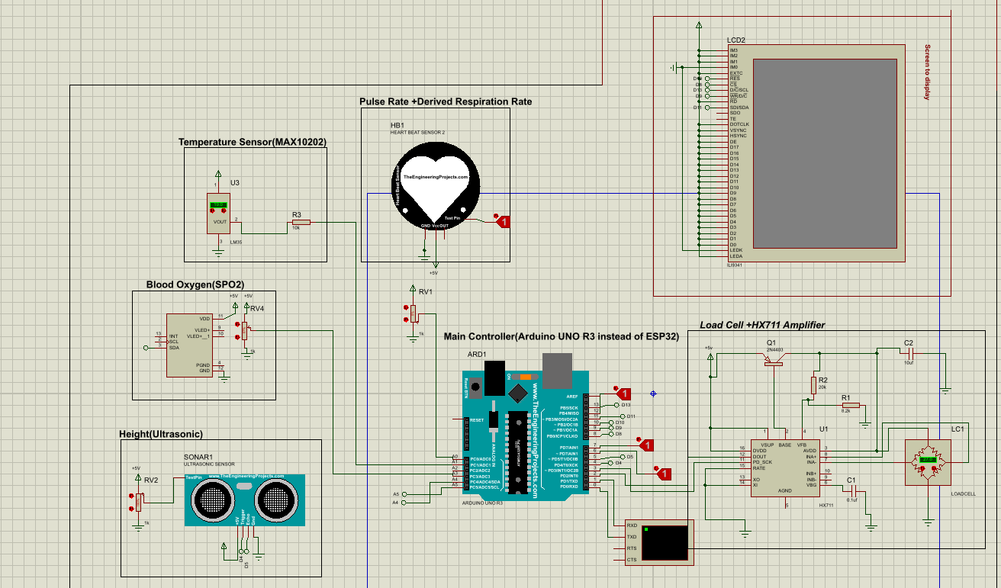
Figure 5: Simulation Circuit

3.4 Software Architecture and System Implementation
The software architecture of the Basic Health Monitoring Station includes all hardware elements in one system including sensors, ESP32 board, Raspberry Pi 4B, LCD screen, and reporting.
The functions were assigned to two control units, with the ESP32 assigned to collect data from such sensors as the MAX30102, MLX90614, VL53L0X, and the load cell via HX711. The Raspberry Pi 4B was assigned to process and output data which include data collection, correction, BMI calculation, interface management, and reporting by QR codes.
It made the development process much simpler since the sensor data collection was differentiated from other operations.

3.5 Data Acquisition Using ESP32
The ESP32 microcontroller was selected for real-time data acquisition from all sensors due to its low cost, compact size, and adequate processing capability. It collects raw readings from each sensor, applies calibration, and prepares the data for transmission to the Raspberry Pi. Specifically, the ESP32 performs the following functions:
- collecting readings from biomedical and measuring sensors;
- receiving information about weight using the HX711 load cell amplifier;
- receiving distance information related to height using the VL53L0X sensor;
- collecting pulse rate and SpO₂ values from the MAX30102 sensor;
- collecting temperature information using the MLX90614 sensor;
- preparing collected values for transfer to the Raspberry Pi;
- managing real-time data collection of the whole system.
Thus, the ESP32 acts as an intermediary between the hardware sensors and the main computing unit.

3.6 Communication Between ESP32 and Raspberry Pi
There will be an essential need for communication between ESP32 and Raspberry Pi in order for the Basic Health Monitoring Station to operate effectively. This is because ESP32 records the values of sensors, while the Raspberry Pi analyzes and shows the results; hence, there will be a need for communication. By communication, ESP32 sends values of sensors to the Raspberry Pi in the form of code, which recognizes them as individual values.
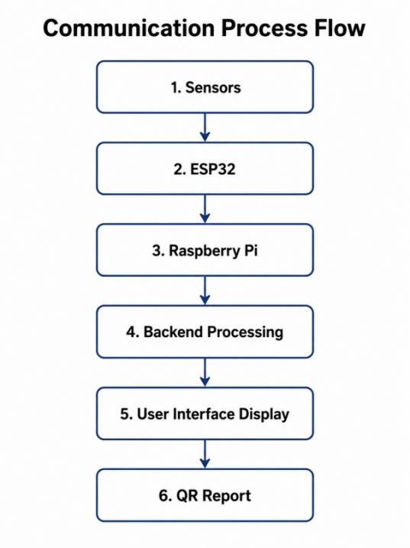
Figure 6: Communication Process Flow of the System

That is why it is necessary to note that the sensors transmit data not to the display but to the ESP32 first, next to the Raspberry Pi, and from there to the touchscreen interface. This allows for a more structured and dependable system.
The sensors first send their information to the ESP32, which then sends it to the Raspberry Pi, and finally, the touchscreen interface. This provides a much better organized system compared to previous versions. This system uses named parameters for sending data, ensuring clarity and eliminating errors. For instance:
- Height: 164.0 cm
- Weight: 57.9 kg
- BMI: 21.5 kg/m²
- SpO₂: 98%
- Pulse: 78 BPM
- Respiration: 16 breaths/min
- Temperature: 36.3°C
In this way, the Raspberry Pi will know where to place each value. Such an approach is necessary to make sure the system can link the hardware measurement part to the software display/reporting part.

3.7 Feeding Data Using Sensors
Feeding data refers to collecting sensor readings and using the collected data for the system’s operation. Feeding of data in case of the Basic Health Monitoring Station starts when the health check starts from the user end. Each of the sensors gathers only one kind of data and feeds it to ESP32.

Feeding Data Process:
3.7.1 Height Measurement Data
Height is determined by the help of VL53L0X laser range finder sensor. The sensor determines the distance between the sensor and the person’s head. Considering the fact that the sensor is fitted at a certain height, the person’s height can be calculated through deducting the distance detected by the sensor from the sensor’s height.
For example:
User Height = Fixed Sensor Height − Measured Distance
This calculated height is then sent for BMI calculation. Proper positioning of the sensor is very important because height measurement depends on alignment between the sensor and the user’s head.

3.7.2 Weight Measurement Data
The measurement of weight is done using four load cells attached at the bottom of the base platform. The instant the user stands on the base platform, the weight exerted will be sensed through the load cells. Since the output signal of load cells is quite small, the HX711 amplification module is employed to amplify the signals and obtain the digital value.
The ESP32 will then read the output signals of the HX711 module. Correction factors are introduced during the calibration process in order to ensure that the weight value measured is very close to the weight of the standard weight. After obtaining the weight, it is combined with height to determine the BMI.
The use of load cells in the project is very crucial since any errors in weighing will lead to erroneous BMI results.

3.7.3 SpO₂ and Pulse Rate Data
The MAX30102 sensor helps in measuring the SpO₂ and pulse rate levels. For measuring these, the user places their finger on the sensor, and the sensor then makes use of optical sensing to calculate changes in blood volume. It provides the pulse rate and SpO₂ values depending upon the measured values.
SpO₂ measures the blood oxygen saturation value in the body, and the pulse rate measures the heartbeat count per minute. These parameters play an important role in basic health check-ups as they give information related to the breathing and heart conditions.
The data measured by the MAX30102 sensor is then sent to the ESP32 device and finally processed using the Raspberry Pi. Calibration correction is done wherever required.
3.7.4 Respiratory Rate Data
The respiratory rate describes the breathing frequency in breaths per minute. This parameter has been incorporated into this study as one of the vital signs that can be assessed by the system. This respiratory rate is derived from the sensing and processing technique adopted in the system.
Once the value has been derived, it will be processed together with the other vital signs for display. Once processed, the data will be compared with the normal respiratory rate range to establish whether the patient’s respiratory rate is low, high, or within normal range.
Respiratory rate has been included because it provides important information about a person’s breathing condition.

3.7.5 Temperature Data
For measuring body temperature, an MLX90614 infrared sensor is used. By using this sensor, there is no need for physical contact with the device; therefore, it becomes more hygienic for multiple users.
In this sensor, body temperature can be calculated by measuring infrared radiation without any physical contact of the object. First, raw body temperature is calculated, and then the result is modified by the offset to get the final output temperature.
It was found during the calibration process that raw body temperature was less than that of reference temperature. So, to make the temperature measurement more accurate, an offset correction technique was introduced.

3.8 Back-end Processing in Raspberry Pi
The backend tasks are carried out primarily through the Raspberry Pi 4B. The Raspberry Pi receives the data sent by the ESP32, and thereafter the processor checks the data, corrects the data, arranges the data, and finally displays the data on the display screen.
The backend must perform the following functions:
- receive sensor readings from ESP32;
- divide the parameter from the received readings;
- check the correctness of the received values;
- calibrate the values of reading;
- calculate the BMI index based on the parameters of height and weight;
- compare the results with the norm;
- determine the overall health condition;
- send the processed values to the user interface;
- produce the health condition report QR-code.
The back end is important since it plays a vital role in converting the readings from the sensors into health readings. While it is correct that the sensor will simply provide a reading, it is also worth noting that the back end provides meaning to the readings. As an example, the back end does not only receive readings of height and weight but rather the one that helps figure out the BMI of the patient. It is also not simply about receiving the reading of SpO2 levels or body temperature but those that can tell whether the readings are normal or not.

3.9 BMI Calculation
The Body Mass Index will be automatically calculated using the height and body weights obtained. The Body Mass Index is a very important indicator to help determine whether one’s body weight is in proportion to his/her height.
The formula used in computing BMI is:
BMI = Weight (kg) / [Height (m)] ²
In this case, the user’s height would be determined by the VL53L0X sensor, while the user’s weight would be detected by the load cells. The RPi uses these measurements to calculate the BMI of the individual according to the formula discussed above.
As an example, suppose that the weight of the individual is 58 kg and height is 1.64 meters,
BMI = 58/(1.64*1.64)
BMI = 21.6 kg/m²
This information can then be displayed on the touch screen panel. BMI is part of the health report of the individual.
Calculating the BMI automatically reduces the burden of doing such calculations manually. Any possible error in the process is therefore avoided by automatic calculations.

3.10 Classification of Health Status Parameters
Once the readings have been obtained, the system categorizes them using easy to understand classifications. The main aim of this feature is to make it easier for the user to know whether the values recorded fall within acceptable parameters.
The classifications include:
- Low
- Normal
- High

The normal readings of oxygen levels would show normal readings while increased readings of body temperatures would indicate high temperature. The readings of body mass index would be high, normal, or low based on actual readings. It must be noted here that the analysis of the health status does not have anything to do with the identification of any illness or disease. It serves as an indication for users to go to the doctor or hospital if there is something wrong with them.

3.11 User Interface Design
Interface development was done in a manner that makes it easy for non-experts to interact with at an academic health center and within the community. The health metrics recorded will be shown on the screen monitor, which is attached to the Raspberry Pi board. The user interface design has been done with the aim of achieving the following objectives:
- To display all key health data systematically
- To minimize chances of confusion during use
- To prevent manual recording of results
- To enable BMI calculation automatically
- To indicate health status easily
- To enable access to a digital health report through QR code
This interface will act as the primary interface through which the user interacts with the monitoring station. After completing the measurements, all the information will be displayed on the screen and therefore the user will have access to all his health information on one platform.
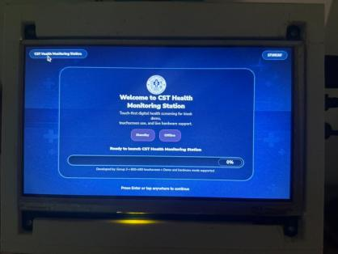  Figure 7: User Interface Home Screen | 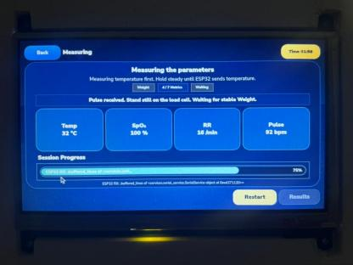  Figure 8: User Interface Measurement Screen | 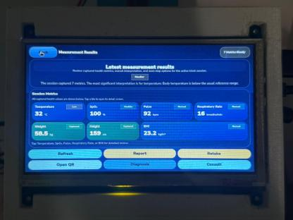  Figure 9: User Interface Result Display Screen

3.12 QR Code and Health Report Creation
QR code based health report generation is yet another important feature of this system. After taking the measurement, the health report with the readings and the health status of the patient is generated by using Raspberry Pi.
The information included in the report is:
- Height;
- Weight;
- Body mass index;
- SpO₂;
- Pulse rate;
- Breathing rate;
- Body temperature;
- Health condition.
The flow chart of the QR code generation is presented as below:
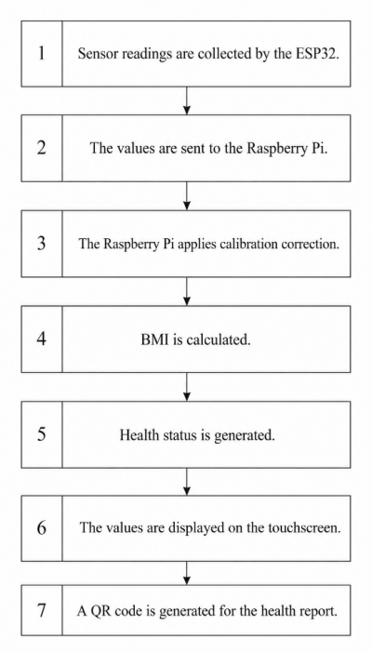
Figure 10: QR Code Process
This feature enhances the system's practicality and modernity through electronic documentation. Furthermore, it increases convenience, as results become available immediately upon completion of the measurement.

CHAPTER 4: MECHANICAL, DESIGN AND FABRICATION

4.1 Mechanical Design Overview
The mechanical body was designed in a way that ensured the strength and stability would be high enough when making different health measurements. This is because the design of the mechanical body had to make sure the person remained upright during all the measurements, especially those concerning measuring his or her height and weight.
It was important to build the mechanical body in such a way that it would house the load cell platform, the height measurement rail, the sensor box, touch screen display, electrical components, and wiring system. It was important to make the base part of the mechanical body strong enough to hold load cells with room for height measurement.

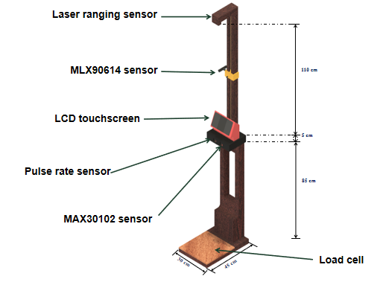
Figure 11: System Model

4.2 3D Model of the System Body
The motive for building the 3D model was to get an overall view of the entire set up before beginning the manufacturing process. Some of the view included the front view, side view, back view, top view, and bottom view. The 3D model helped get an understanding of the base, vertical, sensor box, display stand, and the height sensor rail. The 3D model also gave an idea of the dimensions that would be required during the manufacturing process. The base was utilized to fix the load cell.

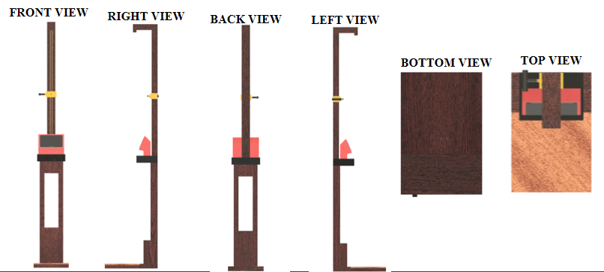
Figure 12: Views of 3D Design
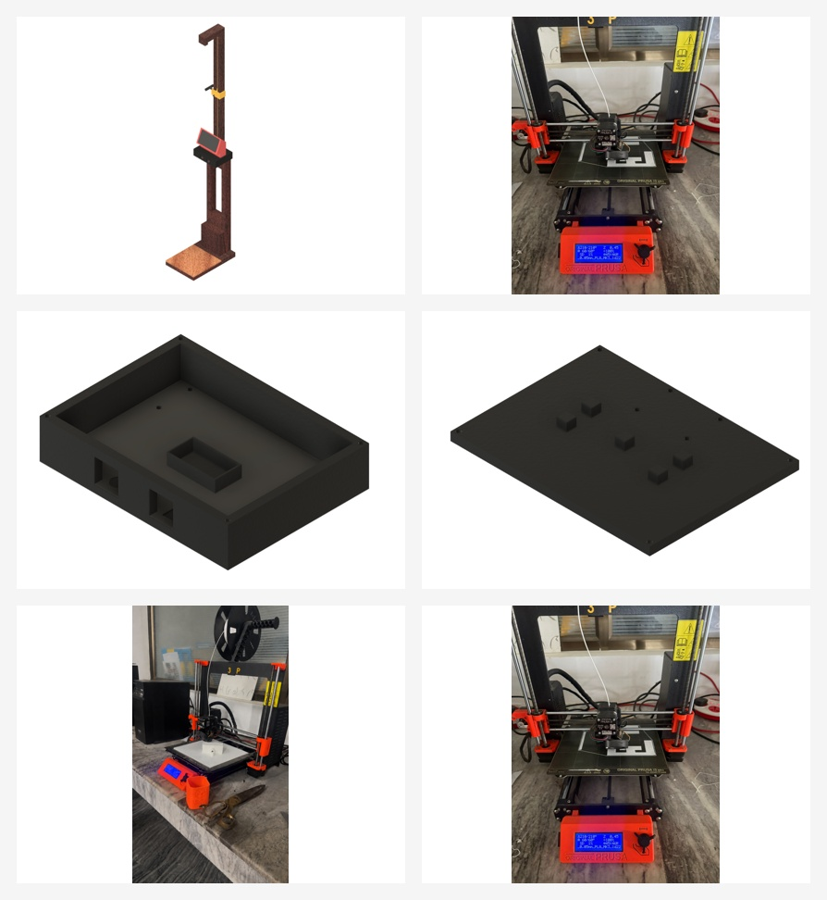
Figure 12(a): 3D-printed sensor box, protective covers, and prototype components fabricated for the BHMS body and sensor housing.

4.3 Dimensions of Components of the System Body

The body system is made up of the base plate having its cover, extended plate, mid box, sensor box having its cover, screen stand, the rail, the clamp, and the height box. All these were manufactured based on the positioning of sensors and the comfort of the user. The base plate is used to secure the load cell and provide support to the weight of the user. The extended plate enhances the stability of the system and prevents the user from touching the top portion of the system.
Design | Name | Dimension
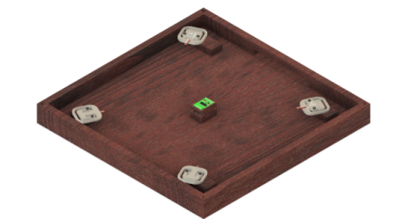 | Base plate | 30cm x 30cmx4cm
 | Base plate cover | 30cm x 30cm
 | Extended plate | 30cm x 15cm x 4cm
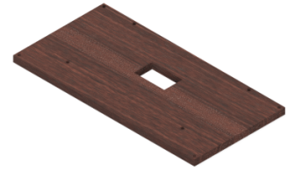 | Extended plate cover | 30cm x 15cm
 | Mid box | 85 cm height
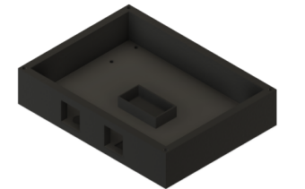 | Sensor box | 24cm x 18cm x 6cm
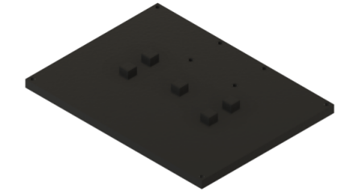 | Sensor box cover | 24cmx 18cm
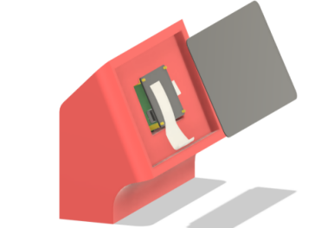 | Screen stand | 22cm x 6cm base
 | Rail | 110cm height
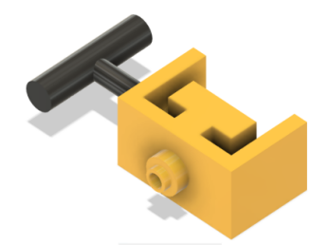  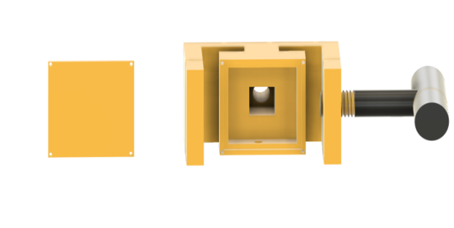 | Clamp | 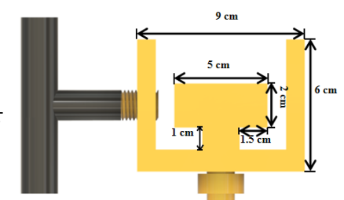
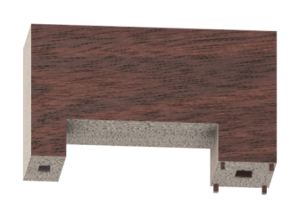 | Height box | 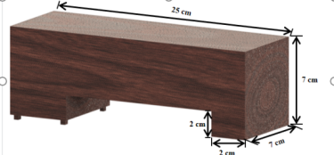

The dimensions were chosen having in mind the positioning of the sensors, screen, load cell, and the standing position of the person being measured. This made it possible to choose the correct rail height, which would enable measuring the height of the person.
4.4 Carpentry Work
The Prototype of the Basic Health Monitoring Station was mostly constructed from wooden materials due to their cost-effectiveness, availability, easy manufacturing process, and durability. Wood was used to construct the base, the main body of the machine, the load cell body, and the screen body. The manufacturing process involves cutting, making, assembling, and finally finishing to get the desired sizes. A lot of consideration was taken into account in designing the base body to ensure that the weight of the individual is supported for proper measurements. The load cell cover was designed to protect the load cells.
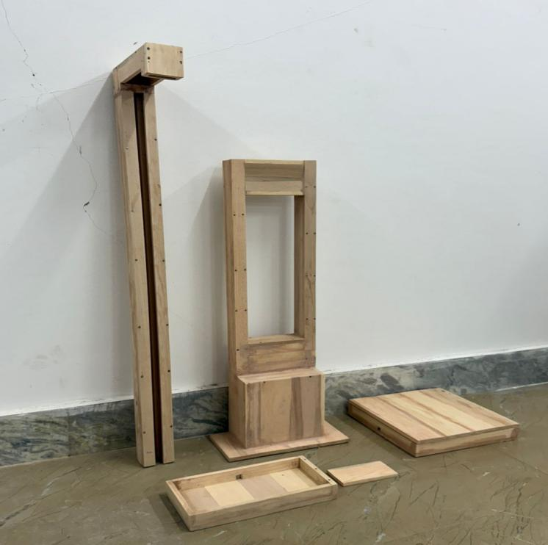
Figure 13: Woodwork
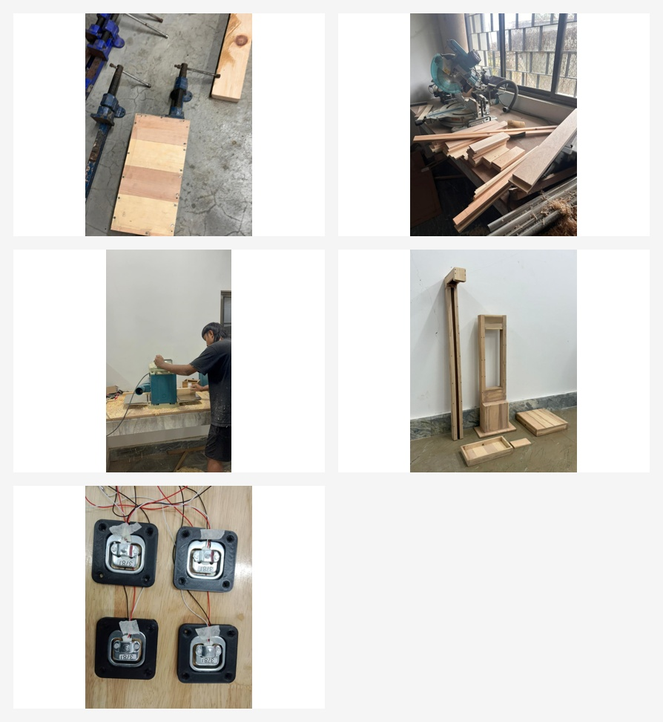
Figure 13(a): Carpentry work, wooden-frame preparation, and fabrication of the main structural parts of the BHMS prototype.

4.5 Modification of Body Frame

Once it had been installed, there was an issue that arose regarding the placement of the sensor box and the LCD, whereby they were placed too close to the body of the individual using the product. This could lead to a situation whereby someone would accidentally touch the top when standing on the base, especially individuals with larger builds. This led to discomfort, as well as instability, as touching the top meant that the sensors would be affected, particularly the height sensors.

4.7 Assembly of the System
Assembly of the wooden frame and 3D components occurred after the completion of all manufacturing processes. Firstly, four load cells were mounted on the base plate. Then, they were attached to the HX711 module. Secondly, the laser rangefinder was mounted at the height measurement module position. Thirdly, MAX30102, pulse rate sensor, and temperature sensor were put into the sensor box.
Connection of ESP32 with sensors enabled data monitoring online. The Raspberry Pi 4B handled computation tasks, GUI creation, mounting of the touch screen LCD, and printing of health reports. Mounting of the touch screen onto the holder was done. All wires were hidden in the body. Power wires powered all components of the project. Testing was done to ensure that all hardware and software worked properly.
Consequently, the final model could be used to calculate a patient’s height, weight, BMI, heart rate, respiration rate, SpO₂ level, and body temperature. The information appeared on the display screen alongside QR codes.
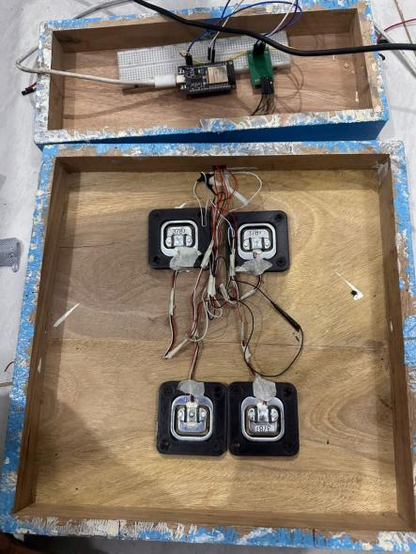  Figure 14: Integration of Load Cells and HX711 | 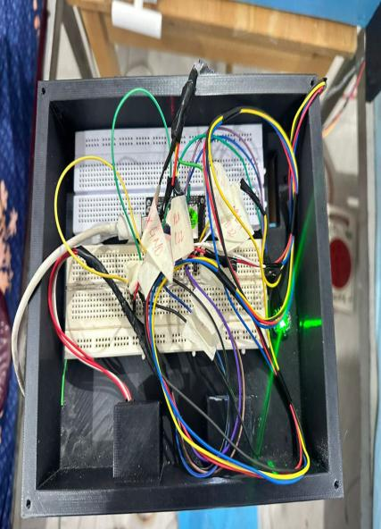  Figure 15: Integration of Sensors in Sensor Box | 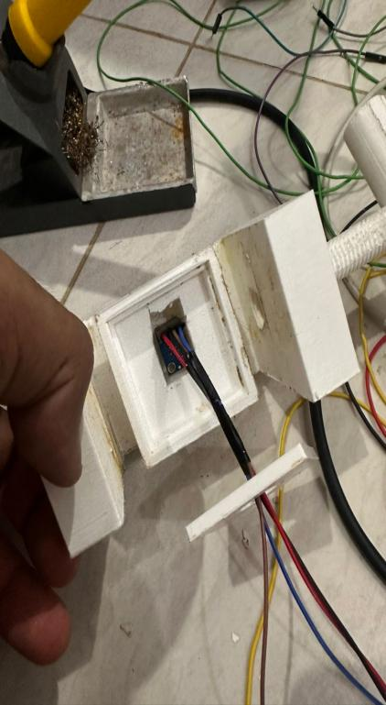  Figure 16: Mounting the temperature sensor
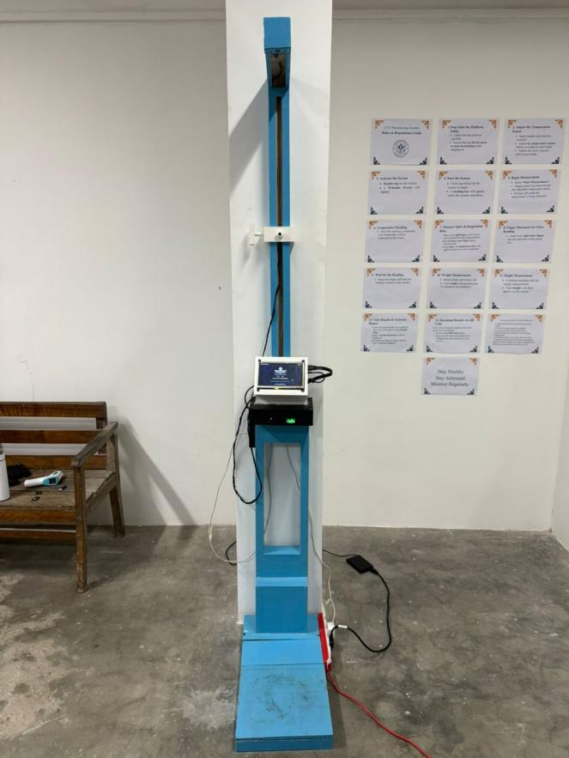
Figure 17: Final Assembly of Basic Health Monitoring Station
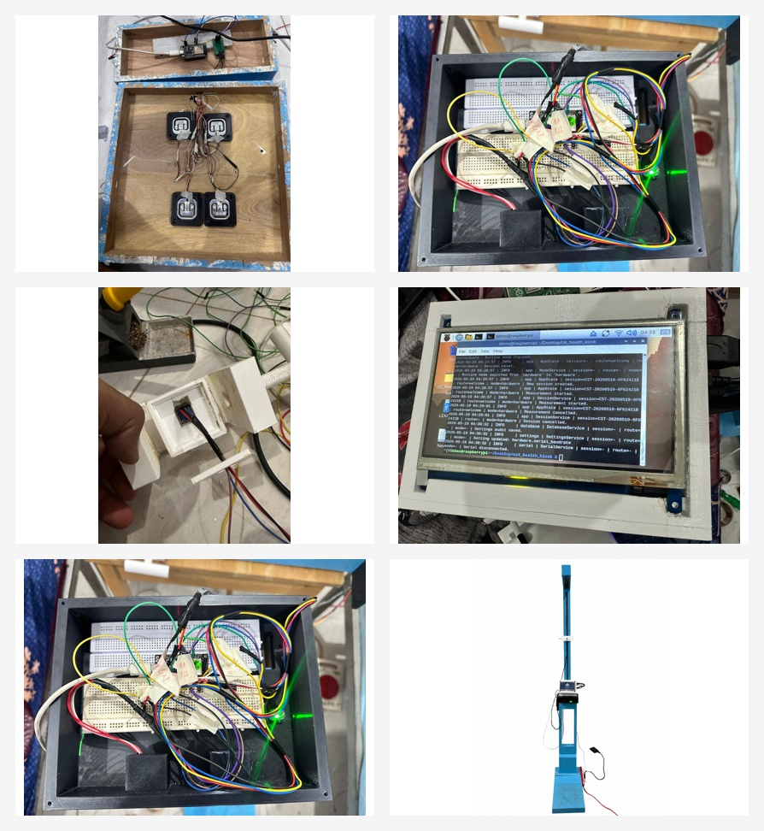
Figure 17(a): Assembly activities showing load-cell mounting, internal wiring, touchscreen integration, and the completed upright prototype.

4.7 Material Selection
The mechanical body was primarily made using wood while the sensors were located inside structures that were produced through 3D printing technology. Wood provided a solid structure for the body and made it stronger, while 3D printing allowed creating a perfectly fitting housing for the sensors. Using these materials made it possible to reduce costs without sacrificing functionality.
Materials used in the prototype were chosen taking into account the following aspects:
- strength to bear the weight of the user
- simplicity in manufacturing
- local availability
- cost effectiveness
- simplicity in modification
- appropriateness for prototype building

The selection of materials was appropriate for making the prototype. But when it comes to future improvements, the mechanical body could be made stronger with the use of metals or any other enclosure material.

4.8 Planning for the College Infirmary and User Guidance
The section describes the installation setting, space layout, and strategy for guidance while installing the Basic Health Monitoring Station within the college infirmary. The installation and usage of the prototype took place after it was successfully tested and calibrated through the tests and calibrations discussed in Chapter 5.
The chosen site for installation was the college infirmary since this setting provided an appropriate environment for health checkups of the individuals. The intended users of the system were adult individuals within the age group of 19 to 35 years.
Guidance labels and on-screen instructions for correct posture, finger positioning, and order of measurements were created as part of the preparation process to enable systematic introduction of the kiosk in the infirmary once the validation phase was complete. Preparation activities allowed for a better understanding of how the kiosk was to be placed and controlled in the infirmary once the validation phase was complete.
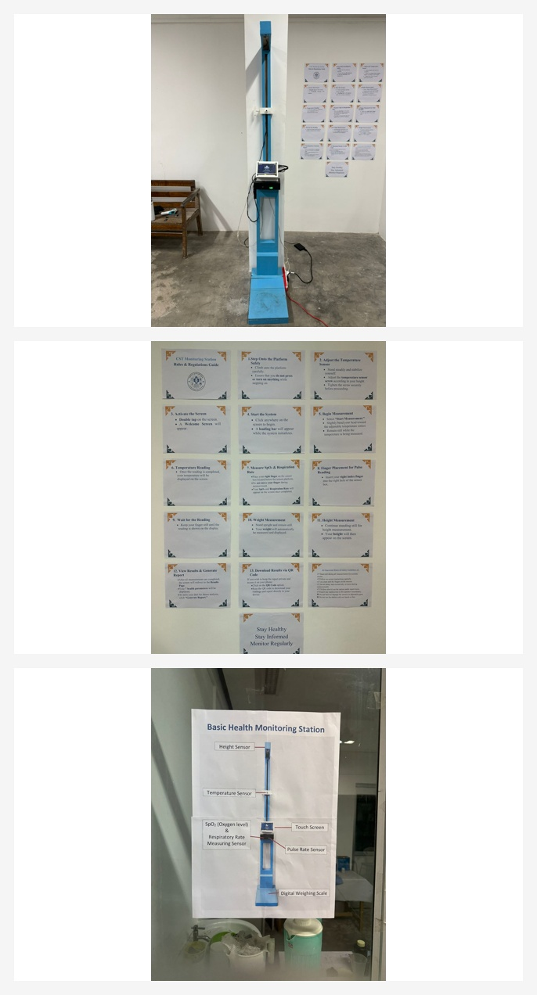
Figure 17(b): Prototype placement in the infirmary area together with the user-guidance poster and installation environment.

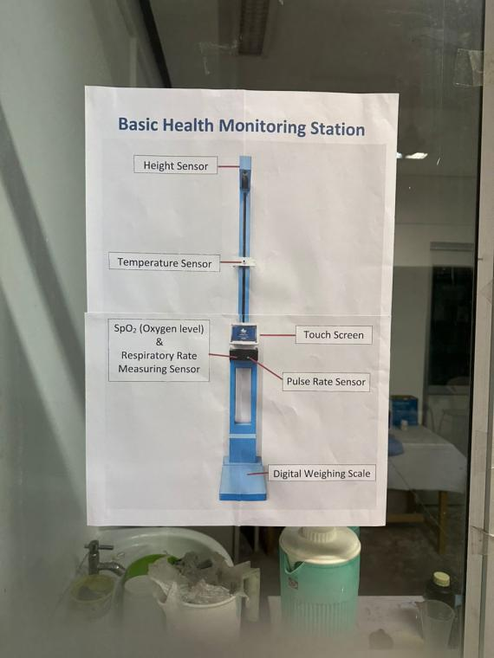
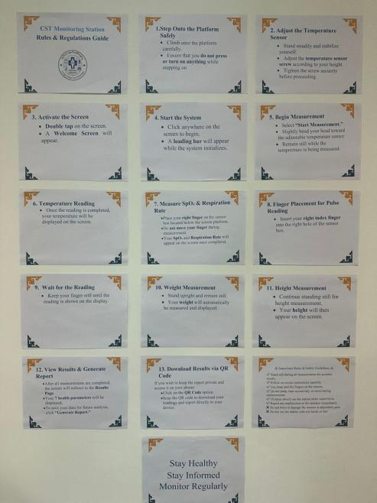

Figure 17.1 User Guideline

CHAPTER 5: TESTING AND CALIBRATION

The process of testing and calibration became critical when developing the Basic Health Monitoring Station, as it is necessary to measure quite a few health indicators. Therefore, before assembling, every single sensor was tested and calibrated. Testing ensures that everything works fine – sensors, microcontroller, Raspberry Pi, monitor, and interface included.
Then, following the testing process, each sensor was calibrated to improve the accuracy of the readings taken. The offset, or the difference between the true reading and the measured value, could be defined.

5.1 Individual component testing
Before joining the entire system together, tests for individual hardware were done to find any faults in connection, sensors, and the software interaction. The important things tested included:
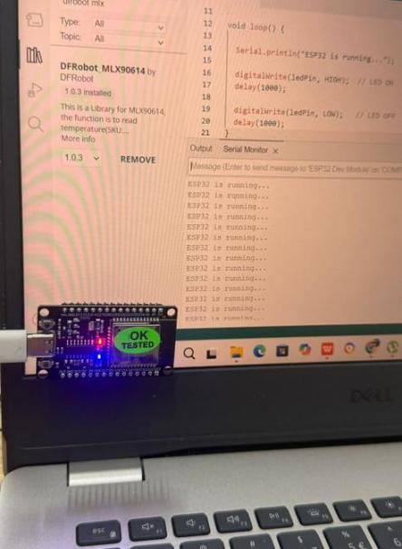  Figure 18: Testing of ESP32 | 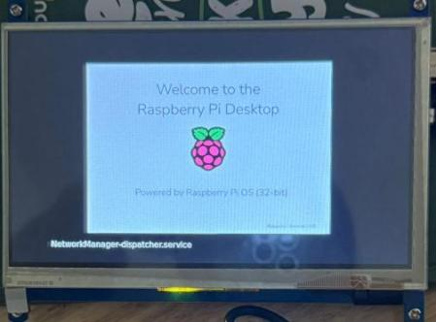  Figure 19: Testing of LCD and Raspberry pi 4 with Raspberry pi | 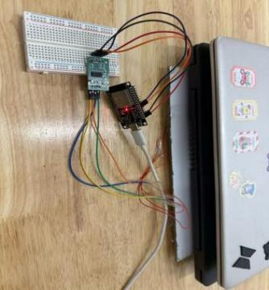  Figure 20: Testing of HX711 with load cell
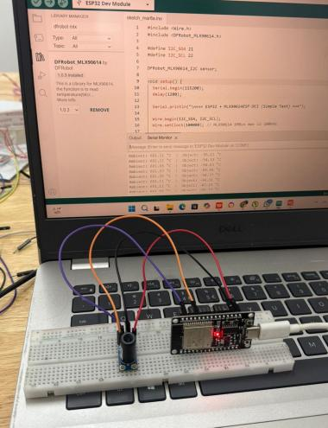  Figure 21: Testing of MLX90614ESF-DCI | 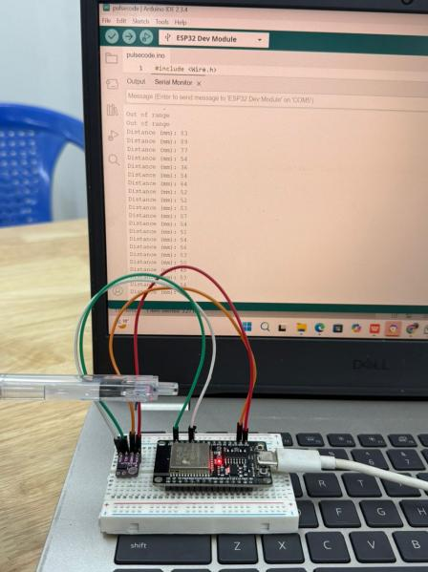  Figure 22: Testing of VLX5L0X | 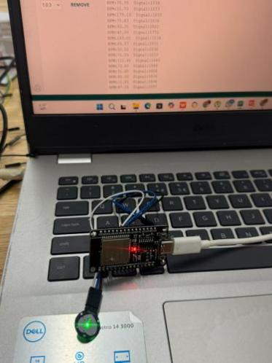  Figure 23: Testing of Pulse rate sensor
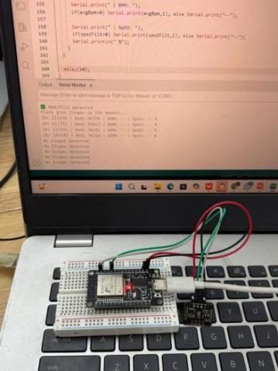
Figure 24: Testing of MAX301202

The test was carried out on ESP32 to find out whether the microcontroller can be able to obtain data from the sensors. Testing of the Raspberry Pi was performed by installation of the operating system and the usage of the Graphical User Interface. Touchscreen display test was performed to ascertain proper display of the output data. HX711 and load cell testing was conducted to verify weight measurement functionality. On the other hand, testing of oxygen satThe test was carried out on ESP32 to find out whether the microcontroller can be able to obtain data from the sensors. Testing of the Raspberry Pi was performed by installation of the operating system and the usage of the Graphical User Interface. Touchscreen display test was performed to ascertain proper display of the output data. HX711 and load cell testing was conducted to verify weight measurement functionality. On the other hand, testing of oxygen saturation (SpO₂), heart rate, and body temperature measurements was performed using MAX30102 and MLX90614 sensors respectively.uration (SpO₂), heart rate, and body temperature measurements was performed using MAX30102 and MLX90614 sensors respectively.

Calibration of sensors
- MAX30102
Calibrating:
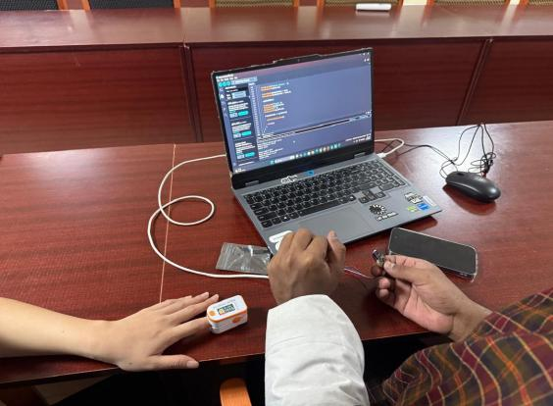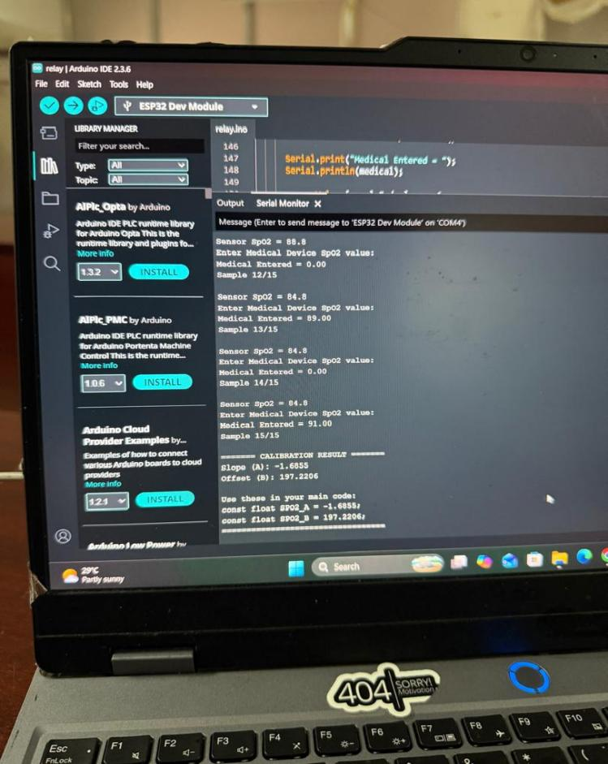
After Calibration:
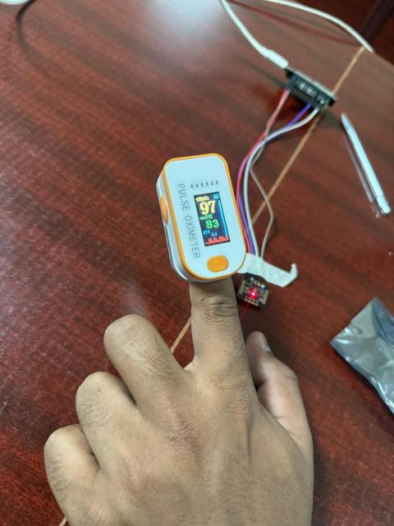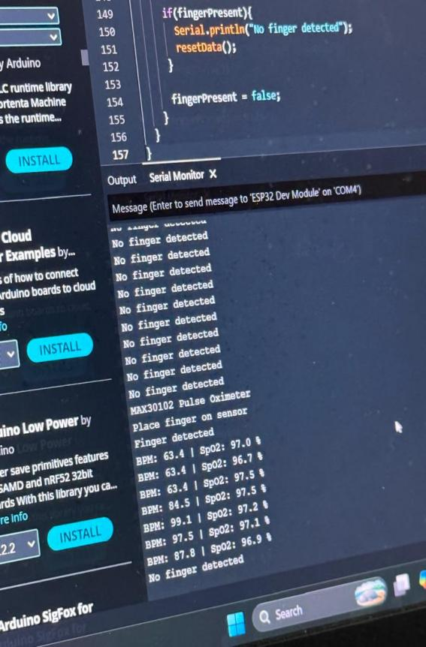
Blood oxygen saturation level was determined using the MAX30102 sensor. In the process of calibration, the readings of SpO₂ from the MAX30102 sensor were compared with the readings of the reference device. It was noted that the sensor readings were a little bit smaller compared to those of the reference device. Thus, an offset was determined.
The offset was calculated using the following formula:
Offset = Raw Sensor Reading − Medical Device Reading

Table 5.1: MAX30102 SpO₂ Calibration Before Correction
Reading | Medical Device SpO2 (%) | MAX30102 Raw SpO2 (%) | Offset (%)
1 | 98 | 96.31 | -1.69
2 | 97 | 95.42 | -1.58
3 | 99 | 97.26 | -1.74
4 | 96 | 94.28 | -1.72
5 | 98 | 96.37 | -1.63
6 | 97 | 95.29 | -1.71
7 | 99 | 97.41 | -1.59
8 | 98 | 96.25 | -1.75
9 | 97 | 95.36 | -1.64
10 | 96 | 94.35 | -1.65

Offset for the readings provided by the MAX30102 SpO2 sensor was around -1.67%. The raw data being smaller than that of the medical device, the correction required is +1.67%.
Table 5.2: MAX30102 SpO₂ Calibration After Correction
Reading | Medical Device SpO₂ (%) | MAX30102 Raw (%) | Correction Applied (%) | Corrected MAX30102 (%)
1 | 98 | 96.46 | +1.67 | 98.13
2 | 97 | 95.21 | +1.67 | 96.88
3 | 99 | 97.34 | +1.67 | 99.01
4 | 96 | 94.41 | +1.67 | 96.08
5 | 98 | 96.18 | +1.67 | 97.85
6 | 97 | 95.47 | +1.67 | 97.14
7 | 99 | 97.12 | +1.67 | 98.79
8 | 98 | 96.52 | +1.67 | 98.19
9 | 97 | 95.33 | +1.67 | 97.00
10 | 96 | 94.26 | +1.67 | 95.93

When the correction factor was applied, the MAX30102 measurements became more in line with the reference medical device. It made the measurement of the SpO₂ more accurate.

- MLX90614ESF-DCI
Calibration of the MLX90614 temperature sensor was done through the analysis of the relationship between the raw values recorded by the sensor and the actual temperature. It was observed that during the five trials carried out, the readings taken were slightly lower than the actual temperature.
The correction factor was +2.30°C.
Corrected temperature = Temperature raw value + 2.30°C
Following correction, the readings taken were close to the actual temperature.
Table 5.3: MLX90614 Temperature Calibration
Reaadings | Actual Temperature (°C) | Sensor Raw Temperature (°C) | Offset Applied (°C) | Corrected Temperature (°C)
1 | 36.30 | 34.02 | +2.30 | 36.32
2 | 36.10 | 33.79 | +2.30 | 36.09
3 | 35.90 | 33.61 | +2.30 | 35.91
4 | 36.40 | 34.08 | +2.30 | 36.38
5 | 36.20 | 33.95 | +2.30 | 36.25

- Pulse Rate Sensor
Calibration of the pulse rate sensor involved checking the BPM information from the sensor against the pulse rate readings. There were five readings of the information in the sensor in the same conditions as compared to find the difference between the two readings.
The results revealed that there was high BPM reading from the sensor as opposed to actual readings. An offset correction of -0.30 BPM was used to balance the difference between the two sets of readings.
Corrected Pulse Rate = Sensor Raw Pulse Rate - 0.30 BPM
As a result of offset correction, the pulse rates were near to the actual readings.

Table 5.4: Pulse Rate Calibration
Readings | Actual Pulse Rate (BPM) | Sensor Raw Pulse Rate (BPM) | Offset Applied (BPM) | Corrected Pulse Rate (BPM)
1 | 77.0 | 78.4 | -0.30 | 78.1
2 | 78.0 | 76.9 | -0.30 | 76.6
3 | 76.0 | 76.8 | -0.30 | 76.5
4 | 79.0 | 79.6 | -0.30 | 79.3
5 | 75.0 | 75.2 | -0.30 | 74.9

- VLX53L0X
The calibration of VL53L0X range finder sensor was done by taking raw values and then comparing them with the actual values of distance, using six different data sets. There were some variations observed in the raw values, and thus the offset value, which is nearly equal to −40 mm, was computed as follows:
Calibrated Distance = Sensor Raw Distance − 40 mm
Using the calibrated values, the height in cm was found.
Table 5.5: VL53L0X Height Sensor Calibration
Readings | Sensor Raw Distance (mm) | Calibrated Distance (mm) | Offset Applied (mm) | Calculated Person Height (cm)
1 | 404.00 | 363.55 | -40.45 | 163.6
2 | 405.00 | 364.45 | -40.55 | 163.6
3 | 405.60 | 364.99 | -40.61 | 163.5
4 | 392.60 | 353.30 | -39.30 | 164.7
5 | 395.80 | 356.18 | -39.62 | 164.4
6 | 400.40 | 360.31 | -40.09 | 164.0

- HX711 with Load Cells
Load cell calibration was carried out at Druk Wang by applying loads starting from 20kg up to 200kg using increments of 20kg. At the start, before loading anything on the load cell, the load cell was first set to zero in order to show the load reading as 0kg. There was an offset observed in the reading of load cell as compared to the actual loading. The offset is given by the subtraction of the actual load from the load cell reading. The offset came out as +2.01kg after analyzing ten samples with 1.83% error.

Table 5.6: Load Cell Calibration Using Standard Weights
Reading No. | Standard Weight Applied, kg | Raw Load Cell Reading, kg | Offset / Correction, kg | Corrected Reading, kg
0 | 0 | 0.00 | 0.00 | 0.00
1 | 20 | 19.62 | +0.38 | 20.00
2 | 40 | 39.28 | +0.72 | 40.00
3 | 60 | 58.93 | +1.07 | 60.00
4 | 80 | 78.55 | +1.45 | 80.00
5 | 100 | 98.21 | +1.79 | 100.00
6 | 120 | 117.80 | +2.20 | 120.00
7 | 140 | 137.42 | +2.58 | 140.00
8 | 160 | 157.10 | +2.90 | 160.00
9 | 180 | 176.65 | +3.35 | 180.00
10 | 200 | 196.30 | +3.70 | 200.00

5.2 Integrated testing

Once all sensors were calibrated, they were connected together to complete the Basic Health Monitoring Station. Test runs for the complete system revealed that all sensors, along with the ESP32, Raspberry Pi, touchscreen, and interface, functioned properly.

When the components of the unit were assembled and tested, a person was positioned on the platform in order to determine the body weight through load cells and body height with the use of the VL53L0X sensor. SpO2 and pulse rate readings were determined through MAX30102 sensor and pulse sensor, respectively.
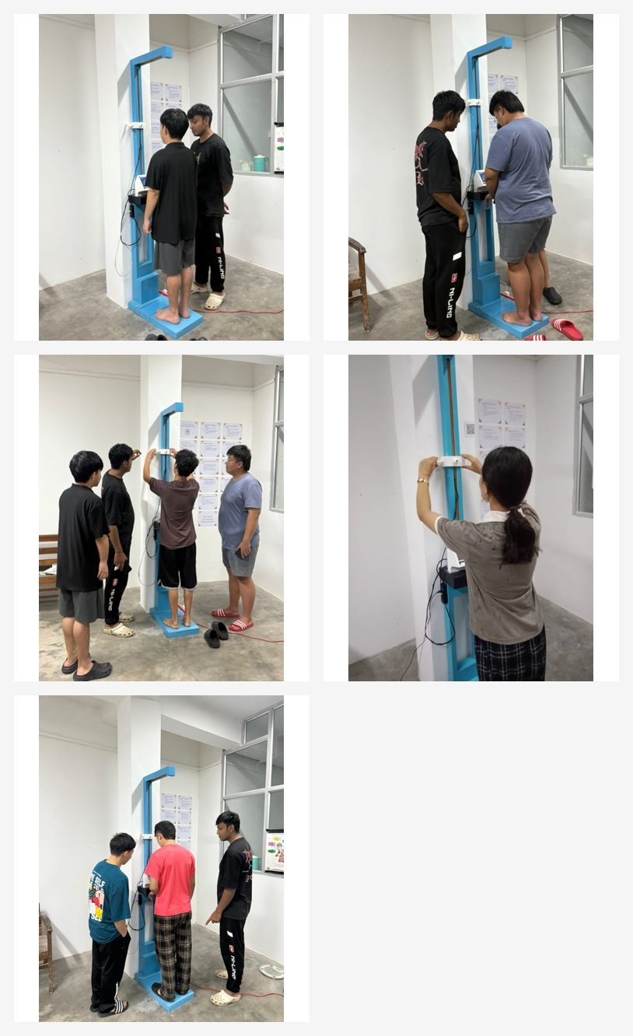
Figure 27(a): Actual user-testing photographs showing different participants using the BHMS for measurement, observation, and height-check procedures.
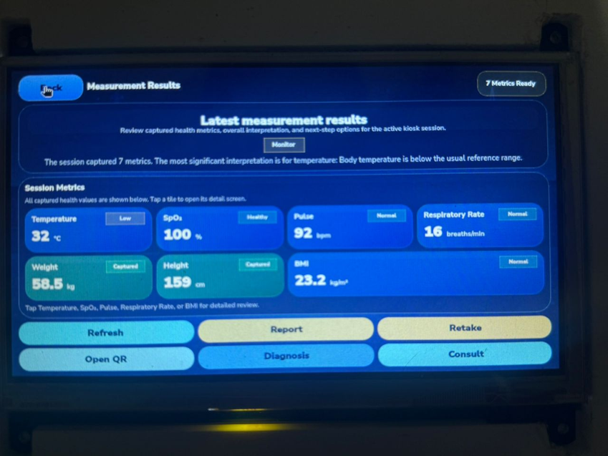
Figure 27(b): Measurement-results screen captured during integrated system testing of the complete BHMS application.
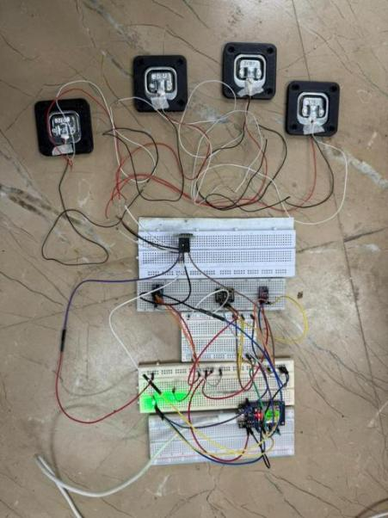  Figure 25: Integrated System Testing | 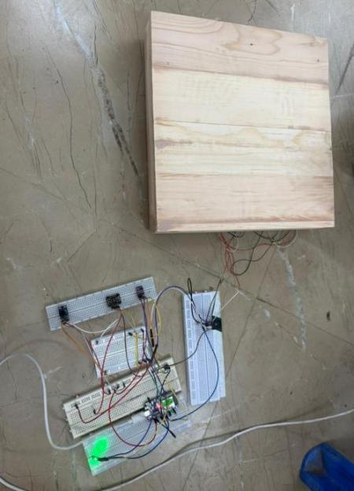

5.4 Uploading of APP to the Capacitive Touch Display Screen.
After developing the health monitoring application, it was uploaded and installed into the Raspberry Pi that was connected to the 7-inch capacitive touch display screen. After installing the application into the Raspberry Pi, all necessary Python libraries and PyQt dependencies were installed to make sure that everything would work properly with regards to the graphical user interface. Once installation was completed successfully, the application was executed in the touchscreen and checked to confirm its suitability in terms of screen usage, touch capabilities, navigation through buttons, and alignment of the display screen. The successful upload of the application ensured that everything worked as expected such as the welcome screen, instructions screen, measurement screen, result screen, diagnosis screen, QR report, and administration screens.
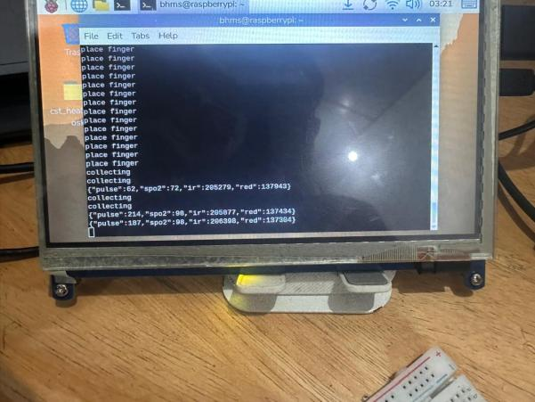
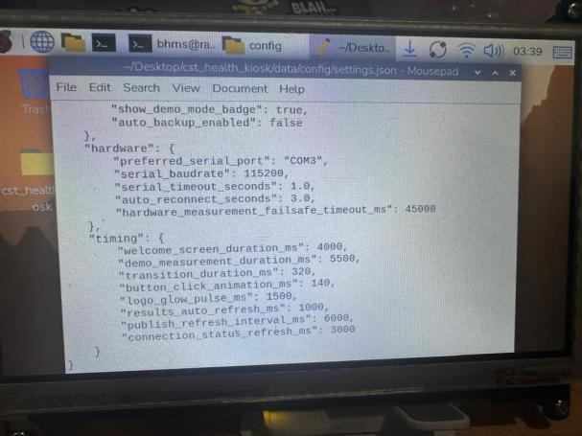
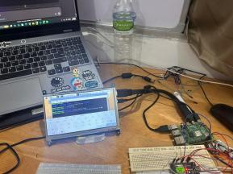

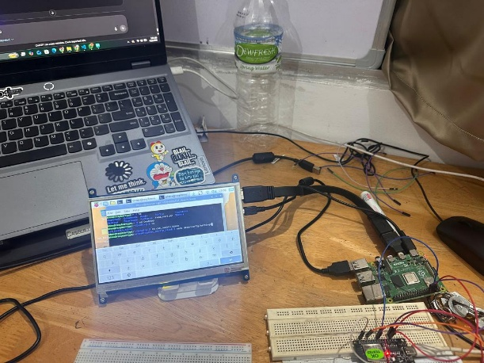
Figure 25.1: Uploading of APPLICATIONS

CHAPTER 6: SOFTWARE DESIGN AND IMPLEMENTATION

6.1 Introduction
This chapter discusses the software design and development processes of building the Basic Health Monitoring Station (BHMS). These include the ESP32 sensor data acquisition module, the Raspberry Pi processing module, touchscreen graphical user interface, QR code report generator, voice guidance, and storage system. The software is responsible for converting sensor data from the sensors into understandable health information that can be understood by non-technical college clinic patients.
ESP32 manages all the real-time sensor data gathering, and the Raspberry Pi 4B handles the graphical user interface, computation, health diagnosis, QR code report generator, and storage. The touchscreen graphical user interface will be designed for a 7-inch capacitive touch screen display, which will give detailed user guidelines using minimal supervisions.
Various software packages were utilized in designing and developing BHMS. Embedded programming, designing the applications on the Python, and graphical user interface design contributed significantly to making the BHMS into a health station.

6.2 ESP32 and Raspberry Pi Programming

The program for ESP32 is designed to receive data provided by various biomedical and sensing devices. Data acquisition is done via ESP32 microcontroller, including acquiring weight with the help of the HX711 amplifier, distance using the VL53L0X sensor, temperature using MLX90614 sensor, and also obtaining information about the pulse (number of pulses, SpO2%, respiratory frequency) using MAX30102 and pulse sensors. After preprocessing the received data, ESP32 will send packets of information with labels enabling the Raspberry Pi to correctly classify the data and further perform actions based on them. ESP32 maintains the serial communication with the Raspberry Pi and implements stepwise measurements in accordance with the application algorithm.

Raspberry Pi 4B computes BMI, classifies health status, updates GUI screens, generates reports and QR codes, and also stores all data locally. For this computer, Python with PyQt graphical library was used for implementing the software. Its functionality included transition of screens, processing of buttons, creation of the diagnosis report, generation of the report, printing QR codes, sound triggering, and administrative actions.

6.3 GUI Design
The following screen shots will be able to help in illustrating all of the functions available in the graphical user interface more effectively. Functions like navigation, report storage, configuration, administrator protection, interpretation, diagnosis, and consulting are just some of the functions that have been shown below.
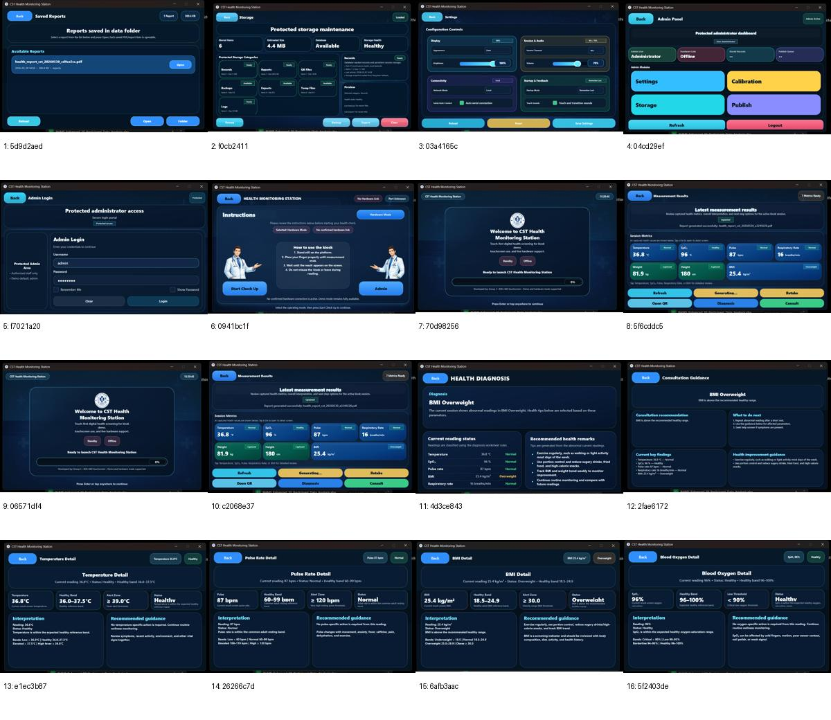
Figure 6.1: Additional GUI screen gallery showing the main operational and administrative screens of the BHMS application.

GUI had been designed in such a way that it could easily be operated by any user without the need for any technical skills. Large buttons, label names, separated metric cards, and indicator lights have been incorporated into the GUI design. Below are some screenshot examples of the GUI windows developed for BHMS application.

Sequential Screen Flow of the Final BHMS Application
To provide clarity in the final report, the screens of the application have been included below in the order that the user encounters them during the process. This ordering has been done according to the final developed GUI interface and the contexts used in the PowerPoint presentation. The sequence starts from the welcome page, proceeds to measurement guidance and results interpretation, and ends with report access and administration screens.
The aim of showcasing the sequence of the screens is to show that BHMS is not just a sensor device but also an entire system for guided digital screening. Each individual screen plays a role in the process, ranging from user onboarding to measurement management, results presentation, health interpretation, consultation management, report generation, QR code access, and system administration.
Step | Screen | Main Purpose
1 | Welcome Screen | Launches the application and introduces the BHMS interface.
2 | Instruction and Mode Selection Screen | Allows the user to choose Start Check Up or Admin and read operating instructions.
3 | Measurement Result Screen | Displays the seven measured parameters and action buttons.
4 | Health Diagnosis Screen | Shows the overall diagnosis and health remarks.
5 | Consultation Guidance Screen | Provides next-step advice and consultation guidance.
6 | Parameter Detail Screens | Shows detailed interpretation for temperature, SpO2, pulse and BMI.
7 | PDF Report and QR Viewer | Makes the result available as a printable report and phone-based viewer.
8 | Administrative Screens | Supports login, settings, storage and saved-report management.
Table 6.A: Sequential flow of the main BHMS application screens.

Step 1: Welcome Screen
The welcome screen will be displayed when the user runs the kiosk software, being the first screen presented to the user. The welcome screen presents the CST Health Monitoring Station and the loading bar along with the stand-by/offline indicators. Furthermore, this screen will ask the user to continue from the beginning.
In actual practice, the purpose of the welcome screen is also to provide confirmation that the system has run correctly. Moreover, it works in collaboration with the voice assistance module that says, “Welcome to CST Basic Health Monitoring Station.”
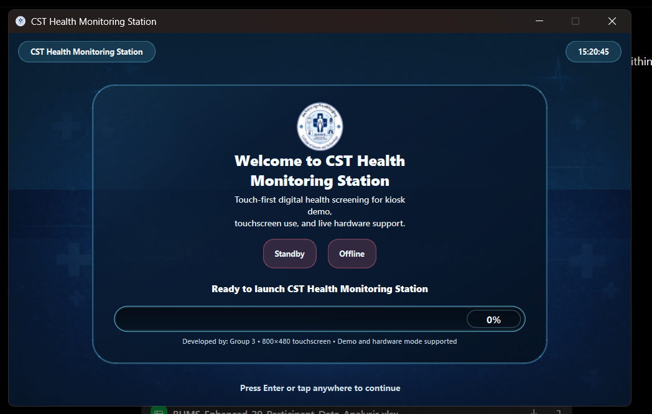
Figure Welcome Screen: Welcome Screen used in the final BHMS application.

Step 2: Instruction and Mode Selection Screen
Once past the welcome page, the user arrives at the instruction and mode page. Here, the user is guided with basic instructions on operating the device and can select between the two modes available – Start Check Up and Admin modes.
The importance of this page lies in the fact that it differentiates between user mode and admin mode. Furthermore, it tells the user about the correct standing position and placement of finger while performing the measurements. Here, the measurement process is almost about to commence and the voice guide directs the user towards the sensor action.
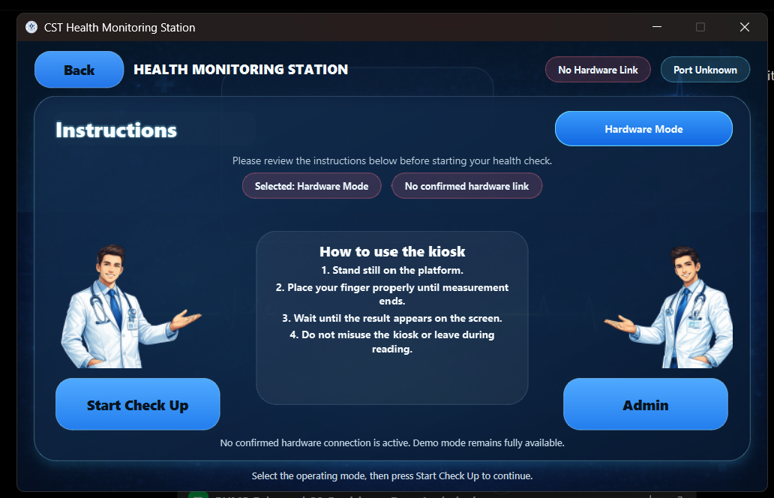
Figure Instruction and Mode Selection Screen: Instruction and Mode Selection Screen used in the final BHMS application.

Step 3: Measurement Result Screen
After all measurements have been taken, the result page shows the seven parameters that are measured, which include temperature, SpO₂, pulse rate, breathing rate, weight, height, and BMI. This is the main result page of the BHMS app.
The layout of the card style helps make the result page more readable, especially when viewed on a touch screen. The user can refresh, redo the test, create a report, get the QR code, see the diagnosis, or get consultation advice. This is why the result page functions as an intermediary between raw data and meaningful health data.
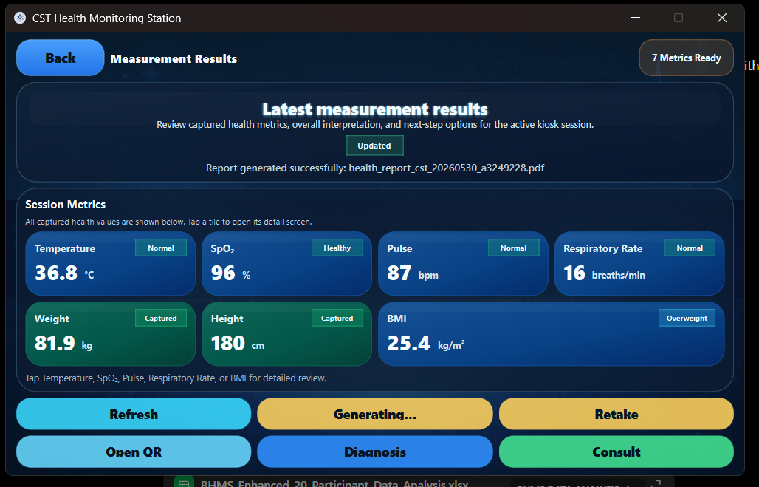
Figure Measurement Result Screen: Measurement Result Screen used in the final BHMS \
Step 4: Health Diagnosis Screen
The Diagnosis screen displays a composite health assessment that is derived from the measured data. The parameter falling outside the range is determined, and the result displayed in a simple message like BMI Overweight along with a chart showing the status of the measurement readings.
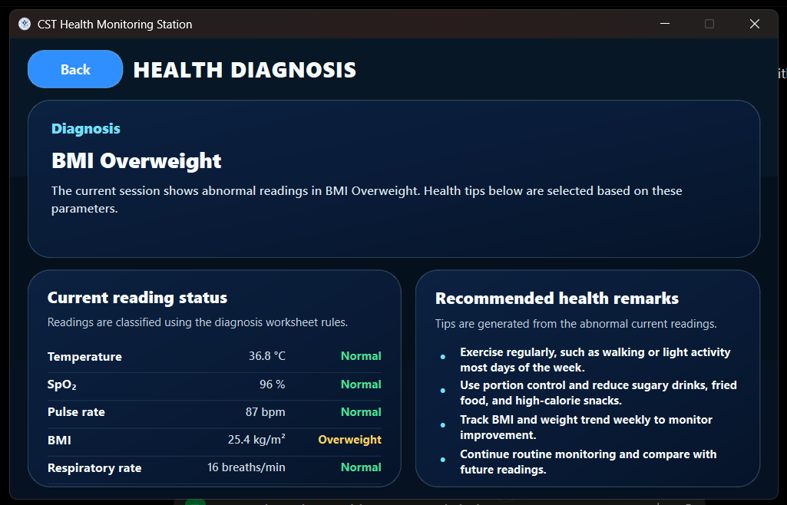
This display serves well when using the kiosk in a college clinic environment since the screen provides information on what the measurements mean to the individual. Rather than displaying numeric data, it shows a key finding and gives remarks based on the parameters.
Figure Health Diagnosis Screen: Health Diagnosis Screen used in the final BHMS application.
Step 5: Consultation Guidance Screen
The Consultation Guidance screen will provide advisory information for the subsequent step. In other words, this screen will contain key information about the results that were obtained by the user as well as suggestions on what needs to be done next. It will contain health improving advice as well.
This screen will function as a supportive element for the user but not as an alternative to medical consultation. The screen will stimulate the user to make decisions related to responsible behavior.

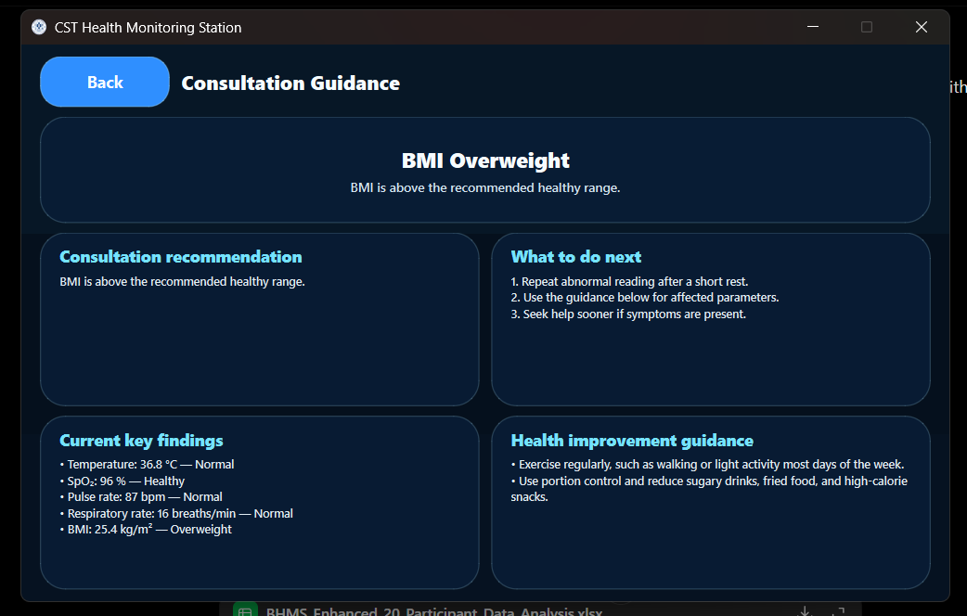
Figure Consultation Guidance Screen: Consultation Guidance Screen used in the final BHMS application.
Interpretation Screens for Specific Parameters
After seeing the results display, the user may tap on any parameter card to see its more detailed interpretation screen. Such screens will provide information about threshold values, the current condition of the parameter, and advice for a specific parameter only.
Step 6: Temperature Detail Display Screen
In the temperature detail screen, information about the current body temperature, the healthy range, the alert value, and the final interpretation will be visible. This screen could prove helpful in determining the legitimacy of the contactless temperature reading.
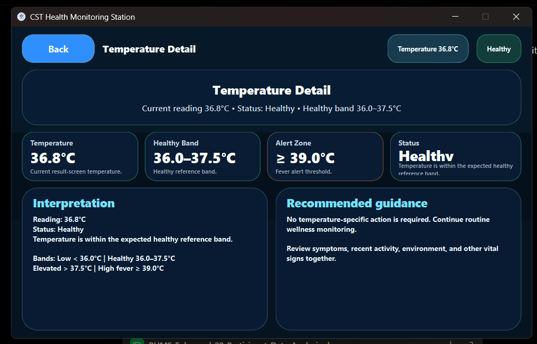
This screen also tells the user that the temperature should be considered together with possible symptoms and the environment. The implemented version will make it clear that there is no need to do anything if everything is fine, except the alert value for a fever.
Figure Temperature Detail Screen: Temperature Detail Screen used in the final BHMS application.
Step 7: Blood Oxygen Detail View
The blood oxygen detail view displays the SpO2 reading along with the normal range of readings and low threshold of SpO2 levels. This enables the user to understand the saturation value without having to read the entire report.
This display further informs the user about any possible interference factors like finger movement, poor sensor contact, nail polish, or signal quality issues.
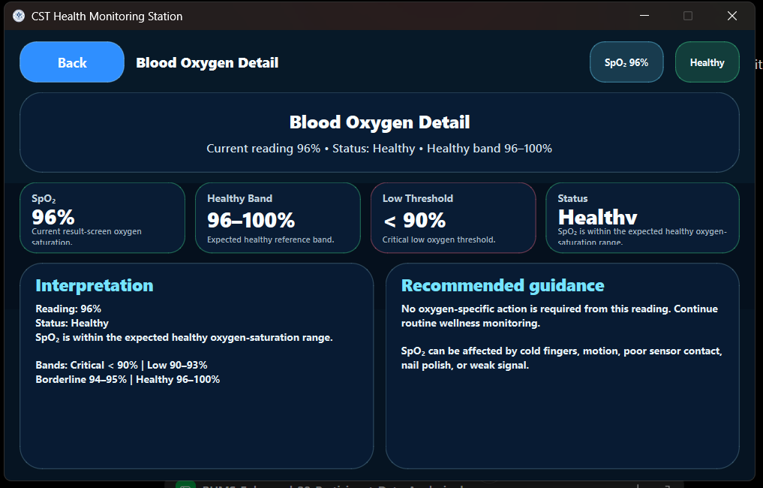
Figure Blood Oxygen Detail Screen: Blood Oxygen Detail Screen used in the final BHMS application.
Button / Area | Functionality
Back | Returns to the result screen.
SpO₂ value | Shows the measured oxygen saturation.
Healthy band | Displays the expected saturation range.
Low threshold | Shows the critical lower limit.
Recommended guidance | Provides oxygen-saturation interpretation.
Table Blood Oxygen Detail Screen: Main functions of the blood oxygen detail screen.
Step 8: Pulse Rate Detail Screen
This screen highlights the pulse rate figure, comparing it against the average resting rate of adults. The other information highlighted in this screen is the highest level of alertness for abnormal pulse rates.
This screen is necessary since pulse rate may vary depending on various factors like physical exercise, caffeine intake, anxiety, fever, and pain.
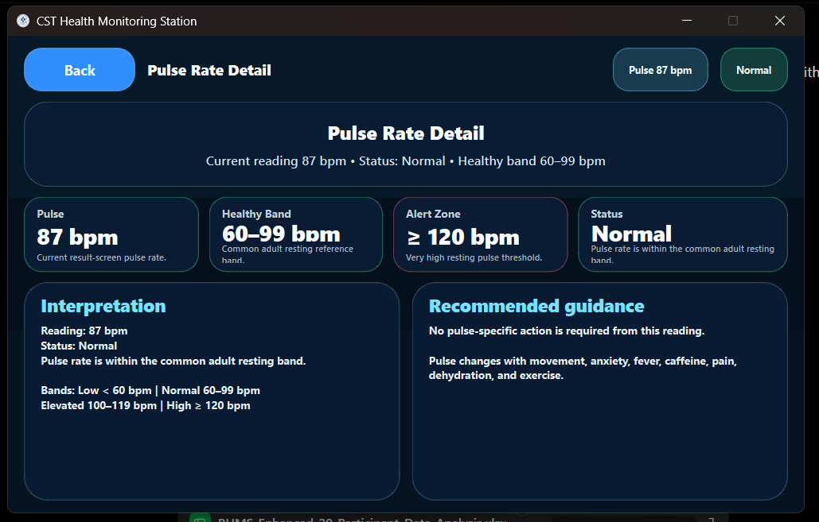
Figure Pulse Rate Detail Screen: Pulse Rate Detail Screen used in the final BHMS application.
Step 9: Detail Screen for BMI
The detail screen for BMI contains both the value computed along with the range for normal, overweight, and obesity levels. The detail screen is critical since BMI is a calculated value based on physical measurements and not a directly measured parameter.
In the actual BHMS software, the detail screen includes explanation regarding the class and actions that should be taken to ensure that the BMI is within the normal range.

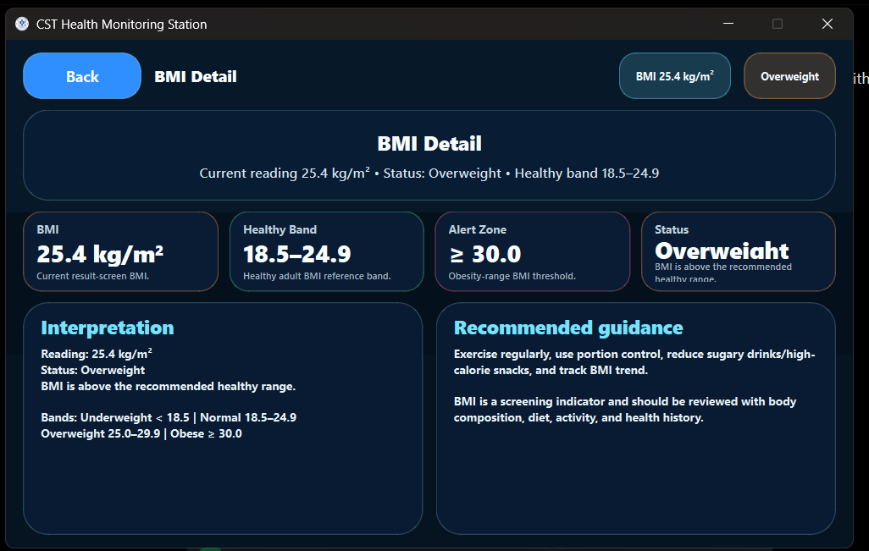
Figure BMI Detail Screen: BMI Detail Screen used in the final BHMS application.

Step 10: PDF Report and QR-enabled Session Viewer
Following data collection and analysis, the BHMS creates a PDF report and links it with the QR code for session viewing. In this way, the BHMS expands its role from a mere local measuring instrument to a report generator that provides access to the report through either the screen itself or a scanning option using Wi-Fi connectivity to get session information on any mobile device.
The report is comprised of session information, all measurements, diagnosis summary, combination of diagnosis, recommendation, and advice in case of consultation/emergency. On the other hand, the mobile viewer offers similar information in a condensed form.
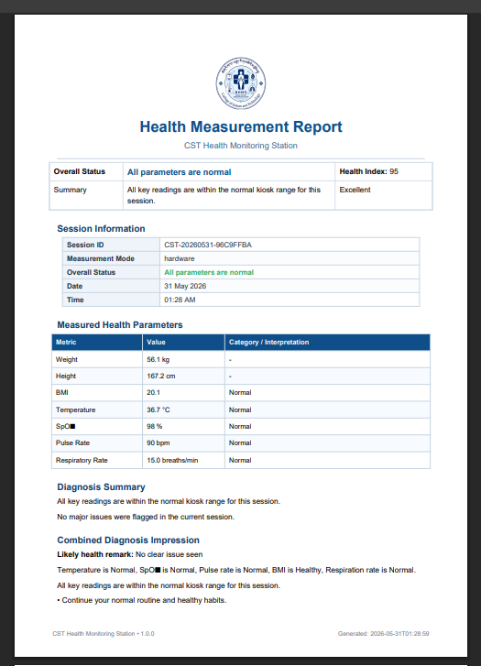
Figure 6.B: Example of the generated BHMS PDF health measurement report.
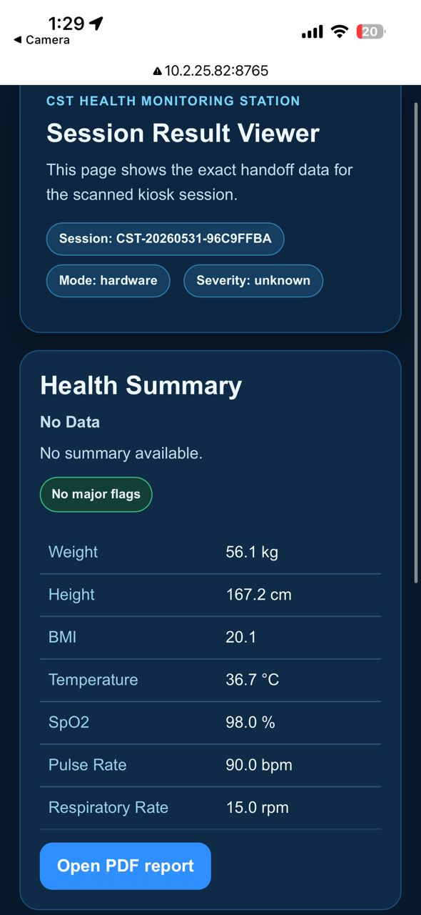
Figure 6.C: Mobile QR session result viewer showing the handoff data.
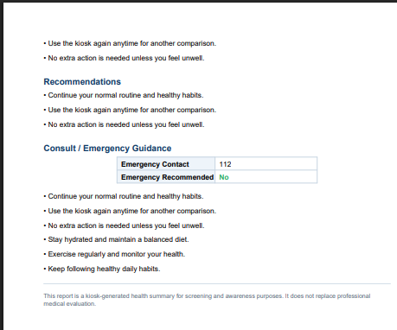
Figure 6.D: Recommendation and emergency guidance section in the generated report.
Report component | Purpose
Session Information | Identifies the measurement session, date, time and mode.
Measured Health Parameters | Lists the final values and interpretations.
Diagnosis / Recommendations | Summarizes the finding and suggests next steps.
QR Viewer | Allows the user to view the report on a phone browser.
Table 6.B: Main components of the BHMS report and QR viewer.
Administrative and Service Support Screens
These screens have not been integrated in the normal measurement process flow, but these are important screens for maintaining and managing the system. They have been shown in the final presentation as well and are added here to fulfill the requirement of complete GUI documentation.
Step 11: Admin Login Screen
The admin login screen ensures that no unauthorized person can use the configuration and maintenance options within the system. It asks the username and password along with providing an option for remembering it and toggling off and on the visibility of the password.
It is required because the configuration and calibration options need to be managed by authorized persons only, and thus the admin login process is separated from the normal student user login process.

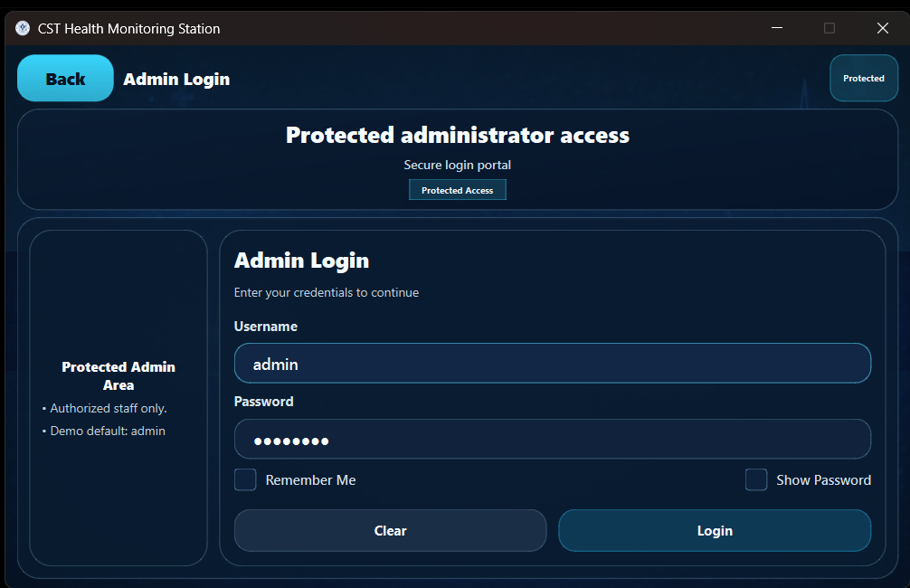
Figure Admin Login Screen: Admin Login Screen used in the final BHMS application.
Step 12: Admin Panel
Upon successful login, the admin panel becomes the central administration hub. The module buttons that will be visible include those of the Settings, Calibration, Storage and Publish modules, along with refresh and logout buttons.
The importance of this screen lies in its role as a one-stop administrative center. Rather than hiding the administration activities in different places, it brings all these functions together on one screen.

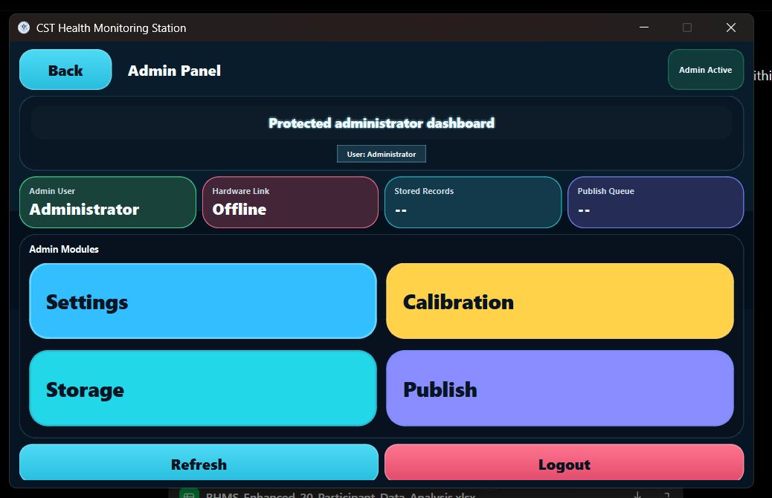
Figure Admin Panel: Admin Panel used in the final BHMS application.
Step 13: Settings Window
Settings allow you to adjust the following parameters: screen brightness, volume levels, start-up mode, network mode, and touch-audio. In addition, there are the options "Save", "Reload", and "Reset". From the point of view of system design, this window improves usability since it enables the kiosk to adapt quickly to the new environment. For example, the screen brightness can be set according to the clinic lighting, while audio can be turned off in an infirmary environment.

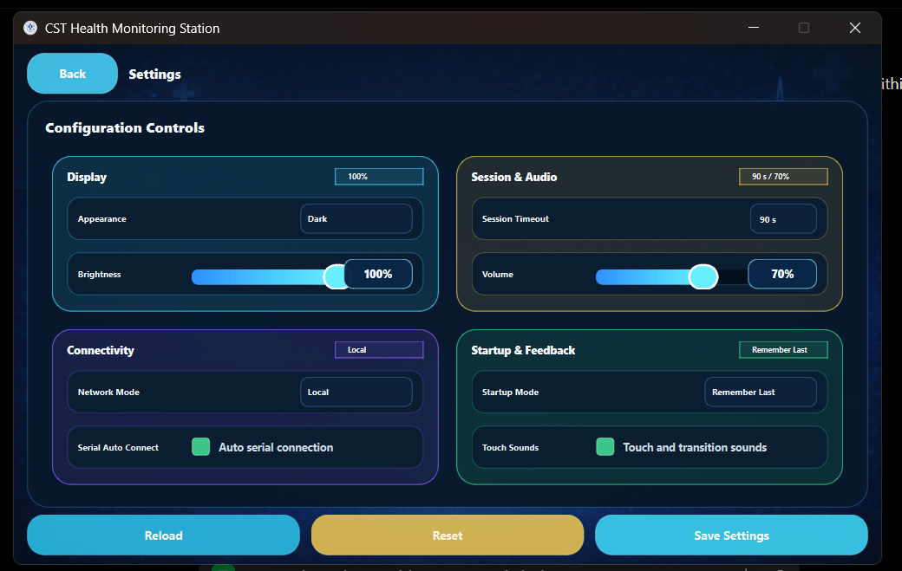
Figure Settings Screen: Settings Screen used in the final BHMS application.
Step 14: Storage Maintenance Screen
The storage maintenance screen will contain information about stored files, their size estimates, storage condition and state of the database. It will also categorize data by records, reports, QR codes, backup, export files, temporary files, and logs.
The screen is necessary in order to run the kiosk on a permanent basis since BHMS keeps records of session outcomes, PDF reports, and other information associated with QR codes.

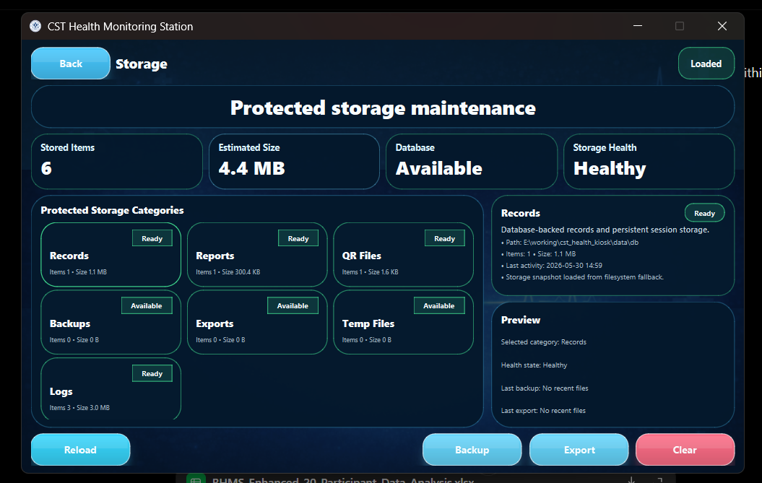
Figure Storage Maintenance Screen: Storage Maintenance Screen used in the final BHMS application..
Screen 15: Saved Reports Screen
The screen displays the list of report file names that have been generated before, and it provides an option to open the selected report, reload the list of report files, or display the path of the folder where all the report files are stored.
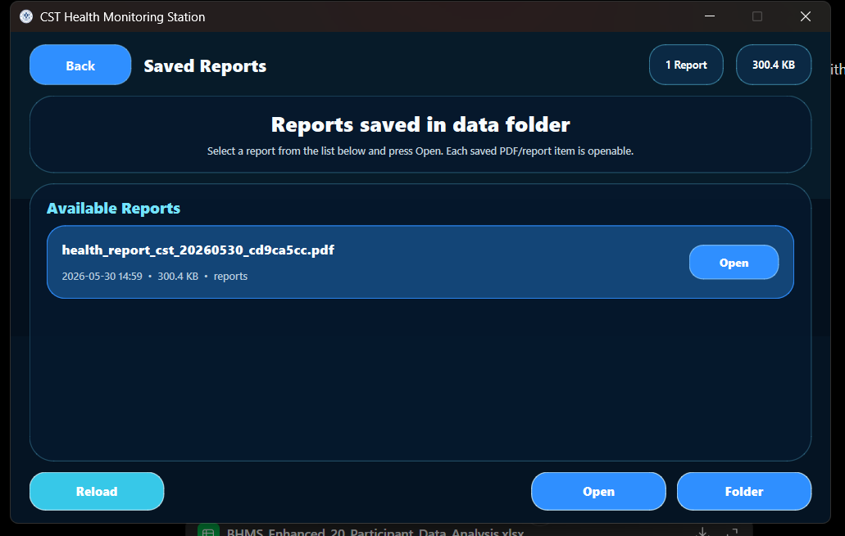
In case of an infirmary, this screen becomes helpful, as the person who operates the system may need to open the generated report file again in PDF format.

Figure Saved Reports Screen: Saved Reports Screen used in the final BHMS application.
As seen in the above-mentioned sequence, the actual steps carried out by the user precede those performed for services and administration purposes. The following subsections in this chapter present the detailed screen-by-screen documentation and other software modules for BHMS.

6.5.1 Saved Reports Screen
Open, Reload, Folder buttons for report access and storage navigation.

Figure 6.1: Saved Reports Screen
Table 6.1: Button and function description for Saved Reports Screen
Button / Indicator | Function
Reload | Refreshes file list or storage status.
Open | Opens selected saved report.
Folder | Opens storage directory.
Backup | Creates backup of records.
Export | Exports available data.
Clear | Deletes selected temporary or protected files after confirmation.

6.5.2 Storage Maintenance Screen
Backup, Export, Clear and Reload controls for protected storage maintenance.

Figure 6.2: Storage Maintenance Screen

6.5.3 Settings Screen
Brightness, volume, appearance, network mode, touch sounds and save settings controls.

Figure 6.3: Settings Screen

6.5.4 Admin Panel
Admin modules for settings, calibration, storage, publish, refresh and logout.

Figure 6.4: Admin Panel

6.5.5 Admin Login Screen
Protected admin login with username, password, remember me, show password, clear and login controls.

Figure 6.5: Admin Login Screen

6.5.6 Instruction and Mode Selection Screen
Start Check Up, Admin and Hardware Mode buttons with operating instructions.
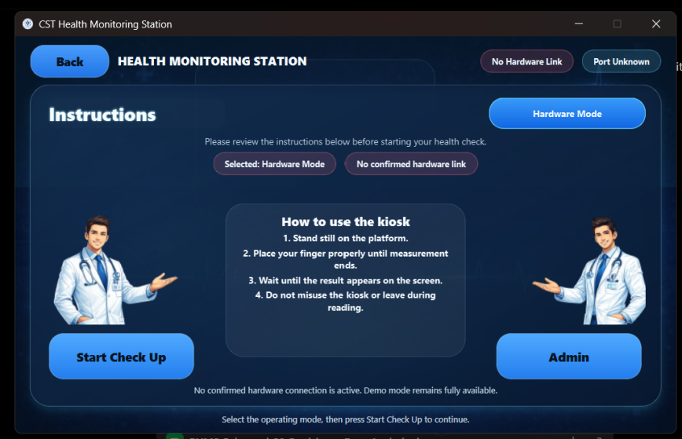
Figure 6.6: Instruction and Mode Selection Screen
Table 6.6: Button and function description for Instruction and Mode Selection Screen

6.5.7 Welcome Screen
Welcome interface with loading bar and standby/offline indicators.

Figure 6.7: Welcome Screen

6.5.8 Measurement Result Screen
Health metrics include seven indicators and actions like report, QR code, diagnose, consult, refresh and retake.
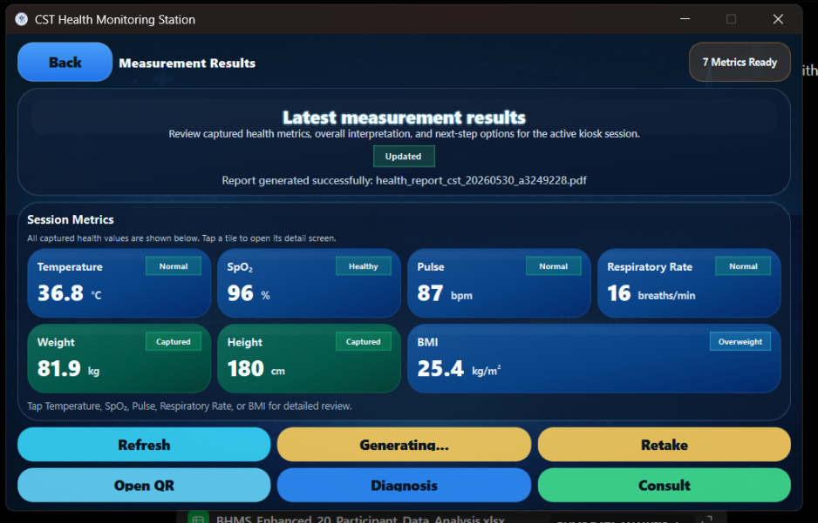
Figure 6.8: Measurement Result Screen

6.5.9 Health Diagnosis Screen
Shows abnormal reading diagnosis and parameter-based health remarks.

Figure 6.9: Health Diagnosis Screen

6.5.10 Consultation Guidance Screen
Shows current key findings, recommendation and next action instructions.

Figure 6.10: Consultation Guidance Screen

6.5.11 Temperature Detail Screen
Provides temperature value, healthy range, alert zone, status and guidance.

Figure 6.11: Temperature Detail Screen

6.5.12 Blood Oxygen Detail Screen
Provides SpO₂ value, healthy band, low threshold, status and guidance.

Figure 6.12: Blood Oxygen Detail Screen

6.5.13 Pulse Rate Detail Screen
Provides pulse value, normal band, alert zone, status and guidance.

Figure 6.13: Pulse Rate Detail Screen

6.5.14 BMI Detail Screen
Provides BMI value, healthy band, overweight/obese alert zones and guidance.

Figure 6.14: BMI Detail Screen
6.6 Voice Guidance Module
The BHMS system also has an audio guidance module which makes use of DFPlayer Mini voice module along with a 3-watt speaker. Commands for triggering voice messages through the serial commands sent by ESP32 occur at every measurement step. The order of messages is as follows: (1) "welcome message"; (2) "Turn the temperature knob on your head"; (3) "temperature measurement complete, insert left index finger in left slot"; (4) "measurement complete, insert right index finger in right slot"; (5) "BPM measurement complete, please stand still for weighing"; (6) "weight measurement complete, please stand straight"; (7) "height measurement complete, check results on display and scan QR code".
Table 6.17: Voice assistance hardware used in BHMS
Component | Role | Description
Obocraze MP3-TF-16P V3.0 SD Card Module | Serial MP3 playback module | Supports FAT16/FAT32 file system, serial command control, 24-bit DAC output, dynamic range around 90 dB and SNR around 85 dB.
ND TECH 2 Inch 3W 4 Ω Full Range Speaker | Audio output device | Mini woofer loudspeaker used to play voice prompts from the MP3 module.
MicroSD Card | Audio storage | Stores recorded MP3 prompt files in the required sequence.
ESP32 / Raspberry Pi command signal | Trigger mechanism | Triggers the correct audio file at each measurement stage.

Table 6.18: Voice prompt sequence used during measurement workflow

Measurement Stage | Voice Prompt | Purpose
Welcome screen | “Welcome to CST Basic Health Monitoring Station.” | Played after the user enters the welcome screen.
Start measurement | “Adjust the temperature screw over your head.” | Guides user to align temperature measurement position.
Temperature completed | “Temperature measurement done. Move your left index finger and place it on the left hole in sensor box.” | Guides user to place finger for SpO₂ and respiratory-rate measurement.
SpO₂/RR completed | “Reading taken. Move your right index finger and place it in right hole.” | Guides user to place finger for pulse/BPM measurement.
BPM completed | “BPM reading is done. Stand still for weight measurement.” | Prepares user for stable weight reading.
Weight completed | “Weight reading is done. Stand straight.” | Guides user to stand correctly for height measurement.
Height completed | “Height measurement is done. Now you can view the result on the screen. Use the Wi-Fi provided to scan the QR to see your report.” | Informs user that final result and QR report are available.

6.7 Serial Communication
Serial communication acts as the link between the ESP32 sensor module and the Raspberry Pi processing module. Information for each parameter is transferred in packets with appropriate labeling to ensure proper identification of height, weight, BMI, temperature, pulse, oxygen saturation levels, and respiratory rate by the receiver.
Table 6.19: Serial data labels used for ESP32 to Raspberry Pi communication
Data Label | Meaning | Example Packet
HEIGHT | Height value in centimetres | HEIGHT: 164.0
WEIGHT | Weight value in kilograms | WEIGHT: 57.9
BMI | Calculated BMI value | BMI: 21.5
TEMP | Temperature in degree Celsius | TEMP: 36.8
SPO2 | Blood oxygen saturation | SPO2: 98
PULSE | Pulse rate in beats per minute | PULSE: 78
RR | Respiratory rate in breaths per minute | RR: 16

There were no instances of significant delay while transferring information from ESP32 to Raspberry Pi during testing. Application worked efficiently after completing measurement, showing obtained results on the screen.
6.8 Data Processing Algorithm
Data processing algorithm is used to convert information from sensors to health indicators. It detects whether information is present and filters unstable information until necessary measurements are taken.
Table 6.20: Data processing algorithm used in BHMS
Step | Processing Action
1 | Initialize Raspberry Pi GUI, ESP32 and sensors.
2 | Check serial connection and hardware mode status.
3 | Read temperature and confirm stable value.
4 | Read SpO₂ and respiratory-rate value from optical sensing stage.
5 | Read pulse value from the pulse/BPM stage.
6 | Read weight from load cell after stabilization.
7 | Read height from VL53L0X distance sensor.
8 | Calculate BMI using height and weight.
9 | Classify each parameter as low, normal, high or abnormal according to rule set.
10 | Display results, generate PDF report and QR code.

6.9 Calculation of Body Mass Index
Body Mass Index can be calculated automatically using the input values for weight and height. This helps minimize errors in calculating the body mass index and also ensures that classification is done instantaneously.
BMI = Weight (kg)/[Height(m)]²
For instance, if the weight is 58 kg while the height is 1.64 meters, then the Body Mass Index will be 58/(1.64 × 1.64) = 21.6 kg/m².

6.10 Health Classification Logic
Table 6.21: Health classification logic used in BHMS
Parameter | Classification Range | Use in System
Temperature | Low < 36.0 °C; Normal 36.0–37.5 °C; Elevated > 37.5 °C; High fever ≥ 39.0 °C | Used for temperature detail screen and diagnosis.
SpO₂ | Critical < 90%; Low 90–93%; Borderline 94–95%; Healthy 96–100% | Used for blood oxygen detail and report.
Pulse Rate | Low < 60 bpm; Normal 60–99 bpm; Elevated 100–119 bpm; High ≥ 120 bpm | Used for pulse detail and guidance.
BMI | Underweight < 18.5; Normal 18.5–24.9; Overweight 25.0–29.9; Obese ≥ 30.0 | Used for BMI detail and diagnosis.
Respiratory Rate | Low, normal and high ranges based on adult resting breathing classification | Used for respiratory-rate status and diagnosis.

This classification logic is meant for preliminary testing purposes only. It is not an alternative to a clinical diagnosis. Abnormal test results are meant to suggest repeat testing or consulting a medical expert.
6.11 QR Report Creation
Once the testing process has been done by the user, a PDF report of all the test parameters, including classification and health information, along with date and time, will be created by the Raspberry Pi. A QR code will then be created to allow users to access the report on their mobile devices after connecting to the Wi-Fi network.
The reporting feature will facilitate documentation, as results will not have to be manually documented. This feature also enables the user to keep an electronic copy of the results for future comparison purposes.
The functionality of the report and QR code viewer was tested. The report is composed of session ID, values of parameters, statuses, diagnosis, recommendation, and advice on emergencies. On the other hand, the mobile QR code viewer provides the same information as the session handover data but with a more suitable layout for phones.
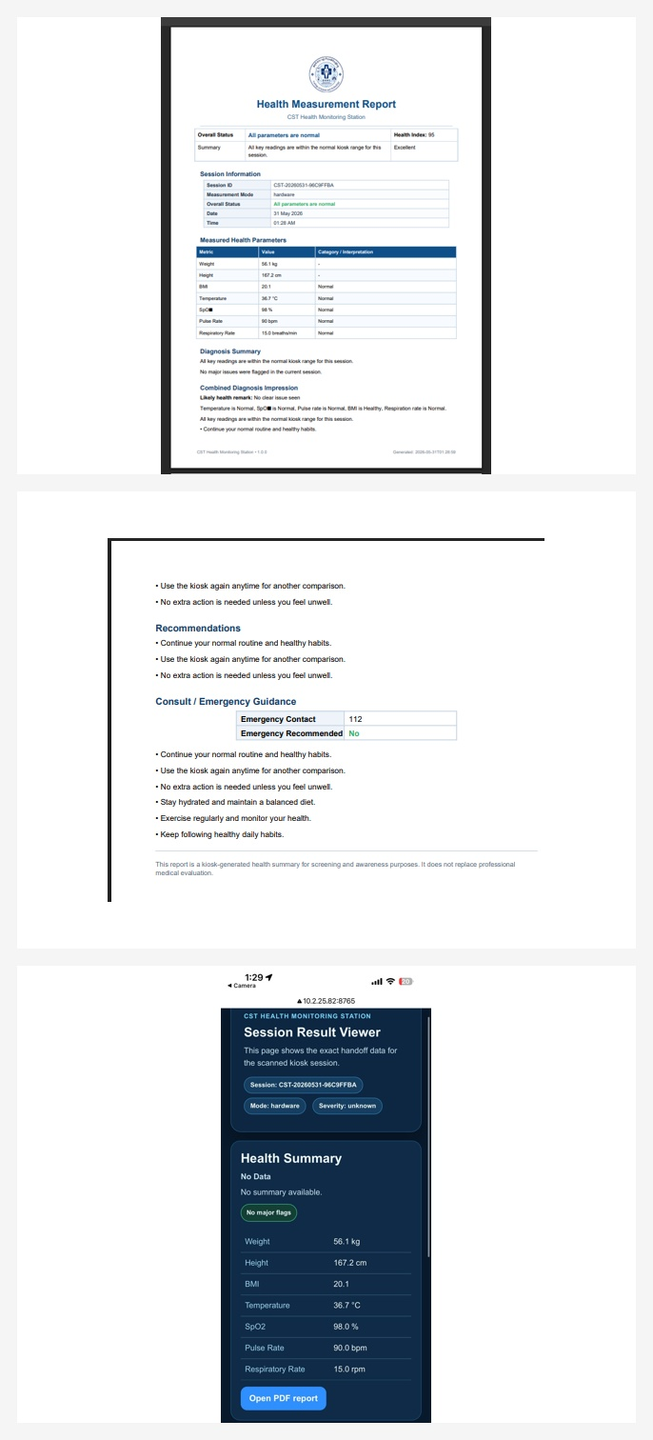
Figure 6.15(a): Generated PDF report pages and the mobile QR-linked session-result viewer produced by the BHMS after measurement completion.
These additional figures have been included from the slides and testing documentation for the project to ensure that the report reflects the actual process followed during the development and testing of the Basic Health Monitoring Station.

Figure 6.15: Generated PDF health measurement report from the BHMS.

Figure 6.16: Mobile QR session result viewer showing the scanned report data.

Figure 6.17: Emergency guidance and recommendation section included in the report.

CHAPTER 7: TESTING WITH NUMBER OF SAMPLES

7.1 Introduction
Tests were performed to confirm individual parts, the functionality of the system as well as the measuring consistency of the Basic Health Monitoring Station. These tests consisted of an individual component test, calibration, integration, and data acquisition based on samples. Finally, the collected data set was increased to 20 individuals to ensure better basis for analysis.
The goal of this chapter is to introduce tests that have been implemented to validate ESP32, Raspberry Pi, sensors, display, voice module, and measurement process. Calibration tables as well as offsets are introduced here to increase measuring accuracy.
7.2 Individual Component Test
Before connecting all parts together, the individual components had to be tested first. It ensured correct connections as well as eliminated any errors such as unstable sensor value readings or communication problems.
Table 7.1: Individual component testing summary
Component | Testing Method | Observation
ESP32 WROOM-32 | Serial monitor and sensor reading test | Successfully collected labelled readings from sensors.
Raspberry Pi 4B | Operating system and GUI launch test | Successfully ran the PyQt touchscreen application.
7-inch Touchscreen Display | Touch response and screen layout test | Buttons and screen transitions responded properly.
HX711 + Load Cells | Known weight testing | Weight values were corrected through offset calibration.
MAX30102 | Finger placement test | SpO₂ and pulse-related signals were obtained after calibration.
MLX90614 | Reference thermometer comparison | Non-contact temperature readings required offset correction.
VL53L0X | Known distance testing | Distance offset was applied for height calculation.
Voice Module and Speaker | Audio file playback test | Voice prompts played according to the measurement workflow.

7.3 Calibration Process
Calibration was done by comparing sensor readings with reference or real values. Afterward, offsets were determined and applied in order to minimize the gap between sensor and reference values. The following are the processes involved in the calibration of each sensor.
7.3.1 MAX30102 Calibration
The MAX30102 sensor was calibrated by comparing the raw SpO₂ values with reference values from an oximeter. The raw sensor values were below the reference values. As such, a positive offset of +1.67% was used.
Table 7.2: MAX30102 SpO₂ calibration before correction
Reading | Medical Device SpO₂ (%) | MAX30102 Raw SpO₂ (%) | Offset (%)
1 | 98.00 | 96.31 | -1.69
2 | 97.00 | 95.42 | -1.58
3 | 99.00 | 97.26 | -1.74
4 | 96.00 | 94.28 | -1.72
5 | 98.00 | 96.37 | -1.63
6 | 97.00 | 95.29 | -1.71
7 | 99.00 | 97.41 | -1.59
8 | 98.00 | 96.25 | -1.75
9 | 97.00 | 95.36 | -1.64
10 | 96.00 | 94.35 | -1.65

Table 7.3: MAX30102 SpO₂ calibration after correction
Reading | Medical Device SpO₂ (%) | MAX30102 Raw (%) | Correction Applied (%) | Corrected MAX30102 (%)
1 | 98 | 96.46 | +1.67 | 98.13
2 | 97 | 95.21 | +1.67 | 96.88
3 | 99 | 97.34 | +1.67 | 99.01
4 | 96 | 94.41 | +1.67 | 96.08
5 | 98 | 96.18 | +1.67 | 97.85
6 | 97 | 95.47 | +1.67 | 97.14
7 | 99 | 97.12 | +1.67 | 98.79
8 | 98 | 96.52 | +1.67 | 98.19
9 | 97 | 95.33 | +1.67 | 97.00
10 | 96 | 94.26 | +1.67 | 95.93

MAX30102 calibration
The application of the correction factor made the MAX30102 sensor readings close to the reference values and acceptable for screening at a prototype level.
7.3.2 MLX90614 Calibration
The MLX90614 infrared sensor was calibrated using reference temperature values. Raw data from the MLX90614 infrared sensor was slightly lower than the reference value. Correction factor of +2.30 °C was added.
Table 7.4: MLX90614 temperature calibration
Reading | Actual Temperature (°C) | Sensor Raw Temperature (°C) | Offset Applied (°C) | Corrected Temperature (°C)
1 | 36.30 | 34.02 | +2.30 | 36.32
2 | 36.10 | 33.79 | +2.30 | 36.09
3 | 35.90 | 33.61 | +2.30 | 35.91
4 | 36.40 | 34.08 | +2.30 | 36.38
5 | 36.20 | 33.95 | +2.30 | 36.25

7.3.3 Calibration of Pulse Sensor
The pulse sensors were compared with a BPM measuring tool. There is an adjustment factor of -0.30 BPM which can be applied to improve the performance of the pulse sensors. The accuracy of pulse detection depends on finger movement and pressure.
Table 7.5: Pulse rate calibration
Reading | Actual Pulse Rate (BPM) | Sensor Raw Pulse Rate (BPM) | Offset Applied (BPM) | Corrected Pulse Rate (BPM)
1 | 77.00 | 78.40 | -0.30 | 78.10
2 | 78.00 | 76.90 | -0.30 | 76.60
3 | 76.00 | 76.80 | -0.30 | 76.50
4 | 79.00 | 79.60 | -0.30 | 79.30
5 | 75.00 | 75.20 | -0.30 | 74.90

7.3.4 VL53L0X Sensor Calibration
Calibration of the VL53L0X sensor was done through comparison between the measured distance and the actual distances. The offset used was around -40 mm. Height is measured using the fixed position of the sensor and then subtracted from the measured distance, so positioning matters.
Table 7.6: VL53L0X height sensor calibration
Reading | Sensor Raw Distance (mm) | Calibrated Distance (mm) | Offset Applied (mm) | Calculated Person Height (cm)
1 | 404.00 | 363.55 | -40.45 | 163.60
2 | 405.00 | 364.45 | -40.55 | 163.60
3 | 405.60 | 364.99 | -40.61 | 163.50
4 | 392.60 | 353.30 | -39.30 | 164.70
5 | 395.80 | 356.18 | -39.62 | 164.40
6 | 400.40 | 360.31 | -40.09 | 164.00

7.3.5 Calibration of Load Cell
Load cell calibration involved adding different standard loads ranging from 0 kg to 200 kg in steps of 20 kg. The reading was taken, and then any offsets that might exist were accounted for. For example, at 200 kg the raw reading was 196.30 kg, and an offset of +3.70 kg was needed.
Table 7.7: Load cell calibration using standard weights
Reading No. | Standard Weight Applied (kg) | Raw Load Cell Reading (kg) | Offset / Correction (kg) | Corrected Reading (kg)
0 | 0.00 | 0.00 | 0.00 | 0.00
1 | 20.00 | 19.62 | 0.38 | 20.00
2 | 40.00 | 39.28 | 0.72 | 40.00
3 | 60.00 | 58.93 | 1.07 | 60.00
4 | 80.00 | 78.55 | 1.45 | 80.00
5 | 100.00 | 98.21 | 1.79 | 100.00
6 | 120.00 | 117.80 | 2.20 | 120.00
7 | 140.00 | 137.42 | 2.58 | 140.00
8 | 160.00 | 157.10 | 2.90 | 160.00
9 | 180.00 | 176.65 | 3.35 | 180.00
10 | 200.00 | 196.30 | 3.70 | 200.00

Calibration helped to minimize errors associated with measurements. With the help of four 50kg load cells in this system, the total load-cell capacity is 200kg. Hence, load distribution and sensor safety are significant concerns.

CHAPTER 8: RESULTS AND DISCUSSION
8.1 Introduction
This chapter describes the results derived from the BHMS prototype. These results consist of the following: data collection with 20 subjects, comparison with reference readings of the medical devices, error analysis, time efficiency analysis, performance analysis, trend analysis, feasibility analysis and cost analysis.
8.2 Integration Test of the System
Integration test confirmed the ability of the ESP32, Raspberry Pi, user-friendly touchscreen, sensors, voice module, QR generator, and reporting feature to function as an overall integrated system. During the testing, the subject followed the instructions and performed the measurements of temperature, SpO2, respiratory rate, pulse, weight and height. The final results were presented to the subject on-screen along with the report.
• Results received by the ESP32 and transferred to Raspberry Pi by sensors.
• Seven results appeared on-screen on the GUI.
• Diagnosis button, QR code button, report button, retake button, and consult button functioned properly.
• There was no noticeable delay during screen navigation and presentation of results.
• The system needs uninterrupted energy supply to Raspberry Pi since there is no battery backup available permanently.
8.3 Data Collection
The data was gathered from a total of 20 subjects. Height, weight, BMI, temperature, and pulse rate data were obtained for the medical device. Given that the SpO2 and respiratory rate data were not recorded on the medical device, the reference data used in the comparison and plotting are assumed to be within ±2% of the BHMS data.

Table 8.1: BHMS dataset for 20 participants
Sl.No | Gender | Age | Height (cm) | Weight (kg) | BMI | Temperature (°C) | Respiratory Rate (breaths/min) | Pulse Rate (bpm) | SpO₂ (%) | BHMS Time (mm:ss) | BHMS Time (s)
1 | M | 19 | 160.60 | 57.50 | 22.29 | 33.60 | 17.00 | 67 | 97 | 1:58 | 118
2 | M | 21 | 159.20 | 58.50 | 23.08 | 33.20 | 17.00 | 80 | 100 | 2:01 | 121
3 | F | 23 | 153.90 | 62.00 | 26.18 | 31.80 | 19.00 | 70 | 100 | 2:08 | 128
4 | F | 22 | 163.40 | 52.30 | 19.59 | 33.70 | 12.00 | 55 | 98 | 1:55 | 115
5 | F | 23 | 150.00 | 43.60 | 19.38 | 33.60 | 15.00 | 83 | 99 | 2:00 | 120
6 | F | 23 | 153.60 | 40.10 | 17.00 | 34.80 | 17.00 | 71 | 96 | 2:04 | 124
7 | F | 22 | 162.20 | 47.80 | 18.17 | 35.40 | 9.00 | 86 | 100 | 1:52 | 112
8 | F | 22 | 155.10 | 68.40 | 28.43 | 33.50 | 18.00 | 67 | 96 | 2:15 | 135
9 | F | 23 | 170.10 | 59.10 | 20.43 | 35.30 | 15.00 | 84 | 98 | 1:59 | 119
10 | F | 23 | 169.90 | 53.50 | 18.53 | 35.00 | 17.00 | 67 | 97 | 2:02 | 122
11 | M | 24 | 167.00 | 54.80 | 19.65 | 33.10 | 14.00 | 70 | 97 | 1:57 | 117
12 | M | 22 | 175.80 | 75.20 | 24.33 | 34.80 | 14.00 | 74 | 100 | 2:06 | 126
13 | F | 25 | 163.80 | 62.30 | 23.22 | 33.80 | 17.00 | 77 | 96 | 2:03 | 123
14 | M | 23 | 170.00 | 71.50 | 24.74 | 34.30 | 16.00 | 68 | 94 | 2:05 | 125
15 | F | 23 | 162.50 | 69.70 | 26.40 | 34.40 | 18.00 | 88 | 95 | 1:56 | 116
16 | M | 34 | 180.30 | 85.74 | 26.37 | 36.50 | 16.00 | 85 | 98 | 2:10 | 130
17 | F | 22 | 159.00 | 58.70 | 23.22 | 34.30 | 12.00 | 66 | 100 | 2:07 | 127
18 | F | 19 | 170.00 | 62.30 | 21.56 | 34.70 | 15.00 | 79 | 97 | 2:01 | 121
19 | M | 29 | 177.30 | 77.56 | 24.67 | 33.90 | 17.00 | 78 | 97 | 2:00 | 120
20 | M | 31 | 179.70 | 87.50 | 27.10 | 34.90 | 16.00 | 74 | 98 | 1:58 | 118

Table 8.2: Medical-device dataset for 20 participants
Sl.No | Gender | Age | Height (cm) | Weight (kg) | BMI | Temperature (°C) | Respiratory Rate (breaths/min) | Pulse Rate (bpm) | SpO₂ (%) | Medical Time (mm:ss) | Medical Time (s)
1 | M | 19 | 161.00 | 59.30 | 22.88 | 34.81 | 16.80 | 59 | 98.00 | 4:58 | 298
2 | M | 21 | 162.00 | 59.80 | 22.79 | 34.00 | 17.10 | 65 | 99.00 | 5:03 | 303
3 | F | 23 | 151.00 | 61.28 | 26.88 | 32.90 | 18.70 | 82 | 100.00 | 5:09 | 309
4 | F | 22 | 163.00 | 51.50 | 19.38 | 33.40 | 12.20 | 58 | 99.00 | 4:55 | 295
5 | F | 23 | 147.00 | 43.35 | 20.06 | 33.50 | 14.90 | 75 | 98.00 | 5:01 | 301
6 | F | 23 | 154.00 | 41.15 | 17.35 | 34.00 | 17.20 | 74 | 97.00 | 5:06 | 306
7 | F | 22 | 160.00 | 46.90 | 18.32 | 33.30 | 8.90 | 69 | 99.00 | 5:11 | 311
8 | F | 22 | 154.50 | 68.00 | 28.49 | 33.50 | 18.30 | 70 | 96.00 | 4:59 | 299
9 | F | 23 | 164.00 | 60.05 | 22.33 | 34.80 | 14.80 | 82 | 99.00 | 5:08 | 308
10 | F | 23 | 170.00 | 52.45 | 18.15 | 34.30 | 17.10 | 74 | 96.00 | 5:02 | 302
11 | M | 24 | 166.00 | 72.00 | 26.13 | 34.00 | 13.90 | 84 | 97.00 | 4:56 | 296
12 | M | 22 | 176.00 | 75.00 | 24.21 | 35.00 | 14.20 | 83 | 99.00 | 5:04 | 304
13 | F | 25 | 164.00 | 64.00 | 23.80 | 33.00 | 16.80 | 77 | 97.00 | 5:12 | 312
14 | M | 23 | 171.00 | 72.00 | 24.62 | 35.30 | 16.10 | 69 | 93.00 | 4:59 | 299
15 | F | 23 | 163.00 | 69.00 | 25.97 | 33.40 | 17.70 | 87 | 95.00 | 5:07 | 307
16 | M | 34 | 182.00 | 86.00 | 25.96 | 36.00 | 16.20 | 86 | 99.00 | 5:02 | 302
17 | F | 22 | 161.00 | 59.00 | 22.76 | 34.00 | 11.90 | 67 | 99.00 | 4:56 | 296
18 | F | 19 | 172.00 | 63.00 | 21.30 | 35.00 | 15.30 | 79 | 97.00 | 5:03 | 303
19 | M | 29 | 179.00 | 79.00 | 24.66 | 34.00 | 16.80 | 79 | 98.00 | 5:09 | 309
20 | M | 31 | 179.00 | 87.00 | 27.15 | 34.00 | 16.20 | 76 | 97.00 | 4:55 | 295

8.4 Comparison with Medical Devices
The comparison process has been done by putting the data from BHMS and medical devices side by side for each individual. It is better to compare each individual's reading in BHMS to the reading on their medical device.
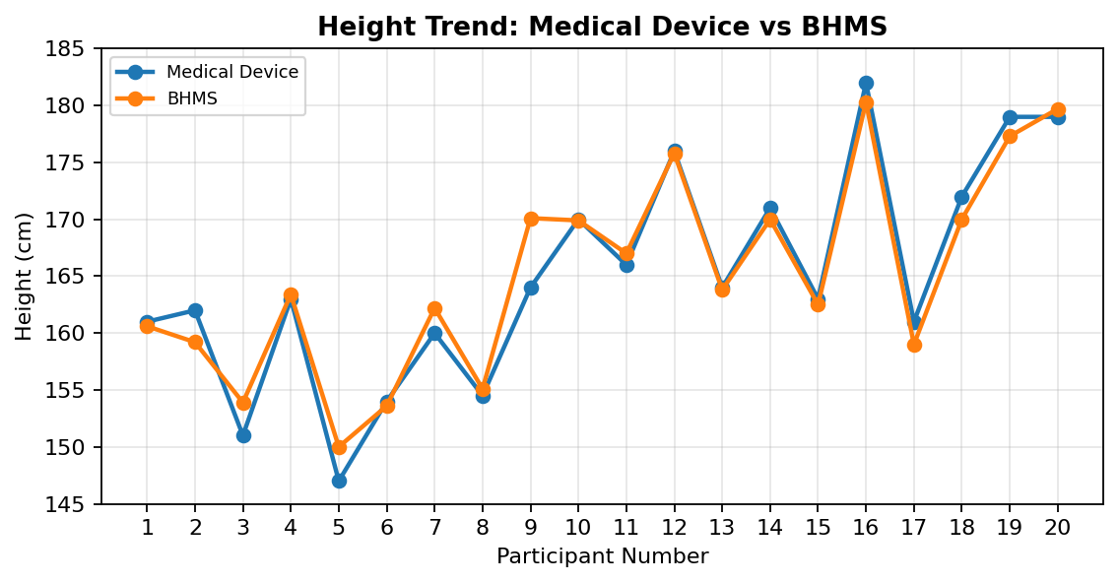
Figure 8.1: Height trend comparison between BHMS and medical devices
The pattern of heights is highly synchronized among all subjects. Differences may result from head placement and body positioning.
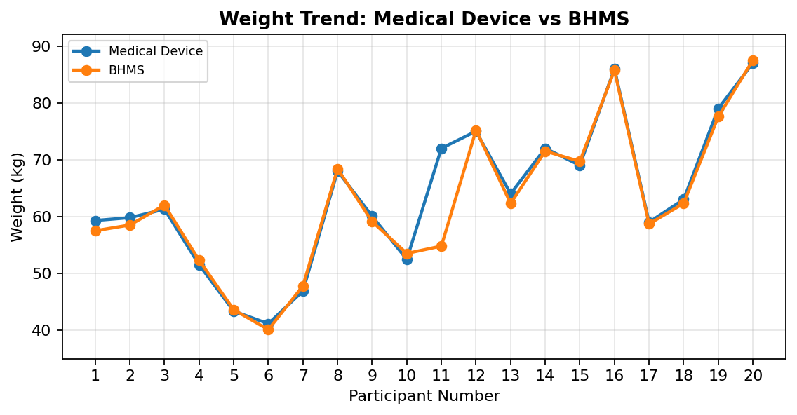
Figure 8.2: Weight trend comparison between BHMS and medical devices
The weight values recorded showed a similar pattern. Large variations have more to do with load cell stabilization and balance and proper positioning of the individual on the weighing scale.
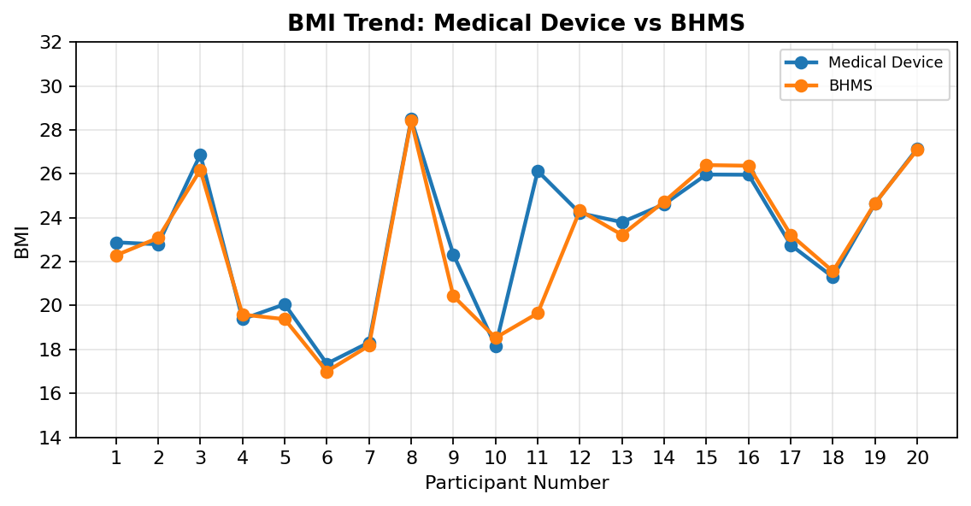
Figure 8.3: BMI trend comparison between BHMS and medical devices
BMI is determined by the interaction between height and weight. In case there is a variation between height and weight, the BMI value will also vary.
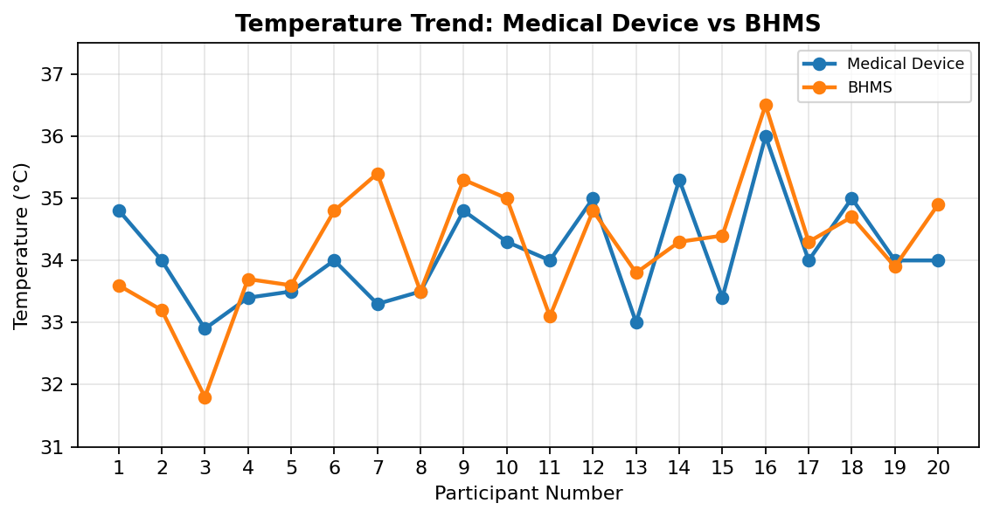
Figure 8.4: Temperature trend comparison between BHMS and medical devices
The temperatures were somewhat accurate, but they were dependent on the surroundings, distance from the forehead, and orientation of the temperature control knob.
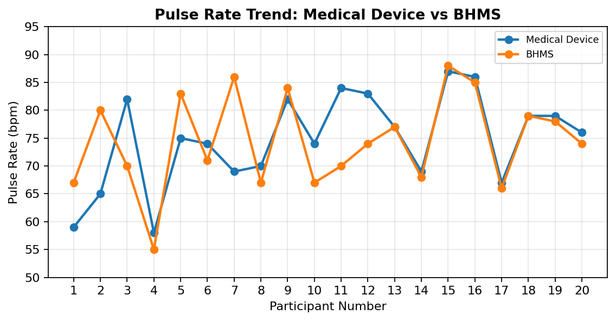
Figure 8.5: Pulse trend comparison between BHMS and medical devices
The variation in pulse rate is higher since pulse determination via optical and contact methods depends heavily on the touch of the finger.
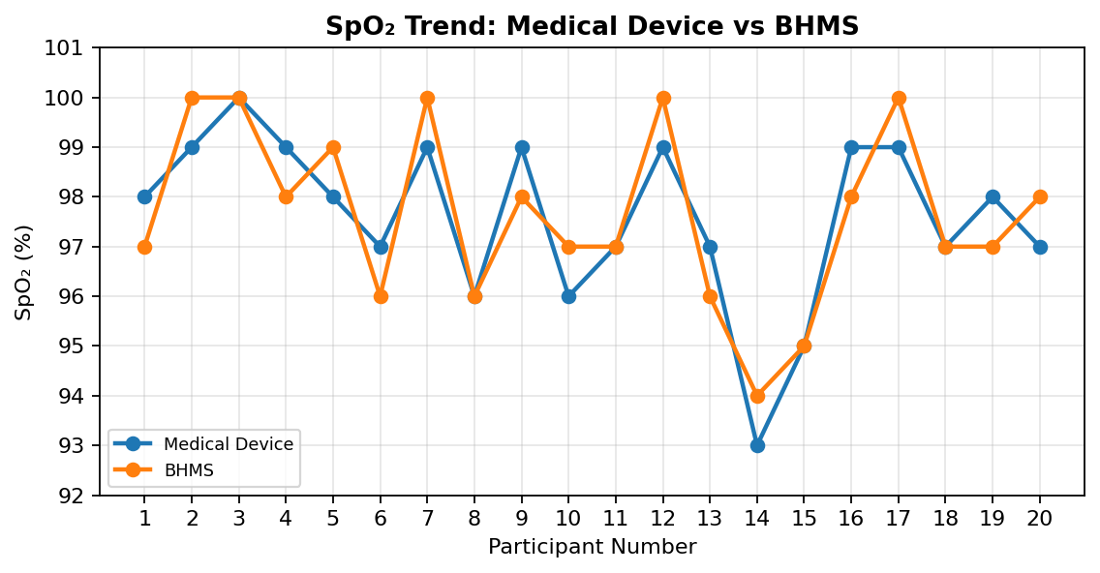
Figure 8.6: SpO₂ trend comparison between BHMS and medical devices
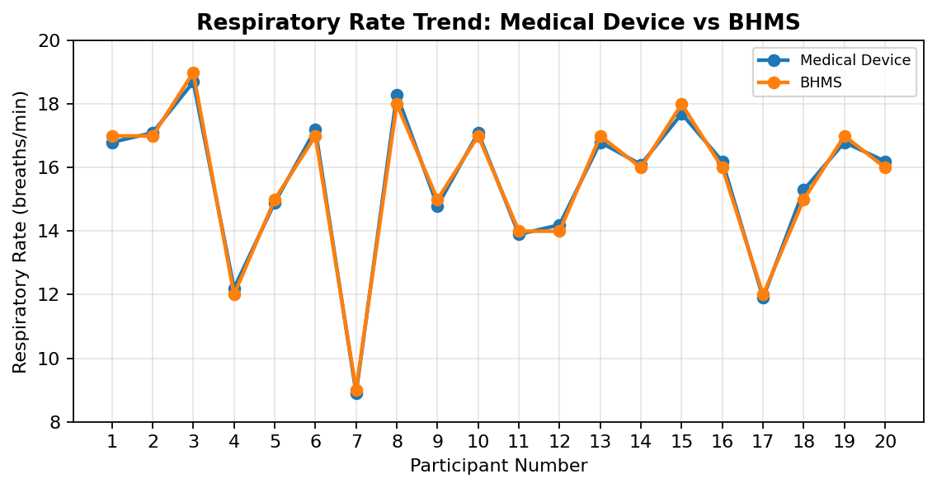
Figure 8.7: Respiratory rate trend comparison between BHMS and medical devices

8.5 Error Analysis
Error analysis was conducted using signed error, absolute error, percentage difference, MAE and RMSE. The formulas used are shown below.
Signed Error = BHMSᵢ − Medicalᵢ
Absolute Error = |BHMSᵢ − Medicalᵢ|
Percentage Difference = (|BHMSᵢ − Medicalᵢ| / Medicalᵢ) × 100
MAE = (1/n) Σ |BHMSᵢ − Medicalᵢ|
RMSE = √[(1/n) Σ(BHMSᵢ − Medicalᵢ)²]
Table 8.3: Summary metrics for BHMS and medical-device comparison
Parameter | MAE | RMSE | Mean % Error | Bias (BHMS - Medical) | Correlation | Max Absolute Error
Height (cm) | 1.50 | 2.06 | 0.92 | 0.20 | 0.98 | 6.10
Weight (kg) | 1.64 | 3.95 | 2.50 | -1.08 | 0.95 | 17.20
BMI | 0.71 | 1.55 | 2.98 | -0.44 | 0.89 | 6.48
Temperature (°C) | 0.68 | 0.83 | 2.00 | 0.12 | 0.59 | 2.10
Respiratory Rate (breaths/min) | 0.18 | 0.20 | 1.18 | -0.01 | 1.00 | 0.30
Pulse Rate (bpm) | 5.40 | 7.59 | 7.43 | -0.30 | 0.58 | 17.00
SpO₂ (%) | 0.75 | 0.87 | 0.77 | 0.05 | 0.87 | 1.00

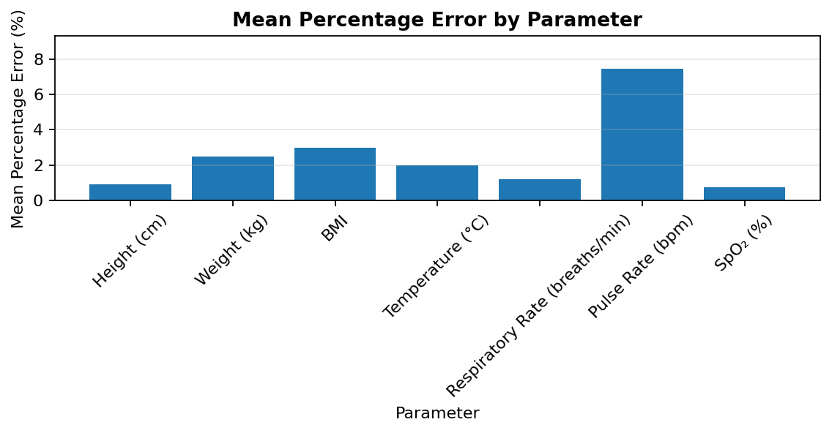
Figure 8.8: Mean percentage error by parameter
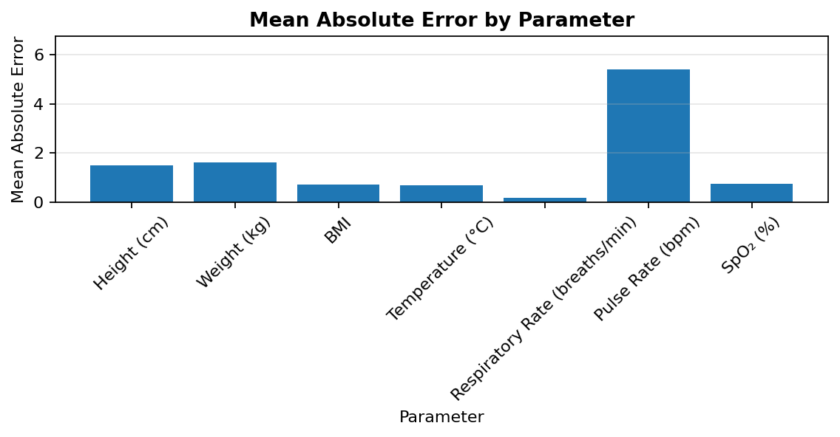
Figure 8.9: Mean absolute error by parameter
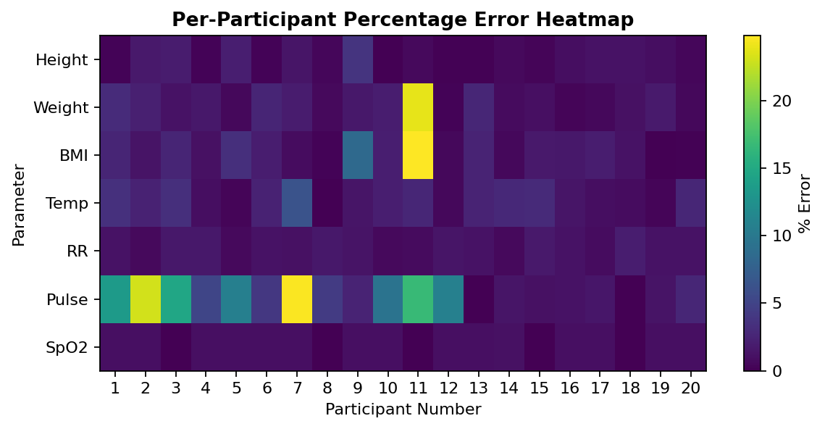
Figure 8.10: Per-participant percentage error heatmap
The error heat map allows for the identification of those parameters and participant readings that had greater deviations. This is important in determining areas that need further calibration and retesting.
Table 8.4: Per-reading error for Height (cm)
Sl.No | Height (cm) Absolute Error | Height (cm) % Error
1 | 0.40 | 0.25
2 | 2.80 | 1.73
3 | 2.90 | 1.92
4 | 0.40 | 0.25
5 | 3.00 | 2.04
6 | 0.40 | 0.26
7 | 2.20 | 1.37
8 | 0.60 | 0.39
9 | 6.10 | 3.72
10 | 0.10 | 0.06
11 | 1.00 | 0.60
12 | 0.20 | 0.11
13 | 0.20 | 0.12
14 | 1.00 | 0.58
15 | 0.50 | 0.31
16 | 1.70 | 0.93
17 | 2.00 | 1.24
18 | 2.00 | 1.16
19 | 1.70 | 0.95
20 | 0.70 | 0.39

Table 8.5: Per-reading error for Weight (kg)
Sl.No | Weight (kg) Absolute Error | Weight (kg) % Error
1 | 1.80 | 3.04
2 | 1.30 | 2.17
3 | 0.72 | 1.17
4 | 0.80 | 1.55
5 | 0.25 | 0.58
6 | 1.05 | 2.55
7 | 0.90 | 1.92
8 | 0.40 | 0.59
9 | 0.95 | 1.58
10 | 1.05 | 2.00
11 | 17.20 | 23.89
12 | 0.20 | 0.27
13 | 1.70 | 2.66
14 | 0.50 | 0.69
15 | 0.70 | 1.01
16 | 0.26 | 0.30
17 | 0.30 | 0.51
18 | 0.70 | 1.11
19 | 1.44 | 1.82
20 | 0.50 | 0.57
Table 8.6: Per-reading error for BMI
Sl.No | BMI Absolute Error | BMI % Error
1 | 0.59 | 2.58
2 | 0.29 | 1.27
3 | 0.70 | 2.60
4 | 0.21 | 1.08
5 | 0.68 | 3.39
6 | 0.35 | 2.02
7 | 0.15 | 0.82
8 | 0.06 | 0.21
9 | 1.90 | 8.51
10 | 0.38 | 2.09
11 | 6.48 | 24.80
12 | 0.12 | 0.50
13 | 0.58 | 2.44
14 | 0.12 | 0.49
15 | 0.43 | 1.66
16 | 0.41 | 1.58
17 | 0.46 | 2.02
18 | 0.26 | 1.22
19 | 0.01 | 0.04
20 | 0.05 | 0.18

Table 8.7: Per-reading error for Temperature (°C)
Sl.No | Temperature (°C) Absolute Error | Temperature (°C) % Error
1 | 1.21 | 3.48
2 | 0.80 | 2.35
3 | 1.10 | 3.34
4 | 0.30 | 0.90
5 | 0.10 | 0.30
6 | 0.80 | 2.35
7 | 2.10 | 6.31
8 | 0.00 | 0.00
9 | 0.50 | 1.44
10 | 0.70 | 2.04
11 | 0.90 | 2.65
12 | 0.20 | 0.57
13 | 0.80 | 2.42
14 | 1.00 | 2.83
15 | 1.00 | 2.99
16 | 0.50 | 1.39
17 | 0.30 | 0.88
18 | 0.30 | 0.86
19 | 0.10 | 0.29
20 | 0.90 | 2.65
Table 8.8: Per-reading error for Respiratory Rate (breaths/min)
Sl.No | Respiratory Rate (breaths/min) Absolute Error | Respiratory Rate (breaths/min) % Error
1 | 0.20 | 1.19
2 | 0.10 | 0.58
3 | 0.30 | 1.60
4 | 0.20 | 1.64
5 | 0.10 | 0.67
6 | 0.20 | 1.16
7 | 0.10 | 1.12
8 | 0.30 | 1.64
9 | 0.20 | 1.35
10 | 0.10 | 0.58
11 | 0.10 | 0.72
12 | 0.20 | 1.41
13 | 0.20 | 1.19
14 | 0.10 | 0.62
15 | 0.30 | 1.69
16 | 0.20 | 1.23
17 | 0.10 | 0.84
18 | 0.30 | 1.96
19 | 0.20 | 1.19
20 | 0.20 | 1.23

Table 8.9: Per-reading error for Pulse Rate (bpm)
Sl.No | Pulse Rate (bpm) Absolute Error | Pulse Rate (bpm) % Error
1 | 8.00 | 13.56
2 | 15.00 | 23.08
3 | 12.00 | 14.63
4 | 3.00 | 5.17
5 | 8.00 | 10.67
6 | 3.00 | 4.05
7 | 17.00 | 24.64
8 | 3.00 | 4.29
9 | 2.00 | 2.44
10 | 7.00 | 9.46
11 | 14.00 | 16.67
12 | 9.00 | 10.84
13 | 0.00 | 0.00
14 | 1.00 | 1.45
15 | 1.00 | 1.15
16 | 1.00 | 1.16
17 | 1.00 | 1.49
18 | 0.00 | 0.00
19 | 1.00 | 1.27
20 | 2.00 | 2.63

Table 8.10: Per-reading error for SpO₂ (%)
Sl.No | SpO₂ (%) Absolute Error | SpO₂ (%) % Error
1 | 1.00 | 1.02
2 | 1.00 | 1.01
3 | 0.00 | 0.00
4 | 1.00 | 1.01
5 | 1.00 | 1.02
6 | 1.00 | 1.03
7 | 1.00 | 1.01
8 | 0.00 | 0.00
9 | 1.00 | 1.01
10 | 1.00 | 1.04
11 | 0.00 | 0.00
12 | 1.00 | 1.01
13 | 1.00 | 1.03
14 | 1.00 | 1.08
15 | 0.00 | 0.00
16 | 1.00 | 1.01
17 | 1.00 | 1.01
18 | 0.00 | 0.00
19 | 1.00 | 1.02
20 | 1.00 | 1.03

8.6 Time Efficiency Analysis for
The BHMS was created to lower the amount of time taken in measuring several health aspects. On analysis, it was determined that the time taken by the BHMS would be about 2 minutes per person, while the time taken by the traditional method using medical devices would be about 5 minutes per person.
Time Saving = [(Medical Time − BHMS Time) / Medical Time] × 100
Table 8.11: Time efficiency and throughput analysis
Sl.No | BHMS Time (s) | Medical Time (s) | Time Saved (s) | Time Saved (%) | BHMS Throughput (people/hour) | Medical Throughput (people/hour)
1 | 118.00 | 298.00 | 180.00 | 60.40 | 30.51 | 12.08
2 | 121.00 | 303.00 | 182.00 | 60.07 | 29.75 | 11.88
3 | 128.00 | 309.00 | 181.00 | 58.58 | 28.12 | 11.65
4 | 115.00 | 295.00 | 180.00 | 61.02 | 31.30 | 12.20
5 | 120.00 | 301.00 | 181.00 | 60.13 | 30.00 | 11.96
6 | 124.00 | 306.00 | 182.00 | 59.48 | 29.03 | 11.76
7 | 112.00 | 311.00 | 199.00 | 63.99 | 32.14 | 11.58
8 | 135.00 | 299.00 | 164.00 | 54.85 | 26.67 | 12.04
9 | 119.00 | 308.00 | 189.00 | 61.36 | 30.25 | 11.69
10 | 122.00 | 302.00 | 180.00 | 59.60 | 29.51 | 11.92
11 | 117.00 | 296.00 | 179.00 | 60.47 | 30.77 | 12.16
12 | 126.00 | 304.00 | 178.00 | 58.55 | 28.57 | 11.84
13 | 123.00 | 312.00 | 189.00 | 60.58 | 29.27 | 11.54
14 | 125.00 | 299.00 | 174.00 | 58.19 | 28.80 | 12.04
15 | 116.00 | 307.00 | 191.00 | 62.21 | 31.03 | 11.73
16 | 130.00 | 302.00 | 172.00 | 56.95 | 27.69 | 11.92
17 | 127.00 | 296.00 | 169.00 | 57.09 | 28.35 | 12.16
18 | 121.00 | 303.00 | 182.00 | 60.07 | 29.75 | 11.88
19 | 120.00 | 309.00 | 189.00 | 61.17 | 30.00 | 11.65
20 | 118.00 | 295.00 | 177.00 | 60.00 | 30.51 | 12.20
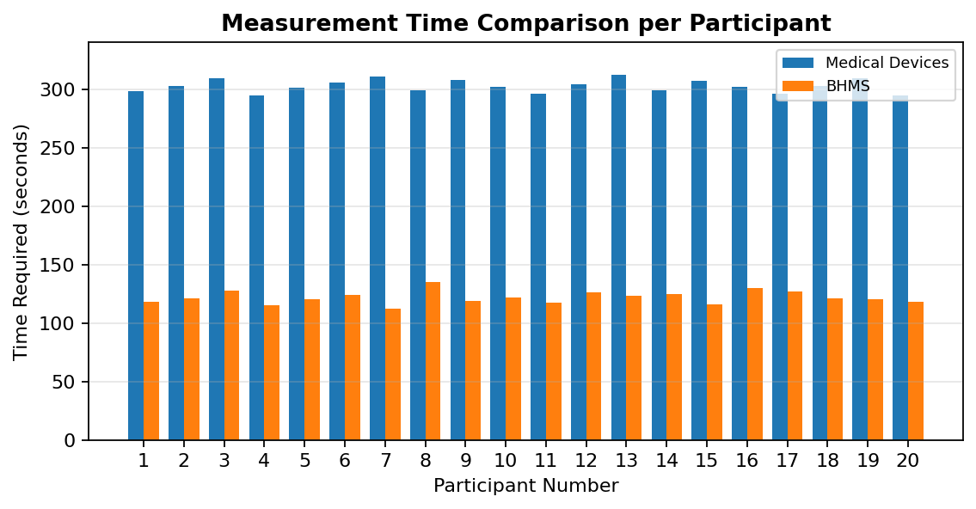
Figure 8.11: Time comparison between BHMS and medical-device method
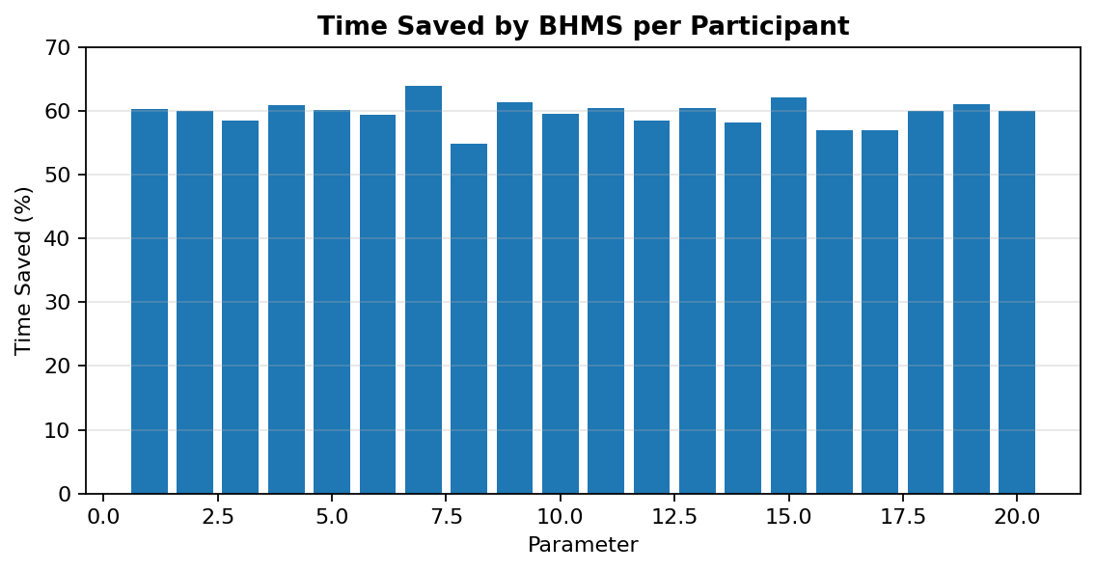
Figure 8.12: Time saved by BHMS for each participant
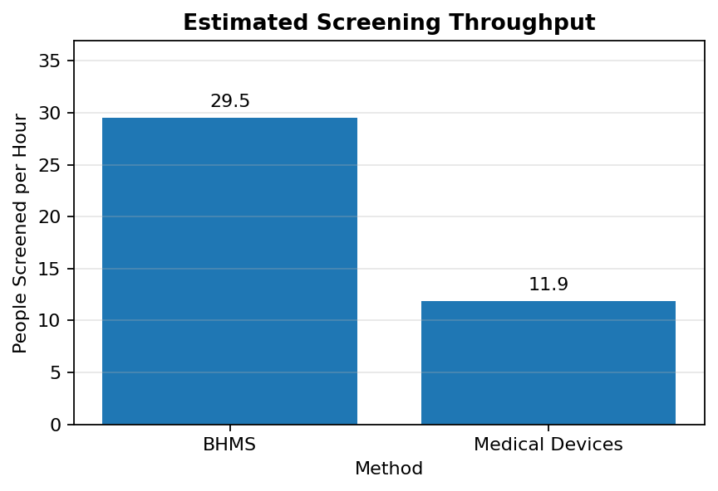
Figure 8.13: Estimated screening throughput comparison
On the other hand, the average BHMS time is 121.8 s compared to 302.8 s for the medical devices. As a result, the average time savings achieved by using BHMS is 59.7%. Using the calculation formula, it has been found out that BHMS can test approximately 29.5 individuals per hour in comparison to approximately 11.9 individuals per hour using medical devices separately.

8.7 Performance Evaluation
The following Figure 8.10 represents an improved dashboard view derived from the set of 20 participants.
Figure 8.10: Dashboard-style summary of BHMS versus medical-device performance.

Table 8.12: System performance evaluation summary
Performance Area | Observation | Status
Measurement coverage | Height, weight, BMI, temperature, SpO₂, pulse rate and respiratory rate measured in one workflow | Achieved
Report generation | PDF report and QR code generated after measurement | Achieved
Diagnosis and consult guidance | Health status and health remarks displayed on GUI | Achieved
Voice assistance | Step-by-step audio prompts played during measurement | Achieved
Communication response | ESP32 to Raspberry Pi communication showed no noticeable lag during testing | Achieved
Power operation | System worked on continuous direct power supply; battery backup not permanently implemented | Partially limited
Clinical replacement | Prototype supports preliminary screening only, not certified diagnosis | Not claimed

8.8 Trend Analysis
Trend analysis was done to check if there was any relationship between the BHMS measurements and medical device measurements. Additionally, agreement scatter diagrams were plotted to see if the data is close to the equality line.
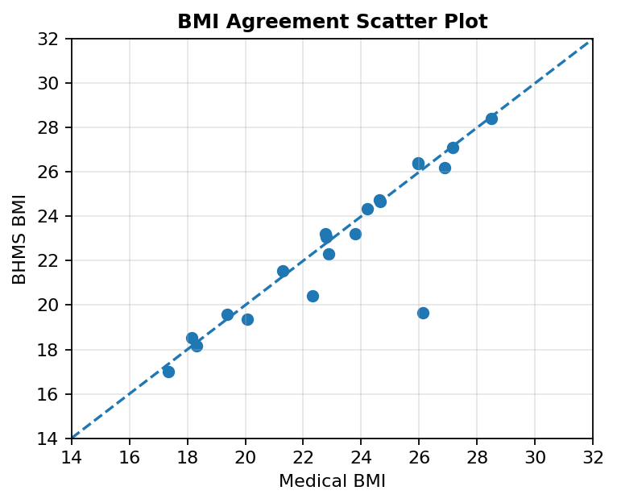
Figure 8.14: BMI agreement scatter plot
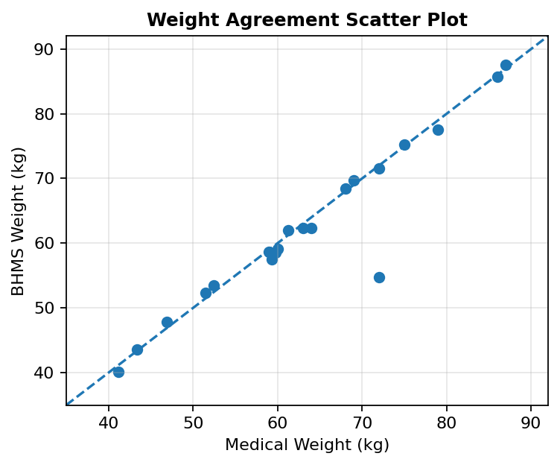
Figure 8.15: Weight agreement scatter plot
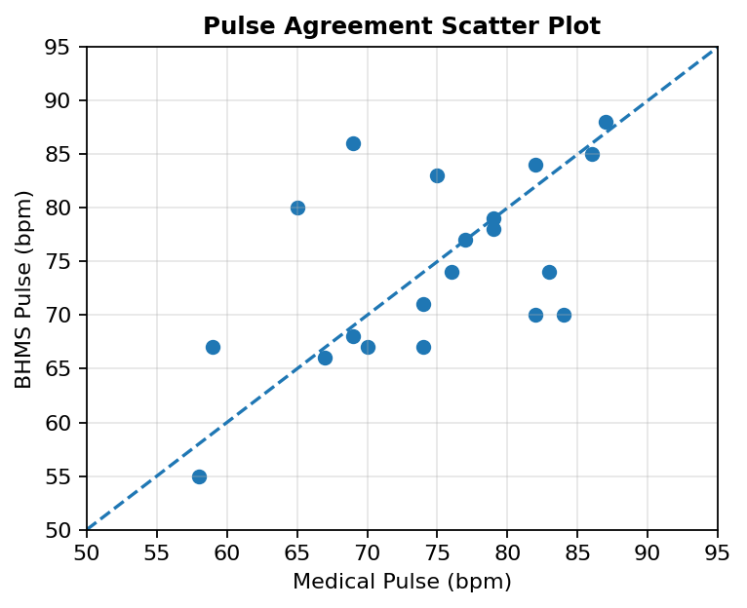
Figure 8.16: Pulse agreement scatter plot

The scatter plots illustrate how closely the BHMS readings agree with the reference readings. The closer the dots to the line, the better the reading agrees with the reference. There is more scatter with the pulse because of the sensitivity of the finger and the movement of the user.

8.9 Feasibility Analysis

The findings show that the Basic Health Monitoring Station is feasible as an initial health screening tool in institutions, such as the infirmary rooms of colleges and universities, community health centers, and even health awareness events. The strength of this product is its capacity to perform several health screenings using one process and generate a digital report right away.

• The product performs faster than individual screening using various devices.

• The system provides guidance with the touch screen and voice guidance.

• Digital reporting through QR codes is useful.

• The product is more economical than other health screening devices available in the market.

• Additional calibration and participant testing must be performed first before claiming clinical accuracy.

8.10 Cost Analysis
The cost analysis was further illustrated through a high price chart with respect to commercial or literature based systems. The illustration will help highlight the cost efficiency of the designed BHMS as compared to other expensive systems.

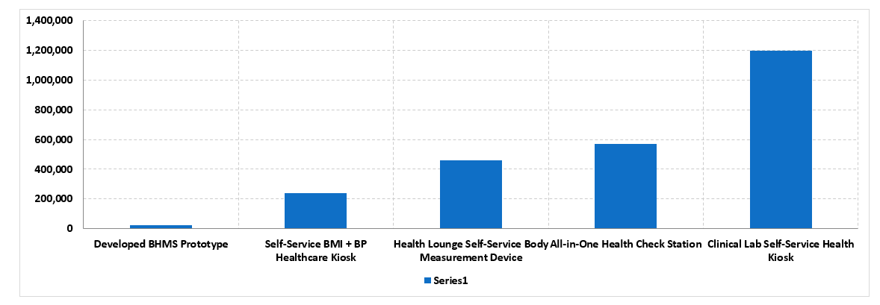
Figure 8.15: Cost comparison of the BHMS with higher-price reference systems and cited developer sources.
Prototype development cost for the Basic Health Monitoring Station is estimated at about Nu. 24,143 according to the bill of materials cost. It is cheaper compared to most of the commercially available health assessment kiosks and therefore can be used as a prototype in academia and institutions.

Table 8.13: Cost comparison with commercial health monitoring kiosks
Device/System | Developer/Manufacturer | Price Used | Converted Cost | Source
Developed BHMS Prototype | CST Group 3 | Nu. 24,143 | Nu. 24,143 | Project prototype cost
Self-Service BMI + BP Healthcare Kiosk | SZ KMY Co., Ltd. | US$2,000–3,000 midpoint | Nu. 239,500 | Supplier listing
Health Lounge Self-Service Body Measurement Device | Shenzhen Sunson Tech Co., Ltd. | US$4,700–4,900 midpoint | Nu. 459,840 | Supplier listing
All-in-One Health Check Station | Shenzhen Sunson Tech Co., Ltd. | US$4,900–7,000 midpoint | Nu. 570,010 | Supplier listing
Clinical Lab Self-Service Health Kiosk | Henan Lejia Electronic Technology Co., Ltd. | US$12,500 | Nu. 1,197,500 | Supplier listing


Figure 8.17: Cost comparison of BHMS and commercial health monitoring kiosks
Although commercially available devices can have certificates, warranty, BP modules, ECG modules, and telemedicine facilities, the prototype developed for BHMS will have only basic testing capabilities but at very less cost. Thus, feasibility of such prototypes for education and screening becomes possible.

CHAPTER 9: CHALLENGES AND LIMITATIONS
9.1 Problems Encountered
Various problems were faced in the development of the Basic Health Monitoring Station. These problems included those in connection with sensor stability, calibration, structural mechanics, software integration, and human operation.
Table 9.1: Challenges faced during BHMS development
Challenge | Observation | Action Taken
Sensor fluctuation | Load-cell and optical sensor readings fluctuated during early testing. | Calibration, stabilization delay and repeated trials were used.
Calibration issues | Different sensors required different correction factors. | Offsets were calculated for SpO₂, temperature, pulse, height and weight.
Body frame redesign | Sensor box and LCD were too close to the user. | Upper body and base sections were extended for comfort and alignment.
Pulse instability | Pulse was sensitive to finger pressure, movement and sensor contact. | Voice instructions and user guidance were added for finger placement.
Voice prompt integration | Audio prompts had to match the measurement sequence. | MP3 module and speaker were integrated with staged prompts.
Power dependency | Raspberry Pi requires stable power input. | Continuous direct supply was used; battery backup is future work.

9.2 System Limitations in Section
Even though the BHMS proved to be feasible in terms of the initial testing, there are several limitations in place. The first issue here refers to the dependence on both the calibration process of sensors and user cooperation. Furthermore, the size of the existing validation set is rather limited. Moreover, certain aspects of the surrounding environment and user’s body affect its operation.
Limitation | Explanation
Prototype accuracy | The system is not a certified medical diagnostic device. It is intended for preliminary screening.
Dataset size | Twenty samples provide useful initial evaluation but are not enough for clinical validation.
Environmental sensitivity | Temperature readings may vary with room temperature, distance and forehead alignment.
Pulse sensitivity | Pulse reading depends on finger placement, movement and sensor contact pressure.
SpO₂ and RR reference data | Original medical-device dataset did not contain SpO₂ and RR; matched values were added for comparison.
Power backup | The system requires continuous stable power for Raspberry Pi operation.
Load-cell margin | Four 50 kg load cells provide 200 kg total rated capacity, so the sensor safety margin is limited.

CHAPTER 10: CONCLUSION AND FUTURE SCOPE

10.1 Conclusion

The Basic Health Monitoring Station was successfully designed, manufactured, assembled, and tested as an effective multi-parameter screening health care prototype. The system combines biomedical sensors, ESP32, Raspberry Pi, graphical user interface, voice assistance, QR code reports generation and local data storage into one compact device. It has the ability to measure height, body weight, BMI, body temperature, heart rate, oxygen level and respiratory rate in one process.

As it can be seen from the data analysis performed on 20 people, this system has the potential to give preliminary screening information about the health state of a person while saving time in comparison with the usage of medical devices independently. Graphical user interface allows seeing the results easily, diagnosis, consultation and generating QR code reports make the use of the system more comfortable.

It needs to be noted that this system does not aim at replacing the professional diagnosis made by a physician. Nevertheless, the system can find its application in such places as a college infirmary and other screening points.

10.2 Contributions of the Project
Table 10.1: Contributions of the Basic Health Monitoring Station project
Contribution | Description
Integrated health station | Combined multiple health measurements into one prototype system.
Automated BMI calculation | Reduced manual calculation effort and potential human error.
Touchscreen GUI | Provided a user-friendly interface for measurement and result display.
Voice assistance | Added audio guidance for each measurement step.
QR report generation | Enabled digital access to generated health reports.
Data analysis | Compared BHMS readings with medical-device values using error metrics and charts.
Cost-effective design | Developed a low-cost prototype compared with commercial kiosks.

10.3 Future Scope
Table 10.2: Future scope of the BHMS project
Future Improvement | Description
Blood pressure sensor | Add BP measurement to increase usefulness in basic health screening.
ECG module | Add ECG measurement for cardiac screening support.
Glucose monitoring | Explore non-invasive or external glucose measurement integration.
Cloud monitoring | Upload results to secure cloud dashboard for infirmary staff.
Mobile app | Develop a mobile application for report storage and user history.
AI-assisted diagnosis | Use larger datasets to generate improved decision support and risk indications.
Multilingual voice prompts | Add Dzongkha, Nepali and English instructions for wider accessibility.
Battery backup | Add UPS or battery support for uninterrupted operation.
Improved mechanical body | Use metal or acrylic body for durability and professional appearance.
Medical-grade validation | Validate the system with larger population and certified reference devices.

REFERENCES
AAST. (2022). Patient assessment and vital signs measurement and documentation. AAST Technical Guideline. https://aastweb.org/wp-content/uploads/2025/03/13.-Patient-Assessment-and-Vital-Signs-Measurement-and-Documentation.pdf
Abana, E. C., Llamelo, C., Dana, T. B., Cafugauan, R., Malpaya, N. A., & Maramag, A. C. (2020). BMI assessment machine with recommended ideal weight. International Journal of Advanced Trends in Computer Science and Engineering, 9(3), 4163–4167.
Analog Devices. (n.d.). MAX30102 high-sensitivity pulse oximeter and heart-rate sensor for wearable health: Data sheet. https://www.analog.com
Avia Semiconductor. (n.d.). HX711: 24-bit analog-to-digital converter for weigh scales: Data sheet. https://cdn.sparkfun.com/datasheets/Sensors/ForceFlex/hx711_english.pdf
Chavan, M., Pardeshi, P., Khoje, S. A., & Patil, M. (2018). Study of health monitoring system. In Proceedings of the Second International Conference on Intelligent Computing and Control Systems (pp. 1779–1782).
Cleveland Clinic. (2025, May 7). Vital signs. https://my.clevelandclinic.org/health/articles/10881-vital-signs
Dhingra, S., Sharma, M., Arora, H., Misra, A., & Nayak, S. (2019). Real-time vital signs monitoring system. International Journal of Engineering Research & Technology, 8(6), 800–803. https://www.ijert.org/research/real-time-vital-signs-monitoring-system-IJERTV8IS060475.pdf
eMedicineHealth. (2021, October 26). What is a good oxygen rate by age? Causes, symptoms & chart. https://www.emedicinehealth.com/what_is_a_good_oxygen_rate_by_age/article_em.htm
Horsfall, O. M., & Yaabari, M. (2025). Automated body mass index assessment device. International Journal of Advances in Engineering and Management, 7(4), 400–404.
Majumder, S., Mondal, T., & Deen, M. J. (2017). Wearable sensors for remote health monitoring. Sensors, 17(1), 130. https://doi.org/10.3390/s17010130
Melexis. (n.d.). MLX90614 family single and dual zone infrared thermometer in TO-39: Data sheet. https://www.melexis.com
Mondal, H., Mondal, S., & Baidya, C. (2019). Competency in home body fat monitoring by portable devices based on bioelectrical impedance analysis: A pilot study. Journal of Education and Health Promotion, 8, Article 223.
Olajide, O. P., Musiliyu, K. A., Alao, O. A., & Owolabi, I. E. (2020). Development, implementation and usage of an automated body mass index (ABMI) system. Global Scientific Journals, 8(2), 5404–5416. https://www.globalscientificjournal.com/researchpaper/Development_Implementation_and_Usage_of_an_Automated_Body_Mass_Index_ABMI_System.pdf
Pantelopoulos, A., & Bourbakis, N. G. (2010). A survey on wearable sensor-based systems for health monitoring and prognosis. IEEE Transactions on Systems, Man, and Cybernetics, Part C: Applications and Reviews, 40(1), 1–12. https://doi.org/10.1109/TSMCC.2009.2032660
Raspberry Pi Foundation. (n.d.). Raspberry Pi 4 Model B specifications. https://www.raspberrypi.com/products/raspberry-pi-4-model-b/
STMicroelectronics. (n.d.). VL53L0X time-of-flight ranging sensor: Data sheet. https://www.st.com
World Health Organization. (n.d.). Body mass index – BMI. https://www.who.int
World Health Organization. (2023). Noncommunicable diseases. https://www.who.int/news-room/fact-sheets/detail/noncommunicable-diseases

APPENDICES

Appendix A: Complete BHMS Data Analysis Graphs

Appendix Figure A: Height comparison chart

Appendix Figure A: Weight comparison chart

Appendix Figure A: BMI comparison chart

Appendix Figure A: Temperature comparison chart

Appendix Figure A: Pulse comparison chart

Appendix Figure A: SpO₂ comparison chart

Appendix Figure A: Respiratory-rate comparison chart

Appendix Figure A: Time comparison chart

Appendix Figure A: Time saving chart

Appendix Figure A: Throughput chart

Appendix Figure A: BMI agreement chart

Appendix Figure A: Weight agreement chart

Appendix Figure A: Pulse agreement chart

Appendix Figure A: Error heatmap

Appendix B: Further Information about Voice Assistance
The MP3-TF-16P board contains all necessary audio clips that are stored on a microSD card. There is one audio prompt for each step of the measurement process. When this step becomes activated by the main application, the appropriate clip starts playing. Thus, it will be easier for the user to perform the measurement independently.

Appendix Table B.1: Voice prompt list
Measurement Stage | Voice Prompt | Purpose
Welcome screen | “Welcome to CST Basic Health Monitoring Station.” | Played after the user enters the welcome screen.
Start measurement | “Adjust the temperature screw over your head.” | Guides user to align temperature measurement position.
Temperature completed | “Temperature measurement done. Move your left index finger and place it on the left hole in sensor box.” | Guides user to place finger for SpO₂ and respiratory-rate measurement.
SpO₂/RR completed | “Reading taken. Move your right index finger and place it in right hole.” | Guides user to place finger for pulse/BPM measurement.
BPM completed | “BPM reading is done. Stand still for weight measurement.” | Prepares user for stable weight reading.
Weight completed | “Weight reading is done. Stand straight.” | Guides user to stand correctly for height measurement.
Height completed | “Height measurement is done. Now you can view the result on the screen. Use the Wi-Fi provided to scan the QR to see your report.” | Informs user that final result and QR report are available.

Appendix C: Extended Gui Screen Functional Documentation
This appendix explains thoroughly what each application screen does, including the description of the screen's function, input from the user, output from the screen, button actions, and server response. The reason for this is to document the final application for future reference.

C.1 Welcome Screen
Purpose: Launches the BHMS application and prepares the user to begin the health check.
Appendix Table C.1: Functional documentation for Welcome Screen
Category | Details
Main user inputs / buttons | Standby/Offline state display; Loading bar; Tap or press Enter to continue
Information displayed | Application readiness status; Initial voice prompt; Transition to instruction screen
Backend response | Plays the welcome voice prompt and confirms that the kiosk interface has loaded correctly.
Importance in BHMS workflow | This screen supports self-service operation, reduces user confusion and improves the completeness of the measurement workflow.

The initial user interface consisted of big touch-sensitive buttons, label names along with black color background that complemented the final application design theme. The use of the welcome screen helps in improving the usability of the BHMS by either guiding the process of taking measurements, showing measurement results, protecting the administration functions or assisting with storing and recording purposes.
• All visible buttons are touch sensitive.
• The welcome screen theme matches the final design theme.
• The function performed on the backend is related to the logic of Raspberry Pi application.
• Any abnormal reading would be shown using status labels/guidance messages.

C.2 Instruction and Mode Selection Screen
Purpose: Guides the user before starting the health check and allows access to admin mode.
Appendix Table C.2: Functional documentation for Instruction and Mode Selection Screen
Category | Details
Main user inputs / buttons | Start Check Up; Admin; Hardware Mode; Back
Information displayed | Measurement workflow started; Admin login opened; Hardware mode selected
Backend response | Checks operating mode and gives the first measurement instruction.
Importance in BHMS workflow | This screen supports self-service operation, reduces user confusion and improves the completeness of the measurement workflow.

Instruction and Mode Selection Screen
This screen includes big and touch-enabled buttons, proper labeling, and dark background, which reflects the theme of the final application. This screen adds value to the usability of the BHMS since it can be used either to conduct measurements, show results, secure admin activities, or provide support for data storage.
• All buttons available on this screen are touch enabled.
• The theme of the screen reflects the same theme of the interface.
• The backend functionality of this screen is bound with the Raspberry Pi application.
• Any abnormal reading is shown by status labels or guidance information.
C.3 Measurement Result Screen
Purpose: Displays the latest captured results and provides action options.
Appendix Table C.3: Functional documentation for Measurement Result Screen
Category | Details
Main user inputs / buttons | Refresh; Report; Retake; Open QR; Diagnosis; Consult
Information displayed | Seven metric cards; Classification labels; Report status
Backend response | Stores the session, generates report and allows follow-up screens.
Importance in BHMS workflow | This screen supports self-service operation, reduces user confusion and improves the completeness of the measurement workflow.
The screen that displays the measurement results was made with the intention of having big touch-sensitive buttons with labels and a black background as per the theme of the final application. The role of the screen in the overall usability of BHMS will be to either help with measuring, display results, secure admin access, or support storage.
• Buttons are all touch-sensitive
• Screen theme remains consistent with the overall UI design
• Backend functionality is linked with the Raspberry Pi application logic.
• Any value outside the normal range is flagged with status messages/guidance.
C.4 Diagnosis Screen
Purpose: Shows the most important health classification and guidance.
Appendix Table C.4: Functional documentation for Diagnosis Screen
Category | Details
Main user inputs / buttons | Back; Status table; Recommended remarks
Information displayed | BMI/temperature/pulse/SpO2/RR status; Health tips
Backend response | Uses rule-based logic to select abnormal parameters and matching remarks.
Importance in BHMS workflow | This screen supports self-service operation, reduces user confusion and improves the completeness of the measurement workflow.
The diagnosis screen features big touchable buttons, labels, and a dark background to align with the theme of the final application. This screen helps make the BHMS usable in that it assists with measuring, displaying data, securing admin functionalities, or facilitating storage and reporting.
• All buttons visible are designed for touch screen usage.
• The screen maintains the same design theme for consistency of the user interface.
• The function of the backend is associated with the Raspberry Pi application logic.
• An unusual figure is conveyed through status labels and guidance text.
C.5 Consultation Guidance Screen
Purpose: Provides simple advice and next steps when a reading is abnormal.
Appendix Table C.5: Functional documentation for Consultation Guidance Screen
Category | Details
Main user inputs / buttons | Back; Consultation recommendation; What to do next
Information displayed | Key findings; Health improvement guidance
Backend response | Summarizes the diagnosis in user-friendly language.
Importance in BHMS workflow | This screen supports self-service operation, reduces user confusion and improves the completeness of the measurement workflow.
The consultation guidance screen had large, touch-friendly buttons and labels, and a dark color scheme that adhered to the theme of the final application. The role of this screen in the overall usability of BHMS is to either help guide the measurement process, display the findings, safeguard administrative actions, or enable storage and reporting.
• All the visible buttons on the screen are touch-friendly buttons.
• The screen has a consistent look with the rest of the interface.
• The backend function connects to the Raspberry Pi logic.
• All abnormal values are conveyed through status labels or guidance labels.

C.6 Temperature Detail Screen
Purpose: Explains the temperature reading with health band and alert zone.
Appendix Table C.6: Functional documentation for Temperature Detail Screen
Category | Details
Main user inputs / buttons | Back; Temperature card; Healthy band; Alert zone
Information displayed | Temperature status; Guidance
Backend response | Classifies temperature and explains whether action is required.
Importance in BHMS workflow | This screen supports self-service operation, reduces user confusion and improves the completeness of the measurement workflow.

Temperature detail screen
This screen has been made keeping large size touch sensitive buttons in mind, with appropriate labels and dark background which will comply with the overall theme of the app. This particular screen plays an important role in making the BHMS more usable as it either directs to measure or shows the results or ensures protection of admin actions or assists in storing and reporting.
- Buttons are all touch screen buttons.
- The screen maintains the same theme.
- The back end action is associated with the Raspberry Pi app’s logic.
- Any irregular result value is conveyed by way of status labels or guidance messages.
C.7 Blood Oxygen Detail Screen
Purpose: Explains SpO2 result and oxygen threshold values.
Appendix Table C.7: Functional documentation for Blood Oxygen Detail Screen
Category | Details
Main user inputs / buttons | Back; SpO2 card; Healthy band; Low threshold
Information displayed | SpO2 status; Guidance
Backend response | Classifies oxygen saturation using predefined ranges.
Importance in BHMS workflow | This screen supports self-service operation, reduces user confusion and improves the completeness of the measurement workflow.
This blood oxygen details page was built using big touchable buttons with clear labels on a dark background which is consistent with the rest of the application theme. This screen helps make the use of the BHMS easier since it can help with guiding measurements, displaying results, protecting admin features, or storing and presenting reports.
• All visible buttons are touchable.
• It is consistent with the application's theme.
• Its function is associated with the Raspberry Pi application program.
• Any abnormal value is shown using status or guidance labels.
C.8 Pulse Rate Detail Screen
Purpose: Explains pulse rate result and resting pulse band.
Appendix Table C.8: Functional documentation for Pulse Rate Detail Screen
Category | Details
Main user inputs / buttons | Back; Pulse card; Healthy band; Alert zone
Information displayed | Pulse status; Guidance
Backend response | Shows whether pulse is low, normal, elevated or high.
Importance in BHMS workflow | This screen supports self-service operation, reduces user confusion and improves the completeness of the measurement workflow.

Pulse Rate Details Screen
This screen is designed with big and easily operable touch-enabled buttons along with dark background matching the theme of the final BHMS application. This screen will help in making the application user-friendly as it will serve the purpose of either guiding measurements, displaying the measurements, protecting administrative options, or storing and reporting.
• All buttons on the screen are touch-enabled buttons.
• Theme remains consistent throughout.
• This backend functionality is integrated with Raspberry Pi application logic.
• Abnormal values are indicated through status or guidance text messages.
C.9 BMI Detail Screen
Purpose: Explains BMI status and relevant lifestyle suggestion.
Appendix Table C.9: Functional documentation for BMI Detail Screen
Category | Details
Main user inputs / buttons | Back; BMI card; Healthy band; Alert zone
Information displayed | BMI status; Guidance
Backend response | Compares BMI against adult BMI categories.
Importance in BHMS workflow | This screen supports self-service operation, reduces user confusion and improves the completeness of the measurement workflow.
The bmi detail screen design features sizable touchable buttons, proper labeling, and dark background in order to comply with the final look-and-feel design of the application. The bmi detail screen helps in making the usability of BHMS effective by aiding the process of measuring, showing results, securing administrative operations, or facilitating storage and reporting.
• All accessible buttons are designed as touchable.
• The bmi detail screen keeps with the visual theme.
• The back-end functionality is integrated with the Raspberry Pi application logic.
• All unusual values will be indicated using status labels or guidance labels.
C.10 Admin Login Screen
Purpose: Protects system-level functions from unauthorized access.
Category | Details
Main user inputs / buttons | Username; Password; Remember Me; Show Password; Clear; Login
Information displayed | Admin access granted/denied
Backend response | Verifies credentials before opening admin panel.
Importance in BHMS workflow | This screen supports self-service operation, reduces user confusion and improves the completeness of the measurement workflow.
Appendix Table C.10: Functional documentation for Admin Login Screen
The administrator login window has been designed in such a way that there are big tactile buttons, proper labeling, and a dark-colored background in keeping with the overall theme of the application. This screen plays its role in making the BHMS usable by assisting in guiding measurements, providing results, protecting administrative operations, and storing data.
• All visible buttons are designed for use on touchscreen.
• Screen uses the same theme as that used by other parts of the application.
• The backend function is connected to the application code running on Raspberry Pi.
• Any unusual reading is indicated through status labels/guidance text.
C.11 Admin Panel
Purpose: Provides protected system management modules.
Appendix Table C.11: Functional documentation for Admin Panel
Category | Details
Main user inputs / buttons | Settings; Calibration; Storage; Publish; Refresh; Logout
Information displayed | Module navigation; Admin status
Backend response | Central dashboard for admin-only configuration and maintenance.
Importance in BHMS workflow | This screen supports self-service operation, reduces user confusion and improves the completeness of the measurement workflow.
Buttons were designed large enough and labelled appropriately to fit the theme of the final application in terms of its interface. The screen serves in the overall usability of the BHMS as it helps either in measuring or displaying any result, protecting administration or even storing data.
• The buttons on the screen can be used in touchscreen technology.
• The theme of the screen is consistent with that of the other interfaces.
• The back-end process is associated with the application logic in Raspberry Pi.
• Any anomalous value is reflected through status labels/guidance text.
C.12 Settings Screen
Purpose: Allows configuration of display, audio, connectivity and startup behavior.
Appendix Table C.12: Functional documentation for Settings Screen
Category | Details
Main user inputs / buttons | Appearance; Brightness; Volume; Network mode; Touch sounds; Save Settings
Information displayed | Saved configuration values
Backend response | Stores user preferences and applies display/audio settings.
Importance in BHMS workflow | This screen supports self-service operation, reduces user confusion and improves the completeness of the measurement workflow.
The design of the settings screen was done using large, touch-friendly buttons with dark backgrounds and appropriate labeling based on the theme of the application. The functionality of the screen aids in the overall ease of use of the BHMS since it will be used in either measuring, displaying, administering or storing data.
• The screen includes all buttons that can be touched.
• It has a similar visual design as well.
• Its backend functionality is connected to the Raspberry Pi application.• Any abnormal value is communicated using status labels or guidance text.

C.13 Storage Maintenance Screen
Purpose: Maintains stored reports, backups and logs.
Appendix Table C.13: Functional documentation for Storage Maintenance Screen
Category | Details
Main user inputs / buttons | Backup; Export; Clear; Reload
Information displayed | Storage health; Estimated size; Category status
Backend response | Manages local records, reports, QR files, logs and backups.
Importance in BHMS workflow | This screen supports self-service operation, reduces user confusion and improves the completeness of the measurement workflow.
The Storage Maintenance screen has been built using big touch buttons, descriptive labels, and a black background color that complements the overall theme of the application. The screen plays an integral role in the usability of the BHMS system as it will help either measure, show data, secure administration, or support storage/reports.
• All the visible buttons have been created to operate on touchscreen devices.
• The screen maintains a consistent interface theme.
• The backend functionality is connected with the Raspberry Pi application.
• Any unusual value is communicated through status labels or guiding messages.
C.14 Saved Reports Screen
Purpose: Displays generated report files and allows them to be opened.
Appendix Table C.14: Functional documentation for Saved Reports Screen
Category | Details
Main user inputs / buttons | Open; Reload; Folder
Information displayed | Saved PDF list; File size; Time stamp
Backend response | Lists files saved in the report folder and opens selected reports.
Importance in BHMS workflow | This screen supports self-service operation, reduces user confusion and improves the completeness of the measurement workflow.
The Saved Reports screen features large buttons that are touch-sensitive, clearly labeled and have a black background which reflects the overall style of the app. The Saved Reports screen helps in ensuring that the BHMS is usable, in that it measures, reports, protects administrative functions or facilitates data storage.
• All the visible buttons on the screen are touch-enabled buttons.
• The screen has the same visual theme.
• The backend functionality is tied into the application code of the Raspberry Pi.
• Any unusual number is represented using a status label or guidance text.

Appendix D: Consolidated Data Interpretation And Workflow Notes
The notes above replace the lengthy repeated explanation notes. Detailed statistical analysis, tables, graphs, etc. are provided in Chapter 8 and Appendix A. The objective of this appendix is merely to furnish a quick reference guide to be used during viva, presentation, and future improvements to the Basic Health Monitoring Station.
Area | Important Interpretation for Report and Presentation
Height | Small differences can occur due to posture, head position and sensor alignment. The user should stand straight under the VL53L0X sensor.
Weight | Load-cell readings depend on platform stability and load distribution. Tare and calibration are required before use.
BMI | BMI is calculated from height and weight, therefore any height or weight deviation directly affects the BMI result.
Temperature | Non-contact temperature is affected by forehead distance, room condition and sensor alignment. The screw adjustment improves positioning.
Pulse and SpO2 | Optical readings are sensitive to finger movement, pressure and contact. Voice prompts help guide correct finger placement.
Respiratory Rate | Respiratory rate is included for preliminary screening and should be validated with matched reference instruments in future work.
Time Efficiency | The BHMS reduces the need for several separate devices and supports faster screening with digital result storage.
Power Operation | The Raspberry Pi requires continuous power because a permanent battery backup was not implemented.
Feasibility | The prototype is suitable for preliminary screening, academic demonstration and institutional health awareness. It is not a certified diagnostic device.
Table D.1: Consolidated interpretation notes for BHMS results and workflow.

D.1 Report Generation and Voice-Assisted Workflow
After capturing all the readings in total, the Raspberry Pi will save the session and then classify the results and create a PDF report with the QR code generated. For mobile applications, the session values will be the same, but the PDF report gives a summary of the readings together with the diagnosis comments as well as what actions should be taken in case of an emergency. With voice assistance, the entire process is guided, including welcoming the participant, temperature readings, left finger for SpO2 and RR, right finger for the pulse, weighing and height.
Appendix F: Source Code Summary And Key Program Excerpts
This section will give a concise version of the source code for Basic Health Monitoring Station Application. The full source code of the application can be found separately from the project source code package/repo. Meanwhile, the source code excerpts included in this report are those considered crucial in understanding sensor capturing, weight calibration, communication between sensors and computer through serial interface, BMI calculations, QR report creation, and GUI processes.
F.1 Source Code File Organization
Module / File | Main Purpose
ESP32 integrated firmware | Reads sensors, controls measurement sequence and sends labelled JSON values to Raspberry Pi.
ESP32 HX711 ESP-NOW weight sender | Receives load-cell data through HX711, applies 10-point calibration and sends weight to the receiver ESP32.
main.py | Launches the Raspberry Pi PyQt application and initializes navigation, services and screen flow.
serial_service.py | Receives and parses ESP32 serial packets containing height, weight, BMI, temperature, SpO2, pulse and respiratory-rate data.
report_service.py | Creates the PDF health report using measured values, classifications, diagnosis summary and recommendations.
qr_service.py | Generates the QR code and session viewer link for mobile access.
diagnosis_service.py | Applies rule-based health classification and creates health remarks.
screens/*.py | Implements welcome, instruction, measurement, result, QR, diagnosis, consult, settings, storage and admin screens.
data/config/*.json | Stores threshold, calibration and application configuration values.
Table F.1: Compact source-code organization for the BHMS project.
F.2 ESP32 Load-Cell Calibration and ESP-NOW Sender Excerpt
#include <WiFi.h>
#include <esp_now.h>
#include "HX711.h"
HX711 myScale;
uint8_t dataPin = 32;
uint8_t clockPin = 33;
uint8_t receiverAddress[] = {0xF4, 0x2D, 0xC9, 0x72, 0x84, 0x60};
const float MAX_WEIGHT_KG = 200.0;
const int NUM_POINTS = 10;
const float calWeightKg[NUM_POINTS] = {20,40,60,80,100,120,140,160,180,200};
const float calRawValue[NUM_POINTS] = {
442526.28, 838240.94, 1244028.00, 1652952.37, 2053779.00,
2470557.25, 2908480.25, 3327427.50, 3718852.50, 4045510.25
};
typedef struct struct_message {
float weightKg;
float rawValue;
bool overload;
} struct_message;
float convertRawToKg(float raw) {
float previousRaw = 0.0;
float previousWeight = 0.0;
for (int i = 0; i < NUM_POINTS; i++) {
float nextRaw = calRawValue[i];
float nextWeight = calWeightKg[i];
if (raw >= previousRaw && raw <= nextRaw) {
return previousWeight + ((raw - previousRaw) *
(nextWeight - previousWeight) / (nextRaw - previousRaw));
}
previousRaw = nextRaw;
previousWeight = nextWeight;
}
return calWeightKg[NUM_POINTS - 1];
}
void loop() {
float rawValue = myScale.get_value(10);
float weightKg = convertRawToKg(rawValue);
bool overload = weightKg > MAX_WEIGHT_KG;
struct_message outgoingData = {weightKg, rawValue, overload};
esp_now_send(receiverAddress, (uint8_t *)&outgoingData, sizeof(outgoingData));
delay(500);
}
F.3 ESP32 BMI and JSON Data Transfer Excerpt
float calculateBMI(float weightKg, float heightCm) {
float h = heightCm / 100.0;
if (weightKg <= 0 || heightCm <= 0 || h <= 0) return 0.0;
return weightKg / (h * h);
}
void sendFullResultPacket() {
String json = "{";
json += "\"type\":\"measurement\",";
json += "\"weight\":" + String(finalWeight, 1) + ",";
json += "\"height\":" + String(finalHeight, 1) + ",";
json += "\"bmi\":" + String(finalBMI, 1) + ",";
json += "\"temperature\":" + String(finalTemperature, 1) + ",";
json += "\"spo2\":" + String(finalSpO2) + ",";
json += "\"pulse_rate\":" + String(finalPulse) + ",";
json += "\"respiratory_rate\":" + String(finalRespiration);
json += "}";
PiSerial.println(json);
PiSerial.flush();
}
F.4 Raspberry Pi Serial Parsing Excerpt
def process_serial_packet(packet: str) -> dict:
"""Convert ESP32 serial packet into a measurement dictionary."""
packet = packet.strip()
if not packet:
return {}
data = json.loads(packet) if packet.startswith("{") else parse_key_value_packet(packet)
return {
"height": data.get("height"),
"weight": data.get("weight"),
"bmi": data.get("bmi"),
"temperature": data.get("temperature"),
"spo2": data.get("spo2") or data.get("spo2_percent"),
"pulse_rate": data.get("pulse_rate") or data.get("pulse") or data.get("bpm"),
"respiratory_rate": data.get("respiratory_rate") or data.get("rr"),
}
F.5 QR Report Generation Excerpt
def generate_session_report(session_data):
"""Generate PDF report and QR code after measurement completion."""
report_path = report_service.create_pdf_report(session_data)
qr_path = qr_service.create_qr_for_report(report_path)
database_service.save_session(session_data, report_path, qr_path)
return report_path, qr_path
# The generated PDF report contains measured values, health categories,
# diagnosis summary, recommendations and emergency guidance.
F.6 Voice-Assisted Workflow Trigger Excerpt
def play_voice_prompt(stage_name: str):
"""Play the audio prompt linked to the current measurement stage."""
prompt_map = {
"welcome": "001_welcome.mp3",
"temperature": "002_adjust_temperature_screw.mp3",
"spo2": "003_place_left_index_finger.mp3",
"pulse": "004_place_right_index_finger.mp3",
"weight": "005_stand_still_for_weight.mp3",
"height": "006_stand_straight_for_height.mp3",
"result": "007_view_result_and_scan_qr.mp3",
}
audio_file = prompt_map.get(stage_name)
if audio_file:
dfplayer_service.play(audio_file)

F.7 Appendix Note
Only the selected excerpts have been included in the hard copy of the report in order to keep it brief. The entire folder containing the source code must accompany the report when submitted via GitHub, Google Drive, or zipped source code.

