
BASIC HEALTH MONITORING STATION
User Manual
Laser ranging sensor
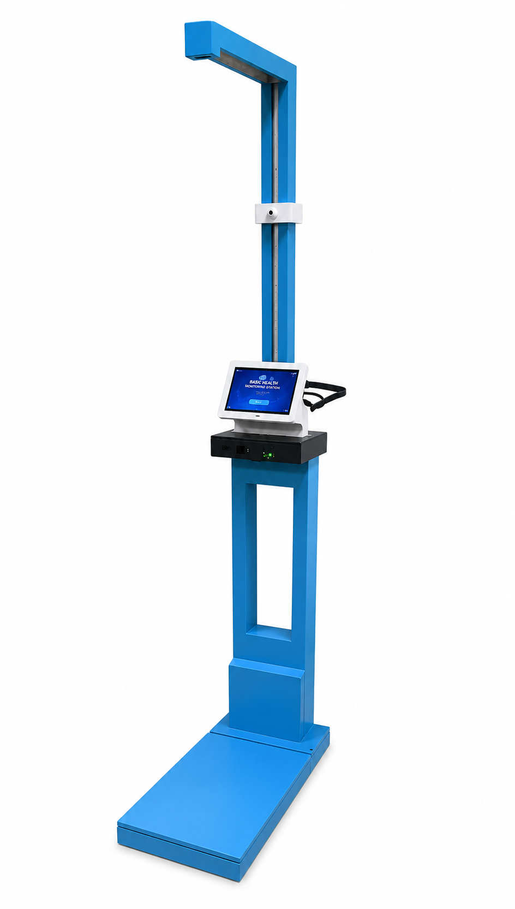
SpO₂ and Respiratory rate sensor
Pulse rate sensor
Digital weighing scale
LCD touchscreen
Temperature sensor

Prepared by
Arun Sanyasi
Sherab Zangmo
Tashi Chozom

CONTENTS
1. Introduction and Scope
2. System Overview
3. Main Components and Interconnection
4. Safety Instructions and Operating Conditions
5. Starting and Shutting Down the System
6. User Measurement Procedure
7. Voice Assistance Workflow
8. Reading Results and QR Reports
9. Admin Panel and Maintenance Functions
10. Calibration Guidelines
11. Cleaning and Preventive Maintenance
12. Troubleshooting Guide
13. Standard Reading Categories
14. Limitations and User Cautions
Appendix A: Quick Operation Checklist
Appendix B: Voice Prompt List

Features of the system:
- Voice assistance: Includes DFPlayer Mini, speaker, and a full step-wise voice prompt sequence.
- Power system: Continuous regulated electrical supply; no battery backup in the final prototype.
- User interface: Operating steps arranged sequentially from welcome screen to QR report and admin functions.
- Report / QR system: Includes PDF report, QR mobile viewer, and report-access instructions.
- Maintenance: Includes storage, admin, saved reports, calibration, and troubleshooting procedures.

- Introduction and Scope
This user manual explains how to safely operate, maintain, and troubleshoot the Basic Health Monitoring Station (BHMS). The BHMS is a touchscreen-based health-screening kiosk developed to measure seven basic health parameters: height, weight, body mass index (BMI), body temperature, blood oxygen saturation (SpO2), pulse rate, and respiratory rate.
The system is intended for preliminary health screening in locations such as a college infirmary, health camp, office clinic, or community health-check environment. It provides guided instructions, voice prompts, digital result display, QR-based report access, and protected administrative controls.

Important Medical Disclaimer: The BHMS is a preliminary screening prototype. It does not replace professional medical diagnosis, treatment, or emergency decision-making. Abnormal results should be repeated once and then reviewed by qualified medical personnel if they continue.
2. System Overview
The BHMS uses an ESP32 controller for sensor data acquisition and a Raspberry Pi 4B for graphical interface processing, result display, report generation, QR code viewing, and record storage. The user interacts with the system through a 7-inch capacitive touchscreen. Voice guidance is provided using a DFPlayer Mini MP3 module and speaker.
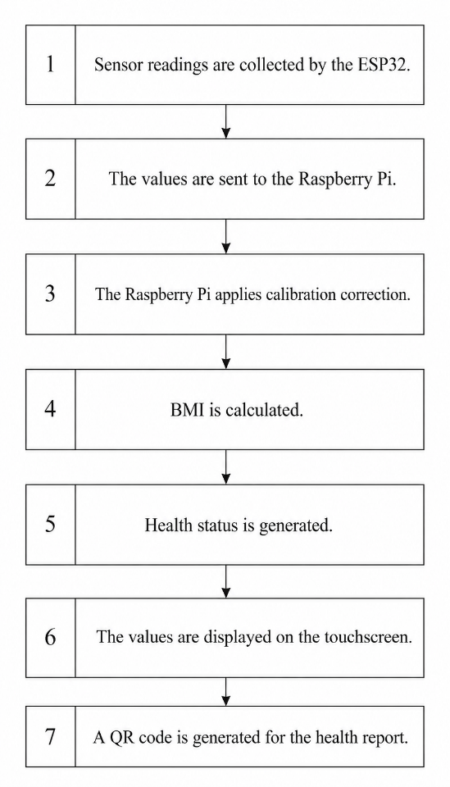
Figure 1: Step-wise BHMS data flow from sensor acquisition to QR report generation.
During operation, the sensors collect readings and send them to the ESP32. The values are then transferred to the Raspberry Pi application. The application performs calibration correction, BMI calculation, health-status classification, result display, PDF report generation, and QR-code display.

2.1 Parameters Measured by the System
Parameter | Sensor / Method | Output Unit
Height | VL53L0X distance sensor mounted at fixed height | cm
Weight | Four load cells with HX711 amplifier | kg
BMI | Calculated from height and weight | kg/m²
Temperature | MLX90614 infrared temperature sensor | °C
SpO2 | MAX30102 PPG sensor | %
Pulse Rate | MAX30102 / pulse sensor logic | bpm
Respiratory Rate | Derived from PPG signal pattern | breaths/min

3. Main Components and Interconnection
The major hardware components used in the final BHMS prototype are shown below. The system includes biomedical sensors, a processing unit, touchscreen display, voice-assistance hardware, and power supply arrangement.

Component | Function
ESP32 Controller | Collects sensor readings, handles sensor control, and communicates with Raspberry Pi.
Raspberry Pi 4B | Runs GUI, receives sensor values, stores reports, generates PDF and QR output.
7-inch Capacitive Touchscreen | Main user interface for instructions, results, diagnosis, and admin access.
MAX30102 | Measures SpO2 and PPG signal used for pulse and respiratory-rate estimation.
MLX90614 | Measures non-contact body temperature.
VL53L0X | Measures distance for height calculation.
HX711 + 4 Load Cells | Measures body weight on the platform.
DFPlayer Mini MP3-TF-16P V3.0 | Plays pre-recorded voice instructions.
3 W, 4 Ohm Speaker | Provides audible voice guidance to the user.
Regulated Power Supply | Provides stable power; final prototype requires continuous electric supply.
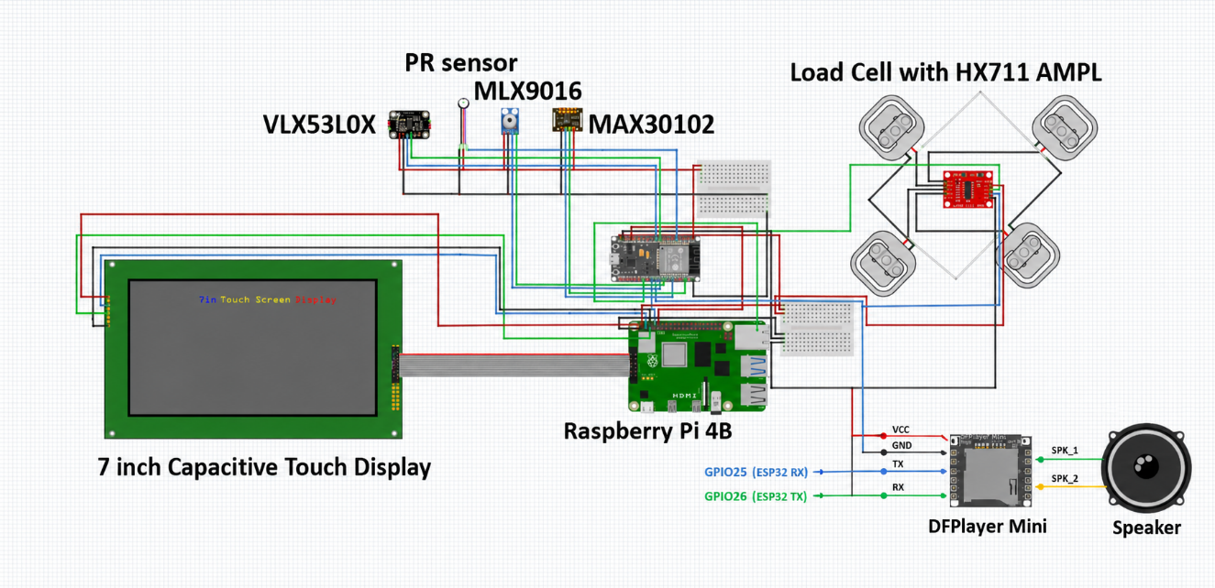
Figure 2: Latest circuit and interconnection diagram used for the BHMS system.
Power Note: The final system requires continuous electrical supply because no battery backup is used for the Raspberry Pi. Do not switch off or unplug power while a measurement or report generation process is active.

3.1 Fabricated and Installed Prototype
The prototype body includes a wooden frame, load-cell platform, touchscreen section, sensor box, and adjustable temperature-sensor mount. The latest report also includes fabrication, assembly, and installation photos used in this manual.
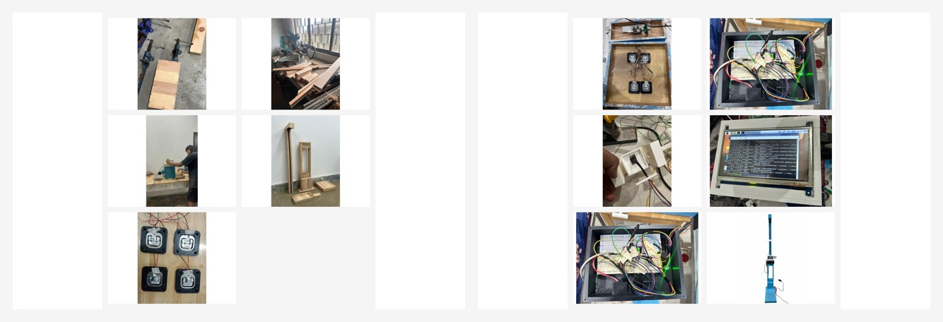
Figure 3: Fabrication, wiring, and assembly work carried out during prototype development.
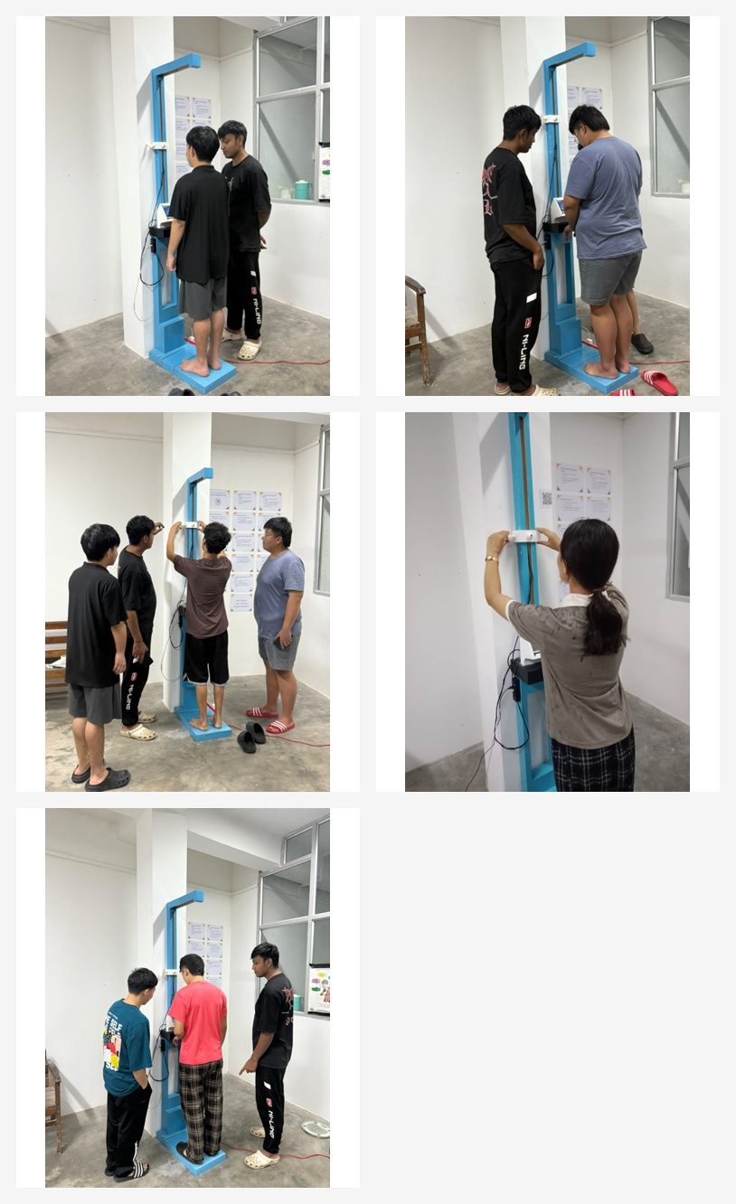
Figure 4: Actual use and testing of the BHMS prototype with participants.

4. Safety Instructions and Operating Conditions
- Place the system on a flat, dry, and stable floor before use.
- Do not use the platform if it is wet, unstable, damaged, or overloaded.
- Do not pull the sensor wires, speaker wires, display cable, or power cable.
- Do not use the system with wet hands or wet feet.
- Do not step on the edge of the platform; stand near the center and remain still.
- Do not move away from the system during measurement.
- Do not unplug the Raspberry Pi or power adapter while the application is running.
- Clean the finger sensor and temperature sensor surface between multiple users.
- Children or users with balance difficulty should use the system only with supervision.

Emergency Use: The system should not be used as the only basis for emergency treatment. If a user feels chest pain, breathing difficulty, faintness, severe fever, or other serious symptoms, seek medical assistance immediately.

5. Starting and Shutting Down the System
5.1 Switching On
- Confirm that the platform is clear and no object is placed on the load-cell surface.
- Connect the regulated power supply to the system.
- Switch on the main supply and wait for the Raspberry Pi and ESP32 to boot.
- Wait until the welcome screen appears on the touchscreen.
- Do not start measurement until the system is stable and the display is ready.
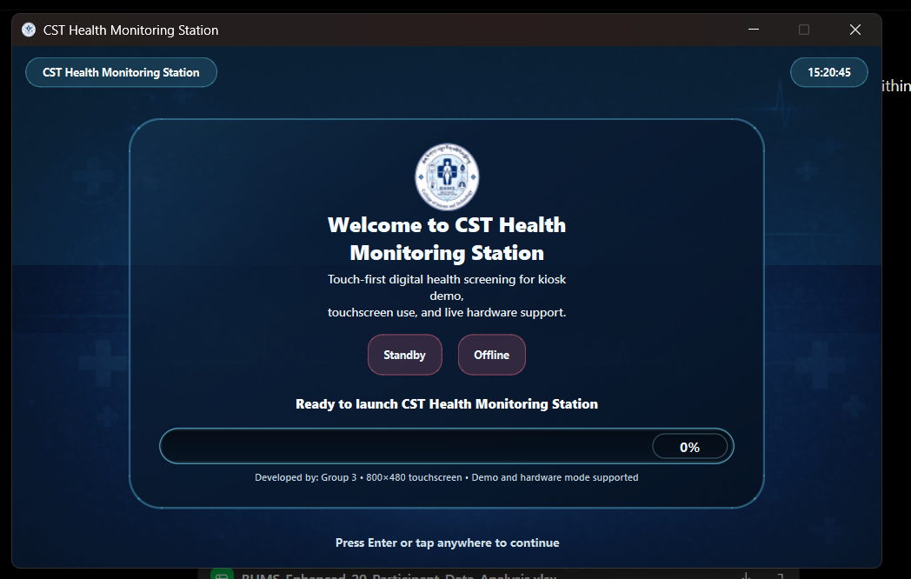
Figure 5: Welcome screen shown after the BHMS application starts.
5.2 Shutting Down
- Return to the main screen if a measurement is already completed.
- Ensure that report generation or QR loading is not in progress.
- Use the system shutdown procedure configured on the Raspberry Pi, or allow the authorized operator to shut down the device.
- Switch off the main power only after the Raspberry Pi has safely shut down.

6. User Measurement Procedure
The following sequence should be followed by every user. This sequence matches the final report workflow and voice-assistance logic.
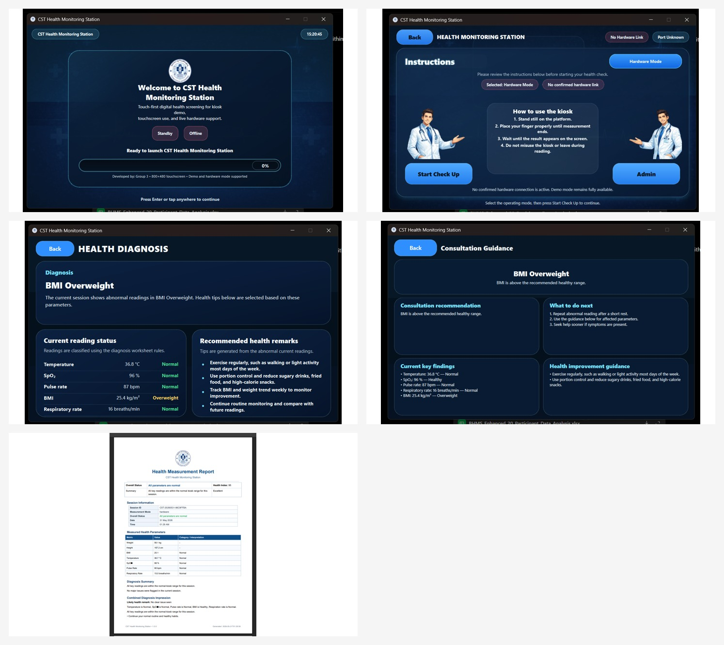
Figure 6: Sequential GUI screens from welcome screen to result, diagnosis, and QR/report viewing.

6.1 Quick Procedure for the User
- Step onto the platform carefully and stand steadily.
- On the welcome screen, tap the screen or press the required key to continue.
- On the mode-selection screen, select Start Check Up for normal measurement.
- Adjust the temperature screw so the temperature sensor is positioned correctly over the forehead area.
- Remain still while temperature is measured.
- Place the left index finger in the left sensor hole until SpO2 and respiratory-rate reading is completed.
- Move the right index finger to the right sensor hole and keep it steady until pulse-rate reading is completed.
- Stand still for automatic weight measurement.
- Stand straight for automatic height measurement.
- Review the result screen showing all seven metrics.
- Open Diagnosis or Consult if interpretation guidance is required.
- Press Report and Open QR to view or download the generated health report on a phone.

6.2 Correct Body Position
- Stand straight on the platform with feet placed evenly.
- Do not lean on the station frame or touchscreen section.
- Keep the head under the height sensor during height measurement.
- Keep fingers steady during SpO2, respiratory-rate, and pulse-rate measurement.
- Repeat measurement if movement, loose contact, or unstable reading occurs.

6.3 Result Screen Actions
After the final measurement, the result screen displays temperature, SpO2, pulse rate, respiratory rate, weight, height, and BMI. The user can then choose the next action from the buttons shown on the screen.
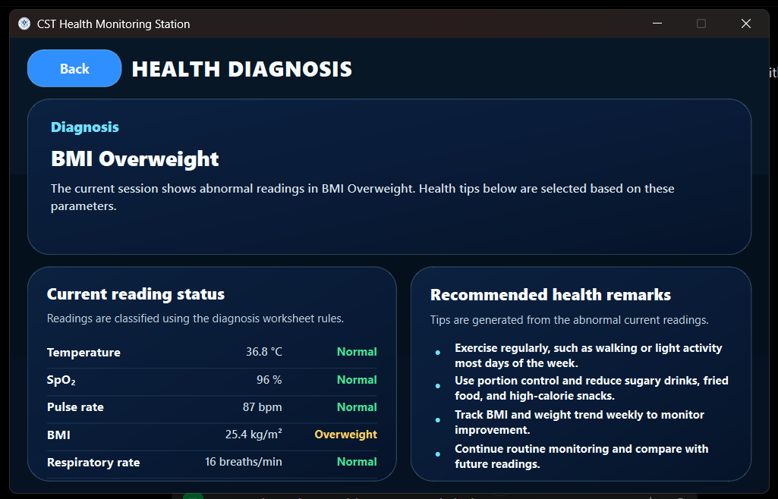
Figure 7: Measurement result screen showing captured health parameters and action buttons.
Button / Area | Purpose
Refresh | Reloads the current result values displayed on the screen.
Report | Generates the PDF health report for the current session.
Retake | Restarts the measurement procedure if the reading is unstable or incorrect.
Open QR | Displays QR access to view the report on a mobile phone.
Diagnosis | Shows the interpretation and health-status summary.
Consult | Shows consultation guidance and next-step recommendations.

7. Voice Assistance Workflow
The final system includes voice assistance using the DFPlayer Mini MP3-TF-16P V3.0 module and a 3 W, 4 Ohm speaker. The ESP32 triggers prerecorded audio files during the measurement workflow. This helps first-time users follow the correct steps without needing constant supervision.
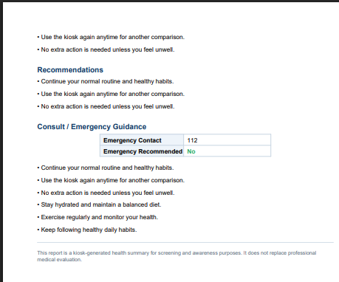
Figure 8: Voice-assistance hardware consisting of DFPlayer Mini module and speaker.

Stage | Voice Prompt
Application start | Welcome to CST Basic Health Monitoring Station.
Temperature step | Adjust the temperature screw over your head.
After temperature | Temperature measurement done, move your left index finger and place it on the left hole in the sensor box.
After SpO2/RR | Reading taken, move your right index finger and place it in the right hole.
After BPM | BPM reading is done, stand still for weight measurement.
After weight | Weight reading is done, stand straight.
After height | Height measurement is done. Now you can view the result on the screen. Use the Wi-Fi provided to scan the QR to see your report.

8. Reading Results and QR Reports
8.1 Diagnosis and Consultation Screens
The Diagnosis screen summarizes the condition detected from the measured values. The Consultation screen gives simple guidance such as repeating abnormal readings, monitoring health status, and seeking medical assistance when symptoms are present.
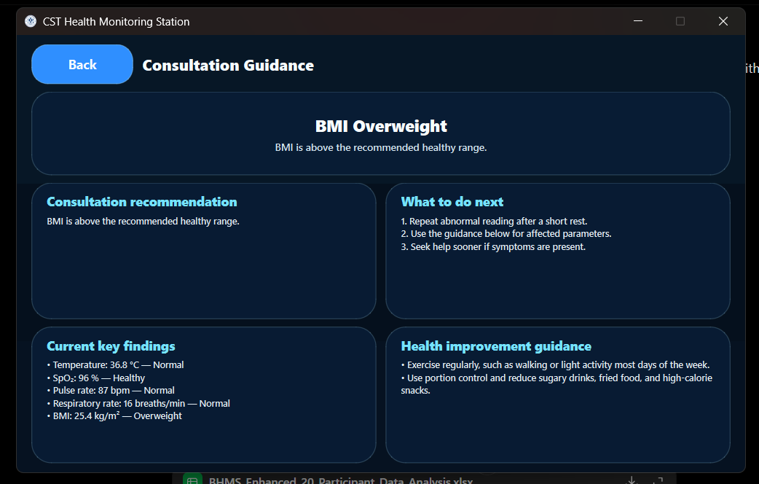
Figure 9: Diagnosis screen displaying current status and recommended remarks.
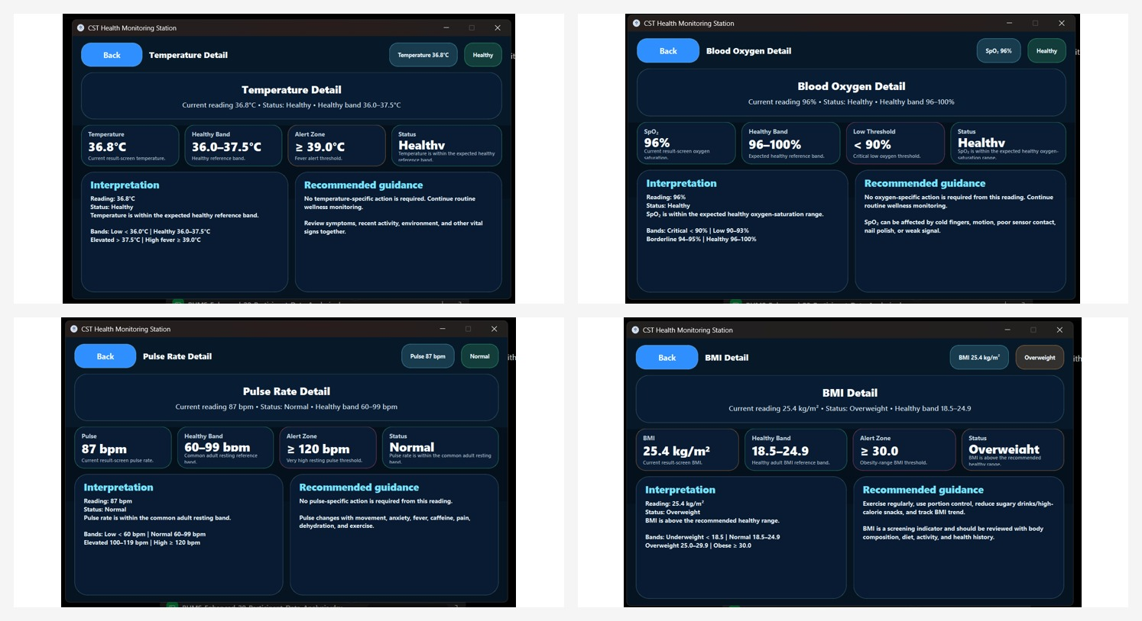
Figure 10: Detailed interpretation screens for temperature, SpO2, pulse rate, and BMI.
8.2 PDF Report and Mobile QR Viewer
The Report button generates a PDF report containing session information, measured parameters, diagnosis summary, combined diagnosis impression, recommendations, and consultation or emergency guidance. The Open QR button allows the report to be viewed using a mobile phone connected to the system network.
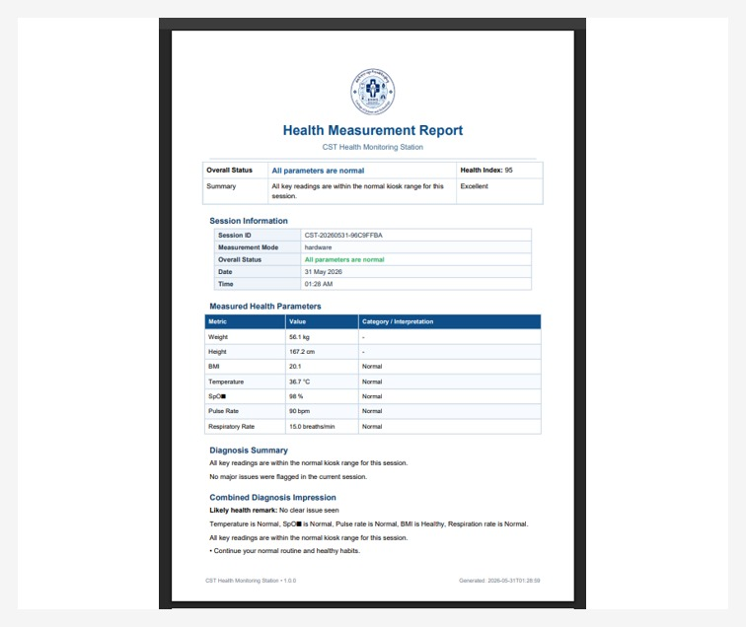
Figure 11: Generated PDF report and mobile QR-linked session result viewer.

- Press Report after confirming the result screen.
- Wait until the report is generated successfully.
- Press Open QR to display the QR code or report link.
- Connect the phone to the Wi-Fi network provided for the BHMS report viewer.
- Scan the QR code and open the report in the phone browser.
9. Admin Panel and Maintenance Functions
The Admin section is for authorized users only. It allows access to settings, calibration-related support, storage management, publishing/export functions, saved report access, and system maintenance.
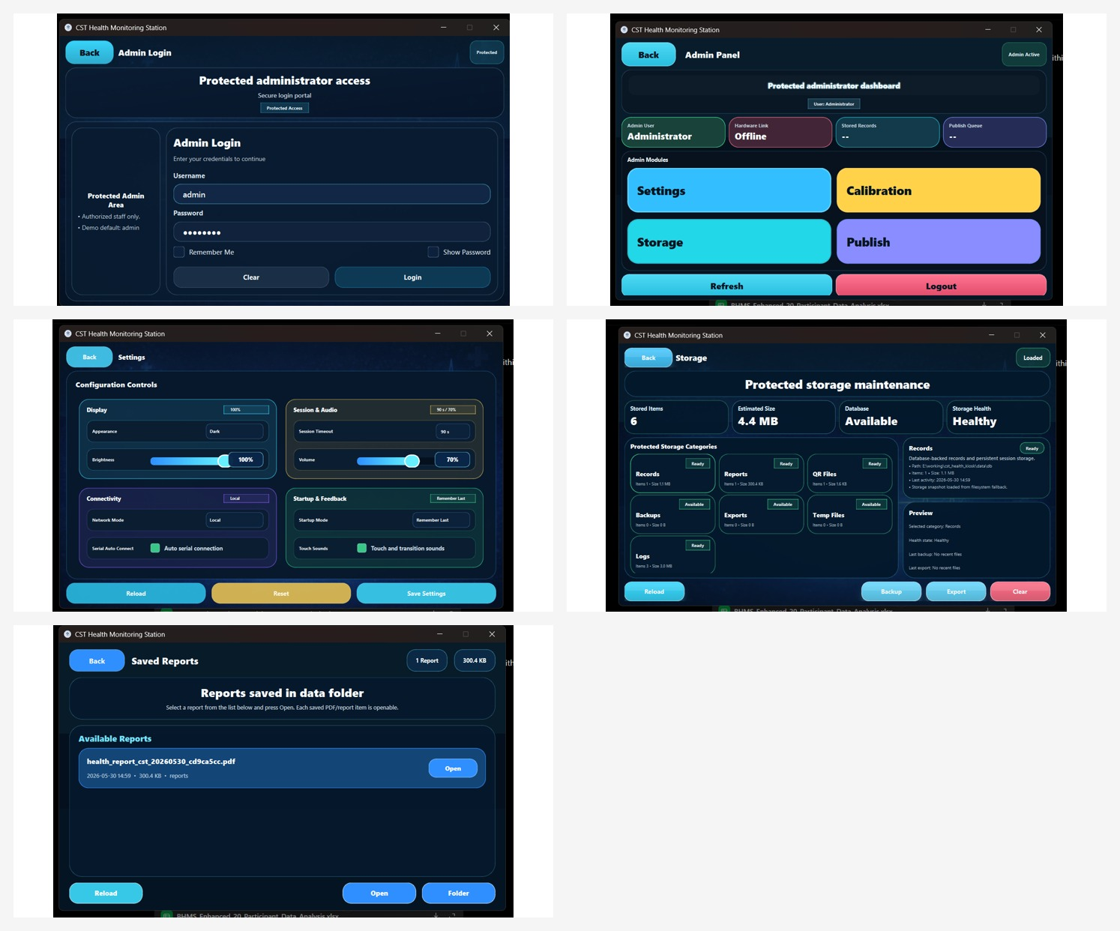
Figure 12: Admin login, admin panel, settings, storage, and saved report management screens.

Admin Screen | Function
Admin Login | Protects access using authorized credentials.
Admin Panel | Provides access to Settings, Calibration, Storage, Publish, Refresh, and Logout.
Settings | Controls brightness, volume, startup mode, touch sound, and network mode.
Storage | Displays records, reports, QR files, backups, exports, temporary files, and logs.
Saved Reports | Allows opening previously generated PDF reports from the reports folder.
Access Control: Admin controls should be used only by trained project members, infirmary staff, or authorized maintenance personnel. Do not share admin credentials with normal users.

10. Calibration Guidelines
Calibration improves the reliability of measurements by comparing sensor readings with reference devices and applying correction values. Calibration should be performed after installation, after hardware replacement, or whenever readings become unstable.
10.1 Load Cell and HX711 Calibration
- Remove all load from the platform and allow the system to tare at zero.
- Place known calibration weights on the platform in steps.
- Record the raw HX711 readings and actual known weights.
- Apply the calibration table or correction factor in the software.
- Verify the result using several known weights, including higher loads.
10.2 VL53L0X Height Sensor Calibration
- Fix the sensor at the final mounting position.
- Measure known distances with a measuring tape.
- Compare sensor readings with actual measured distances.
- Apply height offset correction in the program.
- Verify using users of different heights.
10.3 MAX30102, Pulse Sensor, and MLX90614 Calibration
- Compare SpO2 and pulse readings with a standard pulse oximeter.
- Ensure proper finger placement and avoid motion during comparison.
- Compare MLX90614 temperature readings with a reference thermometer under stable room conditions.
- Apply offset correction if repeated readings show consistent deviation.
11. Cleaning And Preventive Maintenance
Frequency | Task
Before daily use | Check power connection, display response, platform cleanliness, and visible cable condition.
After repeated users | Clean touchscreen, sensor box, finger-contact area, and temperature-sensor window.
Weekly | Check platform stability, loose screws, sensor alignment, and storage space.
Monthly | Verify basic calibration using known weight, reference thermometer, and reference pulse oximeter.
As needed | Backup reports, remove unnecessary temporary files, and inspect logs from the admin storage page.

- Use a soft, dry or slightly damp cloth for cleaning.
- Do not spray liquid directly on the touchscreen or sensors.
- Do not use strong chemicals on sensor lenses or 3D-printed parts.
- Keep the system away from excessive dust, direct sunlight, and water exposure.
12. Troubleshooting Guide
Problem | Possible Cause | Recommended Action
Touchscreen does not turn on | Power disconnected or Raspberry Pi not booted | Check power adapter and wait for full boot.
No hardware link / port unknown | Serial connection not detected | Check ESP32-to-Raspberry Pi cable and restart application.
Weight reading unstable | User movement or load-cell calibration issue | Stand still, clear platform, retare, or recalibrate load cell.
Height reading incorrect | User posture or sensor misalignment | Stand straight and check VL53L0X mounting height.
Temperature low/high unexpectedly | Wrong sensor distance or forehead not aligned | Adjust temperature screw and repeat reading.
SpO2 not detected | Poor finger placement or weak PPG signal | Place finger fully and keep it steady.
Pulse fluctuates | Finger motion, pressure, or sensor contact issue | Keep finger relaxed and repeat measurement.
No voice prompt | Speaker/DFPlayer not powered or audio file missing | Check speaker wiring, SD card, and DFPlayer supply.
QR report does not open | Phone not connected to system Wi-Fi or server unavailable | Connect to provided Wi-Fi and reopen QR page.
Report not saved | Storage issue or app permission error | Check admin storage page and available space.

13. Standard Reading Categories
The following ranges are used as basic screening references in the BHMS interface. These values are for preliminary interpretation and should be confirmed by medical staff when abnormal readings are repeated.
Parameter | Normal / Healthy Range Used in System | Alert / Remark
BMI | 18.5-24.9 kg/m² | 25.0-29.9 overweight; >=30 obese
Temperature | 36.0-37.5 °C | >=39.0 °C high fever alert; low values should be repeated
SpO2 | 96-100 % | <90 % critical low; 90-95 % needs attention
Pulse Rate | 60-99 bpm | >=120 bpm high alert; <60 low
Respiratory Rate | 12-20 breaths/min | Repeat if outside expected band
Weight/Height | Captured values | Used for BMI calculation and report record
14. Limitations And User Cautions
- The BHMS is a prototype for preliminary screening and academic validation.
- Sensor readings can be affected by movement, improper posture, finger pressure, sensor distance, and environmental conditions.
- Small differences from medical-device readings are expected and should be interpreted as screening variation.
- The system does not measure blood pressure, ECG, or blood glucose in the current version.
- The Raspberry Pi requires continuous power; operation may stop if power is interrupted.
- All abnormal readings should be repeated and reviewed by medical personnel if they persist.

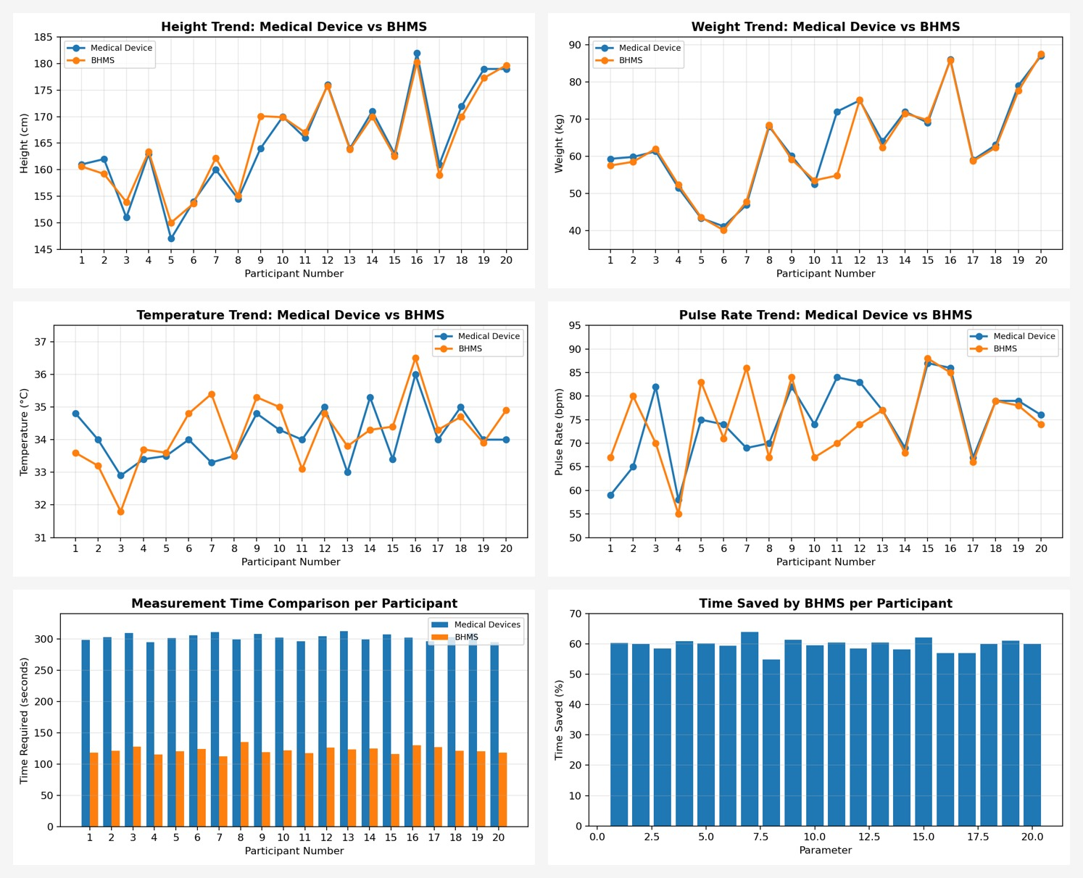
Figure 13: Example analysis charts from the final report used to evaluate BHMS performance.

APPENDIX A: Quick Operation Checklist
Check | Status
Power adapter connected and system booted | ☐
Platform clear before measurement | ☐
Touchscreen shows welcome screen | ☐
Temperature screw adjusted over forehead | ☐
Finger placed correctly for SpO2/RR | ☐
Finger placed correctly for pulse | ☐
User stands still for weight and height | ☐
Report generated and QR opened if needed | ☐
Sensor surfaces cleaned after use | ☐

APPENDIX B: Voice Prompt List
The following audio files should be stored in the DFPlayer Mini SD card in the same sequence as the software trigger commands. File naming may be adjusted according to the ESP32 code, but the order and meaning should remain the same.
Audio No. | Prompt Content
001 | Welcome to CST Basic Health Monitoring Station.
002 | Adjust the temperature screw over your head.
003 | Temperature measurement done. Move your left index finger and place it on the left hole in the sensor box.
004 | Reading taken. Move your right index finger and place it in the right hole.
005 | BPM reading is done. Stand still for weight measurement.
006 | Weight reading is done. Stand straight.
007 | Height measurement is done. Now you can view the result on the screen. Use the Wi-Fi provided to scan the QR to see your report.

APPENDIX C: Document Update Note
This updated manual includes the latest project report changes, including the sequential GUI workflow, voice-assistance module, QR report viewing, admin storage/settings functions, continuous-power note, latest circuit diagram, fabrication images, user-testing images, and report-based analysis visuals.

