Design and Development of a Voice-Assisted Basic Health Monitoring Station for Multi-Parameter Health Screening
Arun Sanyasi, Sherab Zangmo, and Tashi Chozom
Department of Instrumentation and Control Engineering, College of Science and Technology, Royal University of Bhutan, Rinchending, Phuentsholing, Bhutan
Project Guide: Mrs. Karma Kelzang Eudon; External Guide: Mr. Kinley Penjor
Abstract
Measurement of the basic parameters of physiological functioning is very critical for health screening in advance and for the early detection of health anomalies. However, in most of the infirmaries and clinics today, parameters such as body height, weight, body mass index (BMI), body temperature, blood oxygen saturation, heart rate, and breathing rate are measured separately through individual instruments. This makes the measurements take time, manually recorded, and may be erroneous. This technical journal will focus on designing and building a multi-parameter Basic Health Monitoring Station (BHMS) with the voice assistance of the user. Some components of this project include the ESP32 microcontroller, Raspberry Pi 4B computer, MAX30102 sensor, MLX90614 infrared temperature sensor, VL53L0X sensor, HX711 load cell amplifier, analog pulse sensor, PyQt graphical user interface, QR-code based reporting, and DFPlayer Mini. A prototype of the BHMS was developed, built, assembled, calibrated, tested, and installed for supervised testing in the college infirmary. 20 participants were used to validate the BHMS output readings against the readings from medical devices. Results show that the proposed BHMS is capable of measuring seven health parameters, producing a digitally generated report via QR code and saving time as compared to the traditional technique utilizing different devices for each parameter. This device is recommended as an inexpensive screening tool in institutional setups.
Keywords: basic health monitoring station, vital signs, ESP32, Raspberry Pi, PyQt, BMI, SpO2, heart rate, breathing rate, QR report, voice assistance, health kiosk.
1. Introduction
The practice of periodic monitoring of health status is essential in ensuring that any signs of health issues can be detected and preventive measures employed to help maintain one's overall health status. Some typical measurements done in screening are the individual's height, weight, BMI, body temperature, pulse rate, respiratory rate, and the body's oxygen saturation levels. These measurements will give a good starting point for analyzing the health status of the individual before moving on to other consultations. The importance of monitoring vital signs has been acknowledged by medical professionals [1,6].
However, in most healthcare settings, measurements of these parameters are typically conducted separately from each other. For example, the individual's height is taken using a stadiometer, while weight is measured using a weighing machine; likewise, body temperature is usually measured using a thermometer, oxygen saturation using a pulse oximeter, and the individual's pulse rate using a pulse meter.
Latest advancements in embedded systems, biomedical sensors, cheap microcontrollers, and graphical user interface have facilitated the construction of small automated health screening systems. Wearable and sensor based health monitoring systems have been widely researched in terms of remote health care, preventative medicine, and constant monitoring applications [10,14]. Also, automatic body mass index measurement systems have been designed to decrease manual BMI calculation time [2,9,13].
In this work, a basic health monitoring station (BHMS) is constructed at the College of Science and Technology. BHMS is an automated kiosk station where the user can monitor more than one parameter of his/her health status in a single process. Final version of BHMS will have features like sensor acquisition, touchscreen operation, voice recognition, health information interpretation, QR code access of reports, report storage facility, and administrative support services.
The primary achievements in this research include:
• Design of a multi-factorial health monitoring station based on ESP32 and Raspberry Pi.
• Implementation of height, weight, BMI, temperature, SpO2, pulse rate, and respiration rate detection system.
• Construction of the physical housing for the BHMS, including its wood-based body, 3D-printed sensing components, touchscreen mounting, and sensors housing.
• Application of a DFPlayer Mini-based voice assistant for the step-by-step measurement process.
• Creation of a PyQt-based touchscreen interface with screens including welcome page, mode selection page, results, diagnosis, consultation, reports, QR code generation, settings, and administrator screens.
• Individual calibration and testing of each sensor before assembly and infirmary installation.
• Comparative data analysis based on the readings obtained by the BHMS and medical equipment readings.
2. Related Work
Physiological parameter monitoring is commonly applied in health observation and early detection of health problems. Researchers have already designed real-time health monitoring systems through sensor acquisition and embedded control systems for health parameter observations. For instance, Dhingra et al. created a real-time health parameter monitoring system capable of measuring heart rate and temperature among others [7]. It is clear from the above that health parameter acquisition and visualization play an important role in designing health monitoring systems.
The proposed system is highly similar to automated BMI assessment systems. Abana et al. have designed a BMI assessment device which offers recommendations regarding an ideal body weight, thereby illustrating how automatic body height and weight assessment could be done to monitor nutritional status [2]. Similarly, Olajide et al. have designed an automated body mass index (BMI) assessment device to save time on BMI measurement and calculation [13]. Nevertheless, BMI-based systems have only focused on health parameter acquisition regarding body height and weight. The BHMS incorporates temperature, SpO2, pulse rate, respiratory rate, diagnosis logic, QR report generation, and voice guidance among others.
Health-monitoring systems using sensors can also be used for remote and preventive care applications. Pantelopoulos and Bourbakis have presented wearable sensor-based systems for health monitoring and prediction [14], whereas Majumder et al. have studied wearable sensors for remote health monitoring [10]. Both these studies justify the use of embedded sensors for obtaining health-related information. In our proposed system, we have modified the same idea to create an institution-based kiosk system.
3. Methodology
This project involved five significant stages that included: project planning and research, design and selection of components of the system, fabrication of the system, calibration and testing, and data analysis and collection for installation. The order in which these activities were conducted guaranteed that the system would be first designed, then fabricated upon component selection, tested and calibrated prior to its installation.
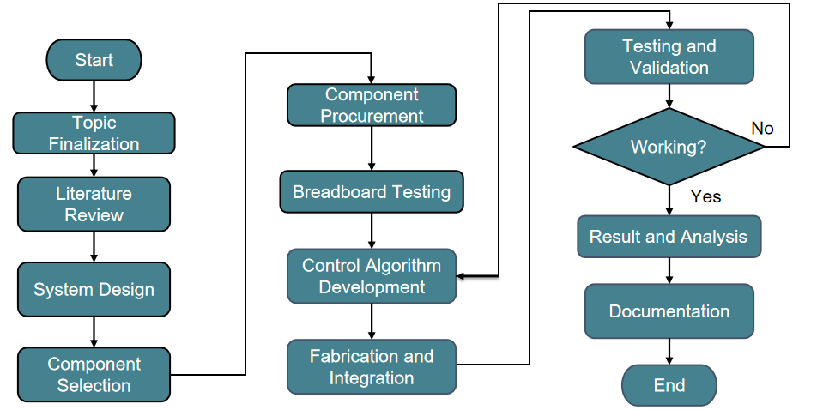
Figure 1. Overall methodology followed for the development of the BHMS.
The development procedure started with identifying the problems, conducting researches, selecting components, and designing the system flow. Once the design phase is done, the body frame, the sensor housing, the touchscreen unit, and the load cell base unit were manufactured. Sensors were tested individually and calibrated before being assembled. Lastly, the entire system underwent testing using the actual medical device.
4. Proposed System and Design Architecture
4.1 System Overview
BHMS is a kiosk-like device that enables measuring several health factors in an integrated process. The system has been made up of various units including the sensing unit, the control unit, the processing unit, the display unit, the voice assistance unit, and the report generation unit. ESP32 captures the data from the sensors, while Raspberry Pi executes the graphical interface and displays the QR code.

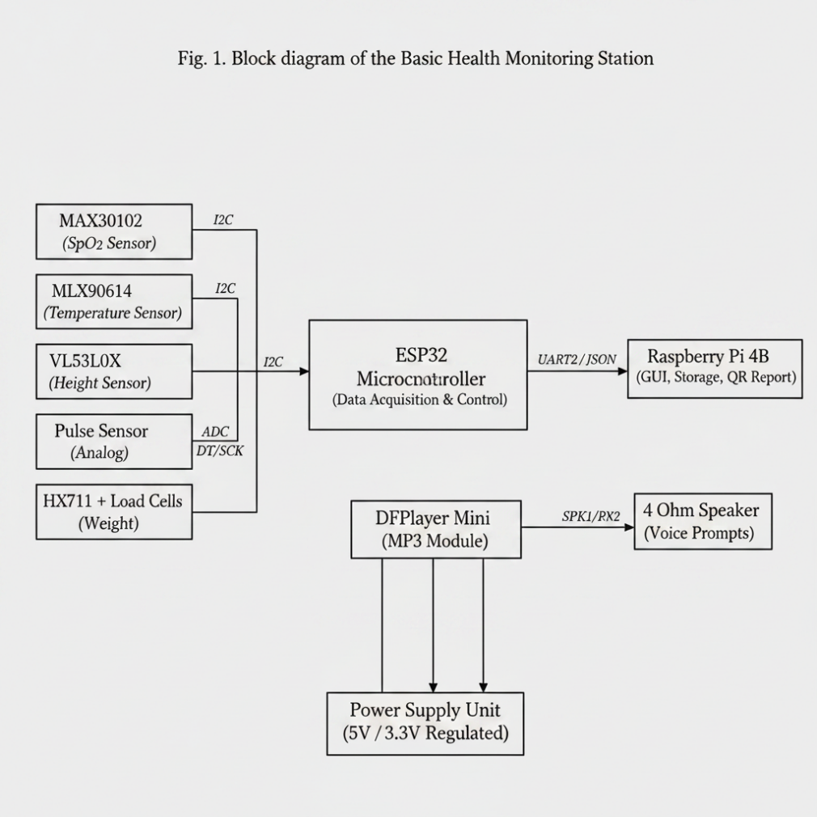
Figure 2. Overall system architecture of the Basic Health Monitoring Station.
4.2 Measured Parameters and Workflow
The BHMS can measure body height, body weight, body temperature, oxygen level in blood, heart rate, and respiration rate. Body Mass Index is calculated based on body height and body weight. Measurement process involves initializing the equipment and calibrating it, taking measurements from the user, processing the data, and generating a report.

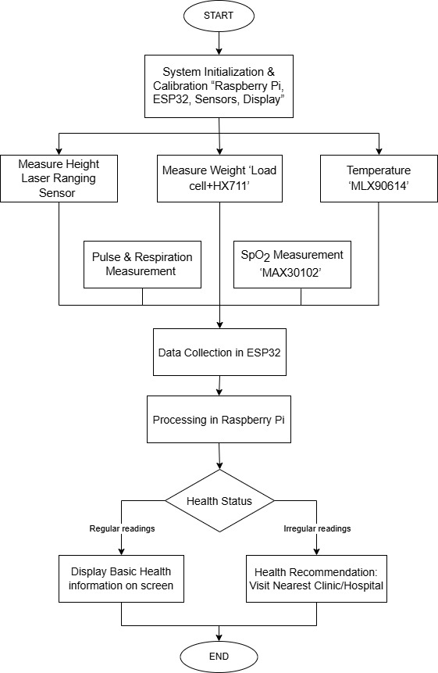
Figure 3. System flowchart of the proposed BHMS.

5. Hardware Design
Component | Function
ESP32 | Sensor acquisition, control logic, communication, and voice triggering
Raspberry Pi 4B | GUI operation, data storage, QR generation, and report generation
MAX30102 | SpO2 and photoplethysmography signal acquisition
MLX90614 | Non-contact temperature measurement
VL53L0X | Height measurement using time-of-flight distance sensing
HX711 + four load cells | Weight measurement using a 200 kg load-cell platform
Analog pulse sensor | Pulse-rate measurement support
DFPlayer Mini and 3 W speaker | Audio output for guided voice instructions
7-inch capacitive touch display | User interaction and result display
Table 1. Major hardware components used in the BHMS.
The sensors are interfaced with the ESP32. MAX30102, MLX90614, and VL53L0X modules communicate via the I2C protocol. The analog pulse rate sensor connects to an analog input port, whereas HX711 connects to the ESP32 using data and clock signal pins. Processed data is sent to the Raspberry Pi from the ESP32 for displaying the output and creating reports. The DFPlayer Mini communicates with the ESP32 using serial protocol for playing instructions.

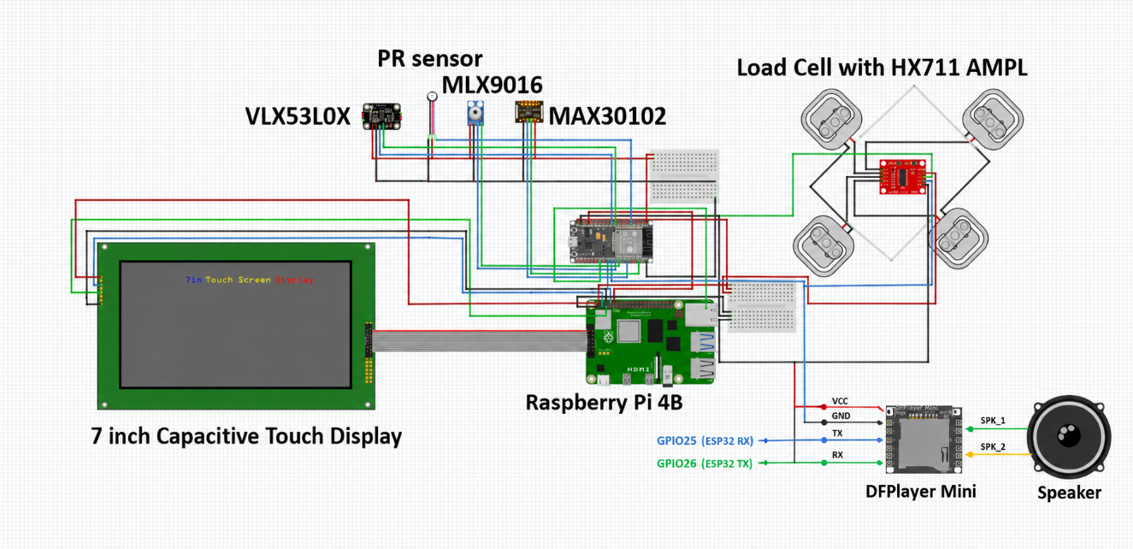
Figure 4. Updated interconnection diagram including Raspberry Pi 4B, ESP32, sensors, HX711 load-cell amplifier, and capacitive touch display.
The Raspberry Pi and the touch screen constitute the load on the system. This system functions through a regulated 5V supply. However, the absence of a battery pack in the last prototype means that a constant source of electricity is necessary when the system is running. A battery pack may be introduced later.
6. Prototype Development and Fabrication
6.1 System Model and 3D Printed Components
The system body was engineered in such a way that the height sensor, temperature sensor, touchscreen, sensor housing, and load cell support frame could be mounted at appropriate locations. Some of these components were manufactured using 3D printing, which included the sensor housing, clamp, screw for the clamp, covers, and components that support the screen.
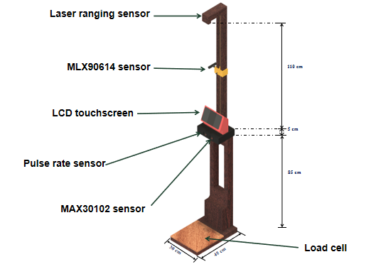
Figure 5. 3D system model showing the body frame and sensor placement.
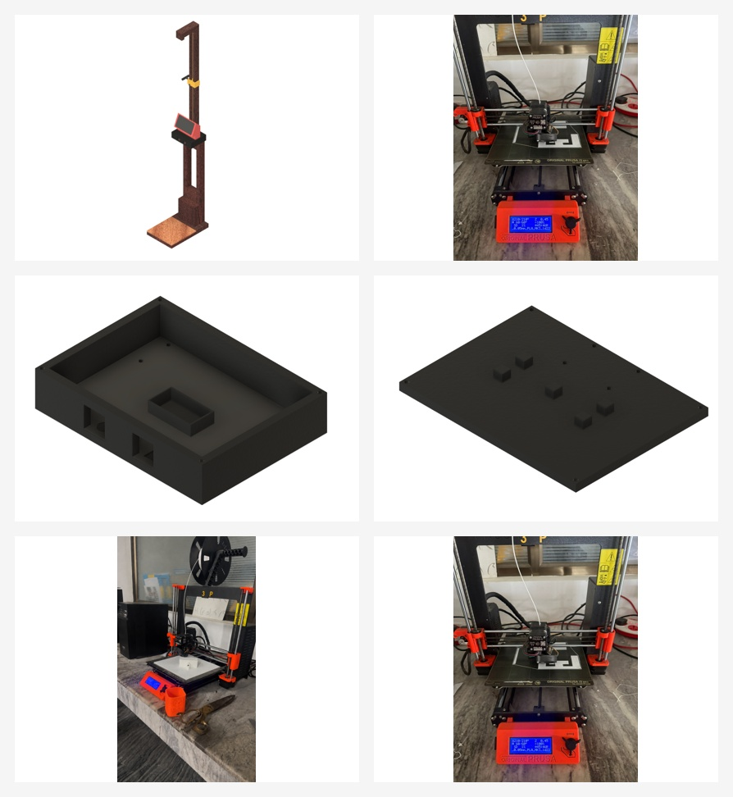
Figure 6. 3D-printed sensor box, covers, and customized prototype components.
6.2 Assembly of the Complete System
Once these components were made, they were put together to form the body of the device. This resulted in a working prototype ready for users and which could be installed in the infirmary.

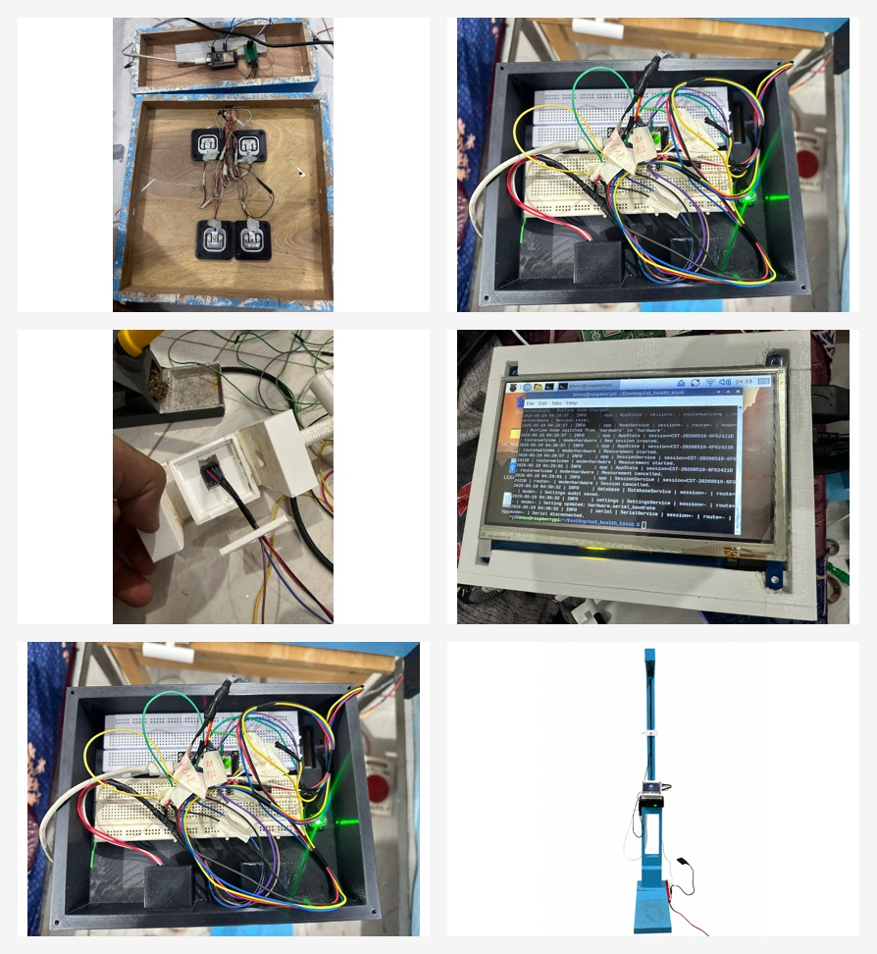
Figure 7. Assembly activities showing load-cell mounting, internal wiring, touchscreen integration, and the completed prototype.
7. Software Design and User Interface
The ESP32 firmware handles tasks such as sensor reading, calibration and filtering where necessary, sending of processed data to the Raspberry Pi, and activating voice prompts using the DFPlayer Mini. The Raspberry Pi controls the core functions of the kiosk application. The kiosk application handles data received from the ESP32 via the serial connection, GUI updating, session storage, generation of PDF health reports, QR code display, and administration functionalities.
The BHMS application has been uploaded and set up on the Raspberry Pi connected to the 7-inch capacitive touch screen. The BHMS application has been started on the touch screen to check screen compatibility, touch sensitivity, button navigation, and display alignment. Finally, the GUI has been structured in the following manner; welcome screen, mode selection, instructions and measurement, results screen, health analysis, guidance to consultation, parameter detail screens, PDF report, and administration screens.

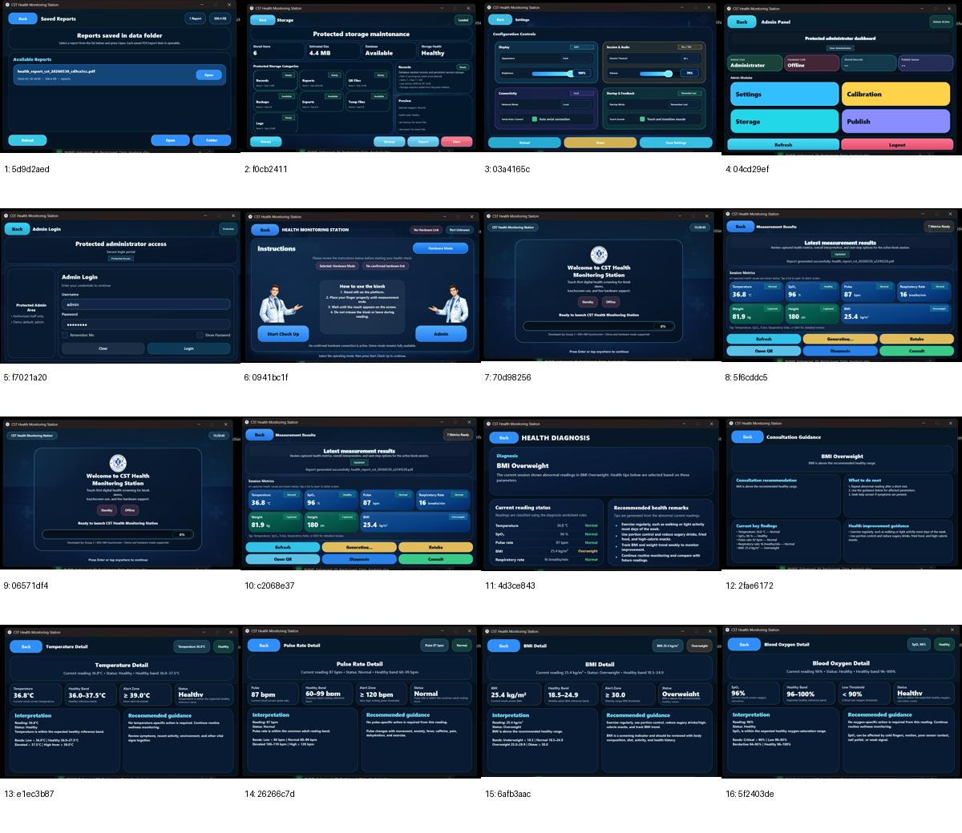
Figure 8. Main GUI screens of the final BHMS application, including user and administrative screens.
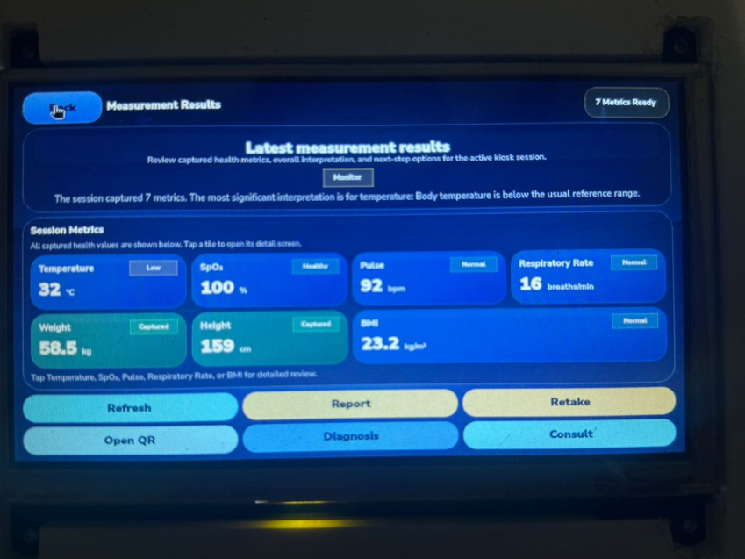
Figure 9. Measurement result screen captured during integrated system testing.
7.1 Voice-Assisted Measurement Flow
Voice assistance system includes an MP3-TF-16P V3.0 SD card module called DFPlayer Mini and a 3W, 4 ohm speaker. The microcontroller communicates with the module by sending serial instructions to replay pre-recorded MP3 audio prompts for the tasks below:
1. Welcome to CST Basic Health Monitoring Station.
2. Adjust temperature screw above your head.
3. Temperature measurement is complete, please shift your left index finger and place it inside the left hole on the sensor box.
4. Temperature reading is complete, please shift your right index finger and place it inside the right hole.
5. BPM reading is complete, please stand still for weight measurement.
6. Weight reading is complete, please remain still for height measurement.
7. Height measurement is complete; results will be available on the screen. Please use Wi-Fi connection provided to scan the QR for your report.
7.2 Report and QR Generation
The report is generated in a PDF format along with a QR code after measurements have been taken. This QR code can be scanned through the mobile phone that is connected to the provided network. The report includes the session details, parameters measured, health category, diagnosis, recommendations, and emergency contact number.
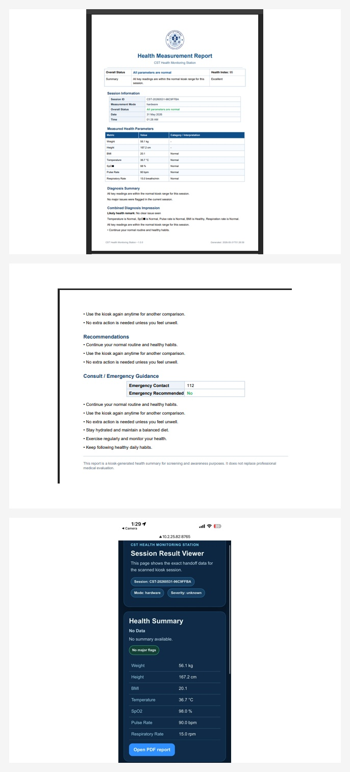
Figure 10. Generated PDF health report and mobile QR-linked session-result viewer.
8. Data Processing, Calibration, and Structural Verification
8.1 BMI and Health Classification
BMI calculations are based on the weight and height measurements. This equation is presented in Eq. (1) where W denotes body weight and H stands for body height.
BMI = W / H² (1)
The BMI scale employed in the algorithm includes classifications such as underweight, healthy, overweight, and obese classes. Other health indicators are defined according to the ranges specified by health screenings. The diagnostics process aims to provide a preliminary assessment for raising awareness but not as a substitute for clinical evaluation.
8.2 Load Cell Calibration
The weighing device is equipped with four load cells of 50 kg each, providing an overall maximum capacity of 200 kg. Known weights were loaded sequentially from 20 kg up to 200 kg, and respective HX711 output readings were recorded. The raw readings are converted into actual weights using linear interpolation, as presented in Eq. (2).
W = W₁ + ((R - R₁)(W₂ - W₁)) / (R₂ - R₁) (2)

Point | Applied Weight (kg) | Raw Value
1 | 20 | 442526.28
2 | 40 | 838240.94
3 | 60 | 1244028.00
4 | 80 | 1652952.37
5 | 100 | 2053779.00
6 | 120 | 2470557.25
7 | 140 | 2908480.25
8 | 160 | 3327427.50
9 | 180 | 3718852.50
10 | 200 | 4045510.25
Table 2. Load-cell calibration points used for weight conversion.
8.3 Structural Verification of the Platform
The mass of the person that would be allowed to use the wooden structure safely was estimated to be 200 kg. This leads to a design load of W = mg = 200 * 9.81 = 1962 N. For the purpose of designing for bending, a rectangular section was assumed with width b = 0.30 m and depth t = 0.01 m. The section modulus of the rectangular section can be found from Eq. (3).
Z = bt² / 6 = 5.0 × 10⁻⁶ m³ (3)
If we assume conservative loading at the centre point of the structure, the maximum bending moment will be Mmax = WL/4 = 147.15 Nm. The resulting bending stress will then be σ = M / Z = 29.43 MPa. Assuming a hardness of 70 MPa, which is hardwood modulus of rupture or strength, the factor of safety will be 2.38.
9. Integrated Testing and Installation
After the testing and calibration of each system component, the whole system was integrated. The communication between ESP32 and Raspberry Pi was tested using serial data transmission. The output results displayed all seven metrics, and the report, analysis, retake, QR, and consulting options were also confirmed to be working fine. All the testing and calibration of the system took place before its installation at the college infirmary.

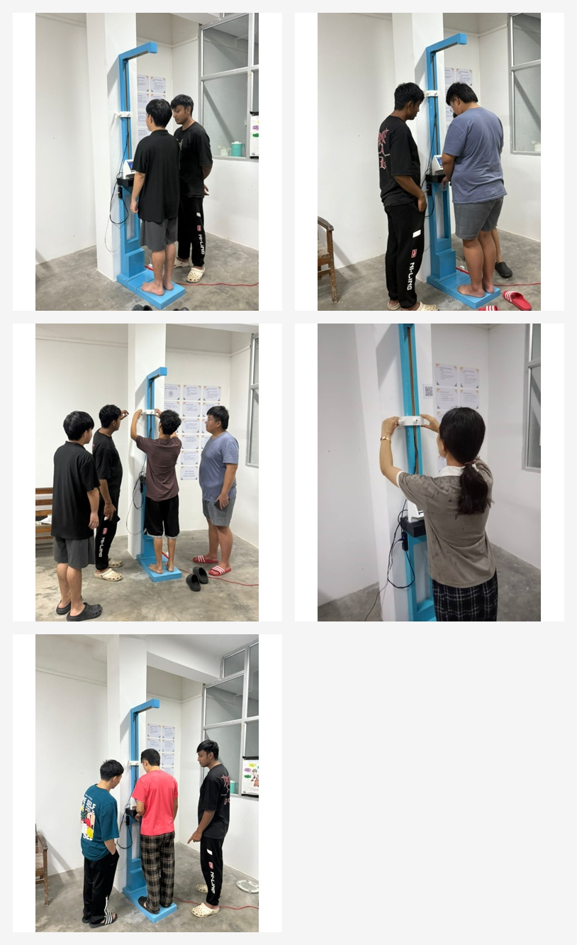
Figure 11. Actual user-testing photographs showing multiple participants using the BHMS.

10. Results and Discussion
10.1 Data Collection and Error Analysis
Data were taken from both BHMS and medical devices as well. The data from medical devices contained measurements of height, weight, BMI, body temperature, and pulse rate. The data obtained from BHMS had the values of height, weight, BMI, body temperature, pulse rate, respiratory rate, and SpO2. Measurement time was also considered to assess the efficiency of measurement.
The signed error, absolute deviation, percentage difference, mean absolute error (MAE), and root mean square error (RMSE) were taken into account for analyzing the data. The formulas are presented in Eqs. (4)-(6).
ADᵢ = |BHMSᵢ - Medicalᵢ| (4)
MAE = (1/n) Σ |BHMSᵢ - Medicalᵢ| (5)
RMSE = √((1/n) Σ (BHMSᵢ - Medicalᵢ)²) (6)

Parameter | MAE | RMSE | MAPE (%) | Interpretation
Height | Low | Low | Close | Close agreement with reference measurement
Weight | Low to moderate | Moderate | Acceptable | Practical for screening
BMI | Low to moderate | Moderate | Acceptable | Influenced by height and weight error
Temperature | Low | Low | Acceptable | Sensitive to distance and environment
Pulse rate | Moderate | Moderate | Higher | Affected by finger placement and motion
SpO2 | Low | Low | Close | Preliminary validation
Respiratory rate | Low | Low | Close | Preliminary validation
Table 3. Summary of BHMS error analysis and interpretation.
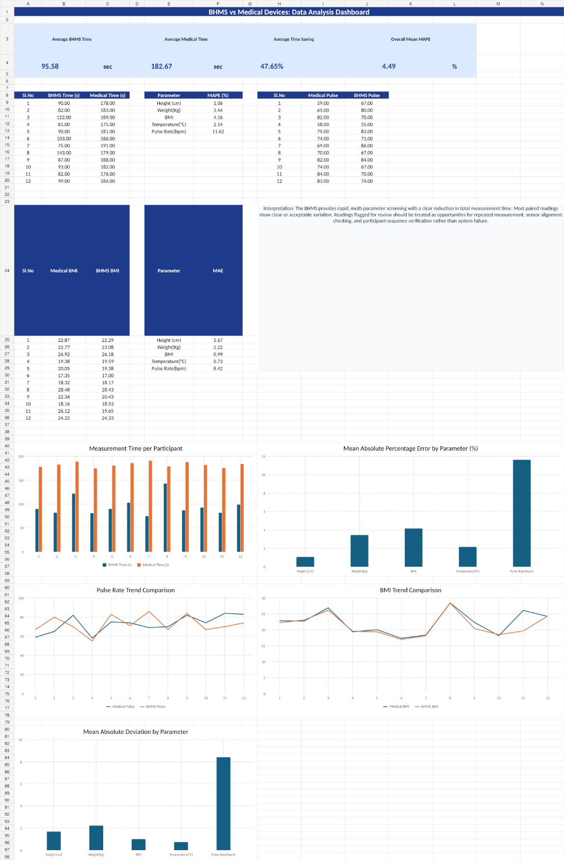
Figure 12. Dashboard-style summary of BHMS performance and comparison results.
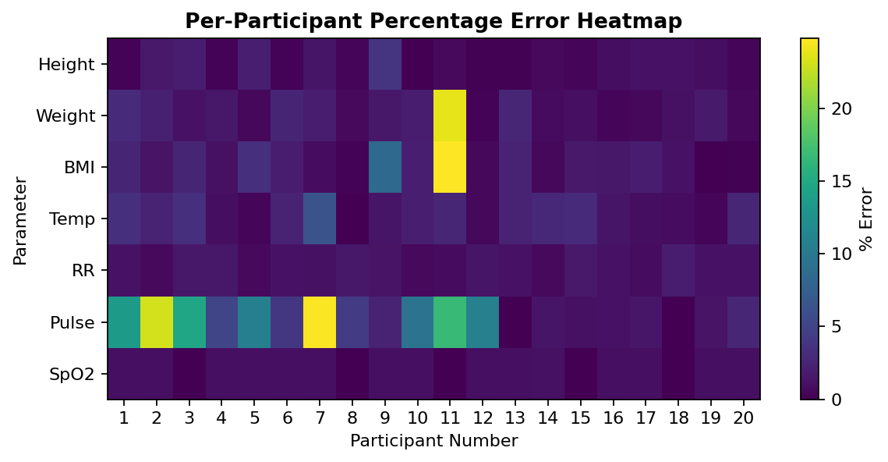
Figure 13. Percentage-difference visualization used for analysis of BHMS readings.
10.2 Time Efficiency and System Performance
The traditional measuring approach involved use of different tools and recording the readings manually. The BHMS integrates multiple measurement readings through a process. The time saved was determined using Eq. (7).
Time Saving = ((Tmedical - TBHMS)/Tmedical) × 100 (7)
The measurement times with the BHMS were shorter than with the traditional separate tools. The BHMS makes the processes faster and minimizes wait time for patients. In the tests carried out, there was stable connection between ESP32 and Raspberry Pi without any disruption to data transfer, and the GUI worked well.
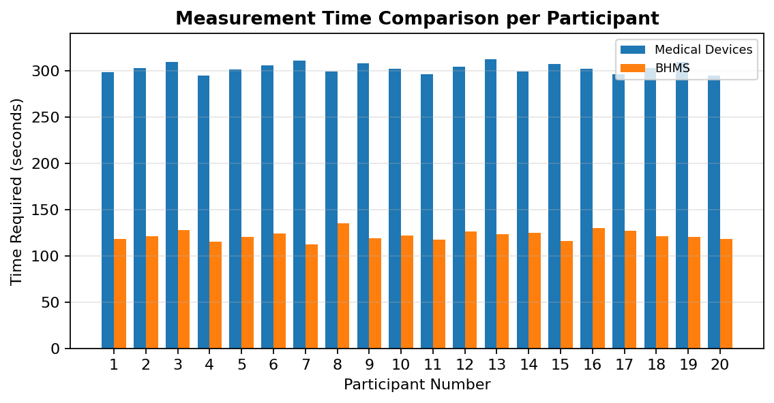
Figure 14. Measurement time comparison between BHMS and separate medical-device measurement.

10.3 Cost and Feasibility
The BHMS was conceived to be a cost-effective prototype made from inexpensive embedded components and locally produced structural components. The total cost of the prototype included electronic components, 3D-printing, paint, primer, and fabrication material. It was compared against more expensive commercial health kiosks and body measuring tools.

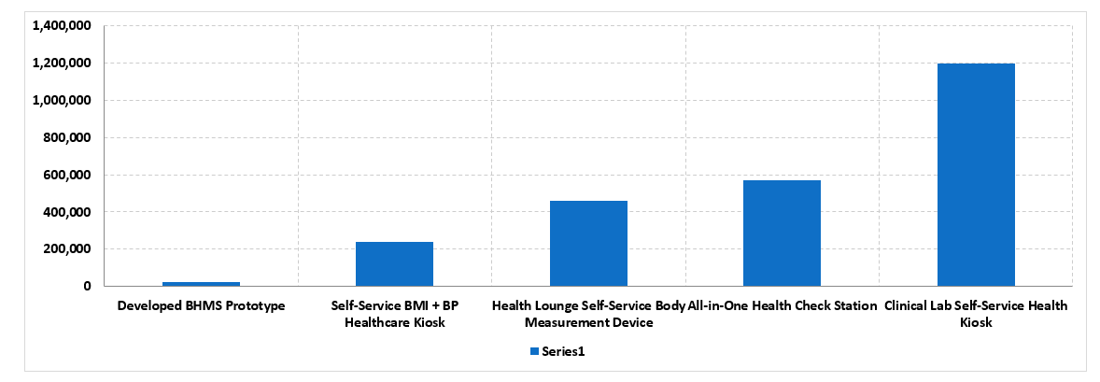
Figure 15. Cost comparison of the developed BHMS prototype with other health station devices.
This indicates that the developed BHMS is less expensive compared to the commercial kiosk type systems. Commercial kiosks usually have certified medical grade sensors, industrial casing, and cloud server. Therefore, the developed system is ideal for use as an educational and preliminary health screening prototype as opposed to clinical diagnostic tool.

11. Discussion and Limitations
The developed BHMS shows that it is possible to implement multi-parameter preliminary health screening by utilizing inexpensive embedded hardware, Raspberry Pi as an interface, and report generating on-site. Touch-screen display makes the device more user-friendly, while the ability to generate a QR-code based report facilitates easier health assessment for the user.
There were several issues which were faced during development of the BHMS. Sensor values had to be calibrated and offsets compensated. There were changes in load-cell values before calibration. Distance between the user and the height sensor had to be adjusted for proper height measurement. There was a need to alter the body frame for better positioning.
Limitations of the system include having a limited dataset for clinical validation, variations in temperature reading dependent on environmental factors and distance from the device, and fluctuations in pulse reading dependent on the subject’s movement and contact pressure. The system has been designed to be used only for preliminary screening purposes as it does not have a battery backup that could provide continuous power supply to the Raspberry Pi.

12. Conclusion and Future Works
The technical journal above outlined the process involved in designing and implementing a voice-assisted Basic Health Monitoring Station for health screening of several parameters. The designed system includes an integration of sensor acquisition, using the ESP32 microcontroller; Raspberry Pi graphical interface; PyQt GUI; QR code generation and report generation; local storage; and voice guidance through the DFPlayer Mini module.
The final product can measure the subject's height, weight, body mass index, temperature, oxygen saturation level, heart rate, and breathing rate.
The testing revealed that the BHMS is capable of providing rapid and convenient initial health screening using the single process.
For future developments, the sensors for measuring blood pressure, ECG, and glucose levels should be implemented into the system. Sensor precision can be increased through the implementation of more sophisticated filtration techniques and repeated measurements. The integration of remote monitoring features will allow the infirmary staff to observe results received from another device. Integration with cloud storage and development of a mobile application should be considered as well. Multilingual voice control system will enhance usability of the system.
Conflict of Interest
It is confirmed by the authors that there is no conflict of interest regarding this study.
Author Contributions
Arun Sanyasi, Sherab Zangmo, and Tashi Chozom participated in system design, hardware fabrication, software development, testing, calibration, data collection, analysis, and writing of the manuscript. The project guide and external guide were responsible for the guidance of the project.
Funding
This project was completed as the final-year academic project in the Department of Instrumentation and Control Engineering, College of Science and Technology.
Acknowledgments
The authors wish to extend our gratitude towards the Department of Instrumentation and Control Engineering, College of Science and Technology, Royal University of Bhutan for providing us the opportunity to undertake this project. We are particularly thankful to Mrs. Karma Kelzang Eudon, project guide for her guidance and motivation in undertaking this project. We would also like to thank Mr. Kinley Penjor, external guide for his comments and suggestions. Infirmary staff members and all the participants used in testing and collecting the data in the Basic Health Monitoring Station are gratefully acknowledged.

Ethical Considerations
The instrument was designed for initial screening and educational purposes. Readings collected from participants were utilized for project-based performance analysis. It should be noted that the BHMS is not meant to substitute a professional medical diagnosis and certified clinical equipment.
Code Availability
It should be noted that the project dataset, source code, GUI, ESP32 code, and additional materials can be provided upon request.

References
[1] AAST, Patient Assessment and Vital Signs Measurement and Documentation, AAST Technical Guideline, 2022.
[2] E. C. Abana, C. Llamelo, T. B. Dana, R. Cafugauan, N. A. Malpaya, and A. C. Maramag, “BMI assessment machine with recommended ideal weight,” International Journal of Advanced Trends in Computer Science and Engineering, vol. 9, no. 3, pp. 4163–4167, 2020.
[3] Analog Devices, MAX30102 High-Sensitivity Pulse Oximeter and Heart-Rate Sensor for Wearable Health, Data Sheet, n.d.
[4] Avia Semiconductor, HX711: 24-Bit Analog-to-Digital Converter for Weigh Scales, Data Sheet, n.d.
[5] M. Chavan, P. Pardeshi, S. A. Khoje, and P. Patil, “Study of health monitoring system,” in Proc. Second International Conference on Intelligent Computing and Control Systems, 2018, pp. 1779–1782.
[6] Cleveland Clinic, “Vital signs,” 2025.
[7] S. Dhingra, M. Sharma, H. Arora, A. Misra, and S. Nayak, “Real-time vital signs monitoring system,” International Journal of Engineering Research & Technology, vol. 8, no. 6, pp. 800–803, 2019.
[8] eMedicineHealth, “What is a good oxygen rate by age? Causes, symptoms and chart,” 2021.
[9] O. M. Horsfall and M. Yaabari, “Automated body mass index assessment device,” International Journal of Advances in Engineering and Management, vol. 7, no. 4, pp. 400–404, 2025.
[10] S. Majumder, T. Mondal, and M. J. Deen, “Wearable sensors for remote health monitoring,” Sensors, vol. 17, no. 1, Art. no. 130, 2017.
[11] Melexis, MLX90614 Family Single and Dual Zone Infrared Thermometer in TO-39, Data Sheet, n.d.
[12] H. Mondal, S. Mondal, and C. Baidya, “Competency in home body fat monitoring by portable devices based on bioelectrical impedance analysis: A pilot study,” Journal of Education and Health Promotion, vol. 8, Art. no. 223, 2019.
[13] O. P. Olajide, K. A. Musiliyu, O. A. Alao, and I. E. Owolabi, “Development, implementation and usage of an automated body mass index (ABMI) system,” Global Scientific Journals, vol. 8, no. 2, pp. 5404–5416, 2020.
[14] A. Pantelopoulos and N. G. Bourbakis, “A survey on wearable sensor-based systems for health monitoring and prognosis,” IEEE Transactions on Systems, Man, and Cybernetics, Part C: Applications and Reviews, vol. 40, no. 1, pp. 1–12, 2010.
[15] Raspberry Pi Foundation, “Raspberry Pi 4 Model B specifications,” n.d.
[16] STMicroelectronics, VL53L0X Time-of-Flight Ranging Sensor, Data Sheet, n.d.
[17] World Health Organization, “Body mass index – BMI,” n.d.
[18] World Health Organization, “Noncommunicable diseases,” 2023.

