Design and Development of a Voice-Assisted Basic Health Monitoring Station for Multi-Parameter Health Screening
Arun Sanyasi, Sherab Zangmo, and Tashi Chozom
Instrumentation and Control Engineering Programme
College of Science and Technology, Royal University of Bhutan
Rinchending, Phuentsholing, Bhutan
Abstract- The measurement of physiological parameters is a requirement for health screening and determination of health conditions. In most of the infirmaries, some of the parameters measured include body height, body weight, body mass index (BMI), body temperature, oxygen saturation, heartbeat and respiration rate. The measurements are performed individually using different devices hence leading to increased measurement time and possible human error. This work focuses on designing and developing a voice-assisted Basic Health Monitoring Station (BHMS) that performs multi-parameter health screening. The components used in making BHMS include the ESP32 microcontroller, Raspberry Pi 4B, MAX30102, MLX90614 infrared sensor, VL53L0X time of flight sensor, HX711 load-cell amplifier, pulse sensor, PyQt graphical user interface, QR report generation and the DFPlayer Mini voice-assistant. The system was designed, fabricated, assembled, calibrated, tested, and deployed to the college infirmary for supervised tests. Data from twenty participants was analyzed by comparing BHMS readings to readings from medical devices. Mean absolute error, root mean square error, percentage difference, trend analysis, time efficiency, and feasibility were considered. The BHMS measures seven health-related parameters and generates a digital report available via QR code. It reduces the total time taken to perform the measurements than the traditional measurement with separate devices. Therefore, BHMS is feasible as a cost-effective preliminary health screening station.
Index Terms- Basic health monitoring station, vital signs, ESP32, Raspberry Pi, PyQt, BMI, SpO2, pulse rate, respiratory rate, QR report, voice assistance, health kiosk.

I. INTRODUCTION
Health assessment on a regular basis is critical for identifying any early signs of diseases and facilitating preventive care for patients. Some basic screening criteria that are used include height, weight, body mass index, body temperature, pulse rate, breathing rate, and blood oxygen levels. These screening measures provide essential details regarding a patient’s overall state of health for a more comprehensive health assessment to be conducted.[1], [6].
In many cases, each of the values will be taken separately by a dedicated instrument. Thus, height may be measured with a stadiometer, weight – with a weight scale, temperature – with a thermometer, oxygen saturation – with an oximeter, and pulse – with a pulse monitor or by manually counting pulses. Even though this method is common, it is quite tedious and involves manual input, thus leaving more room for potential human errors.
The advancements that have recently occurred in the field of embedded systems, biomedical sensors, inexpensive microcontrollers, and graphical user interface have helped the development of small-sized and automated health screening systems. The research about wearable and sensor-based health monitoring systems has been extensively conducted. [10], [14]. Automated BMI assessment systems have also been developed using load cells and height sensors to reduce manual calculation time and improve screening convenience [2], [9], [13].
This paper discusses the designing and development of a Basic Health Monitoring Station (BHMS). The final product consists of sensor data acquisition, touchscreen interface, voice help, health interpretation, access to reports using QR code, report storing, and administration assistance features.
II. RELATED WORK
Health monitoring systems are popular tools for the measurement of physiological parameters, which help detect health problems earlier. Researchers have developed real-time monitoring systems of vital signs using sensor technology, microcontrollers, and user interfaces for displaying data. Dhingra et al. have proposed a design of real-time monitoring of vital signs to measure various physiological parameters like heartbeat and temperature. [7]. Similar systems show the importance of integrating sensor acquisition with user-friendly visualization.
The BMI assessment tools are very close in nature to our proposed system. In the same way, Abana et al. designed a BMI assessment system with an ideal weight. Their research proves that measuring height and weight is possible using a system [2]. Another study conducted by Olajide et al. also showed an automatic BMI assessment system that could minimize manual labor in the process [13]. However, most systems based on BMI just include height, weight, and BMI calculations. Our BHMS goes beyond those basic features.
Sensor-based health-monitoring systems also support remote and preventive healthcare applications. Pantelopoulos and Bourbakis reviewed wearable sensor-based systems for health monitoring and prognosis [14], while Majumder et al. discussed wearable sensors for remote health monitoring [10]. The BHMS adapts this concept into a fixed kiosk-based institutional platform suitable for college infirmary use.
III. METHODOLOGY
The implementation of the project involved five significant phases, namely project planning and research, design and selection of components of the system, development and fabrication, testing and calibration of the system, and data collection and analysis/installation of the system. The process involved designing the system, developing and fabricating it only after component selection, followed by testing/calibration prior to its installation in the college infirmary.
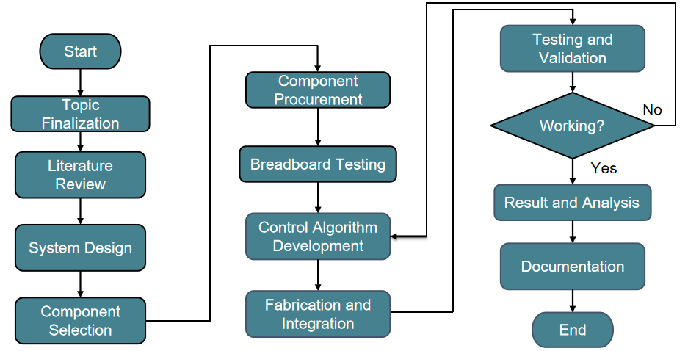
Fig. 1. Methodology followed for the development of the BHMS.
The development process began with problem identification, literature review, component selection, and system-flow planning. After the design stage, the body frame, sensor housing, touchscreen section, and load-cell platform were fabricated. Individual sensor modules were tested and calibrated before integration. Finally, the complete system was tested with users and compared with reference medical-device readings.
IV. PROPOSED SYSTEM
A. System Overview
The BHMS is a kiosk-type prototype designed to measure multiple health parameters in a single guided workflow. The system consists of a sensing unit, control unit, processing unit, display unit, voice-assistance unit, and report-generation unit. The ESP32 collects readings from the sensors, while the Raspberry Pi runs the graphical application, stores records, generates reports, and displays QR codes.
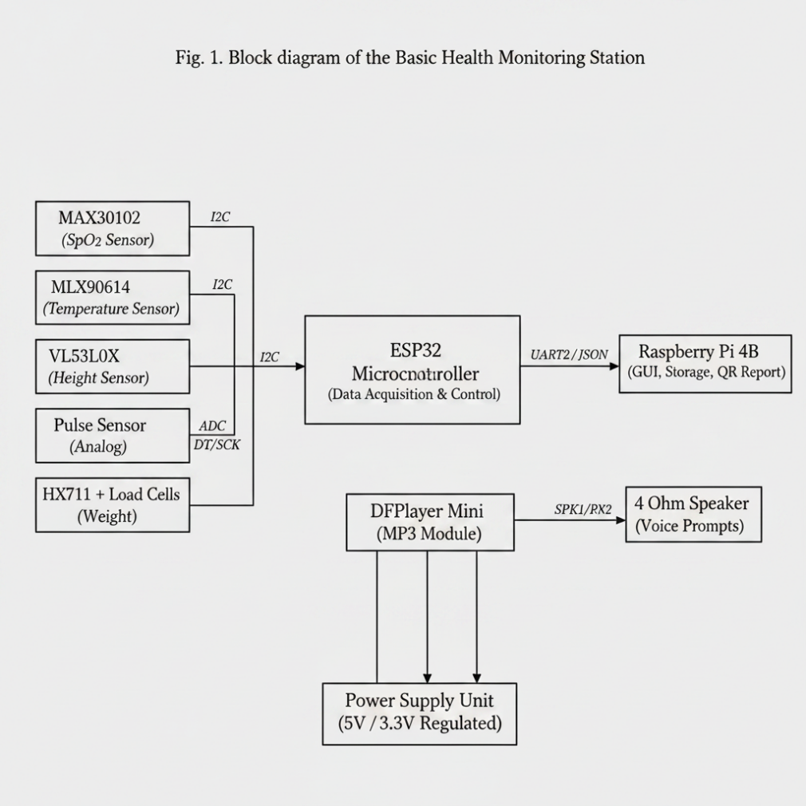
Fig. 2. Overall system architecture of the Basic Health Monitoring Station.
B. Measured Parameters and Workflow
The BHMS takes readings of height, weight, body temperature, oxygen level in blood, pulse rate, and breathing rate. The BMI is determined based on height and weight readings obtained. The work process begins with system initialization, proceeding to measurements guided by instructions, data transfer, calibration corrections, results display, diagnosis, PDF report generation, and QR-coded report retrieval.
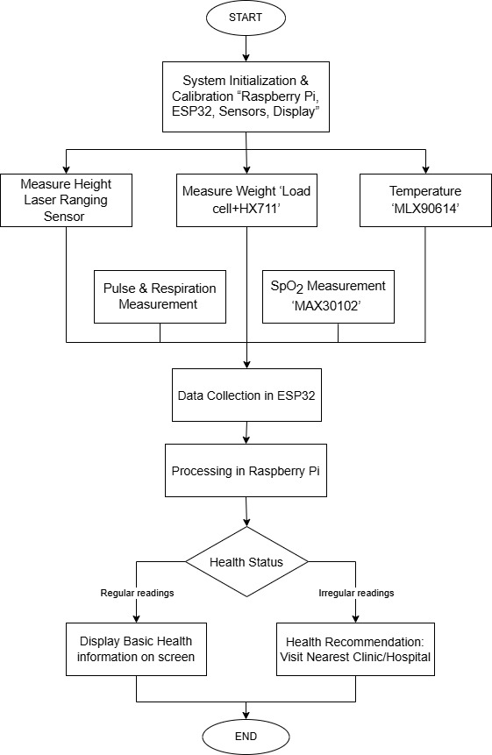
Fig. 3. System flowchart of the proposed BHMS.
V. HARDWARE DESIGN
TABLE I
MAJOR HARDWARE COMPONENTS USED IN THE BHMS
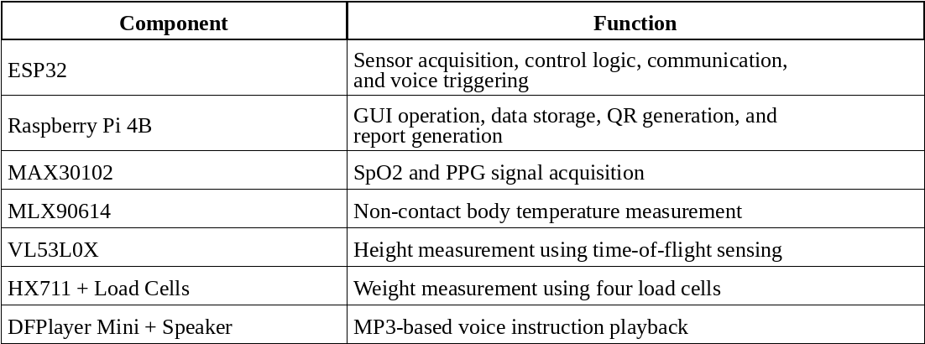
Sensing modules are connected to the ESP32. Data transmission from the MAX30102, MLX90614, and VL53L0X modules will be done via the I2C protocol. Analog pulse sensor module data will be received via the analog pin of the ESP32, whereas the HX711 will connect with ESP32 via DT and SCK pins. Processed data will then be passed by the ESP32 to the Raspberry Pi to display the result and make reports.
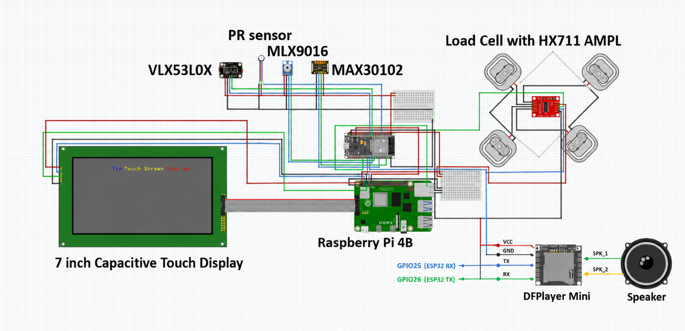
Fig. 4. Updated interconnection diagram including Raspberry Pi 4B, ESP32, sensors, load cell with HX711 amplifier, and capacitive touch display.
The Raspberry Pi and touchscreen form the main load of the system. The system operates using a regulated 5 V supply. Since the final prototype does not include a battery backup, continuous electrical power is required during operation.
VI. PROTOTYPE DEVELOPMENT AND FABRICATION
The system body was designed to position the height sensor, temperature sensor, touchscreen, sensor box, and load-cell platform in suitable locations. The design was revised to improve user comfort and sensor alignment. The height measurement structure was designed with a fixed vertical reference, while the sensor box was placed at a convenient hand position.
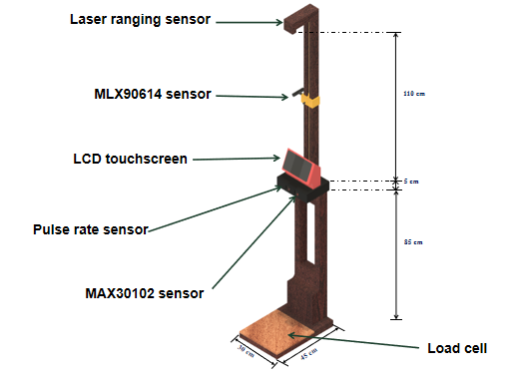
Fig. 5. 3D system model showing the body frame and sensor placement.
Several parts were developed through 3D printing, including the sensor box, clamp, clamp screw, and screen support components. These parts were used to hold the sensors and improve the arrangement of the touchscreen and measurement modules. The main body frame was fabricated using wood and later modified to improve spacing between the user and the upper sensor section.
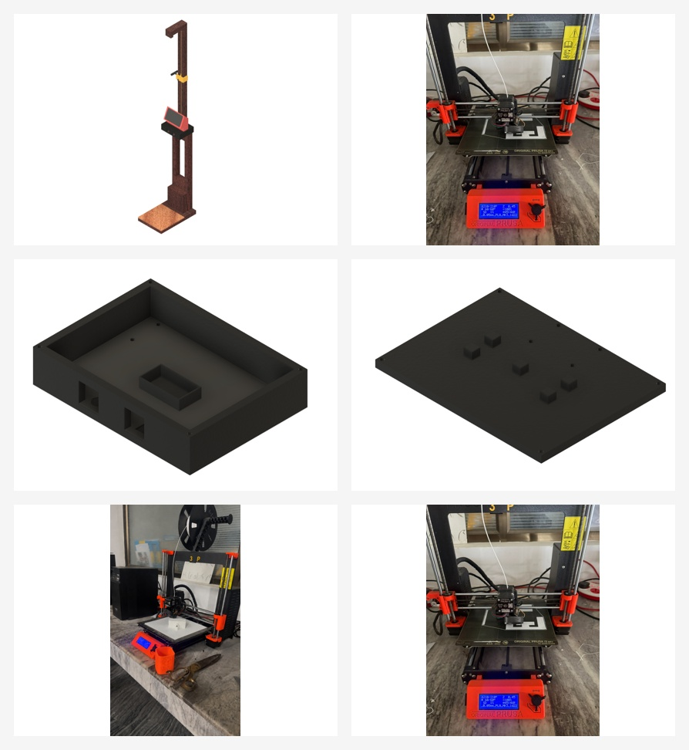
Fig. 6. 3D-printed sensor box, covers, and customized prototype components.
After fabrication, the sensors, touchscreen, Raspberry Pi, ESP32, power supply, DFPlayer Mini, speaker, load-cell platform, and wiring were assembled into the system body. The final assembly produced an upright prototype suitable for user testing and infirmary placement.
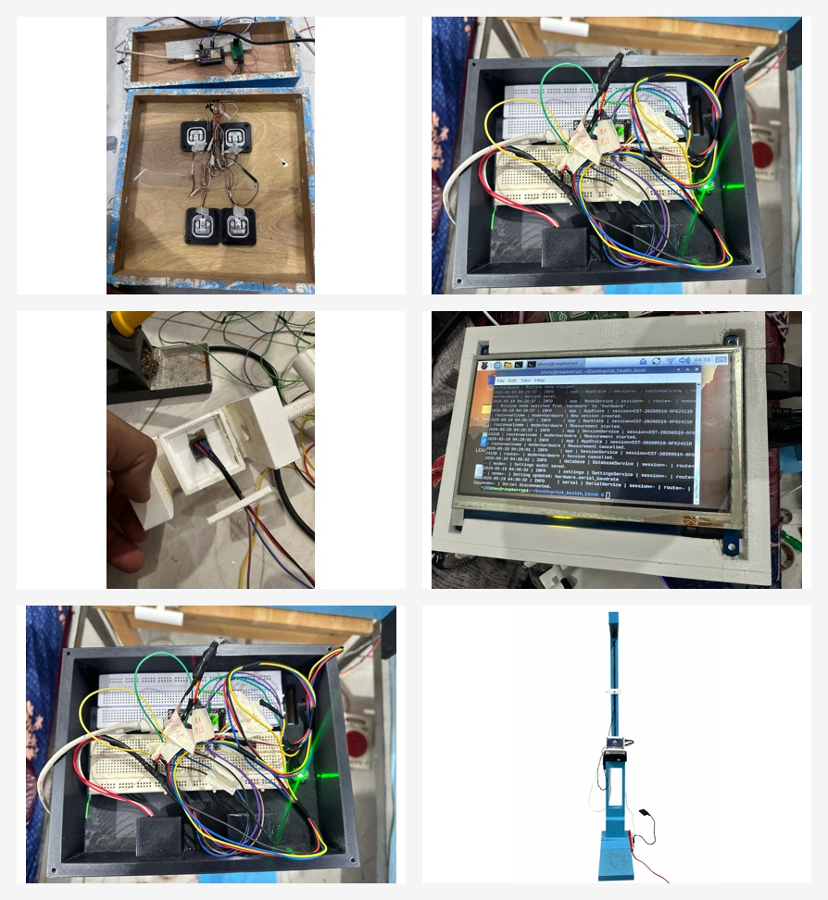
Fig. 7. Assembly activities showing load-cell mounting, internal wiring, touchscreen integration, and the completed prototype.
VII. SOFTWARE DESIGN AND USER INTERFACE
The function of the ESP32 firmware is to read sensor data, calibrate or filter as needed, send data to the Raspberry Pi, and activate voice prompts using the DFPlayer Mini module. On the other hand, the Raspberry Pi executes the kiosk software and handles serial communication with the ESP32, updating the GUI, storing logs, generating health reports in PDF format, showing QR codes, and providing an admin interface.
The BHMS application was uploaded and configured on the Raspberry Pi connected to the 7-inch capacitive touch display. The application was launched on the touchscreen to verify screen compatibility, touch response, button navigation, and display alignment.
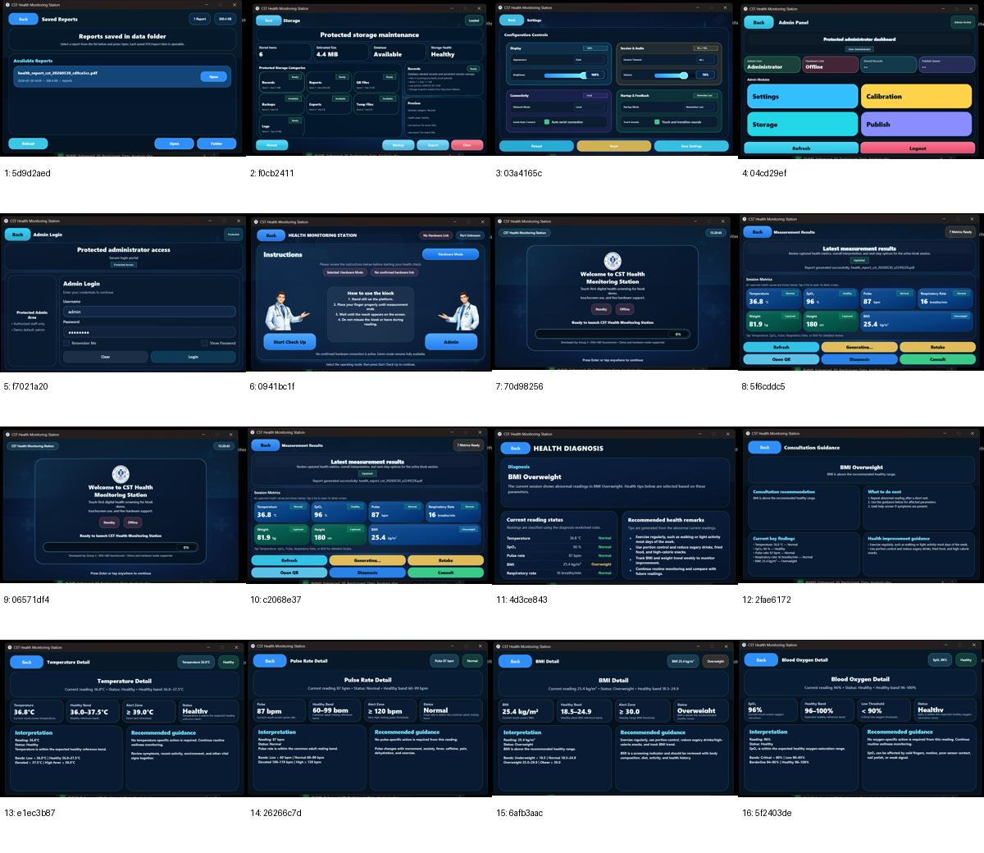
Fig. 8. Main GUI screens of the final BHMS application, including user and administrative screens.
A. Voice-Assisted Measurement Flow
The voice assistance sub-system uses the MP3-TF-16P V3.0 SD card module popularly referred to as DFPlayer Mini and a 3 W, 4 Ohm speaker. The ESP32 issues serial commands for playing the pre-recorded MP3 files for prompts on how to input temperatures, SpO2, pulse rate, weight, height, and the results viewed. This is to enhance convenience when using the device.
B. Reporting and QR Code Generation
Once the measurement process is completed, a PDF report and QR codes are automatically generated. The user is required to use his/her mobile phone with internet connectivity on the given network to scan the QR codes. The report includes session details, parameters tested, health status, diagnosis, recommendations, and emergency instructions.
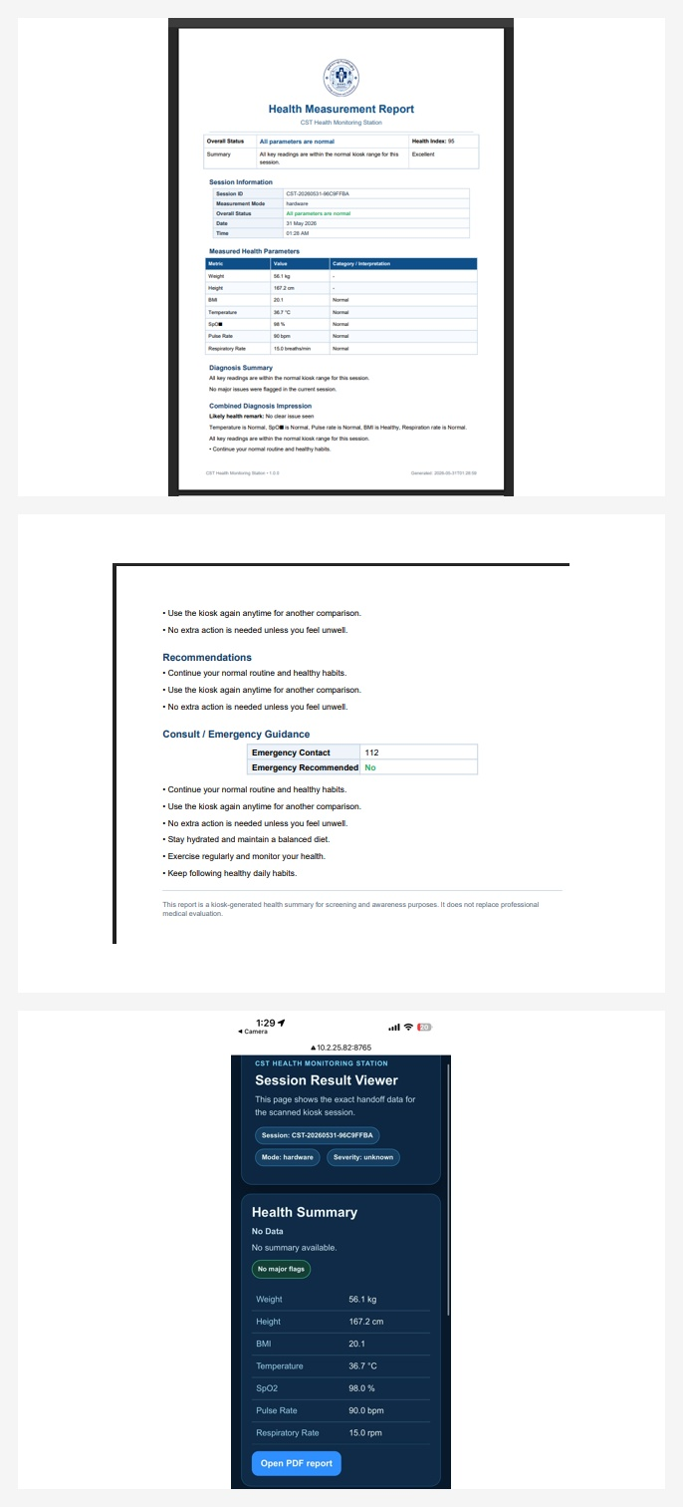
Fig. 9. Generated PDF health report and mobile QR-linked session-result viewer.
VIII. DATA PROCESSING AND CALIBRATION
BMI is calculated using the measured weight and height. The calculation is shown in (1), where W is body weight in kilograms and H is height in meters.
BMI = W / H^2 (1)
The BMI classification used in the system follows underweight, normal, overweight, and obese bands. Other health parameters are classified using predefined screening ranges. The diagnosis logic is intended for preliminary screening and awareness, not for replacing professional medical evaluation.
The load-cell platform uses four 50 kg load cells, giving a total rated capacity of 200 kg. Known weights were applied incrementally from 20 kg to 200 kg, and raw HX711 values were recorded. The raw-to-weight conversion was calculated using linear interpolation, as shown in (2).
W = W1 + ((R - R1)(W2 - W1)) / (R2 - R1) (2)
TABLE II
LOAD CELL CALIBRATION POINTS
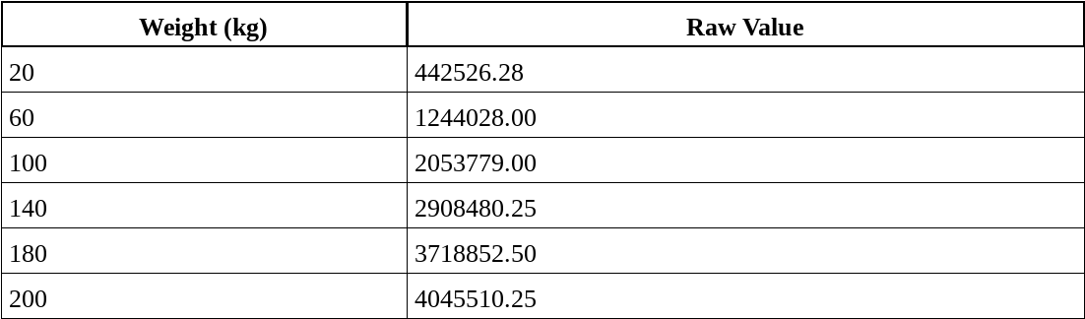
IX. INTEGRATED TESTING AND INSTALLATION
After individual component testing and calibration, the complete system was integrated. Communication between the ESP32 and Raspberry Pi was tested through serial data transfer. The result screen displayed all seven metrics, and the report, diagnosis, retake, QR, and consultation options were verified.
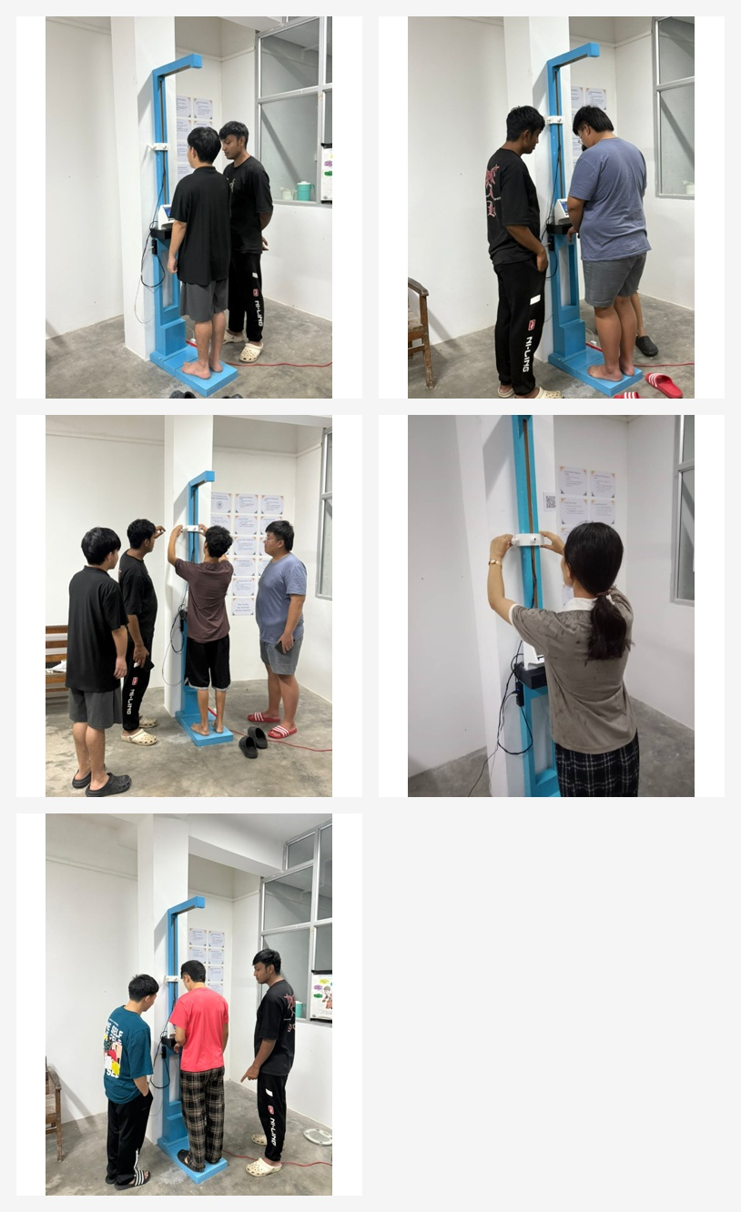
Fig. 10. Actual user-testing photographs showing multiple participants using the BHMS.
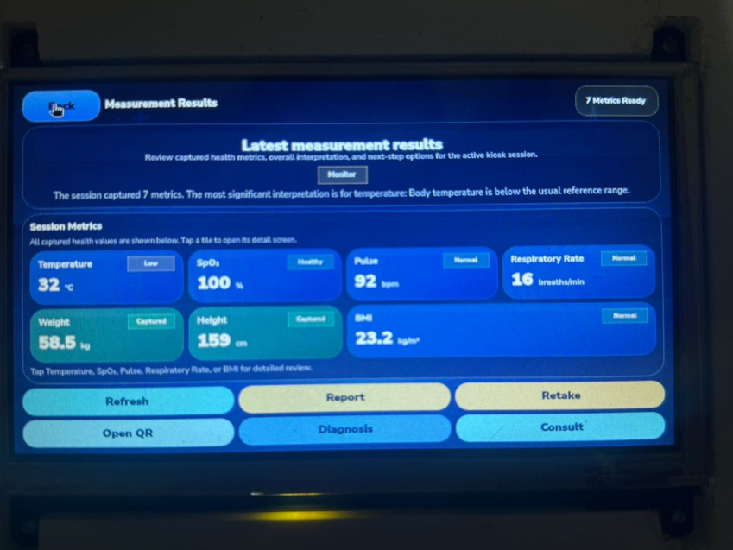
Fig. 11. Measurement-results screen captured during integrated system testing.
Testing and calibration were completed before placing the system in the college infirmary. The system was installed in the infirmary for supervised testing and demonstration. Safety rules and user guidance information were placed near the system to help users follow the correct measurement procedure.
X. RESULTS AND DISCUSSION
A. Error Analysis
Data were collected from both the BHMS and reference medical devices. The medical-device dataset included height, weight, BMI, temperature, and pulse rate measured using separate instruments. The BHMS dataset included height, weight, BMI, temperature, pulse rate, respiratory rate, and SpO2 values recorded from the kiosk application. Measurement time was also recorded for comparing time efficiency.
The signed error, absolute deviation, percentage difference, mean absolute error (MAE), and root mean square error (RMSE) were used to analyze the readings. The main formulas are shown in (3)-(5).
AD_i = |BHMS_i - Medical_i| (3)
MAE = (1/n) Σ |BHMS_i - Medical_i| (4)
RMSE = sqrt((1/n) Σ (BHMS_i - Medical_i)^2) (5)
TABLE III
SUMMARY OF BHMS ERROR ANALYSIS
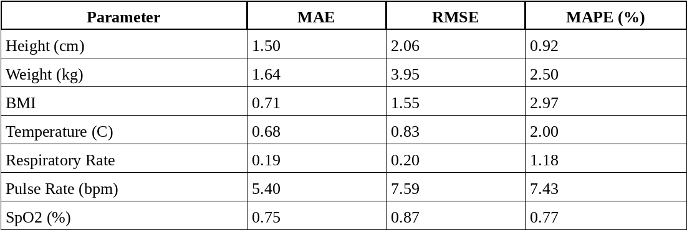
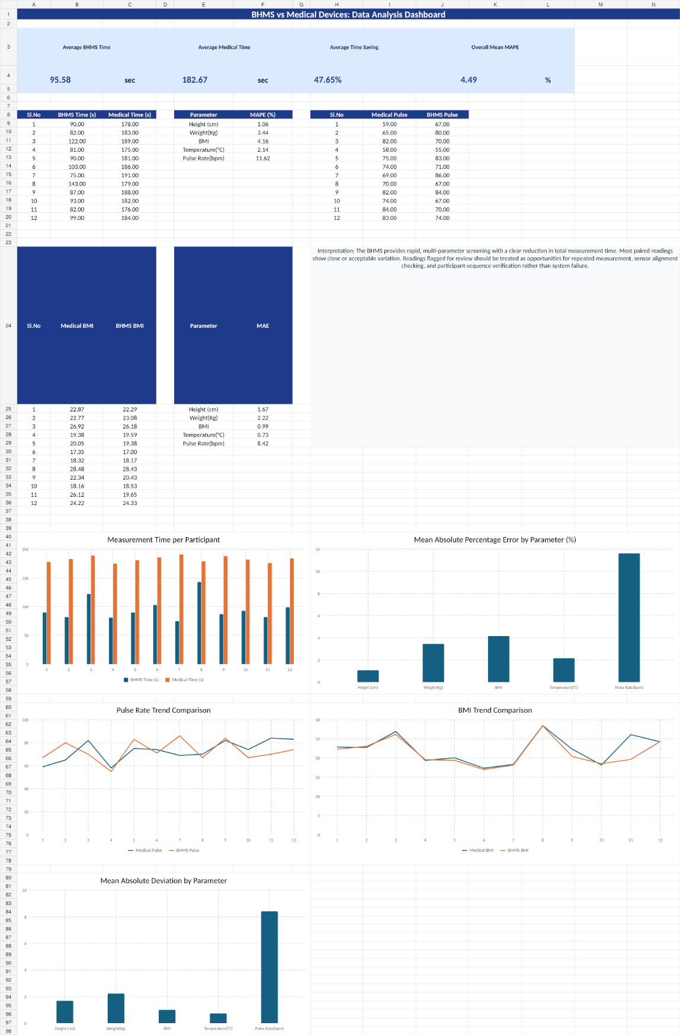
Fig. 12. Dashboard-style summary of BHMS performance and comparison results.
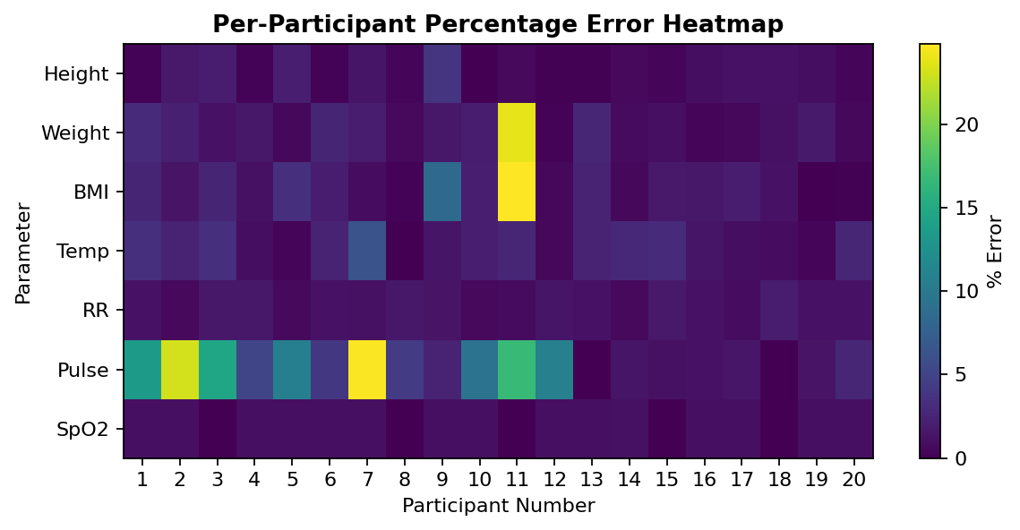
Fig. 13. Per-participant percentage error heatmap prepared from the 20-participant dataset.
B. Time Efficiency
The conventional measurement method requires separate devices and manual recording. The BHMS combines multiple measurements into a single guided workflow. Time saving was calculated using (6).
Time Saving = ((T_medical - T_BHMS) / T_medical) x 100 (6)
TABLE IV
TIME EFFICIENCY COMPARISON
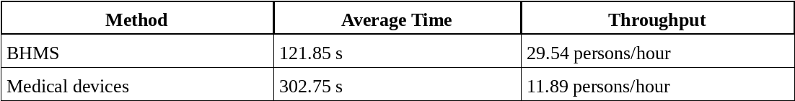
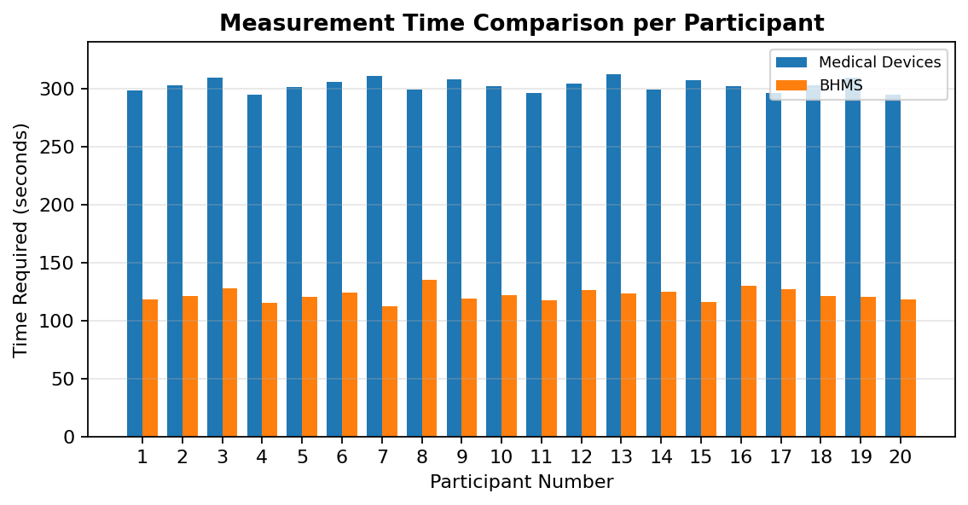
Fig. 14. Measurement time comparison between BHMS and separate medical-device measurement.
C. Cost and Feasibility
The developed BHMS was designed as a low-cost prototype using accessible embedded components and locally fabricated structural parts. The comparison shows that the developed BHMS is more affordable than commercial kiosk-type systems. However, commercial systems may include certified medical-grade sensors, industrial enclosures, cloud services, and manufacturer support. Therefore, the BHMS is suitable as an academic and preliminary screening prototype rather than a certified clinical diagnostic device.
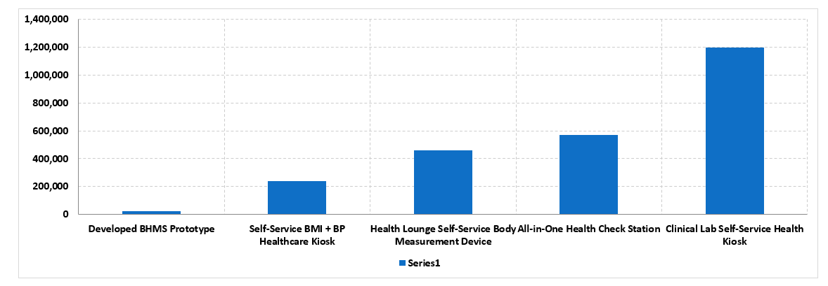
Fig. 15. Cost comparison of the developed BHMS prototype with higher-price reference systems.
XI. CHALLENGES AND LIMITATIONS
Several challenges were encountered during development. Sensor readings required calibration and offset correction. Load-cell values fluctuated before calibration. The height sensor required distance adjustment for accurate height calculation. The body frame required alteration to improve user comfort, sensor alignment, and stability. Pulse reading was sensitive to finger placement and movement.
The system also has limitations. The dataset size is limited for clinical validation. Temperature readings can vary with environmental conditions and sensor distance. Pulse readings may fluctuate due to user movement and contact pressure. The Raspberry Pi requires continuous power because a battery backup was not integrated. Therefore, the system is intended for preliminary screening and educational use, not clinical diagnosis.
XII. CONCLUSION AND FUTURE WORK
In this paper, we explored the designing and development process of the voice-assisted Basic Health Monitoring Station for multi-parameter health screening. The system was designed with the combination of ESP32, Raspberry Pi, PyQt-GUI, QR-code generating report, local storage facility, and DFPlayer Mini for voice assistance. The completed prototype includes measurement for height, weight, BMI, temperature, SpO2 level, pulse rate, and respiratory rate.

The project was successfully executed from design to fabrication, 3D printing, modifying the body frame, assembling the components, calibrating, combined testing, uploading an application, collecting and analyzing the data, and installing in the infirmary of the college campus. The test results indicated that the BHMS is able to perform rapid health screening through a single process. Future improvements can include measuring blood pressure, ECG, glucose levels, cloud storage, accessing mobile application, multilingual voice assistance, AI interpretation, and battery-powered operation.
ACKNOWLEDGMENT
In this regard, the authors wish to sincerely acknowledge the Department of Instrumentation and Control Engineering, College of Science and Technology, Royal University of Bhutan, for granting them this chance of undertaking the project as their final year project. The authors would also like to extend their heartfelt appreciation to Mrs. Karma Kelzang Eudon, the guide for their project, and Mr. Kinley Penjor, their external guide for their help and advice.
REFERENCES
[1] AAST, "Patient assessment and vital signs measurement and documentation," AAST Technical Guideline, 2022.
[2] E. C. Abana, C. Llamelo, T. B. Dana, R. Cafugauan, N. A. Malpaya, and A. C. Maramag, "BMI assessment machine with recommended ideal weight," International Journal of Advanced Trends in Computer Science and Engineering, vol. 9, no. 3, pp. 4163-4167, 2020.
[3] Analog Devices, "MAX30102 high-sensitivity pulse oximeter and heart-rate sensor for wearable health: Data sheet," n.d.
[4] Avia Semiconductor, "HX711: 24-bit analog-to-digital converter for weigh scales: Data sheet," n.d.
[5] M. Chavan, P. Pardeshi, S. A. Khoje, and M. Patil, "Study of health monitoring system," in Proc. Second International Conference on Intelligent Computing and Control Systems, pp. 1779-1782, 2018.
[6] Cleveland Clinic, "Vital signs," 2025.
[7] S. Dhingra, M. Sharma, H. Arora, A. Misra, and S. Nayak, "Real-time vital signs monitoring system," International Journal of Engineering Research and Technology, vol. 8, no. 6, pp. 800-803, 2019.
[8] eMedicineHealth, "What is a good oxygen rate by age? Causes, symptoms and chart," 2021.
[9] O. M. Horsfall and M. Yaabari, "Automated body mass index assessment device," International Journal of Advances in Engineering and Management, vol. 7, no. 4, pp. 400-404, 2025.
[10] S. Majumder, T. Mondal, and M. J. Deen, "Wearable sensors for remote health monitoring," Sensors, vol. 17, no. 1, p. 130, 2017.
[11] Melexis, "MLX90614 family single and dual zone infrared thermometer in TO-39: Data sheet," n.d.
[12] H. Mondal, S. Mondal, and C. Baidya, "Competency in home body fat monitoring by portable devices based on bioelectrical impedance analysis: A pilot study," Journal of Education and Health Promotion, vol. 8, Article 223, 2019.
[13] O. P. Olajide, K. A. Musiliyu, O. A. Alao, and I. E. Owolabi, "Development, implementation and usage of an automated body mass index (ABMI) system," Global Scientific Journals, vol. 8, no. 2, pp. 5404-5416, 2020.
[14] A. Pantelopoulos and N. G. Bourbakis, "A survey on wearable sensor-based systems for health monitoring and prognosis," IEEE Trans. Systems, Man, and Cybernetics, Part C, vol. 40, no. 1, pp. 1-12, 2010.
[15] Raspberry Pi Foundation, "Raspberry Pi 4 Model B specifications," n.d.
[16] STMicroelectronics, "VL53L0X time-of-flight ranging sensor: Data sheet," n.d.
[17] World Health Organization, "Body mass index - BMI," n.d.
[18] World Health Organization, "Noncommunicable diseases," 2023.

