**Loops**

In Python two key constructs that are used to create loops are ‘for’ and ‘while’.

Both of them come with an interesting control known as ‘break’ which is used to prematurely come out of the loop (plz refer to my second example, case 2).

Here is how they work –

**for Loop** – it is used to iterate over the known sequence e.g. – list, range of numbers etc.

**Scenario 1** – Findout the square of first 20 natural numbers

Here we know the iterator has to run 20 times and do the square of each number hence we can safely write a for loop and will know the efficiency before hand.

**while Loop** – it is used to repeatedly execute a block of code up until a certain predefined condition often termed as “termination condition” is False. While loops are employed when each iteration depends upon a dynamic termination condition.

While loops require an extra compute to calculate the termination condition.

**Scenario 2** – creating a simple login program which accepts username and password and authenticate the request.

Here we don’t know how many attempts a user would take to input the correct username and password so first we set the max_attempts variable and then run a while loop to check if the login attempts are well within the allowed attempts (max_attempt).

In every while iteration an if block will check for correct username and password and when it is found the break statement will break out of the loop.

**Case 1**: 3 wrong tries –

We have a while loop that keeps a check on the login attempts and make sure it doesn’t go beyond 3 and with every pass the termination variable (login_counter) in incremented by 1.

And as soon as the user enters 3 incorrect usernames or passwords, the system comes out of the loop and returns the locked out message back on screen.

**Case 2**. 1 wrong try

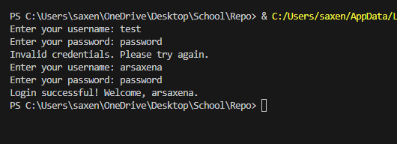

Here in the while loop my if statement checks for the username and password’s correctness in every pass and break statement is executed in the while loop because it found the correct match on the second try.