**Node.js Express and MongoDB: Login and Registration example**

[Last modified: May 19, 2022](https://www.bezkoder.com/node-js-express-login-mongodb/)  [bezkoder](https://www.bezkoder.com/author/bezkoder/)  [Node.js](https://www.bezkoder.com/category/node-js/), [Security](https://www.bezkoder.com/category/security/)

In this tutorial, we’re gonna build a Node.js Express Login and Registration Rest API example that supports JWT ([JSONWebToken](https://www.npmjs.com/package/jsonwebtoken)) and works with MongoDB database using Mongoose ODM. You’ll know:

* Appropriate Flow for User Login and Registration with JWT Authentication
* Node.js Express Architecture with CORS, Authentication & Authorization middlewares & Sequelize
* How to configure Express routes to work with JWT
* How to define Data Models and association for Authentication and Authorization
* Way to use Mongoose ODM to interact with MongoDB Database

Related Posts:  
– [Node.js & MongoDB: JWT Refresh Token example](https://bezkoder.com/jwt-refresh-token-node-js-mongodb/)  
– [MERN stack Authentication example](https://bezkoder.com/react-node-mongodb-auth/)  
– [MEAN stack Authentication with Angular 8 example](https://bezkoder.com/mean-stack-authentication-angular-8/)  
– [MEAN stack Authentication with Angular 10 example](https://bezkoder.com/mean-stack-authentication-angular-10/)  
– [MEAN stack Authentication with Angular 11 example](https://bezkoder.com/mean-stack-authentication-angular-11/)  
– [MEAN stack Authentication with Angular 12 example](https://bezkoder.com/mean-stack-auth-angular-12/)  
– [Node.js, Express & MongoDb: Build a CRUD Rest Api example](https://bezkoder.com/node-express-mongodb-crud-rest-api/)  
– [MongoDB One-to-Many Relationship tutorial with Mongoose examples](https://bezkoder.com/mongoose-one-to-many-relationship/)  
– [MongoDB Many-to-Many Relationship with Mongoose examples](https://bezkoder.com/mongodb-many-to-many-mongoose/)

Deployment: [Docker Compose: Node.js Express and MongoDB example](https://www.bezkoder.com/docker-compose-nodejs-mongodb/)

**Contents**[[hide](https://www.bezkoder.com/node-js-express-login-mongodb/)]

* [Overview](https://www.bezkoder.com/node-js-express-login-mongodb/#Overview)
* [Flow for Login and Registration](https://www.bezkoder.com/node-js-express-login-mongodb/#Flow_for_Login_and_Registration)
* [Node.js Express Login with MongoDB Architecture](https://www.bezkoder.com/node-js-express-login-mongodb/#Nodejs_Express_Login_with_MongoDB_Architecture)
* [Technology](https://www.bezkoder.com/node-js-express-login-mongodb/#Technology)
* [Project Structure](https://www.bezkoder.com/node-js-express-login-mongodb/#Project_Structure)
* [Create Node.js Login with MongoDB App](https://www.bezkoder.com/node-js-express-login-mongodb/#Create_Nodejs_Login_with_MongoDB_App)
* [Setup Express web server](https://www.bezkoder.com/node-js-express-login-mongodb/#Setup_Express_web_server)
* [Configure MongoDB database](https://www.bezkoder.com/node-js-express-login-mongodb/#Configure_MongoDB_database)
* [Define the Mongoose Model](https://www.bezkoder.com/node-js-express-login-mongodb/#Define_the_Mongoose_Model)
* [Initialize Mongoose](https://www.bezkoder.com/node-js-express-login-mongodb/#Initialize_Mongoose)
* [Configure Auth Key](https://www.bezkoder.com/node-js-express-login-mongodb/#Configure_Auth_Key)
* [Create Middleware functions](https://www.bezkoder.com/node-js-express-login-mongodb/#Create_Middleware_functions)
* [Create Controllers](https://www.bezkoder.com/node-js-express-login-mongodb/#Create_Controllers)
  + [Controller for Registration, Login, Logout](https://www.bezkoder.com/node-js-express-login-mongodb/#Controller_for_Registration_Login_Logout)
  + [Controller for testing Authorization](https://www.bezkoder.com/node-js-express-login-mongodb/#Controller_for_testing_Authorization)
* [Define Routes](https://www.bezkoder.com/node-js-express-login-mongodb/#Define_Routes)
* [Run & Test with Results](https://www.bezkoder.com/node-js-express-login-mongodb/#Run_Test_with_Results)
* [Conclusion](https://www.bezkoder.com/node-js-express-login-mongodb/#Conclusion)
* [Further Reading](https://www.bezkoder.com/node-js-express-login-mongodb/#Further_Reading)
* [Source Code](https://www.bezkoder.com/node-js-express-login-mongodb/#Source_Code)

**Overview**

We will build a Node.js Express and MongoDB Login example in that:

* User can signup new account, or login with username & password.
* By role (admin, moderator, user), the User has access to protected resources or not

These are APIs that we need to provide:

| **Methods** | **Urls** | **Actions** |
| --- | --- | --- |
| POST | /api/auth/signup | signup new account |
| POST | /api/auth/signin | login an account |
| POST | /api/auth/signout | logout the account |
| GET | /api/test/all | retrieve public content |
| GET | /api/test/user | access User’s content |
| GET | /api/test/mod | access Moderator’s content |
| GET | /api/test/admin | access Admin’s content |

**Flow for Login and Registration**

Following diagram shows you the flow that we’re gonna implement for User Registration, User Login and Authorization process.

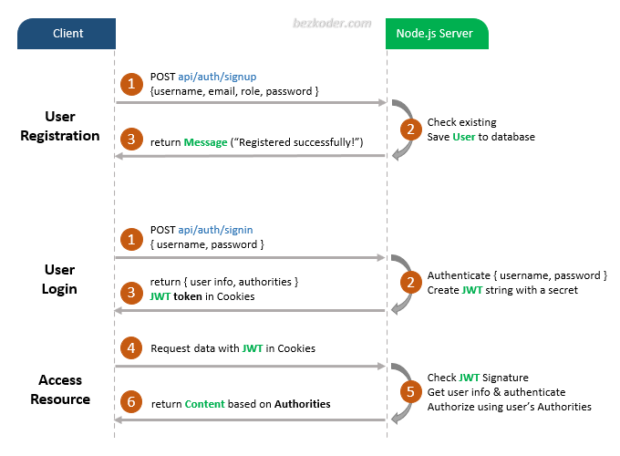

A legal JWT must be stored in **Cookies** if Client accesses protected resources.

**Node.js Express Login with MongoDB Architecture**

Here is an overview of our Node.js Express App:

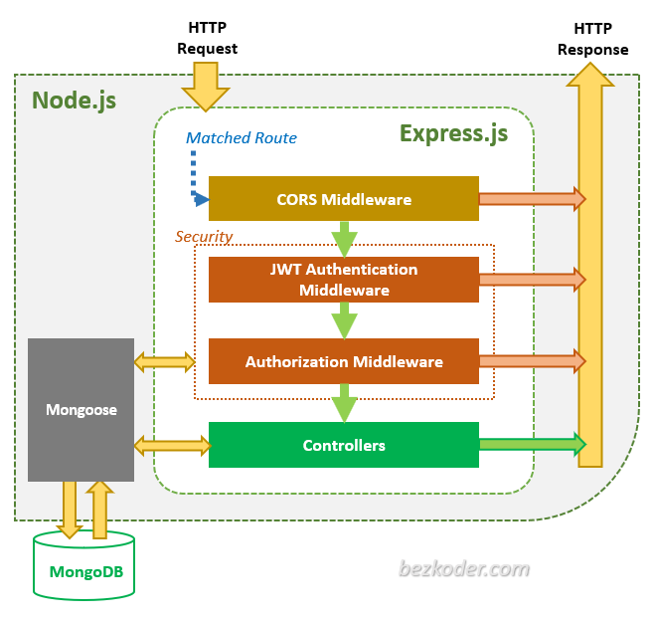

Via *Express* routes, **HTTP request** that matches a route will be checked by **CORS Middleware** before coming to **Security** layer.

**Security** layer includes:

* JWT Authentication Middleware: verify SignUp, verify token
* Authorization Middleware: check User’s roles with record in database

An error message will be sent as HTTP response to Client when the middlewares throw any error, .

**Controllers** interact with MongoDB Database via *Mongoose* library and send **HTTP response** (token, user information, data based on roles…) to Client.

**Technology**

* Express 4.17.1
* cookie-session 1.4.0
* bcryptjs 2.4.3
* jsonwebtoken 8.5.1
* mongoose 5.13.13
* MongoDB

**Project Structure**

This is directory structure for our Node.js Express & MongoDB Login application:

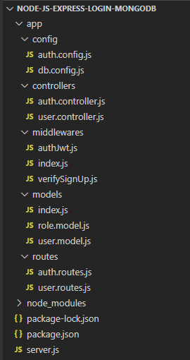

– **config**

* configure MongoDB database
* configure Auth Key

– **routes**

* *auth.routes.js*: POST signup, signin & signout
* *user.routes.js*: GET public & protected resources

– **middlewares**

* *verifySignUp.js*: check duplicate Username or Email
* *authJwt.js*: verify Token, check User roles in database

– **controllers**

* *auth.controller.js*: handle signup, signin & signout actions
* *user.controller.js*: return public & protected content

– **models** for Mongoose Models

* *user.model.js*
* *role.model.js*

– *server.js*: import and initialize necessary modules and routes, listen for connections.

**Create Node.js Login with MongoDB App**

Create a folder for our project with command:

$ mkdir node-js-express-login--mongodb

$ cd node-js-express-login--mongodb

Then we initialize the Node.js App with a *package.json* file:

npm init

name: (node-js-express-login--mongodb)

version: (1.0.0)

description: Node.js Express + MongoDB: Login and Registration example with Mongoose

entry point: (index.js) server.js

test command:

git repository:

keywords: node.js, express, jwt, login, registration, authentication, authorization, mongodb, mongoose

author: bezkoder

license: (ISC)

Is this ok? (yes) yes

Let’s install necessary modules such as: express, cors, cookie-session, mongoose, jsonwebtoken and bcryptjs.  
Run the command:

npm install express mongoose cors cookie-session jsonwebtoken bcryptjs --save

Check *package.json* file, you can see it looks like this:

{

"name": "node-js-jwt-auth-mongodb",

"version": "1.0.0",

"description": "Node.js + MongoDB: JWT Authentication & Authorization",

"main": "server.js",

"scripts": {

"test": "echo \"Error: no test specified\" && exit 1"

},

"keywords": [

"node.js",

"express",

"jwt",

"login",

"registration",

"authentication",

"authorization",

"mongodb",

"mongoose"

],

"author": "bezkoder",

"license": "ISC",

"dependencies": {

"bcryptjs": "^2.4.3",

"cookie-session": "^1.4.0",

"cors": "^2.8.5",

"express": "^4.17.1",

"jsonwebtoken": "^8.5.1",

"mongoose": "^5.13.13"

}

}

**Setup Express web server**

In the root folder, let’s create a new *server.js* file:

const express = require("express");

const cors = require("cors");

const cookieSession = require("cookie-session");

const app = express();

var corsOptions = {

origin: "http://localhost:8081"

};

app.use(cors(corsOptions));

// parse requests of content-type - application/json

app.use(express.json());

// parse requests of content-type - application/x-www-form-urlencoded

app.use(express.urlencoded({ extended: true }));

app.use(

cookieSession({

name: "bezkoder-session",

secret: "COOKIE_SECRET", // should use as secret environment variable

httpOnly: true

})

);

// simple route

app.get("/", (req, res) => {

res.json({ message: "Welcome to KVCET application." });

});

// set port, listen for requests

const PORT = process.env.PORT || 8080;

app.listen(PORT, () => {

console.log(`Server is running on port ${PORT}.`);

});

Let me explain what we’ve just done:  
– import express, cookie-session and cors modules:

* Express is for building the Rest apis
* [cookie-session](https://www.npmjs.com/package/cookie-session) helps to stores the session data on the client within a cookie without requiring any database/resources on the server side
* [cors](https://www.npmjs.com/package/cors) provides Express middleware to enable CORS

– create an Express app, then add request parsing, cookie-based session middleware and cors middlewares using app.use() method. Notice that we set origin: http://localhost:8081.  
– define a GET route which is simple for test.  
– listen on port 8080 for incoming requests.

Let’s talk about following code:

app.use(

cookieSession({

name: "bezkoder-session",

// keys: ['key1', 'key2'],

secret: "COOKIE_SECRET", // should use as secret environment variable

httpOnly: true

})

);

* keys: sign & verify cookie values. Set cookies are always signed with keys[0], while the other keys are valid for verification, allowing for key rotation.
* secret: we don’t provide keys, so we use this as single key. In practice, you must provide value as secret environment variable (.env file for example) for security.
* httpOnly: indicate that the cookie is only to be sent over HTTP(S), and not made available to client JavaScript.

Now let’s run the app with command: node server.js.  
Open your browser with url <http://localhost:8080/>, you will see:

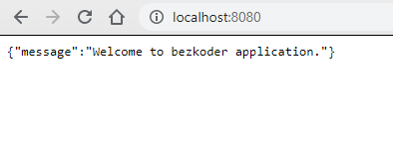

**Configure MongoDB database**

In the **app** folder, create **config** folder for configuration.

Then create a new *db.config.js* file that contains parameters for setting up MongoDB later:

module.exports = {

HOST: "localhost",

PORT: 27017,

DB: "bezkoder_db"

};

**Define the Mongoose Model**

In *models* folder, create User and Role data model as following code:

**models**/*role.model.js*

const mongoose = require("mongoose");

const Role = mongoose.model(

"Role",

new mongoose.Schema({

name: String

})

);

module.exports = Role;

**models**/*user.model.js*

const mongoose = require("mongoose");

const User = mongoose.model(

"User",

new mongoose.Schema({

username: String,

email: String,

password: String,

roles: [

{

type: mongoose.Schema.Types.ObjectId,

ref: "Role"

}

]

})

);

module.exports = User;

These Mongoose Models represents **users** & **roles** collections in MongoDB database.  
User object will have a roles array that contains ids in **roles** collection as reference.

This kind is called *Reference Data Models* or *Normalization*. You can find more details at:  
[MongoDB One-to-Many Relationship tutorial with Mongoose examples](https://bezkoder.com/mongoose-one-to-many-relationship/)

After initializing Mongoose, we don’t need to write CRUD functions because Mongoose supports all of them:

* create a new User: object.[save()](https://mongoosejs.com/docs/api/model.html#model_Model-save)
* find a User by id: User.[findById(id)](https://mongoosejs.com/docs/api.html#model_Model.findById)
* find User by email: User.[findOne](https://mongoosejs.com/docs/api.html#model_Model.findOne)({ email: … })
* find User by username: User.findOne({ username: … })
* find all Roles which name in given roles array: Role.[find](https://mongoosejs.com/docs/api.html#model_Model.find)({ name: { $in: roles } })

These functions will be used in our Controllers and Middlewares.

**Initialize Mongoose**

Now create **app**/**models**/*index.js* with content like this:

const mongoose = require('mongoose');

mongoose.Promise = global.Promise;

const db = {};

db.mongoose = mongoose;

db.user = require("./user.model");

db.role = require("./role.model");

db.ROLES = ["user", "admin", "moderator"];

module.exports = db;

Open *server.js* and add following code to open Mongoose connection to MongoDB database:

...

const app = express();

app.use(...);

const db = require("./app/models");

const Role = db.role;

db.mongoose

.connect(`mongodb://${dbConfig.HOST}:${dbConfig.PORT}/${dbConfig.DB}`, {

useNewUrlParser: true,

useUnifiedTopology: true

})

.then(() => {

console.log("Successfully connect to MongoDB.");

initial();

})

.catch(err => {

console.error("Connection error", err);

process.exit();

});

...

function initial() {

Role.estimatedDocumentCount((err, count) => {

if (!err && count === 0) {

new Role({

name: "user"

}).save(err => {

if (err) {

console.log("error", err);

}

console.log("added 'user' to roles collection");

});

new Role({

name: "moderator"

}).save(err => {

if (err) {

console.log("error", err);

}

console.log("added 'moderator' to roles collection");

});

new Role({

name: "admin"

}).save(err => {

if (err) {

console.log("error", err);

}

console.log("added 'admin' to roles collection");

});

}

});

}

initial() function helps us to create 3 important rows in roles collection.

**Configure Auth Key**

**jsonwebtoken** functions such as verify() or sign() use algorithm that needs a secret key (as String) to encode and decode token.

In the **app**/**config** folder, create *auth.config.js* file with following code:

module.exports = {

secret: "bezkoder-secret-key"

};

You can create your own secret String.

**Create Middleware functions**

To verify a Signup action, we need 2 functions:  
– check duplications for username and email  
– check if roles in the request is legal or not

**middlewares**/*verifySignUp.js*

const db = require("../models");

const ROLES = db.ROLES;

const User = db.user;

checkDuplicateUsernameOrEmail = (req, res, next) => {

// Username

User.findOne({

username: req.body.username

}).exec((err, user) => {

if (err) {

res.status(500).send({ message: err });

return;

}

if (user) {

res.status(400).send({ message: "Failed! Username is already in use!" });

return;

}

// Email

User.findOne({

email: req.body.email

}).exec((err, user) => {

if (err) {

res.status(500).send({ message: err });

return;

}

if (user) {

res.status(400).send({ message: "Failed! Email is already in use!" });

return;

}

next();

});

});

};

checkRolesExisted = (req, res, next) => {

if (req.body.roles) {

for (let i = 0; i < req.body.roles.length; i++) {

if (!ROLES.includes(req.body.roles[i])) {

res.status(400).send({

message: `Failed! Role ${req.body.roles[i]} does not exist!`

});

return;

}

}

}

next();

};

const verifySignUp = {

checkDuplicateUsernameOrEmail,

checkRolesExisted

};

module.exports = verifySignUp;

To process Authentication & Authorization, we create following functions:  
- check if token is provided, legal or not. We get token from HTTP request session, then use **jsonwebtoken**'s verify() function  
- check if roles of the user contains required role or not

**middlewares**/*authJwt.js*

const jwt = require("jsonwebtoken");

const config = require("../config/auth.config.js");

const db = require("../models");

const User = db.user;

const Role = db.role;

verifyToken = (req, res, next) => {

let token = req.session.token;

if (!token) {

return res.status(403).send({ message: "No token provided!" });

}

jwt.verify(token, config.secret, (err, decoded) => {

if (err) {

return res.status(401).send({ message: "Unauthorized!" });

}

req.userId = decoded.id;

next();

});

};

isAdmin = (req, res, next) => {

User.findById(req.userId).exec((err, user) => {

if (err) {

res.status(500).send({ message: err });

return;

}

Role.find(

{

_id: { $in: user.roles },

},

(err, roles) => {

if (err) {

res.status(500).send({ message: err });

return;

}

for (let i = 0; i < roles.length; i++) {

if (roles[i].name === "admin") {

next();

return;

}

}

res.status(403).send({ message: "Require Admin Role!" });

return;

}

);

});

};

isModerator = (req, res, next) => {

User.findById(req.userId).exec((err, user) => {

if (err) {

res.status(500).send({ message: err });

return;

}

Role.find(

{

_id: { $in: user.roles },

},

(err, roles) => {

if (err) {

res.status(500).send({ message: err });

return;

}

for (let i = 0; i < roles.length; i++) {

if (roles[i].name === "moderator") {

next();

return;

}

}

res.status(403).send({ message: "Require Moderator Role!" });

return;

}

);

});

};

const authJwt = {

verifyToken,

isAdmin,

isModerator,

};

module.exports = authJwt;

**middlewares**/*index.js*

const authJwt = require("./authJwt");

const verifySignUp = require("./verifySignUp");

module.exports = {

authJwt,

verifySignUp

};

**Create Controllers**

**Controller for Registration, Login, Logout**

There are 3 main functions for Authentication:  
- signup: create new User in MongoDB database (role is **user** if not specifying role)  
- signin:

* find username of the request in database, if it exists
* compare password with password in database using **bcrypt**, if it is correct
* generate a token using **jsonwebtoken**
* return user information & access Token

- signout: clear current session.

**controllers**/*auth.controller.js*

const config = require("../config/auth.config");

const db = require("../models");

const User = db.user;

const Role = db.role;

var jwt = require("jsonwebtoken");

var bcrypt = require("bcryptjs");

exports.signup = (req, res) => {

const user = new User({

username: req.body.username,

email: req.body.email,

password: bcrypt.hashSync(req.body.password, 8),

});

user.save((err, user) => {

if (err) {

res.status(500).send({ message: err });

return;

}

if (req.body.roles) {

Role.find(

{

name: { $in: req.body.roles },

},

(err, roles) => {

if (err) {

res.status(500).send({ message: err });

return;

}

user.roles = roles.map((role) => role._id);

user.save((err) => {

if (err) {

res.status(500).send({ message: err });

return;

}

res.send({ message: "User was registered successfully!" });

});

}

);

} else {

Role.findOne({ name: "user" }, (err, role) => {

if (err) {

res.status(500).send({ message: err });

return;

}

user.roles = [role._id];

user.save((err) => {

if (err) {

res.status(500).send({ message: err });

return;

}

res.send({ message: "User was registered successfully!" });

});

});

}

});

};

exports.signin = (req, res) => {

User.findOne({

username: req.body.username,

})

.populate("roles", "-__v")

.exec((err, user) => {

if (err) {

res.status(500).send({ message: err });

return;

}

if (!user) {

return res.status(404).send({ message: "User Not found." });

}

var passwordIsValid = bcrypt.compareSync(

req.body.password,

user.password

);

if (!passwordIsValid) {

return res.status(401).send({ message: "Invalid Password!" });

}

var token = jwt.sign({ id: user.id }, config.secret, {

expiresIn: 86400, // 24 hours

});

var authorities = [];

for (let i = 0; i < user.roles.length; i++) {

authorities.push("ROLE_" + user.roles[i].name.toUpperCase());

}

req.session.token = token;

res.status(200).send({

id: user._id,

username: user.username,

email: user.email,

roles: authorities,

});

});

};

exports.signout = async (req, res) => {

try {

req.session = null;

return res.status(200).send({ message: "You've been signed out!" });

} catch (err) {

this.next(err);

}

};

**Controller for testing Authorization**

There are 4 functions:  
– /api/test/all for public access  
– /api/test/user for loggedin users (any role)  
– /api/test/mod for **moderator** users  
– /api/test/admin for **admin** users

**controllers**/*user.controller.js*

exports.allAccess = (req, res) => {

res.status(200).send("Public Content.");

};

exports.userBoard = (req, res) => {

res.status(200).send("User Content.");

};

exports.adminBoard = (req, res) => {

res.status(200).send("Admin Content.");

};

exports.moderatorBoard = (req, res) => {

res.status(200).send("Moderator Content.");

};

Let's combine middlewares with controller functions in the next section.

**Define Routes**

When a client sends request for an endpoint using HTTP request (GET, POST, PUT, DELETE), we need to determine how the server will response by setting up the routes.

We can separate our routes into 2 part: for Authentication and for Authorization (accessing protected resources).

**Authentication:**

* POST /api/auth/signup
* POST /api/auth/signin
* POST /api/auth/signout

**routes**/*auth.routes.js*

const { verifySignUp } = require("../middlewares");

const controller = require("../controllers/auth.controller");

module.exports = function(app) {

app.use(function(req, res, next) {

res.header(

"Access-Control-Allow-Headers",

"Origin, Content-Type, Accept"

);

next();

});

app.post(

"/api/auth/signup",

[

verifySignUp.checkDuplicateUsernameOrEmail,

verifySignUp.checkRolesExisted

],

controller.signup

);

app.post("/api/auth/signin", controller.signin);

app.post("/api/auth/signout", controller.signout);

};

**Authorization:**

* GET /api/test/all
* GET /api/test/user for loggedin users (user/moderator/admin)
* GET /api/test/mod for moderator
* GET /api/test/admin for admin

**routes**/*user.routes.js*

const { authJwt } = require("../middlewares");

const controller = require("../controllers/user.controller");

module.exports = function(app) {

app.use(function(req, res, next) {

res.header(

"Access-Control-Allow-Headers",

"Origin, Content-Type, Accept"

);

next();

});

app.get("/api/test/all", controller.allAccess);

app.get("/api/test/user", [authJwt.verifyToken], controller.userBoard);

app.get(

"/api/test/mod",

[authJwt.verifyToken, authJwt.isModerator],

controller.moderatorBoard

);

app.get(

"/api/test/admin",

[authJwt.verifyToken, authJwt.isAdmin],

controller.adminBoard

);

};

Don't forget to add these routes in *server.js*:

...

// routes

require('./app/routes/auth.routes')(app);

require('./app/routes/user.routes')(app);

// set port, listen for requests

...

**Run & Test with Results**

Run Node.js application with command: node server.js.

The console shows:

Server is running on port 8080.

Successfully connect to MongoDB.

added 'user' to roles collection

added 'admin' to roles collection

added 'moderator' to roles collection

Let's check roles collection in MongoDB database:

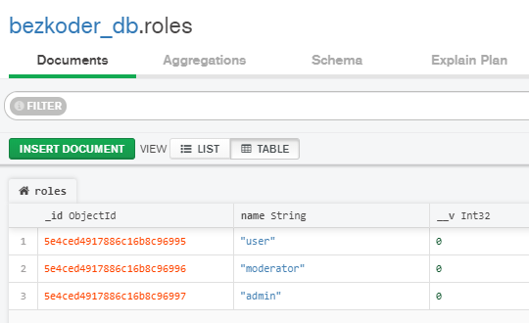

Register some users with /signup API:

* **admin** with admin role
* **mod** with moderator and user roles
* **bezkoder** with user role

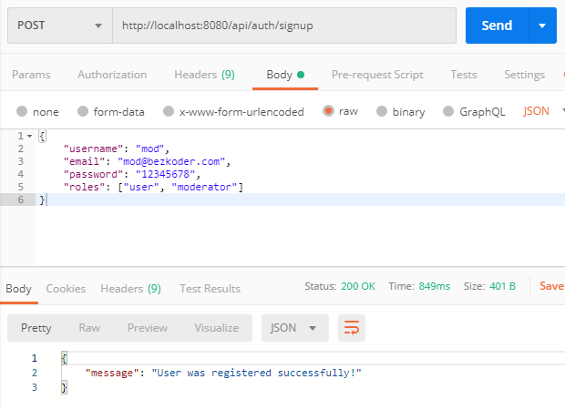

users collection after signup could look like this.

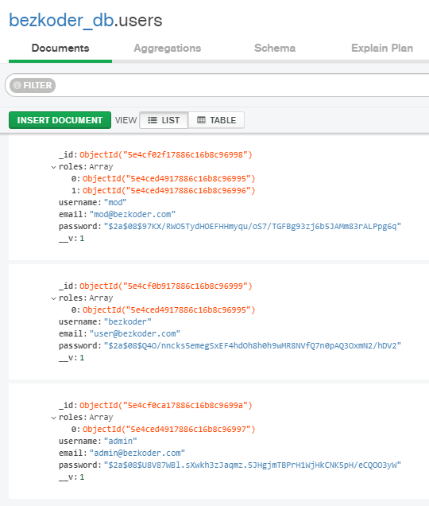

**Access public resource:** GET /api/test/all

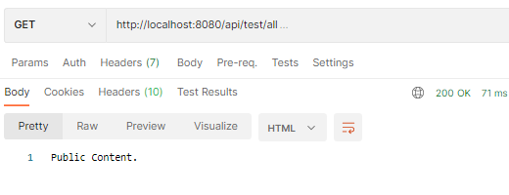

**Access protected resource:** GET /api/test/user

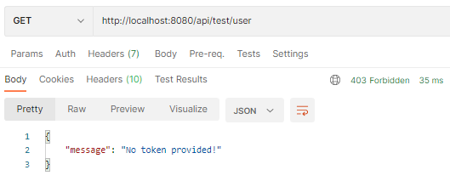

**Login an account (with wrong password):** POST /api/auth/signin

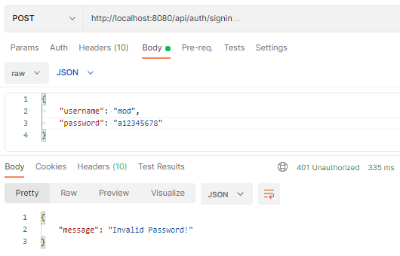

**Login with correct username and password:** POST /api/auth/signin

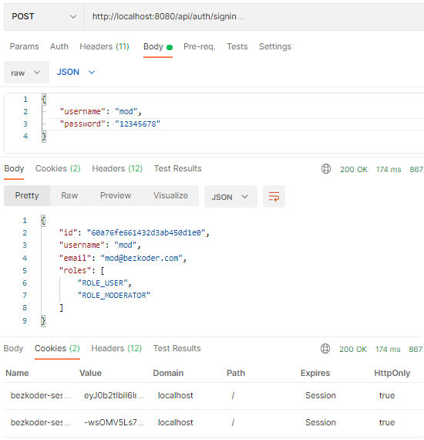

You can check the Cookies with JWT:

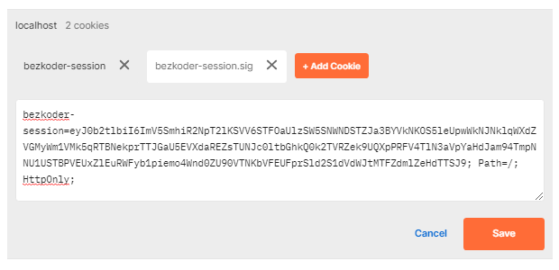

**Access protected resources with legal account:** GET /api/test/user

