MUTUAL FUND ANALYTICS DASHBOARD

Capstone Project I – Mutual Fund Analytics

Submitted By:
Arun Vk

Data Analyst Internship Program



Bluestock Fintech

June 2026

Executive Summary
The Mutual Fund Analytics Dashboard is an end-to-end financial analytics platform developed to assist investors in evaluating mutual fund performance and risk characteristics.

The project integrates data collection, validation, database management, performance analytics, risk assessment, recommendation generation, and dashboard visualization into a unified solution.

Using Python, Pandas, SQLite, Streamlit, Plotly, and Scikit-Learn, the platform enables users to explore mutual funds, analyze performance metrics, evaluate risk indicators, and generate investor-specific recommendations.

The dashboard includes four major modules:

• Fund Explorer
• Performance Analytics
• Risk Analysis
• Recommendation Engine

The final solution was successfully deployed on Streamlit Cloud, enabling users to access the dashboard through a web-based interface.

This project demonstrates practical applications of Data Analytics, Financial Modeling, Database Management, and Dashboard Development in the Fintech domain.

Index
1. Project Overview

2. Problem Statement

3. Objectives

4. Dataset Description

5. Data Pipeline

6. Database Design

7. Analytics Methodology

8. Dashboard Modules

9. Results and Findings

10. Live Dashboard Deployment

11. Conclusion

12. Future Enhancements

13. References

1. Project Overview
The Mutual Fund Analytics Dashboard is a comprehensive financial analytics platform designed to help investors evaluate mutual fund performance, assess investment risks, and identify suitable investment opportunities.

The system integrates data collection, preprocessing, database management, analytical computation, and interactive dashboard visualization into a single solution. Using historical mutual fund data and financial performance metrics, the platform enables users to gain meaningful insights into various mutual fund schemes.

The project demonstrates practical applications of Data Analytics, Financial Modeling, Database Management, and Dashboard Development within the Fintech domain.

2. Problem Statement
Investors often face challenges when comparing mutual funds due to the large volume of available schemes and the complexity of financial metrics. Evaluating returns, risk, and fund performance manually can be time-consuming and prone to errors.

The objective of this project is to develop an automated analytics platform that simplifies mutual fund analysis by providing performance metrics, risk indicators, and personalized recommendations through an interactive dashboard.

3. Objectives
• Collect and process mutual fund datasets.

• Store structured data in a SQLite database.

• Calculate key performance metrics such as CAGR, Sharpe Ratio, Sortino Ratio, and Value at Risk (VaR).

• Analyze risk and return characteristics of mutual funds.

• Develop an interactive dashboard for visualization and exploration.

• Generate investor-specific mutual fund recommendations.

• Deploy the dashboard for public access using Streamlit Cloud.

4. Dataset Description
The project utilizes multiple mutual fund datasets obtained from publicly available financial data sources.

The datasets contain information related to mutual fund schemes, Net Asset Values (NAV), Assets Under Management (AUM), monthly SIP inflows, category-wise fund statistics, investor transactions, portfolio holdings, and benchmark indices.

Key datasets used in the project include:

• Fund Master Dataset
• NAV History Dataset
• AUM by Fund House Dataset
• Monthly SIP Inflows Dataset
• Category Inflows Dataset
• Industry Folio Count Dataset
• Investor Transactions Dataset
• Portfolio Holdings Dataset
• Benchmark Indices Dataset

These datasets were validated, cleaned, transformed, and integrated before being used for analytics and dashboard development.

5. Data Pipeline
The data pipeline was designed to automate the flow of information from raw datasets to analytical outputs.

The pipeline consists of the following stages:

1. Data Ingestion
- Loading raw CSV datasets.

2. Data Validation
- Checking for missing values, duplicates, and data inconsistencies.

3. Data Cleaning
- Standardizing column names and formats.

4. Feature Engineering
- Creating performance and risk-related metrics.

5. Database Storage
- Storing processed data into SQLite.

6. Analytics Computation
- Calculating CAGR, Sharpe Ratio, Sortino Ratio, Volatility, Maximum Drawdown, and Value at Risk.

7. Dashboard Visualization
- Presenting results through Streamlit dashboards.

6. Database Design
SQLite was used as the primary database for storing processed mutual fund data.

The database provides a lightweight and efficient storage solution that supports analytical queries and dashboard integration.

Major database tables include:

• fund_master
• nav_history
• performance_metrics
• category_ranking
• top_recommendations

The database was connected directly to the Streamlit application, enabling real-time querying and visualization of mutual fund analytics.

7. Analytics Methodology
The analytical component of the project focuses on evaluating mutual fund performance and investment risk using widely accepted financial metrics.
The following metrics were computed:

• CAGR (Compound Annual Growth Rate)
- Measures the average annual growth rate of an investment over a specified period.

• Volatility
- Measures the variation in returns and represents investment risk.

• Sharpe Ratio
- Evaluates risk-adjusted return by comparing excess return against total volatility.

• Sortino Ratio
- Measures risk-adjusted return using only downside volatility.

• Maximum Drawdown
- Represents the maximum observed loss from a peak to a trough.

• Value at Risk (VaR)
- Estimates the potential loss that may occur within a specified confidence interval.

The calculated metrics were stored in the database and subsequently used for ranking, risk assessment, and recommendation generation.

8. Dashboard Modules
The Streamlit dashboard consists of four major analytical modules designed to provide investors with an interactive experience.

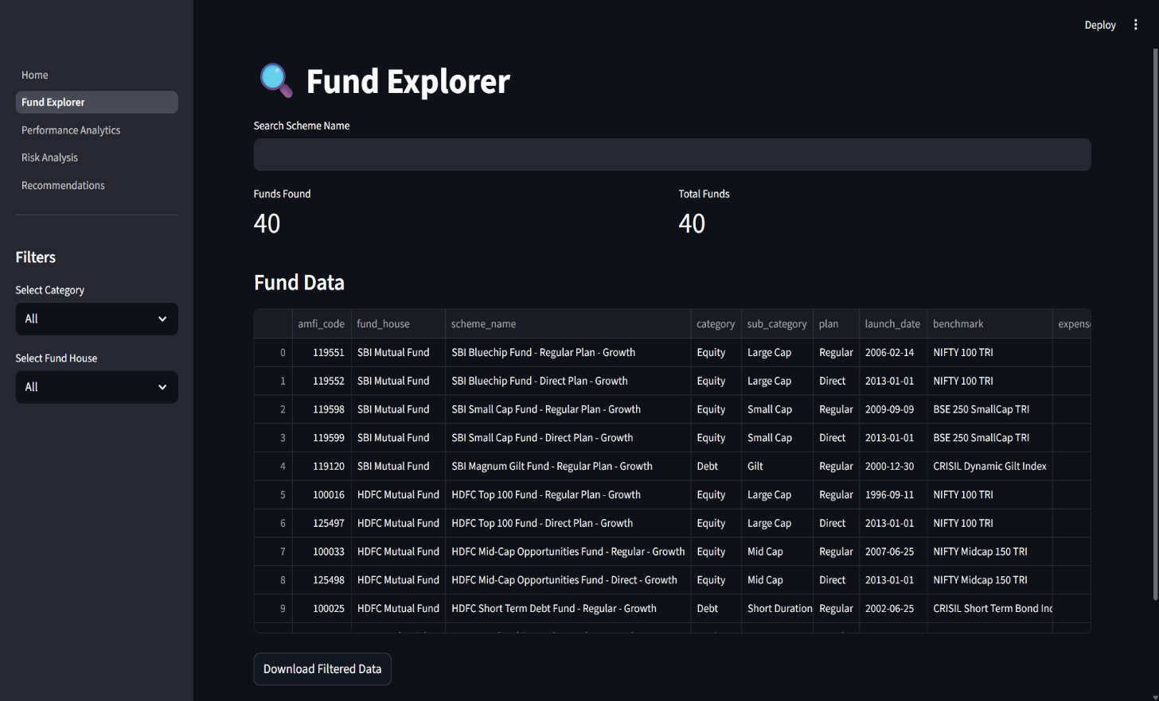
1. Fund Explorer

The Fund Explorer module enables users to search mutual funds, filter schemes by category and fund house, and download filtered results.

2. Performance Analytics
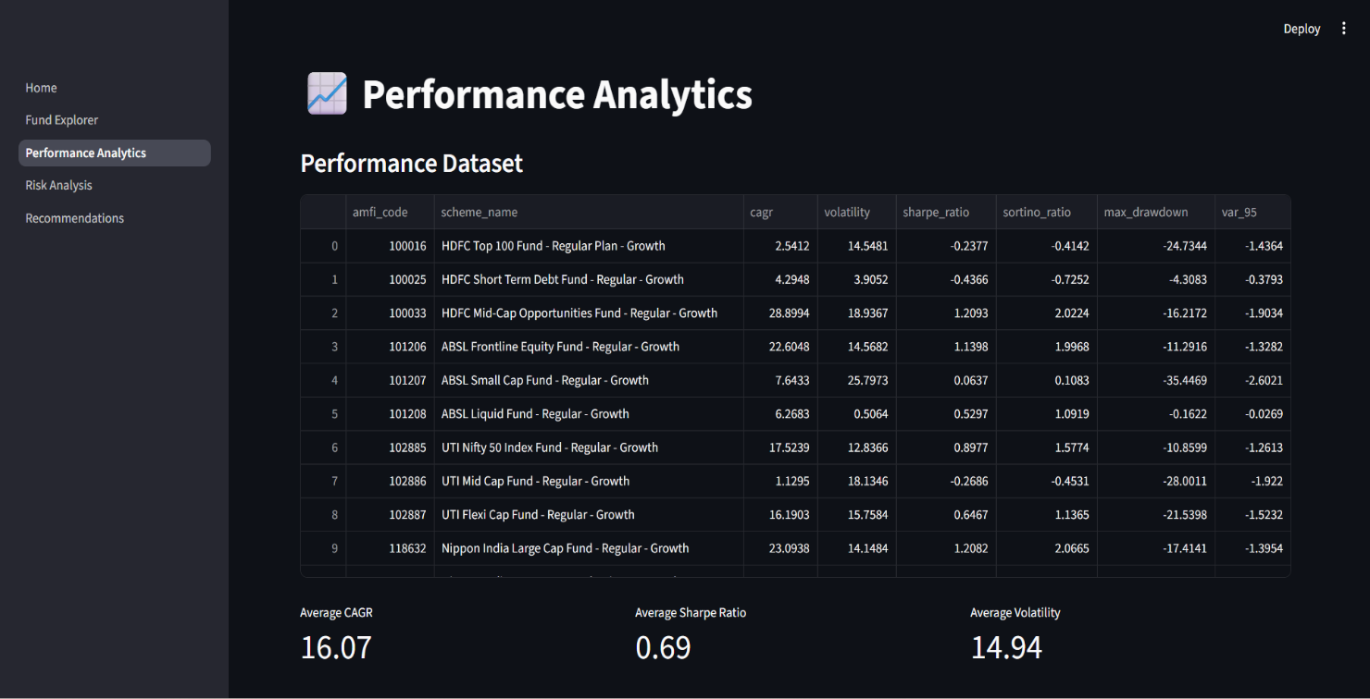
This module presents CAGR, Sharpe Ratio, Sortino Ratio, and performance rankings for various mutual fund schemes.
3. Risk Analysis
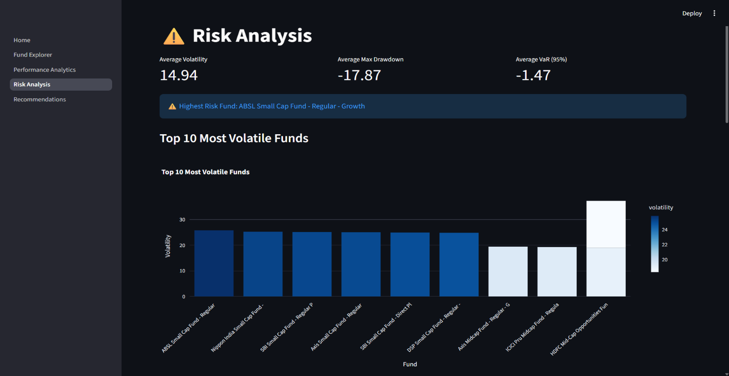
The Risk Analysis module evaluates volatility, maximum drawdown, and Value at Risk to identify high-risk and low-risk investment options.
4. Recommendation Engine
The Recommendation Engine generates fund recommendations for Conservative, Moderate, and Aggressive investor profiles based on calculated financial metrics.
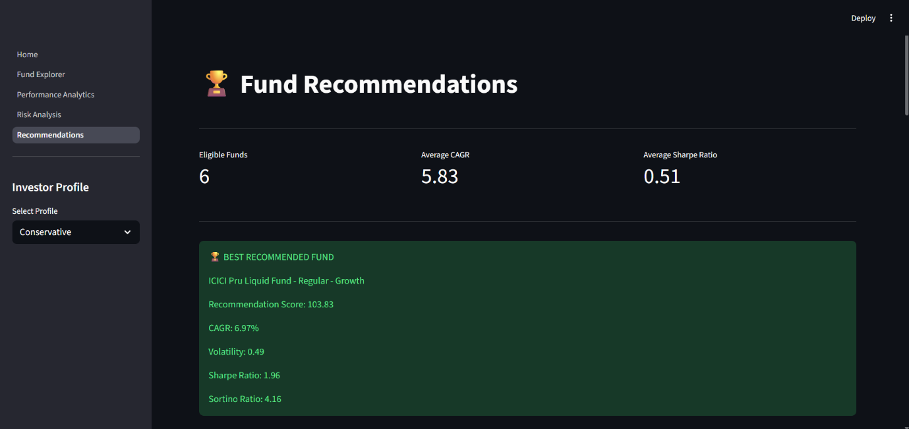
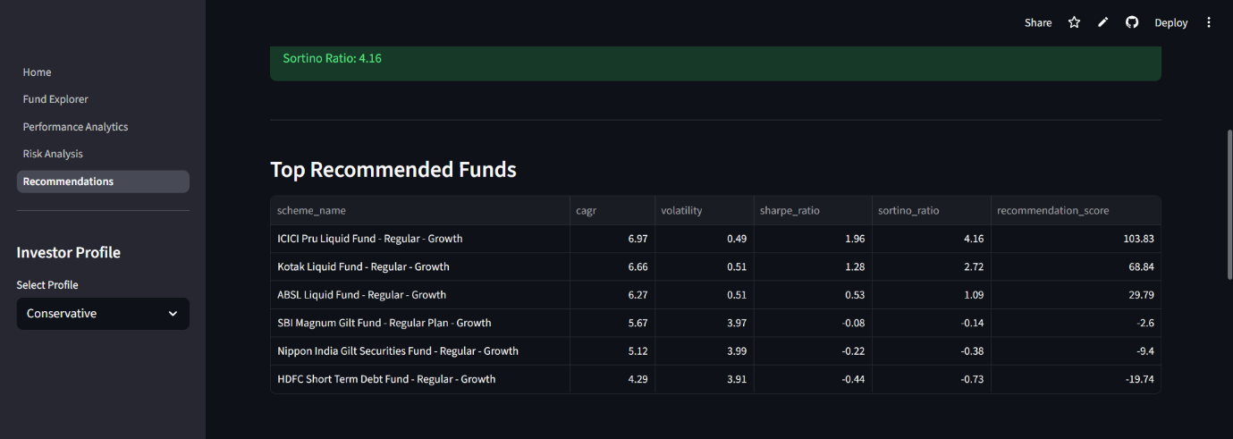
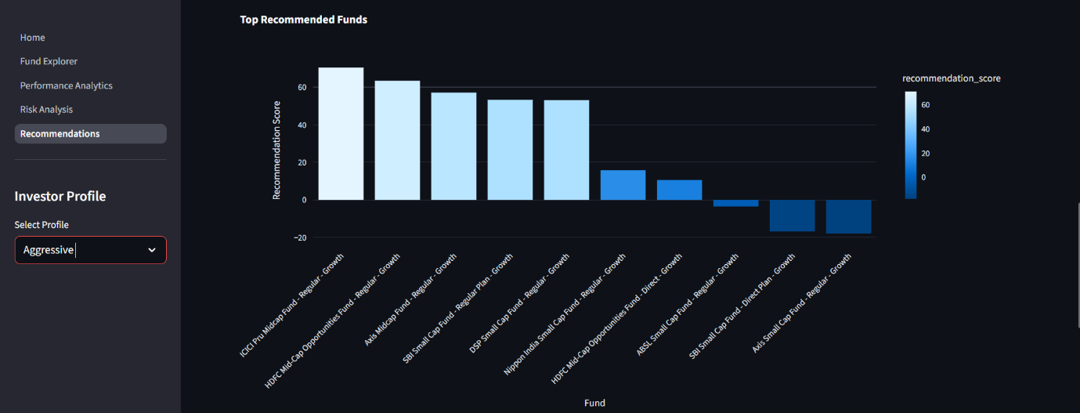
9. Results and Findings
The project successfully generated analytical insights from multiple mutual fund datasets.

Key findings include:

• Several equity-oriented schemes demonstrated CAGR values exceeding 20%, indicating strong long-term growth potential.

• Higher return-generating funds generally exhibited greater volatility, confirming the risk-return tradeoff.

• Sharpe Ratio analysis identified schemes with superior risk-adjusted performance.

• Risk metrics such as Maximum Drawdown and Value at Risk helped identify funds with elevated downside exposure.

• The recommendation engine successfully categorized mutual funds according to investor risk preferences.

• The Streamlit dashboard enabled interactive exploration of performance, risk, and recommendation analytics through a user-friendly web interface.

Overall, the project demonstrated the practical application of data analytics techniques in mutual fund evaluation and investment decision support.

10. Live Dashboard Deployment
The Mutual Fund Analytics Dashboard was successfully deployed on Streamlit Cloud to provide public access through a web-based interface.

Live Dashboard URL:

https://mutualfundanalytics-a5cjfcqbqf5bb9bjydutnb.streamlit.app/

Deployment Features:

• Cloud-hosted dashboard

• Accessible from any modern web browser

• Interactive filtering and visualization

• Real-time analytics display

• Download functionality for processed results

The deployment process involved integrating the SQLite database, Streamlit application, and GitHub repository into a production-ready environment.

The live deployment demonstrates the successful transition of the project from development to a publicly accessible analytical platform.

11. Conclusion

The Mutual Fund Analytics Dashboard successfully integrates data collection, preprocessing, database management, financial analytics, and interactive visualization into a unified platform.

The project provides investors with the ability to evaluate mutual fund performance, assess investment risk, and receive customized recommendations based on their risk profiles.

Using Python, Pandas, SQLite, Plotly, Scikit-Learn, and Streamlit, the project demonstrates practical applications of data analytics techniques in the Fintech domain.

The developed dashboard improves accessibility to mutual fund insights and supports data-driven investment decision-making.

Overall, the project successfully achieved all predefined objectives and serves as a scalable foundation for future financial analytics applications.

12. Future Enhancements

Several enhancements can further improve the functionality and scalability of the system:

• Integration with live mutual fund APIs

• Automated daily NAV updates

• Portfolio optimization using Modern Portfolio Theory

• Monte Carlo simulation for future fund projections

• Advanced machine learning recommendation models

• Personalized investment goal planning

• Mobile-responsive dashboard interface

• PostgreSQL migration for large-scale deployment

• Cloud database integration

• Automated email-based investment reports

These enhancements would increase analytical capabilities and improve the overall user experience.

13. References
1. AMFI (Association of Mutual Funds in India)
https://www.amfiindia.com/

2. SEBI (Securities and Exchange Board of India)
https://www.sebi.gov.in/

3. RBI (Reserve Bank of India)
https://www.rbi.org.in/

4. Streamlit Documentation
https://docs.streamlit.io/

5. Pandas Documentation
https://pandas.pydata.org/

6. NumPy Documentation
https://numpy.org/

7. Scikit-Learn Documentation
https://scikit-learn.org/stable/

8. SQLite Documentation
https://www.sqlite.org/

9. Plotly Documentation https://plotly.com/

10. Python Documentation
https://docs.python.org/3/

