**Topics: Descriptive Statistics and Probability**

1. Look at the data given below. Plot the data, find the outliers and find out $μ, σ, σ^{2}$

|  |  |
| --- | --- |
| **Name of company** | **Measure X** |
| Allied Signal | 24.23% |
| Bankers Trust | 25.53% |
| General Mills | 25.41% |
| ITT Industries | 24.14% |
| J.P.Morgan& Co. | 29.62% |
| Lehman Brothers | 28.25% |
| Marriott | 25.81% |
| MCI | 24.39% |
| Merrill Lynch | 40.26% |
| Microsoft | 32.95% |
| Morgan Stanley | 91.36% |
| Sun Microsystems | 25.99% |
| Travelers | 39.42% |
| US Airways | 26.71% |
| Warner-Lambert | 35.00% |

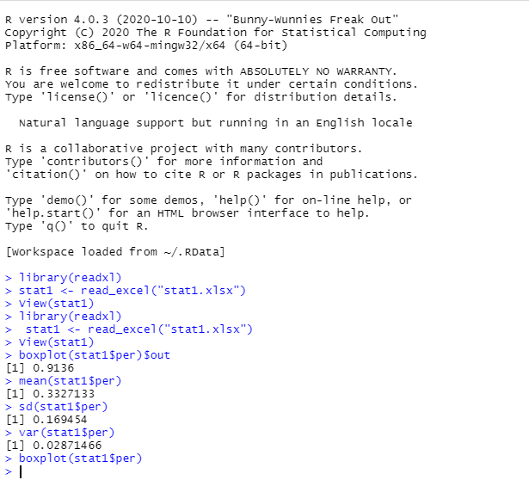

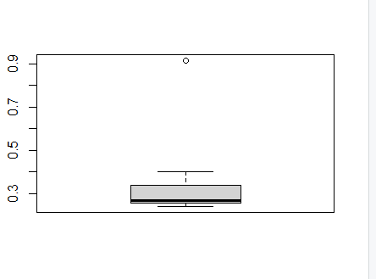



Answer the following three questions based on the box-plot above.

1. What is inter-quartile range of this dataset? (please approximate the numbers) In one line, explain what this value implies.
2. IQR=Q3-Q1

13-5=8

The interquartile range is range of the middle 50% of data.

So here 50% of data is 8 and remaining 50% present in two whiskers.

1. What can we say about the skewness of this dataset?

The skewness of this data is positive because Q3-Q2>Q2-Q1

1. If it was found that the data point with the value 25 is actually 2.5, how would the new box-plot be affected?

The new boxplot have maximum value 20 and minimum value 2.5



Answer the following three questions based on the histogram above.

1. Where would the mode of this dataset lie?

The mode of this data lies between 5 to 8

1. Comment on the skewness of the dataset.

The skewness of above data is positive.

1. Suppose that the above histogram and the box-plot in question 2 are plotted for the same dataset. Explain how these graphs complement each other in providing information about any dataset.
2. From both plots we will tell that the data is positive skewed and the outlier is 20.
3. AT&T was running commercials in 1990 aimed at luring back customers who had switched to one of the other long-distance phone service providers. One such commercial shows a businessman trying to reach Phoenix and mistakenly getting Fiji, where a half-naked native on a beach responds incomprehensibly in Polynesian. When asked about this advertisement, AT&T admitted that the portrayed incident did not actually take place but added that this was an enactment of something that “could happen.” Suppose that one in 200 long-distance telephone calls is misdirected. What is the probability that at least one in five attempted telephone calls reaches the wrong number? (Assume independence of attempts.)

Given that one in 200 long distance telephone calls is misdirected

Probability of call misdirecting p=1/200

Probability of call not misdirecting is 199/200

Number of calls=5

N=5

P=1/200

Q=199/200

We know p(x)= nCXPXqn-x

Probability of At least one in five attemps reaches a wrong number

=1-none of calls reach wrong number

=1-p(0)

=1-(199/200)5

=0.02475

1. Returns on a certain business venture, to the nearest $1,000, are known to follow the following probability distribution

|  |  |
| --- | --- |
| x | P(x) |
| -2,000 | 0.1 |
| -1,000 | 0.1 |
| 0 | 0.2 |
| 1000 | 0.2 |
| 2000 | 0.3 |
| 3000 | 0.1 |

1. What is the most likely monetary outcome of the business venture?
2. The most likely monetary outcome of business venture is ∑x*p(x)

(-2000*0.1)+(-1000*0.1)+(1000*0.2)+(2000*0.3)+(3000*0.1)

=800

1. Is the venture likely to be successful? Explain

Yes the probability is associated for values greater than or equal to $1000

1. What is the long-term average earning of business ventures of this kind? Explain

Expected value=800

1. What is the good measure of the risk involved in a venture of this kind? Compute this measure

By using plots like histogram and box plot we will able to tell the risk if it is positive kurtosis then risk is high.