# *Stock Price Analysis and Forecasting using Yahoo Finance Data*

## 1. Introduction

The objective of this project is to analyze stock price performance and forecast future trends using historical data from Yahoo Finance.  
This analysis helps in understanding market behavior, identifying growth patterns, and predicting potential future movements.  
Python libraries such as Pandas, Matplotlib, Seaborn, and Statsmodels were used for data analysis and visualization.

## 2. Data Understanding and Cleaning

The dataset was imported directly from Yahoo Finance and includes columns such as Date, Open, High, Low, Close, and Volume.  
The Date column was converted to datetime format for time-series operations.  
Missing values and inconsistencies were checked and handled to ensure data reliability.

## 3. Exploratory Data Analysis (EDA)

### a. Stock Price Trend

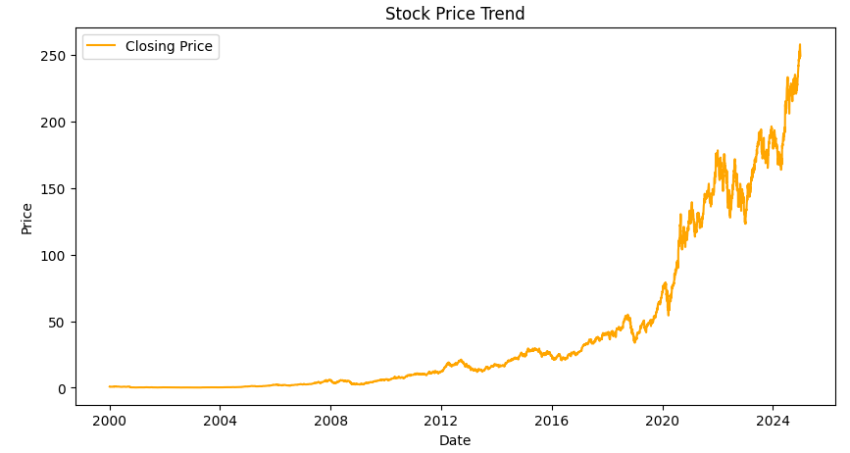  
The stock price shows a consistent upward trajectory over the years, with a significant surge post-2020.  
Periodic dips reflect market corrections, but the overall momentum remains bullish.  
This trend suggests strong long-term investor confidence in the stock.

### b. Distribution of Daily Returns

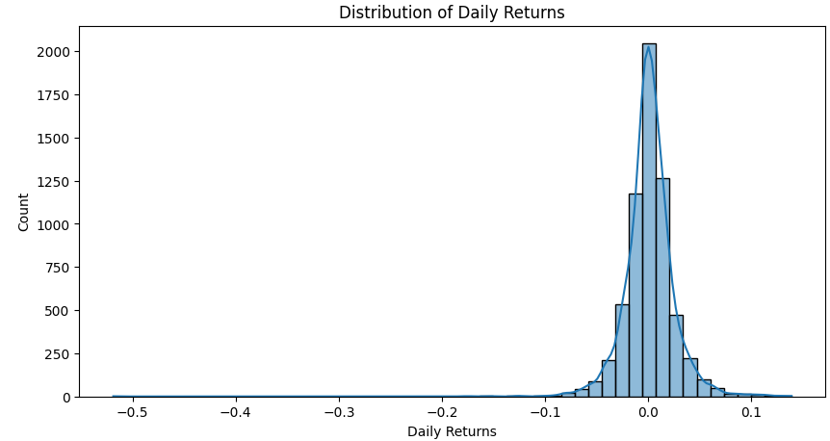  
The histogram of daily returns indicates that most returns are clustered around zero, implying stability.  
However, there are a few extreme positive and negative returns, highlighting occasional short-term volatility.  
This is typical in equity markets where investor sentiment and macroeconomic factors influence fluctuations.

### c. Moving Average Analysis

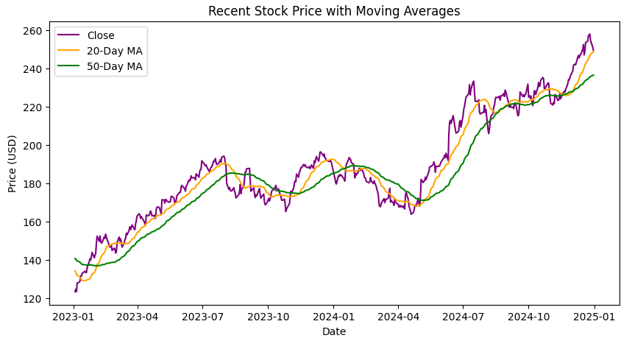  
Both 20-day and 50-day moving averages closely follow the closing price trend.  
The 20-day moving average responds more rapidly to market changes, while the 50-day average provides a smoother, long-term perspective.  
Periods where the 20-day MA crosses above the 50-day MA often indicate a bullish phase, while the reverse implies possible corrections.

## 4. Forecasting (Next 30 Days)

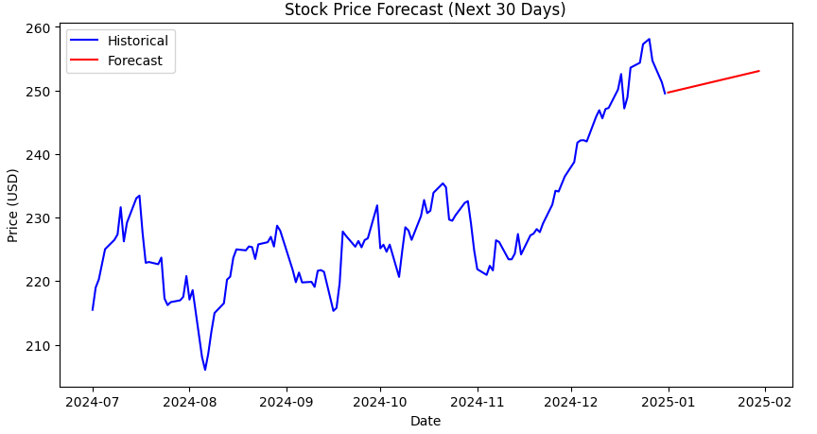  
The forecasting model predicts a mild upward trend for the next 30 days, suggesting positive short-term sentiment.  
While the growth rate is moderate, it indicates a stable and progressive market outlook.  
Investors may expect steady gains if the current momentum continues.

## 5. Recommendations

1. Short-Term Outlook: The 30-day forecast suggests a slight uptrend; consider holding or gradually adding positions.  
2. Long-Term Perspective: Consistent growth patterns indicate strong fundamentals for long-term investment.  
3. Caution on Volatility: Occasional sharp price movements advise investors to maintain diversification.  
4. Technical Indicators: Crossovers between moving averages can help identify entry and exit points.  
5. Diversification Tip: This stock should be part of a diversified portfolio to mitigate risk.

## 6. Conclusion

This analysis concludes that the stock has demonstrated robust long-term growth with manageable short-term volatility.  
The forecast supports a stable, moderately bullish outlook. Investors can consider maintaining or slightly increasing their exposure,  
while keeping an eye on market sentiment and broader economic indicators.