DS 413/613 **HOMEWORK 7**  Web Scraping and Rectangling

**Instructions**: Create an R markdown file and a Word file and push both files to a Repository that you have created in GitHub. Required packages and libraries are given below;

install.packages("rvest") install.packages("listviewer") listviewer::jsonedit(gh_users)

library(rvest) library(dplyr) library(tidyverse) library(repurrrsive)

1) Using the following link, <https://www.imdb.com/list/ls091520106/>, R coding for Web scraping and Selector Gadget, produce the following tibble. (The first 5 rows are shown below) **Use the step by step methodology suggested in class showing all steps and code.**

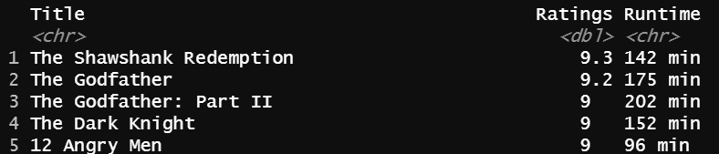

2)

a) Explain or describe nested Lists. (Three or four sentences)

b) Open and explore data for Git Hub repos by running the following code gh_repo. Comment on the structure and arrangement of the data (Two or three sentences)

c) In two or three sentences, explain what happens to the data when you run the code;

repos <- tibble(repo = gh_repos)

repos

d) Describe the data representation when the listserver tool is applied. And go into detail explaining why we have a nested List configuration. What do the numbers 30 and 68 represent ? (6 or 7 sentences)

Run the following code:

listviewer::jsonedit(gh_repos)

e) Use and show R unesting code to produce the tibble below.

