**Stressed coral reef identification using Convolution Neural Network**

1S P Aruna and 2M.Thamarai

1Skilltroniks Technologies, Tadepalligudem, Andhra Pradesh

Email:arunavasi1997@gmail.com

2ECE Department, Sri Vasavi Engineering College, Tadepalligudem,

Andhra Pradesh

email:mthamarai2014@gmail.com

**Abstract:**Deep learning is machine learning technique that allows the computer to process things that occur naturally to humans. Today, deep learning techniques are commonly used in computer vision to classify images and videos. As a result, for challenging computer vision problems, deep learning provides state of the art solutions to it. Coral reefs are an essential resource of the earth. A new study finds the planet has lost half of its coral reefs since 1950. It is necessary to restore and prevent damage to coral reefs as they play an important role in maintaining a balance in the marine ecosystem. This proposed work helps to prevent the corals from bleaching and restore them to a healthy condition by identifying the root cause of the threats. In the proposed work, using Deep learning CNN techniques, the images are classified into Healthy and Stressed coral reefs. Stressed coral reefs are an intermediate state of coral reef between healthy and bleached coral reefs. The pre-trained models Resnet50 and inceptionv3 are used in this study to classify the images. Also, a proposed CNN model is built and tested for the same. The results of Inception V3 and Resnet 50 are improved to 70% and 55% by tuning the hypermeters such as dropouts and batchnormalisation. Similarly, the proposed model is tuned as required and obtains a maximum of up to 90% accuracy. With large datasets, optimum amount of neural networks and tuning it as required brings high accuracy than other methods.

Keywords: Stressed coral reef, Deep Learning, Convolutional Neural Network, Pretrained Models.

**1.Introduction**

Ocean is a large resource that supports life, fights climate crisis, and home to large biodiversity. Unlike landforms, oceans are one continuous body that connects every corner of our planet. Ocean ecosystems are the largest of Earth's aquatic ecosystems which support many lives and also benefit human beings in many ways. Coral ecosystems are part of marine ecosystems are formed up of coral reefs. These coral reefs provide shelter to millions of marine species and protect the land coastline from storms and erosions. It provides rich aquatic life for fishing and other purposes. Increasing ocean temperature and rapid global warming are one of the risks of coral reef bleaching. Human activities such as water pollution also affect the quality and life of the corals. So, it is necessary to prevent the coral from damage and detect the early signs of coral damage and restore it. In this method, we are detecting whether the coral is stressed or not using CNN deep learning algorithm.

* 1. Coral Reef biodiversity

Coral reefs are formed of **colonies of hundreds to thousands of tiny individual corals commonly known as polyps.** These marine invertebrate animals have hard exoskeletons made of calcium carbonate and are sessile. The large coral reef(Great Barrier Reef) is found in Queensland, Australia. These corals are colourless in nature. The microscopic algae named Zooxanthellae that live in it, adds different colours. Corals and algae have a mutual relationship. The coral offers the zooxanthellae a safe environment as well as the substances essential for photosynthesis. The zooxanthellae create oxygen and aid the coral in removing trash as payment. Millions of zooxanthellae produce pigments that add colours to coral. Depending on the colour of the coral image, we can predict using CNN whether the coral is stressed or not. It is an advantage for us, at this point the damage made is minimum we can prevent it from bleaching.

1.2 Coral bleaching

The corals are classified as the following stages.

**Healthy coral:**Healthy coral reefs are bright corals filled with microscopic algae called zooxanthellae that live in their tissues. These algae give bright colors to coral reefs.

**Stressed Coral:**Stressed coral reefs are less brighter compared to healthy coral reefs. Due to the temperature rise, it loses its color as algae tend to leave the coral reefs.

**Bleached Coral:** Bleached coral reefs are empty coral reefs with any algae present in them. It is white because only the coral skeleton is present

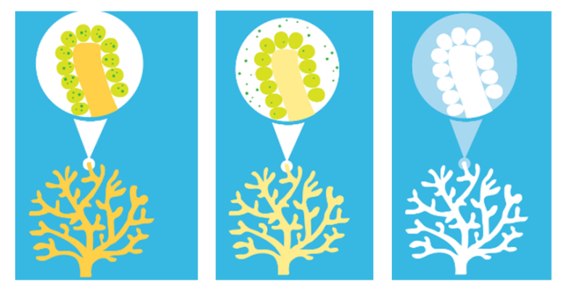

1. (b) (c)

Figure-1a. Healthy coral b. Stressed coral c.Bleached coral

Causes for Bleaching:

Climate change causes a rise in the ocean temperature that result in coral bleaching. Industrial pollutants and fertilizer wastes that drain into the ocean also change its environment and cause coral bleaching. Direct exposure to sunlight in shallow waters also causes coral bleaching. Low tides and exposure to air may also cause bleaching. When water get too warm for corals, corals release their colorful microalgae ,turning a skeletal white.If bleaching events are prolonged or happen too frequently with not enough time to recover in between, significant coral mortality can occur, sealing the fate of coral reefs.

The Global Coral Reef Monitoring Network (GCRMN) is a network of the International Coral Reef Initiative (ICRI) that has published a report titled The Status of Coral Reefs of the World: 2020. Its findings illustrate that, between 2009 and 2018, there was a progressive loss of 14% of the corals brought on by frequent, massive bleaching events. More hard coral was destroyed than is currently present on Australia's coral reefs, totalling around 11,700 square kilometres. Similar to the decline in hard coral throughout this time period, the amount of algae on coral reefs around the world has increased by roughly 20% since 2010. The report depicts four decades of falling coral abundance, increased bleaching, and rising algae levels, which are indicators of deteriorating reef health.

The paper also highlights the remarkable capacity of coral reefs to recover in the absence of local and global threats. Both conclusions ought to spur immediate action. Coral reefs are largely invisible, but environmental protection must prioritize their health. Global Coral Reef Monitoring Network (GCRMN) is a network that maintains and operates the international coral reef and provides information about it[15]. GCRMN divides it into ten regional nodes. They are Australia, the Caribbean, ETP, etc., GCRMN collects the database, monitors it from time and time, and publishes its status. It states that almost all the coral reefs are extinct due to global warming and local human activities. Also, some parts of coral reefs proved to remain resilient and can recover from damage by taking appropriate measures.

There are more than 600 sub species in just the Great Barrier Reef in Australia.They come in a wide range of sizes, shapes, and colours, making them a diversified species. Hard corals and soft corals are the two main types of corals.Soft corals are flexible and frequently mistaken for plants because they lack the Skelton, which hard corals have. The best coral reef health indicator is hard coral. The most crucial factor to quantify the coral population is the hard coral cover percentage.

Coral reefs that are dominated by algae lose some of their architectural complexity and structural integrity.The goal of NOAA's Coral Health and Monitoring Programme (CHAMP), which was established to help protect and preserve the health of coral reefs around the world, is to offer resources and services to researchers and the general public.Contributions:

The proposed work comprises the following

* Pretrained models such as InceptionV3 and ResNet 50 are fine tuned by adding batch normalization and dropout layers for eliminate over fitting parameters problem and improve the stressed coral reef identification accuracy.
* An efficient low complexity CNN architecture is proposed for stressed coral reef identification.
* The performance of the Pretrained models and proposed CNN model are analysed using performance metrics such as classification accuracy, F1 score, precision and Recall.

The paper is organized as follows. Section 1 describes the introduction about coral reefs and the importance stressed of coral reef identification. Section 2 reviews deep learning and previous work on coral reef classification using convolution neural networks. Section 3 describes the proposed work for stressed coral reef identification using Pretrained models and proposed low complexity CNN architecture. Section 4 discusses about the results and section 5 concludes the paper.

2.Deep Learning

Deep learning networks, which are Advanced Neural Networks with a lower error rate, are crucial for solving prediction and classification problems. Deep Learning networks, a subtype of artificial intelligence, are employed for a number of tasks, including image identification, speech to text conversion, scene description, drug discovery, face detection and recognition, weather forecasting, and more [1,2].

2.1 Convolutional Neural Network

A convolutional neural network is a network architecture of deep learning algorithms. It has high performance and accuracy in image classifications by finding or recognizing required patterns in the images. It breaks the pixels of the image into smaller pixels and detects the required data in them. A typical convolutional Neural Network has the following layers and the architecture is shown in figure 2.

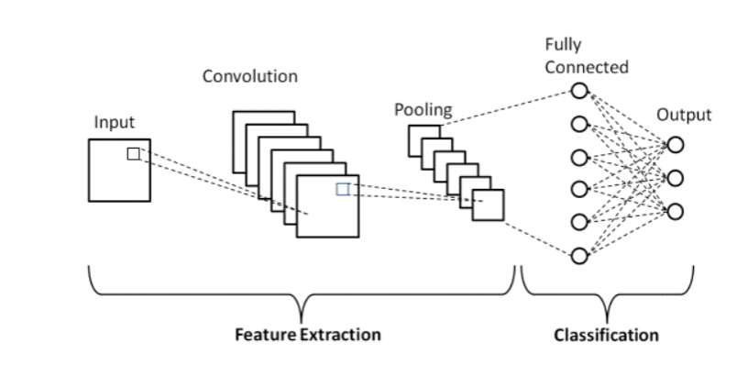

**Figure 2:Typical Convolutional Neural Network Architecture**

**A. Convolutional Layer**

The convolution layer is the mathematical layer that processes the image segment by segment and filters it as given. The input image is divided into three for an RGB image and one for a gray image. The filter filters the input image with provided kernel size. Using the Dot product, the value of the input image and filter is multiplied and stored in them.

**B Pooling Layer**

### The pooling layer is next to the convolution layer. There are two types of pooling, max pooling, and average pooling. Max pooling returns the max value in the feature map. Average pooling returns the average value of the feature map. For example, the kernel size is 2X2, and its values are 34 56 78 23. If max pooling is selected, it returns the value 78 from the feature map. If the average pooling is selected, it returns the value 48. Between the Convolutional layer and the fully linked layer, the Pooling Layer frequently acts as an intermediate.

### C. Fully Connected Layer

### The fully connected layer is the layer that connects one neutral network to the output neutral network. It connects the weights and biases of previous neurons to the weights and biases of the next neurons. The final layers of CNN are used to summarize the network by using flattening and connecting it to the output layer. The flattening layer reduces the dimension of the network to one. Here, based on the type of problem, the output layer is provided. For example, If it is classification, then it is sigmoid.

### D. Activation Functions

The activation function is an essential function of the CNN model. It identifies and transfers the variables from one neuron to another neuron. It decides what should be transferred and what should be not. This network is non-linear. Activation functions like ReLu, sigmoid, tanh, and softmax are used in it. ReLu connects the value of the variable from zero to infinity. If any negative value is present in the ReLu, it is considered zero. The tanh connects from a negative one to a positive one. Sigmoid is for binary classification problems and Softmax is for multiclass classification problems.

2.2. Deep learning in Coral reef classification:

This section describes the previous work done in the coral reef classification using Deep Learning.

Automated underwater vehicles (AUVs) have been successfully used to monitor these reefs in recent years. These computers can be improved to categorise many coral species, though, by integrating neural networks [3] and [16].

Additionally, poor picture quality is a constant problem, resulting in hazy and blurry images. This is because the sediments in the water make it difficult to take high-quality pictures, even though the coral photo transect uses this technique for image capture and processing. Then, it generates photos of excellent quality and makes it noticeably simpler to see the characteristics of corals [4].

Elawadyet.al(2014) developed a machine vision algorithm to enable underwater robot to locate coral reef and to pick it up using CNN[6]. The shape and texture features are added as supplementary cannels along with basic spatial color cannels of coral input image and used for classification.Raphael,et.al(2020) developed an automated DL classification scheme 11 species of corals present in EilatGulf region[7].Chindapol et al.(2013)used advection diffusion equations to model the effects of flow on coral reef colony growth and shape[8].Mahmood,et.al(2013) used Neural network and deep learning to distinguish various coral species and also live corals from bleached corals. Author used VGGNet with a 2 layer MLP classifier for classification of corals in their work[9].Mahmoodet.al(2017) discussed the power of Deep learning for monitoring coral reefs in their survey work[10].Mahmood,et.al(2016) used VGGNet for the classification of unlabeled coral mosaics[11].

Gómez-Ríoset.al(2019) used three various CNN architectures -Inception V3, ResNet, and Densenet and data auumentation techniques to obtain high accuracy in coral texture image classification[12]. Mahmoodet.al(2017) combined CNN images and handcrafted features for coral classification, But this approach is computationally expensive and not suitable for large datasets[10].

Mary et.al (2017) used improved local derivative pattern for submarine coral reef images classification[13].Luminiet.al(2020) developed ensemble based different convolution neural network models for underwater imagery analysis[14].

**3.Proposed work**

The proposed work Pretrained models have been trained using transfer learning concept and tested.The pre-trainedCNN models InceptionV3 and Resnet50 are fine tuned to improve the performance in stressed coral reef identification. In the addition to it, a new CNN model is also built and studied and compared its performance with the pre-trained models.

3.1 Resnet 50 architecture.

The pretrained model, Resnet 50 architecture is shown in figure 3b.The architecture as 50 layers and is specially designed to eliminate training error. The network has special block called residual block and is shown in figure 3.a. A residual block, also referred to as a "bottleneck", uses 11 convolutions to cut down on the number of

parameters and matrix multiplications. This makes each layer's training significantly faster.

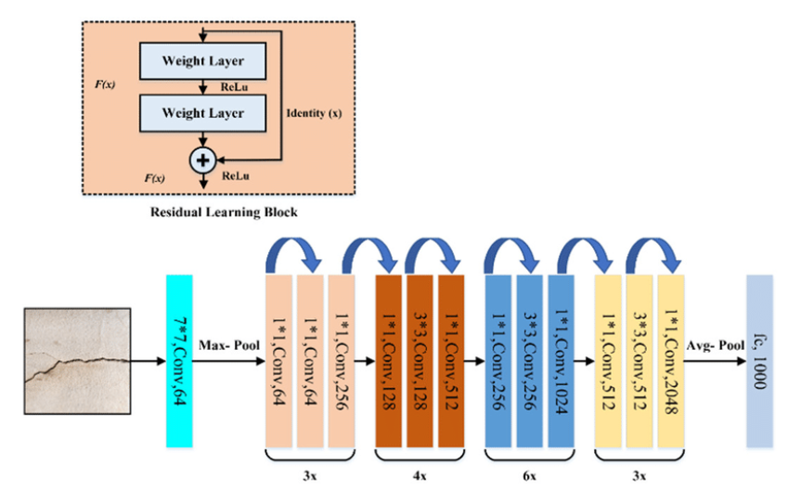

Figure 3.Resnet 50 architecture.

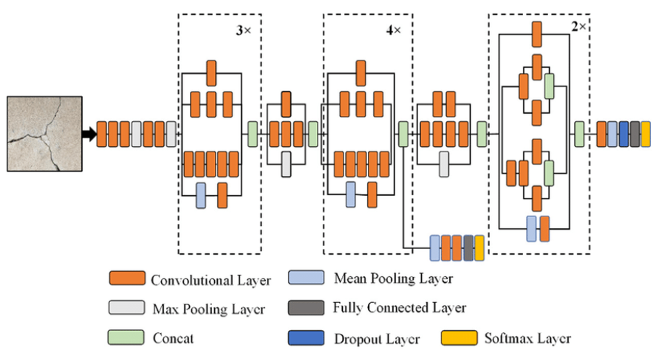

Figure 4.InceptionV3 architecture

3.2 Inception V3 architecture

The important milestone in CNN development is the Inception network.Convolutional neural network model Inception-v3 has 48 layers and was pre-trained. It is an Inception network variant that has been trained on more than a million images from the Image Net collection. It is the third iteration of Google's Inception CNN model.

A popular image recognition algorithm called Inception v3 has demonstrated improved accuracy on the ImageNetdataset.

3.3 Fine tuning the Pre-trained models:

For the models, the Pretrained models of InceptionV3 and Resnet50 are inherited using keras library. For InceptionV3, the base model is loaded and then fine-tuned with required parameters. Using GlobalAveragePooling3D() function, the dimensions of the inputs given are adjusted cause channels_last corresponds to inputs with shape (batch, height, width, channels) while channels_first corresponds to inputs with shape (batch, channels, height, width). To extend the base model, GlobalAveragePooling3D is used and also to avoid dimension conflicts. In case of InceptionV3, the model is trained with more accuracy and it is in overfitting condition. To avoid this condition, Dropout(0.1) of weights is added to improve the model efficiency and avoid overfitting. Dropout is the layer of keras which is used to remove the weights that are overtrained based on the percentage given. Then, it is connected to intermediate dense layer with “Relu” activation and connected to output layer as softmax activation. After the changes made, the model is trained with train and test datasets. It is compiled using adam optimizers and then fitted with the validation data as 20% and batch size as 32.

Similarly, the works are done for the Resnet50 model. The base model is loaded and then fine-tuned with required parameters. Using GlobalAveragePooling3D() function, the dimensions of the inputs given are adjusted cause channels_last corresponds to inputs with shape (batch, height, width, channels) while channels_first corresponds to inputs with shape (batch, channels, height, width). To extend the base model, GlobalAveragePooling3D is used and also to avoid dimension conflicts. In case of Restnet50, our model is learning too slow and also reaches the steady learning rate. Once the model reaches the steady learning rate, adjusting learning rate may not give significant results. So, the Batchnormalisation function is added to the neutral network to improve the model efficiency. Like InceptionV3, it is also connected to intermediate dense layer with “Relu” activation and connected to output layer as Softmax activation. After the changes made, the model is trained with train and test datasets. It is complied using adam optimizers and then fitted with the validation data as 20% and batch size as 32.

**3.4 Proposed low complexity CNN model**

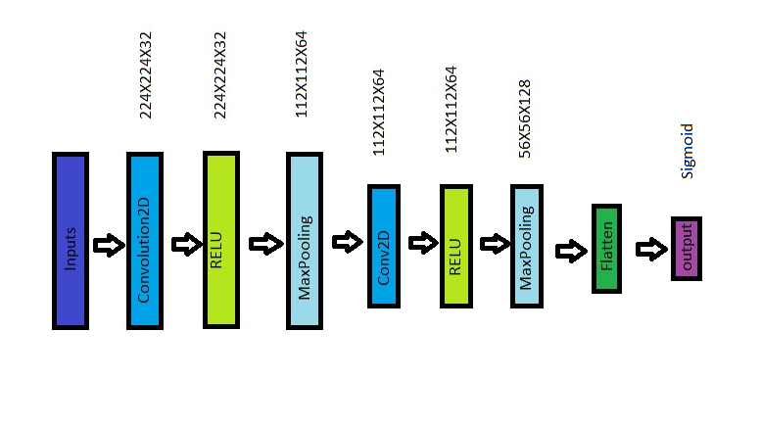

Figure 5.Proposed CNN model

In the proposed CNN model, we trained the data separately and created a sequential model using keras. Inside the model, we added two convolution2D layers with required parameters. RELU activation is used in each neutral network as shown in figure 5. Also, added dropouts and Batchmormalisation hypermeters and adjusted as required to improve the model efficiency. It is connected to output layers with dense = 1 and activation = sigmoid since it is the binary class classification. The model size is very small when compared to the Resnet 50 and Inception V3 pre-trained models. The proposed model is memory efficient with less number of training parameters. The model is compiled and fitted with the validation data as 20% and batch size as 4.

|  |  |
| --- | --- |
| True positive - The image of stressed coral reefs are identified correctly. | False positive – The image of stressed coral reef is identified as healthy coral reef. (Type II error) |
| False Negative - The image of healthy coral reef is identified as stressed coral reef. ( Type I error) | True Negative – The image of coral reefs are found not stressed. |

**4.Results and Metrics**

The Pretrained models and proposed CNN model are trained and tested with theour own dataset collected from internet sources. The dataset contains 120 images. The dataset has equal number of healthy and stressed coral images.(healthy coral reef images:60,stressed coral reef images:60).All the models are compiled and fitted with the validation data as 20% and different batch sizes. The sample input images in the two categories (Healthy and stressed corals reef images)are shown in figure 6.

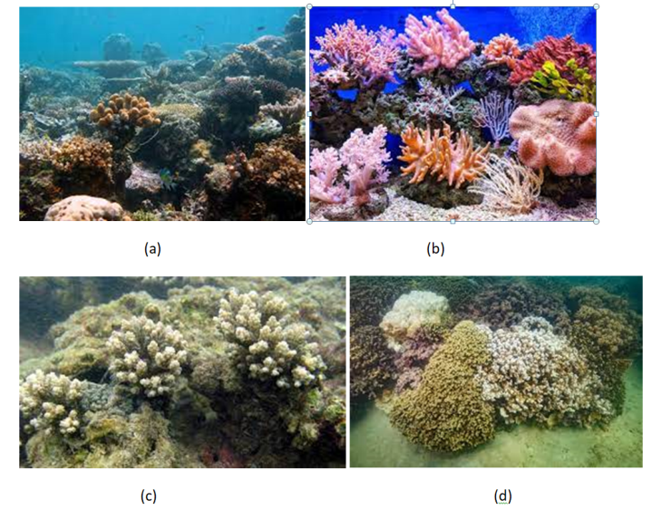

Figure 6. (a) & (b) represents the healthy coral reef images used in the dataset. Fig (c) & (d) represents the healthy coral reef images used in the dataset.

The Confusion matrix of each model is extracted for the test images. Then, precision, recall, accuracy of each model are calculated.

Confusion matrix for our model is represented as below in table-1.

Table-1:Confusion matrix for the coral reef classification (proposed) model

Precision = True Positive /(True Positive + False Positive)

Precision gives us the quality of positive predictions.

Recall formula, = True Positive /(True Positive + False Negative)

Recall, also known as sensitivity gives us the proportion of actual positives that was identified correctly.

Accuracy formula = (True Positive +True Negative) / (True Positive + False Positive + False Negative + True Negative)

Accuracy gives us the number of correct predictions that the trained model achieves.

Comparing the precision, recall, accuracy for the three models, Based on the correct predictions of stressed coral reefs and healthy coral reefs, the values are calculated and given in the table-1.The dataset is collected from coral website images in google. Totally 120 images are in the dataset. The training images are 100(Healthy:50 images; stressed :50 images).The sample test images given are 20 images, 10 – healthy coral reef images and 10 – stressed coral reef images. The performance of the proposed CNN in classifying stressed coral is 90% ,which is the highest accuracy when compared to the fine tuned Pretrained models. The accuracy is 15% higher than the Inception V3 model and 35% higher than the Resnet50 model. The proposed model CNN model predicts the healthy and stressed coral with same accuracy ( 90%. )

Table:2 performance comparison of the proposed CNN model with pre-trained models

|  |  |  |  |  |
| --- | --- | --- | --- | --- |
| **CNN Model** | **Test Data** | **Precision** | **Recall** | **F1 score** |
| Inception V3(Pretrained fine tuned model using transfer learning concept) | Healthy | 0.67 | 0.80 | 0.73 |
| Stressed | 0.75 | 0.60 | 0.67 |
| Resnet50(Pretrained finetuned model using transfer learning concept ) | Healthy | 0.56 | 0.50 | 0.53 |
| Stressed | 0.55 | 0.60 | 0.57 |
| **Proposed CNN Model** | Healthy | **0.90** | **0.90** | **0.90** |
| Stressed | **0.90** | **0.90** | **0.90** |

The classification accuracy is computed as follows for sample 20 input test images

Accuracy of Inception V3 model is(8+6)/(8+2+4+6)= 0.7

Accuracy of Resnet50 model is (5+6)/(5+5+4+6)= 0.55

**Accuracy of proposed CNN model is (9+9)/(9+1+9+1)= 0.9**

**5.Conclusion:**

**Action need to be taken after identifying stressed corals**

Once the stressed coral reef is identified in a particular area. Scientists can analyse the reasons behind its decay and its root causes. If the coral is stressed, it tend to lose its pigmentation cause the algae that are living mutual together starts to move away from it, due to some natural causes or man-made pollutions. Natural causes involves Ocean temperature rise, climate change, etc.,Man-made causes involves water pollution, global warming, etc., Once the scientists analysed and found its root cause, it would be easy to restore the coral reef to healthy from stressed state. It would take a lot of efforts to restore it from bleached state. Which is why, we are identifying it in the stressed state itself.

Prevention is better than cure. The coral reef forms a major economic source from ocean resources for a country or a state. It is necessary to maintain it in its state healthy. Because healthy coral reef enhances many fish productions, healthy aquatic lives such as sea weeds that have economic values. That’s why; it is significant to prevent the coral from bleaching. In our models, we are identifying in our early bleaching stage (i.e. stressed stage) and helping them to restore it to healthy state.

The proposed work describes an efficient low computational complexity CNN model to predict the stressed corals and the model classification accuracy is 90% and which is 15% higher than the Inception V3 model accuracy and 35% higher than the Resnet50 model. In future the pre-processing techniques will be applied to overcome the underwater image blur and colours balancing and then proposed method will be suitable for real-time applications.

**References:**

1. V. Chandrasekar, V. Sureshkumar, T.Satish Kumar, S. Shanmugapriya, Disease prediction based on microarray classification using deep learning techniques, Microprocess. Microsyst. 77 (2020) 1–15, https://doi.org/10.1016/j. micpro.2020.103189.
2. K.C.J. Chen, M. Ebrahimi, T.Y. Wang, Y.C. Yang, Y.H. Liao, A NoC-based simulator for design and evaluation of deep neural networks, Microprocess. Microsyst. 77 (2020) 1–15, <https://doi.org/10.1016/j.micpro.2020.103145>.
3. Moniruzzaman, M., Islam, S. M. S., Bennamoun, M., &Lavery, P. (2017). Deep learning on underwater marine object detection: A survey. In *Advanced Concepts for Intelligent Vision Systems: 18th International Conference, ACIVS 2017, Antwerp, Belgium, September 18-21, 2017, Proceedings 18* (pp. 150-160). Springer International Publishing.
4. K. Marks, “Coral Photo Transect: Scientific Underwater Photography Using Quadrat,” *Living Oceans Foundation*, 25-Feb-2014. [Online]. Available: https://www.livingoceansfoundation.org/pvc-paparazzi/.
5. O'Shea, K., & Nash, R. (2015). An introduction to convolutional neural networks. *arXiv preprint arXiv:1511.08458*.
6. Elawady, M., E.: Sparse Coral Classification Using Deep Convolutional Neural Net-works. Msc Thesis, Hariot-Watt University (2014)
7. Raphael, A., Dubinsky, Z., Iluz, D., Benichou, J. I., & Netanyahu, N. S. (2020). Deep neural network recognition of shallow water corals in the Gulf of Eilat (Aqaba). *Scientific reports*, *10*(1), 12959.
8. Chindapol, N., Kaandorp, J. A., Cronemberger, C., Mass, T., &Genin, A. (2013). Modelling growth and form of the scleractinian coral Pocilloporaverrucosa and the influence of hydrodynamics. *PLoS computational biology*, *9*(1), e1002849.
9. Mahmood, A., Bennamoun, M., An, S., Sohel, F., Boussaid, F., Hovey, R., ...& Fisher, R. B. (2016, September). Coral classification with hybrid feature representations. In *2016 IEEE International Conference on Image Processing (ICIP)* (pp. 519-523). IEEE.
10. Mahmood, A., Bennamoun, M., An, S., Sohel, F., Boussaid, F., Hovey, R., ...& Fisher, R. B. (2017). Deep learning for coral classification. In Handbook of neural computation (pp. 383-401). Academic Press.
11. Mahmood, A., Bennamoun, M., An, S., Sohel, F., Boussaid, F., Hovey, R., ...& Fisher, R. B. (2016, September). Automatic annotation of coral reefs using deep learning. In Oceans 2016 mts/IEEE monterey (pp. 1-5). IEEE
12. Gómez-Ríos, A., Tabik, S., Luengo, J., Shihavuddin, A. S. M., Krawczyk, B., & Herrera, F. (2019). Towards highly accurate coral texture images classification using deep convolutional neural networks and data augmentation. Expert Systems with Applications, 118, 315-328.
13. Mary, N. A. B., & Dharma, D. (2017). Coral reef image classification employing improved LDP for feature extraction. Journal of Visual Communication and Image Representation, 49, 225-242.
14. Lumini, A., Nanni, L., &Maguolo, G. (2020). Deep learning for plankton and coral classification. Applied Computing and Informatics, (ahead-of-print).
15. <https://www.unep.org/resources/status-coral-reefs-world-2020>.
16. Borbon, J., Javier, J., Llamado, J., Dadios, E., &Billones, R. K. (2021, November). Coral Health Identification using Image Classification and Convolutional Neural Networks. In 2021 IEEE 13th International Conference on Humanoid, Nanotechnology, Information Technology, Communication and Control, Environment, and Management (HNICEM) (pp. 1-6). IEEE.