Ass

Aruna

20 November 2018

# Write a program to create histogram for all columns  
  
str(mtcars)

## 'data.frame': 32 obs. of 11 variables:  
## $ mpg : num 21 21 22.8 21.4 18.7 18.1 14.3 24.4 22.8 19.2 ...  
## $ cyl : num 6 6 4 6 8 6 8 4 4 6 ...  
## $ disp: num 160 160 108 258 360 ...  
## $ hp : num 110 110 93 110 175 105 245 62 95 123 ...  
## $ drat: num 3.9 3.9 3.85 3.08 3.15 2.76 3.21 3.69 3.92 3.92 ...  
## $ wt : num 2.62 2.88 2.32 3.21 3.44 ...  
## $ qsec: num 16.5 17 18.6 19.4 17 ...  
## $ vs : num 0 0 1 1 0 1 0 1 1 1 ...  
## $ am : num 1 1 1 0 0 0 0 0 0 0 ...  
## $ gear: num 4 4 4 3 3 3 3 4 4 4 ...  
## $ carb: num 4 4 1 1 2 1 4 2 2 4 ...

ncol(mtcars)

## [1] 11

names(mtcars)

## [1] "mpg" "cyl" "disp" "hp" "drat" "wt" "qsec" "vs" "am" "gear"  
## [11] "carb"

library(tidyr)  
library(ggplot2)  
ggplot(gather(mtcars), aes(value)) +   
 geom_histogram(bins = 10) +   
 facet_wrap(~key, scales = 'free_x')

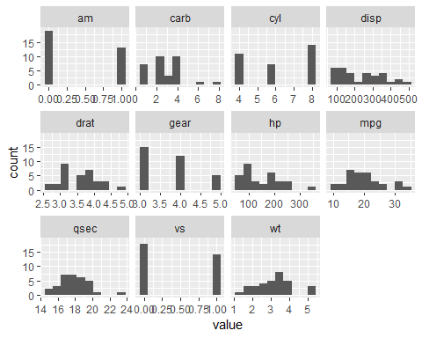

for (col in 1:ncol(mtcars)) {  
 hist(mtcars[,col],type='l',  
 main=paste("Histogram of mtCars Varibales ",colnames(mtcars[[col]])),  
 ylab=names(mtcars[col]),type="l")  
}

## Warning in plot.window(xlim, ylim, "", ...): graphical parameter "type" is  
## obsolete  
  
## Warning in plot.window(xlim, ylim, "", ...): graphical parameter "type" is  
## obsolete

## Warning in title(main = main, sub = sub, xlab = xlab, ylab = ylab, ...):  
## graphical parameter "type" is obsolete  
  
## Warning in title(main = main, sub = sub, xlab = xlab, ylab = ylab, ...):  
## graphical parameter "type" is obsolete

## Warning in axis(1, ...): graphical parameter "type" is obsolete  
  
## Warning in axis(1, ...): graphical parameter "type" is obsolete

## Warning in axis(2, ...): graphical parameter "type" is obsolete  
  
## Warning in axis(2, ...): graphical parameter "type" is obsolete

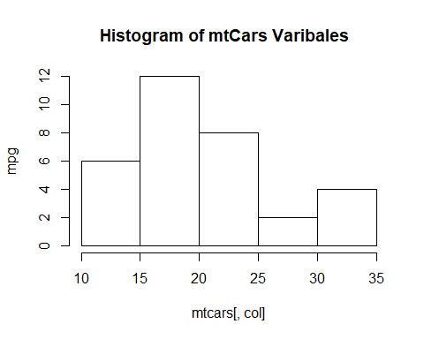

## Warning in plot.window(xlim, ylim, "", ...): graphical parameter "type" is  
## obsolete

## Warning in plot.window(xlim, ylim, "", ...): graphical parameter "type" is  
## obsolete

## Warning in title(main = main, sub = sub, xlab = xlab, ylab = ylab, ...):  
## graphical parameter "type" is obsolete  
  
## Warning in title(main = main, sub = sub, xlab = xlab, ylab = ylab, ...):  
## graphical parameter "type" is obsolete

## Warning in axis(1, ...): graphical parameter "type" is obsolete  
  
## Warning in axis(1, ...): graphical parameter "type" is obsolete

## Warning in axis(2, ...): graphical parameter "type" is obsolete  
  
## Warning in axis(2, ...): graphical parameter "type" is obsolete

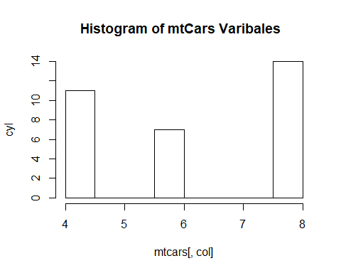

## Warning in plot.window(xlim, ylim, "", ...): graphical parameter "type" is  
## obsolete

## Warning in plot.window(xlim, ylim, "", ...): graphical parameter "type" is  
## obsolete

## Warning in title(main = main, sub = sub, xlab = xlab, ylab = ylab, ...):  
## graphical parameter "type" is obsolete  
  
## Warning in title(main = main, sub = sub, xlab = xlab, ylab = ylab, ...):  
## graphical parameter "type" is obsolete

## Warning in axis(1, ...): graphical parameter "type" is obsolete  
  
## Warning in axis(1, ...): graphical parameter "type" is obsolete

## Warning in axis(2, ...): graphical parameter "type" is obsolete  
  
## Warning in axis(2, ...): graphical parameter "type" is obsolete

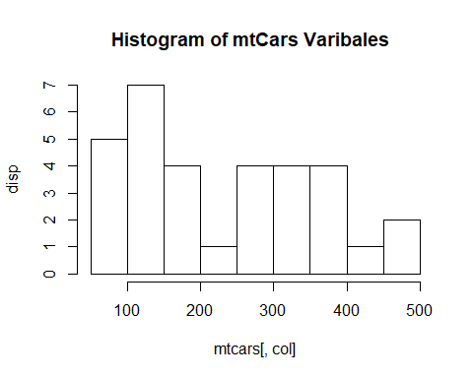

## Warning in plot.window(xlim, ylim, "", ...): graphical parameter "type" is  
## obsolete

## Warning in plot.window(xlim, ylim, "", ...): graphical parameter "type" is  
## obsolete

## Warning in title(main = main, sub = sub, xlab = xlab, ylab = ylab, ...):  
## graphical parameter "type" is obsolete  
  
## Warning in title(main = main, sub = sub, xlab = xlab, ylab = ylab, ...):  
## graphical parameter "type" is obsolete

## Warning in axis(1, ...): graphical parameter "type" is obsolete  
  
## Warning in axis(1, ...): graphical parameter "type" is obsolete

## Warning in axis(2, ...): graphical parameter "type" is obsolete  
  
## Warning in axis(2, ...): graphical parameter "type" is obsolete

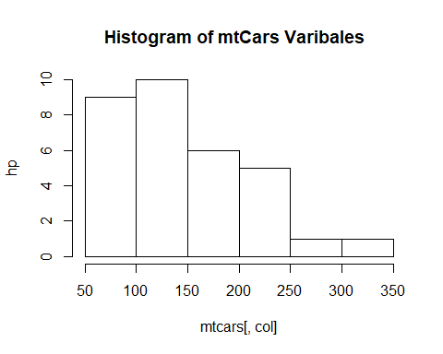

## Warning in plot.window(xlim, ylim, "", ...): graphical parameter "type" is  
## obsolete

## Warning in plot.window(xlim, ylim, "", ...): graphical parameter "type" is  
## obsolete

## Warning in title(main = main, sub = sub, xlab = xlab, ylab = ylab, ...):  
## graphical parameter "type" is obsolete  
  
## Warning in title(main = main, sub = sub, xlab = xlab, ylab = ylab, ...):  
## graphical parameter "type" is obsolete

## Warning in axis(1, ...): graphical parameter "type" is obsolete  
  
## Warning in axis(1, ...): graphical parameter "type" is obsolete

## Warning in axis(2, ...): graphical parameter "type" is obsolete  
  
## Warning in axis(2, ...): graphical parameter "type" is obsolete

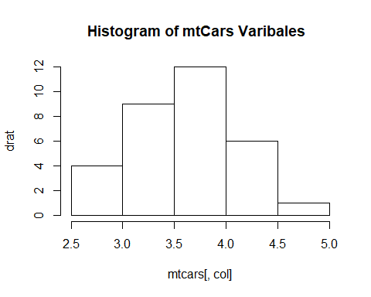

## Warning in plot.window(xlim, ylim, "", ...): graphical parameter "type" is  
## obsolete

## Warning in plot.window(xlim, ylim, "", ...): graphical parameter "type" is  
## obsolete

## Warning in title(main = main, sub = sub, xlab = xlab, ylab = ylab, ...):  
## graphical parameter "type" is obsolete  
  
## Warning in title(main = main, sub = sub, xlab = xlab, ylab = ylab, ...):  
## graphical parameter "type" is obsolete

## Warning in axis(1, ...): graphical parameter "type" is obsolete  
  
## Warning in axis(1, ...): graphical parameter "type" is obsolete

## Warning in axis(2, ...): graphical parameter "type" is obsolete  
  
## Warning in axis(2, ...): graphical parameter "type" is obsolete

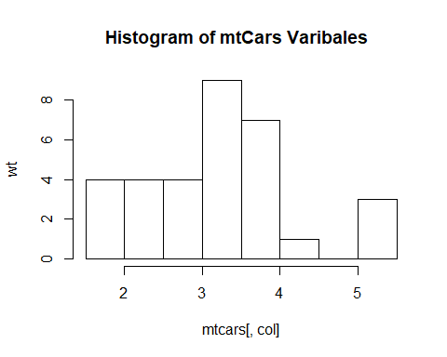

## Warning in plot.window(xlim, ylim, "", ...): graphical parameter "type" is  
## obsolete

## Warning in plot.window(xlim, ylim, "", ...): graphical parameter "type" is  
## obsolete

## Warning in title(main = main, sub = sub, xlab = xlab, ylab = ylab, ...):  
## graphical parameter "type" is obsolete  
  
## Warning in title(main = main, sub = sub, xlab = xlab, ylab = ylab, ...):  
## graphical parameter "type" is obsolete

## Warning in axis(1, ...): graphical parameter "type" is obsolete  
  
## Warning in axis(1, ...): graphical parameter "type" is obsolete

## Warning in axis(2, ...): graphical parameter "type" is obsolete  
  
## Warning in axis(2, ...): graphical parameter "type" is obsolete

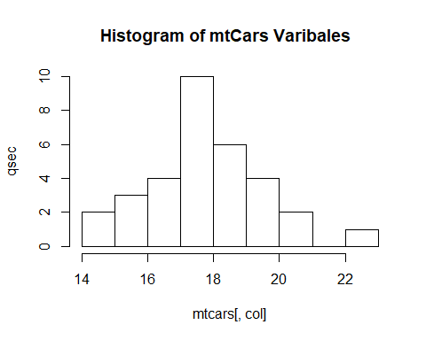

## Warning in plot.window(xlim, ylim, "", ...): graphical parameter "type" is  
## obsolete

## Warning in plot.window(xlim, ylim, "", ...): graphical parameter "type" is  
## obsolete

## Warning in title(main = main, sub = sub, xlab = xlab, ylab = ylab, ...):  
## graphical parameter "type" is obsolete  
  
## Warning in title(main = main, sub = sub, xlab = xlab, ylab = ylab, ...):  
## graphical parameter "type" is obsolete

## Warning in axis(1, ...): graphical parameter "type" is obsolete  
  
## Warning in axis(1, ...): graphical parameter "type" is obsolete

## Warning in axis(2, ...): graphical parameter "type" is obsolete  
  
## Warning in axis(2, ...): graphical parameter "type" is obsolete

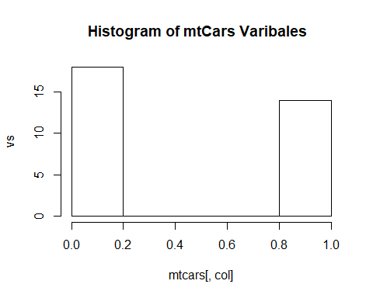

## Warning in plot.window(xlim, ylim, "", ...): graphical parameter "type" is  
## obsolete

## Warning in plot.window(xlim, ylim, "", ...): graphical parameter "type" is  
## obsolete

## Warning in title(main = main, sub = sub, xlab = xlab, ylab = ylab, ...):  
## graphical parameter "type" is obsolete  
  
## Warning in title(main = main, sub = sub, xlab = xlab, ylab = ylab, ...):  
## graphical parameter "type" is obsolete

## Warning in axis(1, ...): graphical parameter "type" is obsolete  
  
## Warning in axis(1, ...): graphical parameter "type" is obsolete

## Warning in axis(2, ...): graphical parameter "type" is obsolete  
  
## Warning in axis(2, ...): graphical parameter "type" is obsolete

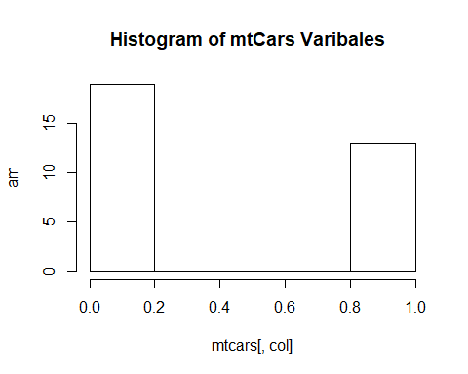

## Warning in plot.window(xlim, ylim, "", ...): graphical parameter "type" is  
## obsolete

## Warning in plot.window(xlim, ylim, "", ...): graphical parameter "type" is  
## obsolete

## Warning in title(main = main, sub = sub, xlab = xlab, ylab = ylab, ...):  
## graphical parameter "type" is obsolete  
  
## Warning in title(main = main, sub = sub, xlab = xlab, ylab = ylab, ...):  
## graphical parameter "type" is obsolete

## Warning in axis(1, ...): graphical parameter "type" is obsolete  
  
## Warning in axis(1, ...): graphical parameter "type" is obsolete

## Warning in axis(2, ...): graphical parameter "type" is obsolete  
  
## Warning in axis(2, ...): graphical parameter "type" is obsolete

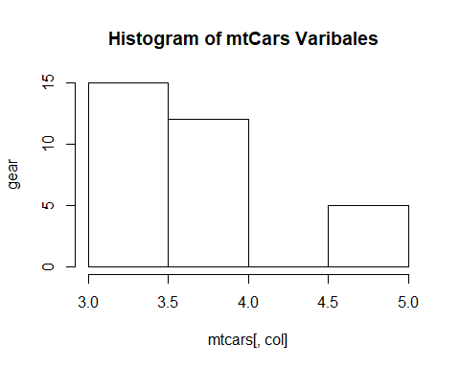

## Warning in plot.window(xlim, ylim, "", ...): graphical parameter "type" is  
## obsolete

## Warning in plot.window(xlim, ylim, "", ...): graphical parameter "type" is  
## obsolete

## Warning in title(main = main, sub = sub, xlab = xlab, ylab = ylab, ...):  
## graphical parameter "type" is obsolete  
  
## Warning in title(main = main, sub = sub, xlab = xlab, ylab = ylab, ...):  
## graphical parameter "type" is obsolete

## Warning in axis(1, ...): graphical parameter "type" is obsolete  
  
## Warning in axis(1, ...): graphical parameter "type" is obsolete

## Warning in axis(2, ...): graphical parameter "type" is obsolete  
  
## Warning in axis(2, ...): graphical parameter "type" is obsolete

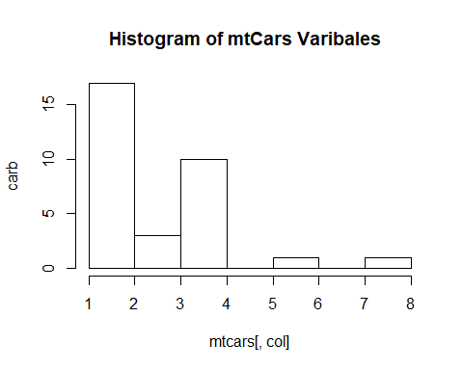

## R Markdown

This is an R Markdown document. Markdown is a simple formatting syntax for authoring HTML, PDF, and MS Word documents. For more details on using R Markdown see <http://rmarkdown.rstudio.com>.

When you click the **Knit** button a document will be generated that includes both content as well as the output of any embedded R code chunks within the document. You can embed an R code chunk like this:

summary(cars)

## speed dist   
## Min. : 4.0 Min. : 2.00   
## 1st Qu.:12.0 1st Qu.: 26.00   
## Median :15.0 Median : 36.00   
## Mean :15.4 Mean : 42.98   
## 3rd Qu.:19.0 3rd Qu.: 56.00   
## Max. :25.0 Max. :120.00

## Including Plots

You can also embed plots, for example:



Note that the echo = FALSE parameter was added to the code chunk to prevent printing of the R code that generated the plot.