**DAILY ONLINE ACTIVITIES SUMMARY**

|  |  |  |  |  |  |  |  |  |
| --- | --- | --- | --- | --- | --- | --- | --- | --- |
| **Date:** | **01-6-2020** | | | | | **Name:** | **Aruna Kumari V** | |
| **Sem & Sec** | **8th sem A sec** | | | | | **USN:** | **4AL16CS018** | |
| **Online Test Summary** | | | | | | | | |
| **Subject** | | **SMS** | | | | | | |
| **Max. Marks** | | **60** | | **Score** | | | **60** | |
| **Certification Course Summary** | | | | | | | | |
| **Course** | **Step into Robotic Process Automation** | | | | | | | |
| **Certificate Provider** | | | **Guvi.in** | | **Duration** | | | **3hrs** |
| **Coding Challenges** | | | | | | | | |
| **Problem Statement:**  **Note:** An element of array is leader if it is greater than or equal to all the elements to its right side. Also, the rightmost element is always a leader.  **Input:** The first line of input contains an integer T denoting the number of test cases. The description of T test cases follows. The first line of each test case contains a single integer N denoting the size of array. The second line contains N space-separated integers A1, A2, ..., AN denoting the elements of the array.  **Output:** Print all the leaders.  **Constraints:** 1 <= T <= 100 1 <= N <= 107 0 <= Ai <= 107. | | | | | | | | |
| **Status:** <https://github.com/ArunaKumariV/online-C-coding/blob/master/01-06-2020> | | | | | | | | |
| **Uploaded the report in Github** | | | | | **NO** | | | |
| **If yes Repository name** | | | | | **----** | | | |
| **Uploaded the report in slack** | | | | | **YES** | | | |

Online Test Details: (Attach the snapshot and briefly write the report for the same)

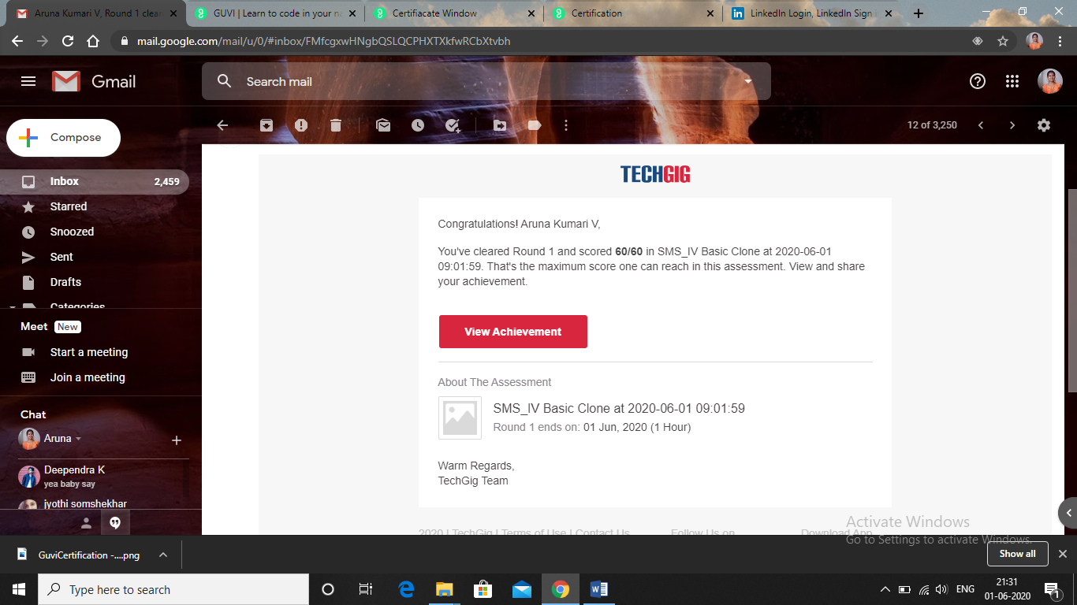

Certification Course Details: (Attach the snapshot and briefly write the report for the same)

