**DAILY ONLINE ACTIVITIES SUMMARY**

|  |  |  |  |  |  |  |  |  |
| --- | --- | --- | --- | --- | --- | --- | --- | --- |
| **Date:** | **27-5-2020** | | | | | **Name:** | **Aruna Kumari V** | |
| **Sem & Sec** | **8th sem A sec** | | | | | **USN:** | **4AL16CS018** | |
| **Online Test Summary** | | | | | | | | |
| **Subject** | | **IOT** | | | | | | |
| **Max. Marks** | | **30** | | **Score** | | | **28** | |
| **Certification Course Summary** | | | | | | | | |
| **Course** | **Introduction to DataScience** | | | | | | | |
| **Certificate Provider** | | | **IBM** | | **Duration** | | | **5days** |
| **Coding Challenges** | | | | | | | | |
| **Problem Statement:**   1. In Bubble sort, each pass consists of comparison each element in the file with its successor (i.e. x[i] with x[i+1]) and interchanging two elements if they are not in the proper order. **The array may be sorted in any pass. If the array is sorted, then remaining passes should be skipped off**. Write a C Program to sort an array of integers in ascending order and display the sorted array and Number of passes performed for sorting. | | | | | | | | |
| **Status:** <https://github.com/ArunaKumariV/online-coding/blob/master/20-5-2020> | | | | | | | | |
| **Uploaded the report in Github** | | | | | **NO** | | | |
| **If yes Repository name** | | | | | **----** | | | |
| **Uploaded the report in slack** | | | | | **YES** | | | |

Online Test Details: (Attach the snapshot and briefly write the report for the same)

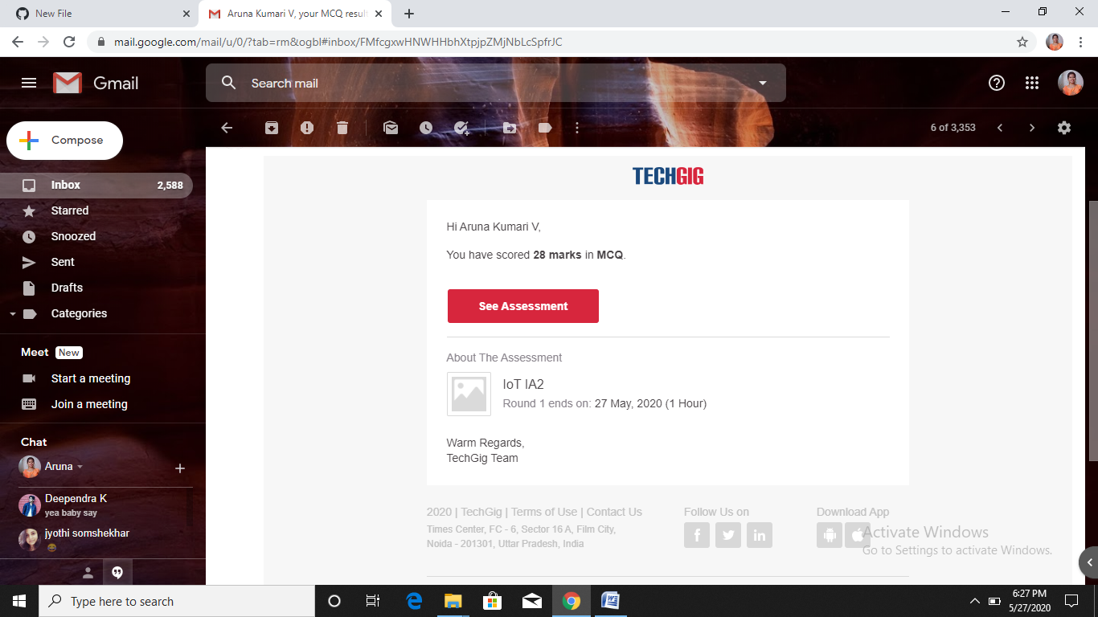

Certification Course Details: (Attach the snapshot and briefly write the report for the same)

