**DAILY ONLINE ACTIVITIES SUMMARY**

|  |  |  |  |  |  |  |  |  |
| --- | --- | --- | --- | --- | --- | --- | --- | --- |
| **Date:** | **28-5-2020** | | | | | **Name:** | **Aruna Kumari V** | |
| **Sem & Sec** | **8th sem A sec** | | | | | **USN:** | **4AL16CS018** | |
| **Online Test Summary** | | | | | | | | |
| **Subject** | | **SMS** | | | | | | |
| **Max. Marks** | | **60** | | **Score** | | | **60** | |
| **Certification Course Summary** | | | | | | | | |
| **Course** | **Deep Learning Fundamentals** | | | | | | | |
| **Certificate Provider** | | | **IBM** | | **Duration** | | | **1hour** |
| **Coding Challenges** | | | | | | | | |
| **Problem Statement:**  The rules for reducing the array are: #The first and last element say X and Y are chosen and removed from the array arr[]. #The values X and Y are added. Z = X + Y. #Insert the value of Z % K into the array arr[] at the position ((N/2) + 1)th position, where N denotes the current length of the array.  Examples: Input: N = 5, arr[] = {1, 2, 3, 4, 5}, K = 7 Output: 1 Explanation: The given array arr[] reduces as follows: {1, 2, 3, 4, 5} -> {2, 6, 3, 4} {2, 6, 3, 4} -> {6, 6, 3} {6, 6, 3} -> {2, 6} {2, 6} -> {1} The last element of A is 1. | | | | | | | | |
| **Status:** <https://github.com/ArunaKumariV/online-C-coding/blob/master/28-05-2020> | | | | | | | | |
| **Uploaded the report in Github** | | | | | **NO** | | | |
| **If yes Repository name** | | | | | **----** | | | |
| **Uploaded the report in slack** | | | | | **YES** | | | |

Online Test Details: (Attach the snapshot and briefly write the report for the same)

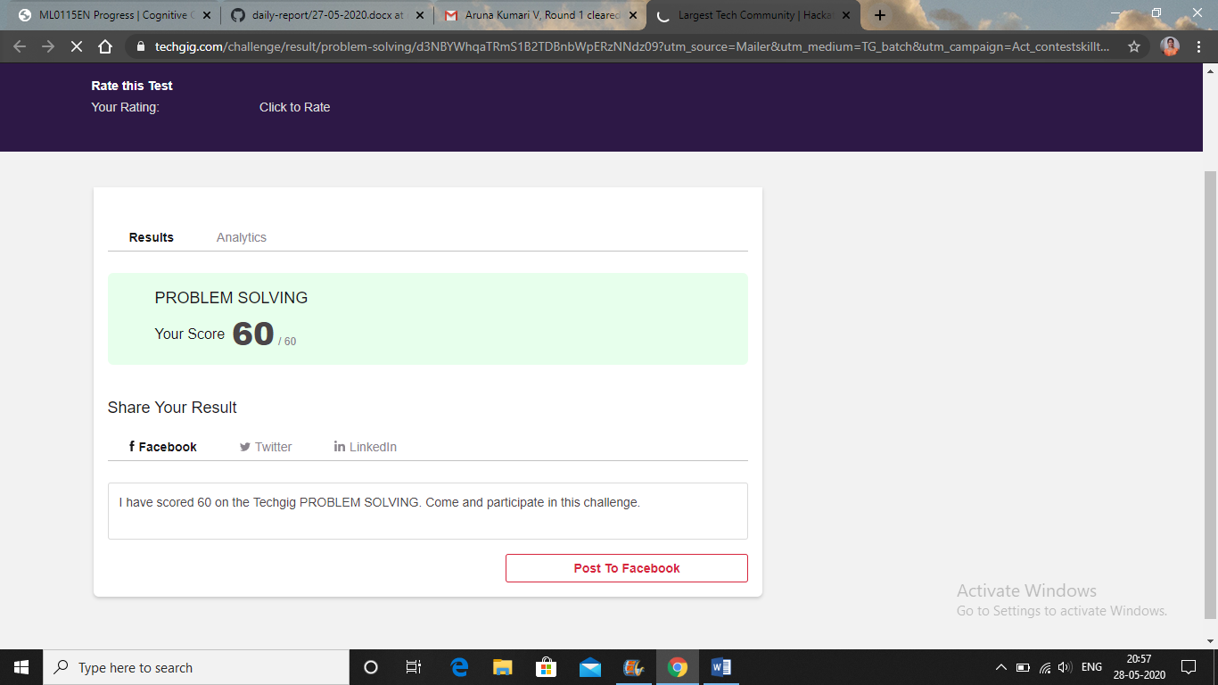

Certification Course Details: (Attach the snapshot and briefly write the report for the same)

