See discussions, stats, and author profiles for this publication at: https://www.researchgate.net/publication/274370182

Power Supply Architecture for Telecom Application: A Review

Conference Paper · October 2010

CITATIONS READS

4 2,093

2 authors:

Sultani Srinivasa Rao Amer Gulam



Professor Jayashankar Telangana Agricultural University Deccan College of Engineering and Technology

30 PUBLICATIONS 146 CITATIONS 16 PUBLICATIONS 32 CITATIONS


SEE PROFILE SEE PROFILE

Some of the authors of this publication are also working on these related projects:


Weed management in greengram View project

POWER CONVERTER FOR TELECOM APPLICATIONS View project

All content following this page was uploaded by Amer Gulam on 01 April 2015.

The user has requested enhancement of the downloaded file.

Power Supply Architecture for Telecom Application: A Review

¹S. Srinivasa Rao and ²Gulam Amer, Student Member IEEE,
¹ ² Department of Electrical Engineering, National Institute of Technology, Warangal-506004, Andhra Pradesh,
²e-mail:amer.nitw@ieee.org

Abstract— In this paper basic power supply architecture for telecom application is briefly explained. The merits and demerits of the architecture are presented. This paper is useful for evaluating issues and challenges in the research area of telecom application. This issue includes not only the improving efficiency, but also increased concern regarding the cost and complexity of power supply systems.

Keywords— Centralized power system, modular power system, distributed power system and centralized modular system.

- INTRODUCTION

Telecommunications is one of the rapidly expanding fields in today’s world. Recent statistics indicate that India now has 49.5 million mobile subscribers and 95.5 million fixed telephone users. The growth in the new users added from 2009 onwards is beyond expectations. It is recorded that, on an average, 9 million new users are added to the list every month. The growth in urban areas is projected at 5.2%, where as the rural India has registered a growth rate of 9.2%. This growth in telecommunications field is always associated with growth in supporting equipment like power supply for telephone exchanges. Given the fact that the rural growth is more, the telecom regulatory authority revised the specification of the power supply units to suit the environmental conditions such as wide input fluctuations, generally present in villages.

Telecommunication systems are designed primarily to provide the backup infrastructure to facilitate communication. Typically a telecommunication system has the AC mains input as the primary power source for the installation, with some critical set-up having an alternative supply in the form of a standby generator as in fig 1. In this case both the generator output and the AC mains input are routed to the power supply cabinets via a mains/generator transfer switch. In the event that the mains supply is compromised this switch is activated allowing the generator to supply energy to the system. During the generator start-up phase the standby batteries provide power to the telecommunication switching equipment. Power converter systems which convert the AC mains voltage to a -48V DC supply are housed inside the power supply cabinets. These power converter systems are used to provide the batteries with charging current when necessary, as well as powering the telecommunication switching equipment, which mainly consists of board mounted power converter units used to convert the -48V to 5V and ±12V.

Basically, there are three different types of power supply architectures. They are

- Centralized power systems

- Modular power systems

- Distributed power system

- Centralized modular power system
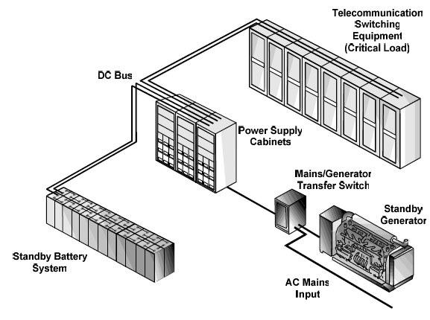

Fig. 1 Typical telecommunication Set-up

- CENTRALIZED POWER SYSTEM
The features of centralized power system are one power conversion stage located in one physical location in the system and multiple outputs generated and bussed to load as in fig 2. The advantage of centralized power system includes concentrating all the power processing technology and thermal management into a single box that can be designed, subcontracted or purchased as stand alone item. However, this type of system fails to provide adequate performance for new generation of electronic equipment [1].
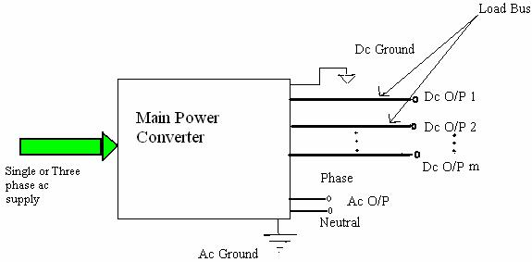

Fig. 1 Centralized power supply

- MODULAR POWER SYSTEM

The features of modular power system are multiple power conversion stages or converters are located in one location in the system, usually far away from the load and voltages and currents can be combined to meet load requirements, when high power is needed as in fig 3.
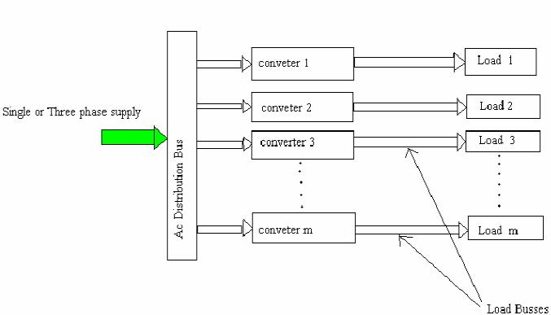

Fig. 3 Modular Power Supply

The advantages of modular power system are best suited for high power applications and high power is achieved by paralleling multiple small power stages in a single package. The merits of a modular power system are [2]:

- Ability to scale and grow.

- Simpler process of duplication

- Ability to specialize the function of modules

- Rapid adaptation to the environment.

- Fault tolerance.

IV. DISTRIBUTED POWER SYSTEM

A distributed power system (DPS) offers many advantages from the standpoint of high power capability, reliability, modularity, redundancy and maintainability. As a result, DPS has become rather popular in telecom and server applications. For centralized power supplies, the reliability must be very high, since a failure would cause the entire system to shut down. However, the failure of any power module in a DPS has a reduced effect on the overall system because of the built-in N+1 redundancy, where N is the minimum number of modules needed to supply the load. Additional advantages of DPS are rapid replacement of faulty modules and flexibility to expand the system capacity as the load requirements increase [3]. Despite several important advantages, a DPS offers two major drawbacks:

- extra cost and (2) noise caused by several converters placed next to each other [4]. Thermal issues may arise because the power supplies are either compressed into ever-smaller cases or because they are mounted on the logic boards to which they supply power. Nevertheless, paralleling decreases the dissipation per module because each module is required to handle less power in the system, which helps simplify thermal design. A typical block diagram of a DPS is illustrated in Fig. 3.
As can be seen, a DPS consists of several stages of power conversion. The name distributed power systems alludes to the fact that the power processing units in the system may not be located in the same place, but are distributed according to load type and location. For the structure shown in fig. 4, the front-end converter is supplied by an AC power source, which can be either a single- or a three -phase bus. The power is processed by the DPS front-end converters represented by the power supplies (PSs) #1 through #N+1 in fig 4.
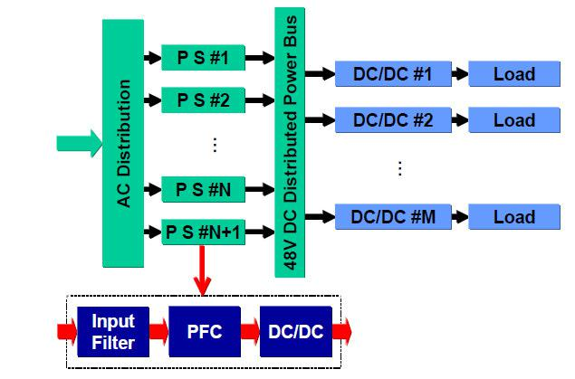

Fig. 4 Distributed Power Supply

Each PS consists of a power factor correction (PFC) stage and a DC/DC front-end converter used to regulate the 48V DC distributed power bus. Small DC/DC high-density power modules are then distributed according to load requirements and location to provide point-of-load regulation. Besides supplying power to the load, the front-end converter for telecom applications, for instance, is also used to charge the backup batteries connected across the distributed DC bus voltage. Front-end converters for DPS applications are typically used in telecom and server applications. There is a wide range of front-end converters available in the market for telecom applications, with power levels ranging from hundreds of watts to several kilowatts. For server applications, the typical power level is 1kW. However, the market for sever applications is growing quickly, as is the power level required for such applications. As predicted in the past, computer applications will continue to drive the power supply industry and to promote the widespread use of DPSs. The PFC stage of the front-end converter has become an important accessory because, especially in Europe, several standards are now limiting the emission of harmonic currents caused by electronic equipment. However, it has always been difficult to justify the cost incurred by adding the PFC stage to the DPS front-

end converters, especially for high-power applications (6kW and up).

- CENTRALIZED MODULAR POWER SYSTEM

Systems which don©t require distributed power can profit immensely by using centralized modular power architecture (CMPA). Figure.5 illustrates such a system incorporating an intermediate voltage bus. Note that the DC -DC converter modules from the intermediate bus don©t have to be centrally located, but can indeed be physically distributed to gain the advantages of (DPA) [5].
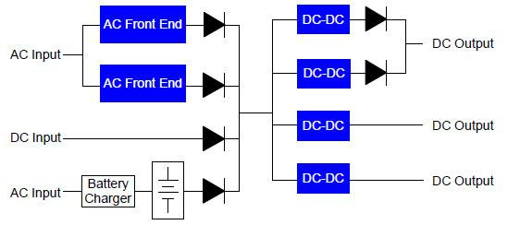

Fig. 5 Centralized Modular Power Architecture

There are many system benefits of a Centralized Modular Power Architecture approach. They include:

- Any Voltage or Voltages

- Any Power Level

- Short Time-to-Market

- Negligible NRE

- Redundancy At Any Level n+1...n+m

- Low Cost UPS

- Current Sharing Paralleling

- Hot Swap Capability

- Expandability

- Flexibility

- Scalability

- Any Form Factor

- High Reliability

- Low Cost

VI. CONCLUSION

The research on PFC circuits for high-power applications is still open in terms of finding solutions able to significantly reduce cost. Research can go in the direction of a centralized modular power supply. Finally, issues and challenges in this research area are identified. This issue includes not only the improving efficiency, but also increased concern regarding the cost and complexity of power supply systems.

REFERENCE

- W.A., Jovanovic M.M., Lee F.C., “Present and Future of Distributed Power Systems”, Virginia Power Electronics Center Seminar, 1992, pp. 161-168.

- B. Mammano, "Distributed Power Systems," Unitrode Power Supply Design Seminar SEM 900, 1993.
- Luo. S “A review of distributed power systems part I: DC distributed power system” Aerospace and Electronic System Magazine IEEE, Aug. 2005, Issue 8, pp 5-16
- Lee, F.C.; Ming Xu; Shuo Wang; “High Density Approaches of AC to DC Converter of Distributed Power Systems (DPS) for Telecom and Computers” Power Conversion Conference, PCC 2007, pp1236 – 1243.

- http://www.vicor-industtry_articles/power_centalized_or_distributed

View publication stats

