Ex.No.2

31/1/25 Implementing various visualization techniques using Time series data

**AIM:**

To implement the various visualization techniques using Time series data

**Implementation:**

import pandas as pd

import matplotlib.pyplot as plt

import seaborn as sns

df = pd.read_csv("ch1_discoveries.csv")

# Convert 'date' column to datetime format

df['date'] = pd.to_datetime(df['date'], format='%d-%m-%Y')

**# Box Plot**

plt.subplot(2, 3, 1)

sns.boxplot(y=df['Y'])

plt.title("Box Plot of Discoveries")

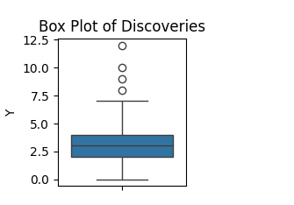

**# Scatter Plot**

plt.subplot(2, 3, 2)

plt.scatter(df['date'], df['Y'], color='red', alpha=0.6)

plt.title("Scatter Plot of Discoveries")

plt.xlabel("Year")

plt.ylabel("Discoveries")

plt.xticks(rotation=45)

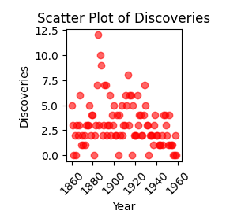

**# Pie Chart (Grouped by occurrences of 'Y')**

pie_data = df['Y'].value_counts()

plt.subplot(2, 3, 3)

plt.pie(pie_data, labels=pie_data.index, autopct='%1.1f%%', startangle=140)

plt.title("Pie Chart of Discovery Frequencies")

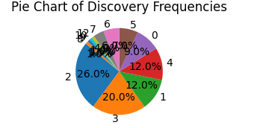

**# Histogram**

plt.subplot(2, 3, 5)

plt.hist(df['Y'], bins=10, color='green', alpha=0.7, edgecolor='black')

plt.title("Histogram of Discoveries")

plt.xlabel("Number of Discoveries")

plt.ylabel("Frequency")

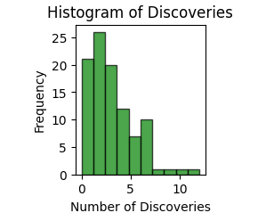

**# Doughnut Plot**

plt.subplot(3, 3, 7)

wedges, texts, autotexts = plt.pie(pie_data, labels=pie_data.index, autopct='%1.1f%%', startangle=140, wedgeprops={'width':0.4})

plt.setp(autotexts, size=8, weight="bold")

plt.title("Doughnut Chart of Discovery Frequencies")

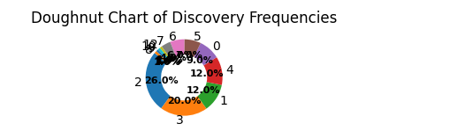

**RESULT:**

Thus the various visualization techniques were done successfully