ARUNA A S

aruna15503@gmail.com

9787822600

s_1 = "Chocolate"

s_2 = "Candy"

s_3 = "IceCream"

s_4 = "Cake"

s_5 = "Cookies"

s_6 = "Brownies"

s_7 = "Cake"

s_8 = "Alaska Cake"

s_9 = "Laddu"

s_10 = "Palkova"

print(s_1)

print(s_2)

print(s_3)

print(s_4)

print(s_5)

print(s_6)

print(s_7)

print(s_8)

print(s_9)

print(s_10)

OUTPUT:

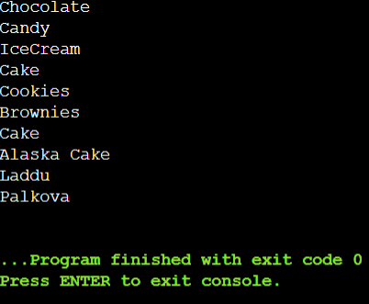

milk_1 = "Whole Milk"

milk_2 = "Wheat Milk"

milk_3 = "Soy Milk"

milk_4 = "Almond Milk"

milk_5 = "Oat Milk"

milk_6 = "Coconut Milk"

milk_7 = "Goat Milk"

milk_8 = "Rice Milk"

milk_9 = "Cashew Milk"

milk_10 = "Cow Milk"

print(milk_1)

print(milk_2)

print(milk_3)

print(milk_4)

print(milk_5)

print(milk_6)

print(milk_7)

print(milk_8)

print(milk_9)

print(milk_10)

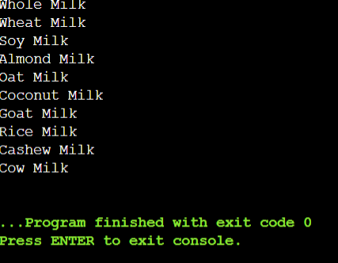

animal_1 = "Lion"

animal_2 = "Tiger"

animal_3 = "Elephant"

animal_4 = "Giraffe"

animal_5 = "Zebra"

animal_6 = "Kangaroo"

animal_7 = "Panda"

animal_8 = "Penguin"

animal_9 = "Dolphin"

animal_10 = "Eagle"

print(animal_1)

print(animal_2)

print(animal_3)

print(animal_4)

print(animal_5)

print(animal_6)

print(animal_7)

print(animal_8)

print(animal_9)

print(animal_10)

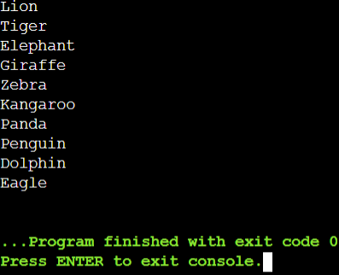

animals = ["Lion", "Tiger", "Elephant", "Giraffe", "Zebra", "Kangaroo", "Panda", "Penguin", "Dolphin", "Eagle"]

user_animal = input("Enter the name of an animal: ")

if user_animal in animals:

print(f"{user_animal} is in the list of animals.")

else:

print(f"{user_animal} is not in the list of animals.")

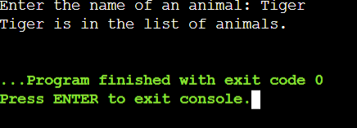

animal_1 = "Lion"

animal_2 = "Tiger"

animal_3 = "Elephant"

animal_4 = "Giraffe"

animal_5 = "Zebra"

user_animal = input("Enter the name of an animal: ")

if user_animal == animal_1:

print(f"{user_animal} is the king of the jungle!")

elif user_animal == animal_2:

print(f"{user_animal} is a fierce big cat.")

elif user_animal == animal_3:

print(f"{user_animal} is the largest land animal.")

elif user_animal == animal_4:

print(f"{user_animal} has a long neck.")

elif user_animal == animal_5:

print(f"{user_animal} has stripes.")

else:

print(f"{user_animal} is not in the predefined list of animals.")

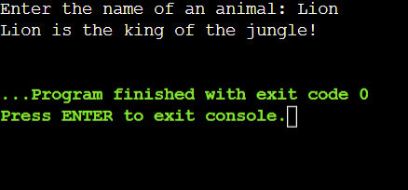

big_cats = ["Lion", "Tiger"]

aquatic_animals = ["Dolphin", "Penguin"]

herbivores = ["Elephant", "Giraffe", "Zebra"]

marsupials = ["Kangaroo"]

mammals=["Cow","Cat"]

birds=["Hen","Crow"]

fish=["Shark","Salmon"]

others = ["Panda", "Eagle"]

user_animal = input("Enter the name of an animal: ")

if user_animal in big_cats:

if user_animal == "Lion":

print(f"{user_animal} is the king of the jungle!")

elif user_animal == "Tiger":

print(f"{user_animal} is a fierce big cat.")

elif user_animal in aquatic_animals:

if user_animal == "Dolphin":

print(f"{user_animal} is very intelligent.")

elif user_animal == "Penguin":

print(f"{user_animal} lives in cold climates.")

elif user_animal in herbivores:

if user_animal == "Elephant":

print(f"{user_animal} is the largest land animal.")

elif user_animal == "Giraffe":

print(f"{user_animal} has a long neck.")

elif user_animal == "Zebra":

print(f"{user_animal} has stripes.")

elif user_animal in marsupials:

if user_animal == "Kangaroo":

print(f"{user_animal} is a great jumper.")

elif user_animal in others:

if user_animal == "Panda":

print(f"{user_animal} loves bamboo.")

elif user_animal == "Eagle":

print(f"{user_animal} soars high in the sky.")

elif user_animal in mammals:

if user_animal == "Cow":

print(f"{user_animal} gives milk.")

elif user_animal == "Cat":

print(f"{user_animal} king of home.")

elif user_animal in fish:

if user_animal == "Shark":

print(f"{user_animal} food of human.")

elif user_animal == "Salmon":

print(f"{user_animal} food of human.")

else:

print(f"{user_animal} is not in the predefined list of animals.")

