

**Report Name: Auto Reorder Point**

**Report Type: DS/Tableau**

**Track: Petchem**

**Module: SAP-APO**

|  |  |
| --- | --- |
| ***Document Control Information*** | |
| **Document Author** | Aruna Singh |
| **Functional Owner** | Aruna Singh |
| **Business Owner** | Debopam Das |
| **Technical Owner** | Aruna Singh |

|  |  |
| --- | --- |
| ***Document Details*** | |
| **Report/Dashboard Name** | Auto Reorder Point |
| **Purpose** | It has direct impact on **sales performance** and **Customer Service Levels** in Petrochemicals sector at RIL. It represents at plant and division level details with maximum cases of inventory falling below or about to below Reorder Point. |
| **Data sources** | Petchem- Auto Reorder Point |
| **HANA Views** | Auto Reorder Point (RSI_M036 and RSI_M037) |
| **Servers Applicable** | RP2/APO |
| **Role ID** |  |
| **URL(Dev and Prod)** | <http://tabdev.ril.com/t/RIL/authoringNewWorkbook/AutoReorderPoint#1> |
| **Folder Hierarchy where Placed** |  |

|  |  |  |  |  |  |  |
| --- | --- | --- | --- | --- | --- | --- |
| ***Change Request History*** | | | | | | |
| **Change Request Number** | **Change Request Date** | **Change Description(Short)** | **CR Number** | **CD Number** | **TR Used for Transport** | **Transport Date** |
| 1 | 14.02.2019 | Inventory Replenishment- Auto Reorder Point | 5026304 | 8030173  8030172 | [BD6K945611](javascript:void(0))  [BD6K945437](javascript:void(0))  [BD6K945008](javascript:void(0)) | 13.03.2019 |
| 2 |  |  |  |  |  |  |
| 3 |  |  |  |  |  |  |
| 4 |  |  |  |  |  |  |
|  |  |  |  |  |  |  |
|  |  |  |  |  |  |  |
|  |  |  |  |  |  |  |
|  |  |  |  |  |  |  |
|  |  |  |  |  |  |  |
|  |  |  |  |  |  |  |
|  |  |  |  |  |  |  |
|  |  |  |  |  |  |  |
|  |  |  |  |  |  |  |
|  |  |  |  |  |  |  |
|  |  |  |  |  |  |  |
|  |  |  |  |  |  |  |
|  |  |  |  |  |  |  |
|  |  |  |  |  |  |  |
|  |  |  |  |  |  |  |
|  |  |  |  |  |  |  |
|  |  |  |  |  |  |  |
|  |  |  |  |  |  |  |
|  |  |  |  |  |  |  |

|  |
| --- |
| ***Change Details (With detail Functional and Technical Spec)*** |

**Change Serial No: 1**

**Functional Change Details:**

**Technical Change Details:**

**Change Serial No: 2**

**Functional Change Details:**

**Technical Change Details:**

**Change Serial No: 3**

**Functional Change Details:**

**Technical Change Details:**

|  |  |
| --- | --- |
| Hana View/Query Details | Base Table |
| Aggregation/Projection/Rank Explanation |
| Join/Union |
| *This section holds detailed explanation of the Hana view with Screenshots for reference | Filter |
| Calculated Columns |

**Calculated Columns:**

RH_BAL_PENDO: **IF(isNull(**"RH_CONPLAN_MTD"**)=**0 **AND** "RH_CONPLAN_MTD"**>**"Z_BILLQTY_MTD"**,**"RH_CONPLAN_MTD"**-**"Z_BILLQTY_MTD"**,**0**)**

**RH_BAL_PENDO_MOU: IF(**"ZPLNCLASS"**=**'A'**,**"RH_BAL_PENDO"**,**0**)**

**AVG_DAILY_DEMAND: IF(isNull(**"RH_REM_DAYS"**)=**0**,** "RH_BAL_PENDO"**/**"RH_REM_DAYS"**,**0**)**

**RH_TRANSIT_STOCK_DAYS: IF(isNull(**"TRNSTCK"**/**"AVG_DAILY_DEMAND"**)=**0**,**"TRNSTCK"**/**"AVG_DAILY_DEMAND"**,**0**)**

**DAYS_OF_COVERAGE: IF(isNull(**"OPNSTK"**/**"AVG_DAILY_DEMAND"**)=**0**,**"OPNSTK"**/**"AVG_DAILY_DEMAND"**,**0**)**

RH_STO_PENDO_DAYS:

**IF(isNull(**"Z_STOPENDO_UNITS"**/**"AVG_DAILY_DEMAND"**)=**0**,**"Z_STOPENDO_UNITS"**/**"AVG_DAILY_DEMAND"**,**0**)**

**RH_REORDER_DAYS:** "RH_OVERALL_RELEVANT_TIME"**+**1**+**"RH_SAFETY_STOCK_DAYS"**-**"RH_TRANSIT_STOCK_DAYS"**-**"RH_STO_PENDO_ORDER_DAYS"

RH_REORDER_DAYS_WOPENDO: "RH_OVERALL_RELEVANT_TIME"**+**1**+**"RH_SAFETY_STOCK_DAYS"**-**"RH_TRANSIT_STOCK_DAYS"

RH_REM_DAYS:

**INT(RIGHTSTR(STRING(lastday(DATE(**"RH_NOW"**))),**2**))- int(midstr(**"RH_NOW"**,**7**,**8**)) +**1

|  |
| --- |
| ***Report Purpose*** |

It has direct impact on **sales performance** and **Customer Service Levels** in Petrochemicals sector at RIL. It represents at plant and division level details with maximum cases of inventory falling below or about to below Reorder Point.

For this, It will create a scenario at division , Plant, Material level for stock falling below or about to fall below reorder point.

|  |
| --- |
| ***KPI Details with Definition*** |

Auto Reorder Point

|  |
| --- |
| ***Functional Logic*** |

It creates a scenario at division , Plant, Material level for stock falling below or about to fall below reorder point.

|  |  |  |  |
| --- | --- | --- | --- |
| Field List in the Report | Table | Field | Joining Logic/Filters |

|  |
| --- |
| ***Technical Details*** |

Used tables: ZAPO_DEP_CONPLAN, ZAPO_PC_CUSCLASS for constraint plan calculation, ZST_SI_095 for open stock and transit stock, VBRK, VBRP for billing qty from MTD calculation, RSI_M013 for Safety Stock , Days of coverage, daily_demnd var units and RSI_M037 (AT_RPLANT, CV_SO_004) for STO Pendo Unit and STO Pendo days Datasource Name

HANA Views: RSI_M036 and RSI_M037

ALV Report Names

Structures

Tables

Tableau Links

|  |
| --- |
| ***HANA View Details*** |

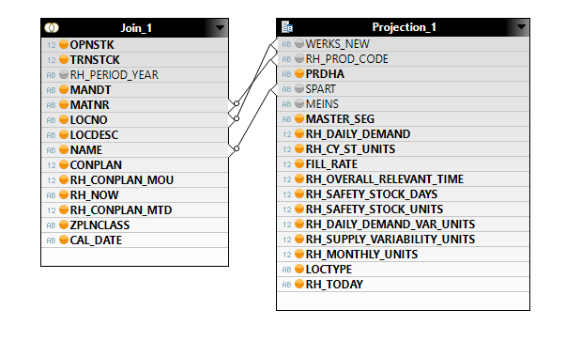

Join 5 to get the demand and Supply at plant material and division level.

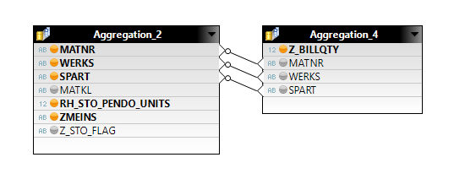

Join 3 to get STO Pendo Units and Billing Qty at plant material and division level.

Join 4 to get billing qty

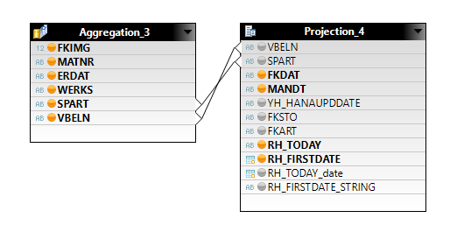

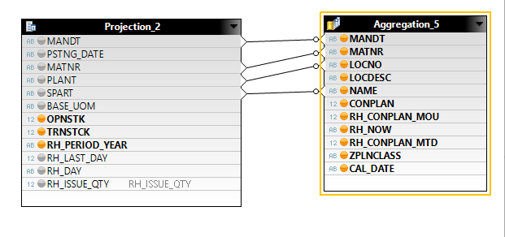

Join 1 to get conplan from month beginning to todays date

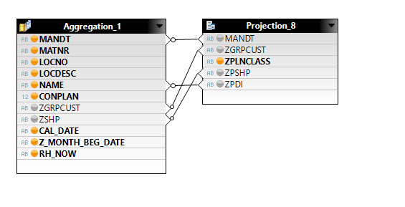

Join 2 to get conplan MOU at customer classification at plant material and division level

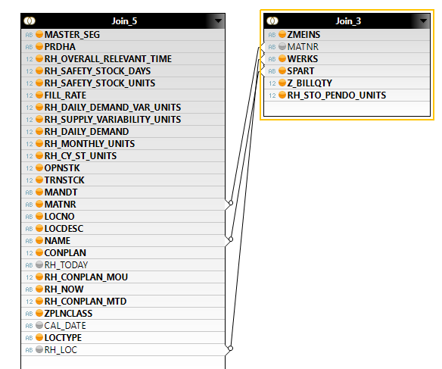

Join 10 to calculate all fields on the basis of material, plants and division.

|  |
| --- |
| ***AMDP Details*** |

|  |
| --- |
| ***Data Source Details*** |

|  |
| --- |
| ***ALV Report Details*** |

|  |
| --- |
| ***Tableau Dashboard*** |

|  |  |
| --- | --- |
| **Dashboard** | |
| **Section** | Each Filter Functionality with Screenshots |
| **Query Used** | Query Screenshots |

**🡸 Use this section to attach screenshots of the Dashboard and explain the Filters used and the functionality of the Filters.**

**🡸 Attach Screenshots of the additional Query Used or Calculation Column with the logic.**

**UAT Mail:**



**\*Kindly attach UAT Mail.**