

**Report Name: Log Comparison Report**

**Report Type: DS/Tableau**

**Track: Petchem**

**Module: SAP-APO**

|  |  |
| --- | --- |
| ***Document Control Information*** | |
| **Document Author** | Aruna Singh |
| **Functional Owner** | Aruna Singh |
| **Business Owner** | Debopam Das |
| **Technical Owner** | Aruna Singh |

|  |  |
| --- | --- |
| ***Document Details*** | |
| **Report/Dashboard Name** | Log Comparison Report |
| **Purpose** | To reduce the manual interventions for comparing the master data and transactional data of multiple tables consisting in specific logs at a particular date and time. |
| **Data sources** | Petchem- Log Comparison |
| **HANA Views** | Log Comparison (RSI_M038 and RSI_S001) |
| **Servers Applicable** | APO |
| **Role ID** |  |
| **URL(Dev and Prod)** | <http://tabdev.ril.com/t/RIL/authoringNewWorkbook/LogComparison> |
| **Folder Hierarchy where Placed** |  |

|  |  |  |  |  |  |  |
| --- | --- | --- | --- | --- | --- | --- |
| ***Change Request History*** | | | | | | |
| **Change Request Number** | **Change Request Date** | **Change Description(Short)** | **CR Number** | **CD Number** | **TR Used for Transport** | **Transport Date** |
| 1 | 11.06.2019 | Petchem- Log Comparison Report | 5030119 | [**8032780**](javascript:void(0)) | [**BD6K947523**](javascript:void(0)) | 11.06.2019 |
| 2 |  |  |  |  |  |  |
| 3 |  |  |  |  |  |  |
| 4 |  |  |  |  |  |  |
|  |  |  |  |  |  |  |
|  |  |  |  |  |  |  |
|  |  |  |  |  |  |  |
|  |  |  |  |  |  |  |
|  |  |  |  |  |  |  |
|  |  |  |  |  |  |  |
|  |  |  |  |  |  |  |
|  |  |  |  |  |  |  |
|  |  |  |  |  |  |  |
|  |  |  |  |  |  |  |
|  |  |  |  |  |  |  |
|  |  |  |  |  |  |  |
|  |  |  |  |  |  |  |
|  |  |  |  |  |  |  |
|  |  |  |  |  |  |  |
|  |  |  |  |  |  |  |
|  |  |  |  |  |  |  |
|  |  |  |  |  |  |  |
|  |  |  |  |  |  |  |

|  |
| --- |
| ***Change Details (With detail Functional and Technical Spec)*** |

**Change Serial No: 1**

**Functional Change Details:**

**Technical Change Details:**

**Change Serial No: 2**

**Functional Change Details:**

**Technical Change Details:**

**Change Serial No: 3**

**Functional Change Details:**

**Technical Change Details:**

|  |  |
| --- | --- |
| Hana View/Query Details | Base Table |
| Aggregation/Projection/Rank Explanation |
| Join/Union |
| *This section holds detailed explanation of the Hana view with Screenshots for reference | Filter |
| Calculated Columns |

**Calculated Columns:**

|  |
| --- |
| ***Report Purpose*** |

To reduce the manual interventions for comparing the master data and transactional data of multiple tables consisting in specific logs at a particular date and time.

|  |
| --- |
| ***KPI Details with Definition*** |

LOG Comparison Report

|  |
| --- |
| ***Functional Logic*** |

The Data is maintained at Plant and material level and calculation done to compare the master data and transaction data of two session ids at start date and start time in RSI_M038.

|  |  |  |  |
| --- | --- | --- | --- |
| Field List in the Report | Table | Field | Joining Logic/Filters |

|  |
| --- |
| ***Technical Details*** |

Used tables in HANA View RSI_S001:

./SAPAPO/SNPOPLMA and ./SAPAPO/SNPOPLPR are used for various stocks comparison,

./SAPAPO/SNPOPPMO for production cost comp ,

./SAPAPO/SNPOPPMA for./SAPAPO/SNPOPPRE for variable quantity comp and

./SAPAPO/SNPOPPRS for variable resource capacity comparison .

./SAPAPO/SNPOPIAM and ./SAPAPO/SNPOPIAR are used for transportation cost comparison.

**HANA Views: op1.rm.sct.log.rsi::RSI_M038 and op1.rd.sct.log.rsi::RSI_S001**

**Tableau Links:** <http://tabdev.ril.com/t/RIL/authoringNewWorkbook/LogComparison>

|  |
| --- |
| ***HANA View Details*** |

1. **op1.rd.sct.log.rsi::RSI_S001**
2. Join 4 to Join the sessionid and get the arc id , matid , tcost on the basis of bucket.

For this, a calculation field “BUCKET” is created to build the relation between VALTO1, VALTO2, VALFR1 and VALFR2.

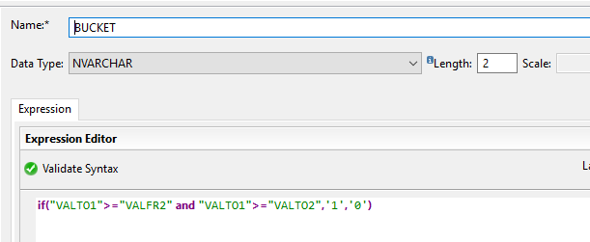

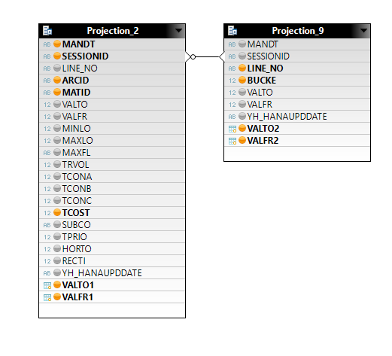

1. Join of Session ID and ARCID to get the source location (LOCFR) and destination location (LOCTO)

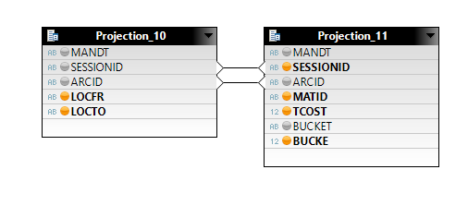

1. Union_1 to Join Tables ./SAPAPO/SNPOPLMA and ./SAPAPO/SNPOPLPR are used for various stocks comparison, ./SAPAPO/SNPOPPMO for production cost comp , ./SAPAPO/SNPOPPMA for./SAPAPO/SNPOPPRE for variable quantity comp and ./SAPAPO/SNPOPPRS for variable resource capacity comparison , ./SAPAPO/SNPOPIAM and ./SAPAPO/SNPOPIAR are used for transportation cost comparison.

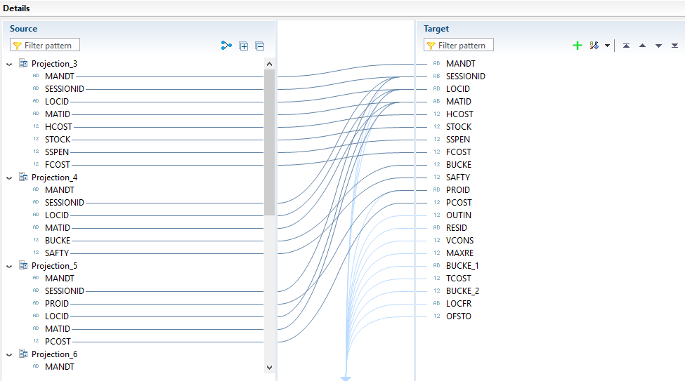

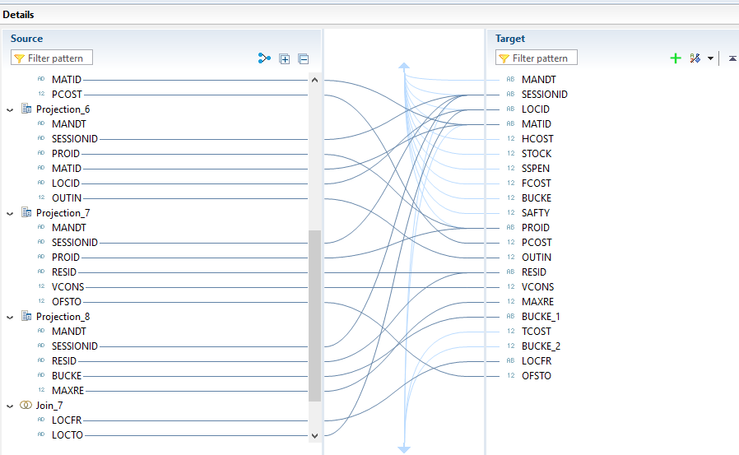

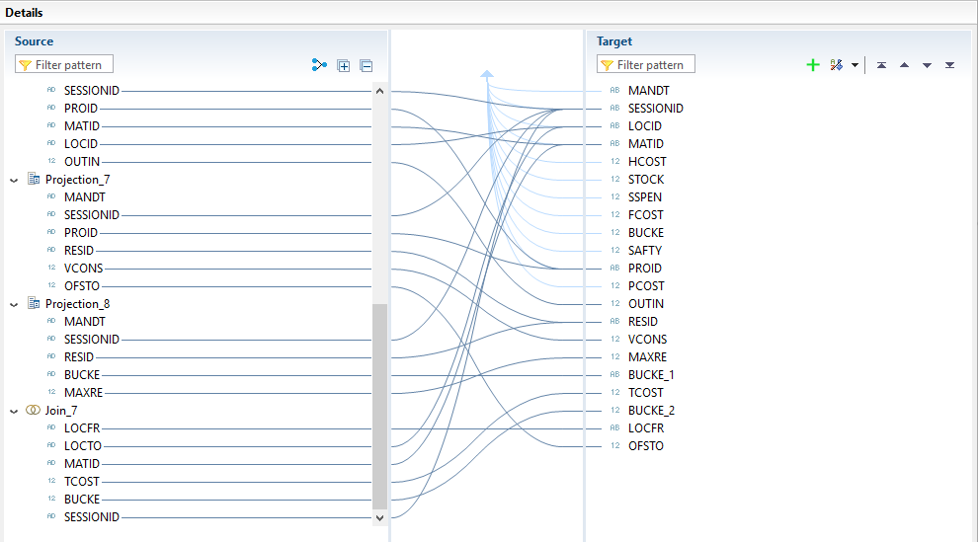

1. Join_1 to create the join of session id to get SDATE and STIME

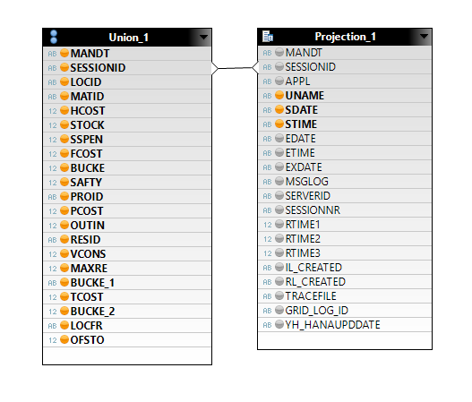

1. Join_2 /sapapo/snpopiek are used to get the production process model model on the basis of its id.

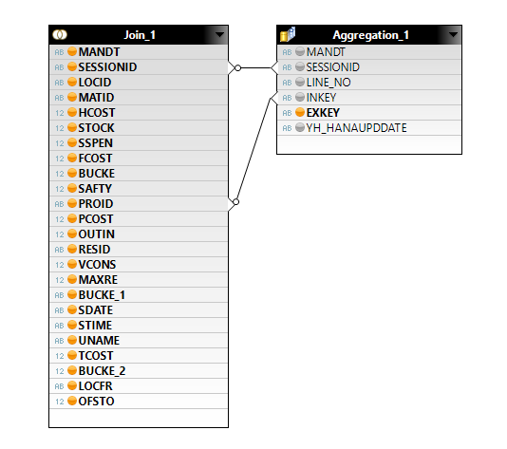

1. Join_2 /sapapo/snpopiek are used to get the resource name on the basis of its id.

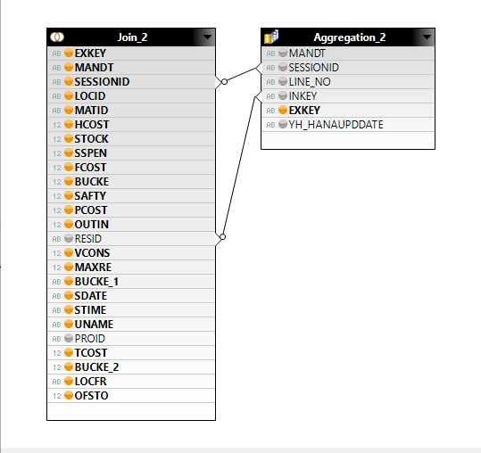

1. Join_3 /sapapo/snpopiek are used to get the LOCNO (source location) on the basis of its id.

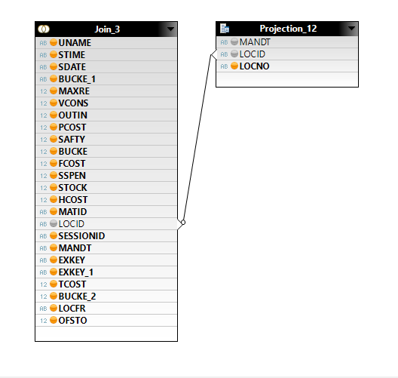

1. Join_5 /sapapo/loc are used to get the MATNR (material) on the basis of its id.

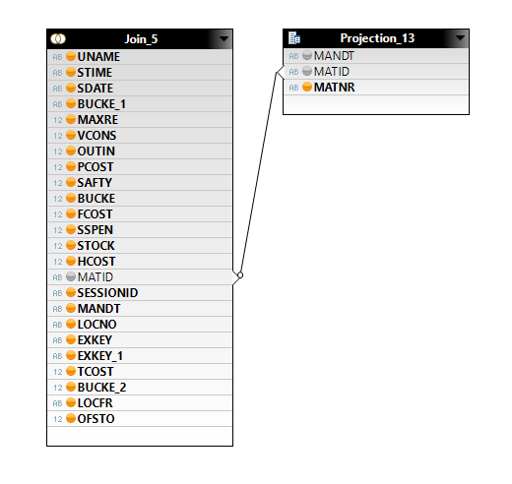

1. Join_5 /sapapo/loc are used to get the LOCNO (source location) on the basis of its id.

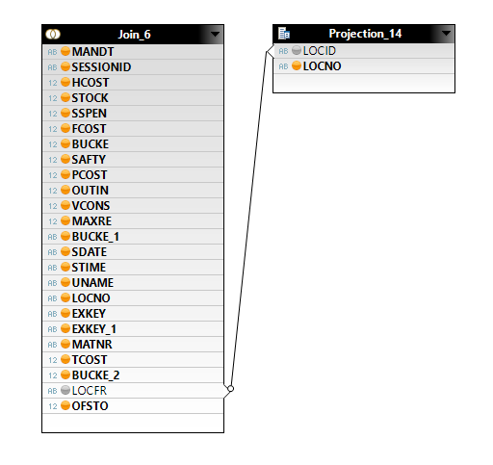

1. **op1.rm.sct.log.rsi::RSI_M038**
2. Union_1 to Join op1.rd.sct.log.rsi::RSI_S001 at first start date and first start time at first session id and second start date and second start at the second session id

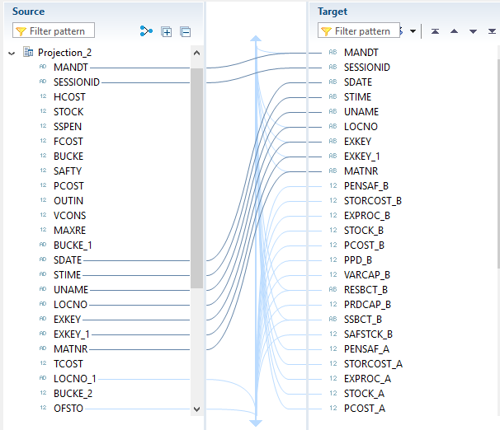

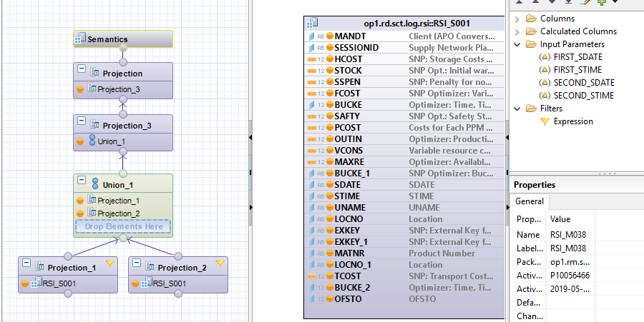

2) At Projection _3, 10 calculation fields are created to calculate the difference between two transactional data from different session ids:

1. **if((**"TCOST_A"**-**"TCOST_B"**) =** 0 **,**0**,(**"TCOST_A"**-**"TCOST_B"**))**
2. **if((**"PENSAF_A"**-**"PENSAF_B"**) =** 0 **,**0**,(**"PENSAF_A"**-**"PENSAF_B"**))**
3. **if((**"STOCK_A"**-**"STOCK_B"**) =** 0 **,**0**,(**"STOCK_A"**-**"STOCK_B"**))**
4. **if((**"EXPROC_A"**-**"EXPROC_B"**) =** 0 **,**0**,(**"EXPROC_A"**-**"EXPROC_B"**))**
5. **if((**"STORCOST_A"**-**"STORCOST_B"**) =** 0 **,**0**,(**"STORCOST_A"**-**"STORCOST_B"**))**
6. **if((**"SAFSTCK_A"**-**"SAFSTCK_B"**) =** 0 **,**0**,(**"SAFSTCK_A"**-**"SAFSTCK_B"**))**
7. **if((**"VARCAP_A"**-**"VARCAP_B"**) =** 0 **,**0**,(**"VARCAP_A"**-**"VARCAP_B"**))**
8. **if((**"PPD_A"**-**"PPD_B"**) =** 0 **,**0**,(**"PPD_A"**-**"PPD_B"**))**
9. **if((**"PCOST_A"**-**"PCOST_B"**) =** 0 **,**0**,(**"PCOST_A"**-**"PCOST_B"**))**
10. **if((**"PRDCAP_A"**-**"PRDCAP_B"**) =** 0 **,**0**,(**"PRDCAP_A"**-**"PRDCAP_B"**))**

|  |
| --- |
| ***AMDP Details*** |

|  |
| --- |
| ***Data Source Details*** |

|  |
| --- |
| ***ALV Report Details*** |

|  |
| --- |
| ***Tableau Dashboard*** |

|  |  |
| --- | --- |
| **Dashboard** | |
| **Section** | Each Filter Functionality with Screenshots |
| **Query Used** | Query Screenshots |

**🡸 Use this section to attach screenshots of the Dashboard and explain the Filters used and the functionality of the Filters.**

**🡸 Attach Screenshots of the additional Query Used or Calculation Column with the logic.**

**UAT Mail:**

**\*Kindly attach UAT Mail.** 