|  |  |
| --- | --- |
| **EXP:1** | **a)Create a Web Page to embed a map along with hotspot,frames,links**  **b)Create a webpage using an embedded,external and inline CSS file** |
|  |  |

# AIM:

Create a Web Page to embed a map along with hotspot,frames,links

Create a webpage using an embedded,external and inline CSS file

# CODE:

<!DOCTYPE html>

<html>

<head>

<title>Hotspot</title>

<!-- Link to the external CSS file -->

<link rel="stylesheet" type="text/css" href="style.css">

<style>

h1 {

text-align: center;

color: #333;

margin-top: 20px;

}

</style>

</head>

<body>

<!-- Inline style for the image itself (optional to override or enhance external styles) -->

<h1>Interactive Map of India</h1>

<img src="india map.webp" usemap="#indiamap" width="900" height="720" alt="Map of India">

<map name="indiamap">

<area shape="rect" coords="324,578,407,535" alt="Tamil Nadu" href="https://en.wikipedia.org/wiki/Tamil_Nadu">

<area shape="rect" coords="343,655,398,599" alt="Tamil Nadu" href="https://en.wikipedia.org/wiki/Tamil_Nadu">

<area shape="rect" coords="407,538,395,602" alt="Tamil Nadu" href="https://en.wikipedia.org/wiki/Tamil_Nadu">

<area shape="rect" coords="346,653,397,605" alt="Tamil Nadu" href="https://en.wikipedia.org/wiki/Tamil_Nadu">

<area shape="rect" coords="406,537,324,579" alt="Tamil Nadu" href="https://en.wikipedia.org/wiki/Tamil_Nadu">

</map>

</body>

</html>

@charset "ISO-8859-1";

body {

font-family: Arial, sans-serif;

margin: 0;

padding: 0;

background-color: #f4f4f4;

}

img {

display: block;

margin: 0 auto;

border-radius: 8px;

box-shadow: 0 4px 6px rgba(0, 0, 0, 0.1);

}

/* Styling for the map areas */

area {

outline: none;

border: none;

transition: transform 0.3s ease-in-out;

}

area:hover {

transform: scale(1.1);

}

# OUTPUT:



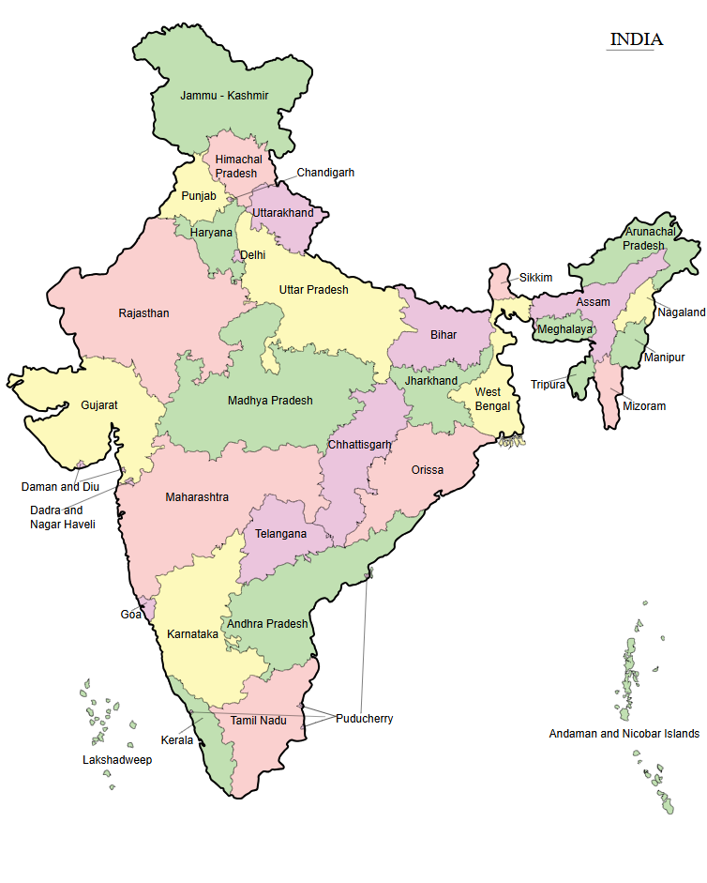

**RESULT:**

The web page to embed a map along with hotspot,frame and links.