-> Attach the required space in ec2 console.

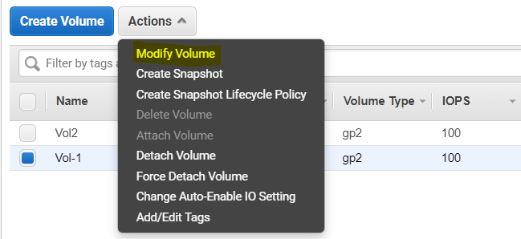

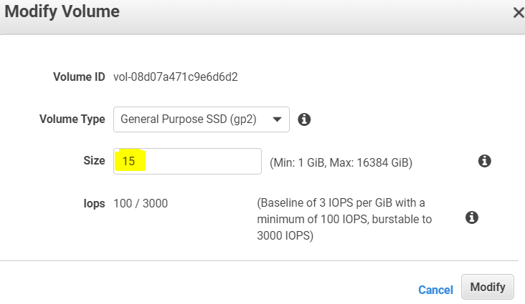

State is showing yellow it will take sometimes to come green.

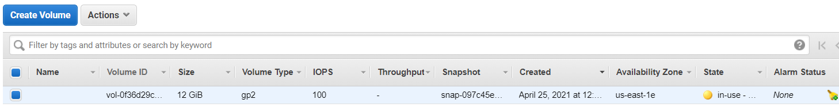



Here I am going to extend my 12GB ‘/’ partition into 15 GB size.

-> To display information about the block devices attached to your instance run below command

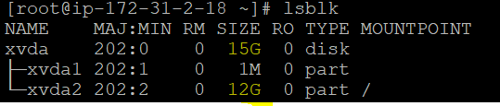

-> Check the space of root volume before it extending.

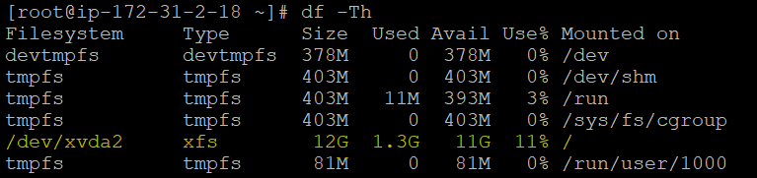

-> To extend the partition on each volume, use the following **growpart** commands



-> Use the **df -h** command to verify the size of the file system for each volume.

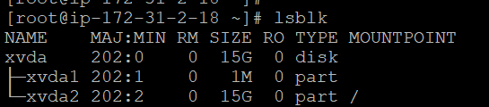

-> Use the **xfs_growfs** command to extend the file system on each volume.

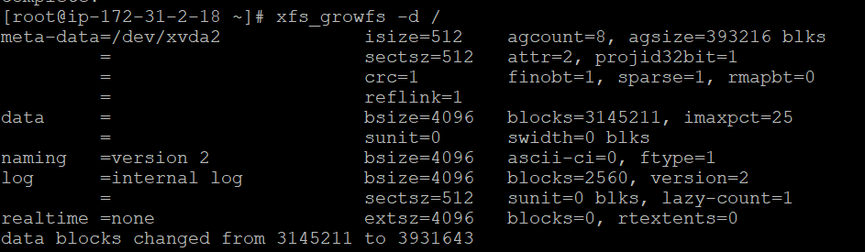

-> Use the **resize2fs** command to extend the file system on each volume.



-> Use the **df -h** command again to verify that each file system reflects

