Configuring elastic ip

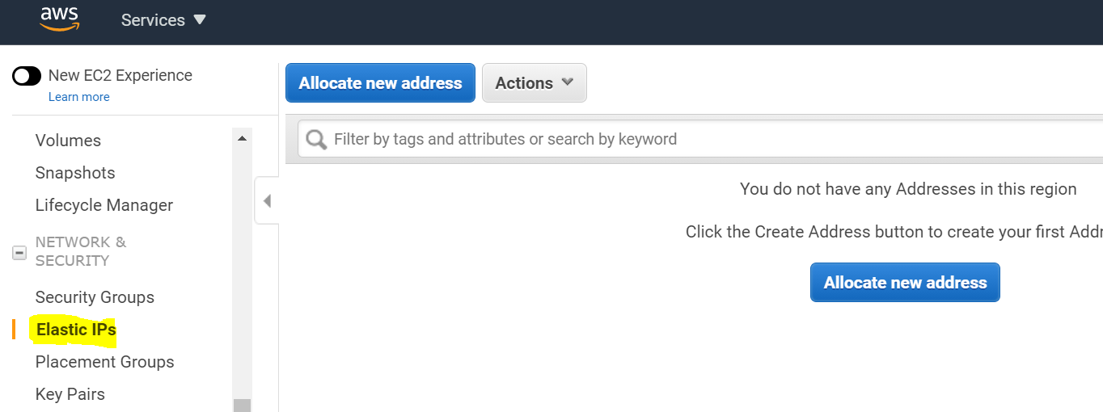

Select Allocate ip address and choose Amazon pool

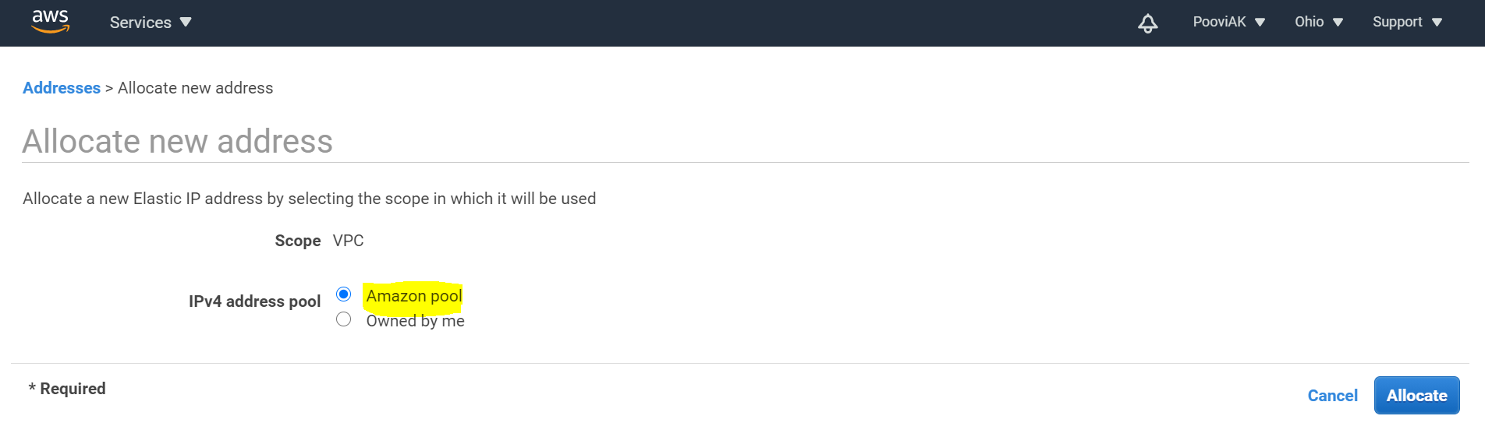

Elastic ip allocated:

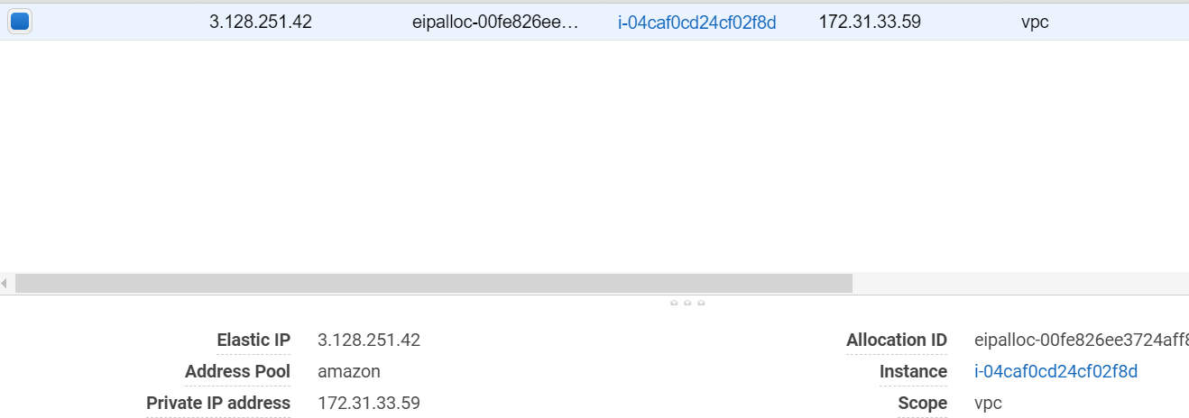

Select Associate address from Action menu:

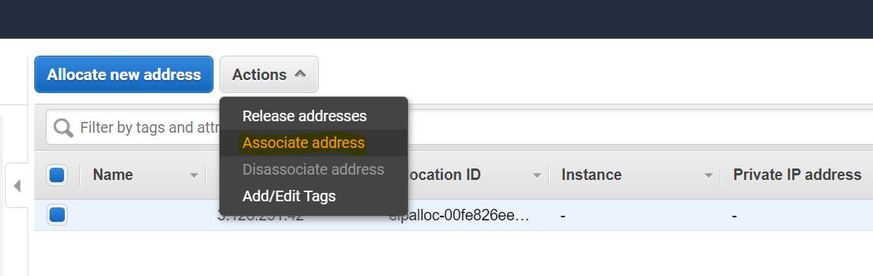

Select Instance and private ip address. Once done click associate.

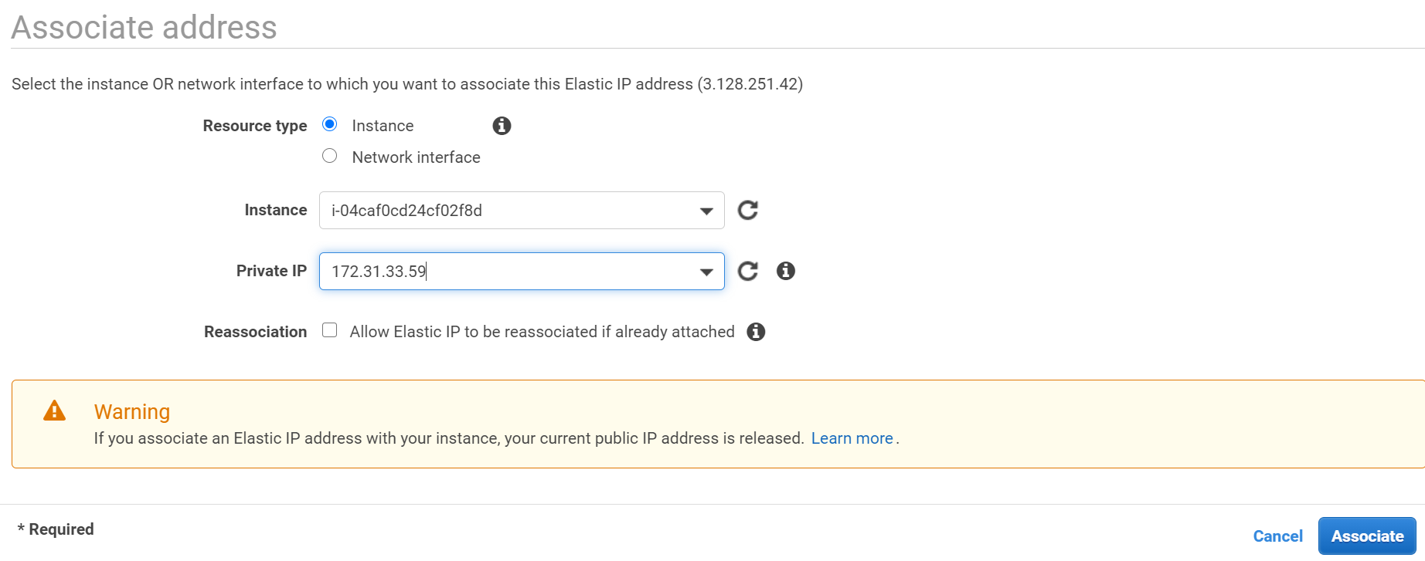

Elastic IP (static ip) successfully assigned to mentioned server:

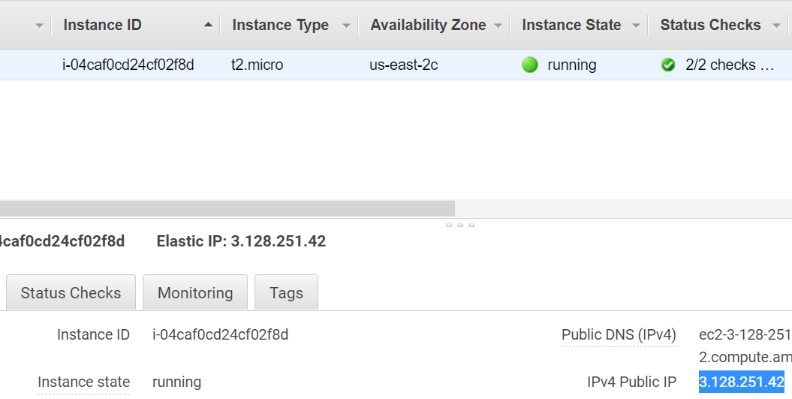

Check the configure Elastic ip:

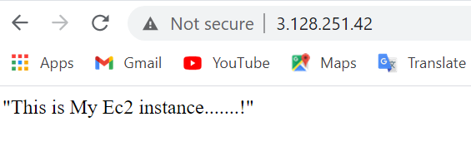

**NOTE**:

Once you created elastic ip you need to assign to some instance. If not assigned cost will be applicable. Better once your usage is done remove the elastic ip.

**Removing elastic ip from instance:**

From Action -> select Disassociate elastic ip

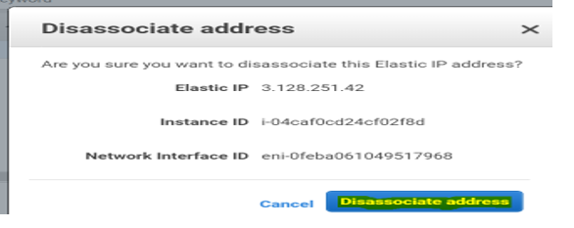

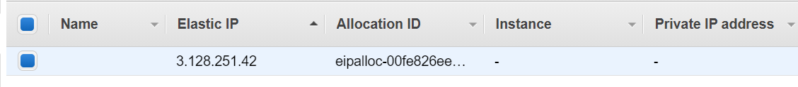

Dynamic IP allocated:

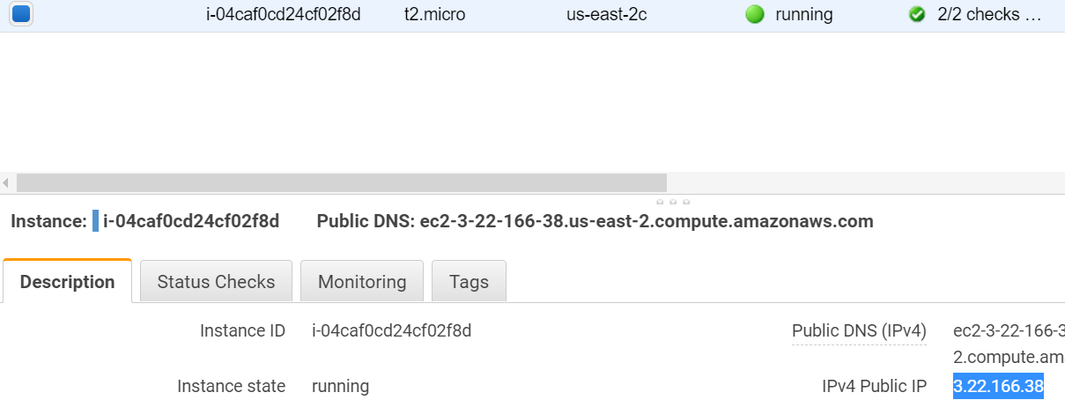

Release the elastic ip:

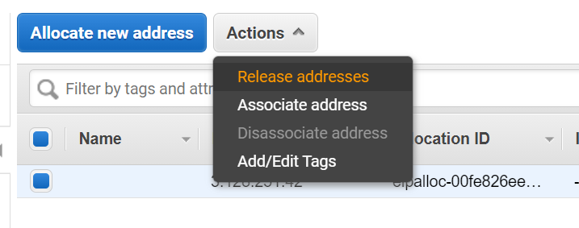

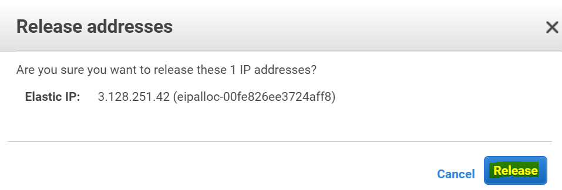

Now successfully removed elastic ip dashboard is showing empty:

