Create two instances:

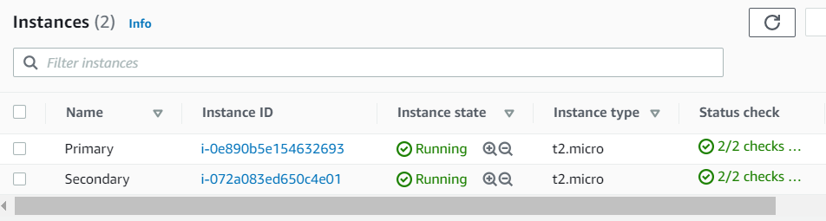

Create new Network interface:

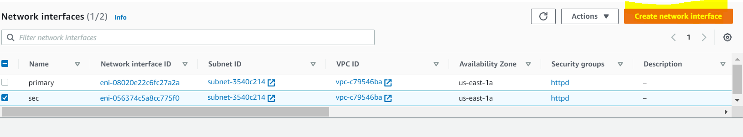

Choose subnet region :

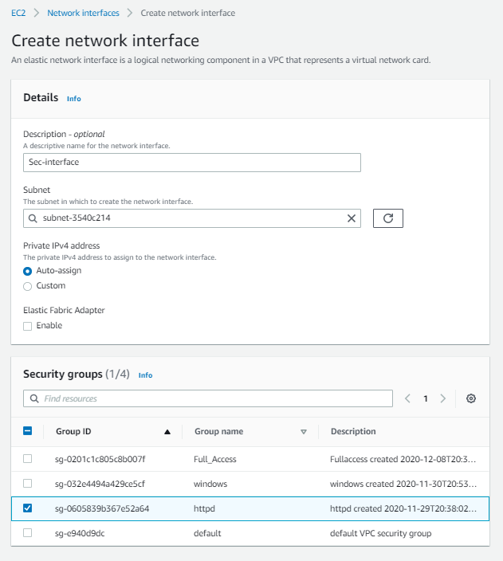

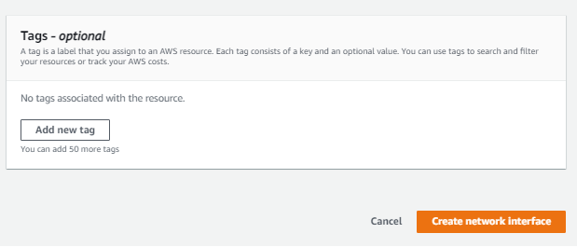

Secondary interface created:

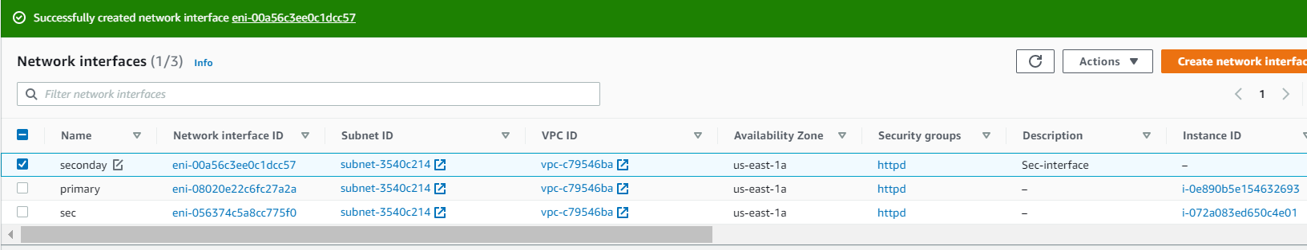

Attach sec int into primary instance:

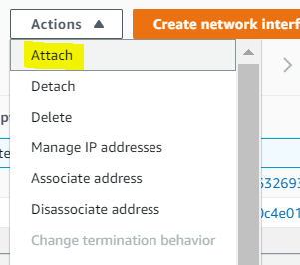

Select primary instance:

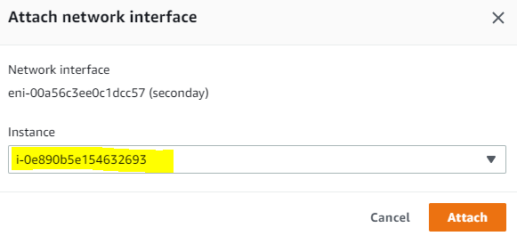

Now u can see two interfaces for primary.

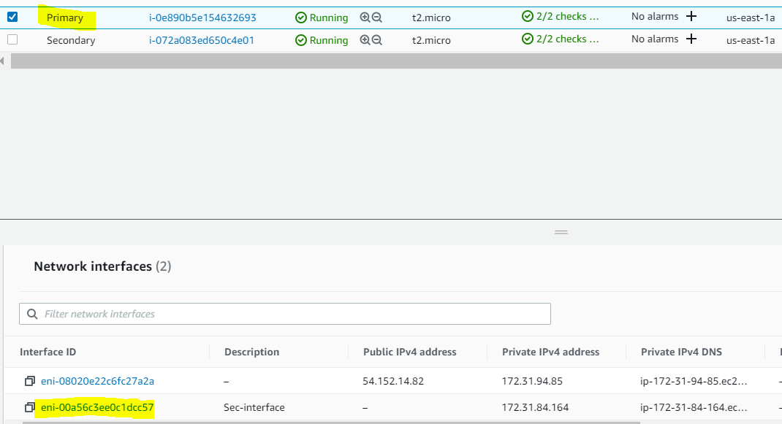

Create elastic IP:

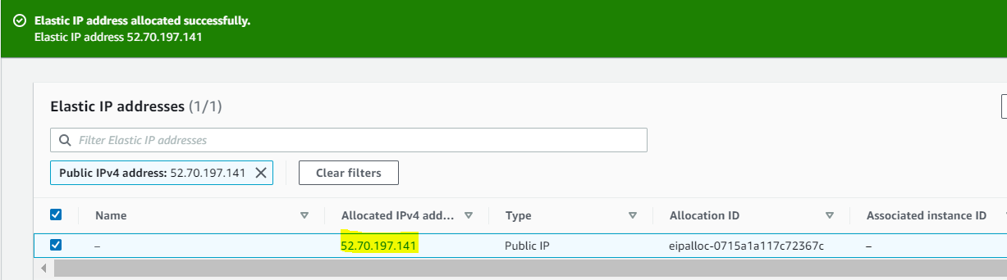

Attach the elastic ip into newly created secondary interface:

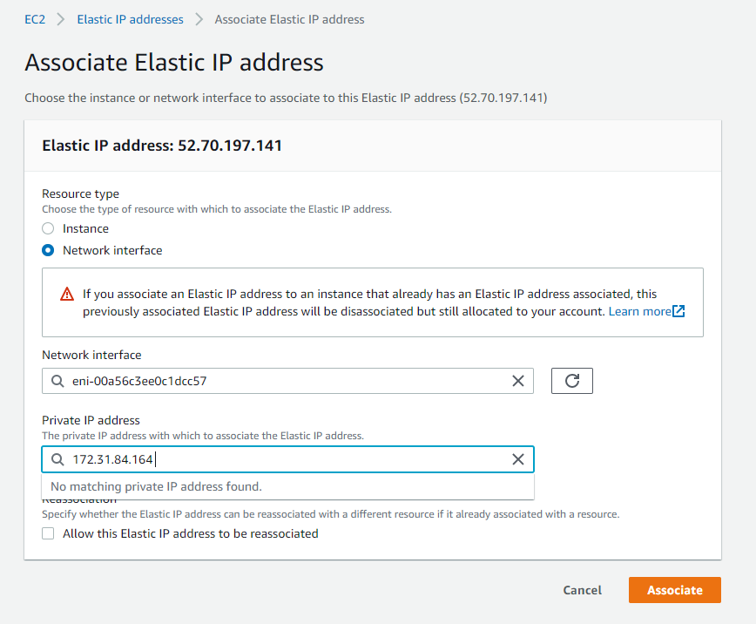

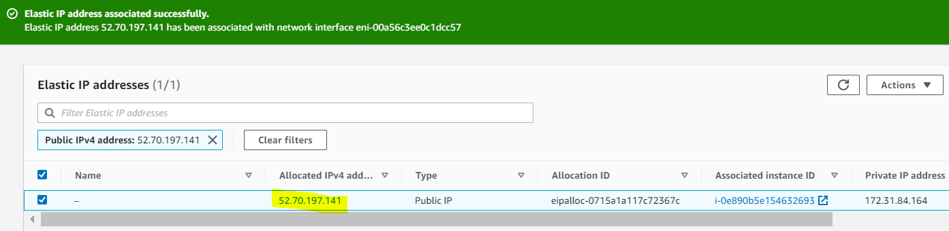

Check the primary instance output:

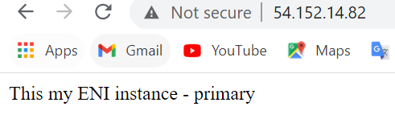

Once validation is done detach the secondary interface. It will take some time to detach.

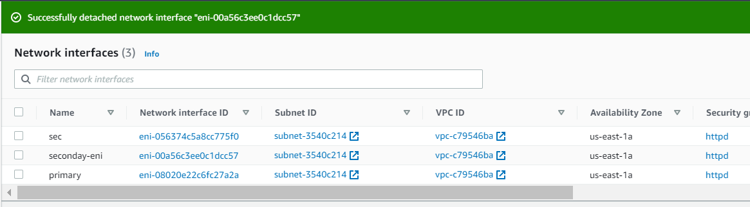

Repeat the same attach the secondary interface into stand by server and check the output.

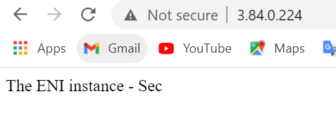

Once test is done remove elastic ip, delete interface and instance: