**Nat-gate-way configuration**

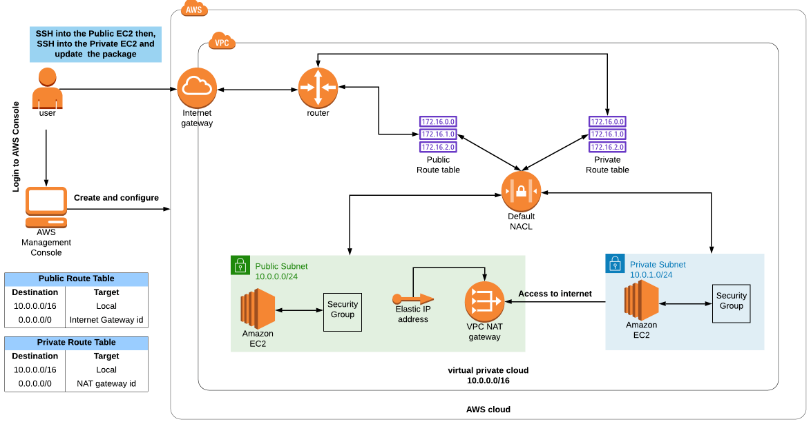

A NAT gateway gives **cloud resources without public IP addresses access to the internet** without exposing those resources to incoming internet connections.

Create VPC.

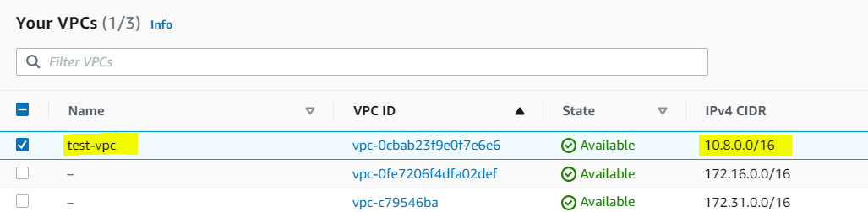

Create two subnets one for public and another one for private

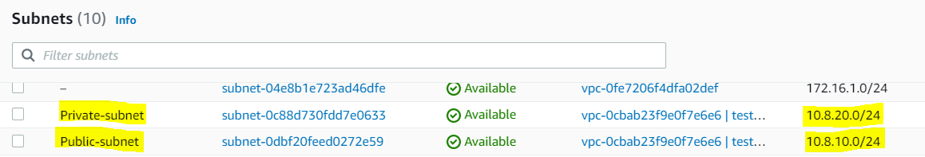

Create two route table one for public and another one for private.



Create IGW for public subnets and attach to VPC.

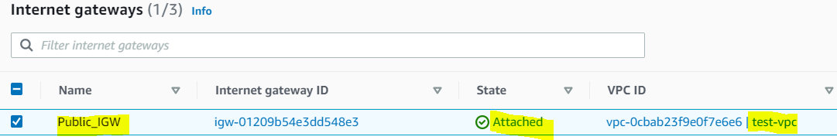

Create NAT gateway for private subnets. For this configuration EIP is required.

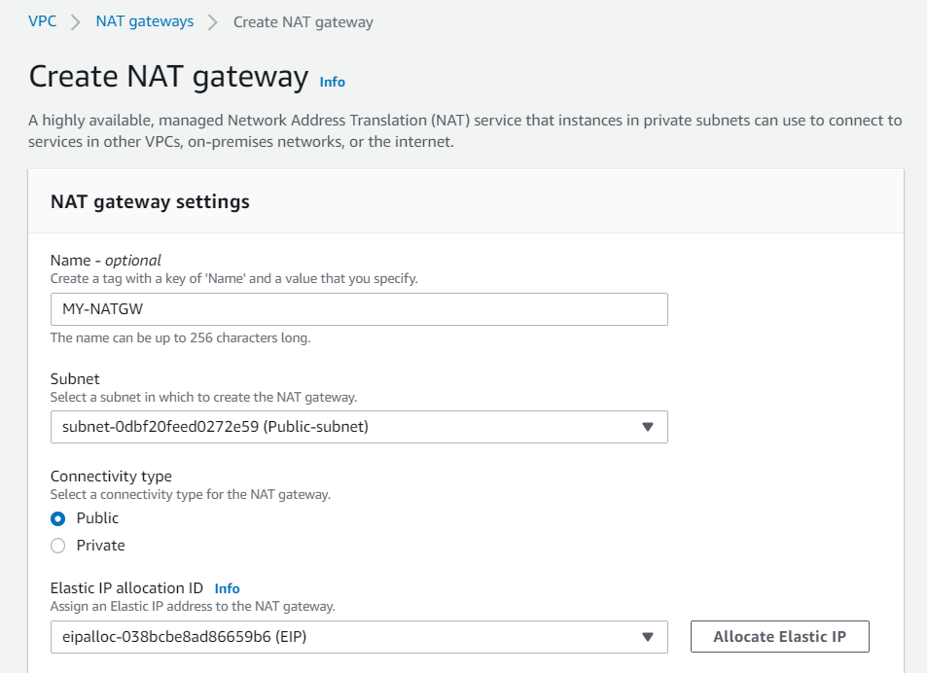

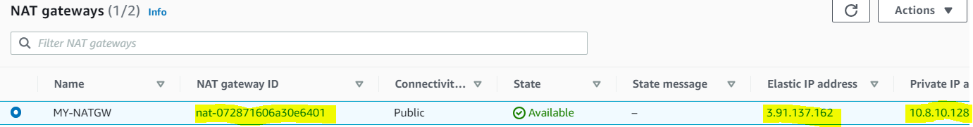

Edit subnet associations in both public and private RT. Here have to choose public subnet and remove the private. Once done click Save.

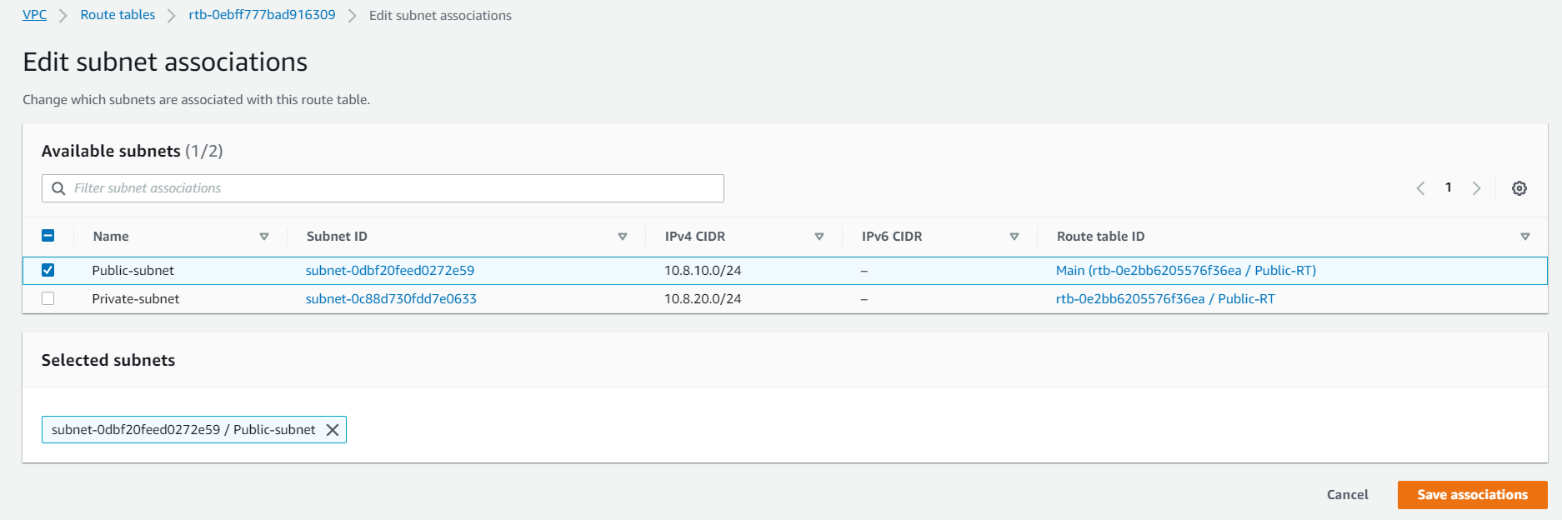

Here have to choose private subnet and remove the public. Once done click Save.

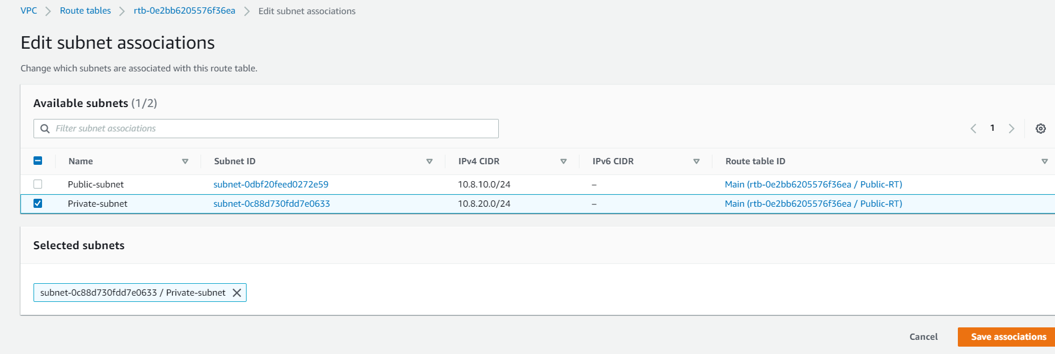

Edit routes in both public and private RTB. Add IGW in public RTB.

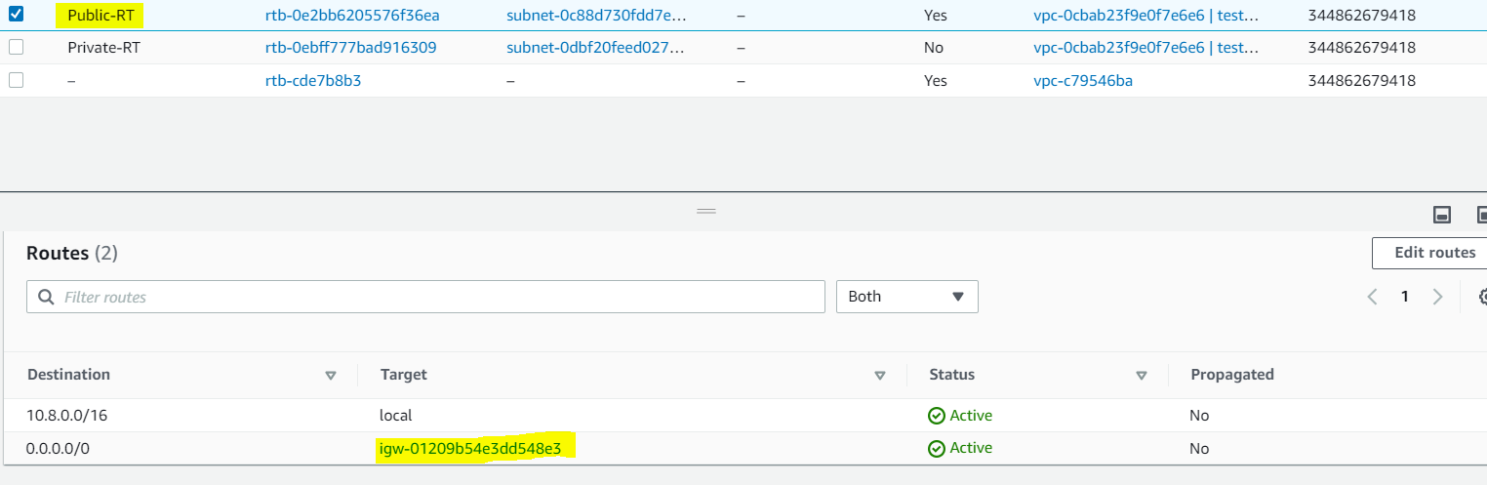

In private RTB add Nat gate way in private RTB.

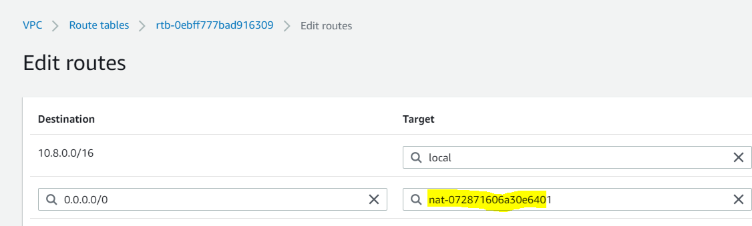

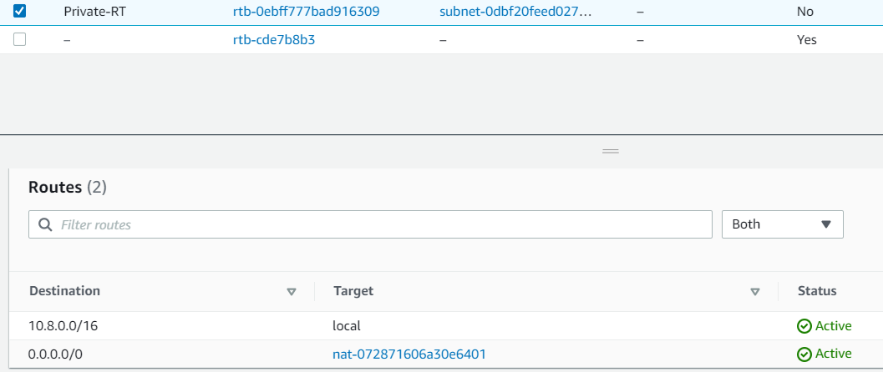

Now create two instance one using public subnet and another one using private subnet.

Choose below while create public instance.

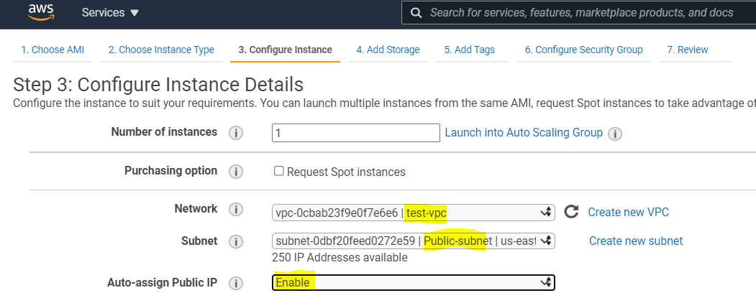

Choose below while creating nat instance.

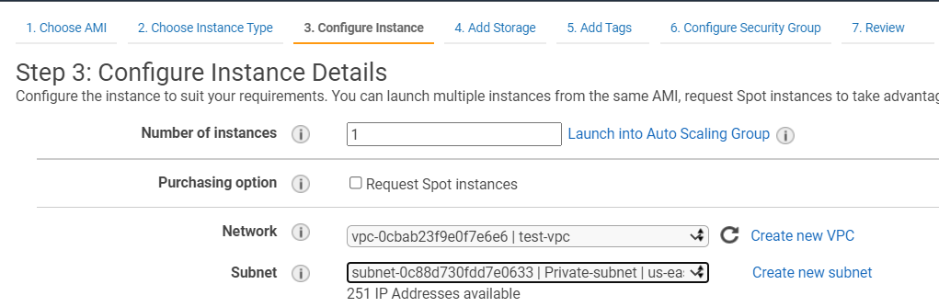

Login Public instance and place the private key for NAT instance.

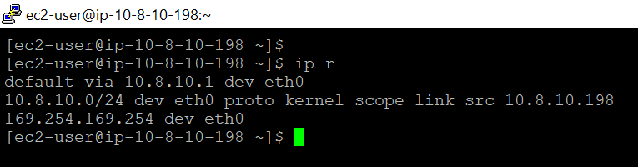

Set the below permission for NAT instance key.

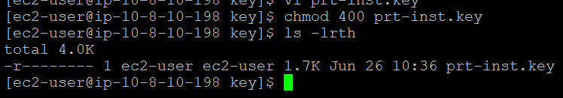

Try login NAT instance via public instance using private key.

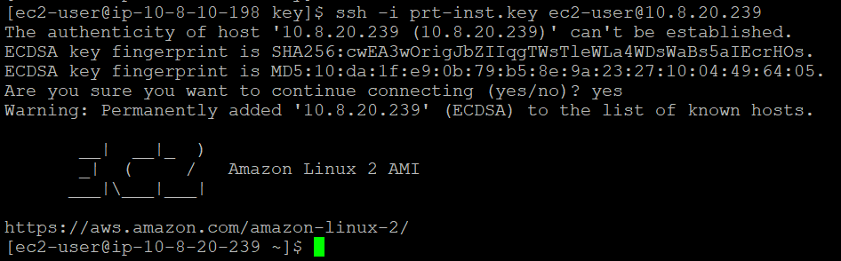

Try ping request from NAT instance. It works

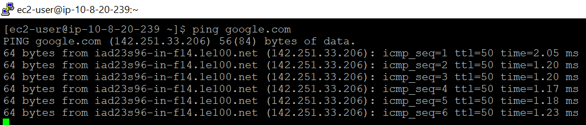

Now try disable Natgateway from route it will disconnect ping request. Internet will disconnected.

