IMPLEMENT CLIENT SCRIPT & UI POLICY (INCIDENT)
PHASE-WISE PROJECT DOCUMENT

Project Description
Incident records require consistent and accurate data entry for effective triage, routing, and resolution. Manual checks can result in incomplete or incorrect information. This project implements ServiceNow UI Policies and Client Scripts to enforce conditional field behavior, mandatory fields, automatic updates, and save-time validation on Incident records.

Objective
The objective is to demonstrate how ServiceNow client-side controls can enforce data integrity on Incident records. The implementation uses UI Policies and Client Scripts to dynamically make fields mandatory, automatically populate values, control field behavior, and prevent invalid record submission.

Skills / Technologies
• Incident Management
• UI Policy
• UI Policy Actions
• Client Scripts
• Form Validation

PHASE 1 – CREATE UI POLICY ON INCIDENT
1. Log in to the ServiceNow instance with administrative or configuration access.
2. Navigate to System UI → UI Policies.
3. Click New to create a new UI Policy record.
4. Enter Name as: High Impact Control.
5. Select Table as: Incident.
6. Set Active to true.
7. Configure the condition: Field = Impact, Operator = is, Value = 1 – High.
8. Create the UI Policy Action for Assignment group and make the field mandatory.
9. Set Reverse if false to true.
10. Review the configuration and click Submit.
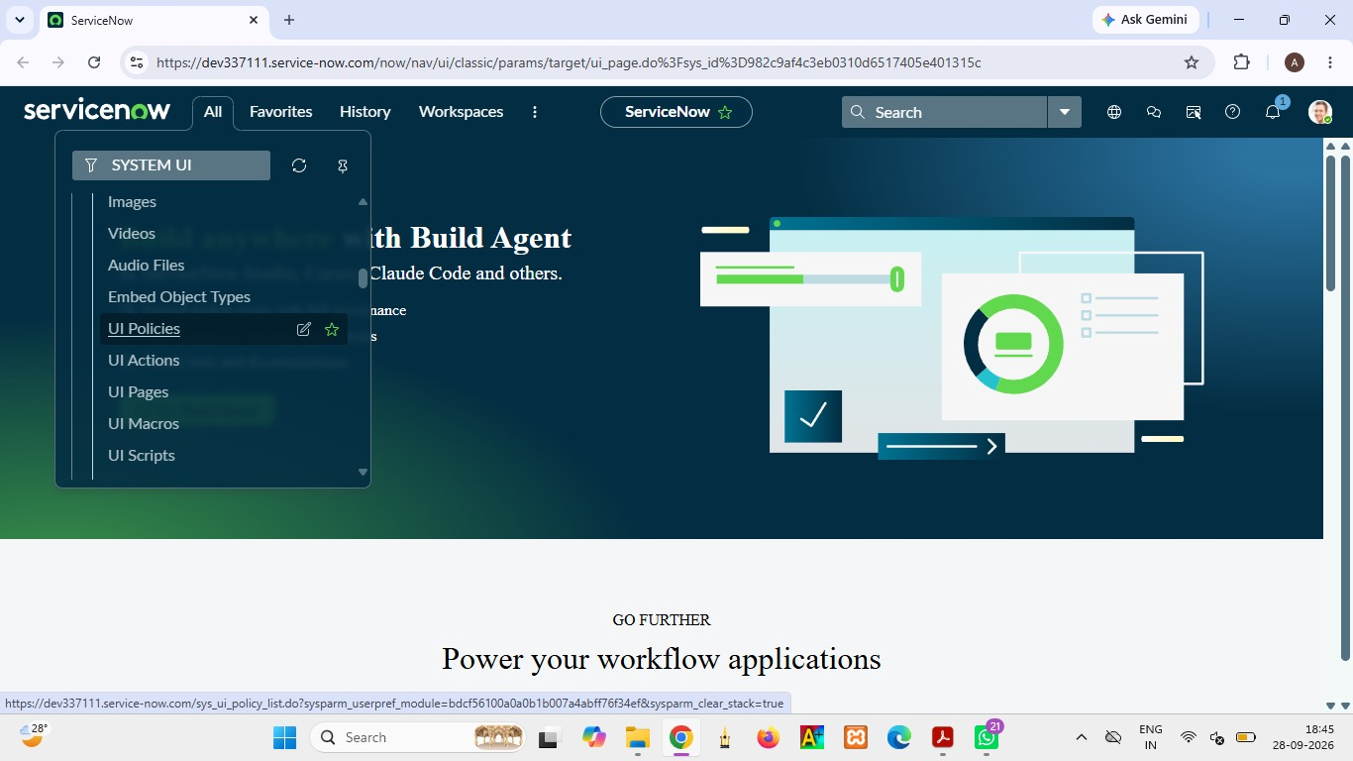

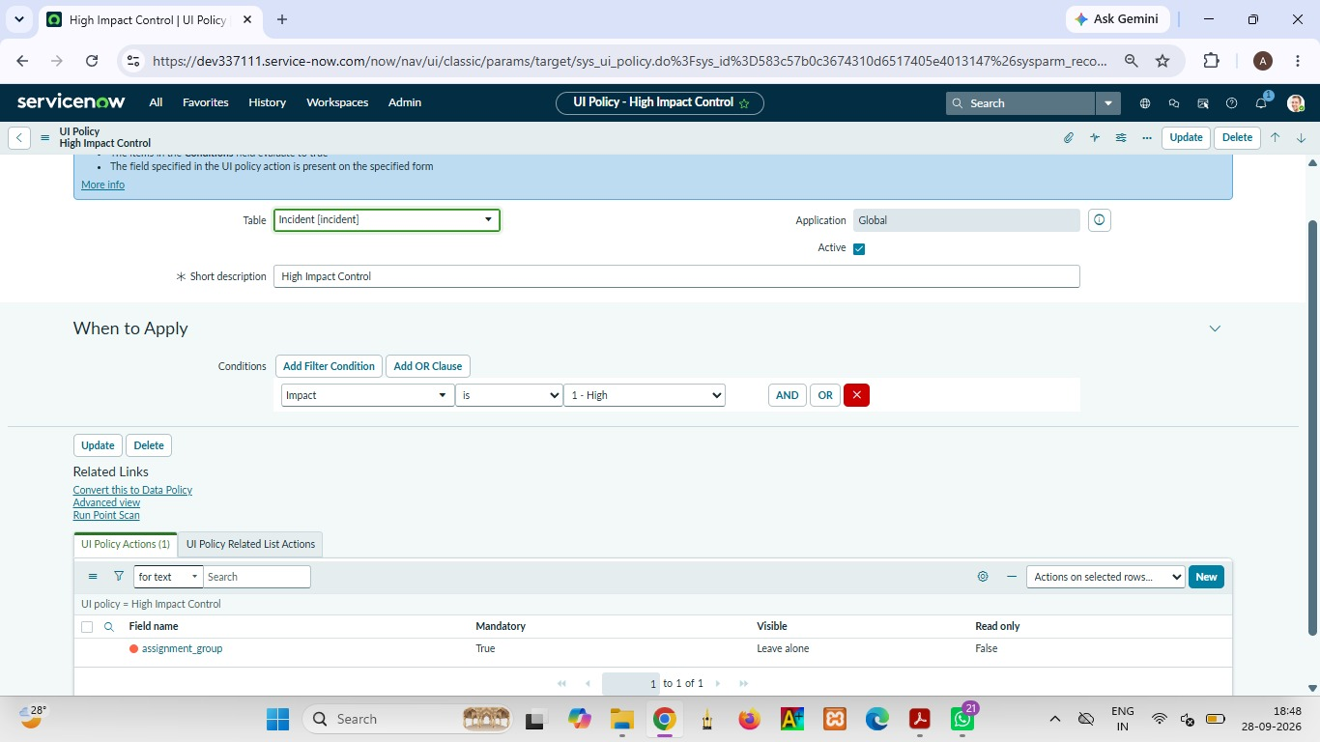

PHASE 2 – CONFIGURE UI POLICY ACTION – URGENCY
1. Open the High Impact Control UI Policy.
2. Scroll to the UI Policy Actions related list and click New.
3. Set Field name as: Urgency.
4. Set Read-only to true.
5. Leave Visible unchanged so the Urgency field remains visible.
6. Click Submit to save the UI Policy Action.
7. Verification: open an Incident, set Impact to High, and confirm that Urgency becomes read-only.
8. Change Impact to another value and verify that the field behavior is reversed when applicable.
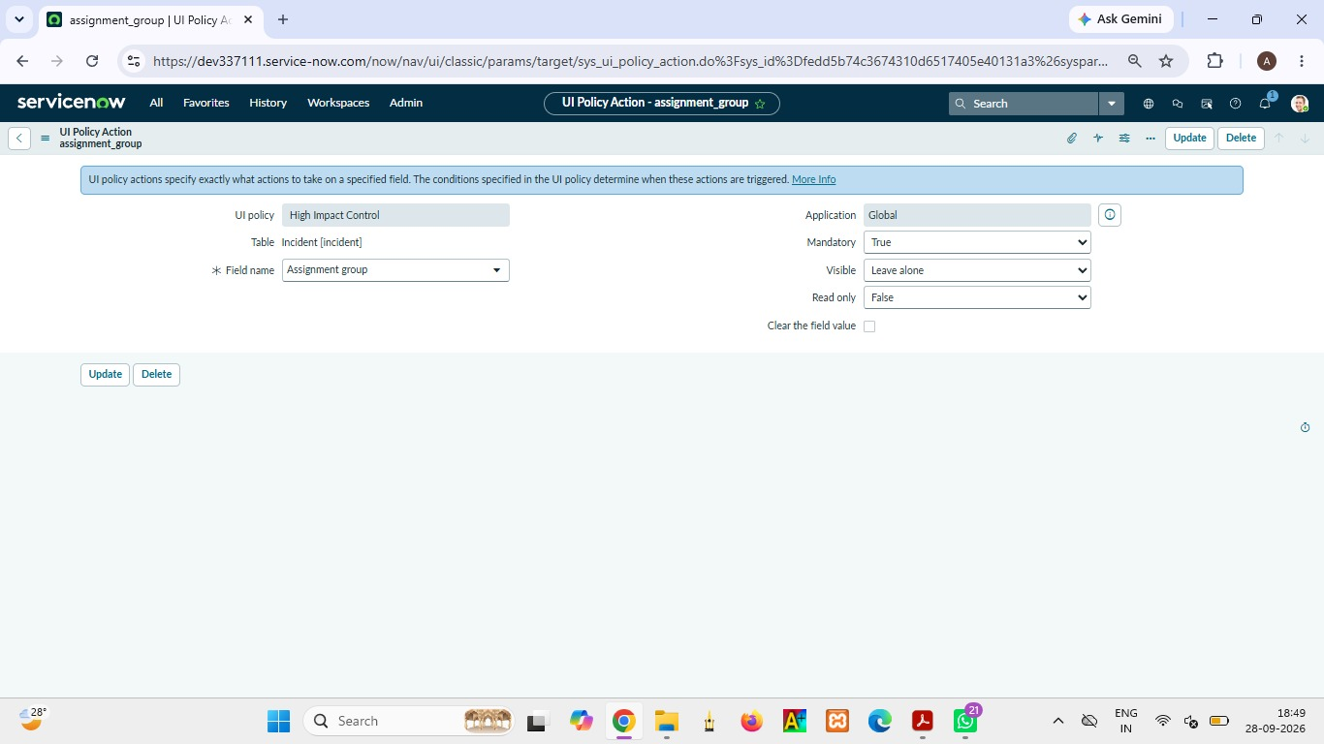

PHASE 3 – CREATE ONCHANGE CLIENT SCRIPT
1. Navigate to System UI → Client Scripts.
2. Click New.
3. Name: Auto set urgency for high impact.
4. Table: Incident.
5. Type: onChange.
6. Field name: Impact.
7. Set Active to true.
8. Paste the following script into the Script field:
function onChange(control, oldValue, newValue, isLoading) {
if (isLoading || newValue == '') {
return;
}
if (newValue == '1') {
g_form.setValue('urgency', '1');
g_form.addInfoMessage('Urgency set to High for High impact incident.');
}
}
9. Click Submit.
10. Verify by opening an Incident and changing Impact to High. Urgency should update automatically.
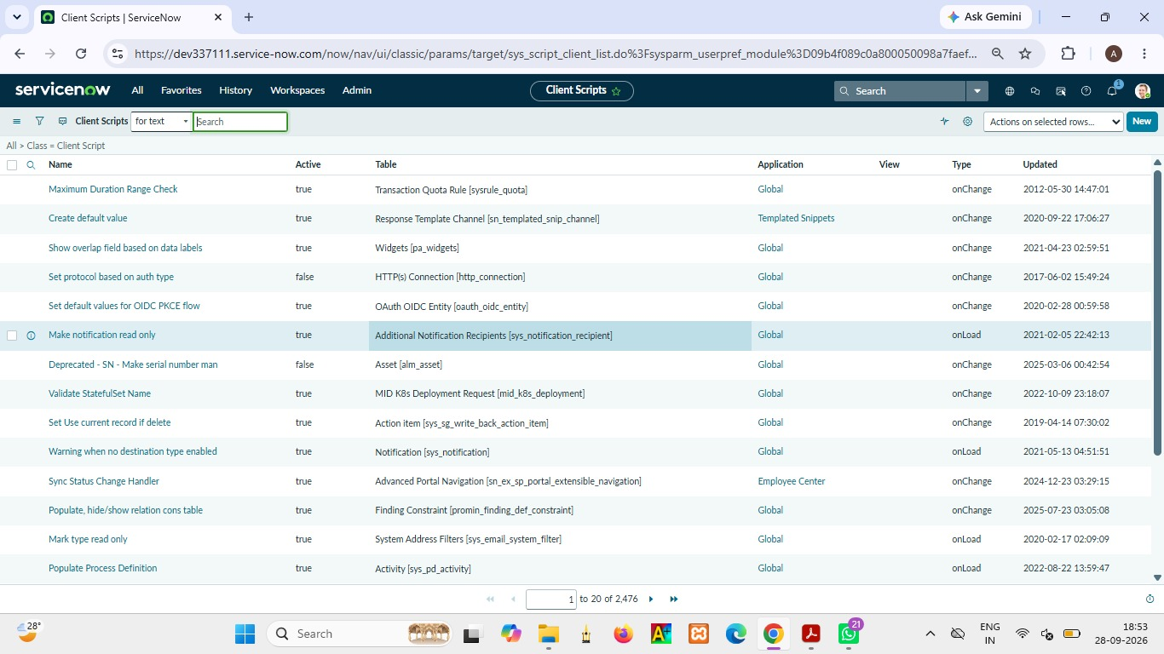

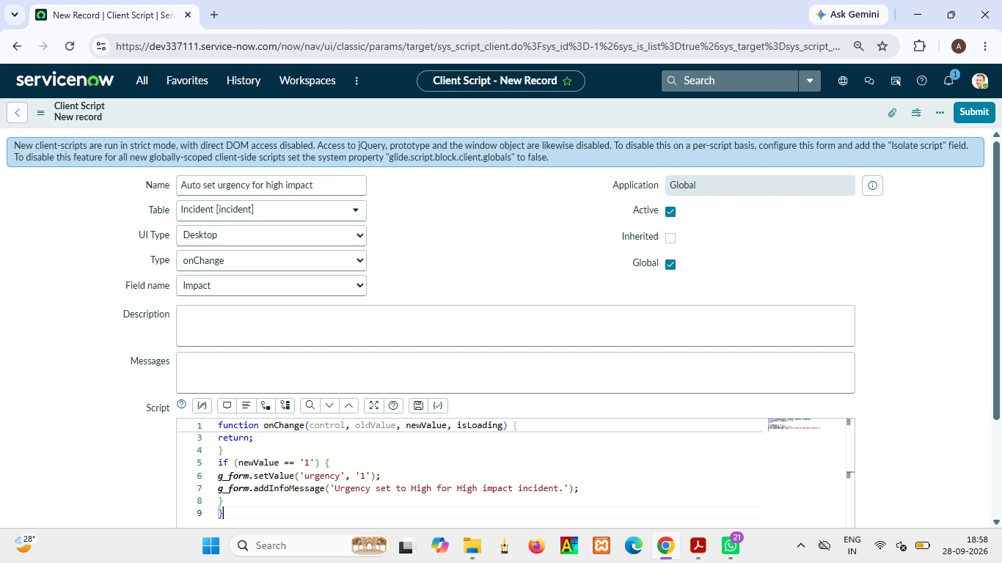

PHASE 4 – CREATE ONSUBMIT CLIENT SCRIPT – SAVE VALIDATION
1. Navigate to System UI → Client Scripts and click New.
2. Name: Prevent save if Assigned To missing.
3. Table: Incident.
4. Type: onSubmit.
5. Set Active to true.
6. Paste the following script into the Script field:
function onSubmit() {
if (g_form.getValue('impact') == '1' &&
g_form.getValue('assigned_to') == '') {
g_form.showErrorBox(
'assigned_to',
'Assigned To is mandatory for High impact incidents.'
);
return false;
}
return true;
}
7. Click Submit.
8. Verification: try saving a High Impact Incident without filling Assigned To. The save should be prevented and a warning should be displayed.
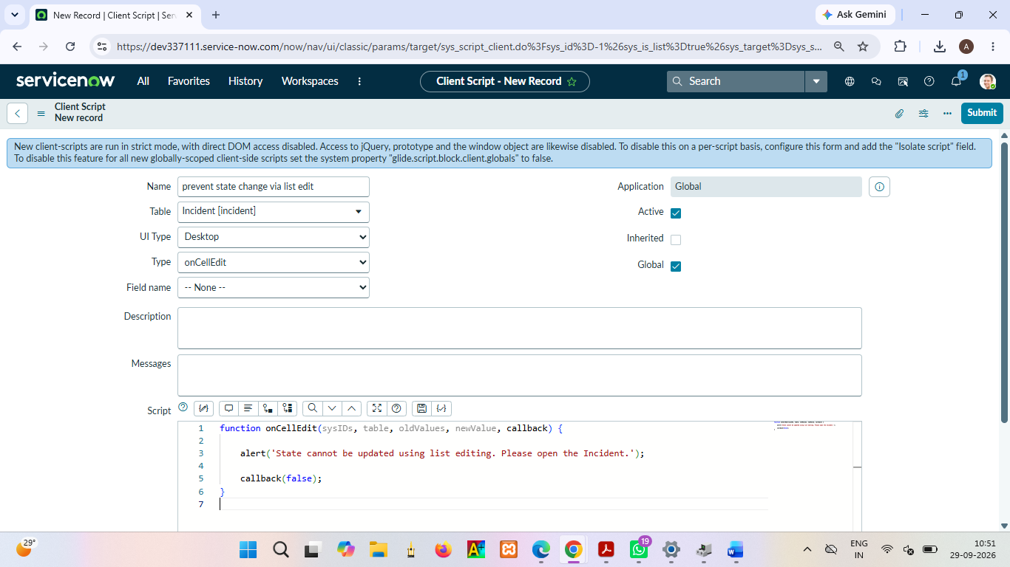

PHASE 5 – CREATE ONCELLEDIT CLIENT SCRIPT
1. Navigate to System UI → Client Scripts and click New.
2. Name: Prevent state change via list edit.
3. Table: Incident.
4. Type: onCellEdit.
5. Field name: State.
6. Set Active to true.
7. Paste the following script into the Script field:
function onCellEdit(sysIDs, table, oldValues, newValue, callback) {
alert('State cannot be updated using list editing. Please open the Incident.');
callback(false);
}
8. Click Submit.
9. Verification: open an Incident list and try to change State directly. The change should be blocked.
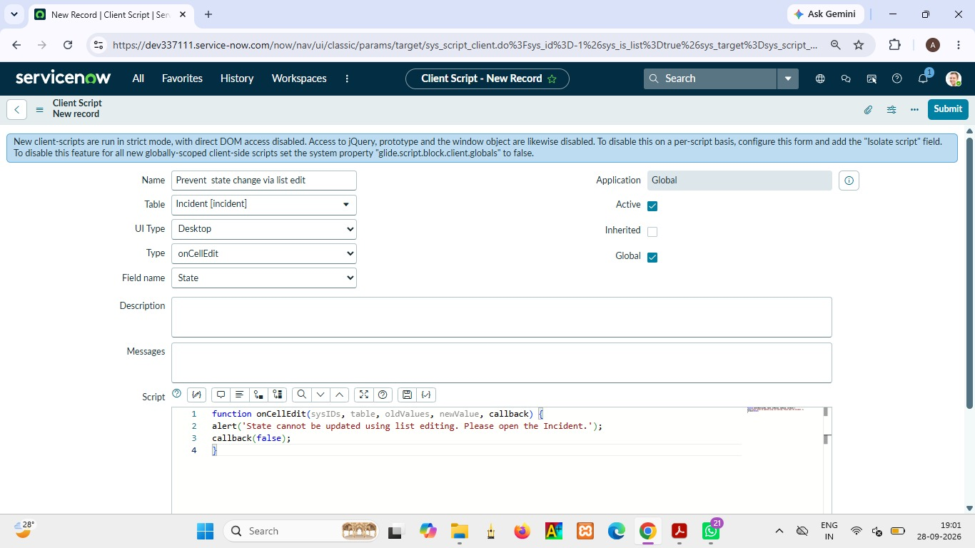

PHASE 6 – TESTING – MANDATORY ENFORCEMENT
1. Navigate to Incident → Create New.
2. Set Impact to High.
3. Leave Assigned To empty.
4. Click Submit.
5. Verify that the Incident is not saved.
6. Verify that an error message indicates Assigned To cannot be empty.
7. Confirm that UI Policy actions and automatic Urgency behavior are working as expected.
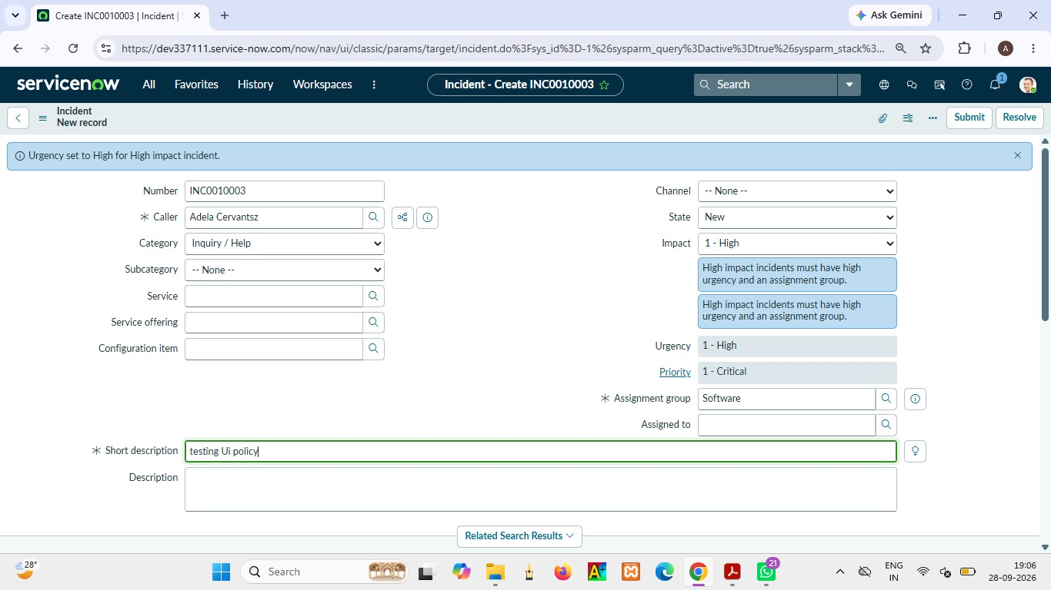

PHASE 7 – TESTING – SUCCESSFUL SAVE
- Navigate to Incident → Create New to open a new Incident form.
- Enter the required Incident information such as Short Description and other required fields.
- Set the Impact field to High.
- Since Impact is High, the configured UI Policy and Client Script conditions will be triggered.
- Verify that the Urgency field is automatically set to High by the onChange Client Script.
- Verify that the Urgency field becomes read-only because of the UI Policy Action.
- Select a valid user in the Assigned To field.
- Ensure that the Assigned To field is not empty before submitting the Incident.
- Click Submit to save the Incident.
- Verify that the Incident is saved successfully without displaying the validation error.
- Confirm that the Incident record appears in the Incident list after successful submission.
- Verify that the configured behaviors continue to work correctly:
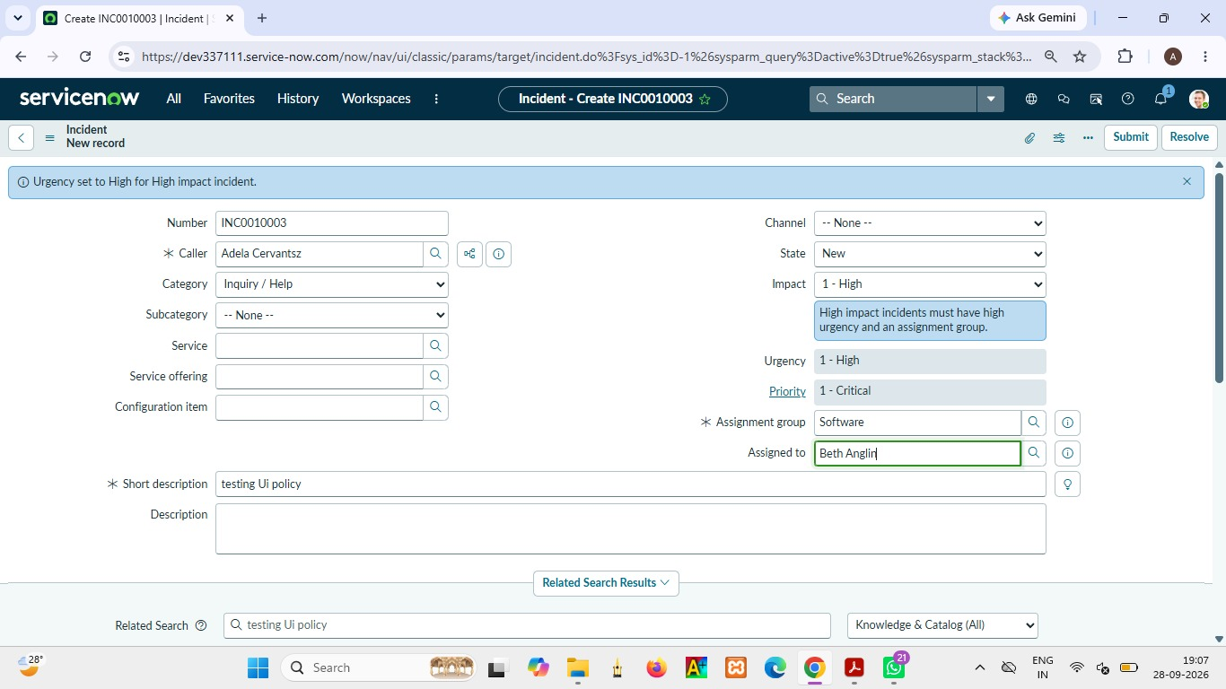

PHASE 8 – TESTING – REVERSE CONDITION
- Navigate to Incident → Open and select an existing Incident record.
- Select an Incident where the Impact field is currently set to High.
- Observe the current field behavior before changing the Impact value.
- Verify that Assigned To is mandatory while Impact is High.
- Verify that the Urgency field is read-only while the High Impact condition is active.
- Change the Impact field from High to Medium.
- Once the Impact value changes, the condition of the High Impact Control UI Policy is no longer satisfied.
- Verify that the UI Policy actions are reversed because Reverse if false has been enabled.
- Check the Assigned To field and verify that it is no longer mandatory due to the High Impact condition being removed.
- Check the Urgency field and verify that it becomes editable again.
- Verify that the form no longer behaves as a High Impact Incident.
- Click Submit to save the updated Incident record.
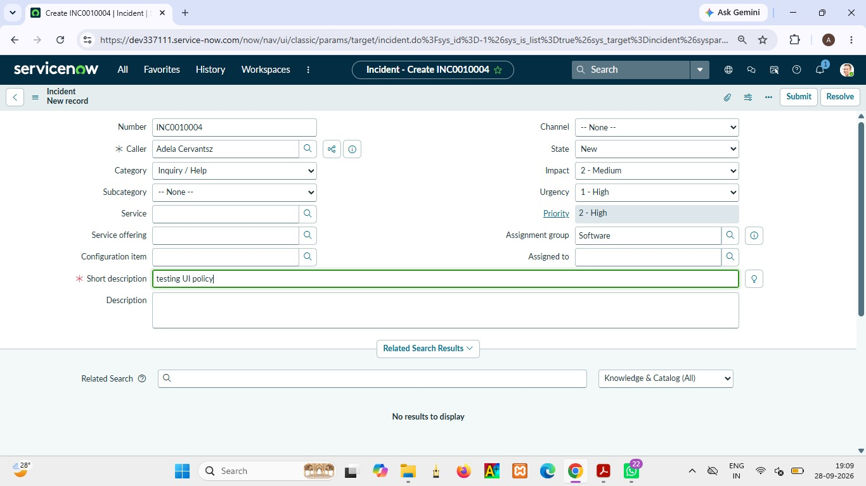

PHASE 9 – TESTING – LIST EDIT BLOCKING
- Navigate to Incident → All to open the Incident list.
- • The Incident list displays multiple Incident records in a tabular format.
- Locate any Incident record from the list.
- Find the State column for the selected Incident.
- Double-click the State field to attempt a direct list edit.
- The onCellEdit Client Script should execute when the State field is edited directly from the list.
- The script displays an alert message informing the user that the State cannot be updated using list editing.
- Verify that the following message is displayed:
- “State cannot be updated using list editing. Please open the Incident.”
- Close the alert message.
- Check the Incident record again in the list.
- Verify that the State value has not been changed.
- Open the Incident record by selecting the record.
- Change the State from the Incident form instead of using direct list editing.
- Save the record using the form.
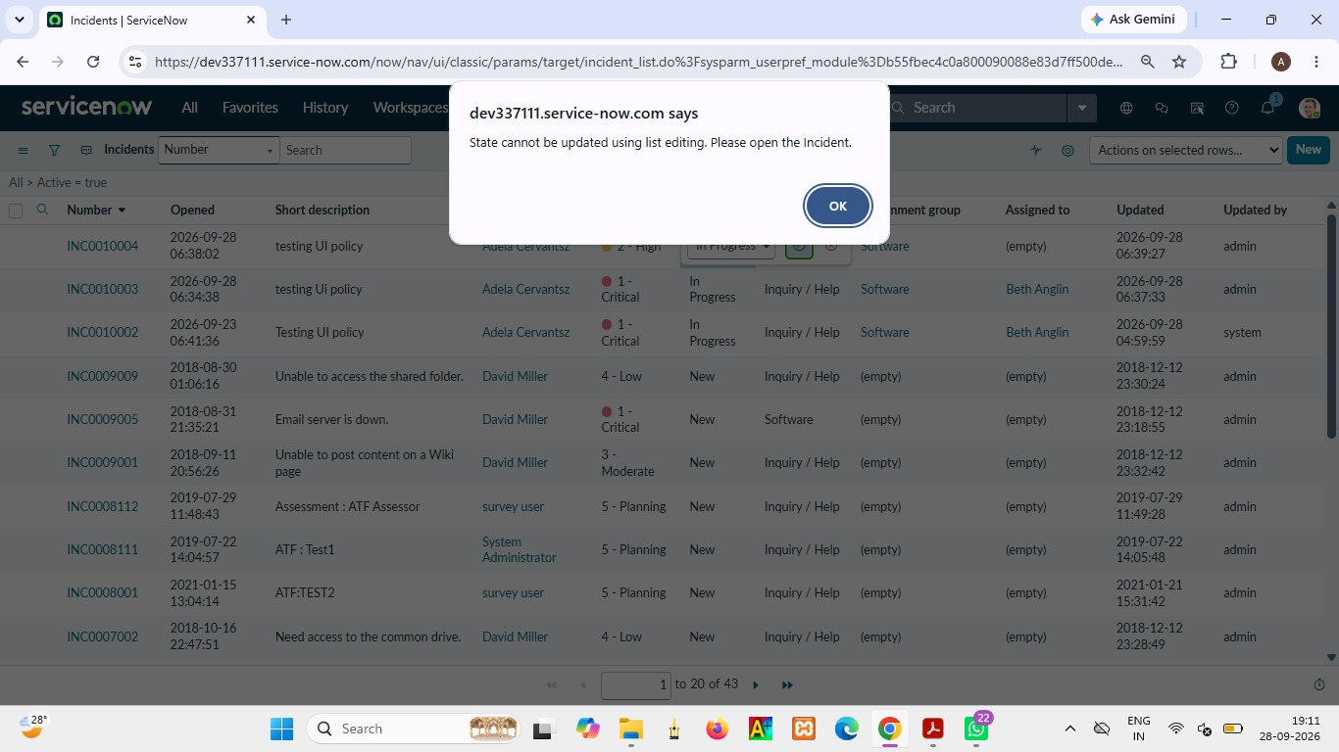

PHASE 10 – TESTING – FORM-BASED UPDATE
- Navigate to Incident → All to open the Incident list.
- Locate the Incident record that was used during the previous testing activities.
- Open the Incident record by clicking on the Incident number or selecting the record.
- Verify that the Incident form is displayed with the configured fields and values.
- Locate the State field on the Incident form.
- Select a new valid value for the State field.
- Verify that the selected State value is displayed correctly on the Incident form.
- Unlike direct list editing, the State field can be updated through the Incident form.
- Review the other important fields before saving the record.
- If the Incident has High Impact, verify that the configured UI Policy and Client Script behavior continues to apply.
- Verify that the Assigned To field follows the mandatory requirement when the High Impact condition is active.
- Verify that the Urgency field continues to follow the configured UI Policy and Client Script behavior.
- Click Update to save the changes made to the Incident.
- Wait for the Incident record to return to the list or updated form view.
- Reopen the same Incident record.
- Verify that the newly selected State value has been saved successfully.
- Confirm that no unexpected validation error is displayed when all configured conditions are satisfied.
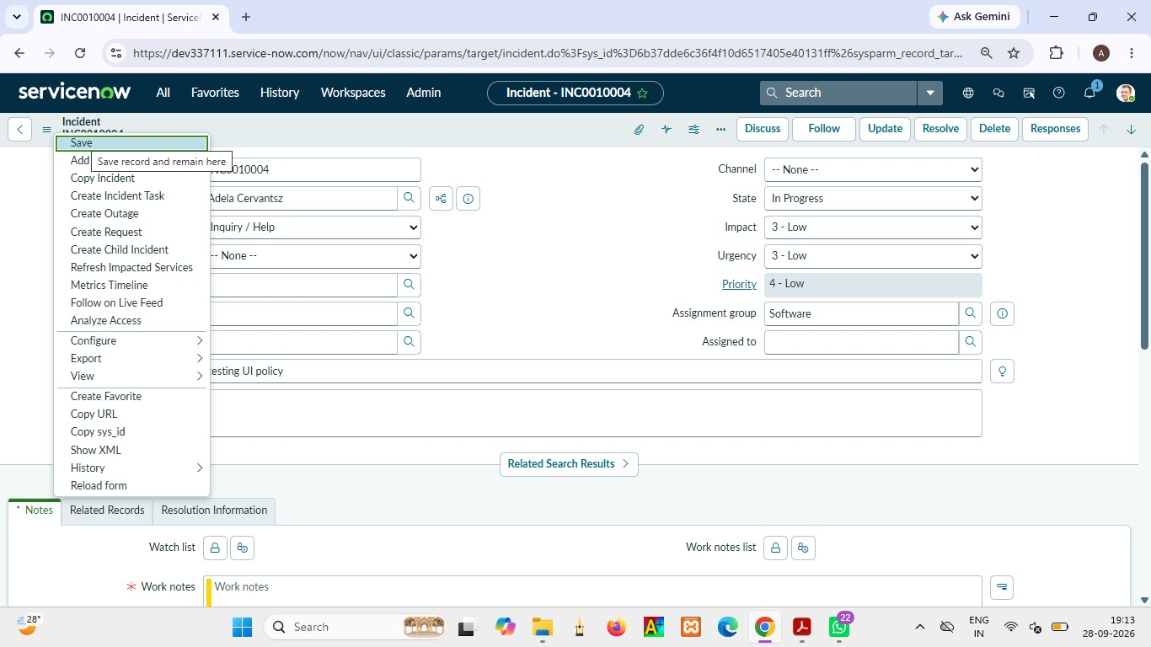

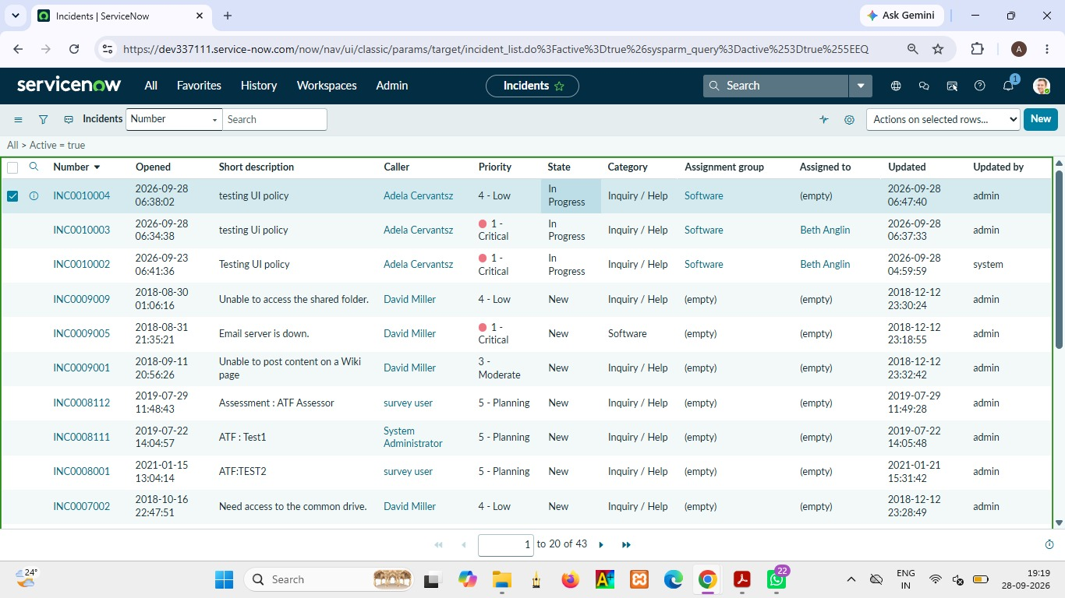

PHASE 11 – PROJECT OUTCOME
The project demonstrates how UI Policies and Client Scripts work together to enforce dynamic field behavior, automate updates, and prevent incorrect data submission on Incident forms. The implementation uses onChange, onSubmit, and onCellEdit scripts along with UI Policy Actions to control Assigned To, Urgency, and State behavior according to Incident Impact and the selected interaction method.
• High Impact makes Assignment group mandatory through the UI Policy.
• High Impact makes Urgency read-only through the UI Policy Action.
• High Impact automatically sets Urgency to High through the onChange Client Script.
• High Impact prevents saving when Assigned To is empty through the onSubmit Client Script.
• Direct State changes from list editing are blocked through the onCellEdit Client Script.
• Form-based State updates remain available and can be saved successfully.
• Reverse condition behavior restores the appropriate field behavior when Impact changes.

Conclusion
This micro project provides a practical demonstration of ServiceNow client-side configuration for Incident Management. By combining UI Policies and Client Scripts, the solution improves data consistency, guides users during form entry, validates required information before saving, and controls list-based editing. The implementation is lightweight and suitable for a short-duration ServiceNow project while demonstrating practical form usability and data-integrity controls.

