**Cognizant Deep Skilling - Digital Nurture 4.0 - Week 8**

**Git Hands-On Lab 1 – Basic Git Operations and Repository Management  
  
Step 1: Setup your machine with Git Configuration**

* git --version
* git config --global user.name "Arunanatchimuthu"
* git config --global user.email "arunakavin01@gmail.com"
* git config –list

**Output:  
  
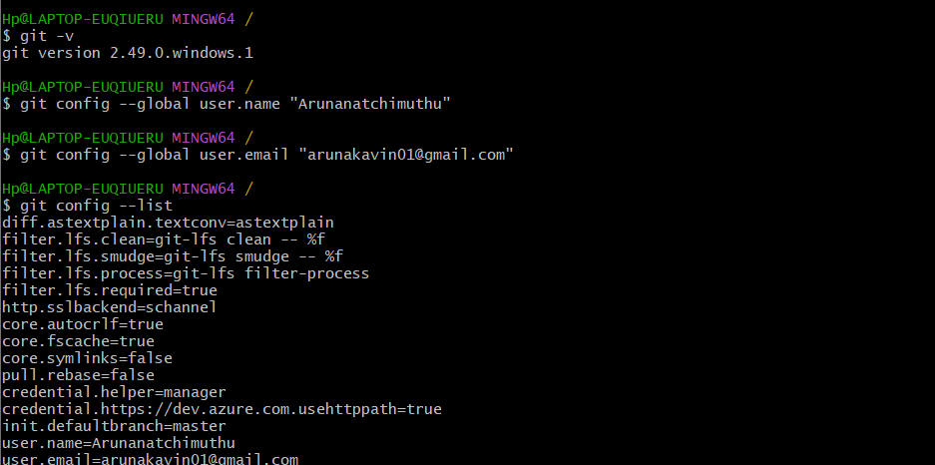**

**Step 2: Integrate notepad++.exe to Git and make it a default editor**

* notepad++
* git config --global core.editor "\"C:/Program Files (x86)/Notepad++/notepad++.exe\" -multiInst -nosession"

**Output:**

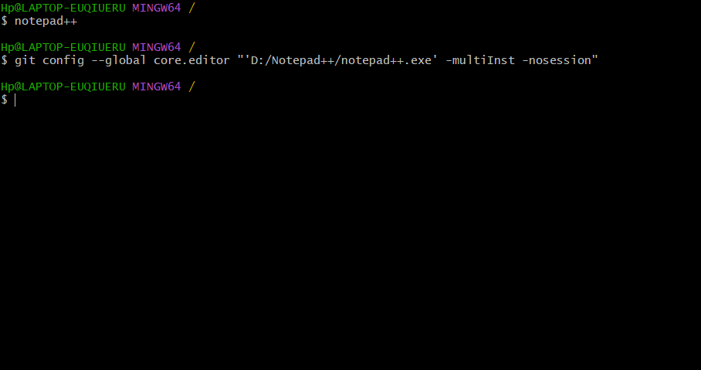

**Step 3: Add a file to source code repository**

* cd ~
* mkdir GitDemo
* cd GitDemo
* git init
* echo "Welcome to version control" > welcome.txt
* cat welcome.txt
* git status
* git add welcome.txt
* git commit
* git remote add origin
* https://github.com/Arunanatchimuthu/GItDemo1.git
* git pull origin master
* git push origin master

**Output:**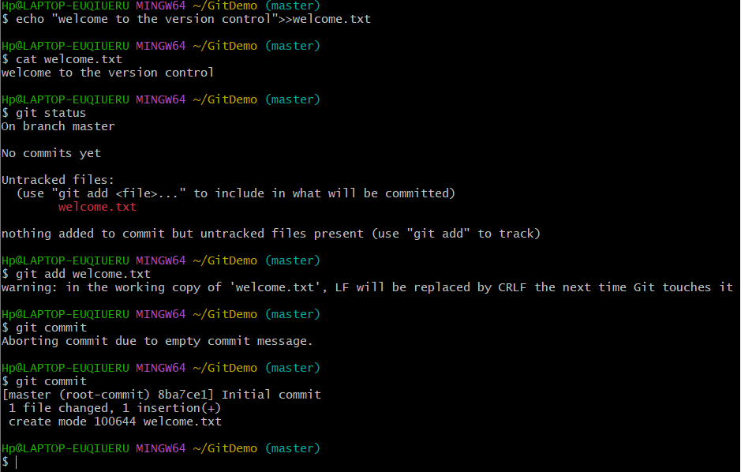

**Git Hands-On Lab 2 – Git Ignore  
  
Step 1: Create Unwanted Files**

* touch debug.log
* mkdir log
* touch log/system.log

**Step 2: Create .gitignore File**

* touch .gitignore
* Add:
* **\*.log**
* **log/**

**Step 3: Check Git Status:**

* git status

**Step 4: Commit and Push**

* git add .gitignore
* git commit -m "Added .gitignore to ignore .log files and log folder"
* git push origin master

**Output:**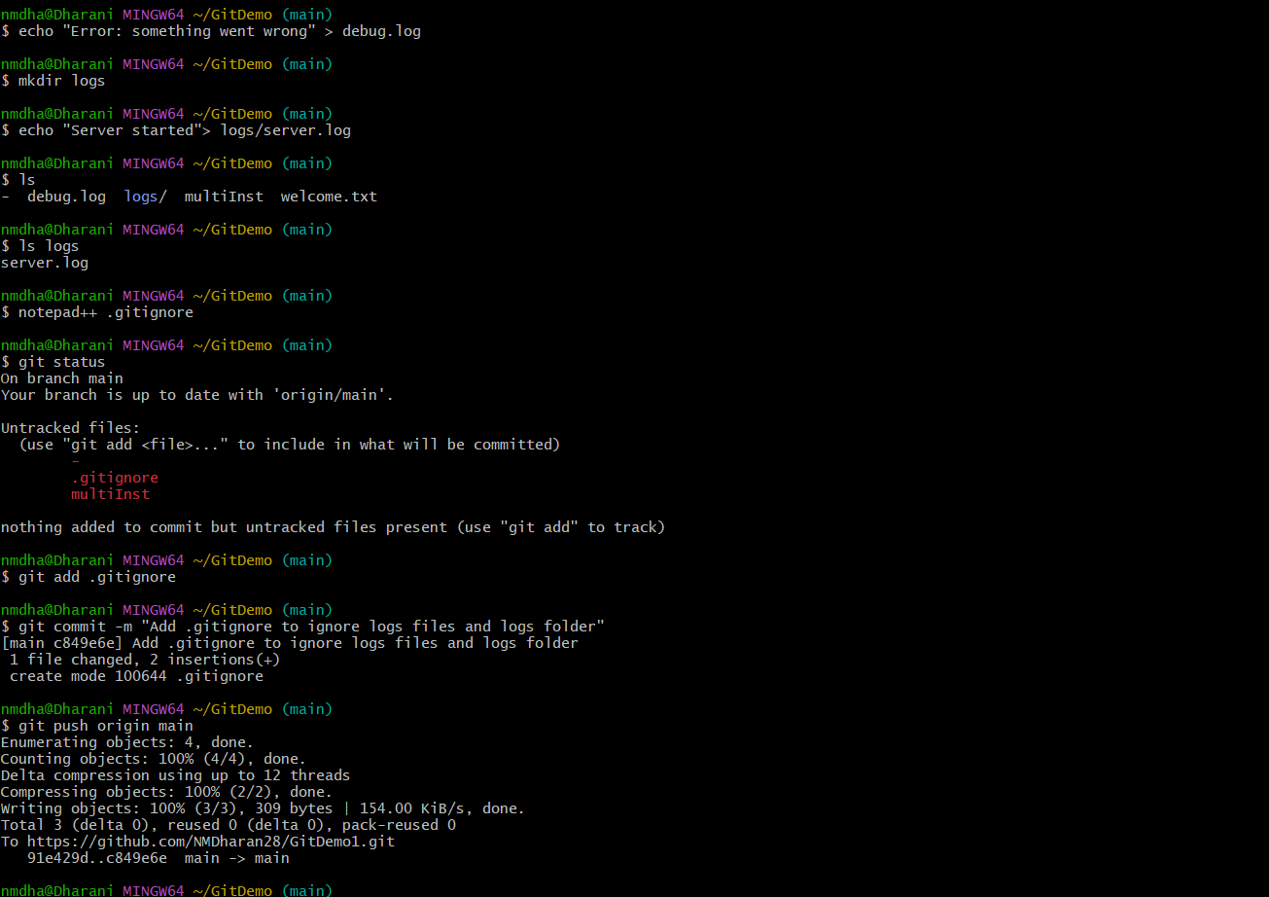

**Git Hands-On Lab 3 – Branching and Merging  
  
1. Created New Branch**

* git checkout -b GitNewBranch

**2. Listed Branches**

* git branch -a

**3. Created a File and Committed**

* echo "This is from GitNewBranch" > branchfile.txt
* git add branchfile.txt
* git commit -m "Added branchfile.txt in GitNewBranch"

**4. Switched Back**

* git checkout master
* git diff master..GitNewBranch

**Output:  
  
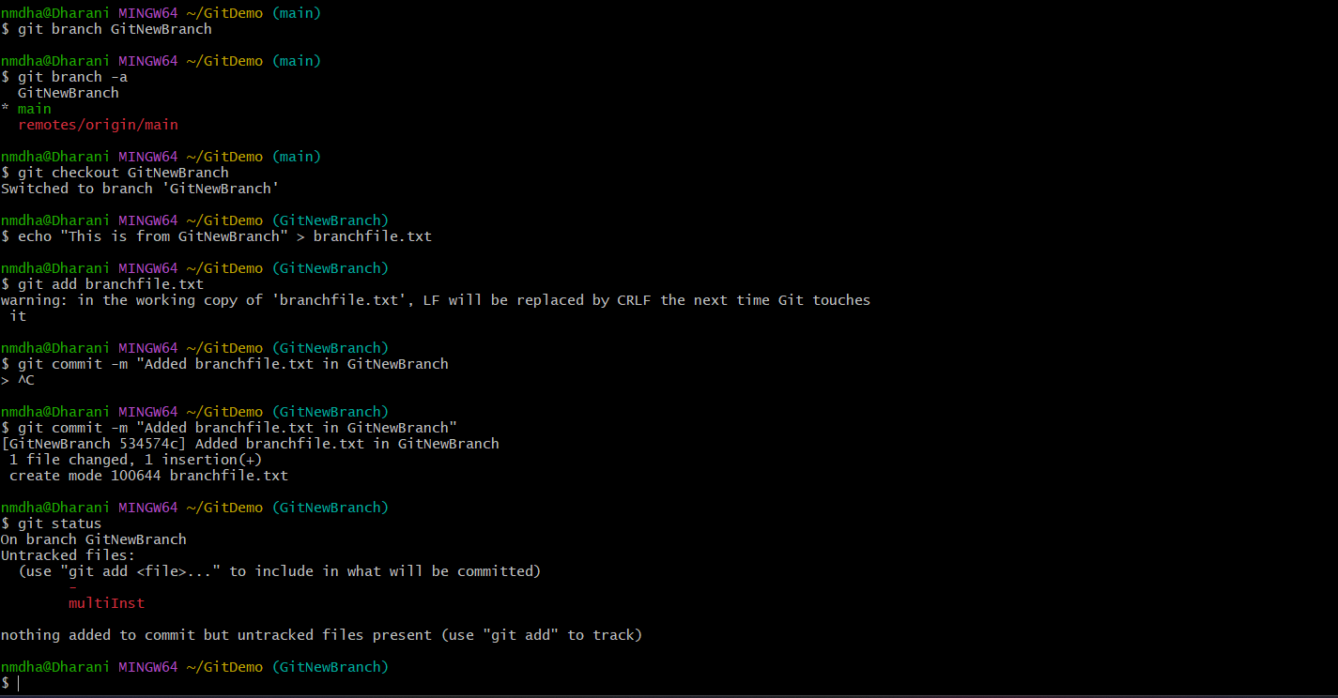  
  
5. Merged**

* git merge GitNewBranch

**6. Checked Logs**

* git log --oneline --graph –decorate

**7. Deleted Branch and Pushed**

* git branch -d GitNewBranch
* git push origin master

**Output:**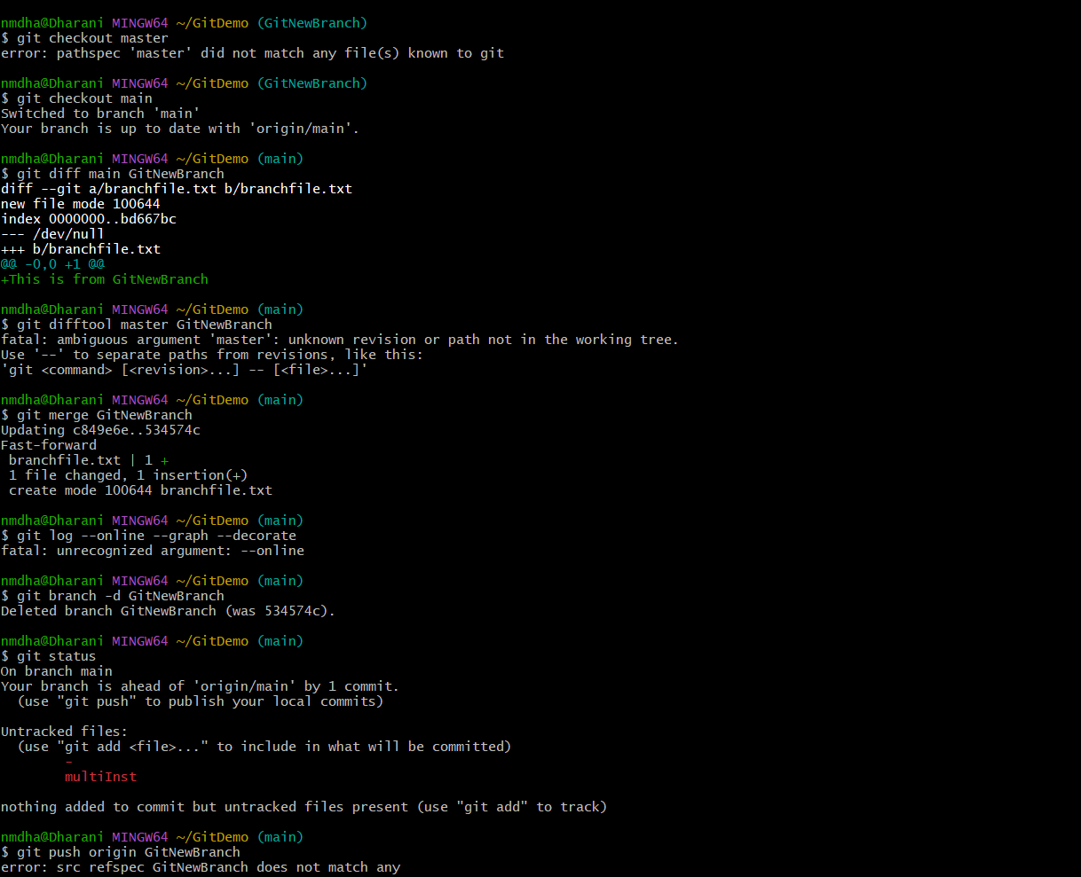

**Git Hands-On Lab 4 – Git Merge Conflict Resolution  
  
1. Created a branch GitWork**

* git checkout -b GitWork

**2. Added hello.xml with unique content in GitWork**

* echo "<message>Hello from GitWork</message>" > hello.xml
* git add hello.xml
* git commit -m "Added hello.xml in GitWork branch"

**3. Switched to master and created conflicting file**

* git checkout master
* echo "<message>Hello from master branch</message>" > hello.xml
* git add hello.xml
* git commit -m "Added hello.xml in master with different content"

**4. Merged and got conflict**

* git merge GitWork

**Output: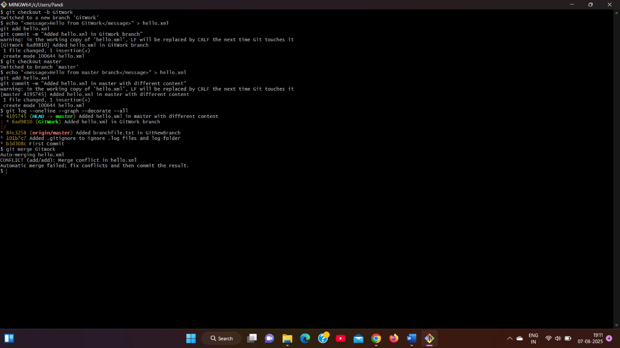 5. Resolved conflict manually and committed**

* git add hello.xml
* git commit -m "Resolved merge conflict in hello.xml"

**6. Updated .gitignore and cleaned up**

* echo "*~" >> .gitignore
* git add .gitignore
* git commit -m "Updated .gitignore to ignore backup files"

**7. Deleted merged branch**

* git branch -d GitWork

**8. View the final graph**

* git log --oneline --graph –decorate

**Output: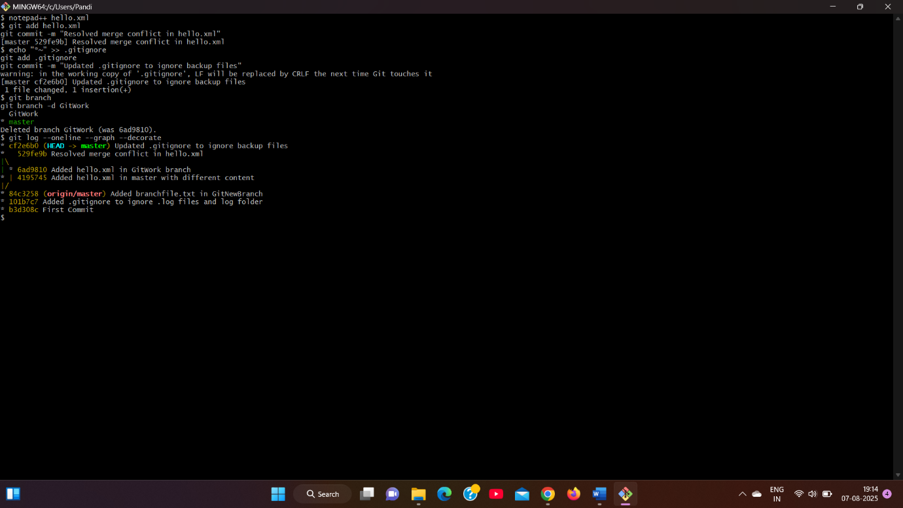 Git Hands-On Lab 5 – Git Cleanup & Push Lab  
  
1. Switched to master branch**

* git checkout master

**2. Checked git status**

* git status

**3. Listed all branches**

* git branch -a

**4. Pulled latest changes**

* git pull origin master

**5. Pushed pending changes**

* git push origin master

**6. Verified updates in GitLab repo  
  
Visited:**https://github.com/Arunanatchimuthu/GItDemo1.git

**Output:  
  
**