**PROJECT TITLE: Requesting wifi access through service now**

**1.Project Overview:** When requesting Wi-Fi access through ServiceNow, the project typically involves setting up a formalized, efficient process for end users to request and receive Wi-Fi access in an organization. This could be for various purposes, such as setting up Wi-Fi access for employees, visitors, contractors, or new devices. ServiceNow is a powerful IT service management (ITSM) platform used to automate and streamline IT processes, including network and connectivity-related requests.

**GOAL:** The goal of the **Wi-Fi Access Request through ServiceNow** project is to establish an efficient, automated, and secure system for managing Wi-Fi access requests within an organization. This system will simplify the process for employees, contractors, and guests to request Wi-Fi access, streamline approval workflows, ensure compliance with security standards, and improve visibility and tracking of requests.

**2.Objectives:**

**1. Project Objective:**

The goal of the project is to provide an easy, structured process for users to request Wi-Fi access via the ServiceNow platform. This ensures that all access requests are captured, tracked, and fulfilled in a timely and secure manner. It may also involve integrating Wi-Fi access request workflows with other IT services such as network management, identity verification, and compliance monitoring.

**2. Key Features of the ServiceNow Wi-Fi Access Request:**

* **User-friendly Request Form:** ServiceNow will host a Wi-Fi access request form where users can submit their requests. The form may require details like location, device type, purpose of access (work-related, guest, etc.), and specific access requirements.
* **Automated Workflows:** Once the request is submitted, ServiceNow will trigger a series of actions—such as approval processes, network configuration, and access provisioning—based on predefined workflows.
* **Approval Process:** Requests may go through an approval stage where managers, IT personnel, or network administrators review and authorize access based on security protocols or resource availability.
* **Self-Service Portal:** Users can track the status of their Wi-Fi access requests via the ServiceNow self-service portal, reducing the need for manual follow-up.
* **Security Checks and Compliance:** Depending on the organization's policies, Wi-Fi access might need to meet security standards, such as device authentication, user credentials, or specific encryption protocols.
* **Notifications and Alerts:** Automated email or in-platform notifications are sent to the user and administrators, keeping them informed of the request status (e.g., approval, denial, or fulfillment).
* **Reporting and Analytics:** ServiceNow’s reporting features can be used to track the number of requests, approval times, and any issues or incidents associated with Wi-Fi access requests.

**3. Benefits of Using ServiceNow for Wi-Fi Access Requests:**

* **Efficiency and Automation:** ServiceNow automates repetitive tasks such as approval routing, notifications, and task assignments, saving time and reducing human error.
* **Transparency:** Users and administrators can track the status of requests in real-time, leading to better communication and more efficient service delivery.
* **Security:** Through controlled access, workflows can include checks that ensure Wi-Fi access is granted only to authorized users or devices, preventing unauthorized connections.
* **Compliance and Auditing:** All requests and approvals are logged within ServiceNow, creating an audit trail for compliance purposes.
* **Scalability:** As an organization grows, the process can scale to handle increased requests without requiring significant manual intervention.

**Detailed Steps and Solution Design:**

**Step 1 :**Sign in to ServiceNow.

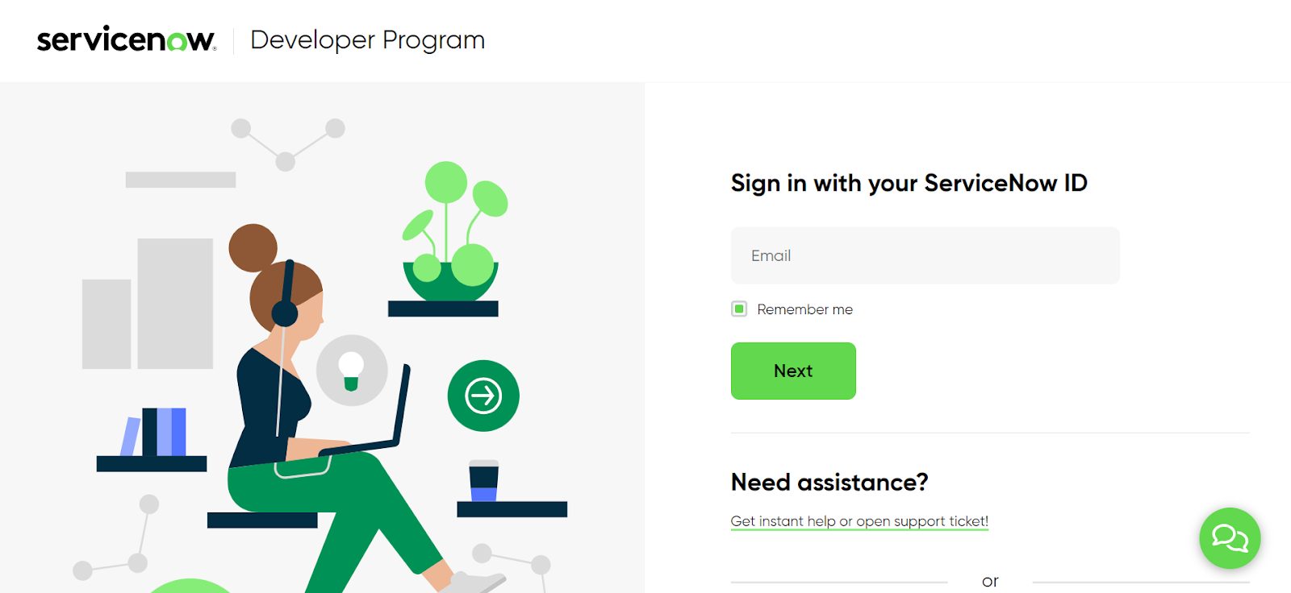

**Step 2 :** Sign up for a developer account on the ServiceNow Developer site “[https://developer.servicenow.com](https://developer.servicenow.com/)”.

**Step 3 :**Once logged in, navigate to the "Personal Developer Instance" section.

Click on "Request Instance" to create a new ServiceNow instance.

**Step 4 :** Fill out the required information and submit the request.

**Step 5 :** You'll receive an email with the instance details once it's ready.

**Step 6 :**Log in to your ServiceNow instance using the provided credentials.

Now you will navigate to the ServiceNow.

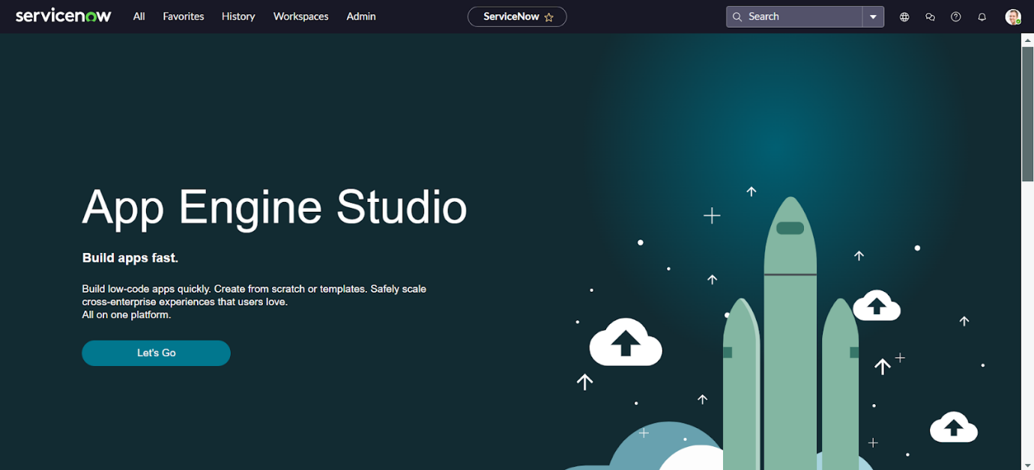

**Step 7 :** Open “Service Catalog” >> maintain items.

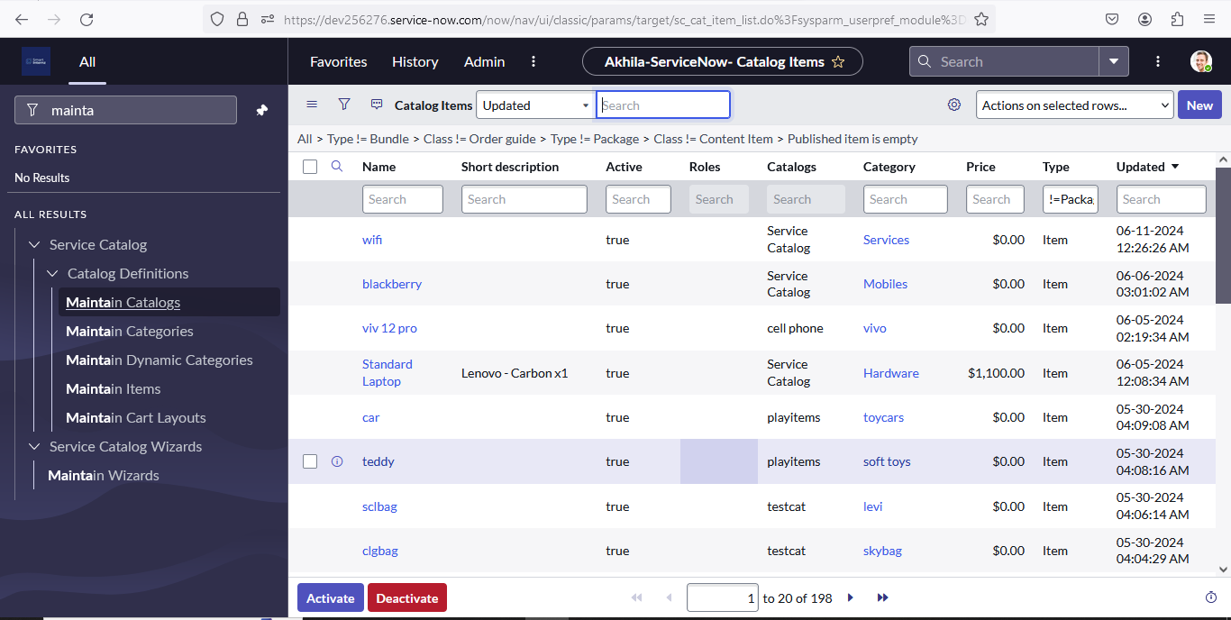

**Step 8 :**To add a new Service Catalog item in ServiceNow, follow these steps to enter a title for the item, select the category,select the catalog, and upload the images

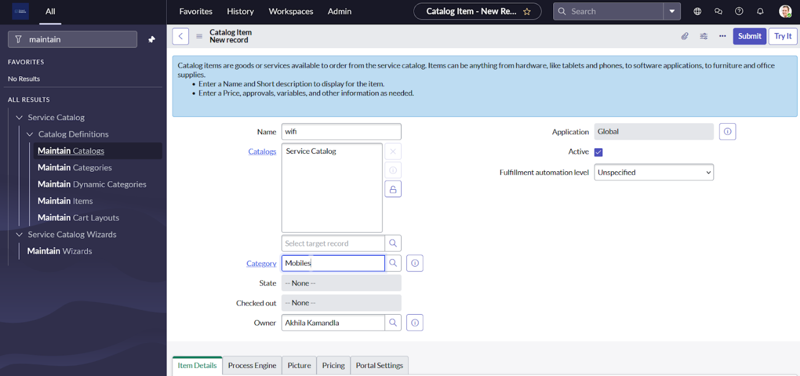

**Step 9 :** Create a Workflow as per your requirements.

                  Workflow>> “Workflow Editor”.

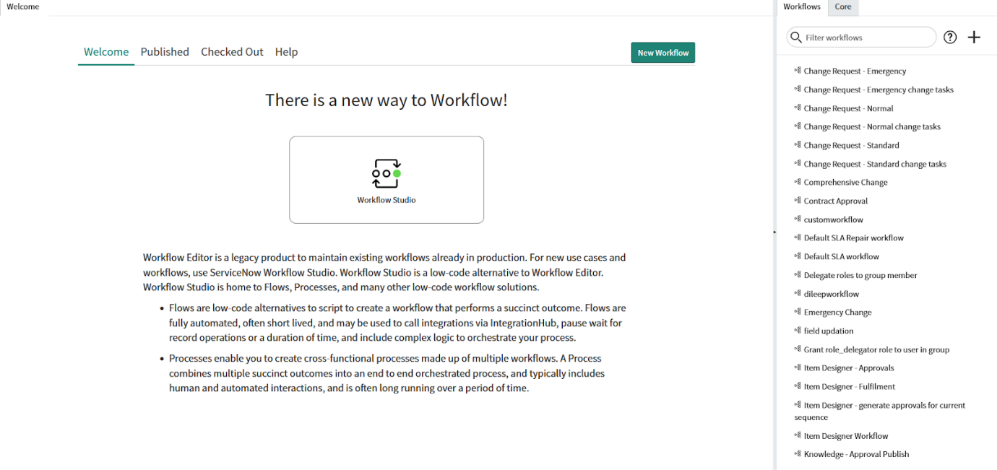

Click on create “New”.

1. Enter the name of the workflow.
2. Select table name as “sc_req_item”.
3. Click on “Submit”.

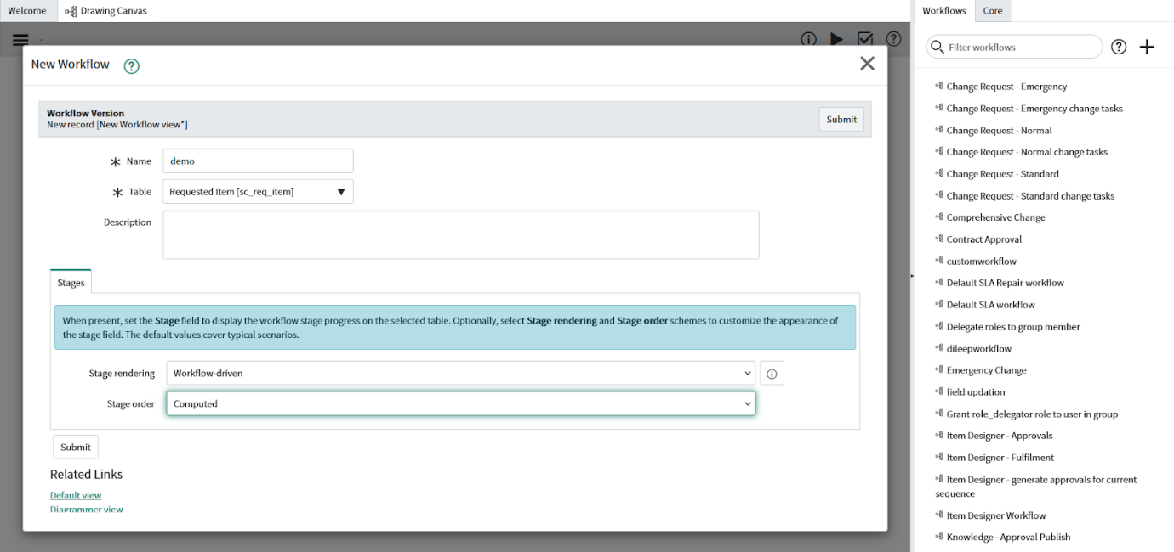

**outlook of workflow**

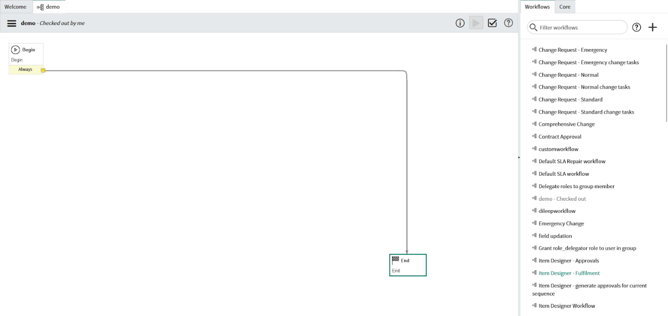

1. This the outlook of workflow.
2. So we should add needed condition.

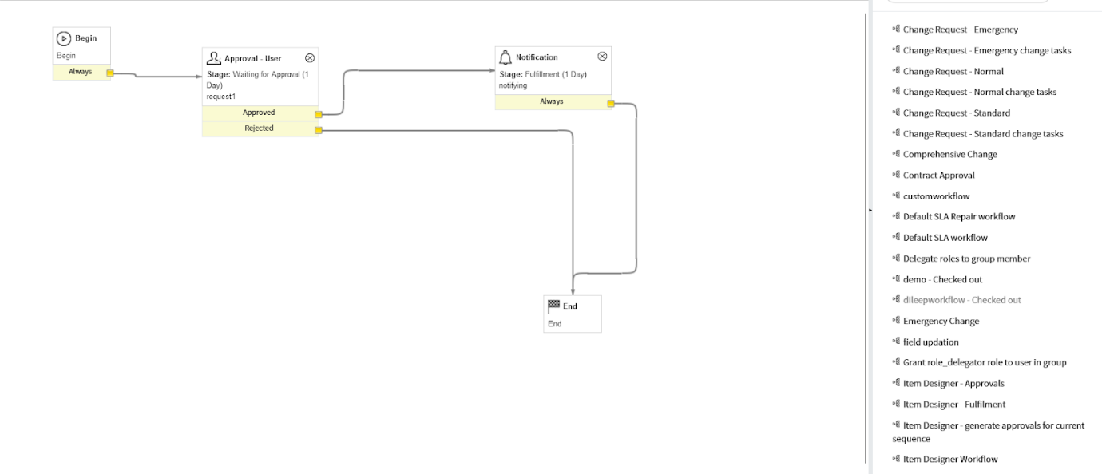

1. This is the workflow after adding needed conditions.
2. When the reauest is generated ,the Approval request automatically generated,After approving the approval the user will get notification about their order.

**Step 10:** Add created Workflow to  Catalog item.

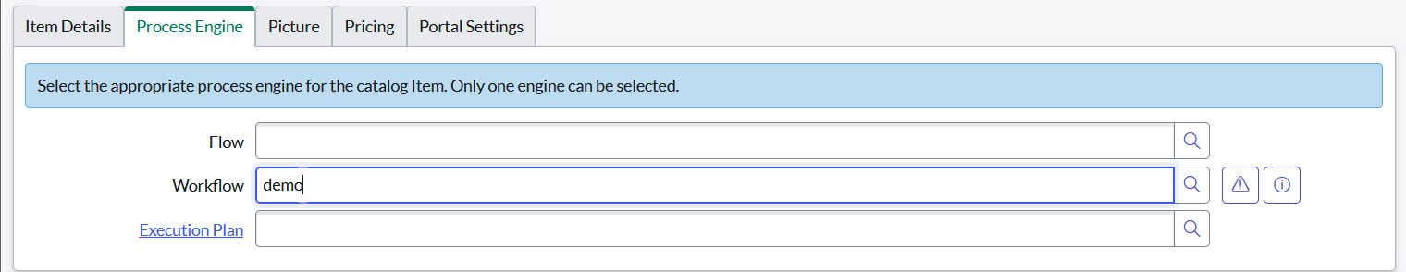

1. Go to “maintain items”,Open “wifi” item ,then open it’s “Process Engine”.
2. Select the Workflow to be performed, that is “demo”.

**Step 11:** Open Service Portal, and request for your created item.  
                Open ‘<https://dev256276.service-now.com/sp>”.

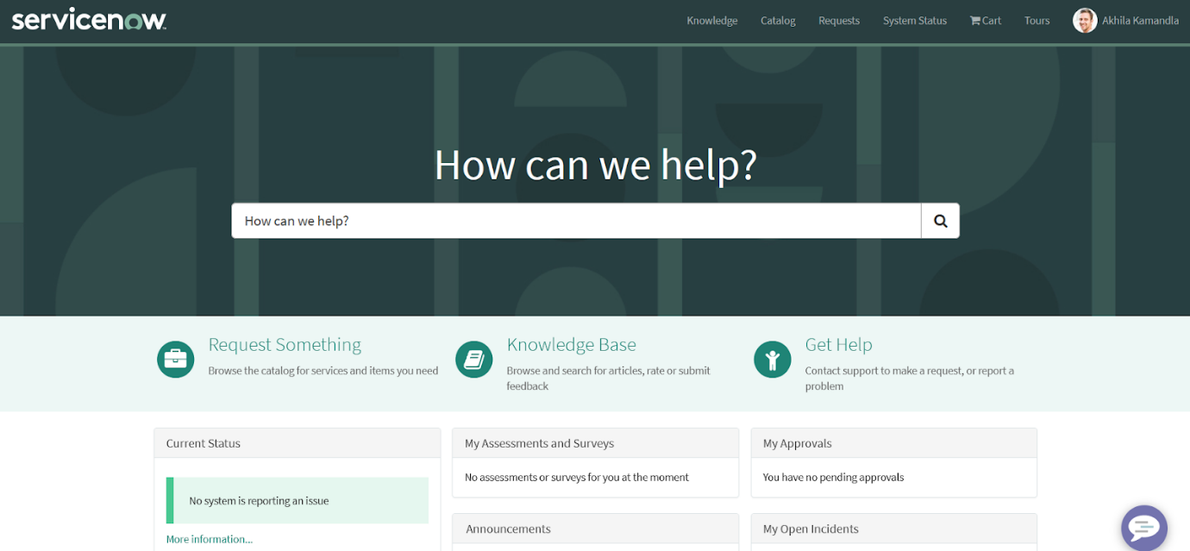

1. Go and search for item “wifi”.



1. Click on “Request”.

#### https://lh7-us.googleusercontent.com/docsz/AD_4nXeXwjzFZVVIZOGg3AcR5VUxRhoeJGiu8xendOTQQ_I1ONeso60XecEd-R8VVsTN6k-RMDR7HW8IYiBJg1CwRQgGbQ4zyFarrOqUANTMq2LkRI4IYv8RnOssI2s6CVXengMhbZ3_5jgMypaV3nmtlSDsvTA?key=As1XQNeiGaIYD6AWaIBdHQ4. Implementation Steps:

* **Requirement Gathering:** Define the specific needs and requirements of the Wi-Fi access process. This includes understanding security policies, user access levels, and how different types of users (e.g., employees, contractors, visitors) will request access.
* **Form and Workflow Creation:** Create and customize the Wi-Fi access request form and configure the associated workflows in ServiceNow, including approval routing, notifications, and integration with network management tools.
* **Security Configurations:** Ensure proper integration with authentication systems (e.g., Active Directory, Single Sign-On) and security measures (e.g., VPN, WPA2) are in place.
* **User Training and Communication:** Ensure employees know how to use the ServiceNow portal to request Wi-Fi access, and communicate any changes in the process or new access policies.
* **Testing:** Test the entire process end-to-end to ensure everything works smoothly, including approvals, notifications, and provisioning of access.
* **Go Live:** Deploy the request process for all users, and monitor its success.

**5. Timeline & Milestones:**

* **Week 1-2:** Requirement gathering and system analysis.
* **Week 3-4:** ServiceNow form and workflow design.
* **Week 5-6:** Testing, security configurations, and integration with network infrastructure.
* **Week 7-8:** Training and deployment.

.**6.Conclusion:**

The implementation of requesting WiFi access through ServiceNow streamlines the process, ensuring efficiency, transparency, and faster resolution times. By automating approvals and tracking requests in a centralized platform, it enhances user experience, reduces administrative overhead, and improves overall network access management. This solution aligns with organizational goals for process optimization and secure connectivity.