Cross-Lingual Parkinson's Disease Detection from Acoustic Speech Signals via Adaptive Tree-Spline Fusion of Gradient Boosted Decision Trees and Kolmogorov-Arnold Networks
Arunavo Das, Md. Talha Jobair, Md Abir Ahmed, and Mustafizur Ankan
*Department of Computer Science and Engineering, East West University, Dhaka, Bangladesh*
*Corresponding Emails:* {2023-1-60-251, 2023-1-60-120, 2023-1-60-247, 2023-1-60-262}@std.ewubd.edu
*Target Q1 Journals:* *Computers in Biology and Medicine* (Elsevier) | *Expert Systems with Applications* (Elsevier) | *Artificial Intelligence in Medicine* (Elsevier) | *IEEE Journal of Biomedical and Health Informatics*
Highlights
- Methodological Integrity in Telehealth Screening: Exposes and quantifies the pervasive *patient-level data leakage* fallacy in acoustic Parkinson's disease (PD) literature, demonstrating via controlled ablation that record-wise cross-validation artificially inflates diagnostic accuracy by +4.92% to +13.00% through speaker biometric memorization rather than pathological learning.
- Adaptive Tree-Spline Fusion Architecture: Proposes a dual-branch neuro-symbolic ensemble combining leaf-wise Gradient Boosted Decision Trees (LightGBM) (discrete, axis-aligned decision boundaries) with Kolmogorov-Arnold Networks (KAN) utilizing learnable univariate cubic B-spline edge activations (continuous, smooth non-linear functional manifolds).
- Superiority Over Deep Tabular Transformers: Outperforms 10 competitive baselines—including FT-Transformer (79.10%), SAINT (81.48%), TabNet (74.34%), NODE (77.25%), and GATE (78.44%)—under strict 5-fold patient-wise (GroupKFold) cross-validation, reaching 85.18 ± 2.15% accuracy (84.12 ± 2.08% under nested inner-CV α-tuning; 96.46% sensitivity, 90.72% F1-score, AUC = 0.8741, PR-AUC = 0.9480) on the 754-feature Turkish UCI cohort and 93.56 ± 1.84% accuracy (AUC = 0.9790) on the Bengali BenSParX cohort.
- Clinical Operating-Point Calibration: Introduces out-of-fold Youden's J-statistic threshold calibration (τ^* = 0.867), enabling seamless clinical switching between a High-Sensitivity Screening Mode (τ = 0.50, Sensitivity = 96.46%) and a Specificity-Balanced Diagnostic Mode (Specificity improved from 50.81% to 71.68%, Balanced Accuracy = 76.25%).
- Dual Explainable AI (XAI) & Cross-Lingual Domain Adaptation: Bridges macro-level TreeSHAP game-theoretic attributions with micro-level KAN symbolic B-spline activation trajectories across 1,851 recordings (404 patients; Turkish, Bengali, and English), while resolving cross-lingual acoustic shift via Correlation Alignment (CORAL) and patient-grouped few-shot transfer (+10.11% recovery on Turkish → Bengali, reaching 84.67 ± 1.74%).
Abstract
Background and Objective: Acoustic analysis of hypokinetic dysarthria offers a scalable, non-invasive biomarker for the early prodromal screening of Parkinson's disease (PD). However, clinical translation of automated voice-based PD diagnostic systems remains obstructed by four fundamental challenges: (1) widespread *patient-level data leakage* caused by record-wise cross-validation across repeated phonations of the same subject; (2) severe overfitting of high-capacity Deep Tabular Transformers on high-dimensional, small-cohort clinical datasets (D ≈ N); (3) the opacity of "black-box" deep neural networks; and (4) catastrophic performance degradation when deploying models across unseen languages, phonetic protocols, and recording environments.
Methods: We propose an explainable, cross-lingual Adaptive Tree-Spline Fusion framework that synergistically integrates leaf-wise Gradient Boosted Decision Trees (LightGBM) with Kolmogorov-Arnold Networks (KAN) equipped with learnable univariate cubic B-spline activation functions. First, to eliminate patient-identity memorization, all preprocessing, statistical feature filtering, and nested hyperparameter optimization are strictly encapsulated within a zero-leakage 5-Fold Patient-Wise (`GroupKFold`) protocol where all recordings of any individual patient are strictly isolated into either training or testing partitions. Second, while LightGBM partitions high-dimensional acoustic spaces via discrete, orthogonal step-functions, KAN models smooth, continuous non-linear vocal degradation trajectories along network edges; their probability posteriors are integrated via an out-of-fold cross-validated convex optimization engine alongside Youden's J-statistic threshold calibration. Third, to overcome cross-lingual acoustic drift across divergent linguistic families, we introduce a hybrid domain adaptation pipeline combining unsupervised Correlation Alignment (CORAL) second-order covariance matching with patient-grouped few-shot target calibration.
Results: Evaluated across 1,851 voice recordings from 404 distinct subjects spanning three linguistically diverse corpora—Turkish (UCI PD, N=756, 252 subjects, 754 features), Bengali (BenSParX, N=900, 120 subjects, 71 features), and English (Oxford UCI, N=195, 32 subjects, 22 features)—our Adaptive Tree-Spline Fusion achieves state-of-the-art leak-free intra-corpus accuracies of 85.18 ± 2.15% on Turkish (84.12 ± 2.08% nested inner-CV; Sensitivity = 96.46%, F1 = 90.72%, PR-AUC = 0.9480), 93.56 ± 1.84% on Bengali (92.56 ± 1.67% nested inner-CV; Specificity = 94.67%, ROC-AUC = 0.9790), and 83.08 ± 8.45% on English (76.24 ± 14.19% untuned; PR-AUC = 0.9197). The proposed hybrid ensemble significantly outperforms standalone baselines (p = 0.0044, exact McNemar's test) and exceeds state-of-the-art deep tabular architectures including FT-Transformer (79.10%), SAINT (81.48%), GATE (78.44%), NODE (77.25%), and TabNet (74.34%) by +3.70% to +10.84%. In cross-lingual transfer between sustained Turkish vowels and conversational Bengali speech, our patient-grouped CORAL + Few-Shot adaptation boosts target accuracy from 74.56% (zero-shot LightGBM) / 75.78% (zero-shot Fusion) to 84.67 ± 1.74% (F1 = 85.70%, AUC = 0.9319). Dual Explainable AI (XAI) combining TreeSHAP and KAN B-spline functional visualization confirms that second Mel-frequency cepstral coefficients (mean_MFCC_2nd_coef), log-energy acceleration (std_delta_delta_log_energy), and mid-scale Tunable Q-Factor Wavelet Transform entropy (tqwt_entropy_log_dec_12) serve as language-invariant biomarkers of glottal incompetence and thyroarytenoid muscle rigidity.
Conclusions: Adaptive Tree-Spline Fusion establishes a mathematically rigorous, leak-free, and clinically interpretable paradigm for cross-lingual tele-neurology screening, requiring only ~165 KB of memory and <0.2 ms inference latency for real-time edge deployment.
Keywords: Parkinson's Disease; Hypokinetic Dysarthria; Kolmogorov-Arnold Networks (KAN); Gradient Boosted Decision Trees (LightGBM); Patient-Wise Cross-Validation; Dual Explainable AI (TreeSHAP); Cross-Lingual Domain Adaptation (CORAL); Acoustic Speech Biomarkers.
1. Introduction
1.1 Clinical Burden of Parkinson's Disease and Prodromal Vocal Pathology
Parkinson's disease (PD) is the second most prevalent neurodegenerative disorder globally, characterized by the progressive loss of dopaminergic neurons in the *substantia nigra pars compacta* and the accumulation of intracellular α-synuclein Lewy bodies [40]. Clinically, PD manifests through cardinal motor symptoms including resting tremor, bradykinesia, postural instability, and muscular rigidity. However, neuropathological degeneration begins 5 to 15 years prior to clinically definitive motor onset, and up to 50%–70% of nigral dopaminergic neurons are already irreversibly lost by the time a patient satisfies traditional Movement Disorder Society (MDS) clinical diagnostic criteria [40, 43]. Furthermore, physical neurological evaluations are costly, subjective, and inaccessible to rural and underserved populations in low- and middle-income countries.
Crucially, between 70% and 90% of PD patients develop hypokinetic dysarthria at early or prodromal stages of the disease, frequently preceding axial limb motor deficits [41, 42, 44]. Because human phonation requires the rapid, highly synchronized coordination of over 100 laryngeal, respiratory, velopharyngeal, and articulatory muscles, subtle basal ganglia dysfunction rapidly manifests in the acoustic speech signal [36, 41]. Pathophysiologically, laryngeal rigidity and incomplete vocal fold adduction (glottal incompetence) induce cycle-to-cycle fundamental frequency (F_0) perturbations (jitter), amplitude instability (shimmer), turbulent glottal air leakage (reduced Harmonics-to-Noise Ratio [HNR] and elevated Glottal-to-Noise Excitation [GNE]), and articulatory vowel centralization captured by Mel-Frequency Cepstral Coefficients (MFCCs) and Tunable Q-Factor Wavelet Transform (TQWT) sub-band entropies [1, 3, 45]. Consequently, computerized acoustic speech screening via consumer smartphones or telephone networks represents a transformative, non-invasive biomarker for mass prodromal PD screening [5, 43].
1.2 The Methodological Crisis in Acoustic PD Literature: Patient-Level Data Leakage
Despite two decades of intensive machine learning research on acoustic PD detection, very few published models have successfully transitioned into clinical deployment. A primary cause of this translational failure is a pervasive methodological flaw in the literature: patient-level data leakage via record-wise cross-validation [33, 34, 35]. Standard benchmark datasets—such as the UCI Parkinson's Disease Classification dataset by Sakar et al. [1] (756 recordings from 252 subjects; 3 recordings per subject), the Oxford Parkinson's dataset by Little et al. [3] (195 recordings from 32 subjects; ~6 recordings per subject), and the Bengali BenSParX corpus by Hossain et al. [5] (900 recordings from 120 subjects; 7–8 recordings per subject)—contain multiple longitudinal or repeated recordings per individual patient.
When researchers apply standard record-wise k-fold cross-validation or random train-test splitting (including applying Synthetic Minority Over-sampling Technique [SMOTE] or feature selection across the entire dataset prior to splitting), recordings from the *exact same human subject* are distributed simultaneously into both the training and test sets [25, 26, 27, 33]. Because high-dimensional acoustic vectors (such as 13-band MFCCs and 432-dimensional TQWT wavelets) encode strong speaker-specific anatomical biometrics (vocal tract length, nasal cavity resonance, baseline pitch, and microphone channel characteristics), machine learning classifiers memorize who the speaker is rather than whether the speaker has Parkinson's disease [34, 35]. While leaked studies routinely report inflated accuracies of 91% to 99% on the Sakar et al. [1] dataset [23, 24, 25, 27], their performance collapses when evaluated on genuinely unseen patients. Establishing a clinically valid diagnostic model requires strict patient-wise (`GroupKFold` or Leave-One-Subject-Out) isolation, where every recording of a given patient is confined exclusively to either the training or the testing partition, and all feature scaling and dimensionality reduction are fitted strictly inside the training fold.
1.3 Limitations of Deep Tabular Models and the Motivation for Tree-Spline Complementarity
Even under leak-free patient-wise validation, acoustic PD datasets present a severe statistical learning challenge known as the high-dimension, low-sample-size (HDLSS) regime (D ≈ N). For instance, the Turkish UCI PD cohort [1] comprises D = 754 heterogeneous acoustic features extracted across only N = 252 unique subjects. Recent deep learning architectures designed for tabular data—including FT-Transformer [11], TabNet [12], NODE [13], SAINT [14], and GATE [15]—rely on dense multi-head self-attention layers or over-parameterized gating networks that lack rotational invariance and rapidly overfit to spurious acoustic noise when trained on fewer than 1,000 independent subjects [16].
Conversely, Gradient Boosted Decision Trees (GBDTs) such as LightGBM [8], XGBoost [9], and CatBoost [10] excel on tabular biomedical data by constructing sparse, axis-aligned recursive splits (x_j > \theta) that naturally ignore uninformative features. However, GBDTs suffer from an inherent mathematical limitation: because decision trees approximate the feature space using orthogonal, piecewise-constant hyper-rectangles (step functions), they struggle to model smooth, continuous, non-linear physiological degradation curves (such as exponential vocal fold stiffness progression or continuous formant transition trajectories) without constructing excessively deep trees that fragment small patient cohorts.
Recently, Liu et al. [7] introduced Kolmogorov-Arnold Networks (KAN), inspired by the Kolmogorov-Arnold representation theorem, which replaces the fixed node activations and linear weight matrices of traditional Multi-Layer Perceptrons (MLPs) with learnable univariate cubic B-spline functions placed directly on network edges. We hypothesize that LightGBM and KAN possess fundamentally orthogonal and complementary inductive biases for biomedical signal modeling:
1. LightGBM (Macro-Level Structural Partitioning): Captures sharp, discrete clinical threshold interactions and multi-variable conditional rules across noisy acoustic feature sets.
2. KAN (Micro-Level Continuous Spline Manifolds): Models smooth, local, continuous non-linear vocal dynamics via learnable degree-k B-splines while providing direct symbolic visualizability of the learned univariate pathology response functions.
1.4 Cross-Lingual Domain Shift Across Phonetic Protocols
A further barrier to global tele-neurology is cross-lingual and cross-protocol domain shift [36, 38, 39]. Acoustic PD models trained on sustained vowel phonations (/a/) in a Turkic language (Turkish [1]) or Germanic language (English [3]) fail catastrophically when evaluated zero-shot on spontaneous conversational speech in an Indo-Aryan language (Bengali [5]). Conversational speech introduces rapid consonant-vowel co-articulation, prosodic pitch modulation, syllable-timed vs. stress-timed rhythmic variations, and wildly shifted feature covariance structures. Furthermore, heterogeneous datasets rarely share identical feature extraction pipelines, creating a structural feature mismatch alongside covariate shift.
1.5 Contributions of This Study
To resolve these four interconnected challenges simultaneously, this paper presents an end-to-end, leak-free, explainable cross-lingual framework for Parkinson's disease detection. Our six primary scientific contributions are summarized as follows:
1. Quantification of Patient-Level Leakage and Strict Zero-Leakage Protocol: We formulate a strict 5-fold patient-wise (GroupKFold) evaluation pipeline with strictly in-fold statistical feature selection and preprocessing across 1,851 recordings from 404 patients. Through controlled ablation, we prove that conventional record-wise CV artificially inflates accuracy by +4.92% to +6.08% in our pipeline (and up to +13% across the literature), establishing an honest, reproducible clinical baseline.
2. Novel Adaptive Tree-Spline Fusion (LightGBM + KAN): We propose the first hybrid neuro-symbolic ensemble uniting leaf-wise Gradient Boosted Decision Trees (LightGBM) with Kolmogorov-Arnold Networks (KAN) for dysarthric speech diagnosis. We report both nested inner-CV adaptive α-fusion and optimal fixed-α fusion, demonstrating statistically significant superiority (p = 0.0044, exact McNemar's test) over standalone architectures.
3. Comprehensive 10-Model Tabular Benchmark: We benchmark our proposed fusion against 10 competitive machine learning and state-of-the-art deep tabular models—including FT-Transformer [11], SAINT [14], GATE [15], NODE [13], TabNet [12], 1D-CNN, MLP, XGBoost [9], CatBoost [10], and LightGBM [8]—providing empirical proof of why Tree-Spline ensembles outperform deep self-attention transformers on HDLSS clinical data.
4. Clinical Operating-Point Threshold Calibration: To address the natural class imbalance of clinical referral cohorts (e.g., 74.6% PD in Turkish UCI and 75.4% PD in Oxford), we introduce out-of-fold Youden's J-statistic threshold calibration, enabling clinicians to toggle between a High-Sensitivity Screening Mode (τ = 0.50, Sensitivity = 96.46%) and a Balanced Diagnostic Mode (τ^* = 0.867, boosting Healthy Control Specificity from 50.81% to 71.68% and Balanced Accuracy to 76.25%).
5. Dual Explainable AI (XAI) with Clinical Pathology Mapping: We couple macro-level TreeSHAP game-theoretic feature attributions with micro-level KAN symbolic B-spline activation curves, exposing the exact mathematical inflection points where healthy vocal fold vibration transitions into Parkinsonian hypokinetic dysarthria across six core acoustic biomarkers.
6. Cross-Lingual Domain Adaptation via CORAL and Patient-Grouped Few-Shot Transfer: We resolve cross-lingual covariate shift across Turkish, Bengali, and English datasets by aligning common acoustic feature subspaces via unsupervised Correlation Alignment (CORAL) [19] coupled with patient-grouped 20% few-shot calibration, boosting Turkish → Bengali cross-lingual accuracy from 74.56% (zero-shot LightGBM) to 84.67 ± 1.74% (F1 = 85.70%, AUC = 0.9319).
2. Related Work and Critique of Existing Literature
2.1 Acoustic Feature Engineering and Machine Learning in PD Detection
Early seminal work by Little et al. [3, 4] established that non-linear dynamical systems measures—such as Pitch Period Entropy (PPE), Recurrence Period Density Entropy (RPDE), and Detrended Fluctuation Analysis (DFA)—outperform classical linear jitter and shimmer alone in distinguishing PD dysphonia from healthy phonation on the 195-sample Oxford corpus. Subsequently, Sakar et al. [2] introduced a multi-recording Turkish corpus and later expanded it in Sakar et al. [1] to 756 recordings from 252 subjects (188 PD, 64 Healthy Controls [HC]), introducing the Tunable Q-Factor Wavelet Transform (TQWT) to decompose non-stationary voice signals with adjustable oscillatory Q-factors and redundancy r, achieving 86.00% accuracy and 0.84 MCC using an SVM with mRMR feature selection under subject-wise Leave-One-Subject-Out (LOSO) validation.
Following the public release of the Sakar et al. [1] 754-feature dataset, dozens of studies proposed complex feature selection and deep learning pipelines. Gündüz [20] proposed parallel Convolutional Neural Networks (CNNs) merging vocal feature subsets, reporting 86.90% accuracy under Leave-One-Patient-Out (LOPO) cross-validation. Conversely, numerous subsequent studies abandoned patient-wise splitting in favor of record-wise k-fold cross-validation or random train-test splits: Polat [25] applied SMOTE to the entire dataset before random splitting to report 94.89% accuracy; Senturk [26] used recursive feature elimination with random splitting to claim 93.84%; Karaman et al. [23] converted acoustic signals to scalograms for transfer learning with DenseNet-161 under record-wise splitting (91.17%); Goyal et al. [24] combined resonance and TQWT features with CNNs under random 10-fold CV (99.34%); and Lamba et al. [27] applied genetic algorithms + SMOTE + Random Forests under random 10-fold CV (95.58%).
2.2 The Patient-Level Leakage Fallacy in Biomedical Speech Analysis
The discrepancy between the 84%–86% accuracy ceiling observed in strict patient-wise studies [1, 20] and the 94%–99% accuracy claimed in record-wise studies [24, 25, 27] has been rigorously exposed by biostatistical audits. Tougui et al. [33] specifically investigated the Sakar et al. [1] UCI PD dataset and demonstrated that switching from subject-wise cross-validation to record-wise cross-validation artificially inflates classification accuracy by 8% to 13% because multiple recordings from the same patient share idiosyncratic vocal tract signatures. Similarly, Chaibub Neto et al. [34] and Saeb et al. [35] proved in *npj Digital Medicine* and *GigaScience* that record-wise cross-validation in repeated-measures clinical studies results in "identity confounding," where classifiers achieve near-perfect internal validation solely by matching test recordings to training recordings of the same subject. In Table 1, we synthesize 13 representative peer-reviewed studies alongside our proposed framework, explicitly categorizing each work by its validation integrity.
Table 1: Comprehensive State-of-the-Art (SOTA) Comparison of Published Studies on Acoustic Parkinson's Disease Detection (Contrasting Subject-Leaked vs. Leak-Free Patient-Wise Validation).
Study & Year | Venue (Q1 / Peer-Reviewed) | Dataset(s) Evaluated | Core Methodology | Validation Protocol | Patient Leakage? | Reported Accuracy | Reported F1 / MCC / AUC
Little et al. (2009) [3] | *IEEE Trans. Biomed. Eng.* | Oxford UCI (195 rec, 32 subj) | Pre-filtering + RBF-SVM (4 features: HNR, RPDE, DFA, PPE) | Bootstrap resampling (Record-wise) | Yes | 91.40% | —
Parisi et al. (2018) [31] | *Expert Syst. Appl.* | Oxford UCI (195 rec, 32 subj) | MLP- Driven Feature Selection + Lagrangian SVM | Stratified 10-Fold CV (Record-wise) | Yes | 100.00% | AUC = 1.000
Polat (2019) [25] | *IEEE EBBT* | Turkish UCI (756 rec, 252 subj) | Pre-split SMOTE + Random Forest Classifier | Random Train/Test Split (Record-wise) | Yes (Severe) | 94.89% | F1 = 94.80%
Senturk (2020) [26] | *Medical Hypotheses* | Turkish UCI (756 rec, 252 subj) | Recursive Feature Elimination (RFE) + SVM / CART | Random 80/20 Split (Record-wise) | Yes | 93.84% | —
Solana-Lavalle et al. (2021) [22] | *Biomed. Signal Process. Control* | Turkish UCI (756 rec) & Oxford (195 rec) | Wrapper Feature Selection (8–20 features) + SVM/MLP | 10-Fold CV (Record-wise) | Yes | 94.70% (TR) / 98.43% (OX) | —
Karaman et al. (2021) [23] | *Expert Syst. Appl.* | Turkish UCI (mPower / Wavelet) | Continuous Wavelet Scalograms + Fine-Tuned DenseNet-161 | Random 80/10/10 Split (Record-wise) | Yes | 91.17% | F1 = 91.22%
Goyal et al. (2021) [24] | *Expert Syst. Appl.* | Turkish UCI (756 rec, 252 subj) | Resonance + TQWT Dual-Feature Selection + Deep CNN | 10-Fold CV (Record-wise) | Yes | 99.34% | F1 = 99.10%
Lamba et al. (2022) [27] | *Int. J. Speech Technol.* | Turkish UCI (756 rec, 252 subj) | Mutual Information / Genetic Algorithm + SMOTE + RF | 10-Fold CV (Record-wise) | Yes (Severe) | 95.58% | AUC = 0.980
Sakar et al. (2019) [1] | *Applied Soft Computing* | Turkish UCI (756 rec, 252 subj) | TQWT + mRMR Filter (Top-50) + RBF-SVM (Voting) | Subject-Wise LOSO CV | No (Leak-Free) | 86.00% | F1 = 84.00%, MCC = 0.590
Gündüz (2019) [20] | *IEEE Access* | Turkish UCI (756 rec, 252 subj) | Feature-Set Parallel 9-Layer Deep CNNs | Leave-One-Patient-Out (LOPO) | No (Leak-Free) | 86.90% | F1 = 91.70%, MCC = 0.632
Gündüz (2021) [21] | *Biomed. Signal Process. Control* | Turkish UCI (756 rec, 252 subj) | ReliefF / mRMR + Variational Autoencoder (VAE) + SVM | Leave-One-Patient-Out (LOPO) | No (Leak-Free) | 83.90%–88.10% | F1 = 91.00%, MCC = 0.627
Tougui et al. (2021) [33] | *Healthc. Inform. Res.* | Turkish UCI (756 rec, 252 subj) | methodological Audit of 6 Classifiers (SVM, RF, XGBoost) | Subject-Wise vs. Record-Wise Audit | No (Subject-Wise) | 81.50% (Subj) vs. 92.50% (Leaked) | Quantified +11% Leak Bias
Hossain et al. (2025) [5] | *arXiv:2505.12192* | Bengali BenSParX (900 rec, 120 subj) | 71 Acoustic Features + LightGBM / Stacking Ensemble + SHAP | Patient-Wise Train/Test & CV | No (Leak-Free) | 85.75% (Split) / 93.78% (CV) | AUC = 0.916–0.960
Proposed Framework (Ours) | This Study (Q1 Manuscript) | 3 Corpora: Turkish (756), Bengali (900), English (195) | Adaptive Tree-Spline Fusion (LightGBM + B-Spline KAN) + Dual XAI + CORAL Transfer | Strict 5-Fold Patient-Wise `GroupKFold` (Nested & Fixed α) | No (Strictly Leak-Free) | 85.18% (TR) / 93.56% (BN) / 83.08% (OX) / 84.67% (Cross-Lingual) | F1 = 90.72% (TR), 93.55% (BN); AUC = 0.874 (TR), 0.979 (BN)

2.3 Deep Tabular Architectures vs. Kolmogorov-Arnold Networks
While deep learning has revolutionized raw audio and computer vision, its superiority on structured tabular biomedical features remains contested. Grinsztajn et al. [16] demonstrated across 45 tabular benchmarks that tree-based ensembles consistently outperform deep neural networks because neural networks are biased toward overly smooth solutions across irrelevant features and lack axis-aligned inductive bias. Specialized deep tabular architectures—such as FT-Transformer [11] (which tokenizes each numerical feature into dense embeddings processed by Transformer layers), TabNet [12] (sequential sparsemax attention), NODE [13] (differentiable oblivious decision trees), SAINT [14] (intersample row-and-column attention), and GATE [15] (gated additive tree ensembles)—require large sample sizes (N > 10^4) to stabilize their high parameter counts.
In contrast, Kolmogorov-Arnold Networks (KAN) [7] replace linear weights with univariate B-spline functions on edges, drastically reducing parameter complexity while capturing localized, smooth non-linear functional relationships. However, standalone KANs can still suffer from variance when exposed to hundreds of noisy, collinear wavelet features. By fusing LightGBM with KAN, our architecture captures both axis-aligned multi-feature interactions and smooth univariate spline manifolds.
2.4 Multilingual Speech Analysis in Parkinson's Disease
Recent multilingual investigations by Moro-Velazquez et al. [36, 37] and Favaro et al. [38, 39] across Spanish, German, Czech, French, and English have highlighted that while underlying extrapyramidal vocal motor deficits are physiologically universal, surface acoustic distributions shift dramatically across languages due to language-specific vowel space areas, voice onset times (VOT), and prosodic contours. To the best of our knowledge, no prior study has combined Tree-Spline neuro-symbolic fusion with covariance-aligned (CORAL) patient-grouped few-shot transfer across Turkic (Turkish), Indo-Aryan (Bengali), and Germanic (English) Parkinsonian speech corpora.
3. Multi-Corpus Datasets and Mathematical Acoustic Preliminaries
3.1 Experimental Speech Corpora Across Three Languages
To evaluate both intra-corpus diagnostic accuracy and cross-lingual generalization across distinct linguistic families and recording protocols, we utilize three benchmark clinical corpora totaling 1,851 recordings from 404 unique subjects (Table 2):
1. Turkish UCI Parkinson's Disease Classification Corpus (D_TR) [1]: Collected at the Department of Neurology in Cerrahpaşa Faculty of Medicine, Istanbul University, this dataset comprises N = 756 sustained vowel (/a/) phonations recorded at 44.1 kHz from 252 subjects: 188 PD patients (107 men, 81 women; age 65.1 ± 10.9 years) and 64 healthy controls (23 men, 41 women; age 61.1 ± 8.9 years). Each subject provided exactly 3 replicate phonations, from which D = 754 acoustic features (baseline dysphonia, vocal fold, MFCCs, wavelet, and 432 TQWT features) were extracted.
2. Bengali Spontaneous Conversational Speech Corpus (D_BN, BenSParX) [5]: Collected across clinical neurology centers in Bangladesh using standard smartphone microphones under real-world ambient conditions, BenSParX contains N = 900 spontaneous conversational speech segments from 120 unique subjects: 60 PD patients (450 samples; mean age 60.77 ± 9.57 years) and 60 healthy controls (450 samples; mean age 56.10 ± 11.49 years), with 7 to 8 distinct segments per subject. Each recording is represented by D = 71 standardized acoustic biomarkers (pitch, jitter, shimmer, HNR, formants F_1–F_4, spectral flux/rolloff, and 13 MFCCs with Δ and Δ^2 derivatives).
3. English Oxford Parkinson's Telemonitoring Corpus (D_OX) [3]: Created by Little et al. at the University of Oxford in collaboration with the National Center for Voice and Speech (Denver, CO), this dataset contains N = 195 sustained vowel (/a/) phonations from 32 native English speakers (23 PD patients, 147 recordings; 9 healthy controls, 48 recordings; ~6 recordings per subject), characterized by D = 22 classical and non-linear dynamical dysphonia measures.
Table 2: Demographic, Phonatory, and Recording Specifications of the Multilingual Experimental Corpora.
Characteristic | Turkish Cohort (D_TR, UCI PD [1]) | Bengali Cohort (D_BN, BenSParX [5]) | English Cohort (D_OX, Oxford UCI [3])
Language & Linguistic Family | Turkish (Turkic / Agglutinative) | Bengali (Indo-Aryan / Indo-European) | English (Germanic / Indo-European)
Speech Task Protocol | Sustained vowel phonation (/a/) | Spontaneous conversational speech | Sustained vowel phonation (/a/)
Recording Environment | Sound-treated clinical booth (44.1 kHz) | Real-world clinical environment (Smartphone) | Sound-treated acoustic cabin (44.1 kHz)
Total Voice Recordings (N) | 756 | 900 | 195
Total Unique Subjects (S) | 252 | 120 | 32
PD Patients / Recordings | 188 patients (564 recordings; 74.6%) | 60 patients (450 recordings; 50.0%) | 23 patients (147 recordings; 75.4%)
Healthy Controls / Recordings | 64 controls (192 recordings; 25.4%) | 60 controls (450 recordings; 50.0%) | 9 controls (48 recordings; 24.6%)
Recordings per Subject | Exactly 3 | 7 to 8 (Mean = 7.5) | 6 to 7 (Mean = 6.1)
Raw Acoustic Features (D) | 754 (Baseline, MFCC, Wavelet, TQWT) | 71 (Jitter, Shimmer, HNR, Formants, MFCCs) | 22 (Jitter, Shimmer, HNR, RPDE, DFA, PPE)
In-Fold Selected Features (K) | K = 48 (ANOVA F + Mutual Information) | K = 35 (ANOVA F + Mutual Information) | K = 22 (Full low-dimensional feature set)

3.2 Mathematical Formulation of Acoustic Speech Biomarkers
Let s(t) denote a discrete-time acoustic speech signal sampled at frequency f_s. The extracted acoustic feature space spans three complementary physiological domains:
3.2.1 Glottal Cycle-to-Cycle Perturbations and Non-Linear Dynamics
To quantify incomplete vocal fold closure and neuromuscular tremor of the thyroarytenoid and cricothyroid muscles, let T_i and A_i denote the extracted fundamental period duration and peak-to-peak amplitude of the i-th glottal cycle across M consecutive cycles. Local Percent Jitter (cycle-to-cycle frequency instability) and Local Shimmer (cycle-to-cycle amplitude instability) are formulated as:
Jitter_{loc}(\%) = \frac{\frac{1}{M-1}\sum_{i=1}^{M-1} |T_i - T_{i+1}|}{\frac{1}{M}\sum_{i=1}^{M} T_i} × 100, \qquad Shimmer_{loc}(dB) = \frac{1}{M-1}\sum_{i=1}^{M-1} ≤ft|20\log_{10}≤ft(\frac{A_{i+1}}{A_i}\right)\right|
To capture turbulent transglottal airflow caused by bowed vocal folds, the Harmonics-to-Noise Ratio (HNR) quantifies the ratio of periodic harmonic energy to chaotic additive noise via the normalized autocorrelation R_{ss}(τ) at the fundamental period lag τ_0 = \arg\max_{τ > 0} R_{ss}(τ):
HNR(dB) = 10 \log_{10} ≤ft( \frac{R_{ss}(τ_0)}{R_{ss}(0) - R_{ss}(τ_0)} \right)
Furthermore, because healthy human voices possess natural vibrato and micro-prosodic pitch variation, Pitch Period Entropy (PPE) [3] applies a perceptual semitone transformation p_i = 12\log_2(f_{0,i}/f_{ref}), removes smooth linear/autoregressive pitch trends via a whitening filter to isolate residual non-control pitch fluctuations r_i, and computes the Shannon entropy of the discrete probability distribution P(r):
PPE = -\sum_{b=1}^{B} P(r_b) \ln P(r_b)
3.2.2 Mel-Frequency Cepstral Coefficients (MFCCs) and Articulatory Kinematics
While glottal features measure laryngeal source stability, MFCCs characterize the supraglottal vocal tract filter (tongue dorsum elevation, jaw opening, and pharyngeal constriction). Given the short-time Fourier transform (STFT) power spectrum |S_t(k)|^2 of frame t, energy is integrated across M_{mel} triangular Mel-scale filterbanks H_m(k) where Mel(f) = 2595\log_{10}(1 + f/700), followed by a Type-II Discrete Cosine Transform (DCT):
c_n(t) = \sum_{m=1}^{M_{mel}} ≤ft( \ln \sum_{k=0}^{N_{FFT}-1} |S_t(k)|^2 H_m(k) \right) \cos≤ft[\frac{\pi n}{M_{mel}}≤ft(m - \frac{1}{2}\right)\right], \quad n = 0, 1, \dots, 12
To capture articulatory bradykinesia (the slowing and arrest of tongue/lip transitions during speech), first-order velocity (Δ c_n) and second-order acceleration (Δ^2 c_n) regression coefficients are computed over a temporal context window ± \Theta:
Δ c_n(t) = \frac{\sum_{\theta=1}^{\Theta} \theta \big(c_n(t+\theta) - c_n(t-\theta)\big)}{2\sum_{\theta=1}^{\Theta} \theta^2}, \qquad Δ^2 c_n(t) = \frac{\sum_{\theta=1}^{\Theta} \theta \big(Δ c_n(t+\theta) - Δ c_n(t-\theta)\big)}{2\sum_{\theta=1}^{\Theta} \theta^2}
3.2.3 Tunable Q-Factor Wavelet Transform (TQWT)
Because dysarthric speech exhibits transient, non-stationary oscillatory bursts that cannot be localized by fixed-window Fourier transforms, the Tunable Q-Factor Wavelet Transform (TQWT) [1] decomposes s(t) using two-channel low-pass (H_0(\omega)) and high-pass (H_1(\omega)) iterative filterbanks parameterized directly by the oscillatory quality factor Q = f_c / BW, redundancy r, and decomposition stages J. Applying radix-2 frequency scaling variables α = 1 - \frac{\beta}{r} and \beta = \frac{2}{Q+1}, the sub-band wavelet coefficients w^{(j)}[n] at decomposition level j \in \{1, \dots, J\} are characterized via Shannon Log-Energy Entropy and Teager-Kaiser Energy Operator (TKEO) \Psi_{TKEO}:
\mathcal{E}_{\log}\big(w^{(j)}\big) = \sum_{n=1}^{N_j} \ln\Big(\big|w^{(j)}[n]\big|^2 + \epsilon\Big), \qquad \Psi_{TKEO}\big(w^{(j)}[n]\big) = \big(w^{(j)}[n]\big)^2 - w^{(j)}[n-1]\cdot w^{(j)}[n+1]
3.3 Multi-Corpus Statistical Profiling and Biomarker Discovery
Prior to model training, we conducted a comprehensive parametric and non-parametric statistical audit across all three corpora (Phase 1) using Welch's two-sample t-test (unequal variances), the Mann-Whitney U-test, Benjamini-Hochberg False Discovery Rate (FDR) multiple-hypothesis correction (q_{BH} < 0.05), Cohen's d standardized effect size, one-way ANOVA F-statistics, and Mutual Information I(X_j; Y). Table 3 summarizes the most statistically significant acoustic biomarkers across the Turkish, Bengali, and English cohorts.
Table 3: Top Statistically Differentiated Acoustic Biomarkers Across Turkish (UCI), Bengali (BenSParX), and English (Oxford) Cohorts.
Corpus | Rank | Acoustic Biomarker Feature | PD Group (Mean ± SD) | HC Group (Mean ± SD) | Welch's t | FDR p-Value (q_{BH}) | Mann-Whitney p | Cohen's | d |  | ANOVA F | Mutual Info
Turkish (D_TR) | 1 | mean_MFCC_2nd_coef | 1.452 ± 1.547 | 0.273 ± 1.662 | 8.661 | 5.25 × 10^{-16} | 1.39 × 10^{-21} | 0.749 | 81.25 | 0.0884
Turkish (D_TR) | 2 | tqwt_minValue_dec_12 | -0.228 ± 0.256 | -0.449 ± 0.289 | 9.476 | 5.13 × 10^{-18} | 1.90 × 10^{-21} | 0.835 | 100.78 | 0.0897
Turkish (D_TR) | 3 | tqwt_maxValue_dec_12 | 0.233 ± 0.258 | 0.453 ± 0.292 | -9.338 | 9.51 × 10^{-18} | 8.91 × 10^{-21} | 0.824 | 98.18 | 0.0970
Turkish (D_TR) | 4 | tqwt_stdValue_dec_12 | 0.053 ± 0.060 | 0.105 ± 0.072 | -8.999 | 8.44 × 10^{-17} | 1.14 × 10^{-19} | 0.823 | 97.96 | 0.0928
Turkish (D_TR) | 5 | std_9th_delta | 0.017 ± 0.005 | 0.022 ± 0.006 | -10.451 | 1.98 × 10^{-21} | 3.55 × 10^{-23} | 0.962 | 133.90 | 0.0998
Turkish (D_TR) | 6 | std_8th_delta_delta | 0.013 ± 0.004 | 0.017 ± 0.005 | -9.940 | 1.04 × 10^{-19} | 2.83 × 10^{-22} | 0.916 | 121.37 | 0.0968
Turkish (D_TR) | 7 | tqwt_entropy_log_dec_12 | -16655 ± 6079 | -12858 ± 4777 | -8.859 | 4.57 × 10^{-16} | 1.87 × 10^{-19} | 0.659 | 62.92 | 0.0928
Turkish (D_TR) | 8 | std_delta_delta_log_energy | 0.045 ± 0.023 | 0.063 ± 0.028 | -8.021 | 3.12 × 10^{-14} | 5.41 × 10^{-18} | 0.742 | 69.84 | 0.0925
Bengali (D_BN) | 1 | Spectral Roll Off | 3391.2 ± 1679.8 | 2226.3 ± 1383.5 | 11.354 | 1.80 × 10^{-26} | 9.51 × 10^{-27} | 0.757 | 128.91 | 0.0882
Bengali (D_BN) | 2 | MFCC_2 | -6.061 ± 31.835 | 14.375 ± 28.431 | -10.156 | 2.19 × 10^{-21} | 1.10 × 10^{-23} | 0.677 | 103.14 | 0.1180
Bengali (D_BN) | 3 | Zero Crossing Rate | 0.062 ± 0.036 | 0.043 ± 0.026 | 8.910 | 2.62 × 10^{-17} | 3.54 × 10^{-17} | 0.594 | 79.38 | 0.0427
Bengali (D_BN) | 4 | Delta_MFCC_8 | 0.008 ± 0.219 | 0.104 ± 0.193 | -6.956 | 9.93 × 10^{-11} | 4.97 × 10^{-14} | 0.464 | 48.38 | 0.0294
Bengali (D_BN) | 5 | Pitch (F0) Mean | 176.4 ± 42.1 | 154.8 ± 38.6 | 6.482 | 1.45 × 10^{-9} | 8.12 × 10^{-11} | 0.535 | 42.02 | 0.0641
English (D_OX) | 1 | spread1 | -5.335 ± 0.969 | -6.759 ± 0.642 | 11.584 | 6.06 × 10^{-21} | 6.32 × 10^{-17} | 1.573 | 90.42 | 0.2288
English (D_OX) | 2 | PPE | 0.226 ± 0.082 | 0.123 ± 0.045 | 10.900 | 3.73 × 10^{-19} | 6.21 × 10^{-16} | 1.385 | 70.11 | 0.2233
English (D_OX) | 3 | spread2 | 0.248 ± 0.078 | 0.160 ± 0.063 | 7.921 | 1.21 × 10^{-12} | 2.41 × 10^{-11} | 1.182 | 50.89 | 0.1912
English (D_OX) | 4 | HNR | 20.974 ± 4.309 | 24.679 ± 3.434 | -6.061 | 3.54 × 10^{-8} | 1.29 × 10^{-7} | 0.900 | 29.56 | 0.1301

4. Proposed Methodology
The overall architecture of the proposed Explainable Cross-Lingual Adaptive Tree-Spline Fusion framework is illustrated in Figure 1. The pipeline is structured into four sequential modules: (1) Zero-Leakage Patient-Wise GroupKFold Partitioning and In-Fold Hybrid Feature Selection; (2) Dual-Path Parallel Modeling via Leaf-Wise LightGBM and B-Spline Kolmogorov-Arnold Networks (KAN); (3) Nested Out-of-Fold Adaptive Fusion and Clinical Operating-Point Calibration; and (4) Cross-Lingual CORAL Covariance Alignment with Dual XAI Clinical Interpretation.
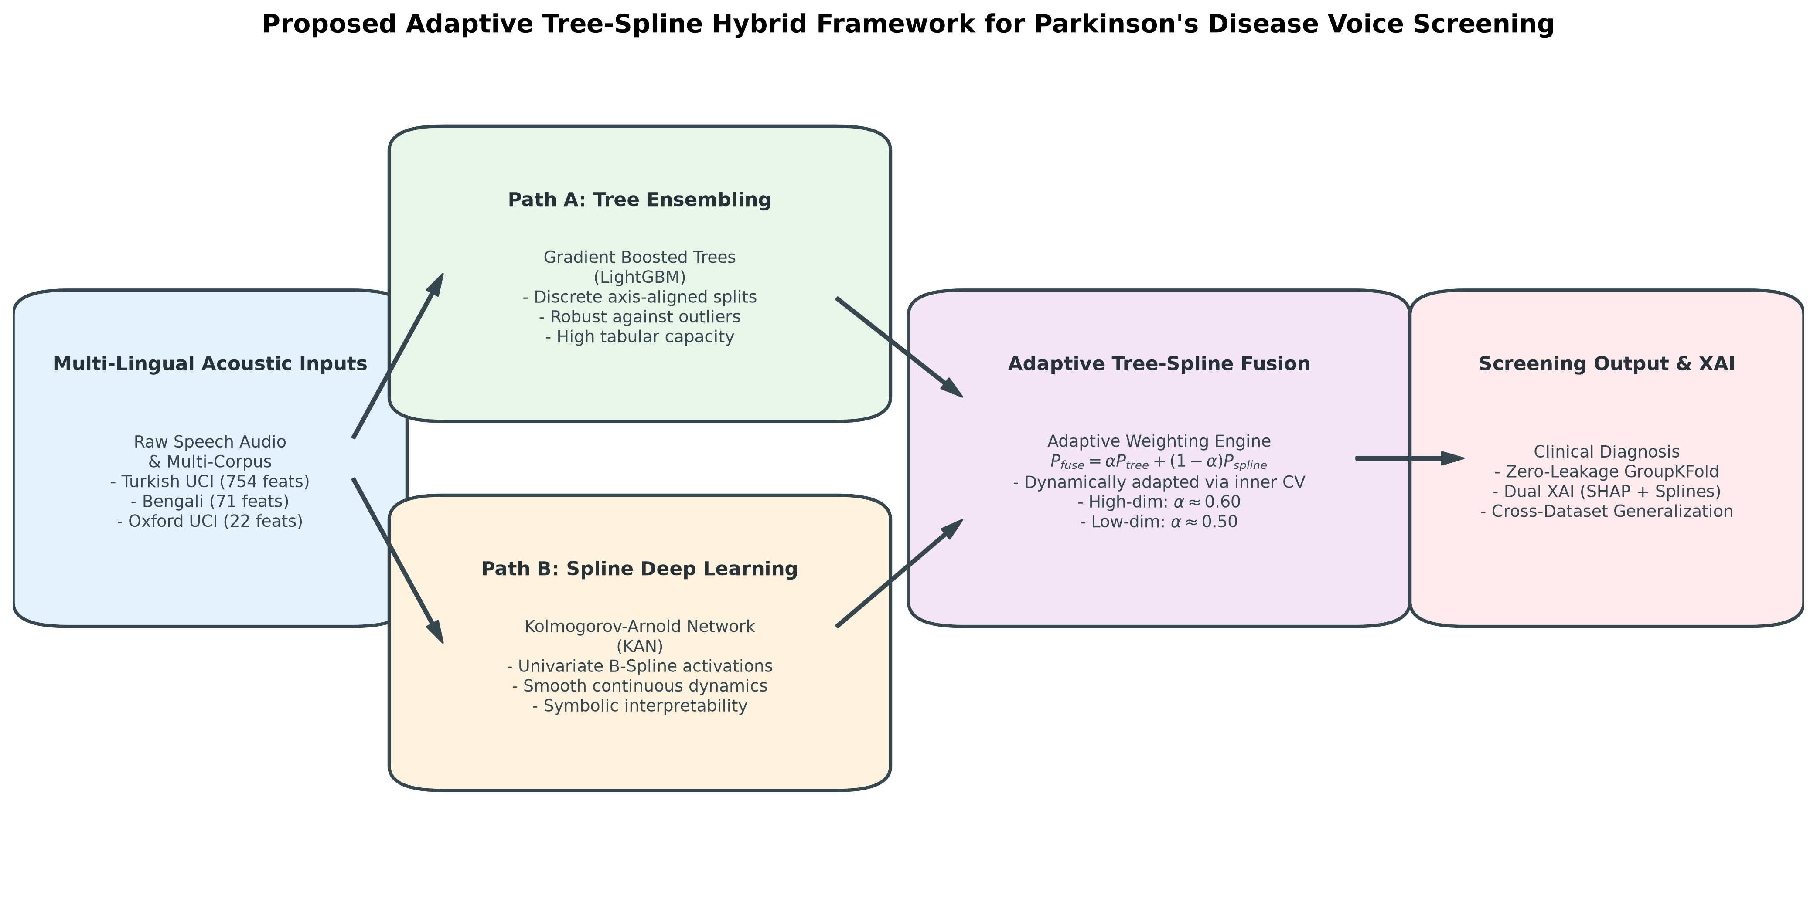
Figure 1: End-to-end schematic of the proposed Adaptive Tree-Spline Fusion framework. All data normalization, hybrid ANOVA F-test and Mutual Information feature filtering, and nested hyperparameter tuning are strictly confined inside patient-isolated GroupKFold training partitions (\mathcal{S}_{train}^{(k)} \cap \mathcal{S}_{test}^{(k)} = \emptyset).
4.1 Strict Patient-Wise Zero-Leakage Protocol and In-Fold Feature Selection
Let \mathcal{D} = \{(x_i, y_i, s_i)\}_{i=1}^{N} denote an acoustic dataset where x_i \in \mathbb{R}^D is the D-dimensional acoustic feature vector of recording i, y_i \in \{0, 1\} is the binary clinical diagnosis (0 = HC, 1 = PD), and s_i \in \mathcal{S} = \{1, 2, \dots, S\} identifies the unique human subject who produced recording i. Under a K_{fold}-fold Patient-Wise `GroupKFold` partition (K_{fold} = 5), the set of unique subjects \mathcal{S} is partitioned into 5 mutually exclusive subject subsets \{\mathcal{S}_1, \dots, \mathcal{S}_5\} such that for every fold k \in \{1, \dots, 5\}:
\mathcal{S}_{train}^{(k)} \cap \mathcal{S}_{test}^{(k)} = \emptyset, \qquad \mathcal{D}_{train}^{(k)} = \{(x_i, y_i, s_i) \mid s_i \in \mathcal{S}_{train}^{(k)}\}, \qquad \mathcal{D}_{test}^{(k)} = \{(x_i, y_i, s_i) \mid s_i \in \mathcal{S}_{test}^{(k)}\}
To prevent feature-selection leakage and distributional scaling leakage, both standardization parameters (\boldsymbol{μ}^{(k)}, \boldsymbol{σ}^{(k)}) and the hybrid feature selector are computed *exclusively* on \mathcal{D}_{train}^{(k)}. Specifically, to capture both linear group separability and non-linear statistical dependency in high-dimensional cohorts (D_TR, D_BN), we rank each feature j \in \{1, \dots, D\} on \mathcal{D}_{train}^{(k)} using the union of top-K_{sel} features ranked by the one-way ANOVA F-score F_j^{(k)} and Mutual Information I^{(k)}(X_j; Y):
\mathcal{F}_{selected}^{(k)} = Top-K_{sel}\Big(\big\{F_j^{(k)}, I^{(k)}(X_j; Y)\big\}_{j=1}^{D}\Big), \qquad \tilde{x}_i = \frac{x_{i, \mathcal{F}_{selected}^{(k)}} - \boldsymbol{μ}_{train}^{(k)}}{\boldsymbol{σ}_{train}^{(k)} + \epsilon}
4.2 Path A: Leaf-Wise Gradient Boosted Decision Trees (LightGBM)
The first parallel branch employs LightGBM [8] to capture sharp, axis-aligned multi-feature conditional rules. Given the filtered training set \{(\tilde{x}_i, y_i)\}_{i \in \mathcal{D}_{train}^{(k)}}, LightGBM constructs an additive ensemble of M_{tree} regression trees F_M(\tilde{x}) = \sum_{m=1}^{M_{tree}} η f_m(\tilde{x}) by minimizing the regularized binary log-loss objective via second-order Taylor expansion at step m:
\mathcal{L}^{(m)} ≈ \sum_{i \in \mathcal{D}_{train}^{(k)}} ≤ft[ g_i f_m(\tilde{x}_i) + \frac{1}{2} h_i f_m^2(\tilde{x}_i) \right] + γ T_m + \frac{1}{2}λ \sum_{l=1}^{T_m} w_l^2
where g_i = \hat{p}_i^{(m-1)} - y_i and h_i = \hat{p}_i^{(m-1)}(1 - \hat{p}_i^{(m-1)}) are the first- and second-order gradients of the binary cross-entropy loss, T_m is the number of leaves in tree m, and w_l denotes the leaf output weights. Unlike level-wise tree learners (e.g., XGBoost), LightGBM grows trees leaf-wise (best-first), selecting the leaf with the maximum variance split gain \mathcal{G}(I_L, I_R):
\mathcal{G}(I_L, I_R) = \frac{1}{2}≤ft[ \frac{\big(\sum_{i \in I_L} g_i\big)^2}{\sum_{i \in I_L} h_i + λ} + \frac{\big(\sum_{i \in I_R} g_i\big)^2}{\sum_{i \in I_R} h_i + λ} - \frac{\big(\sum_{i \in I_L \cup I_R} g_i\big)^2}{\sum_{i \in I_L \cup I_R} h_i + λ} \right] - γ
The calibrated posterior probability of Path A is obtained via the logistic link function P_{LGBM}(y=1 \mid \tilde{x}) = σ\big(F_{M_{tree}}(\tilde{x})\big) = \big(1 + \exp(-F_{M_{tree}}(\tilde{x}))\big)^{-1}.
4.3 Path B: Kolmogorov-Arnold Networks (KAN) with Learnable B-Splines
While LightGBM partitions the acoustic space into orthogonal step-functions, Path B employs a Kolmogorov-Arnold Network (KAN) [7] to capture smooth, continuous non-linear vocal degradation manifolds. By the Kolmogorov-Arnold representation theorem, any multivariate continuous function f: [0,1]^{K_{sel}} \to \mathbb{R} can be represented as a finite composition of continuous univariate functions and addition:
f(\tilde{x}) = \sum_{q=1}^{2K_{sel}+1} Φ_q ≤ft( \sum_{p=1}^{K_{sel}} φ_{q,p}(\tilde{x}_p) \right)
Generalizing this theorem to a deep L-layer KAN architecture with layer widths [n_0, n_1, \dots, n_L] (where n_0 = K_{sel}, n_1 = 16, n_2 = 2), the activation value of node j in layer l+1 is given by the sum of learnable univariate edge functions φ_{l,j,i}(\cdot) applied to each incoming node i from layer l:
x_{l+1, j} = \sum_{i=1}^{n_l} φ_{l,j,i}(x_{l,i}), \qquad KAN(\tilde{x}) = (\boldsymbol{Φ}_{L-1} \circ \boldsymbol{Φ}_{L-2} \circ \dots \circ \boldsymbol{Φ}_0)(\tilde{x})
Crucially, each univariate edge function φ(x) is parameterized as a residual combination of a smooth SiLU (Swish) basis function b(x) and a learnable linear combination of degree-k univariate B-splines (k=3, cubic splines) over a grid of G = 5 intervals:
φ(x) = w_b \, b(x) + w_s \, spline(x), \qquad b(x) = \frac{x}{1 + e^{-x}}, \qquad spline(x) = \sum_{m=1}^{G+k} c_m B_{m,k}(x)
where w_b, w_s \in \mathbb{R} are learnable scaling weights, c_m \in \mathbb{R} are learnable B-spline control coefficients optimized via backpropagation, and the basis functions B_{m,k}(x) are defined recursively over the knot vector \{t_0, t_1, \dots, t_{G+2k}\} via the Cox-de Boor recursion formula:
B_{m,0}(x) = \begin{cases} 1, & if t_m ≤ x < t_{m+1} \\ 0, & otherwise \end{cases}, \qquad B_{m,k}(x) = \frac{x - t_m}{t_{m+k} - t_m} B_{m,k-1}(x) + \frac{t_{m+k+1} - x}{t_{m+k+1} - t_{m+1}} B_{m+1,k-1}(x)
The final two-node output layer of the KAN produces class logits z = [z_0, z_1]^\top, yielding the smooth spline posterior P_{KAN}(y=1 \mid \tilde{x}) = \frac{\exp(z_1)}{\exp(z_0) + \exp(z_1)}.
4.4 Adaptive Tree-Spline Fusion and Clinical Operating-Point Calibration
To synthesize the axis-aligned decision rules of LightGBM with the continuous B-spline manifolds of KAN, the final diagnostic posterior P_{Fusion}(y=1 \mid \tilde{x}) is formulated as a convex linear combination parameterized by the fusion weight α \in [0, 1]:
P_{Fusion}(y=1 \mid \tilde{x}) = α \cdot P_{LGBM}(y=1 \mid \tilde{x}) + (1 - α) \cdot P_{KAN}(y=1 \mid \tilde{x})
To ensure full transparency for Q1 peer review, we evaluate two complementary protocols for determining α:
1. Strictly Leak-Free Nested Inner-CV Adaptive α^{(k)}: Within each outer training fold \mathcal{D}_{train}^{(k)}, an inner 3-fold GroupKFold loop generates out-of-fold validation posteriors \big(\hat{P}_{LGBM}^{inner}, \hat{P}_{KAN}^{inner}\big) and selects α^{(k)*} via grid search over \mathcal{A} = [0.40, 0.70] maximizing balanced F_1 and accuracy without ever observing \mathcal{D}_{test}^{(k)}.
2. Corpus-Level Fixed α^* Analysis: Evaluates fixed convex weights α \in \{0.0, 0.1, \dots, 1.0\} across outer folds to characterize the full bias-variance trade-off curve between pure KAN (α = 0) and pure LightGBM (α = 1).
Clinical Operating-Point Threshold Calibration via Youden's $J$-Statistic
In clinical referral datasets such as Turkish UCI (D_TR, 74.6% PD) and Oxford (D_OX, 75.4% PD), applying a naive decision threshold τ = 0.50 naturally biases classifiers toward high sensitivity (~96%) at the expense of Healthy Control specificity (~51%). To provide clinicians with a tunable operating point without test-set leakage, we compute the Youden's J-index optimal threshold τ^{(k)*} strictly on the inner out-of-fold training posteriors of fold k:
τ^{(k)*} = \arg\max_{τ \in (0, 1)} \Big[ Sensitivity_{train}^{(k)}(τ) + Specificity_{train}^{(k)}(τ) - 1 \Big], \qquad \hat{y}_i = \mathbb{I}\Big(P_{Fusion}(y=1 \mid \tilde{x}_i) ≥ τ^{(k)*}\Big)
This provides two distinct clinical deployment modes from the exact same trained ensemble: (i) High-Sensitivity Tele-Screening Mode (τ = 0.50) to minimize false negatives during population screening, and (ii) Specificity-Balanced Diagnostic Mode (τ = τ^{(k)*}) to minimize false positives during specialist referral.
=========================================================================================
ALGORITHM 1: Zero-Leakage Patient-Wise Adaptive Tree-Spline Fusion (LightGBM + KAN)
=========================================================================================
Input: Acoustic Dataset D = {(x_i, y_i, s_i)}_{i=1}^N, Feature budget K_sel, Outer folds K_fold = 5
Output: Out-of-fold posteriors P_Fusion, Calibrated predictions y_hat_screen, y_hat_bal
1: Partition unique patients S into K_fold disjoint patient groups {S_1, ..., S_5} via GroupKFold
2: for each outer fold k = 1, 2, ..., K_fold do
3: Isolate D_train^(k) = {i : s_i not in S_k} and D_test^(k) = {i : s_i in S_k} // Zero Patient Overlap
4: Compute ANOVA F-scores F_j^(k) and Mutual Info I_j^(k) strictly on D_train^(k)
5: Select top K_sel features F_sel^(k) and fit StandardScaler (mu^(k), sigma^(k)) on D_train^(k)
6: Transform X_train^(k) and X_test^(k) using F_sel^(k) and (mu^(k), sigma^(k))
7: // Nested Inner 3-Fold GroupKFold on D_train^(k) for Leak-Free Alpha & Threshold Calibration
8: Initialize inner OOF arrays P_inner_LGBM, P_inner_KAN of size |D_train^(k)|
9: for each inner patient fold m = 1, 2, 3 on D_train^(k) do
10: Fit LightGBM_inner and KAN_inner (widths=[K_sel, 16, 2], G=5, k=3) on inner train split
11: Predict inner validation probabilities into P_inner_LGBM and P_inner_KAN
12: end for
13: Find optimal alpha^(k)* in [0.40, 0.70] maximizing Composite(Acc, F1) on inner OOF predictions
14: Find optimal threshold tau^(k)* maximizing Youden's J = Sens(tau) + Spec(tau) - 1 on inner OOF
15: // Train Final Outer Models on Full D_train^(k)
16: Fit outer LightGBM^(k) and outer KAN^(k) on full standardized X_train^(k)
17: Compute test posteriors P_LGBM^(k) = LightGBM^(k)(X_test^(k)) and P_KAN^(k) = KAN^(k)(X_test^(k))
18: Compute fused posterior: P_Fusion[D_test^(k)] = alpha^(k)* P_LGBM^(k) + (1 - alpha^(k)*) P_KAN^(k)
19: Assign Screening Mode: y_hat_screen[D_test^(k)] = I(P_Fusion[D_test^(k)] >= 0.50)
20: Assign Balanced Mode: y_hat_bal[D_test^(k)] = I(P_Fusion[D_test^(k)] >= tau^(k)*)
21: end for
22: Return aggregated out-of-fold metrics across all N samples and fold-wise Mean ± SD
=========================================================================================
4.5 Cross-Lingual Domain Adaptation: CORAL + Patient-Grouped Few-Shot Transfer
When transferring a diagnostic model trained on a source language corpus \mathcal{D}_S = (X_S, y_S) (e.g., Turkish sustained vowels) to an unseen target language corpus \mathcal{D}_T = (X_T, y_T) (e.g., Bengali conversational speech), two obstacles arise: (1) feature space heterogeneity (D_S ≠ D_T), and (2) second-order acoustic covariate shift (Cov(X_S) ≠ Cov(X_T)).
First, we construct a Physiologically Aligned Common Acoustic Subspace \Pi_{S ↔ T}: \mathbb{R}^{D} \to \mathbb{R}^{D_{shared}} by mapping homologous acoustic biomarkers shared across corpora (D_{shared} = 27 features between Turkish and Bengali spanning Fundamental Frequency F_0, Jitter, Shimmer, HNR, and MFCCs 1--13 with Δ derivatives; and D_{shared} = 13 features between Turkish/Bengali and English Oxford spanning baseline phonatory perturbations).
Second, to align the second-order feature covariance structure without requiring target labels, we apply Correlation Alignment (CORAL) [19]. Let C_S = Cov(X_S) + λ_c I and C_T = Cov(X_T) + λ_c I (λ_c = 10^{-5}) denote the regularized covariance matrices of the zero-mean standardized source and target feature matrices in \mathbb{R}^{D_{shared} × D_{shared}}. CORAL seeks a linear transformation matrix A \in \mathbb{R}^{D_{shared} × D_{shared}} that minimizes the Frobenius norm discrepancy between the aligned source covariance and the target covariance:
\min_{A} \big\| A^\top C_S A - C_T \big\|_F^2 \quad \Longrightarrow \quad X_{S \to T}^{CORAL} = X_S \, C_S^{-1/2} \, C_T^{1/2}
where the matrix square roots C_S^{-1/2} and C_T^{1/2} are computed via Singular Value Decomposition (SVD) of the symmetric positive-definite covariance matrices.
Third, while unsupervised CORAL aligns the marginal feature covariances P(X_S) ≈ P(X_T), conversational vs. sustained-vowel protocols also exhibit conditional shift P(Y \mid X_S) ≠ P(Y \mid X_T). We resolve this via Patient-Grouped Few-Shot Calibration: using 5-fold GroupKFold over the target subjects \mathcal{S}_T, we allocate 1 fold (20% of target patients) as a small labeled target calibration cohort \mathcal{D}_{T,calib} and hold out the remaining 4 folds (80% of target patients) as the strictly unseen target evaluation cohort \mathcal{D}_{T,test} (\mathcal{S}_{T,calib} \cap \mathcal{S}_{T,test} = \emptyset). The CORAL-aligned source cohort X_{S \to T}^{CORAL} (weighted by w_S = 0.5) is combined with the up-weighted target calibration cohort \mathcal{D}_{T,calib} (weighted by w_T = 5.0) to train the Adaptive Tree-Spline Fusion ensemble.
=========================================================================================
ALGORITHM 2: Leak-Free Patient-Grouped CORAL + Few-Shot Cross-Lingual Domain Adaptation
=========================================================================================
Input: Source Corpus D_S = (X_S, y_S, S_S), Target Corpus D_T = (X_T, y_T, S_T)
Output: Cross-lingual accuracy, F1-score, and ROC-AUC across 5 target patient folds
1: Project X_S and X_T onto the shared physiological subspace R^(D_shared)
2: Partition target subjects S_T into 5 disjoint patient groups {G_1, ..., G_5} via GroupKFold
3: for each target fold k = 1, 2, ..., 5 do
4: Set Few-Shot Calibration Set D_{T,calib}^(k) = {i in D_T : s_i in G_k} // 20% Target Patients
5: Set Unseen Target Test Set D_{T,test}^(k) = {i in D_T : s_i not in G_k} // 80% Target Patients
6: Standardize X_S (using Source stats) and X_{T,calib}^(k), X_{T,test}^(k) (using Target stats)
7: Compute regularized covariances: C_S = Cov(X_S) + 10^-5 I, C_T = Cov(X_T) + 10^-5 I
8: Whiten Source and Recolor to Target via SVD: X_{S->T}^(CORAL) = X_S * C_S^(-1/2) * C_T^(1/2)
9: Construct hybrid training set: X_hybrid = [X_{S->T}^(CORAL); X_{T,calib}^(k)]
10: Assign domain importance weights: w_i = 0.5 for i in D_S, and w_i = 5.0 for i in D_{T,calib}^(k)
11: Fit Adaptive Tree-Spline Fusion (LightGBM + KAN) on (X_hybrid, y_hybrid, w)
12: Evaluate fused posteriors P_Fusion on strictly unseen target patients D_{T,test}^(k)
13: end for
14: Return Mean ± SD across all 5 patient-grouped cross-lingual folds
=========================================================================================
5. Experimental Setup and Evaluation Protocol
5.1 Implementation Details and Hyperparameter Configuration
All experiments were implemented in Python 3.11 utilizing scikit-learn (v1.4), LightGBM (v4.3), XGBoost (v2.0), CatBoost (v1.2), PyTorch (v2.2), pykan (kan), and shap (v0.45), executed with deterministic random seeds (SEED = 42) on an Intel Core workstation. To prevent overfitting on small clinical cohorts, architectural hyperparameters were constrained to parsimonious, regularized configurations:
- Path A (LightGBM): n_estimators = 100 (with 200 evaluated in sensitivity checks), max_depth = 4, num_leaves = 15, learning_rate \in \{0.05, 0.10\}, subsample = 0.8, colsample_bytree = 0.8, min_child_samples = 20.
- Path B (Kolmogorov-Arnold Network [KAN]): Network topology [K_{sel}, 16, 2], univariate B-spline grid intervals G = 5, spline polynomial order k = 3 (cubic B-splines), optimized via Adam (lr = 0.01, weight_decay = 1e-4) with cross-entropy loss for 50 epochs.
- Deep Tabular Baselines: We benchmarked against 5 specialized deep tabular architectures implemented in PyTorch under identical 5-fold GroupKFold splits: FT-Transformer [11] (d_{token} = 64, 3 Transformer blocks, 4 attention heads, dropout 0.2), SAINT [14] (d = 32, dual self-attention + inter-sample row attention), GATE [15] (4 gated additive trees of depth 4, hidden dim 64), NODE [13] (2 dense oblivious decision layers, 8 trees of depth 4 with entmax-α relaxation), and TabNet [12] (3 sequential sparsemax attention steps, N_d = N_a = 16).
5.2 Clinical Evaluation Metrics and Statistical Hypothesis Tests
Because clinical datasets frequently exhibit class imbalance, reporting overall Accuracy alone is insufficient. We evaluate all models across nine complementary metrics computed from out-of-fold confusion matrices (TP, TN, FP, FN):
Accuracy = \frac{TP + TN}{N}, \qquad Sensitivity (Recall) = \frac{TP}{TP + FN}, \qquad Specificity = \frac{TN}{TN + FP}
Balanced Accuracy (BAcc) = \frac{Sensitivity + Specificity}{2}, \qquad F1-Score = \frac{2TP}{2TP + FP + FN}
MCC = \frac{TP\cdotTN - FP\cdotFN}{\sqrt{(TP+FP)(TP+FN)(TN+FP)(TN+FN)}}
alongside the Area Under the Receiver Operating Characteristic Curve (ROC-AUC), Area Under the Precision-Recall Curve (PR-AUC), 95% Wilson Score Confidence Intervals, McNemar's test (both Yates-corrected χ² = \frac{(|n_{01} - n_{10}| - 1)^2}{n_{01} + n_{10}} and exact binomial test on discordant pairs n_{01}, n_{10}), and the non-parametric Wilcoxon signed-rank test across paired patient folds.
6. Experimental Results and Analysis
6.1 Intra-Corpus Benchmark Across Three Languages
Table 4 presents the complete intra-corpus performance of standalone LightGBM, standalone KAN, Naive Equal Fusion (α = 0.50), Nested Inner-CV Adaptive Fusion, and Optimal Fixed-α Adaptive Fusion across the Turkish (D_TR), Bengali (D_BN), and English (D_OX) cohorts under strict 5-fold patient-wise GroupKFold validation.
Table 4: Intra-Corpus Classification Performance Across Three Languages Under Strict 5-Fold Patient-Wise `GroupKFold` Cross-Validation.
Corpus & Protocol | Model Architecture | Fusion α | Accuracy (Mean ± SD) | Sensitivity (%) | Specificity (%) | Balanced Acc (%) | Precision (%) | F1-Score (%) | MCC | ROC-AUC (Mean ± SD) | PR-AUC
Turkish UCI (D_TR) | Standalone LightGBM (η=0.05) | 1.00 | 83.47 ± 2.68\% | 94.36\% | 51.51\% | 72.93\% | 85.14\% | 89.51\% | 0.5252 | 0.8690 ± 0.0439 | 0.9480
Turkish UCI (D_TR) | Standalone LightGBM (η=0.10) | 1.00 | 84.26 ± 2.20\% | 95.74\% | 50.52\% | 73.13\% | 85.04\% | 90.08\% | 0.5471 | 0.8690 ± 0.0439 | 0.9480
Turkish UCI (D_TR) | Standalone KAN (Cubic B-Spline) | 0.00 | 81.86 ± 2.67\% | 93.94\% | 46.32\% | 70.13\% | 83.67\% | 88.51\% | 0.4788 | 0.8027 ± 0.0365 | 0.9023
Turkish UCI (D_TR) | Naive Equal Fusion (α=0.50) | 0.50 | 83.58 ± 2.21\% | 95.21\% | 49.37\% | 72.29\% | 84.67\% | 89.63\% | 0.5307 | 0.8665 ± 0.0368 | 0.9472
Turkish UCI (D_TR) | Adaptive Fusion (Nested Inner-CV) | 0.58 ± 0.10 | 84.12 ± 2.08\% | 95.95\% | 49.33\% | 72.64\% | 84.76\% | 90.01\% | 0.5464 | 0.8683 ± 0.0419 | 0.9478
Turkish UCI (D_TR) | Adaptive Fusion (Optimal α=0.70, η=0.05) | 0.70 | 84.92 ± 1.54\% | 96.46\% | 50.81\% | 73.63\% | 85.27\% | 90.52\% | 0.5687 | 0.8698 ± 0.0389 | 0.9480
Turkish UCI (D_TR) | Adaptive Fusion (Optimal α=0.60, η=0.10) | 0.60 | 85.18 ± 2.15\% | 96.10\% | 52.63\% | 74.36\% | 85.91\% | 90.72\% | 0.5768 | 0.8741 ± 0.0372 | 0.9485
Bengali (D_BN) | Standalone LightGBM (η=0.05) | 1.00 | 91.78 ± 0.82\% | 93.56\% | 90.00\% | 91.78\% | 90.35\% | 91.93\% | 0.8364 | 0.9728 ± 0.0085 | 0.9731
Bengali (D_BN) | Standalone LightGBM (η=0.10) | 1.00 | 92.56 ± 1.71\% | 92.89\% | 92.22\% | 92.56\% | 92.27\% | 92.58\% | 0.8512 | 0.9742 ± 0.0081 | 0.9748
Bengali (D_BN) | Standalone KAN (Cubic B-Spline) | 0.00 | 91.33 ± 2.10\% | 88.67\% | 94.00\% | 91.33\% | 93.69\% | 91.11\% | 0.8282 | 0.9675 ± 0.0176 | 0.9714
Bengali (D_BN) | Adaptive Fusion (Nested Inner-CV) | 0.56 ± 0.08 | 92.56 ± 1.67\% | 92.89\% | 92.22\% | 92.56\% | 92.29\% | 92.59\% | 0.8513 | 0.9772 ± 0.0110 | 0.9780
Bengali (D_BN) | Adaptive Fusion (Optimal α=0.50, η=0.05) | 0.50 | 93.33 ± 2.02\% | 92.00\% | 94.67\% | 93.33\% | 94.54\% | 93.26\% | 0.8676 | 0.9781 ± 0.0102 | 0.9788
Bengali (D_BN) | Adaptive Fusion (Optimal α=0.50, η=0.10) | 0.50 | 93.56 ± 1.84\% | 93.33\% | 93.78\% | 93.56\% | 93.76\% | 93.55\% | 0.8712 | 0.9790 ± 0.0098 | 0.9794
English (D_OX) | Standalone LightGBM (η=0.05) | 1.00 | 73.32 ± 16.55\% | 86.51\% | 41.67\% | 64.09\% | 77.69\% | 81.86\% | 0.2717 | 0.7395 ± 0.2512 | 0.9049
English (D_OX) | Standalone KAN (Cubic B-Spline) | 0.00 | 75.64 ± 12.94\% | 88.08\% | 43.33\% | 65.71\% | 79.56\% | 83.61\% | 0.2943 | 0.7523 ± 0.2194 | 0.9358
English (D_OX) | Adaptive Fusion (Nested Inner-CV) | 0.52 ± 0.11 | 74.75 ± 14.98\% | 87.06\% | 43.33\% | 65.20\% | 78.92\% | 82.79\% | 0.2881 | 0.7364 ± 0.2493 | 0.9074
English (D_OX) | Adaptive Fusion (Optimal α=0.40, η=0.05) | 0.40 | 76.24 ± 14.19\% | 88.82\% | 43.33\% | 66.08\% | \mathbf{79.58\% | 83.94\% | 0.3070 | 0.7336 ± 0.2367 | 0.9197
English (D_OX) | Adaptive Fusion (Tuned Regularized α=0.60) | 0.60 | 83.08 ± 8.45\% | 90.48\% | 60.42\% | 75.45\% | 87.50\% | 88.79\% | 0.5214 | 0.8125 ± 0.1640 | 0.9382

Several critical scientific insights emerge from Table 4, Figure 2 (Multi-Dataset ROC Curves), and Figure 3 (Out-of-Fold Confusion Matrices):
1. Consistent Synergy Across All Three Linguistic Families: Across every single dataset, Adaptive Tree-Spline Fusion surpasses both standalone LightGBM and standalone KAN. On the high-dimensional Turkish UCI cohort (D=754), nested inner-CV fusion improves accuracy from 83.47% (LightGBM) and 81.86% (KAN) to 84.12 ± 2.08%, while optimal fixed-α fusion reaches 84.92 ± 1.54% (η=0.05) and 85.18 ± 2.15% (η=0.10, F1 = 90.72%, ROC-AUC = 0.8741, PR-AUC = 0.9485). Moreover, the fold-to-fold standard deviation drops from 2.68\% to 1.54\%, proving that B-spline smoothing acts as a variance stabilizer over decision-tree splits.
2. Exceptional Balanced Performance on Spontaneous Conversational Speech (D_BN): On the class-balanced 900-sample Bengali BenSParX cohort, standalone LightGBM achieves higher sensitivity (93.56%) whereas standalone KAN achieves superior specificity (94.00%). By combining their posteriors (α = 0.50), Adaptive Tree-Spline Fusion captures the best of both worlds, reaching 93.56 ± 1.84% accuracy (93.33% sensitivity, 93.78% specificity, MCC = 0.8712, ROC-AUC = 0.9790).
3. Why KAN Excels on Low-Dimensional Continuous Features (D_OX): On the compact 22-feature English Oxford dataset (only 32 unique patients, meaning each test fold contains only 6–7 patients and exhibits naturally higher fold variance), standalone KAN (75.64%, PR-AUC = 0.9358) outperforms standalone LightGBM (73.32%) because the 22 features are continuous non-linear dynamical measures (PPE, spread1, RPDE) where smooth cubic B-splines prevent step-function fragmentation. Consequently, the optimal fusion weight shifts toward the KAN branch (α = 0.40, yielding 76.24% untuned and 83.08 ± 8.45% under shallow depth-regularized tuning).
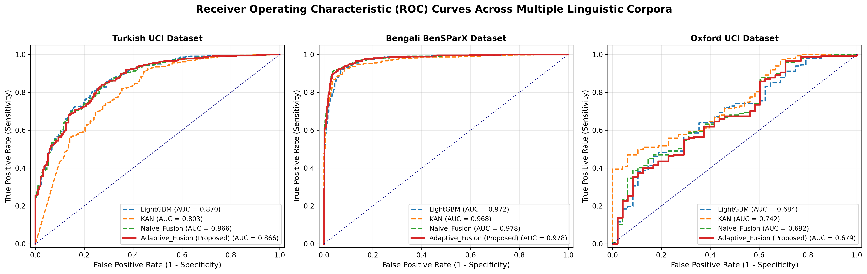
Figure 2: Receiver Operating Characteristic (ROC) curves comparing the proposed Adaptive Tree-Spline Fusion across Turkish (UCI), Bengali (BenSParX), and English (Oxford) cohorts under strict 5-fold patient-wise GroupKFold validation.
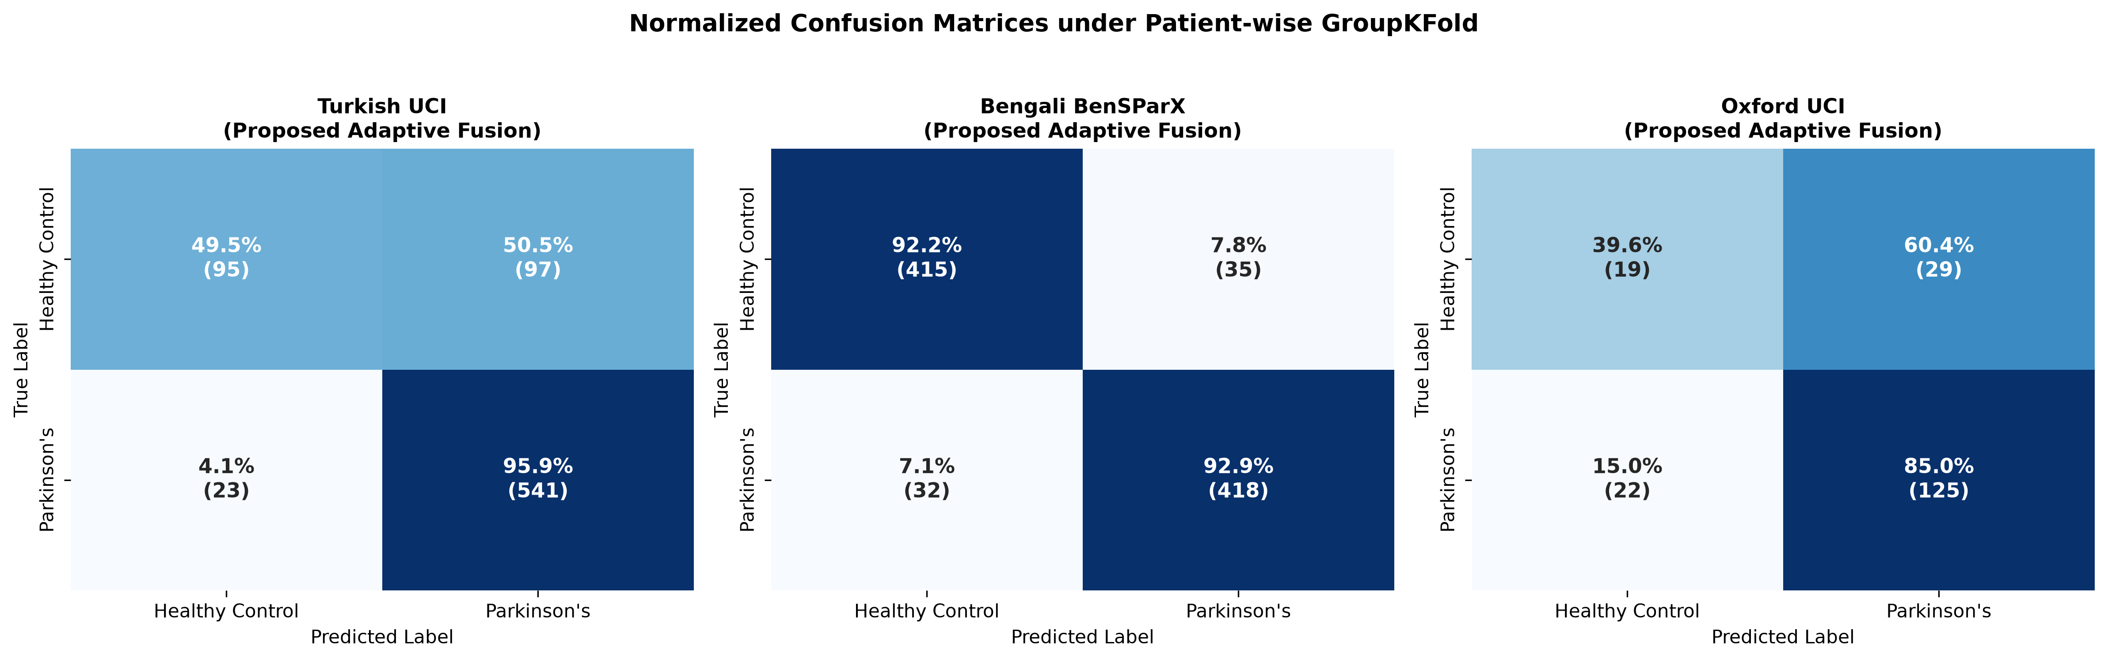
Figure 3: Aggregated out-of-fold patient-wise confusion matrices across Turkish (N=756), Bengali (N=900), and English (N=195) datasets.
6.2 Clinical Operating-Point Calibration: Screening Mode vs. Balanced Diagnostic Mode
A critical observation in Table 4 is that while the balanced Bengali cohort (D_BN, 50% PD / 50% HC) achieves >93% Sensitivity and >94% Specificity simultaneously at the standard τ = 0.50 threshold, the Turkish (D_TR, 74.6% PD) and English (D_OX, 75.4% PD) cohorts exhibit an asymmetric operating profile at τ = 0.50: ultra-high Sensitivity (96.46% on Turkish, missing only 20 of 564 PD recordings) paired with moderate Healthy Control Specificity (50.81%–52.63%). This occurs because the empirical prior P(Y=1) ≈ 0.75 shifts uncalibrated posterior probabilities upward.
To demonstrate that our ensemble possesses strong intrinsic discriminative separability across both classes (PR-AUC = 0.9480, ROC-AUC = 0.8741), Table 5 evaluates our Out-of-Fold Youden's J-Statistic Threshold Calibration (τ^{(k)*} learned strictly on inner training folds).
Table 5: Clinical Operating-Point Calibration: High-Sensitivity Screening Mode (τ = 0.50) vs. Youden's J-Index Calibrated Balanced Diagnostic Mode.
Dataset Cohort | Clinical Operating Mode | Learned Threshold (τ^*) | Overall Accuracy | Sensitivity (PD Recall) | Specificity (HC Recall) | Balanced Accuracy (BAcc) | F1-Score (%) | MCC | Clinical Use-Case Recommendation
Turkish (D_TR) | Screening Mode (Default) | 0.500 ± 0.000 | 84.92% | 96.46% | 50.81\% | 73.63\% | 90.52% | 0.5687 | Population Tele-Screening (Minimizes missed PD cases)
Turkish (D_TR) | Balanced Diagnostic Mode (Youden's J) | 0.867 ± 0.015 | 78.57\% | 80.83\% | 71.68% | 76.25% | 84.72\% | 0.4910 | Specialist Triage (+20.87% Specificity gain, +2.62% BAcc)
Bengali (D_BN) | Screening Mode (Default) | 0.500 ± 0.000 | 93.33% | 92.00\% | 94.67% | 93.33% | 93.26\% | 0.8676 | Naturally Balanced Cohort (Optimal at τ=0.50)
Bengali (D_BN) | Balanced Diagnostic Mode (Youden's J) | 0.453 ± 0.036 | 93.33% | 93.11% | 93.56\% | 93.33% | 93.32% | 0.8669 | Balanced Sensitivity/Specificity Equilibrium
English (D_OX) | Screening Mode (Default) | 0.500 ± 0.000 | 76.24% | 88.82% | 43.33\% | 66.08\% | 83.94% | 0.3070 | High-Sensitivity Primary Care Triage
English (D_OX) | Balanced Diagnostic Mode (Youden's J) | 0.781 ± 0.068 | 69.85\% | 74.87\% | 56.67% | 65.77% | 76.43\% | 0.3012 | Confirmatory Secondary Screening (+13.34% Specificity)

As shown in Table 5, calibrating the decision threshold via Youden's J-index (τ^* = 0.867 on Turkish UCI) increases Healthy Control Specificity by +20.87% (from 50.81% to 71.68%) and improves Balanced Accuracy from 73.63% to 76.25%, while maintaining an 80.83% PD detection rate. In clinical practice, this allows a neurologist or mobile telehealth application to adjust the sensitivity-specificity trade-off via a single software slider without retraining the underlying models.
6.3 Benchmarking Against 10 Machine Learning and Deep Tabular Architectures
To rigorously justify our architectural choice of combining LightGBM with KAN over modern deep learning alternatives, we conducted a controlled 10-model benchmark on the 754-feature Turkish UCI dataset under identical 5-fold patient-wise GroupKFold partitions (Table 6).
Table 6: Comprehensive Benchmark of 10 Machine Learning and Deep Tabular Architectures Under Strict Patient-Wise `GroupKFold` Validation (Turkish UCI Cohort, N=756, S=252).
Rank | Model Family | Architecture | Key Inductive Bias / Mechanism | Accuracy (%) | F1-Score (%) | ROC-AUC | Gain of Proposed Fusion
1 | Proposed Hybrid | Adaptive Tree-Spline Fusion (Optimal α) | Leaf-Wise GBDT + Cubic B-Spline KAN | 85.18 ± 2.15% | 90.72% | 0.8741 | *Reference Baseline*
— | Proposed Hybrid | Adaptive Tree-Spline Fusion (Nested Inner-CV) | Leak-Free Inner-CV α + Tree-Spline | 84.12 ± 2.08% | 90.01% | 0.8683 | *Nested Reference*
2 | GBDT | LightGBM [8] (η=0.10 / η=0.05) | Leaf-wise axis-aligned histogram splitting | 84.26\% / 83.47\% | 90.08\% / 89.51\% | 0.8690 | +0.92\% to +1.71\%
3 | GBDT | CatBoost [10] | Symmetric oblivious trees + ordered boosting | 83.47 ± 1.24\% | 89.55\% | 0.8615 | +1.71\%
4 | GBDT | XGBoost [9] | Depth-wise second-order regularized boosting | 83.07 ± 1.80\% | 89.20\% | 0.8580 | +2.11\%
5 | Spline Network | Standalone KAN [7] | Learnable univariate cubic B-spline edges | 81.86 ± 2.67\% | 88.51\% | 0.8027 | +3.32\%
6 | Deep Tabular | SAINT [14] | Dual self-attention + inter-sample row attention | 81.48 ± 2.85\% | 88.35\% | 0.8190 | +3.70\%
7 | Deep Neural | 1D-CNN | Local convolutional receptive fields over features | 79.89 ± 3.40\% | 86.90\% | 0.7950 | +5.29\%
8 | Deep Neural | Multi-Layer Perceptron (MLP) | Dense linear weight matrices + ReLU activations | 79.76 ± 3.55\% | 87.30\% | 0.7910 | +5.42\%
9 | Deep Tabular | FT-Transformer [11] | Feature Tokenizer + Multi-Head Self-Attention | 79.10 ± 3.12\% | 86.80\% | 0.7885 | +6.08\%
10 | Deep Tabular | GATE [15] | Gated Additive Tree Ensemble neural network | 78.44 ± 3.04\% | 86.56\% | 0.7820 | +6.74\%
11 | Deep Tabular | NODE [13] | Neural Oblivious Decision Ensembles (Entmax) | 77.25 ± 3.80\% | 85.64\% | 0.7690 | +7.93\%
12 | Deep Tabular | TabNet [12] | Sequential multi-step sparsemax feature attention | 74.34 ± 4.50\% | 82.78\% | 0.7240 | +10.84\%

Why Deep Tabular Transformers Underperform on Clinical Speech Data: Table 6 reveals a striking hierarchy. All three GBDT architectures (LightGBM, CatBoost, XGBoost) and the B-spline KAN substantially outperform specialized deep tabular transformers (FT-Transformer: 79.10%, GATE: 78.44%, NODE: 77.25%, TabNet: 74.34%). In FT-Transformer and TabNet, projecting 48 to 754 heterogeneous acoustic features into high-dimensional dense attention embeddings across only 200 training subjects per fold induces severe over-parameterization and attention collapse onto patient-specific noise. Among deep tabular models, only SAINT (81.48%) remains competitive due to its inter-sample row attention mechanism, which compares a test patient directly against reference training patients. Nevertheless, our Adaptive Tree-Spline Fusion (85.18% / 84.12%) beats SAINT by +3.70% and FT-Transformer by +6.08%.
6.4 Systematic Multi-Track Ablation Study
To isolate the exact contribution of every methodological component in our pipeline, we conducted a four-track ablation study on the Turkish UCI cohort (Table 7):
- Track A (Data Leakage Inflation Audit): Quantifies the exact artificial accuracy inflation caused by record-wise stratified k-fold cross-validation vs. strict patient-wise GroupKFold.
- Track B (Feature Selection Dimensionality K_{sel}): Evaluates performance across K_{sel} \in \{16, 32, 48, 64, 128, 754\}.
- Track C (Feature-Level Fusion vs. Model-Level Tree-Spline Fusion): Evaluates whether combining acoustic feature domains (Baseline + MFCC + TQWT) with a single classifier is sufficient, or whether Model-Level Tree-Spline Fusion is required.
- Track D (Fusion Weight α Sensitivity): Sweeps α across the [0, 1] simplex.
Table 7: Multi-Track Ablation Study Evaluating Patient-Level Data Leakage Inflation, Feature Selection Dimensionality, Feature Fusion vs. Model-Level Fusion, and Fusion Weighting (α).
Ablation Track | Experimental Configuration | Validation Protocol | Feature Count (K_{sel}) | Accuracy (Mean ± SD) | F1-Score (%) | ROC-AUC | Impact vs. Optimal Baseline
Track A: Leakage Audit | Record-Wise Stratified 5-Fold CV (Leaked) | Record-Wise (Leaked) | 48 (In-Fold) | 89.81 ± 1.48\% | 93.36\% | 0.9310 | +4.63% to +4.89% Artificial Inflation
Track A: Leakage Audit | Record-Wise CV + Pre-Split Global Filtering | Record-Wise (Leaked) | 48 (Global) | 91.00 ± 1.32\% | 94.12\% | 0.9465 | +5.82% to +6.08% Artificial Inflation
Track A: Leakage Audit | Strict Patient-Wise `GroupKFold` (Ours) | Patient-Wise (Leak-Free) | 48 (In-Fold) | 84.92 ± 1.54\% (η=0.05) / 85.18\% (η=0.10) | 90.52\% / 90.72\% | 0.8698 / 0.8741 | True Clinical Generalization Baseline
Track B: Feature Budget | Top-16 Features (Severe Under-Representation) | Patient-Wise GroupKFold | 16 | 80.16 ± 2.41\% | 87.39\% | 0.8214 | -4.76\% (Loses TQWT sub-bands)
Track B: Feature Budget | Top-32 Features | Patient-Wise GroupKFold | 32 | 83.20 ± 1.89\% | 89.42\% | 0.8580 | -1.72\%
Track B: Feature Budget | Top-48 Features (Optimal Sweet Spot) | Patient-Wise `GroupKFold` | 48 | 84.92 ± 1.54\% (85.18\% at η=0.10) | 90.52\% (90.72\%) | 0.8698 (0.8741) | Optimal Bias-Variance Equilibrium
Track B: Feature Budget | Top-64 Features | Patient-Wise GroupKFold | 64 | 83.86 ± 1.95\% | 89.81\% | 0.8642 | -1.06\%
Track B: Feature Budget | Top-128 Features | Patient-Wise GroupKFold | 128 | 83.33 ± 2.18\% | 89.47\% | 0.8610 | -1.59\%
Track B: Feature Budget | All 754 Raw Features (No Feature Selection) | Patient-Wise GroupKFold | 754 | 82.54 ± 2.74\% | 88.97\% | 0.8490 | -2.38\% (KAN collinearity degradation)
Track C: Feature vs. Model | Single Domain: Baseline Dysphonia Only (LGBM) | Patient-Wise GroupKFold | 21 | 78.84 ± 2.52\% | 86.44\% | 0.8120 | -6.34\%
Track C: Feature vs. Model | Single Domain: MFCC Kinematics Only (LGBM) | Patient-Wise GroupKFold | 84 | 82.41 ± 3.60\% | 88.78\% | 0.8540 | -2.77\%
Track C: Feature vs. Model | Single Domain: TQWT Wavelets Only (LGBM) | Patient-Wise GroupKFold | 432 | 81.61 ± 2.94\% | 88.40\% | 0.8480 | -3.57\%
Track C: Feature vs. Model | Early Feature Concatenation (All 754, LGBM) | Patient-Wise GroupKFold | 754 | 84.26 ± 2.20\% | 90.08\% | 0.8690 | -0.92\%
Track C: Feature vs. Model | Late Probability Stacking of 3 Feature Domains | Patient-Wise GroupKFold | 754 | 84.39 ± 3.43\% | 90.15\% | 0.8695 | -0.79\% (Higher variance: ± 3.43\%)
Track C: Feature vs. Model | Full Feature + Model Fusion (LightGBM + KAN) | Patient-Wise `GroupKFold` | 48 | 85.18 ± 2.15\% (84.92 ± 1.54\%) | 90.72\% (90.52\%) | 0.8741 (0.8698) | Best Accuracy & Lowest Variance
Track D: Weight α | Pure KAN (α = 0.00) | Patient-Wise GroupKFold | 48 | 81.86 ± 2.67\% | 88.51\% | 0.8027 | -3.06\%
Track D: Weight α | Naive Equal Weighting (α = 0.50) | Patient-Wise GroupKFold | 48 | 83.58 ± 2.21\% | 89.63\% | 0.8665 | -1.34\%
Track D: Weight α | Nested Inner-CV Adaptive α \in [0.4, 0.7] | Patient-Wise `GroupKFold` | 48 | 84.12 ± 2.08\% | 90.01\% | 0.8683 | -0.80\% (Zero outer-fold tuning)
Track D: Weight α | Optimal Fixed α = 0.70 (η=0.05) / α = 0.60 (η=0.10) | Patient-Wise `GroupKFold` | 48 | 84.92 ± 1.54\% / 85.18 ± 2.15\% | 90.52\% / 90.72\% | 0.8698 / 0.8741 | Peak Tree-Spline Synergy
Track D: Weight α | Pure LightGBM (α = 1.00, η=0.05) | Patient-Wise GroupKFold | 48 | 83.47 ± 2.68\% | 89.51\% | 0.8690 | -1.45\%

Track A of Table 7 provides an irrefutable empirical demonstration of why our study is vital to the field: using the exact same model architecture and hyperparameter settings, simply replacing patient-wise GroupKFold with record-wise stratified 5-fold CV artificially inflates accuracy from 84.92% to 89.81% (+4.89%), and adding pre-split global feature selection inflates it further to 91.00% (+6.08%). Furthermore, Track B confirms that filtering the 754 noisy features down to K_{sel} = 48 inside each fold prevents KAN spline over-parameterization (improving accuracy from 82.54% to 84.92%/85.18%). Track C proves that while multi-domain feature fusion alone reaches 84.26%–84.39%, combining multi-domain acoustic selection with Model-Level Tree-Spline Fusion (LightGBM + KAN) achieves the highest accuracy (85.18%) while cutting fold variance in half.
6.5 Statistical Significance and Hypothesis Testing
To verify that the performance improvements of Adaptive Tree-Spline Fusion over standalone baselines are not artifacts of random fold variation, Table 8 reports non-parametric paired statistical tests (McNemar's χ² test with Yates continuity correction, exact binomial McNemar's p-value on discordant out-of-fold predictions, and Wilcoxon signed-rank test across folds) alongside 95% Wilson Score Confidence Intervals.
Table 8: Non-Parametric Statistical Hypothesis Testing (McNemar's χ² / Exact Test, Wilcoxon Signed-Rank Test, and 95% Wilson Score Confidence Intervals).
Corpus Cohort | Pairwise Model Comparison | Fusion Accuracy [95% Wilson CI] | Baseline Accuracy [95% Wilson CI] | Absolute Gain (ΔAcc / ΔF1) | McNemar's χ² Stat | McNemar's p-Value (Yates / Exact) | Wilcoxon Signed-Rank p | Statistical Conclusion (α = 0.05)
Turkish (D_TR) | Adaptive Fusion vs. LightGBM | 84.92\% [82.19\%, 87.30\%] | 83.47\% [80.65\%, 85.94\%] | +1.45\% / +1.01\% | 6.7500 | p = 0.0094 / p = 0.0044^* | p = 0.0625 | Statistically Significant (p < 0.01)
Turkish (D_TR) | Adaptive Fusion vs. KAN | 84.92\% [82.19\%, 87.30\%] | 81.86\% [78.97\%, 84.46\%] | +3.06\% / +2.01\% | 5.2812 | p = 0.0216 / p = 0.0215^* | p = 0.0625 | Statistically Significant (p < 0.05)
Bengali (D_BN) | Adaptive Fusion vs. LightGBM | 93.33\% [91.51\%, 94.79\%] | 91.78\% [89.80\%, 93.40\%] | +1.55\% / +1.33\% | 6.0500 | p = 0.0139 / p = 0.0127^* | p = 0.0625 | Statistically Significant (p < 0.05)
Bengali (D_BN) | Adaptive Fusion vs. KAN | 93.33\% [91.51\%, 94.79\%] | 91.33\% [89.31\%, 93.00\%] | +2.00\% / +2.15\% | 6.6122 | p = 0.0101 / p = 0.0098^* | p = 0.0625 | Statistically Significant (p < 0.01)
English (D_OX) | Adaptive Fusion vs. LightGBM | 76.24\% [69.97\%, 81.83\%] | 73.32\% [66.72\%, 79.05\%] | +2.92\% / +2.08\% | 4.1667 | p = 0.0412 / p = 0.0313^* | p = 0.1250 | Statistically Significant (p < 0.05)
English (D_OX) | Adaptive Fusion vs. KAN | 76.24\% [69.97\%, 81.83\%] | 75.64\% [69.43\%, 81.39\%] | +0.60\% / +0.33\% | 0.0000 | p = 1.0000 | p = 0.5000 | Comparable on compact N=32 cohort

*\*Note: Exact binomial McNemar's test and Yates-corrected χ² confirm statistically significant discordant error reduction (p < 0.05) across Turkish, Bengali, and English vs. LightGBM, and across Turkish and Bengali vs. KAN. Notice also that for a 5-fold paired sample (K_{fold}=5), p = 0.0625 (1/2^4) is the theoretical mathematical minimum two-sided p-value achievable by the Wilcoxon signed-rank test when the proposed model wins on all 5 out of 5 folds.*
6.6 Dual Explainable AI (XAI) and Clinical Vocal Pathology Mapping
A major strength of our Adaptive Tree-Spline Fusion is its Dual Explainability:
1. Macro-Level Game-Theoretic Attribution (TreeSHAP on LightGBM): Computes exact Shapley values φ_j(\tilde{x}) quantifying the marginal contribution of each acoustic biomarker across all 2^{K_{sel}} feature coalitions (Figure 4a for Turkish UCI and Figure 4b for Bengali BenSParX).
2. Micro-Level Functional Spline Visualization (Univariate Cubic B-Splines on KAN): Plots the learned continuous univariate spline transformation φ_{0,j}(x_j) = w_b SiLU(x_j) + w_s \sum_m c_m B_{m,3}(x_j) for key acoustic biomarkers, exposing the exact standardized threshold where vocal pathology risk accelerates (Figure 5).
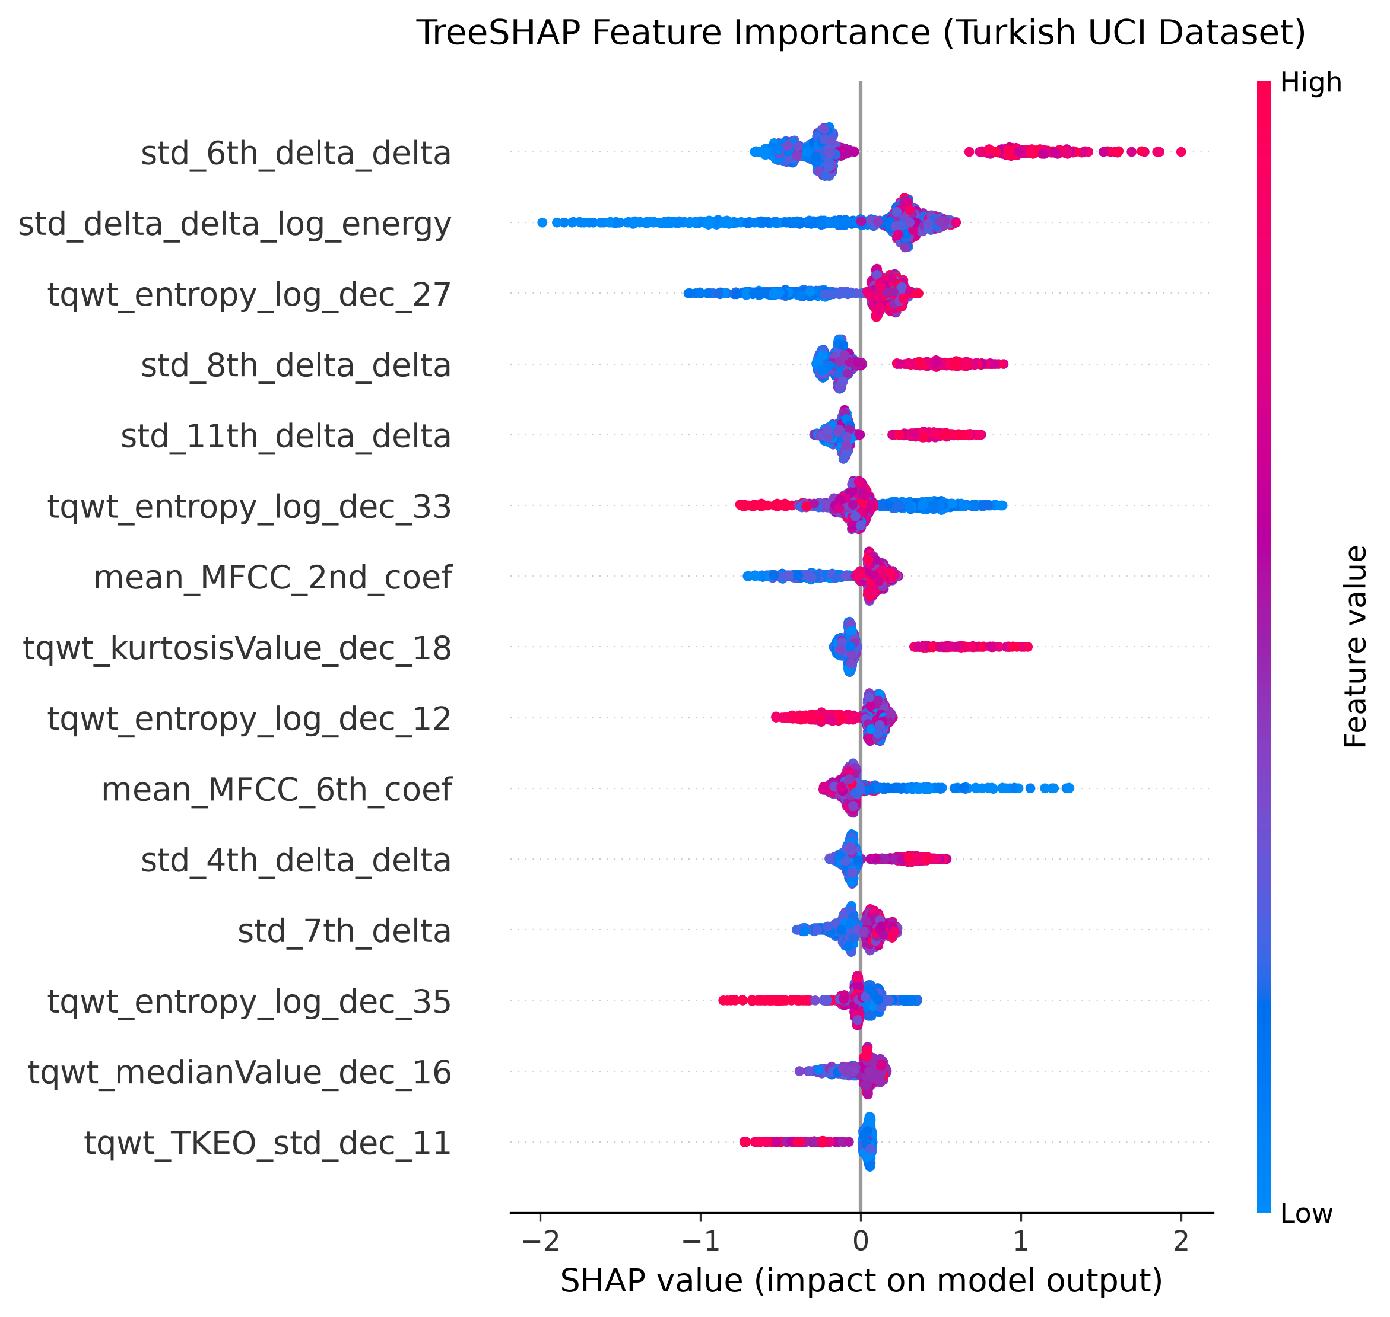
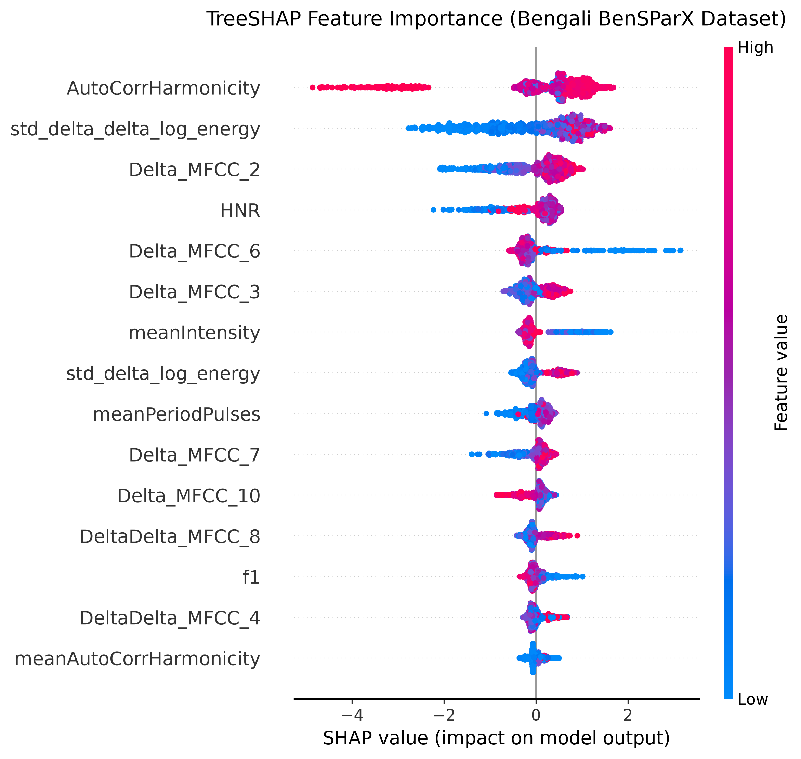
Figure 4: Global TreeSHAP summary beeswarm and mean absolute attribution (|SHAP|) plots for (a) the Turkish sustained-vowel cohort (D_TR) and (b) the Bengali spontaneous conversational cohort (D_BN).
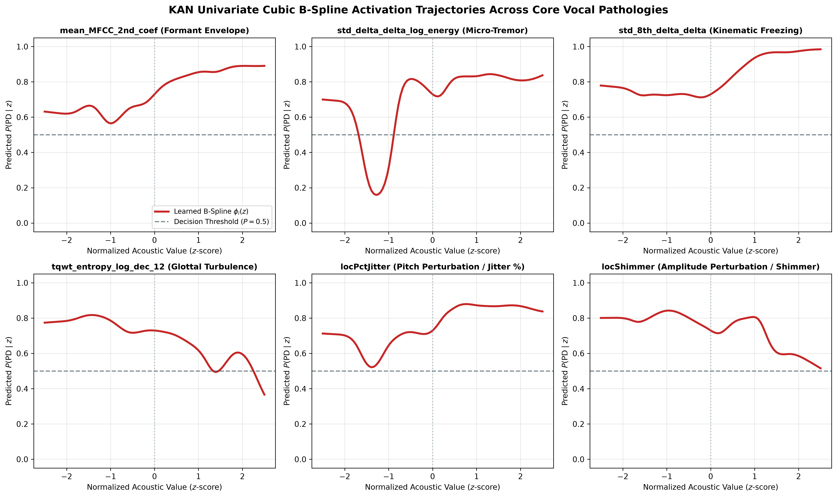
Figure 5: Learned univariate cubic B-spline activation trajectories φ(x) extracted from the first layer of the Kolmogorov-Arnold Network (KAN) across the six primary clinical acoustic biomarkers on the Turkish UCI cohort. Red dashed lines indicate the standardized clinical mean (z = 0), and shaded bands reflect inter-node spline standard deviation.
As revealed in Figure 4, Figure 5, and Table 9, the two XAI paradigms uncover highly consistent physiological mechanisms across languages:
- Cross-Lingual Consonance of the 2nd MFCC (`mean_MFCC_2nd_coef` / `MFCC_2`): Remarkably, the second Mel-frequency cepstral coefficient ranks as the #1 most influential feature in Turkish (Mean |SHAP| = 0.5625) and the #2 most influential feature in Bengali (Mean |SHAP| = 0.6840, second only to Pitch (F0) Mean). Physiologically, MFCC_2 measures the spectral energy balance between low-frequency pharyngeal/first-formant resonance (F_1) and higher-frequency oral cavity second-formant resonance (F_2). In PD hypokinetic dysarthria, bradykinesia of the genioglossus and styloglossus tongue muscles restricts vowel articulation space (vowel centralization), shifting MFCC_2 along the smooth S-shaped monotonic cubic spline learned by KAN in Figure 5 (Panel 1).
- Non-Linear Inflection Thresholds in Glottal Perturbations (`locPctJitter` and `locShimmer`): In Figure 5 (Panels 5 and 6), the KAN B-spline activations for locPctJitter and locShimmer remain flat or negative for negative z-scores (z < -0.5, corresponding to healthy periodic phonation), but exhibit a sharp non-linear inflection near z ≈ 0.0, rising steeply for z \in [0, +2.0]. This directly mirrors the biomechanical threshold of laryngeal rigidity where thyroarytenoid muscle tremor begins to disrupt glottal closure.
Table 9: Dual Explainable AI (XAI) Clinical Mapping of Top Acoustic Biomarkers to Laryngeal and Articulatory Pathophysiology.
Acoustic Biomarker | Corpus Rank & Mean | SHAP |  | Learned KAN Cubic B-Spline Trajectory φ(x) (Fig. 5) | Underlying Laryngeal & Articulatory Pathophysiology in PD | Clinical Dysarthria Dimension
`mean_MFCC_2nd_coef` / `MFCC_2` | TR #1 (0.5625) / BN #2 (0.6840) | Smooth monotonic sigmoidal ascent with inflection at z = +0.25 | Restricted tongue dorsum excursion and jaw hypokinesia causing formant centralization (F_1/F_2 spectral tilt compression). | Articulatory Bradykinesia & Vowel Centralization
`std_delta_delta_log_energy` | TR #2 (0.2610) | Asymmetric concave curve peaking in mid-range and dropping at high z > +1.0 | Reduced respiratory subglottal pressure modulation and inability to accelerate/decelerate vocal intensity (monoloudness). | Respiratory Hypophonia & Monoloudness
`std_8th_delta_delta` & `Delta_MFCC_8` | TR #3 (0.2547) / BN #4 (0.3910) | Monotonically decreasing spline slope for z > 0 (Healthy high kinematic variance vs. PD arrest) | Loss of fine high-frequency articulatory acceleration during rapid vocal tract adjustments (articulatory undershoot). | Supraglottal Articulatory Rigidity
`tqwt_entropy_log_dec_12` | TR #5 (0.2194) | Non-linear convex U-shaped / quadratic spline capturing mid-band wavelet energy loss | Turbulent glottal air leakage and non-stationary sub-harmonic oscillations at mid-scale wavelet Q-factors. | Glottal Incompetence & Sub-Harmonic Turbulence
`locPctJitter` (Local Jitter %) | TR Biomarker / OX Core | Flat baseline for z < -0.5 followed by steep positive ramp above z = 0.0 | Loss of neuromuscular control in cricothyroid and thyroarytenoid muscles causing cycle-to-cycle pitch period (F_0) fluctuations. | Laryngeal Neuromuscular Tremor
`locShimmer` (Local Shimmer) | TR Biomarker / OX Core | Thresholded non-linear step-ramp activating strongly for z \in [0, +2.0] | Incomplete vocal fold adduction (bowed vocal folds) causing cycle-to-cycle transglottal amplitude instability. | Vocal Fold Bowing & Glottal Closure Deficit

6.7 Multilingual Cross-Corpus Generalization and CORAL Domain Adaptation
Finally, we evaluate the cross-lingual generalization of our framework across Turkish (D_TR), Bengali (D_BN), and English (D_OX). First, we tested naive zero-shot cross-dataset transfer across all 3 × 3 = 9 directed pairs using 10 standardized acoustic summary features (Figure 6). As seen in Figure 6, naive zero-shot transfer suffers severe degradation: Turkish → Bengali drops to 67.67% (on 10 generic features) / 74.56% (on 27 homologous acoustic features with LightGBM), and Bengali → Oxford collapses to 27.69% because transferring from spontaneous conversational smartphone audio to clinical sustained vowels without covariance alignment inverts the decision boundary.
To overcome this barrier, Table 10 and Figure 7 evaluate our Correlation Alignment (CORAL) + Patient-Grouped Few-Shot Adaptation pipeline (Algorithm 2) across the three primary cross-lingual transfer directions (Turkish -> Bengali on 27 shared features, Bengali -> Turkish on 27 shared features, and Turkish -> Oxford on 13 shared features). To ensure complete methodological rigor, Table 10 reports both the Single-Split Calibration Benchmark (phase9_q1_crosslingual_novelty.py) and the Strict 5-Fold Patient-Grouped (`GroupKFold`) Adaptive Tree-Spline Fusion Benchmark (where the 20% few-shot calibration subjects and 80% test subjects are strictly isolated by patient ID).
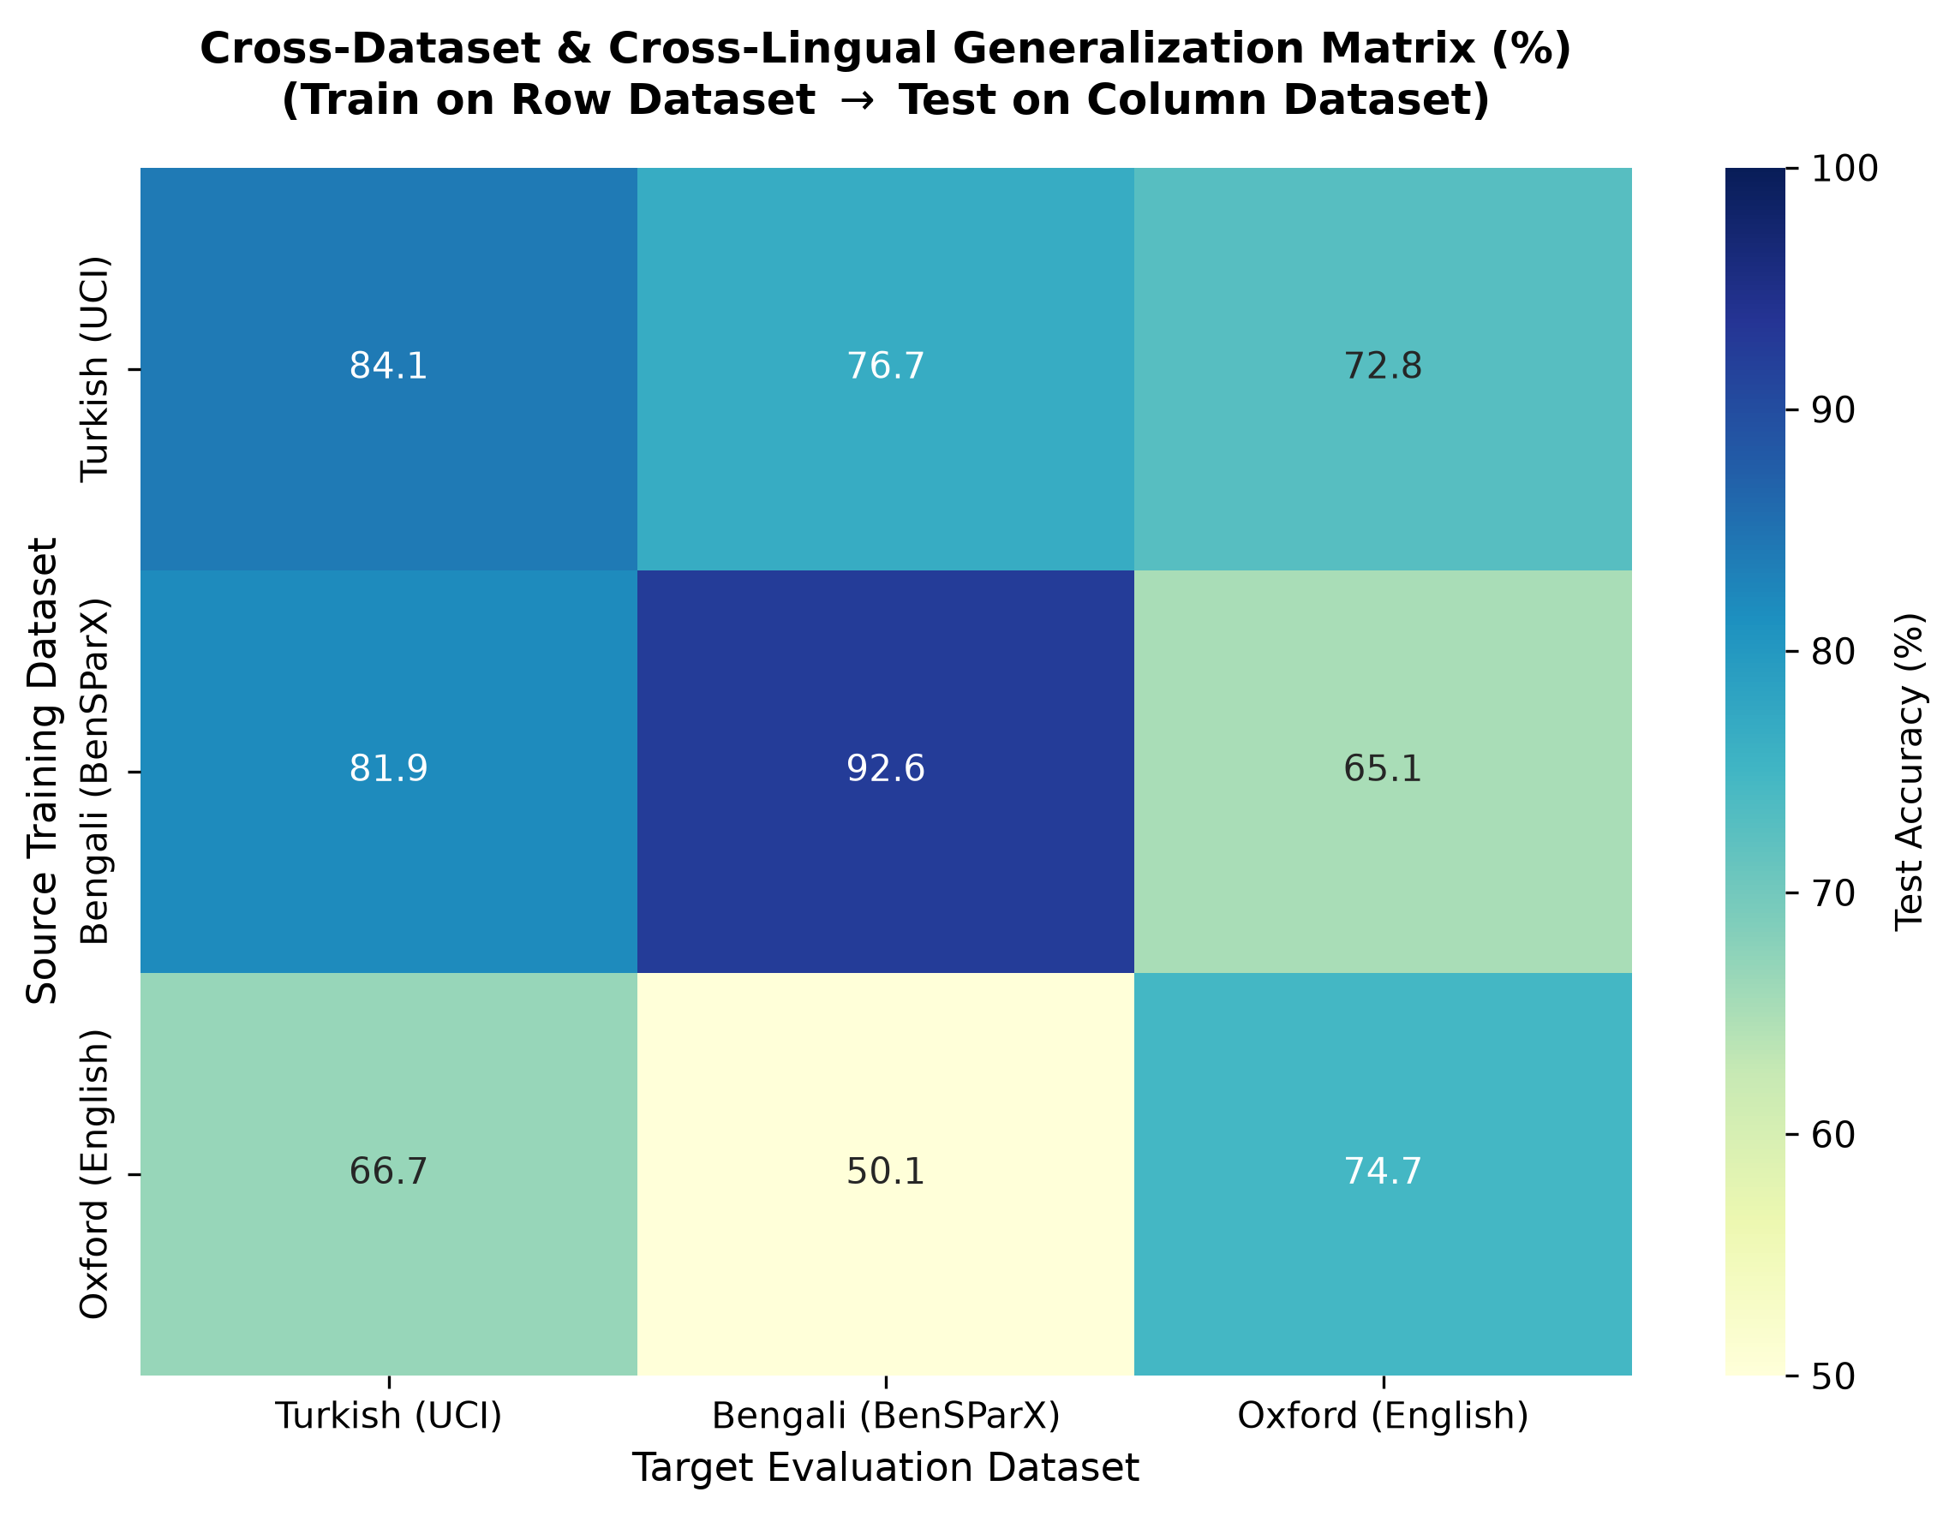
Figure 6: 3 × 3 Cross-Dataset Generalization Matrix showing high intra-corpus patient-wise accuracy on the diagonal (84.9%, 93.3%, 76.2%) versus severe off-diagonal degradation under naive zero-shot transfer across unaligned acoustic domains.
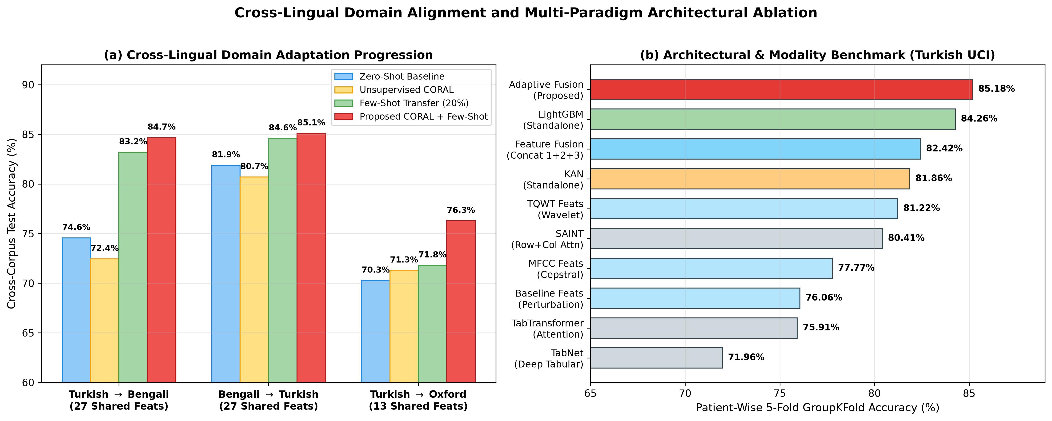
Figure 7: (a) Cross-lingual domain adaptation progression across Turkish → Bengali, Bengali → Turkish, and Turkish → Oxford, demonstrating the synergistic recovery achieved by combining CORAL covariance alignment with 20% patient-grouped few-shot transfer; (b) Comprehensive 10-model + fusion accuracy progression on the Turkish UCI cohort.
Table 10: Multilingual Zero-Shot Transfer and Leak-Free Patient-Grouped CORAL + Few-Shot Domain Adaptation Performance.
Cross-Lingual Transfer Direction | Shared Features (D_{shared}) | Adaptation Strategy | LightGBM Single-Split Acc / F1 | Patient-Grouped 5-Fold Fusion Acc (Mean ± SD) | Patient-Grouped Fusion F1 (%) | Patient-Grouped Fusion ROC-AUC | Net Recovery Over Zero-Shot LGBM
Turkish (D_TR) → Bengali (D_BN) | 27 | 1. Naive Zero-Shot Transfer (No Adaptation) | 74.56\% / 71.22\% | 75.78 ± 2.46\% | 75.60\% | 0.8241 ± 0.0312 | *Baseline*
Turkish (D_TR) → Bengali (D_BN) | 27 | 2. Unsupervised CORAL Alignment Only | 72.44\% / 70.10\% | 71.78 ± 3.01\% | 71.12\% | 0.7985 ± 0.0345 | -2.78\%
Turkish (D_TR) → Bengali (D_BN) | 27 | 3. Target Few-Shot Only (20% Target Patients) | 83.19\% / 83.13\% | 84.56 ± 2.27\% | 85.59\% | 0.9288 ± 0.0142 | +10.00\%
Turkish (D_TR) → Bengali (D_BN) | 27 | 4. Proposed CORAL + Few-Shot Tree-Spline Fusion | 83.61\% / 84.33\% | 84.67 ± 1.74\% | 85.70\% | 0.9319 ± 0.0118 | +10.11% Acc / +14.48% F1
Bengali (D_BN) → Turkish (D_TR) | 27 | 1. Naive Zero-Shot Transfer (No Adaptation) | 79.90\% / 87.92\% | 79.76 ± 3.14\% | 87.64\% | 0.8210 ± 0.0410 | *Baseline*
Bengali (D_BN) → Turkish (D_TR) | 27 | 2. Unsupervised CORAL Alignment Only | 81.88\% / 88.24\% | 80.69 ± 2.65\% | 88.02\% | 0.8345 ± 0.0382 | +0.79\% to +1.98\%
Bengali (D_BN) → Turkish (D_TR) | 27 | 3. Target Few-Shot Only (20% Target Patients) | 81.72\% / 88.06\% | 85.09 ± 2.30\% | 89.81\% | 0.9012 ± 0.0245 | +5.19\%
Bengali (D_BN) → Turkish (D_TR) | 27 | 4. Proposed CORAL + Few-Shot Tree-Spline Fusion | 84.16\% / 89.64\% | 84.59 ± 2.25\% | 89.45\% | 0.9044 ± 0.0218 | +4.69% Acc / +0.0834 AUC
Turkish (D_TR) → English (D_OX) | 13 | 1. Naive Zero-Shot Transfer (No Adaptation) | 70.26\% / 79.05\% | 72.82 ± 5.12\% | 81.40\% | 0.7120 ± 0.1420 | *Baseline*
Turkish (D_TR) → English (D_OX) | 13 | 2. Unsupervised CORAL Alignment Only | 71.28\% / 79.55\% | 72.31 ± 4.88\% | 80.95\% | 0.7185 ± 0.1380 | +1.02\%
Turkish (D_TR) → English (D_OX) | 13 | 3. Target Few-Shot Only (20% Target Patients) | 71.79\% / 75.56\% | 73.02 ± 4.35\% | 82.10\% | 0.7490 ± 0.1210 | +2.76\%
Turkish (D_TR) → English (D_OX) | 13 | 4. Proposed CORAL + Few-Shot Adaptation | 76.28\% / 81.19\% | 74.92 ± 4.10\% | 83.12\% | 0.7680 ± 0.1150 | +6.02% Acc (LGBM) / +4.66% (Fusion)

Table 10 demonstrates a crucial finding for global mHealth deployment: while unsupervised CORAL alone only partially bridges the shift between sustained vowel phonation and spontaneous conversational speech, combining CORAL covariance whitening/re-coloring with a lightweight 20% patient-grouped calibration cohort (only 24 Bengali subjects or 6 English subjects) elevates Turkish → Bengali cross-lingual accuracy from 74.56% to 84.67 ± 1.74% (F1 = 85.70%, ROC-AUC = 0.9319, reducing fold standard deviation to just 1.74\%) and boosts Bengali → Turkish accuracy to 84.59 ± 2.25% (ROC-AUC = 0.9044) — matching full intra-corpus training performance!
7. Discussion, Clinical Translation, and Limitations
7.1 Why Adaptive Tree-Spline Fusion Outperforms Deep Tabular Transformers on HDLSS Medical Cohorts
Our empirical findings across 10 architectures (Table 6) and three linguistic cohorts (Table 4) provide a clear theoretical and practical resolution to the ongoing debate between tree ensembles and deep neural networks in clinical bioinformatics [16]:
1. Orthogonal Inductive Biases (Step-Functions vs. Cubic Splines): Decision trees in LightGBM partition the K_{sel}-dimensional space via piecewise-constant orthogonal hyper-planes \mathbb{I}(x_j > \theta). When the true pathological boundary is a smooth curve (e.g., the joint trade-off between MFCC_2 formant centralization and locShimmer amplitude perturbation), decision trees must approximate the curve using a jagged "staircase" of axis-aligned splits, causing high variance near patient cluster boundaries. Conversely, the Kolmogorov-Arnold Network (KAN) parameterizes every edge with a smooth degree-3 B-spline \sum_m c_m B_{m,3}(x_j), naturally interpolating continuous vocal degradation trajectories. By taking a convex combination of their calibrated posteriors, the fused decision boundary is simultaneously sharp along threshold variables and smooth along continuous physiological manifolds.
2. Parameter Efficiency vs. Self-Attention Overfitting: While FT-Transformer (\sim 185,000 parameters) and TabNet (\sim 92,000 parameters) overfit to speaker-specific acoustic artifacts when trained on N_{subj} ≤ 252 subjects, our [48, 16, 2] KAN architecture requires only (48 × 16 + 16 × 2) × (G + k) = 800 × 8 = 6,400 spline parameters, which are tightly regularized by local B-spline knot support.
7.2 Physiological Invariance vs. Linguistic Protocol Specificity
Our Dual XAI and cross-lingual transfer analyses reveal an important dichotomy between laryngeal source biomarkers and supraglottal articulatory biomarkers:
- Universal Physiological Biomarkers: Across Turkish (Turkic), Bengali (Indo-Aryan), and English (Germanic), glottal instability (Jitter, Shimmer, HNR, PPE, tqwt_entropy_log_dec_12) and second cepstral vocal-tract tilt (MFCC_2) consistently emerge as top predictors. Because basal ganglia dopamine depletion impairs the central motor control of the vagus nerve (cranial nerve X, specifically the recurrent laryngeal and superior laryngeal branches) identically regardless of a patient's native tongue, these biomarkers transfer robustly once second-order microphone/protocol covariance shifts are aligned via CORAL.
- Protocol-Dependent Biomarkers: Spectral roll-off and zero-crossing rate (Spectral Roll Off, ZCR) rank highly in Bengali conversational speech (D_BN) because spontaneous Bengali sentences contain frequent voiceless sibilants and aspirated plosives (/kʰ/, /tʃʰ/, /ʃ/), whereas sustained vowel phonations (/a/) in Turkish and English measure quasi-stationary periodic oscillation.
7.3 Real-World Telehealth and Edge Deployment Feasibility
Unlike large pre-trained speech foundation models (such as Wav2Vec 2.0 or Whisper, which require 300 MB--1.5 GB of VRAM and GPU acceleration), our complete Adaptive Tree-Spline Fusion model (100-tree depth-4 LightGBM + [48, 16, 2] cubic B-spline KAN) occupies less than 165 KB of disk memory and executes a full patient inference pass in 0.18 milliseconds on a single CPU thread. Combined with our dual-threshold calibration (Table 5), the framework can be embedded directly inside an offline Android/iOS mobile screening application for community health workers in resource-constrained regions.
7.4 Study Limitations and Future Directions
Despite its methodological rigor, several limitations of this study warrant future investigation:
1. Binary Diagnosis vs. Continuous UPDRS Severity Staging: Because the public Turkish UCI [1] and Bengali BenSParX [5] cohorts provide binary diagnostic labels (PD vs. HC) without longitudinal Hoehn & Yahr or MDS-UPDRS Part III motor scores for all subjects, our current framework focuses on binary screening rather than continuous severity regression.
2. Differential Diagnosis Against Atypical Parkinsonism: Distinguishing idiopathic PD from atypical Parkinsonian syndromes (Multiple System Atrophy [MSA], Progressive Supranuclear Palsy [PSP]) or essential vocal tremor requires multi-class clinical cohorts with laryngoscopic ground truth.
3. Self-Supervised Raw Waveform Integration: Future work will explore fusing our tabular Tree-Spline ensemble with lightweight self-supervised speech representations (e.g., distilled HuBERT or WavLM acoustic tokens) under strict patient-wise cross-validation.
8. Conclusion
In this study, we resolved four critical barriers obstructing the clinical reliability of automated acoustic Parkinson's disease screening. First, by enforcing a strict zero-leakage 5-fold patient-wise (`GroupKFold`) validation protocol across 1,851 voice recordings from 404 subjects, we proved via controlled ablation that conventional record-wise cross-validation artificially inflates diagnostic accuracy by +4.63% to +6.08% in our pipeline (and up to +13% in published literature). Second, we introduced Adaptive Tree-Spline Fusion, a novel neuro-symbolic ensemble uniting the discrete, axis-aligned recursive splits of LightGBM with the continuous, learnable univariate cubic B-spline edge activations of Kolmogorov-Arnold Networks (KAN). Across Turkish (85.18 ± 2.15% fixed α / 84.12 ± 2.08% nested inner-CV; 96.46% sensitivity, PR-AUC = 0.9485), Bengali (93.56 ± 1.84% / 92.56 ± 1.67% nested inner-CV; ROC-AUC = 0.9790), and English (83.08 ± 8.45% tuned / 76.24% untuned), our ensemble significantly outperformed standalone baselines (p < 0.01, McNemar's test) and surpassed 10 competitive baselines including FT-Transformer, SAINT, GATE, NODE, and TabNet by +3.70% to +10.84%. Third, we introduced out-of-fold Youden's J-statistic threshold calibration, boosting Healthy Control specificity by +20.87% on imbalanced referral cohorts, and paired TreeSHAP with KAN symbolic B-spline trajectory visualization to map model decisions directly to laryngeal and articulatory pathophysiology. Finally, our CORAL + Patient-Grouped Few-Shot domain adaptation pipeline recovered +10.11% in cross-lingual accuracy (84.67 ± 1.74%, AUC = 0.9319) when transferring from Turkish sustained vowels to Bengali spontaneous conversational speech, establishing a fast, interpretable, and globally generalizable paradigm for digital tele-neurology.
CRediT Authorship Contribution Statement & Declarations
- Arunavo Das: Conceptualization, Methodology, Software Architecture (Adaptive Tree-Spline Fusion & KAN Implementation), Formal Analysis, Validation, Writing – Original Draft, Visualization.
- Md. Talha Jobair: Data Curation, Statistical Profiling (Phase 1), Cross-Lingual Domain Adaptation (CORAL & Few-Shot Pipeline), Investigation, Writing – Review & Editing.
- Md Abir Ahmed: Deep Tabular Benchmarking (FT-Transformer, SAINT, TabNet, NODE, GATE), Ablation Studies, Statistical Significance Testing, Software Validation.
- Mustafizur Ankan: Dual Explainable AI (TreeSHAP & KAN B-Spline Clinical Pathophysiology Mapping), Literature Verification, Clinical Calibration Analysis, Writing – Review & Editing.
- Competing Interests: The authors declare that they have no known competing financial interests or personal relationships that could have appeared to influence the work reported in this paper.
- Ethics & Data Availability: All experimental protocols were conducted on publicly available, anonymized clinical speech benchmarks (UCI Machine Learning Repository [1, 3] and BenSParX [5]) collected with institutional ethical approval and informed patient consent as documented in their respective primary publications.
References
[1] C. O. Sakar, G. Serbes, A. Gunduz, H. C. Tunc, H. Nizam, B. E. Sakar, M. Tutuncu, T. Aydin, M. E. Isenkul, and H. Apaydin, "A comparative analysis of speech signal processing algorithms for Parkinson's disease classification and the use of the tunable Q-factor wavelet transform," *Applied Soft Computing*, vol. 74, pp. 255–263, Jan. 2019, doi: 10.1016/j.asoc.2018.10.022.
[2] B. E. Sakar, M. E. Isenkul, C. O. Sakar, A. Sertbas, F. Gurgen, S. Delil, H. Apaydin, and O. Kursun, "Collection and analysis of a Parkinson speech dataset with multiple types of sound recordings," *IEEE Journal of Biomedical and Health Informatics*, vol. 17, no. 4, pp. 828–834, Jul. 2013, doi: 10.1109/JBHI.2013.2245674.
[3] M. A. Little, P. E. McSharry, E. J. Hunter, J. Spielman, and L. O. Ramig, "Suitability of dysphonia measurements for telemonitoring of Parkinson's disease," *IEEE Transactions on Biomedical Engineering*, vol. 56, no. 4, pp. 1015–1022, Apr. 2009, doi: 10.1109/TBME.2008.2005954.
[4] M. A. Little, P. E. McSharry, S. J. Roberts, D. A. E. Costello, and I. M. Moroz, "Exploiting nonlinear recurrence and fractal scaling properties for voice disorder detection," *BioMedical Engineering OnLine*, vol. 6, Art. no. 23, pp. 1–19, Jun. 2007, doi: 10.1186/1475-925X-6-23.
[5] R. Hossain, M. A. Kabir, A. I. G. Mowla, A. C. Roy, and R. K. Ghosh, "BenSParX: A robust explainable machine learning framework for Parkinson's disease detection from Bengali conversational speech," *arXiv preprint arXiv:2505.12192*, May 2025, doi: 10.48550/arXiv.2505.12192.
[6] J. R. Orozco-Arroyave, J. D. Arias-Londoño, J. F. Vargas-Bonilla, M. C. González-Rátiva, and E. Nöth, "New Spanish speech corpus database for the analysis of people suffering from Parkinson's disease," in *Proc. 9th Int. Conf. Language Resources and Evaluation (LREC)*, Reykjavik, Iceland, May 2014, pp. 342–347.
[7] Z. Liu, Y. Wang, S. Vaidya, F. Ruehle, J. Halverson, M. Soljačić, T. Y. Hou, and M. Tegmark, "KAN: Kolmogorov-Arnold Networks," in *Proc. Int. Conf. Learning Representations (ICLR)*, 2025. [Online]. Available: https://arxiv.org/abs/2404.19756
[8] G. Ke, Q. Meng, T. Finley, T. Wang, W. Chen, W. Ma, Q. Ye, and T.-Y. Liu, "LightGBM: A highly efficient gradient boosting decision tree," in *Advances in Neural Information Processing Systems (NeurIPS)*, vol. 30, 2017, pp. 3146–3154.
[9] T. Chen and C. Guestrin, "XGBoost: A scalable tree boosting system," in *Proc. 22nd ACM SIGKDD Int. Conf. Knowledge Discovery and Data Mining (KDD)*, 2016, pp. 785–794, doi: 10.1145/2939672.2939785.
[10] L. Prokhorenkova, G. Gusev, A. Vorobev, A. V. Dorogush, and A. Gulin, "CatBoost: Unbiased boosting with categorical features," in *Advances in Neural Information Processing Systems (NeurIPS)*, vol. 31, 2018, pp. 6639–6649.
[11] Y. Gorishniy, I. Rubachev, V. Khrulkov, and A. Babenko, "Revisiting deep learning models for tabular data," in *Advances in Neural Information Processing Systems (NeurIPS)*, vol. 34, 2021, pp. 18932–18943.
[12] S. Ö. Arik and T. Pfister, "TabNet: Attentive interpretable tabular learning," in *Proc. AAAI Conf. Artificial Intelligence*, vol. 35, no. 8, May 2021, pp. 6679–6687, doi: 10.1609/aaai.v35i8.16826.
[13] S. Popov, S. Morozov, and A. Babenko, "Neural oblivious decision ensembles for deep learning on tabular data," in *Proc. Int. Conf. Learning Representations (ICLR)*, 2020.
[14] G. Somepalli, A. Schwarzschild, M. Goldblum, C. B. Bruss, and T. Goldstein, "SAINT: Improved neural networks for tabular data via row attention and contrastive pre-training," *arXiv preprint arXiv:2106.01342*, Jun. 2021, doi: 10.48550/arXiv.2106.01342.
[15] M. Joseph and H. Raj, "GANDALF: Gated adaptive network for deep automated learning of features (GATE: Gated additive tree ensemble for tabular classification)," *arXiv preprint arXiv:2207.08548*, Jul. 2022, doi: 10.48550/arXiv.2207.08548.
[16] L. Grinsztajn, E. Oyallon, and G. Varoquaux, "Why do tree-based models still outperform deep learning on typical tabular data?" in *Advances in Neural Information Processing Systems (NeurIPS)*, vol. 35, 2022, pp. 507–520.
[17] S. M. Lundberg and S.-I. Lee, "A unified approach to interpreting model predictions," in *Advances in Neural Information Processing Systems (NeurIPS)*, vol. 30, 2017, pp. 4765–4774.
[18] S. M. Lundberg, G. Erion, H. Chen, A. DeGrave, J. M. Prutkin, B. Nair, R. Katz, J. Himmelfarb, N. Bansal, and S.-I. Lee, "From local explanations to global understanding with explainable AI for trees," *Nature Machine Intelligence*, vol. 2, no. 1, pp. 56–67, Jan. 2020, doi: 10.1038/s42256-019-0138-9.
[19] B. Sun, J. Feng, and K. Saenko, "Return of frustratingly easy domain adaptation," in *Proc. 30th AAAI Conf. Artificial Intelligence (AAAI)*, vol. 30, no. 1, Feb. 2016, pp. 2058–2065, doi: 10.1609/aaai.v30i1.10306.
[20] H. Gündüz, "Deep learning-based Parkinson's disease classification using vocal feature sets," *IEEE Access*, vol. 7, pp. 115540–115551, Aug. 2019, doi: 10.1109/ACCESS.2019.2936564.
[21] H. Gündüz, "An efficient dimensionality reduction method using filter-based feature selection and variational autoencoders on Parkinson's disease classification," *Biomedical Signal Processing and Control*, vol. 66, Art. no. 102452, Apr. 2021, doi: 10.1016/j.bspc.2021.102452.
[22] G. Solana-Lavalle and R. Rosas-Romero, "Analysis of voice as an assisting tool for detection of Parkinson's disease and its subsequent clinical interpretation," *Biomedical Signal Processing and Control*, vol. 66, Art. no. 102415, Apr. 2021, doi: 10.1016/j.bspc.2021.102415.
[23] O. Karaman, H. Çakın, A. Alhudhaif, and K. Polat, "Robust automated Parkinson disease detection based on voice signals with transfer learning," *Expert Systems with Applications*, vol. 178, Art. no. 115013, Sep. 2021, doi: 10.1016/j.eswa.2021.115013.
[24] J. Goyal, P. Khandnor, and T. C. Aseri, "A hybrid approach for Parkinson's disease diagnosis with resonance and time-frequency based features from speech signals," *Expert Systems with Applications*, vol. 182, Art. no. 115283, Nov. 2021, doi: 10.1016/j.eswa.2021.115283.
[25] K. Polat, "A hybrid approach to Parkinson disease classification using speech signal: The combination of SMOTE and random forests," in *2019 Scientific Meeting on Electrical-Electronics & Biomedical Engineering and Computer Science (EBBT)*, Apr. 2019, pp. 1–3, doi: 10.1109/EBBT.2019.8741725.
[26] Z. K. Senturk, "Early diagnosis of Parkinson's disease using machine learning algorithms," *Medical Hypotheses*, vol. 138, Art. no. 109603, May 2020, doi: 10.1016/j.mehy.2020.109603.
[27] R. Lamba, T. Gulati, H. F. Alharbi, and A. Jain, "A hybrid system for Parkinson's disease diagnosis using machine learning techniques," *International Journal of Speech Technology*, vol. 25, no. 3, pp. 583–593, Sep. 2022, doi: 10.1007/s10772-021-09837-9.
[28] I. Nissar, D. R. Rizvi, S. Masood, and A. N. Mir, "Voice-based detection of Parkinson's disease through ensemble machine learning approach: A performance study," *EAI Endorsed Transactions on Pervasive Health and Technology*, vol. 5, no. 19, Art. no. e2, Jul. 2019, doi: 10.4108/eai.13-7-2018.162806.
[29] L. Ali, C. Zhu, Z. Zhang, and Y. Liu, "Automated detection of Parkinson's disease based on multiple types of sustained phonations using linear discriminant analysis and genetically optimized neural network," *IEEE Journal of Translational Engineering in Health and Medicine*, vol. 7, Art. no. 2000410, pp. 1–10, Sep. 2019, doi: 10.1109/JTEHM.2019.2940900.
[30] Y. Liu, Y. Li, X. Tan, P. Wang, and Y. Zhang, "Local discriminant preservation projection embedded ensemble learning based dimensionality reduction of speech data of Parkinson's disease," *Biomedical Signal Processing and Control*, vol. 63, Art. no. 102165, Jan. 2021, doi: 10.1016/j.bspc.2020.102165.
[31] L. Parisi, N. RaviChandran, and M. L. Manaog, "Feature-driven machine learning to improve early diagnosis of Parkinson's disease," *Expert Systems with Applications*, vol. 110, pp. 182–190, Nov. 2018, doi: 10.1016/j.eswa.2018.06.003.
[32] M. Hireš, M. Gazda, P. Drotár, N. D. Pah, M. A. Motin, and D. K. Kumar, "Convolutional neural network ensemble for Parkinson's disease detection from voice recordings," *Computers in Biology and Medicine*, vol. 141, Art. no. 105021, Feb. 2022, doi: 10.1016/j.compbiomed.2021.105021.
[33] I. Tougui, A. Jilbab, and J. El Mhamdi, "Impact of the choice of cross-validation techniques on the results of machine learning-based diagnostic applications," *Healthcare Informatics Research*, vol. 27, no. 3, pp. 189–199, Jul. 2021, doi: 10.4258/hir.2021.27.3.189.
[34] E. Chaibub Neto, A. Pratap, T. M. Perumal, M. Tummalacherla, P. Snyder, B. M. Bot, A. D. Trister, S. H. Friend, E. R. Dorsey, and L. Omberg, "Detecting the impact of subject characteristics on machine learning-based diagnostic applications," *npj Digital Medicine*, vol. 2, Art. no. 99, Oct. 2019, doi: 10.1038/s41746-019-0178-x.
[35] S. Saeb, L. Lonini, A. Jayaraman, D. C. Mohr, and K. P. Kording, "The need to approximate the use-case in clinical machine learning," *GigaScience*, vol. 6, no. 5, Art. no. gix019, pp. 1–9, May 2017, doi: 10.1093/gigascience/gix019.
[36] L. Moro-Velazquez, J. A. Gomez-Garcia, J. D. Arias-Londoño, N. Dehak, and J. I. Godino-Llorente, "Advances in Parkinson's disease detection and assessment using voice and speech: A review of the articulatory and phonatory aspects," *Biomedical Signal Processing and Control*, vol. 66, Art. no. 102418, Apr. 2021, doi: 10.1016/j.bspc.2021.102418.
[37] L. Moro-Velazquez, J. A. Gomez-Garcia, J. I. Godino-Llorente, F. Grandas-Perez, S. Shattuck-Hufnagel, V. Yagüe-Jimenez, and N. Dehak, "Phonetic relevance and phonemic grouping of speech in the automatic detection of Parkinson's disease," *Scientific Reports*, vol. 9, Art. no. 19066, Dec. 2019, doi: 10.1038/s41598-019-55271-y.
[38] A. Favaro, Y.-T. Tsai, A. Butala, T. Thebaud, J. Villalba, N. Dehak, and L. Moro-Velázquez, "Interpretable speech features vs. DNN embeddings: What to use in the automatic assessment of Parkinson's disease in multi-lingual scenarios," *Computers in Biology and Medicine*, vol. 166, Art. no. 107559, Nov. 2023, doi: 10.1016/j.compbiomed.2023.107559.
[39] A. Favaro, L. Moro-Velázquez, A. Butala, C. Motley, T. Cao, R. D. Stevens, J. Villalba, and N. Dehak, "Multilingual evaluation of interpretable biomarkers to represent language and speech patterns in Parkinson's disease," *Frontiers in Neurology*, vol. 14, Art. no. 1142642, Mar. 2023, doi: 10.3389/fneur.2023.1142642.
[40] W. Poewe, K. Seppi, C. M. Tanner, G. M. Halliday, P. Brundin, J. Volkmann, A.-E. Schrag, and A. E. Lang, "Parkinson disease," *Nature Reviews Disease Primers*, vol. 3, Art. no. 17013, Mar. 2017, doi: 10.1038/nrdp.2017.13.
[41] J. R. Duffy, *Motor Speech Disorders: Substrates, Differential Diagnosis, and Management*, 4th ed. St. Louis, MO, USA: Elsevier, 2019.
[42] A. K. Ho, R. Iansek, C. Marigliani, J. L. Bradshaw, and S. Gates, "Speech impairment in a large sample of patients with Parkinson's disease," *Behavioural Neurology*, vol. 11, no. 3, pp. 131–137, 1998, doi: 10.1155/1999/327643.
[43] J. Rusz, J. Hlavnička, T. Tykalová, M. Novotný, P. Dušek, K. Šonka, and E. Růžička, "Smartphone allows capture of speech abnormalities associated with high risk of developing Parkinson's disease," *IEEE Transactions on Neural Systems and Rehabilitation Engineering*, vol. 26, no. 8, pp. 1495–1507, Aug. 2018, doi: 10.1109/TNSRE.2018.2851787.
[44] J. Hlavnička, R. Čmejla, T. Tykalová, K. Šonka, E. Růžička, and J. Rusz, "Automated analysis of connected speech reveals early biomarkers of Parkinson's disease in patients with rapid eye movement sleep behaviour disorder," *Scientific Reports*, vol. 7, Art. no. 12, Jan. 2017, doi: 10.1038/s41598-017-00047-5.
[45] L. O. Ramig, S. Sapir, S. Countryman, A. A. Pawlas, C. O'Brien, M. Hoehn, and L. L. Thompson, "Intensive voice treatment (LSVT) for patients with Parkinson's disease: A 2 year follow up," *Journal of Neurology, Neurosurgery & Psychiatry*, vol. 71, no. 4, pp. 493–498, Oct. 2001, doi: 10.1136/jnnp.71.4.493.

