UG-2:

Table of Contents

Introduction 3

User Registration 3

Creating an Account 3

Change Password 4

Logging In and the Front Page 5

Stocks 6

Searching the Stocks List 7

Sorting the Stocks List 7

Trend Graphs 8

Portfolios 8

Creating a Portfolio 9

Set an Active Portfolio 10

Rename Portfolio 10

Delete a Portfolio 12

Buying Shares 13

Selling Shares 15

Competitions 15

Changing Active Portfolios 16

Joining a Competition 16

Creating a Competition 17

Leaving a Competition 18

Playing in a Competition 19

What-If Generator 19

Creating a Scenario 20

Output of the Scenario 20

# Introduction

The Simulated Stock Trading System (SSTS) is a web service designed to simulate aspects of the stock market. Its purpose is to provide an environment for users to explore stock market strategies with real time data and no financial consequences and to pit their strategies against others. Data is pulled from the NASDAQ and Dow Jones stock markets and combined into one virtual stock market. The SSTS is split up into four sections: Stocks, Portfolios, Competitions, and What-If Generator. Every user has access to all four components. This user guide is broken down into five sections for the User Registration functionality and the four components.

# User Registration

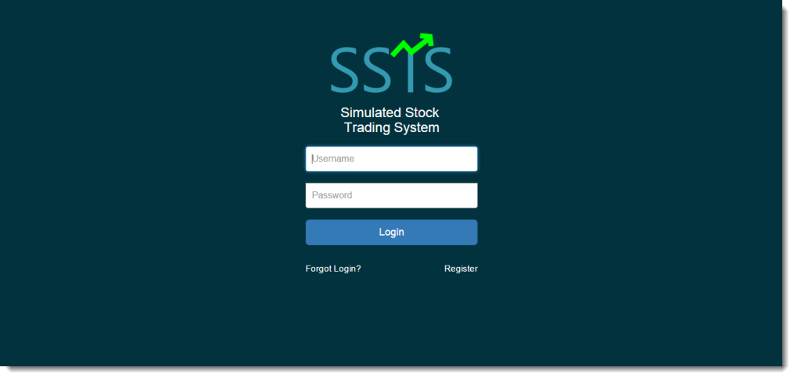

This section of the User Guide describes the front page of the system and the home page of the SSTS. From here, a user can create an account, change their password, and log into the system.

## Creating an Account

To create a new account, click on the “Register” button on the lower right of the login screen.

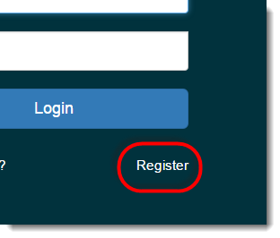

You will be directed to a screen that contains a form to input a username and a password. Fill in a new username and password and click “Submit” to create an account. You will not be able to create an account with the same name as another user. Once the form has been completed successfully, your account will be created with a starter portfolio. To navigate back to the login screen, click “Home”.

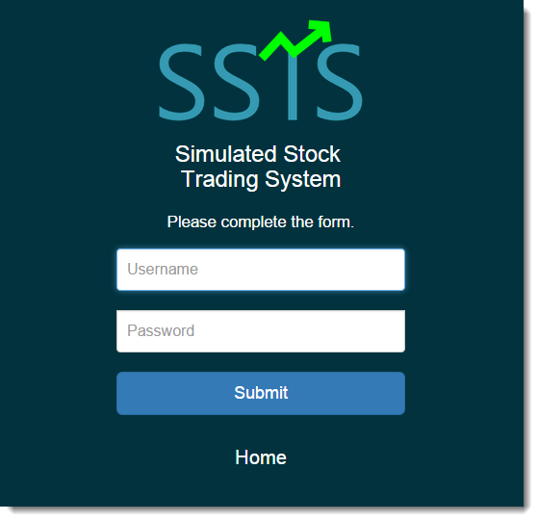

## Change Password

If you have forgotten your password to your account, from the login page, click the “Forgot Login?” link on the bottom left of the page.

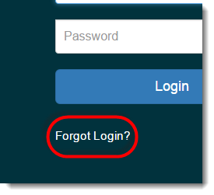

You will be directed to a screen where you can change your current password. To complete the form, fill in your username and a new password, then click “Submit”. The password for your account will have been changed and you may now login with the new password. To navigate back to the login screen, click “Home”.

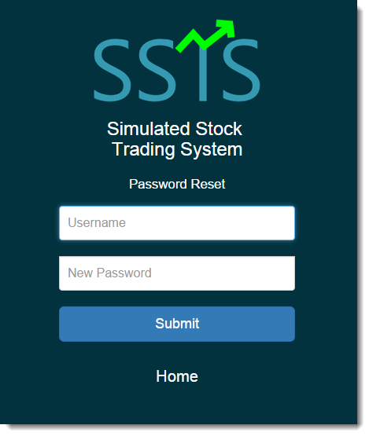

## Logging In and the Front Page

The front page of the SSTS website contains the login form. Type in your username and password and click “Submit” to log into the system.

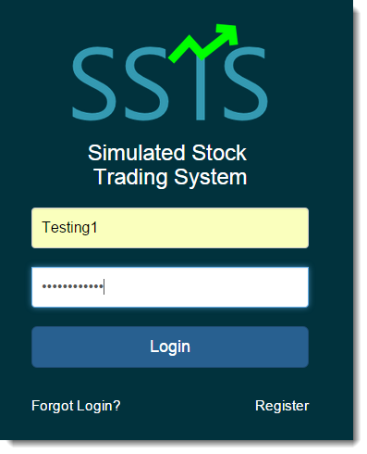

Once logged in, you will see the home page of the website which contains pertinent information about your account and the SSTS community. There is a block for the status of your active portfolio (1), a block for the competitions you are currently enrolled in (2), and a block displaying the top ten portfolios in the SSTS community (3). If you are a new member, you will not see any competitions you are enrolled in and your active portfolio will be the first that was automatically created for you.

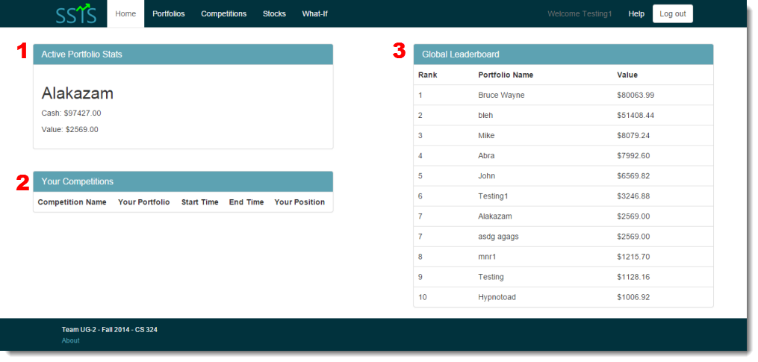

The top navigation bar and the footer are viewable on any page. The top navigation bar contains links to the Portfolios page, the Competitions page, the Stocks page, the What-If Generator, and the user Help page which links to this document. The footer contains copyright information and a link to a brief About page.

# Stocks

The Stocks page is reachable by clicking the “Stocks” button in the top navigation bar on any page.



The Stocks page provides a searchable list of all of the stocks in the SSTS database. Users can browse through various stocks, find their current value, and view other useful information about that stock. The list can be searched or sorted by first letter of the ticker ID.

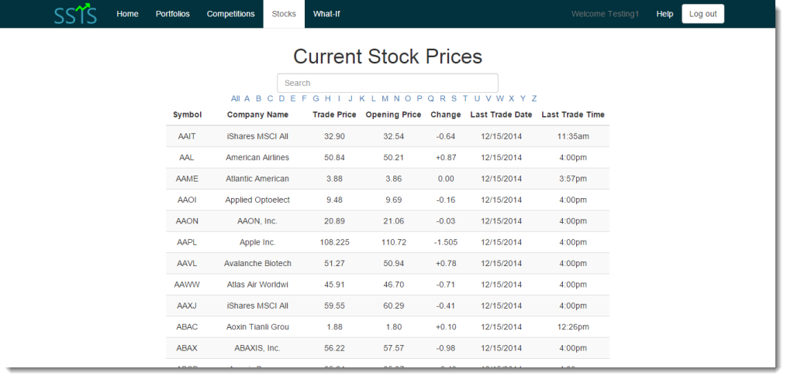

## Searching the Stocks List

There are two ways to look for stocks in the list. The first is to use the search function provided at the top of the page. To use the search feature, simply click into the box and begin typing a Symbol, Company Name, Price, Change, Date, or Time. The stocks list will automatically begin displaying only rows that contain your search criteria.

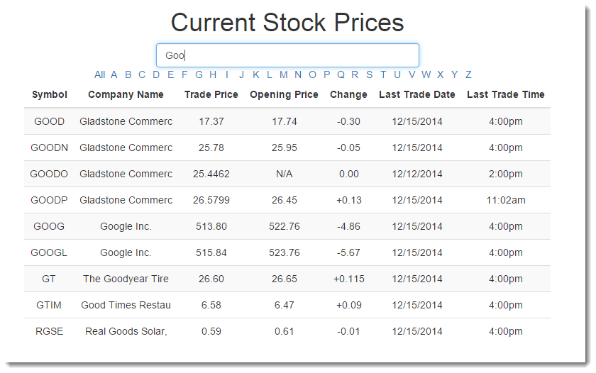

## Sorting the Stocks List

The second way to locate a stock in the list is to use the provided alphabetical sorting links. Clicking a letter in the horizontal alphabet list will display only stocks whose ticker starts with that letter. Clicking another letter will reload to show stocks beginning with that new letter. To go back to the full display of stocks, click the “All” link.

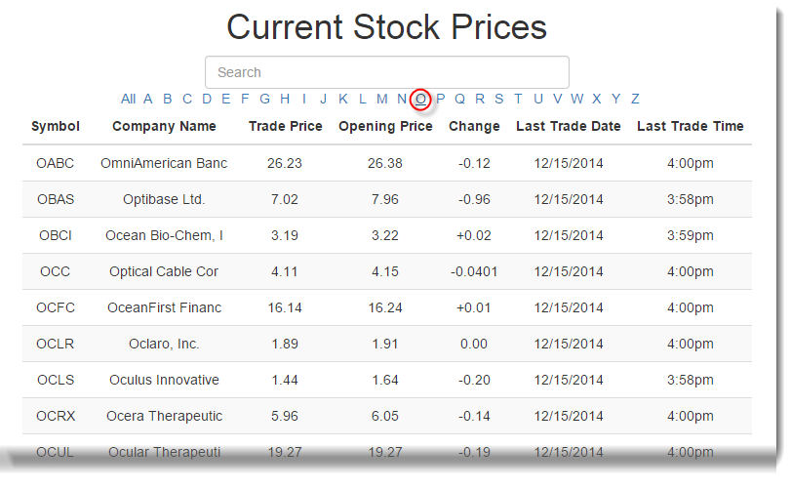

## Trend Graphs

The last feature of the Stocks page is creating a trend graph for a particular stock. Clicking anywhere on a row for a stock will produce a light box containing a trend graph for the value per share of that stock for the past couple months. The light box can be resized by clicking, holding, and dragging the bottom right corner of the small window. It can also be moved around the screen by clicking, holding, and dragging the top bar of the small window. Finally, to close the light box, click the “X” in the top right corner.

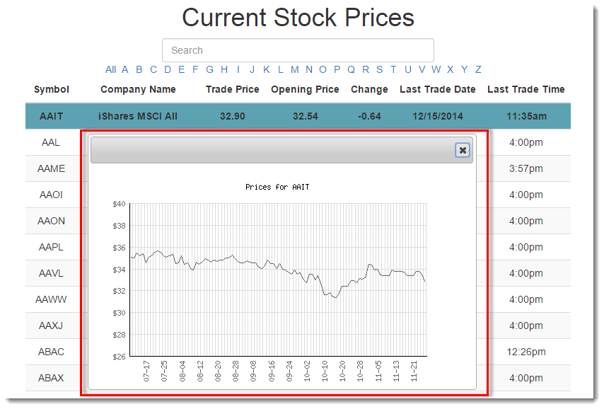

# Portfolios

The Portfolios section is reachable by clicking the “Portfolios” link in the top navigation bar.



The Portfolios section is where the majority of the SSTS functionality lies. Users can create and maintain multiple portfolios with separate cash amounts and owned shares. This way, users can test out multiple strategies for real-time stock market exchanges without real financial consequences. The Portfolios page is where users create, delete, rename, and make active portfolios and also where users buy and sell shares with their various portfolios. The left-hand sidebar (1) contains a list of all your portfolios with the active portfolio on top and buttons for the various portfolio functionalities. The middle box (2) contains all the information about your current active portfolio. This includes the name, cash, total values of all the shares owned, a list of all shares owned, and a list of current transactions. The right-hand sidebar (3) contains the functionality to buy new shares.

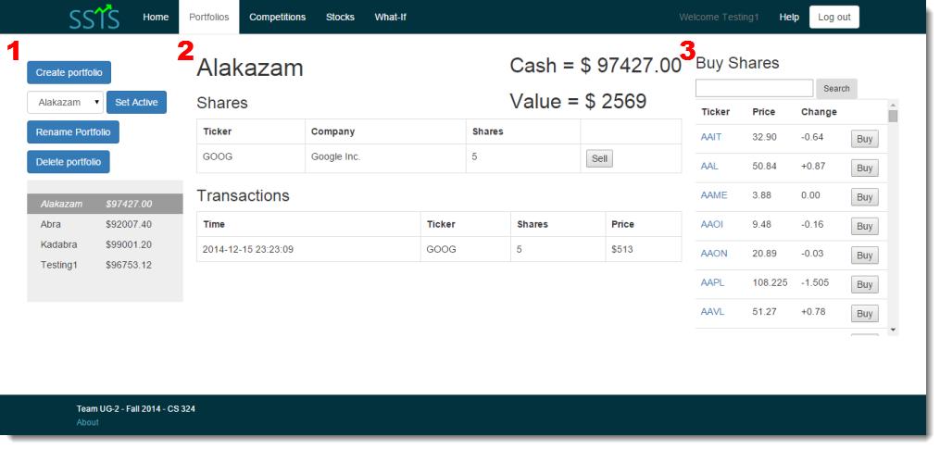

## Creating a Portfolio

To create a new portfolio, click on the “Create Portfolio” button on the left-hand sidebar.

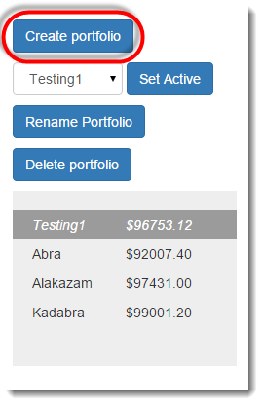

This will bring up a modal box within the window. The modal contains a simple form to choose a name for the new portfolio. Type in the desired name and click “Make New”. Portfolio names may only be 14 characters or less. If you decide not to create a portfolio, simply click the “Cancel” button in the lower left corner or the “X” button in the top left corner.

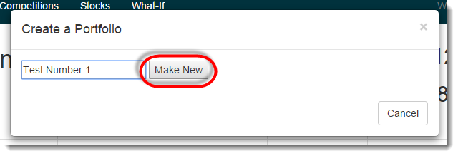

The new portfolio will then show in the portfolio list on the left-hand sidebar list and will be initialized with $100,000 in cash. The new portfolio will not automatically be made active and thus will not immediately show up in the center box. That must be done manually.

## Set an Active Portfolio

Active portfolios are how you use the rest of the features of the system, such as the competitions and buying shares, so it is important to understand how to switch. On the left-hand sidebar on the Portfolios page, click the drop down with the name of the current portfolio displayed in the center box.

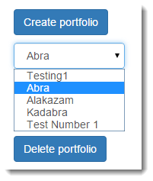

From this dropdown menu, choose the portfolio you would like to be made active. Then click the “Set Active” button and the page will reload with the new active portfolio in the top of the left-hand list and the new active portfolio’s information in the center box.

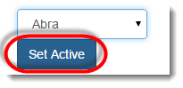

## Rename Portfolio

Because of all the interactions between databases in the SSTS, renaming portfolios should be done with caution. For that reason, you cannot rename the currently active portfolio. To rename the active portfolio, you must switch active portfolios and then follow this procedure. If you do choose to rename a portfolio, click the “Rename Portfolio” button in the left-hand sidebar.

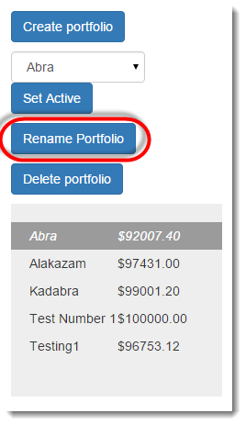

This will bring up a modal box within the window. The modal will contain a list of all your inactive portfolios with radio buttons next to them. Click the button next to the portfolio you wish to rename and click the “Select” button.

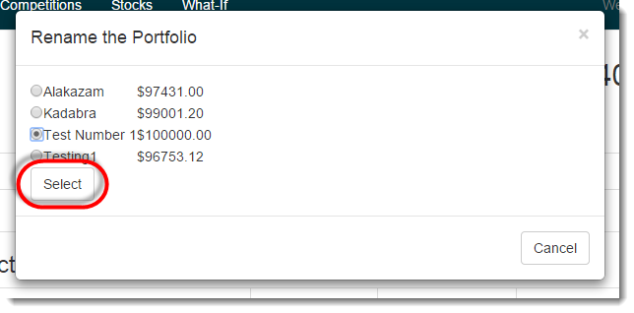

The modal box will reload with a new form requesting a new name for that portfolio. Type in the desired new name and click the “Rename” button. Portfolio names may only be 14 characters or less. Then the Portfolios page will reload with the new name for the portfolio selected. Since it isn’t the active portfolio, it will not show up in the center box. If you decide not to rename a portfolio, simply click the “Cancel” button in the lower left corner or the “X” button in the top left corner.

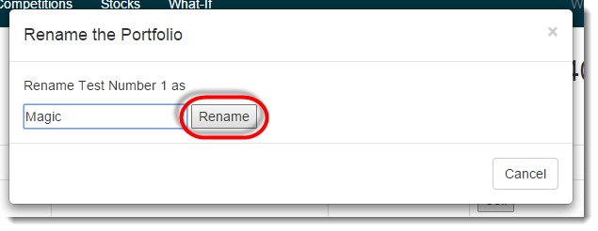

## Delete a Portfolio

Deleting a portfolio should be done with caution because of the interactions between databases. However, the functionality is provided to give users a way to clear out portfolios that are failing and to start anew. Because of the dangerousness of deleting, users may not delete their active portfolio. To delete that portfolio, you must switch active portfolios and then follow this procedure. To delete a portfolio, click the “Delete Portfolio” on the left-hand sidebar.

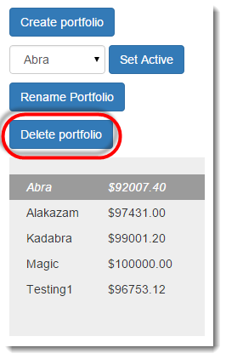

This will bring up a modal box within the window. The modal contains a list of inactive portfolios and radios buttons. Select the radio button next to the portfolio you wish to delete and be sure you clicked the right portfolio. Click the “Delete” button and the Portfolios page will reload with that portfolio gone from the list in the left-hand sidebar. If you decide not to delete a portfolio, simply click the “Cancel” button in the lower left corner or the “X” button in the top left corner.

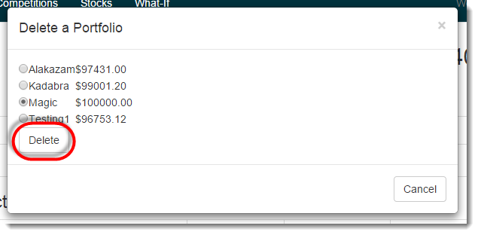

## Buying Shares

Buying shares is an essential function in the SSTS and thus it is important to know how the process works. In the right-hand sidebar of the Portfolios page, there is a scrollable list of stocks with the ticker ID, Price, and Change since the last update to the database. These values are the same as those in the large stocks list on the Stocks Page. Any shares you buy in the right-hand sidebar will be for the active portfolio. Above the list is a search bar to find specific stocks within the list.

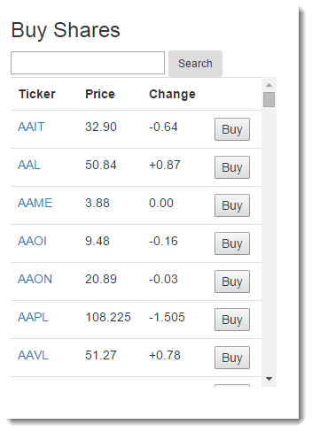

To locate a stock you want to buy, you can either scroll through the list or use the search function. You can type in letters to search for ticker IDs and company names containing your search criteria. Click “Search” to reload the list of stocks to contain those that match your criteria. To return the list of all stocks again, click “Search” when nothing is in the search box.

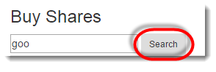

If you would like to see how that stock has fared over the last couple months, click on the ticker ID in the list and a light box will appear with a trend graph showing the change in that stocks value in the last couple months. The light box can be resized by clicking, holding, and dragging the bottom right corner of the small window. It can also be moved around the screen by clicking, holding, and dragging the top bar of the small window. Finally, to close the light box, click the “X” in the top right corner.

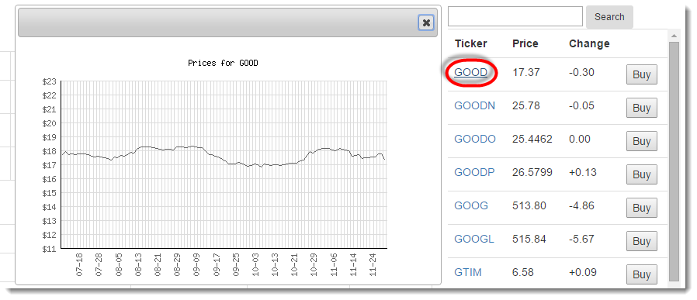

Once you have decided on a stock to buy, click the “Buy” button on its row.

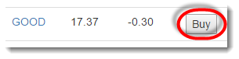

This will bring up a modal with an input box to specify how many shares you would like to purchase of that stock. You cannot enter a decimal, a non-numeric value, or a negative number. If you decide not to buy shares, simply click the “Cancel” button in the lower left corner or the “X” button in the top left corner. You can either type in the full amount you would like, or click the up and down arrows on the side of the box to navigate to the amount you want. Once you have typed in the desired number, click on “Buy”. Then the price of those shares is subtracted from your cash amount, the shares displayed in your owned shares list, and those shares’ value added to your portfolio’s value.

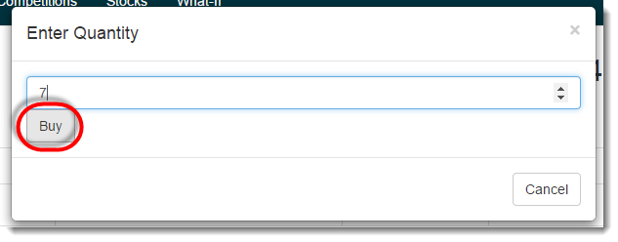

## Selling Shares

The complement to buying shares is to sell share you already own. To do this, search through the list of owned shares in the center region and locate the stock you wish to sell. Click the “Sell” button on the right side of that row.

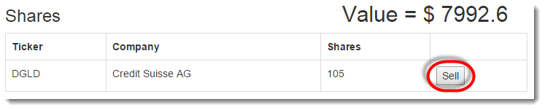

This will open a modal with a form to specify how many shares you would like to sell. You cannot enter a decimal, a non-numeric value, or a negative number. If you decide not to sell a share, simply click the “Cancel” button in the lower left corner or the “X” button in the top left corner. You can either type in the full amount you would like, or click the up and down arrows on the side of the box to navigate to the amount you want. Once you have typed in the desired number, click “Sell”. Then the prices of those shares is deposited to your cash amount, those shares moved out of your owned shares list, and those shares’ value subtracted from your portfolio’s value.

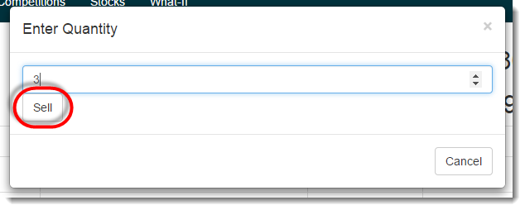

# Competitions

The Competitions Section is reachable from the “Competitions” button in the top navigation bar on any page.



The Competitions section is where users can compete against other users to see who has the best stock market strategies. The competitions are completely virtual so even though there is a buy-in amount, that money is returned to you after the competition is over. Participating in a competition creates a “virtual” portfolio that will disappear after the competition ends. Users can create competitions and compete in each users’ competitions for bragging rights and to test strategies. The view of the page depends on whether your active portfolio is already in a competition. The name of your active portfolio appears in the heading at the top for easy reference.

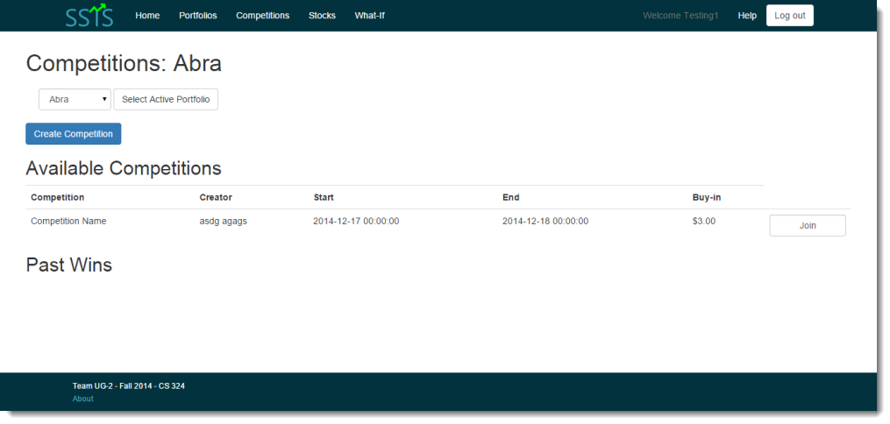

## Changing Active Portfolios

The Competitions Page is another area where you can change your active portfolio. This is so that you don’t have to navigate back to the portfolios page in order to enter multiple portfolios in competitions. It is important to note that a portfolio can only be in one competition as a time. To select a new active portfolio, click the drop down menu, select the portfolio you wish to switch to, and then click “Select Active Portfolio”. Then the page will reload with your newly selected active portfolio’s name in the heading at the top.

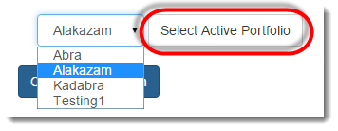

## Joining a Competition

If your active portfolio is not already in a competition, you can join a competition that another user has made. The list of available competitions that have not yet started is under the heading “Available Competitions” and the table contains the name, start date and time, end date and time, and the buy-in amount for each competition. To join the competition, click the “Join” button at the right side of the competition’s row.

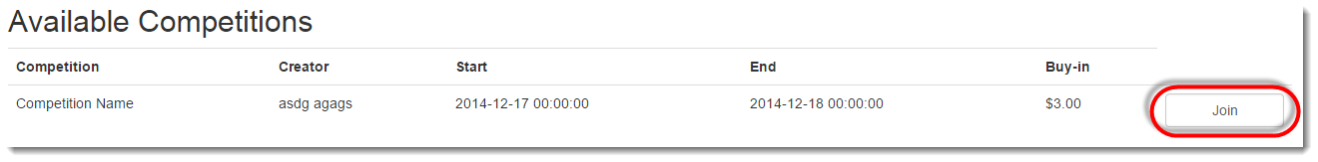

Once you have joined a competition with a portfolio, the view of the Competitiond page changes to show you details pertaining to that competition. It will show the competition name, your cash in your “virtual” portfolio, the value of your “virtual” portfolio, the details of the competition, the shares you own in your “virtual” portfolio, details about your opponents, and a “Buying shares” sidebar like in the Portfolios page.

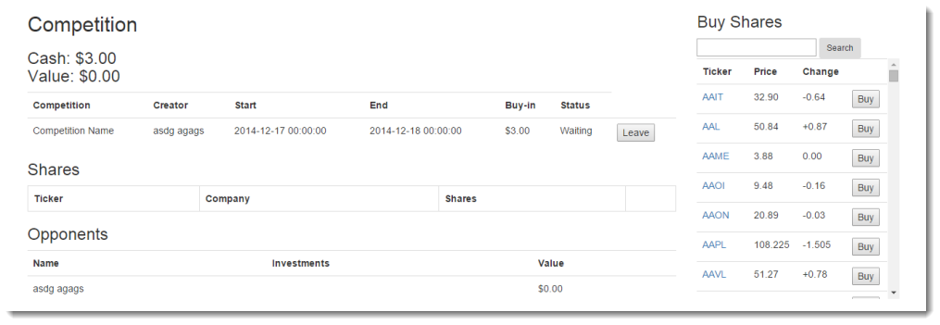

## Creating a Competition

To create your own competition, you must use a portfolio that is not already in a competition. If needed, change your active portfolio to one not already in a competition using the process from earlier in this section. Then, there will be a button titled “Create Competition”.

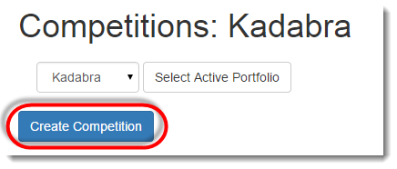

Clicking that button will bring up a modal with a form requesting information about the new competition. If you decide not to create a competition, simply click the “Cancel” button in the lower left corner or the “X” button in the top left corner. The form requires a Competition Name, a start date and time, an end date and time, and a buy-in amount. Each entry box is detailed below.

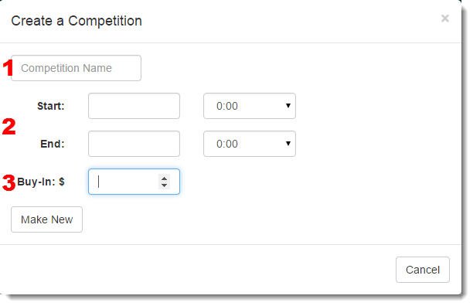

1. The competition name must be 20 characters or less.
2. The Start and End dates are selected by clicking in the text box which will bring up a calendar. Select the desired day for each. The drop downs boxes next to the date boxes are for the Start and End Time in military time. Competitions start on the hour so you cannot have a competition start at another other time than what is in the dropdown menu. Select the desired Start and End time.
3. The Buy-In amount will be subtracted from every participant’s portfolio to be returned after the competition is over. The amount can be specified down cents, but negative buy-in amounts are not allowed.

Once you have entered in all the information correctly, click “Make New”. Then the Competitions page will reload with the competition view page shown in the last section.

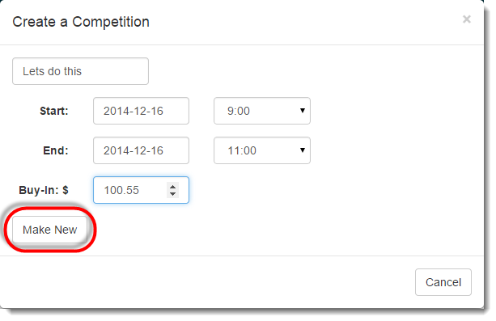

## Leaving a Competition

Sometimes, a user will decide to leave a competition before it starts. The situation could be that the owner decides they don’t actually want to be in a competition with that portfolio or a participant decides to switch to a different more exciting competition. The only stipulation is that a user can only leave a competition before the competition starts. If the owner of the competition leaves the competition before it starts, the competition will be deleted. If there is only one participant in a competition before it starts, the competition will be deleted.

To leave a competition, bring up the competition in question by switching to the associated portfolio. In the table of competition details, the right most column has a button called “Leave”. This will only show up if the competition has not yet started. Clicking on it will cause that portfolio to be removed from the competition and the buy-in amount returned to that portfolio. If you are the user, clicking leave will force all other opponents out of the competition, return all the buy-in amounts, and delete the competition from the database.

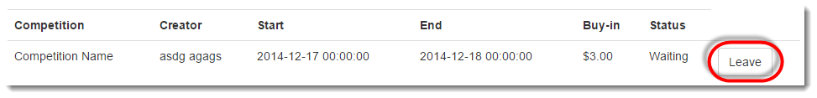

## Playing in a Competition

Participating in a competition is the same as buying and selling shares on a portfolio. To find out the process for those two actions, look at the sections “Buying Shares” and “Selling Shares”. The only additional feature to playing in a competition is that you can see your opponents’ portfolio names, what shares they own, and what the value of their “virtual” portfolio is. This is shown in the table called “Opponents”.

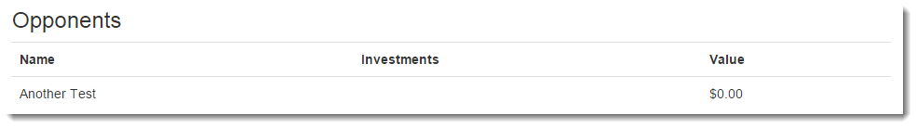

# What-If Generator

The What-If Generator is reachable from the “What-If” button in the top navigation bar on any page.



The What-If Generator provides a user with the means to review their stock market strategies and research alternative strategies they could have employed. The generator asks the user for information about a transaction that they could have taken and displays both textual and graphical data to show how the user would have fared had they chosen to buy a particular number stock on a particular day. The front page includes a form requesting all the required information to create a What-If Scenario.

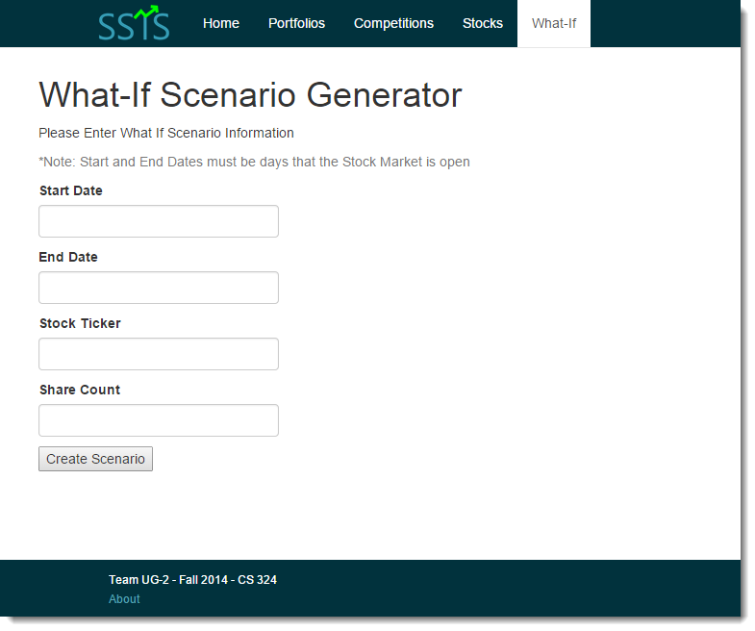

## Creating a Scenario

The form requires a Start and End Date for the scenario. The Start Date is the day that the theorized stock would have been bought and the End Date is the stopping point for the scenario and will be used to calculate profit. Both the Start and End Date must be a weekday when the stock market is already open and they cannot be in the future. To select Start and End Dates, click on text box under the label and a calendar will pop up. Select the date wished and the text field will populate with the correct format for that date.

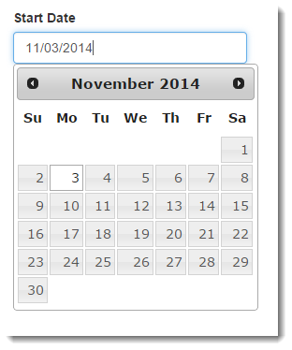

In the Stock Ticker field, type in the ticker ID for the stock that would have been purchased. The ticker ID need not be all uppercase, but it must be complete. Finally, enter an integer in the Share Count field for the amount of shares of that stock that would be have been purchased. The form will not take a decimal, a non-numeric value, or a negative number.

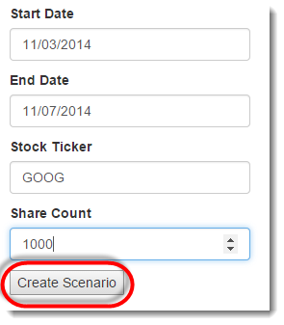

## Output of the Scenario

Once the form has been completely filled out, click the Create Scenario button. If all the information is correct, then the generated scenario data will appear to the right of the form. There will be a table that contains the stock ticker ID, company name, number of shares bought, start date, starting value per share, starting total, end date, ending value per share, ending total, and total profit of the scenario.

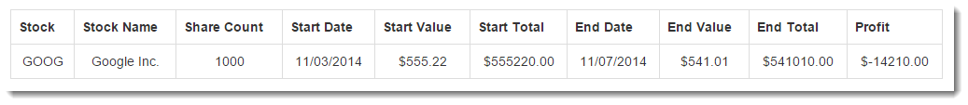

There will also be a line graph depicting the change in that stock’s value from the Start Date to the End Date. The x-axis represents time from the Start and End dates used to create the scenario plus some intermittent dates. The y-axis represents the value per share of that stock.

