**FINAL YEAR PROJECT MANAGEMENT PORTAL**

|  |  |  |
| --- | --- | --- |
| **Sowmiya S**  [sowmiyaselvam01@gmail.com](mailto:sowmiyaselvam01@gmail.com)  Student,  Department of Information Technology,  Sathyabama Institute of Science and Technology,  Chennai, India. | **Yaswanthan S R**  [yashwanthrukmangathan@gmail.com](mailto:yashwanthrukmangathan@gmail.com)  Student,  Department of Information Technology,  Sathyabama Institute of Science and Technology,  Chennai, India. | **Dr. R. M. Gomathi**  [gomathi.it@sathyabama.ac.in](mailto:gomathi.it@sathyabama.ac.in)  Associate Professor, Department of Information Technology,  Sathyabama Institute of Science and Technology,  Chennai, India. |

***Abstract*- Using manual or traditional processes to manage and control student final-year projects is an extremely tiresome task. The creation of an automated system for overseeing all project activities is the project's primary goal. A project management system is a method for organizing, directing, and keeping track of student projects. It is a web-based portal that is helpful to project coordinators, project guides, and students. The system made communication between the user guides and the students easy way.**

***Keywords: project, project management, web-based portal, student project, and guide, web application.***

**I. INTRODUCTION**

Nowadays, no one makes the effort to search through the notices posted on the notice boards. Many students are unaware of several crucial updates and notices related to their final-year projects. Additionally, the students are unable to track the actions involved in their projects. It becomes very simple if the students have quick access to all the project information and updates from the guides and coordinator. The manual project management for the final year is an extremely hard task. However, anyone can complete their project-related tasks using a simple web portal, which is the primary goal of a project management system (PMS). It offers a straightforward web interface for managing and keeping an eye on the entire project activities for students, the project coordinator, and guides. Each system module has a different user ID and password. Any module can then log into the system with its ID and password to continue its authentication. Depending on the domain of the project, the students can select mentors or guides through PMS. The system's core module, the project coordinator, is responsible for giving students different tasks to do. Interactions between the project coordinator and the project guide are occurring. The progress chart for the group is constructed based on the various criteria connected to the task that the coordinator assigned, and grades are automatically issued for that specific student group.

**II. LITERATURE REVIEW**

A balanced scorecard-based information system for managing the development of software for student teamwork is focused on a balanced scorecard (BSC) and can be used at both the strategic management level of the ever-improving university business processes and at the micro level of the teams of students working on various projects [1]. For students' collaborative project planning, a new BSC model is being offered as a project measurement technique is being proposed.

In [2] Web UPMS- a management system f for managing student projects that is being created to improve upon the current manual undergraduate project administration method and facilitate all future undergraduate project administration methods with more efficiency.

To cut down on free-riding in projects, [3] has introduced skill-based group formation. The utilization of GitHub repositories for progress tracking Team members who do peer reviews to assist mentors in identifying and addressing students’ collaborative skillset weaknesses.

The document [4] describes the database design of the information system for managing students' project activities. That primarily focuses on creating database designs for forming common cultural competencies ability to deal with data, skill growth, being a competent team player, leadership skills development, and the capacity for the initiative is all-important for undergraduate students when working on basic level projects. The application in [5] creates a venue for the students to report problems they face in their day-to-day actions. Students can submit their concerns to the Grievance Redressal Committee through the web application.

The creation of a system using cloud computing to coordinate and track students’ learning progress. Analysis of the specifications established for the info and learning environment, evaluation of the components that are part of coordinating and tracking the students’ learning, analysis of cloud services and SWOT analysis of the system were all carried out during the research in [6]. In The process of establishing an environment where students play an active role in educational programs and contribute to dynamic conversations in [7].

**III. MODULES**

There are three main modules in the system:

1. Project Coordinator
2. Project Guide
3. Student
   1. *Project Coordinator:*

The main user of this module is the staff/ coordinator who is in charge of the entire department’s project management. The activities like viewing the dashboard which has all the students with their respective mentors and project progress will be there in this module.

* 1. *Project Guide:*

The staff who are mentoring the students will be the users of this project guide module. This module is designed to reduce the guide work in knowing the progress of their student’s/teams’ work.

* 1. *Student:*

The student module is mainly focused on students entering their updates on the projects. Each student will have a separate account to submit the documents after reviews to the guide.

**IV. SYSTEM ARCHITECTURE**



*Fig 1. System architecture diagram*

The basic architecture of the system is shown in the above diagram. The system basically interacts with the users (project coordinators, project guides, students). The students data will be stored in the database so that it can be fetched when needed.

**V. METHODOLOGY**

The front end of the application needs to be created initially. A web application is being created with features like login, team registration, date updates, document uploads, team details downloads, etc. HTML, CSS, and JavaScript are the only fundamental technologies used for all front-end tasks. After that, PHP is utilized for the backend to connect to the server and the MySQL database. The XAMPP server localhost can be used to host the website locally. The system's three primary users are the project coordinator, project mentor, and student. Using his or her login information, the project coordinator will be able to access the account. After successfully registering, users will be able to view a list of all the teams and their information.

The user (project coordinator) will see a table with the team members' names, emails, phone numbers, project topics, and chosen guides in the comprehensive report. For later usage, he or she can download it as an excel file. The coordinator will have the ability to add and delete guides. He or she will be the one who is the main administrator of the system. The total number of batches under a guide is allocated based on the number of students and the number of faculties available at that time. Based on the two metrics, a mathematical distribution will be made. The issue of one guide getting large number of batches while another guide gets very few or none will not exist as a result of this method. The following module is the project mentor/guide, which will be the staff member (faculty) guiding the student on a certain subject. The instructor will have access to the system. A table listing the teams that chose them as their project manager will be available on their home page. They will have the team member’s contact information, which can be used for upcoming communications. The final module of the project management system is students. The students must sign up for the project as a two-person team in the system. The list of available guides and information about them such as name, domain, etc. will be shown on the view guide list page. When registering their teams, students can look at them and select their mentors from among them. After registering successfully, they will receive a prompt message.

Following this action, each user (student) will have their account created. For system login, each student will have their user credentials. The students must first submit the titles of their projects. They will be accepted by their respective guides. They will then begin working on the projects. The project coordinator will post updates on the review dates and the files that students need to upload for the reviews. Students can upload documents like PPTs, reports, and other types of content to the system by logging into their accounts after attending each review and receiving the appropriate guide's approval. The team's progress will be visible to the project mentors on their dashboard. They have access to the documents uploaded by the students. The project coordinator will have access to every student's progress chart. He/she has full access to the network.

**VI. RESULTS AND DISCUSSIONS**

The prototype of the project is done and shared with IT department students, Sathyabama Institute of Science and Technology, Chennai for usage. They used our system to sign up and choose their guide for the final semester project. For that purpose, the website is hosted on infinity -free a free hosting platform for hosting PHP websites.

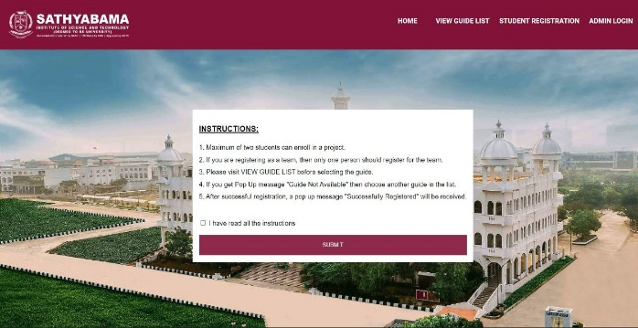

*Fig 2. Student registration-1*

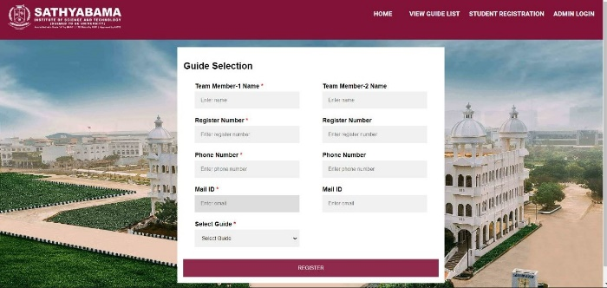

*Fig 3. Student registration form*

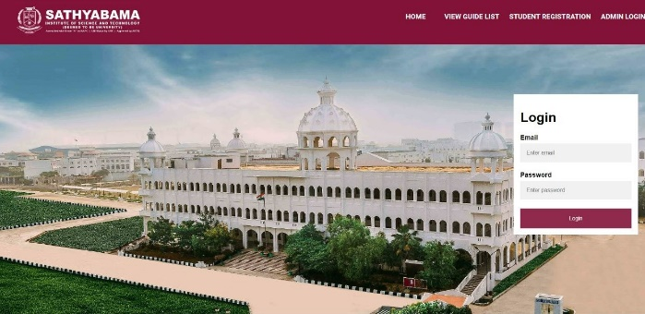

*Fig 4. Login form*

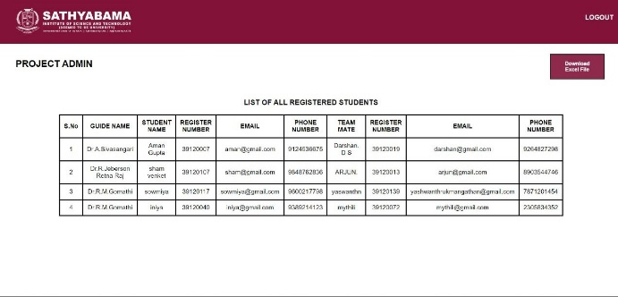

*Fig 5. Admin home page*

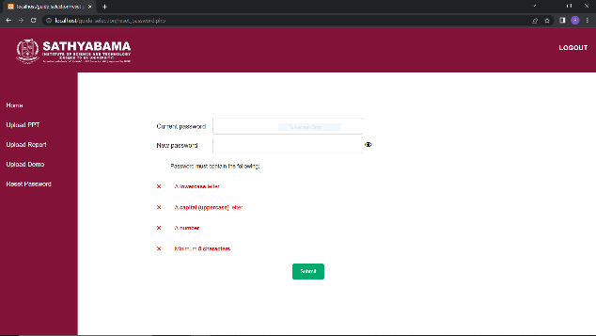

*Fig 6. Reset password page*

**VII. CONCLUSION**

The proposed project management system allowed for control of the workflow of a typical project in a university setting. When the system was used in conjunction with the essential requirements for a university project, the workflow of the entire project management process was effectively completed. Compared to the conventional management approach, the system makes communication between its three main modules—the project coordinator, project guide, and students—much simpler.

Even if the system functions as planned, it may benefit from new technology and functionalities. The vast majority of project management tools available today meet universal requirements. The value of developing a unique project management system is substantially greater given the diversity of requirements for universities.

**ACKNOWLEDGMENT**

We would like to express our gratitude to our institution for allowing us to test out a research paper at this moment. Also, I want to express our thanks to our guide Dr. R. M. Gomathi for supporting and motivating us throughout the process.

**REFERENCES**

1. T. N. E. Amaras kara, H. G. P. Isurindi, E. H. D. T. D. Navanjana, O. M. Gamage, U. Samarakoon and A. Kugathasan, "Project Zone: An Advanced Undergraduate Project Management System for Software Development," 2021 21st International Conference on Advances in ICT for Emerging Regions (ICter), 2021, pp. 183-188,doi: 10.1109/ICter53630.2021.9774820.
2. L. Kazi and B. Radulovic, "Information system based on balanced scorecard for student teamwork software project management," 2011 Proceedings of the 34th International Convention MIPRO, 2011, pp. 1549-1554.
3. Li Li, P. Li, Q. Liu, J. Zhang, Z. Wang, and J. Han, “WebUPMS: A Web-based Undergraduate Project Management System,” Information Technologies and Applications in Education, 2007. ISITAE ’07. First IEEE International Symposium on, Kunming, 2007, pp. 360-364.
4. P. I. Mozgaleva, O. M. Zamyatina, and K. V. Gulyaeva, "Database design of information system for students' project activity management", 2014 International Conference on Interactive Collaborative Learning (ICL), 2014, pp. 886-890, doi: 10.1109/ICL.2014.7017891.
5. K. Aravindhan, K. Periyakaruppan, K. Aswini, S. Vaishnavi and L. Yamini, "Web Portal for Effective Student Grievance Support System," 2020 6th International Conference on Advanced Computing and Communication Systems (ICACCS), 2020, pp. 1463-1465
6. O.I. Chuyko ”Development of an Information System for Organizing and Monitoring the Educative Process of Students on the Basis of Cloud Technologies” 2019 International Science and Technology Conference EastConf doi: 10.1109/EastConf.2019.8725342
7. Y. Javed and H. Odhabi, "Active Learning in Classrooms Using online Tools: Evaluating Pear-Deck for Students' Engagement," 2018 Fifth HCT Information Technology Trends (ITT), 2018, pp. 126-131