Artifacts
Rise of Gallantmon
A project for CPSC 1045 which uses Javascript, HTML, CSS and Bootstrap along with various sound effects to create a functional game.
My Roles:
- Uses Javascript, HTML and CSS.
- Bootstrap for the front end framework.
- Uses MP3 to create sound effects and background music.
- Used cut out images for characters from GIMP.
- Creating a timer based setup per level.
- Scoreboard for the fastest time.
Located:

Chess Program
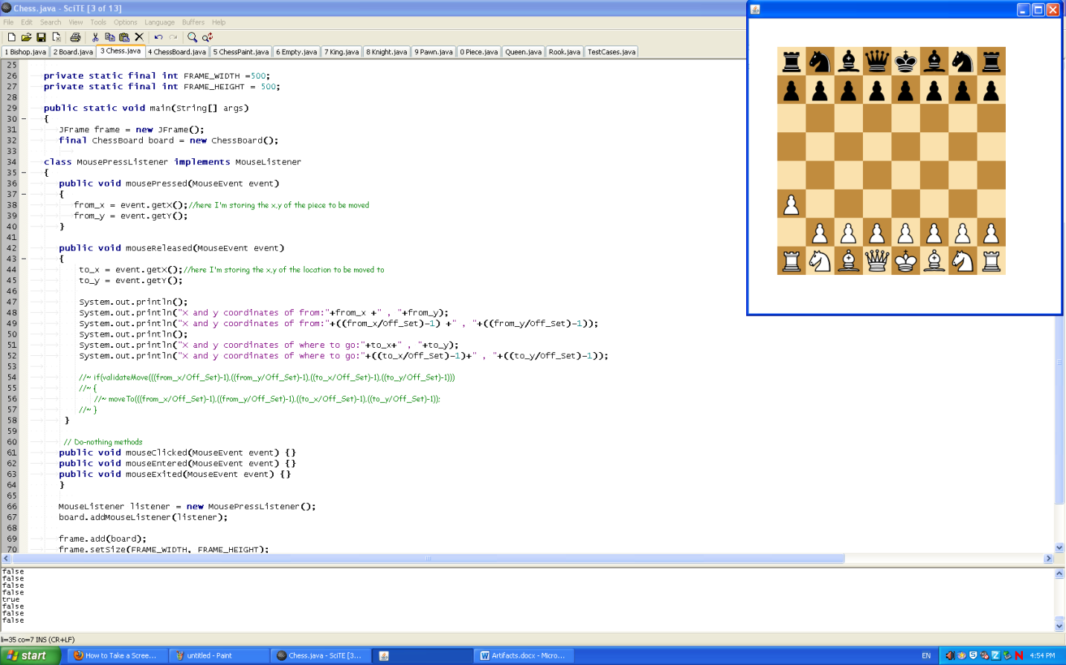
A project for CPSC 1181 which the user has to make a 2d chess board with chess rules implemented using Java based coding.
My Roles:
- Uses Java based coding.
- Java documentation.
- GUI of a 2d chess board which allows users to click and drag to move pieces.
- Chess rules: Movement of individual pieces.
Further increased knowledge of Java based coding and Object Oriented programming skills.
It also helped improved my GUI knowledge of primarily the mouse interface.
Located:

College Program
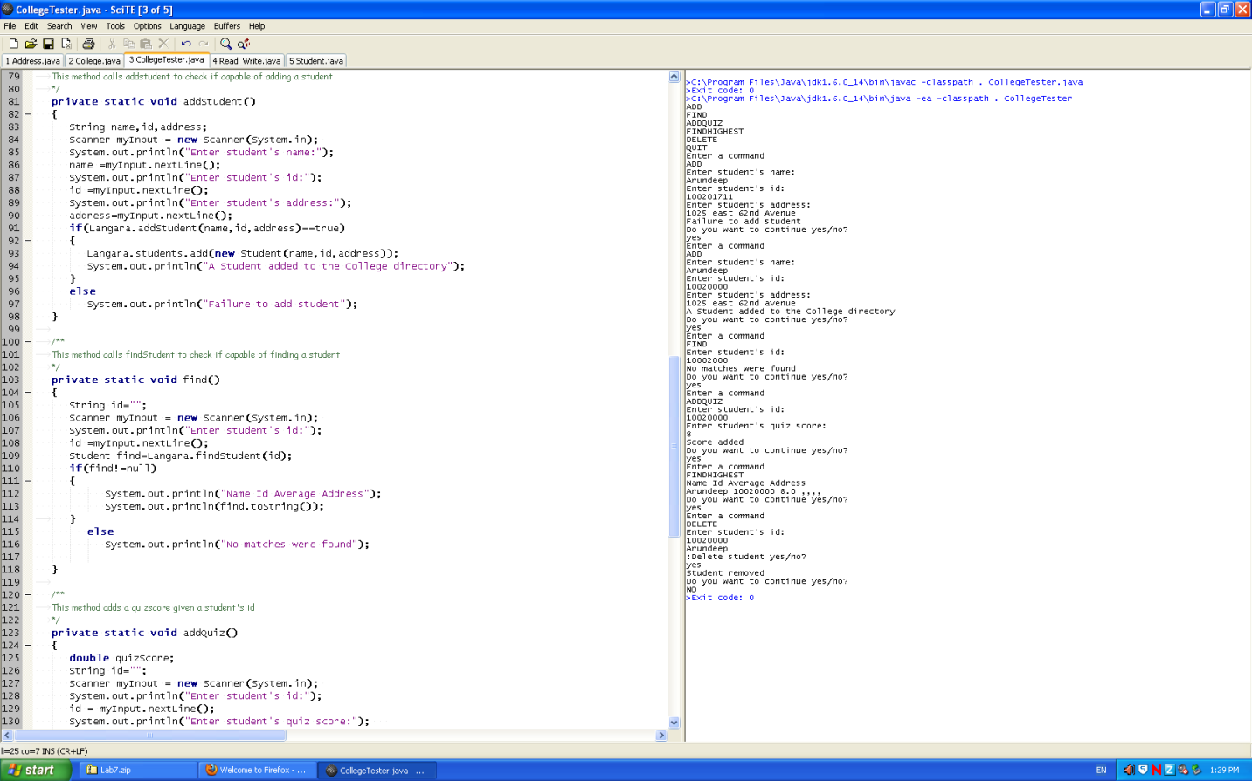
A project for CPSC 1181 used to add, find, add quiz scores or delete students from/to a database.
My Roles:
- Uses Java based coding.
- Java documentation.
- Input user commands from the keyboard and outputs proper information.
- General math skills.
- Multiple programs infused to form a bigger program(Object oriented programming).
Improved Java based coding and Object Oriented programming.
Located:

Polynomials
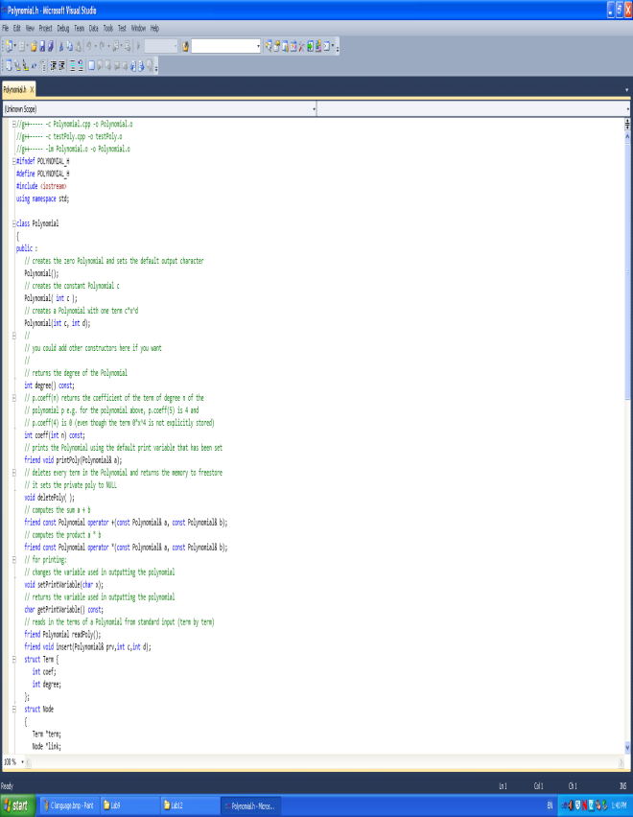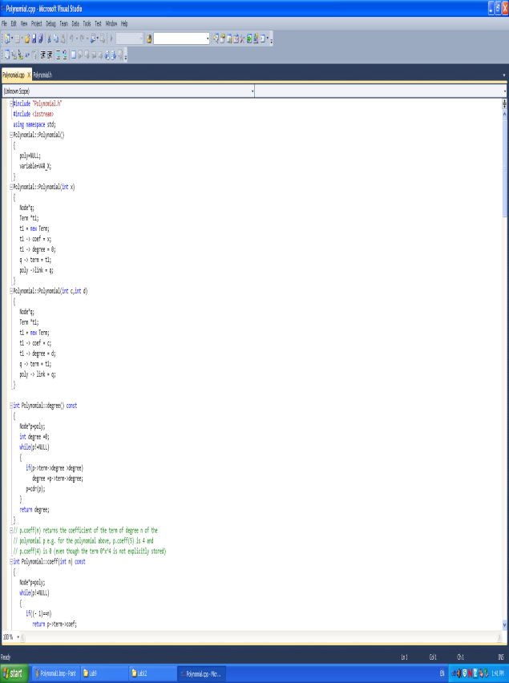

A project for CPSC 1160 dealing with Polynomials with Nodes.
My Roles:
- Uses C based coding.
- C documentation.
- Creates Polynomials based on input.
- Find coefficient, degree of Polynomials.
- Dealing with addition, multiplication between different Polynomials.
- Deleting and inserting Polynomials.
More knowledge using Nodes in C++.

Located:

Oracle

Used SQL commands to retrieve information from Oracle for a Lab in CPSC 2221.
My Roles:
- Used scripts to create tables.
- Used SQL commands to retrieve certain information.
Improved my usage of the Oracle database.
Located:

Animation Project
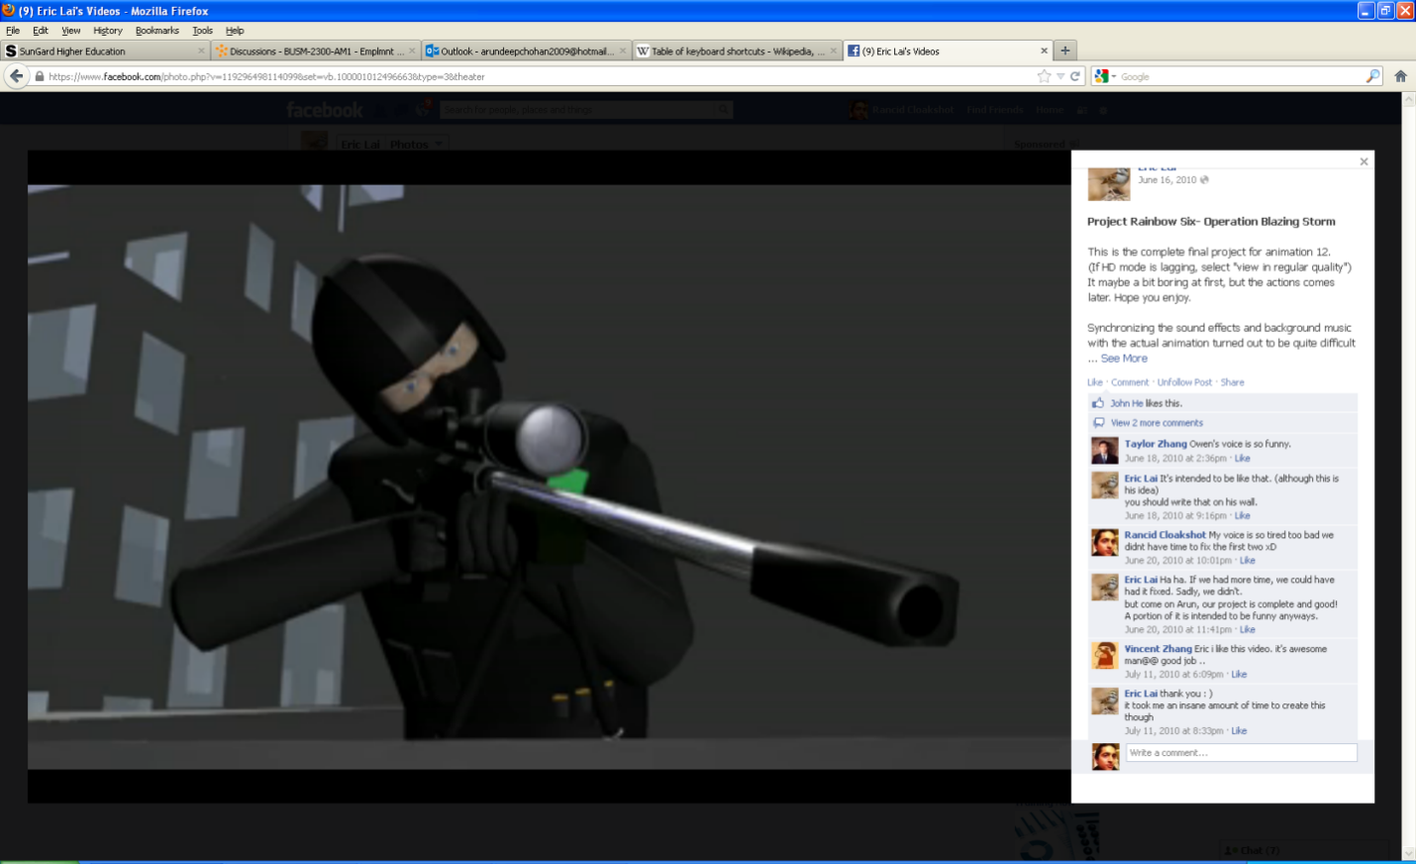
A group (2) video project for an animation course taught in high school.
My Roles:
- Voice recording from a variety of people.
- 3d modeling and animation.
- Sound effects.
Communication and teamwork skills were acquired from various interactions with voice actors and my partner to complete this project. Along with media and computer skills required to complete the project.
Located:
https://www.facebook.com/photo.php?v=119296498114099&set=vb.100001012496663&type=3&theater
Gunz Video Contest
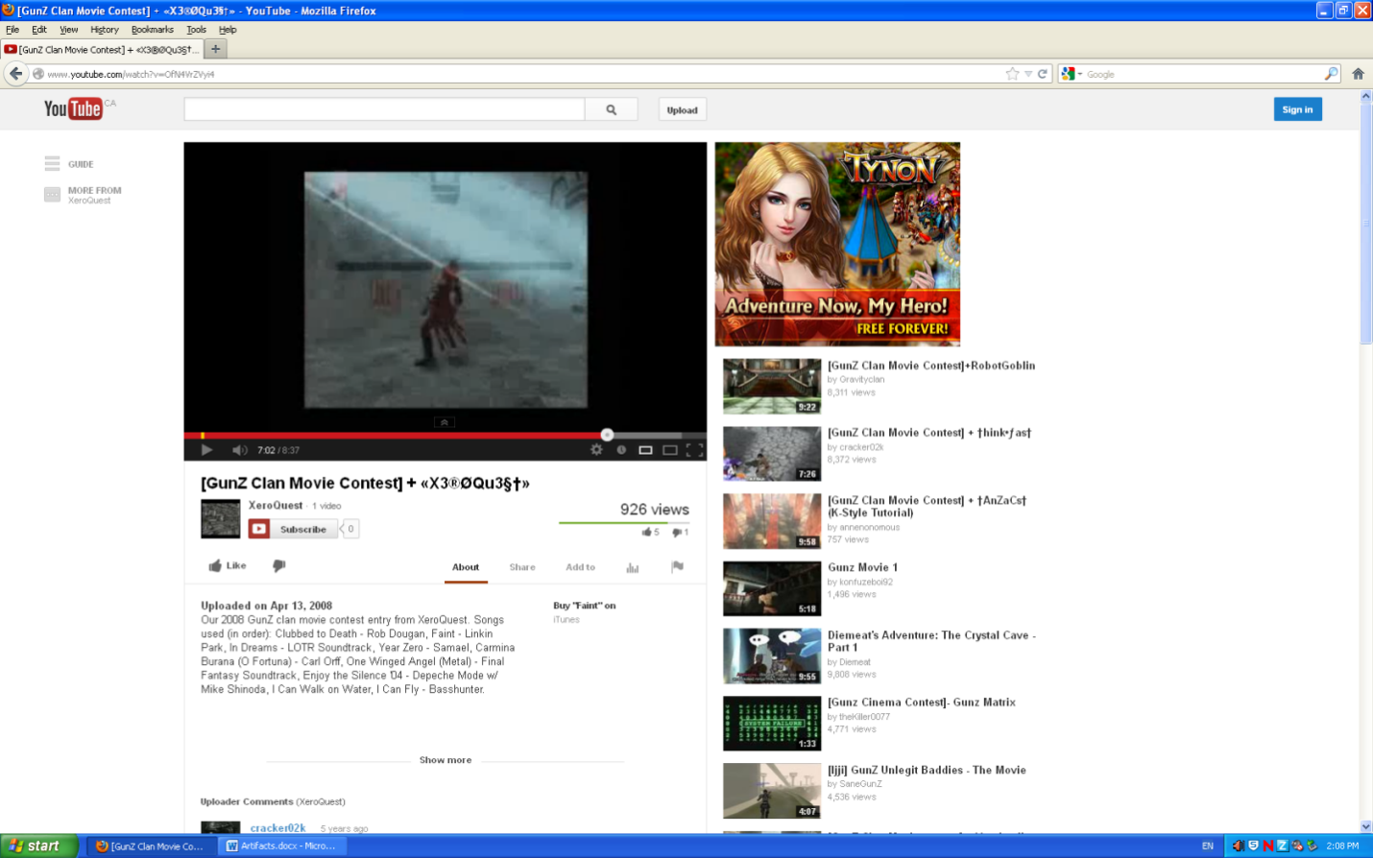
A Gunz Video Contest for 2008 with a gaming clan.
My Roles:
- Collect clips of in game footage(Gunz) and manage people to record.
Communication and Interpersonal skills were improved from group discussions. Time management was also improved as it was necessary to get everyone together to record.
Located:
www.youtube.com/watch?v=OfN4VrZVyi4

Ms Excel
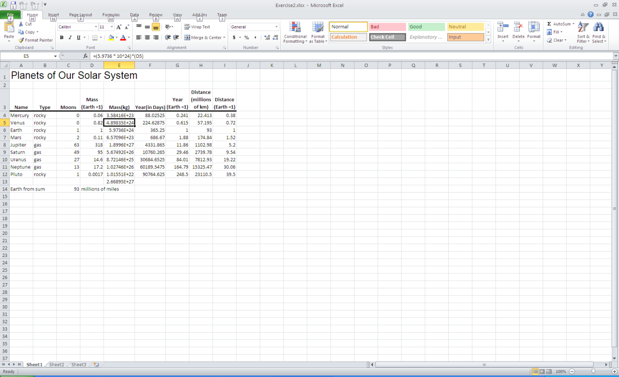
Demonstrating proficiency using Ms Excel to create charts or visual representation of data.
My Roles:
- Used formulas to effectively create a chart in Ms Excel.

Knowledge of using Excel to create spreadsheets.
Located:

