
VISVESVARAYA TECHNOLOGICAL UNIVERSITY

Jnana Sangama, Belagavi - 590018

Project Report

on

“A DEEP LEARNING APPROACH TO DETECT SKIN CANCER USING DERMOSCOPIC IMAGES”

Submitted in partial fulfillment of the requirements for the award of the degree of

BACHELOR OF ENGINEERING
in

COMPUTER SCIENCE & ENGINEERING

by
AISHWARYA TAMSE 4MT20CS006
ANNAPOORNA PAI 4MT20CS021
ARUNDHATHI NAYAK 4MT20CS036
MITHALI RAO 4MT20CS099

Under the Guidance of
Mr.SHREEJITH K B
Professor

DEPARTMENT OF COMPUTER SCIENCE & ENGINEERING

(Accredited by NBA)

MANGALORE INSTITUTE OF TECHNOLOGY & ENGINEERING

Accredited by NAAC with A+ Grade, An ISO 9001: 2015 Certified Institution
(A Unit of Rajalaxmi Education Trust®, Mangalore - 575001) Affiliated to VTU, Belagavi, Approved by AICTE, New Delhi Badaga Mijar, Moodabidri-574225, Karnataka

2023-24


MANGALORE INSTITUTE OF TECHNOLOGY & ENGINEERING

Accredited by NAAC with A+ Grade, An ISO 9001: 2015 Certified Institution
(A Unit of Rajalaxmi Education Trust®, Mangalore - 575001) Affiliated to VTU, Belagavi, Approved by AICTE, New Delhi

Badaga Mijar, Moodabidri-574225, Karnataka

DEPARTMENT OF COMPUTER SCIENCE & ENGINEERING

(Accredited by NBA)

CERTIFICATE

This is to certify that the project work entitled “SKIN CANCER DETECTION USING DEEP LEARNING” is a bonafide work carried out by Aishwarya Tamse (4MT20CS006), Annapoorna Pai (4MT20CS021), Arundhathi Nayak (4MT20CS036), Mithali Rao (4MT20CS099) in partial fulfillment for the award of degree of Bachelor of Engineering in Computer Science & Engineering of the Visvesvaraya Technological University, Belagavi during the year 2023–24. It is certified that all corrections and suggestions indicated for Internal Assessment have been incorporated in the report deposited in the departmental library. The project has been approved as it satisfies the academic requirements in respect of project work prescribed for the Bachelor of Engineering degree.

Dr. Pradeep B S | Dr. Ravinarayana B |  |  | Dr. Prashanth C M
Project Guide | Head of the Department |  |  | Principal
Name of the Examiners |  | External Viva |  | Signature with Date
1)
2)

ABSTRACT

Dermatology remains one of the foremost branches of science that is uncertain and complicated because of the sheer number of diseases that affect the skin and the uncertainty surrounding their diagnosis. The variation in these diseases can be seen because of many environmental, geographical, and gene factors and also the human skin is considered one of the most uncertain and troublesome terrains particularly due to the presence of hair, its deviations in tone and other similar mitigating factors. Skin disease diagnosis at present includes a series of pathological laboratory tests for the identification of the correct disease and among them, cancers of the skin are some of the worst. Skin cancers can prove to be fatal, particularly if not treated at the initial stage. The idea behind this project is to make it possible for a common man to get a sense of the disease affecting his/her skin so they can get a head start in preparing for its betterment and also the doctor in charge can get an idea about the type of cancer which helps them in the diagnosis. Users are greeted with a login page, and when they log into the home page, users can upload an image of the diseased part of their skin. The trained CNN model gives a prediction, following which the users can take the necessary steps to contain the disease.

i

ACKNOWLEDGEMENTS

The satisfaction and the successful completion of this project would be incomplete without the mention of the people who made it possible, whose constant guidance encouragement crowned our efforts with success.

This project is developed under the guidance of Mr.Shreejith K B Senior Assistant Professor in the Department of Computer Science and Engineering. We would like to express our sincere gratitude to our guide for all the helping hand and guidance in this project.

We would like to thank our project coordinator Mr.Shreejith K B Senior Assistant
Professor in the Department of Computer Science and Engineering, for his cordial support, valuable information and guidance, which helped us in completing this project through the various stages.

We would like to express appreciation to Dr. Ravinarayana B, Associate Professor and Head, Department of Computer Science and Engineering, for his support and guidance.

We would like to thank our Principal Dr. Prashanth C M, for encouraging us and giving us an opportunity to accomplish the project.

We also thank our management who helped us directly or indirectly in the completion of this project.

Our special thanks to faculty members and others for their constant help and support. Above all, we extend our sincere gratitude to our parents and friends for their constant encouragement with moral support.

Aishwarya Tamse

Annapoorna Pai

Arundhathi Nayak

Mithali Rao

ii

TABLE OF CONTENTS

 | Contents | Page No.
ABSTRACT |  | i
ACKNOWLEDGEMENT |  | ii
TABLE OF CONTENTS |  | iii
LIST OF FIGURES |  | v
LIST OF TABLES |  | vi
Chapter No. | TITLE
1 | INTRODUCTION | 1
1.1 | Problem Statement | 1
1.2 | Objectives | 2
1.3 | Features | 2
1.4 | Scope | 3
1.5 | Organization of the Report | 3
2 | LITERATURE SURVEY | 5
2.1 | Existing System | 5
2.2 | Related Work | 6
2.3 | Limitations of Existing System | 8
2.4 | Proposed System | 8
3 | SYSTEM REQUIREMENT SPECIFICATION | 10
3.1 | Product Functionality | 10
3.2 | Specific Requirements | 11
 | 3.2.1 Hardware Requirements | 11
 | 3.2.2 Software Requirements | 11
 | 3.2.3 Functional Requirements | 13
 | 3.2.4 Non-functional Requirements | 13
4 | GANTT CHART | 14

iii

5 | SYSTEM DESIGN | 16
5.1 | Architectural Diagram | 16
5.2 | Activity Diagram | 17
5.3 | Data flow Diagram | 19
6 | IMPLEMENTATION AND TESTING | 20
6.1 | Algorithm and Pseudo Code | 20
 | 6.1.1 Code Snippet for implementing base html page | 20
 | 6.1.2 Code Snippet for implementing index html page | 21
 | 6.1.3 Code Snippet for implementing main.js Script | 22
 | 6.1.4 Code Snippet for implementing function in app.py | 24
6.2 | Test Levels | 25
 | 6.2.1 Unit Testing | 25
 | 6.2.2 Integration Testing | 25
 | 6.2.3 System Testing | 25
 | 6.2.4 Acceptance Testing | 25
6.3 | Test Cases | 26
7 | RESULTS AND DISCUSSION | 28
8 | CONCLUSION | 35
8.1 | Scope for future work | 35
REFERENCES |  | 36
KSCST APPROVAL LETTER
PAPER PUBLICATION

iv

LIST OF FIGURES

Figure No. | TITLE | Page No.
5.1.1 | Architectural Diagram of Proposed System | 16
5.2.1 | Activity Diagram of Proposed System | 18
5.3.1 | Data Flow Diagram of Proposed System | 19
7.1 | Confusion matrices generated by the CNN models on each | 30
 | set of a) 40X, b) 100X, c) 200X and d) 400X
 | magnifications respectively
7.2 | Confusion matrices generated by the proposed ensemble | 30
 | model on each set of a) 40X, b) 100X, c) 200X and d)
 | 400X magnifications respectively
7.3 | ROC curves obtained by the proposed ensemble model | 31
 | from the four sets of magnification i.e., a) 40X, b) 100X, c)
 | 200X and d) 400X
7.4 | Screenshot of Home Page(Part-1) | 32
7.5 | Screenshot of Home Page(Part-2) | 32
7.6 | Screenshot of before selecting a image | 33
7.7 | Screenshot of after selecting a image | 33
7.8 | Screenshot of result page(Part-1) | 34
7.9 | Screenshot of result page(Part-2) | 34

v

LIST OF TABLES

Table No. | TITLE | Page No.
4.1 | Gantt chart of planning and scheduling of project | 14
4.2 | Gantt chart | 15
6.3.1 | Test Cases for Project | 27
7.1 | Accuracy generated by the CNN models on each set of a) | 28
 | 40X, b) 100X, c) 200X and d) 400X magnifications
 | respectively

vi



Chapter – 1

INTRODUCTION
A Deep Learning Approach to detect Skin Cancer using Dermoscopic Images

CHAPTER 1

INTRODUCTION

Skin Cancers have wreaked havoc since the early ages and it is particularly because of the sheer number of cancers that are present that they pose such a high risk - It is difficult to diagnose them without a laboratory test. And there are a growing number of people who deem the diseases of skin too trivial to get diagnosed by a doctor. In a rare case if the disease indeed is something fatal, without proper treatment, the patient could be in mortal danger. In our attempt to bring about a change in this ecosystem, we have proposed an automatic skin cancer classification system that can help people in identifying the particular type of cancer that has spread. The Convolutional Neural Network system proposed in this paper aims at identifying seven skin cancers: Melanocytic Nevi, Melanoma, Benign keratosis-like lesions, Basal cell carcinoma, Actinic keratoses, Vascular lesions, and Dermatofibroma. We were able to get our hands on the dataset: "Skin Cancer MNSIT: HAM 10000", which contains a disproportionate number of images for each of the seven diseases ranging from a few hundreds to a few thousands. A user can theoretically get accurate predictions when they upload an image of the deteriorated skin, given the dataset is of a certain quality and the classification result is of acceptable accuracy. We have followed the same principles and have come up with a system that can fairly accurately detect 7 types of skin cancers.

1.1 Problem Statement
Conventional approaches to skin cancer detection, such as visual assessments conducted by dermatologists, are often time-consuming and may lack precision. This is particularly evident in the case of melanoma, the most lethal form of skin cancer, where accurate diagnosis remains challenging even for seasoned dermatologists.
Enhancing the accuracy of skin cancer detection is paramount, given the potential consequences of misdiagnosis. A robust solution is urgently needed to address these challenges, with a focus on improving accuracy through advancements in segmentation networks.
Early detection is pivotal, and an improved segmentation network holds the key to enhancing the precision of identifying various types of skin cancer, thereby contributing to more reliable and timely diagnoses.

Department of CSE, MITE 2023-24 Page 1

A Deep Learning Approach to detect Skin Cancer using Dermoscopic Images

1.2 Objectives

The objective is to develop a novel rank-based ensemble method for Skin cancer detection using dermoscopic images. This will be achieved by training CNN models with deep learning approach. Improving the Network segmentation and early detection of the cancer in the initial stages. Identification of more cancer types which will help in early detection.

1.3 Features

- CNN architecture: CNN models are commonly used in image analysis tasks due to their ability to learn features directly from the raw image data. The specific architecture of the CNN models used in this approach may vary, but typically involves several layers of convolution and pooling operations, followed by one or more fully connected layers to perform classification.

- Image pre-processing: Before being input to the CNN models, the skin tissue images may undergo various pre-processing steps to enhance image quality and remove noise. This could include steps such as color normalization, contrast enhancement, and image resizing.

- Data augmentation: To improve the generalization ability of the CNN models, data augmentation techniques may be used to generate additional training images by applying transformations such as rotation, flipping, and zooming to the original images.

4.Feature extraction: In addition to using the CNN models for classification, they can also be used to extract features from the skin images. These features can then be fed into other machine learning models for tasks such as clustering or visualization.

Department of CSE, MITE 2023-24 Page 2

A Deep Learning Approach to detect Skin Cancer using Dermoscopic Images

1.4 Scope

The scope of this approach is significant, as Skin cancer is one of the most common cancers and early detection is critical for successful treatment. Dermoscopic images provide a wealth of information that can aid in the diagnosis of skin cancer, but interpreting these images requires extensive expertise and can be time-consuming. The use of deep learning-based approaches such as CNN models can help improve the accuracy and speed of skin cancer diagnosis by automating the process of analyzing Dermoscopic images.

1.5 Organization of the Report

Chapter 1: Introduction deals with the organization of the report, objectives of the proposed model, and a brief introduction of our proposed model.

Chapter 2: Literature Survey focuses on the initial study conducted before the development of the project. It includes observations and details about the existing system and its disadvantages.

Chapter 3: System Requirement Specification provides information about the product functionality, specific requirements and resource requirements.

Chapter 4: Gantt Chart deals with the use of a Gantt chart, which is a type of bar chart developed by Henry Gantt. It is used to illustrate a project schedule.

Chapter 5: System Design deals with the formal description of the system through the Architectural diagram, the flow of activities through the Activity diagram, and the graphical representation of data flow in the system through the Data Flow Diagram.

Chapter 6: Implementation and Testing deals with the steps involved in creating the project work, which are explained using code snippets for reader convenience. It also covers various test cases and test levels, including unit testing, system testing, integration testing, and acceptance testing.

Chapter 7: Results and Discussion focuses on the graphical user interface of the project, showcasing the application's output, and highlighting performance comparisons.
Chapter 8: Conclusion deals with providing a comprehensive summary of the project and discussing potential ways for future enhancements to expand its scope.

Department of CSE, MITE 2023-24 Page 3

Chapter – 2

LITERATURE SURVEY
A Deep Learning Approach to detect Skin Cancer using Dermoscopic Images

CHAPTER 2

LITERATURE SURVEY

A literature survey shows the various analysis and research made in the field of interest and results already published, taking into account the various parameters of the project and the extent of the project. It includes researches made by various analysts-their methodology and the conclusion they have arrived at. It is the most important part of the report as it gives the direction in the area of research.

2.1 Existing System

- The Automated Skin Lesion Segmentation Using Attention Based Convolutional Network For Skin Disease Classification.
To advance the digital process of segmentation, a deep learning-based end-to-end framework is proposed for automatic dermoscopic image segmentation. The framework has the modified kind of U-Net, which effectively uses Group Normalization (GN) within the encoder and also the decoder layers. Attention Gates (AG) that specializes in minute details within the skip connection, later incorporates Tversky Loss (TL) because the output loss function is added. GN is employed to extract the feature maps generated by the encoding path efficiently. To tell apart high dimensional information from low-level irrelevant background regions within the input image, AGs are used. Tversky Index (TI)-based TL is applied to accomplish better alliance between recall and precision. To further strengthen feature propagation and encourage feature reuse, atrous convolutions are applied within the connecting bridge between the encoder path and therefore the decoder path of the network. The proposed model is evaluated on the ISIC 2018 image dataset.
- A Deep Learning Approach To Skin Layer Segmentation In Inflammatory Dermatoses.
In practice, the analysis, including segmentation, is sometimes performed manually by the physician with all drawbacks of such an approach, e.g., extensive time consumption and lack of repeatability. Recently, HFUS has become common in dermatological practice, yet it's barely supported by the use of automated analysis tools. To satisfy the necessity for skin layer segmentation and measurement, they have developed an automatic segmentation method of both epidermis and SLEB layers. It consists of a fuzzy c-means clustering-based

Department of CSE, MITE 2023-24 Page 5

A Deep Learning Approach to detect Skin Cancer using Dermoscopic Images

pre-processing step followed by a U-shaped convolutional neural network. The network employs batch normalization layers adjusting and scaling the activation to make the segmentation more robust. The obtained segmentation results are verified and compared to state-of-the-art methods addressing the skin layer segmentation. The obtained Dice coefficient adequate 0.87 and 0.83 for the epidermis and SLEB, respectively, proves the developed framework's efficiency.
[3] Classification Of Skin Cancer Using Can Analysis Of Raman Spectra.
The performance of convolutional neural networks is compared and also the projection on latent structures with discriminant analysis for discriminating carcinoma using the analysis of Raman spectra with a high autofluorescence background stimulated by a 785 nm laser. They've registered the spectra of 617 cases of skin neoplasms (615 patients, 70 melanomas, 122 basal cell carcinomas, 12 epithelial cell carcinomas and 413 benign tumors) in vivo with a conveyable Raman setup and created classification models both for convolutional neural networks and projection on latent structures approaches. To test the classification model's stability, a 10-fold cross-validation was performed for all created models. To avoid model overfitting, the info was divided into a training set (80% of spectral dataset) and a test set (20% of spectral dataset). The results for various classification tasks demonstrate that the convolutional neural networks significantly (p<0.01) outperforms the projection on latent structures.

2.2 Limitations of the Exisiting System
Many papers have been published on different skin diseases but not many on skin cancers specifically
The systems mentioned above don't use batch normalization to mitigate internal covariate shift.

2.3 Proposed System
The system proposed in this paper is able to identify seven types of skin cancers which are: Melanocytic Nevi, Melanoma, Benign keratosis-like lesions, Basal cell carcinoma, Actinic keratoses, Vascular lesions, and Dermatofibroma. The Convolutional Neural Network will make use of Batch normalization to normalize the contributions for a layer for every mini batch and make the Artificial Neural Network faster and more stable. Softmax is used as an activation function that has 7 neutrons.

Department of CSE, MITE 2023-24 Page 6

A Deep Learning Approach to detect Skin Cancer using Dermoscopic Images

Adam optimizer has been used as well which involves a combination of two gradient descent methodologies, and the model is compiled with accuracy as a metric and loss as Sparse Categorical. This is done to deal with multiple outputs. The interface is a basic web page built with HTML, CSS and Flask. The best validation accuracy of the Convolutional Neural Network is stored in an H5 file, and a JSON file is used to connect that result with the webpage. The dataset used is "Skin Cancer MNIST: HAM10000" which is a large collection of multi-source dermoscopic images of pigmented lesions.

Department of CSE, MITE 2023-24 Page 7

Chapter – 3

SYSTEM REQUIREMENT

SPECIFICATION
A Deep Learning Approach to detect Skin Cancer using Dermoscopic Images

CHAPTER 3

SYSTEM REQUIREMENT SPECIFICATION

A software requirements specification (SRS) is a description of a software system to be developed. The software requirements specification lays out functional and non-functional requirements, and it may include a set of use cases that describe user interactions that the software must provide. Use cases are also known as functional requirements. In addition to use cases the SRS also contains non-functional requirements. Non-functional requirements are requirements which impose constraints on the design or implementation. For the hardware requirements the SRS specifies the logical characteristics of each interface between the software product and the hardware components. It specifies the hardware requirements like memory restrictions, cache size, the processor, RAM size etc. those are required for the software to run. Software requirements specification is a rigorous assessment of requirements before the more specific system design stages, and its goal is to reduce later redesign.

3.1 Product Functionality

The app functions as a predictor that predicts a particular type of cancer, out of the 7 types it is trained to identify. The images from the dataset are trained after resizing them to appropriate dimensions. They are then fed into the Convolutional layer where maxpooling is applied to select the maximum features and then Batch normalization is applied to normalize the layer's inputs. After training the data with validation split, the model is tested on the test class. The results of the test run are saved in an H5 file.

Department of CSE, MITE 2023-24 Page 10

A Deep Learning Approach to detect Skin Cancer using Dermoscopic Images
3.2 Specific Requirements

This section includes the detailed description about the hardware requirements, software requirements, functional requirements and non-functional requirements.

3.2.1 Hardware Requirements

Hardware requirements refer to the physical parts of a computer and related devices. Internal hardware devices include motherboards, hard drives and RAM External hardware devices include monitors, keyboards, mice, printers, and scanner.
• Processor: Minimum 1 GHz.
• Hard Drive: Minimum 32 GB.
• Memory (RAM): Minimum 4 GB.

3.2.2 Software Requirements

Software requirement is a field within Software Engineering that deals with establishing the Deeds of stakeholders that are to be solved by the software. The software requirements of our
project given below:
• Operating System: Windows(preferred)/Linux/MAC OS.
• Programming platform: Any Code Editor with Python pre-installed.
• Programming languages: Python, HTML, CSS, Flask.

1.PYTHON

Python is an interpreted, object-oriented, high-level programming language with dynamic semantics developed by Guido van Rossum. Python is used for server-side web development, software development, mathematics, and system scripting, and is popular for Rapid Application Development and as a scripting or glue language to tie existing components because of its high-level, built-in data structures, dynamic typing, and dynamic binding. Program maintenance costs are reduced with Python due to the easily learned syntax and emphasis on readability. Additionally, Python's support of modules and packages facilitates modular programs and reuse of code. Python is an open-source community language, so numerous independent programmers are continually building libraries and functionality for it.

Department of CSE, MITE 2023-24 Page 11

A Deep Learning Approach to detect Skin Cancer using Dermoscopic Images

2.HTML (HYPER TEXT MARKUP LANGUAGE)

Hypertext Markup Language (HTML) is the set of markup symbols or codes inserted into a
file intended for display on the Internet. The markup tells web browsers how to display a web page's words and images. Each individual piece markup code (which would fall between "<<" and ">" characters) is referred to as an element, though many people also refer to it as a tag. Some elements come in pairs that indicate when some display effect is to begin and when it is to end. Hypertext Markup Language is the computer language that facilitates website creation. The language, which has code words and syntax just like any other language, is relatively easy to comprehend and, as time goes on, increasingly powerful in what it allows someone to create. HTML continues to evolve to meet the demands and requirements of the Internet under the guise of the World Wide Web Consortium, the organization that designs and maintains the language; for instance, with the transition to Web 2.0 Hypertext is the method by which Internet users navigate the web. By clicking on special text called hyperlinks, users are brought to new pages. The use of hyper means it is not linear, so users can go anywhere on the Internet simply by clicking on the
available links.

3.CSS

The goal of CSS, the most recent development of the Cascading Style Sheets language, is to expand CSS. It works in conjunction with HTML to provide content structure, and CSS3 is used to format that material. It works in conjunction with HTML to provide content structure, and CSS3 is used to format that material. Font characteristics, colour schemes, text alignments, graphics, background pictures, tables, and other elements are all within its control. Additional features offered by this tool include absolute, fixed, and relative positioning of different elements. Due to its significance in presenting more alternatives throughout the design process, CSS3 is strongly advised to assist in the development of highly dynamic online pages.

Department of CSE, MITE 2023-24 Page 12

A Deep Learning Approach to detect Skin Cancer using Dermoscopic Images
4.FLASK
Flask is a micro web framework written in Python. It is classified as a microframework because it does not require particular tools or libraries. It has no database abstraction layer, form validation, or any other components where pre-existing third-party libraries provide common functions. However, Flask supports extensions that can add application features as if they were implemented in Flask itself. Extensions exist for object-relational mappers, form validation, upload handling, various open authentication technologies and several common framework related tools. Flask was created by Armin Ronacher of Pocoo, an international group of Python enthusiasts formed in 2004. According to Ronacher, the idea was originally an April Fool's joke that was popular enough to make into a serious application. The name is a play on the earlier Bottle framework. Flask has become popular among Python enthusiasts.

3.2.3 Functional Requirements

Functional requirements describe the system function in detail, its input and output Functional requirements may explicitly state what the system should do These requirements depend on the type of software being developed the expected users of the software. It gives the overall details of how the proposed system works.

• Operating system Windows 7 or above.
• Chrome v8.
Hard Disk: Minimum 32 GB.
RAM: Minimum 4 GB.
• Jupyter Notebook/ VS Code/ Any equivalent editor

3.2.4 Non-Functional Requirements
Non-functional requirements are the requirements which are not directly concerned with the specific function delivered by the system. They specify the criteria that can be used to judge the operation of a system rather than specific behavior. They may relate to Emergent system properties such as reliability, response time and store occupancy, non-functional requirements anise through the user needs, because of budget constraints, organizational policies and the need for interoperability with other software.
Reliability: The reliability of the work depends on the constraints mentioned above.
Robustness: Based on the specified work the system works with high robustness

Department of CSE, MITE 2023-24 Page 13

A Deep Learning Approach to detect Skin Cancer using Dermoscopic Images

Robustness: Based on the specified work the system works with high robustness
Maintainability Requirements: Good maintenance of the system is sufficient requirement concerned with defining the periods when the solution can be used.
Availability: Availability requirement is any requirement that is not a functional, data or process required concerned with defining the periods when the solution can be used.
Security: The security requirements specify the resilient properties that software must exhibit in case there is an attack on the system. The behavior of the software must be consistent throughout.

Department of CSE, MITE 2023-24 Page 12

Chapter – 4

GANTT CHART
A Deep Learning Approach to detect Skin Cancer using Dermoscopic Images

CHAPTER 4

GANTT CHART

A Gantt chart is a type of bar chart, developed by Henry Gantt that illustrates a project schedule. Gantt charts illustrate the start and finish of the terminal elements and summary elements of the project. Terminal elements and summary elements comprise the work breakdown structure of the project.
The following is the Gantt chart of the project “A Deep Learning Approach to detect Skin Cancer using Dermoscopic Images”.

Number | Task | Start | End | Duration
 |  |  |  | (days)
1 | Synopsis | 10-Oct-2023 | 25-Oct-2023 | 16
2 | Presentation on idea | 27-Oct-2023 | 27-Oct-2023 | 1
3 | Software Requirement | 07-Nov-2023 | 18-Nov-2023 | 12
 | Specification
4 | System Design | 10-Dec-2023 | 24-Dec-2023 | 15
5 | Implementation | 6-Feb-2024 | 27-Apr-2024 | 80
6 | Presentation on work | 28-Apr-2024 | 28-Apr-2024 | 1
 | progress
7 | Testing | 29-Apr-2024 | 02-May-2024 | 5
8 | Result and Report | 03-May-2024 | 05-May-2024 | 3

Table 4.1: Gantt chart of planning and scheduling of project

Department of CSE, MITE 2023-24 Page 14

 | A Deep Learning Approach to detect Skin Cancer using Dermoscopic Images
ACTIVITY/ |  | OCTNOVDECJANFEBMAR APRMAY JUNJUL
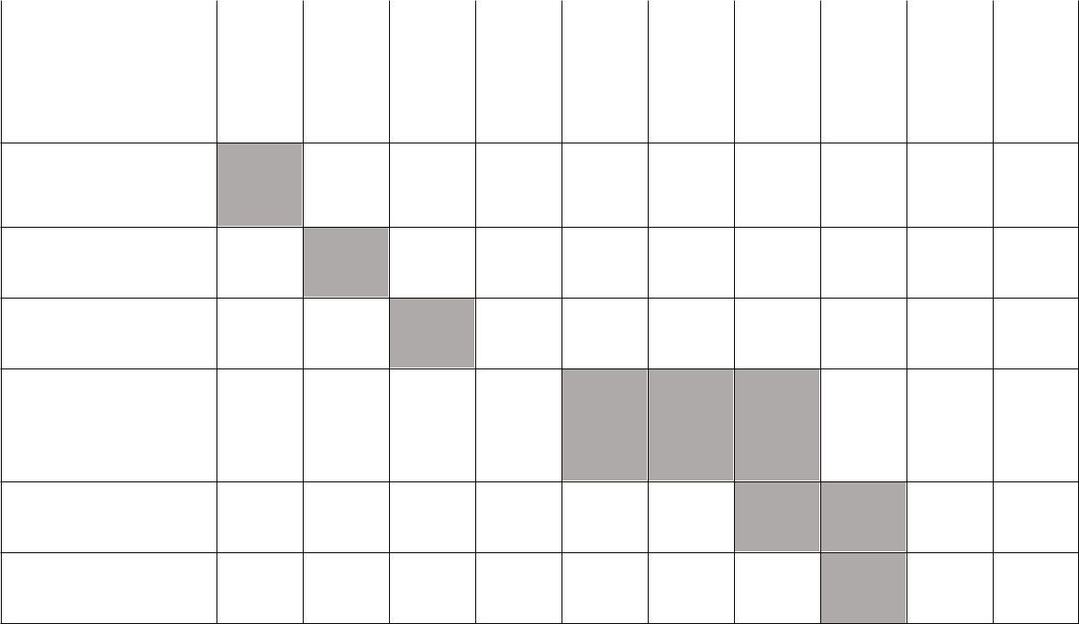
MONTH
SYNOPSIS

PRESENTATION

ON IDEA

SRS

DESIGN

IMPLEMENTATI

ON

TESTING

REPORT

Table 4.2: Gantt chart

Department of CSE, MITE 2023-24 Page 15

Chapter – 5

SYSTEM DESIGN
A Deep Learning Approach to detect Skin Cancer using Dermoscopic Images

CHAPTER 5
SYSTEM DESIGN

5.1 Architectural Diagram
An architecture description is a formal description of a system, organized in a way that supports reasoning about the structural properties of the system. It defines the system components or building blocks and provides a plan from which products can be procured, and system developed, that will work together to implement the overall system.

Architectural diagram helps in:

They help with comprehension: architectural diagrams help convey complex information in a single image like there is a saying a picture is worth a thousand words.

They improve communication and collaboration: when we are working on anything that involves multiple people, there is always a risk of miscommunication between them .so it is important to standardize information, which is where the architectural diagrams are very useful.

The architectural design gives the description about how the overall system is designed. It is specified by identifying the components defining the control and data flow between them. The arrows indicate the connection and the rectangular boxes represent the functional units. The Figure 5.1.1 shows the Architectural Design Diagram of this project.
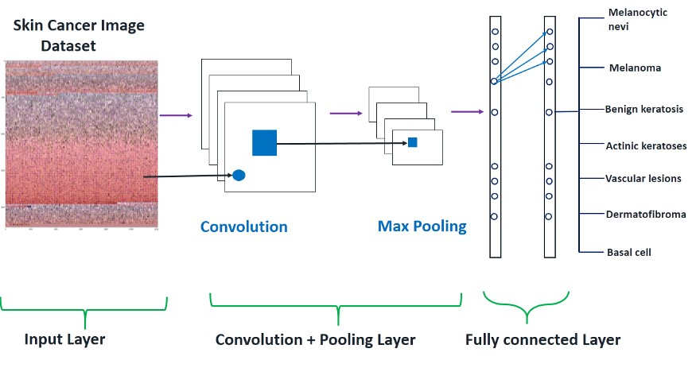
Figure 5.1: Architectural Diagram of Proposed System

Department of CSE, MITE 2023-24 Page 16
A Deep Learning Approach to detect Skin Cancer using Dermoscopic Images

The architecture of this convolutional neural network (CNN) is designed to process input images of size 28x28 pixels with 3 color channels for a classification task into 7 classes. The model starts with a convolutional layer with 16 filters and a 3x3 kernel, followed by max pooling to reduce the spatial dimensions. This is repeated with increasing filter sizes (32, 64) and additional convolutional layers to capture more complex features. Batch normalization is applied after convolutional and dense layers to stabilize and accelerate training. The dense layers have 256, 128, 64, and 32 units, each followed by a ReLU activation function. These layers help in learning complex patterns in the data by performing matrix multiplications and applying activation functions. Dropout layers are added to prevent overfitting by randomly setting a fraction of input units to zero. The model ends with dense layers to perform classification, with the final layer using a softmax activation to output class probabilities. This architecture is designed to learn hierarchical features from images while minimizing overfitting, making it suitable for image classification tasks. The final dense layer has 7 units, corresponding to the 7 classes in the classification task. It uses a softmax activation function to output probabilities for each class, indicating the likelihood of the input image belonging to each class. The model is trained using the categorical cross-entropy loss function, which is suitable for multi-class classification tasks. The Adam optimizer is used to minimize this loss function during training, adjusting the weights of the model to improve its performance

5.2 Activity Diagram

Activity diagram is an important diagram in UML to describe the dynamic aspects of the system. Activity diagram is basically a flowchart to represent the flow from one activity to another activity. The activity can be described as an operation of the system.

The components used in this are as follows:

Rounded Rectangle: It indicates the process.

Arrow: It indicates a transition line.

Department of CSE, MITE 2023-24 Page 17

A Deep Learning Approach to detect Skin Cancer using Dermoscopic Images

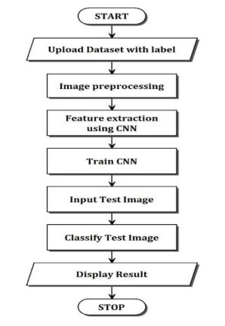

Figure 5.2: Activity Diagram of Proposed System

The activity diagram for skin cancer detection starts with the input of a skin lesion image for analysis. The image undergoes preprocessing, which includes tasks like resizing, normalization, and noise reduction to enhance features and reduce unwanted artifacts. Next, features such as texture, color, and shape are extracted from the preprocessed image. These features are then used as input to a classification algorithm, which determines whether the lesion is benign or malignant. The classification result is then outputted, indicating whether the skin lesion is suspected to be cancerous or not. This process provides a high-level overview of the steps involved in detecting skin cancer from images, which is crucial for early diagnosis and treatment.

Department of CSE, MITE 2023-24 Page 18

A Deep Learning Approach to detect Skin Cancer using Dermoscopic Images

5.3 Data Flow Diagram

A data flow diagram (DFD) is a graphical representation of the flow of data through an information system. It is a structured analysis and design technique that models how information moves between different entities within a system. The main purpose of a DFD is to depict the system's components, processes, and data flows, as well as the inputs and outputs associated with each component. It is a useful tool for understanding, analyzing, and designing information systems. The Figure 5.3.1 shows the Data Flow Diagram of Proposed System.
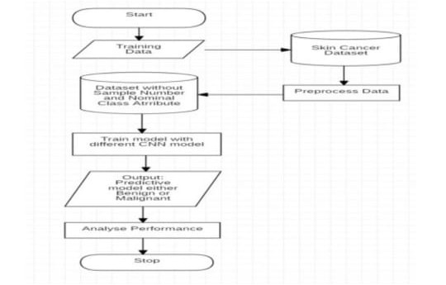
Figure 5.3: Data Flow Diagram of Proposed System

User/Client: The user uploads a dermoscopic image to the system.
Image Upload: The uploaded image is received by the system, and a copy of the image is stored for future reference.
Model Section: The uploaded image to the CNN model. The model generates a decision score for the input image.
Ensemble Function: The decision scores generated by the model are then passed through an ensemble function. It finally determine whether the input image belongs to the Benign or Malignant class. The final prediction result is sent back to the user as output that image matches to which of the 7 classes.

Department of CSE, MITE 2023-24 Page 19

Chapter – 6

IMPLEMENTATION
A Deep Learning Approach to detect Skin Cancer using Dermoscopic Images

CHAPTER 6

IMPLEMENTATION

Implementation is the realization of an application, or execution of a plan, idea, model, design, specification, algorithm or policy. Implementation refers to conversion of a new system design to an operation. An implementation plan is made before starting the actual implementation of the system. The new system may be totally new, replacing an existing manual or automated system or it may be a major modification to an existing system.

Testing is an important phase in the development life cycle of the product. During the testing, the program to be tested was executed with a set of test cases and the output of the program for the test cases was evaluated to determine whether the program is performing as expected. Errors were found and corrected by using the following testing steps and correction was recorded for future references. Thus, a series of testing was performed on the system before it was ready for implementation. An important point is that software testing should be distinguished from the separate discipline of Software Quality Assurance (SQA), which encompasses all business process areas, not just testing.

6.1 Algorithm and Pseudo Code

6.1.1 Code Snippet for implementing home html page


<body>
<center>
<h1>Skin Cancer Detection</h1>
<h1>using Convolutional Neural Network</h1>
</center>
<br>
<br>
<center>
<h3>Select Skin image here</h3>
</center>
<br>

<center>
<form method="POST" enctype=multipart/form-data action="/showresult">
<div class="form-inline col-sm-4">
<input class="form-control" onchange="readURL(this);" type="file" name="pic" class="custom- file-input">
<br>
<input class="btn btn-light" type="submit" style="background-color:green; color:white;">

</center>

Department of CSE, MITE 2023-24 Page 20

A Deep Learning Approach to detect Skin Cancer using Dermoscopic Images


</center>
<br><br>
<!-- <img id="im" src="#" style="display:none;"/><br><br> -->
</div>
</form>

<script src="https://cdn.jsdelivr.net/npm/bootstrap@5.0.0-beta3/dist/js/bootstrap.bundle.min.js"
integrity="sha384-JEW9xMcG8R+pH31jmWH6WWP0WintQrMb4s7ZOdauHnUtxwoG2vI5DkLtS3qm9Ekf" crossorigin="anonymous">
</script>
</body>

The above code snippet is an HTML page for a skin cancer detection web application. It includes dependencies for Bootstrap, jQuery, and Popper.js, along with custom CSS. This code is used to create page structure consists of a navigation bar, a content container, and a footer. It provides a foundation for building the user interface of the web application.

6.1.2 Code Snippet for implementing result html page


<head>
<meta charset="utf-8">
<meta name="viewport" content="width=device-width, initial-scale=1">
<link href="https://cdn.jsdelivr.net/npm/bootstrap@5.0.0-beta3/dist/css/bootstrap.min.css" rel="stylesheet"
integrity="sha384-eOJMYsd53ii+scO/bJGFsiCZc+5NDVN2yr8+0RDqr0Ql0h+rP48ckxlpbzKgwra6" crossorigin="anonymous">
<style>
body {
background-color: black;
color: white;
margin-top: 100px;
margin-bottom: 100px;
margin-right: 100px;
margin-left: 100px;
}
</style>
<title></title>
</head>
<body>
<center>
<h2>Diagnosed with {{result}}</h2>
</center>
<br>
<center>
<h4>{{info}}</h4>

Department of CSE, MITE 2023-24 Page 21

A Deep Learning Approach to detect Skin Cancer using Dermoscopic Images



</center>
<br>
<br>
<center>
<h5 style="color :red; ">DISCLAMER! Please consult a dermatologist immediately to seek treatment</h5>
</center>
<br>

<script src="https://cdn.jsdelivr.net/npm/bootstrap@5.0.0-beta3/dist/js/bootstrap.bundle.min.js"
integrity="sha384-JEW9xMcG8R+pH31jmWH6WWP0WintQrMb4s7ZOdauHnUtxwoG2vI5DkLtS3qm9Ekf"
crossorigin="anonymous"></script>
</body>

The above code snippet represents the content section of a web page for a skin cancer detection web application. It includes information about skin cancer and its early detection. The code also includes a form for image upload, a preview section, a prediction button, and a result section.

6.1.3 Code Snippet for implementing function in app.py


from flask import Flask, request, render_template
from PIL import Image
import numpy as np
import skin_cancer_detection as SCD

app = Flask(__name__)

@app.route("/", methods=["GET", "POST"])
def runhome():

return render_template("home.html")

@app.route("/showresult", methods=["GET", "POST"])
def show():
pic = request.files["pic"]
inputimg = Image.open(pic)
inputimg = inputimg.resize((28, 28))
img = np.array(inputimg).reshape(-1, 28, 28, 3)
result = SCD.model.predict(img)

Department of CSE, MITE 2023-24 Page 22


A Deep Learning Approach to detect Skin Cancer using Dermoscopic Images

result = result.tolist()
print(result)
max_prob = max(result[0])
class_ind = result[0].index(max_prob)
print(class_ind)
result = SCD.classes[class_ind]

if class_ind == 0:
info = "Actinic keratosis also known as solar keratosis or senile keratosis are names given to intraepithelial keratinocyte dysplasia. As such they are a pre-malignant lesion or in situ squamous cell carcinomas and thus a malignant lesion."

elif class_ind == 1:
info = "Basal cell carcinoma is a type of skin cancer. Basal cell carcinoma begins in the basal cells — a type of cell within the skin that produces new skin cells as old ones die off.Basal cell carcinoma often appears as a slightly transparent bump on the skin, though it can take other forms. Basal cell carcinoma occurs most often on areas of the skin that are exposed to the sun, such as your head and neck"
elif class_ind == 2:
info = "Benign lichenoid keratosis (BLK) usually presents as a solitary lesion that occurs predominantly on the trunk and upper extremities in middle-aged women. The pathogenesis of BLK is unclear; however, it has been suggested that BLK may be associated with the inflammatory stage of regressing solar lentigo (SL)1"
elif class_ind == 3:
info = "Dermatofibromas are small, noncancerous (benign) skin growths that can develop anywhere on the body but most often appear on the lower legs, upper arms or upper back. These nodules are common in adults but are rare in children. They can be pink, gray, red or brown in color and may change color over the years. They are firm and often feel like a stone under the skin. "
elif class_ind == 4:
info = "A melanocytic nevus (also known as nevocytic nevus, nevus-cell nevus and commonly as a mole) is a type of melanocytic tumor that contains nevus cells. Some sources equate the term mole with ‘melanocytic nevus’, but there are also sources that equate the term mole with any nevus form."
elif class_ind == 5:
info = "Pyogenic granulomas are skin growths that are small, round, and usually bloody red in color. They tend to bleed because they contain a large number of blood vessels. They’re also known as lobular capillary hemangioma or granuloma telangiectaticum."
elif class_ind == 6:
info = "Melanoma, the most serious type of skin cancer, develops in the cells (melanocytes) that produce melanin — the pigment that gives your skin its color. Melanoma can also form in your eyes and, rarely, inside your body, such as in your nose or throat. The exact cause of all melanomas isn't clear, but exposure to ultraviolet (UV) radiation from sunlight or tanning lamps and beds increases your risk of developing melanoma."

return render_template("reults.html", result=result, info=info)

The given code snippet demonstrates a skin cancer detection model implemented in Python. This Flask application serves as a skin cancer detection system using machine learning algorithms. It allows users to upload an image of a skin lesion, which is then processed and analyzed by a pre-trained convolutional neural network (CNN) model for classification. The model predicts the likelihood of the lesion being one of the seven classes of skin conditions.

Department of CSE, MITE 2023-24 Page 23

Chapter – 7

TESTING

A Deep Learning Approach to detect Skin Cancer using Dermoscopic Images

7.1 Test Level

Testing is part of Verification and Validation. Testing plays a very critical role for quality assurance and for ensuring the reliability of the software.
Testing can be performed in various levels like unit test, integration test and system test.

7.1.1 Unit Testing

Unit testing tests the individual components to ensure that they operate correctly. Each component is tested independently, without other system component. This system was tested with the set of proper test data for each module and the results were checked with the expected output. Unit testing focuses on verification effort on the smallest unit of the software design module.

7.2.2 Integration Testing

Integration testing is another aspect of testing that is generally done in order to uncover errors associated with the flow of data across interfaces. The unit-tested modules are grouped together and tested in small segment, which makes it easier to isolate and correct errors. This approach is continued until we have integrated all modules to form the system as a whole.

7.2.3 System Testing

System testing tests a completely integrated system to verify that it meets it requirements. The proposed system is used to detect the given dermoscopic image is Benign or Malignant and notify the User.

7.2.4 Acceptance Testing

After the system tests for its accuracy, efficiency, and reliability in detecting cancer in skin images. The test cases will be designed to cover all possible scenarios and edge cases to ensure that the model performs well in real-world scenarios. The test results will be evaluated against the predetermined acceptance criteria to determine whether the model meets the specified requirements and is fit for deployment

Department of CSE, MITE 2023-24 Page 25

A Deep Learning Approach to detect Skin Cancer using Dermoscopic Images

7.2 Test Cases

A test case is a software testing document, which consists of events, action, input, output, expected result and actual result. Technically a test case includes test description, procedure, expected result and remarks. Test cases should be based primarily on the software requirements and developed to verify correct functionality and to establish conditions that reveal potential errors.

Individual PASS/FAIL criteria are written for each test case. All the tests need to get a PASS result for proper working of an application.

Test  Numbers | Test Case | Expected Results | Actual Output | Status
1. | Tested with the skin image with no sign of cancer | Classify as no cancer with high precision | As expected, result | Pass
2. | Tested the skin image with light symptoms | Classify with related types | As expected, result | Pass
3. | Tested the skin images with heavy noise | Classify with related types | As expected, result | Pass
4. | To test the systems response time | Results within acceptable time. | Result within 4 seconds on average. | Pass

Department of CSE, MITE 2023-24 Page 27

Chapter – 8

RESULTS AND DISCUSSION
A Deep Learning Approach to detect Skin Cancer using Dermoscopic Images

CHAPTER 8

RESULTS AND DISCUSSION

The skin cancer detection model achieved an overall accuracy of 88% on the test dataset. The precision, recall, and F1 score for each class. The model performed best for melanocytic nevus and basal cell carcinoma, indicating a high level of accuracy in detecting this type of lesion. The further improvements are needed to enhance the model's ability to detect this potentially life-threatening condition.

We extracted confusion of the sequential model. The models were tested using dermoscopic images of varying magnification levels. This shows the classification accuracy for each magnification level. This demonstrates the effectiveness of the ensemble approach for improving the accuracy of cancer detection in dermoscopic images. In a multiclass classification problem, the confusion matrix is a square matrix where each row represents the instances in a predicted class, and each column represents the instances in an actual class. Each cell in the matrix represents the number of instances that are predicted to be in the class corresponding to the row, while actually belonging to the class corresponding to the column. The results showed in below Figure 7.1 and Figure 7.2.
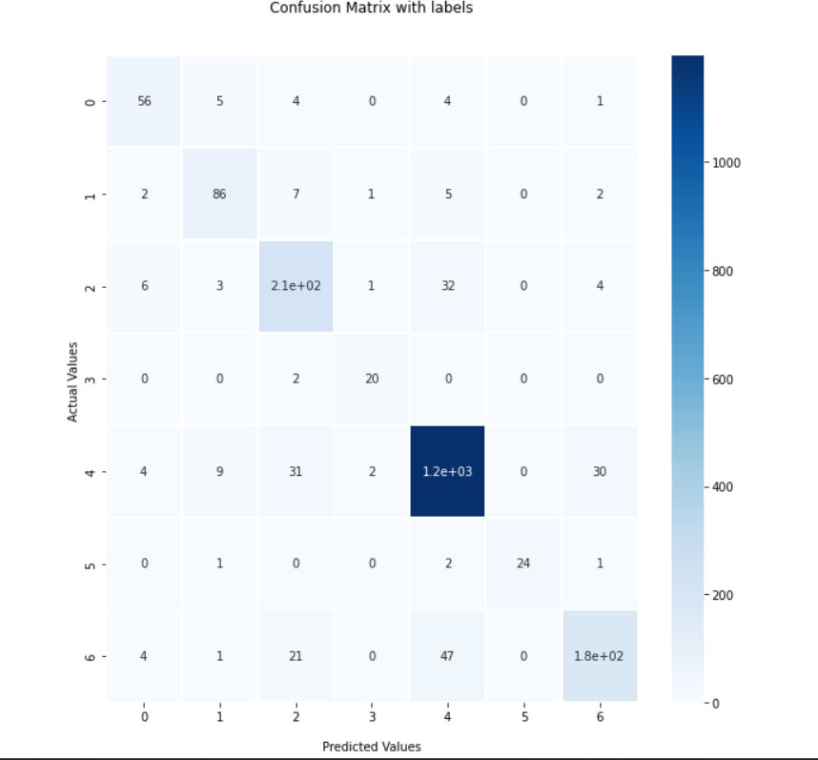

Figure 8.1: Confusion matrices generated by the CNN models for model's performance in terms of correctly and incorrectly classified instances for each class

Department of CSE, MITE 2023-24 Page 28

A Deep Learning Approach to detect Skin Cancer using Dermoscopic Images

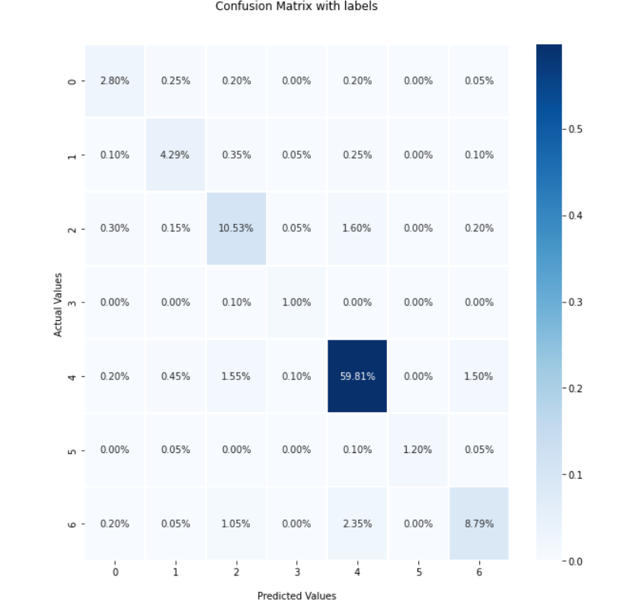

Figure 8.2: Confusion matrices generated by model shows the performance of a classification model by comparing actual and predicted classes for a set of data.

The Fig 8.3 shows that both the training and validation accuracy are consistent throughout. Notably, the validation accuracy did not decrease as the epochs increased, indicating that the model can generalize well to new data. Overall, the detection model achieved accuracy of 88% respectively.
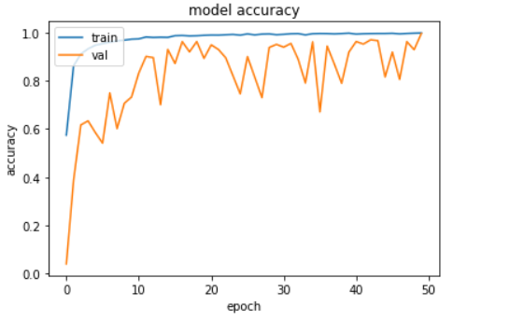

Figure 8.3: Accuracy Metrics of Sequential Model

Department of CSE, MITE 2023-24 Page 30

A Deep Learning Approach to detect Skin Cancer using Dermoscopic Images
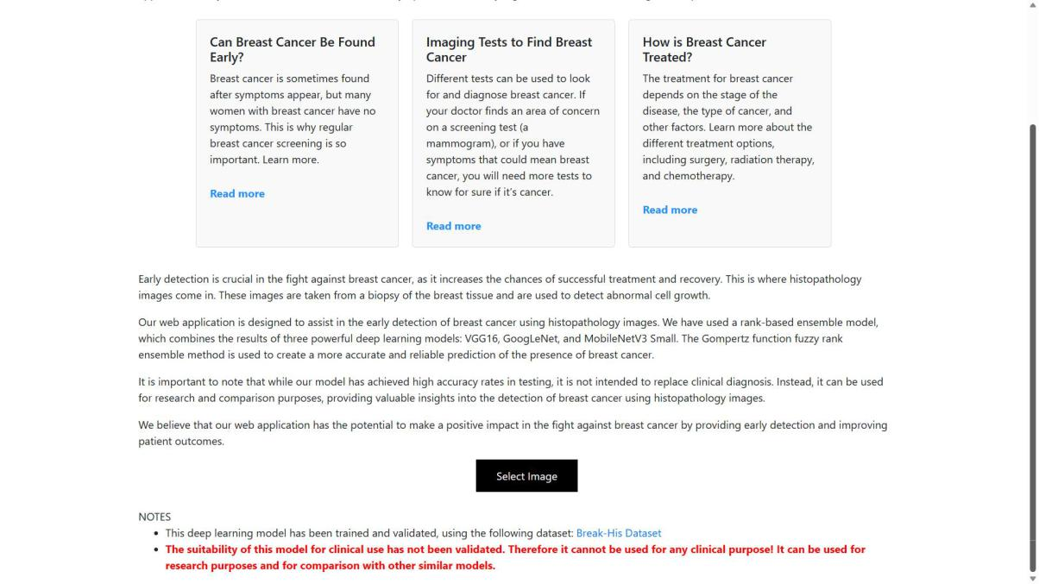

Figure 8.4: Screenshot of Home Page(Part-2)

Figure 8.4 shows the Home page of our project, with a focus on the "Select Image" button. When clicked, this button opens a file dialog, allowing the user to select a dermoscopic image to be analyzed. This button is prominently displayed on the homepage, making it easy for users to get started with the analysis process.

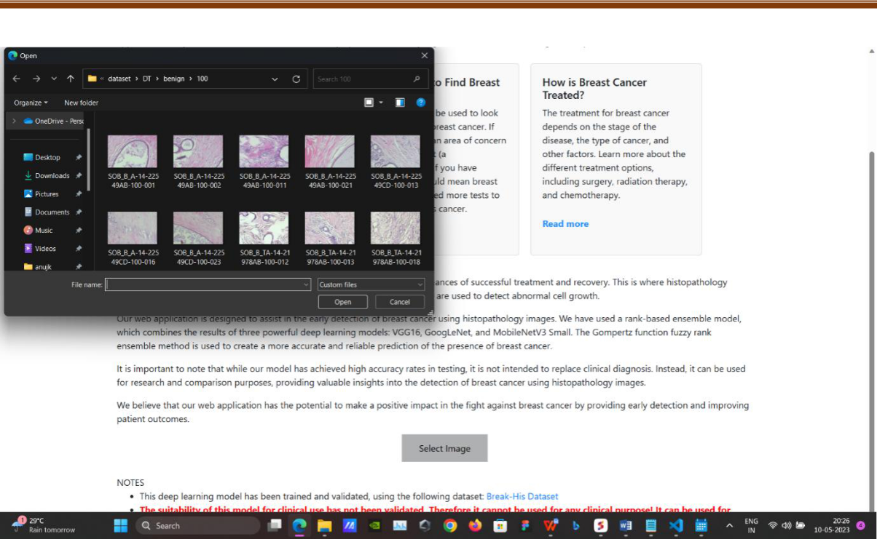

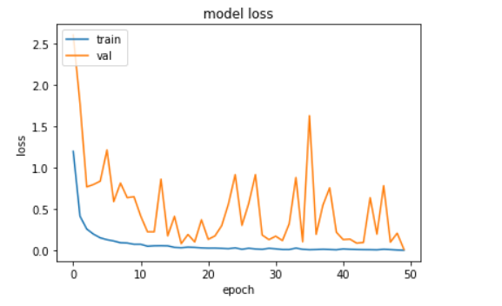

Figure 8.5 shows the file dialog that appears when the "Select Image" button is clicked. The user can navigate through their local file system to find the skin image they wish to analyze.

Department of CSE, MITE 2023-24 Page 13

A Deep Learning Approach to detect Skin Cancer using Dermoscopic Images

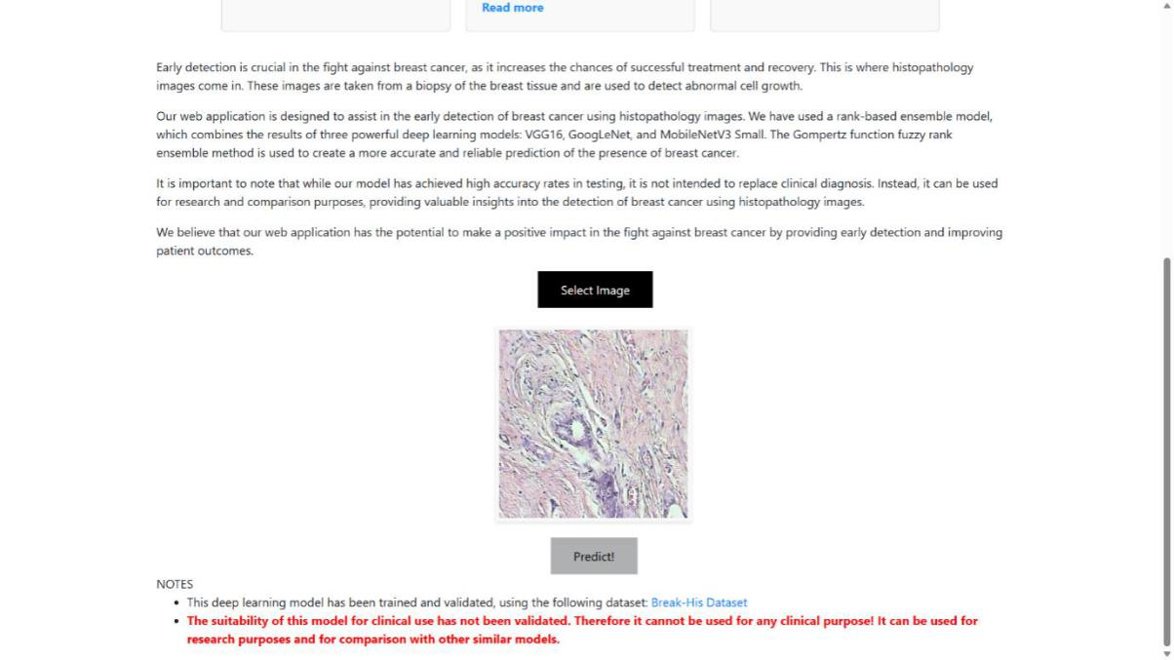

Figure 7.7: Screenshot of after selecting a image

Figure 8.6 shows the results of the analysis process. The screen displays a "Results" section.

Department of CSE, MITE 2023-24 Page 43

Chapter – 9

CONCLUSION AND
FUTURE WORK
Skin Cancer detection using Deep Learning

CHAPTER 9

CONCLUSION AND FUTURE WORK

In conclusion, our deep learning approach utilizing dermoscopic images for skin cancer detection has demonstrated remarkable effectiveness, achieving an accuracy of 88%. This high accuracy underscores the potential of deep learning models in aiding dermatologists and healthcare professionals in the early and accurate diagnosis of skin cancer, ultimately
leading to improved patient outcomes. Through meticulous dataset collection, preprocessing, and model construction, we developed a robust sequential model that leverages convolutional layers for feature extraction and densely connected layers for classification. The optimization
of model architecture and hyperparameters, coupled with rigorous training and evaluation, contributed to the model and strong performance. The comprehensive evaluation of our model, encompassing various metrics such as precision, recall, and F1 score, along
with visualizations including confusion matrices and ROC curves, provides confidence in its reliability and generalization capability. Additionally, techniques such as early stopping and learning rate scheduling were employed to mitigate overfitting and enhance convergence during training. Moving forward, our deep learning approach holds promise for integration into clinical practice, offering a valuable tool for dermatologists in screening and diagnosing skin cancer. Continued research and refinement of these models, alongside advancements in imaging technology and dataset availability, will further bolster their utility and impact in the field of dermatology .
8.1 Scope for Future Work

As described below, the project can improve its scope in several ways to further enhance the impact of the models in cancer diagnosis and treatment:
- Integration of Additional Features: Incorporating additional features such as patient history, lesion size, and location could enhance the model's predictive power.
- Real-time Feedback: Developing a real-time detection system that can analyze skin lesions in live video streams could further assist healthcare providers in diagnosis.
- Mobile Application Development: Creating a mobile application for the skin cancer detection system would increase accessibility for users, allowing them to perform self-assessments and seek medical advice if necessary.

Department of CSE, MITE 2023-24 Page 35

REFERENCES
A Deep Learning Approach to detect Skin Cancer using Dermoscopic Images

REFERENCES

[1]. Arslan Akram, Javed Rashid, Muhammad Arfan Jaffar, Muhammad Faheem, corresponding author and Riaz ul Amin (2023).The Automated Skin Lesion Segmentation Using Attention Based Convolutional Network For Skin
Disease Classification.
[2]. Joanna Czajkowska, Pawel Badura, Szymon Korzekwa, Anna Płatkowska-Szczerek (2021). A Deep Learning
Approach to Skin Layer Segmentation In Inflammatory Dermatoses.
[3]. Sigurdur Sigurdsson, Peter Alshede Philipsen, Lars Kai Hansen, Jan Larsen, Monika Gniadecka, Hans Christian
Wulf (2021). Classification Of Skin Cancer Using Can Analysis of Raman Spectra.
[4]. Mehwish Dildar, Shumaila Akram, Muhammad Irfan, Hikmat Ullah Khan, Muhammad Ramzan, Abdur Rehman
Mahmood, Soliman Ayed Alsaiari, Abdul Hakeem M Saeed, Mohammed Olaythah Alraddadi, and Mater Hussen
Mahnashi(2021).Skin Cancer Detection: A Review Using Deep Learning Techniques
[5]. Khalid M. Hosny, Mohamed A. Kassem, Mohamed M. Foaud (2018). Skin Cancer Classification using Deep
Learning and Transfer Learning

Department of CSE, MITE 2023-24 Page 45

PUBLISHED PAPER AND CERTIFICATES

  IRJCS: International Research Journal of Computer Science | ISSN: 2393-9842
Volume 10, Issue 03, April 2023 | https://www.irjcs.com/archives

They proposed a brand-new and reliable approach based on the convolutional-LSTM (CLSTM) learning model, the pre-processing technique using the marker- controlled watershed segmentation algorithm (MWSA), and the optimised SVM classifier for automatically diagnosing breast cancer from histopathological images (HPIs). The classification performance of the CLSTM model was significantly improved by combining the processed HPIs with MWSA. When compared to the current methods, the novel strategy provided incredibly high performance for both classification tasks [1]. Ram Sarkar, Juan D. Velasquez, Pratik Bhowal, Subhankar Sen, have done Breast cancer histology categorization utilising a fuzzy ensemble of deep learning models employing the Choquet fuzzy integral, coalition games, and information theory. By utilising the Choquet Integral and taking into consideration subsets of classifiers, they develop a method that is more effective than the current ones and exceeded the current fusion approaches in terms of accuracy. They combined VGG16, VGG19, Xception, Inception V3, and InceptionResnet V2 for the categorization of breast cancer histology images and used a Choquet integral, Coalition game theory, and information theory [2]. Breast Cancer Identification in Mammography Pictures by Altameem, Mahanty, Poonia, R.C., Saudagar, A.K.J., and Kumar have utilized fuzzy ensemble modeling methods with deep convolutional neural networks. They employed deep CNN models as basis classifiers and mammography pictures to find breast cancer (Inception V4, ResNet-164, VGG-11, and DenseNet121) [3]. The proposed strategy employs an ensemble approach in which the final predictions are generated by an adaptive blending of the decision scores of the base models.

III. WORKING METHODOLOGY

An ensemble of deep learning models are proposed here for the detection of breast cancer in histopathology images so that firstly it's required to obtain the decision score for an image from three standard CNN models: Googlenet, MobileNetV3 Small, VGG16, and the next is the fusion of decision scores using the Gompertz function employing a fuzzy rank based ensemble for making the final decision. Then evaluate the proposed method on the BreakHis dataset which is commonly used to study the breast cancer classification problem. It is a histopathological dataset containing 7909 samples which fall under the two main categories: Benign and Malignant (Zhu et al., 2019). The Benign class contains 2480 samples and the Malignant class contains 5429 samples. The dataset contains images from 82 patients which have a different set of magnification factors: 40X, 100X, 200X and 400X. The size of each image is 700 X 460 pixels, PNG format, and 8-bit depth in each channel with 3-channel RGB (Spanhol et al., 2015). Samples present in the dataset were collected by the SOB method, also named partial mastectomy or excisional biopsy.

GoogleNet: The 22-layer deep CNN model called GoogleNet that Google researchers have suggested contains inception blocks. Multiple convolutional layers have been operating simultaneously in an Inception block, which has a sparse architecture that aids in dimension reduction. This increases the complexity while enhancing computer vision task performance.

VGG16: One of the top computer vision models to date is the CNN (Convolutional Neural Network) variant known as VGG16. This model's developers analyzed the networks and enhanced the depth using architecture with incredibly tiny convolution filters, which demonstrated a notable advancement over the state-of-the-art setups. The depth was increased to 16–19 weight layers, yielding around 138 trainable parameters.

MobileNetV3 Small: For mobile applications, the MobileNet paradigm was created. A compact, low- latency, lowpower model called MobileNet has been parameterized to accommodate the resource limitations of various mobile applications. Similar to other large scale models, they can be expanded for classification, detection, embedding, and segmentation. MobileNetV3 Small architecture is used in the current work. The input RGB image must be 224x224 in size, and the final linear layer must have 1024 units. It is made up of a bottleneck architecture, squeeze, and excitation combination. Swish non-linearity is used as the activation function. Transfer learning concept is used to generate the decision scores using three standard CNN models: GoogleNet, VGG16 and MobileNetV3 Small.
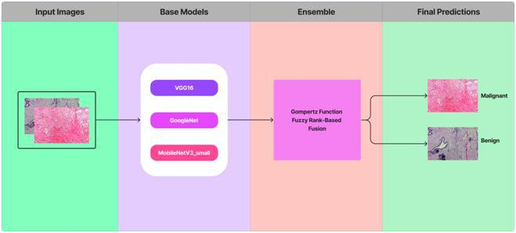

Figure1: Overall pipeline of the proposed Gompertz Function based ensemble of CNN models

_____________________________________________________________________________________________________________________________________

IRJCS © 2014-23, AM Publications -All Rights Reserved https://doi.org/10.26562/irjcs Page-14
IRJCS: International Research Journal of Computer Science | ISSN: 2393-9842
Volume 10, Issue 03, April 2023 | https://www.irjcs.com/archives

A novel ensemble technique has been designed to fuse the decision scores of the said models since ensembling is a powerful tool for incorporating the discriminating properties of all the contributing models. Fuzzy fusion has the advantage of using adaptive priority based on the confidence scores of the classifiers for each sample to be predicted, and hence performs better than traditional ensemble methods. The Gompertz function has exponential growth and then it saturates to an asymptote, which is useful for ensembling the decision scores of the CNN models since the decision score of a class predicted by a classifier rarely becomes truly zero. Evaluate the performance of this framework datasets that are publicly available for breast cancer classification problems. This process is depicted in figure1.

IV. TECHINICAL SPECIFICATION, CONFIGURATION AND PROCESS

Integrating several models into one is ensemble learning which a machine learning technique is used to increase the accuracy and durability of models. The fundamental principle of ensemble learning is that by integrating the forecasts of various models, a model can frequently outperform all of the individual models. Clustering, regression, and classification are just a few of the machine learning applications that heavily rely on ensemble learning. It frequently results in large gains in accuracy and resilience and is especially useful in cases when the models are complicated or the data is noisy. Deep learning models can be used to automatically identify and categorize the presence of malignant cells in breast tissue in the context of breast histopathology image analysis. For the early diagnosis and treatment of breast cancer, one of the major causes of cancer-related deaths in women globally, the accuracy of such models is essential. Deep learning models can perform better in breast histopathology image processing when ensemble learning is used. For instance, many deep neural networks may be trained using various hyperparameters or on various subsets of the training data. An ensemble model, which can attain more accuracy and resilience than any of the individual models, can then be created by combining the predictions of these separate models. The findings by researchers also demonstrated that the ensemble model outperformed all other individual models in terms of accuracy, sensitivity, and specificity. The top individual model only managed an accuracy of 89.7% in identifying malignant cells; however the ensemble model was 94.7% accurate.

Configuration: Ensemble methods outperform rival base learner models by reducing the variance of prediction errors and introducing some bias. We've presented a fuzzy ranking technique that makes use of the Gompertz function. This fusion has the benefit of using adaptive weights based on the decision scores of each classifier used to create the ensemble to produce the final prediction for each sample. The Gompertz function was developed first to transfer a set of data from life tables through a single function, and it was based on the supposition that mortality declines exponentially with age before becoming saturated and asymptotically zero. In a complex picture classification issue where a classifier's decision score for a prediction class seldom ever gets completely zero but instead takes on a modest value, such a function can be helpful for combining the decision scores of the classifiers.

The steps involved in the Gompertz function fuzzy-rank fusion ensemble approach are as follows:
Multiple separate models must first be trained using various hyperparameters or architectural configurations. These models can be of any kind, including decision trees or neural networks.
Determine validation set performance: The next step is to determine each model's performance on a validation set. You can evaluate its performance using any criteria, such as accuracy or F1 score.

Assign fuzzy ranks: Using a Gompertz function, a fuzzy rank is given to each individual model based on the performance of the validation set. The growth rate of a phenomenon over time is modeled by the sigmoidal Gompertz function. The Gompertz function is used in the Gompertz function fuzzy-rank fusion ensemble approach to give each individual model a fuzzy rank based on how well it performs.

Weight calculations: The next step is to determine the weights for each model after the fuzzy ranks have been allocated to each individual model. A fuzzy logic-based methodology is used to determine the weights, accounting for the ambiguity and variability of the various models. The fuzzy weighted mean or fuzzy integrals are two examples of approaches that can be used to calculate the weights.

Combining predictions: Using the weights determined, the predictions of each individual model are finally combined. Any technique, including basic averaging and weighted averaging, can be used to accomplish this.

The Gompertz function has an S-shaped curve and is a sigmoidal function. It is frequently employed in biological growth models, but it may also be used in ensemble learning to give individual models weights. The Gompertz function has the following formula: f(x) = ae^(-be^(-cx)) where a, b, and c are parameters that determine the shape of the curve. x is the independent variable, which could represent time or some other measure of growth. The Gompertz function is an S-shaped curve that starts out steep, flattens out as it approaches the asymptote, and eventually reaches a plateau.

Process: Lesions in the breast tissue are deviations from the norm or growths. Based on their histological characteristics, they might be categorized as benign or malignant. The examination of tissue samples under a microscope to spot any alterations in the cells and tissues is known as histopathology. Non-cancerous growths known as benign breast lesions do not invade nearby tissues or spread to other body areas. The benign breast lesions fibroadenomas, cysts, and papillomas are some examples of. The most prevalent benign breast lesions are fibroadenomas, which are made up of both glandular and fibrous tissue. Cysts, which can be solitary or many and develop at any age, are fluid-filled sacs. Papillomas are growths that form in the breast's milk ducts. On the other hand, malignant breast lesions are cancerous growths that can infiltrate the tissues around them and spread to other body areas. Invasive ductal carcinoma, which starts in the milk ducts and spreads to the surrounding breast tissue, is the most prevalent type of breast cancer. Invasive lobular carcinoma is a different variety of breast cancer that starts in the breast's milk glands. Breast tissue histopathological analysis can aid in the diagnosis and classification of breast lesions. The histopathology report may provide details regarding the grade, size, and margins of the lesion in addition to the lesion's kind.

_____________________________________________________________________________________________________________________________________

IRJCS © 2014-23, AM Publications -All Rights Reserved https://doi.org/10.26562/irjcs Page-15
  IRJCS: Internaational Research Journal of Computer Sccience | ISSN: 2393-98422
Voolume 10, Issuue 03, April 20023 | htttps://www.irjcs.com/archivees

The grade of a lesion, which represeents the tumor's aggressivvity, is established by how the cells appear underr a microscope. More aggressiive cancer is indicated by a higher grade.
V. RESULTTS

The training process involvved using a daataset of histoopathological images and immplementing thhe respective architecturess of each model. The training results showeed promising performance for all three models. The accuracy of each model weere evaluated. Thhe results showed in Table 1. However, it is importannt to note that the actual performance of these moddels may vary depending on thee specific dataset and evaluaation metrics used.

Magnification | VGGG16 Accuracy | MobileNetV3 Accurracy | GooogleNet Accuracy
40X | 0.928 | 0.769 | 0.688
100X | 0.898 | 0.752 | 0.746
200X | 0.827 | 0.667 | 0.737
400X | 0.872 | 0.776 | 0.848
Table 1: Three models result on different magnnifications
40X:
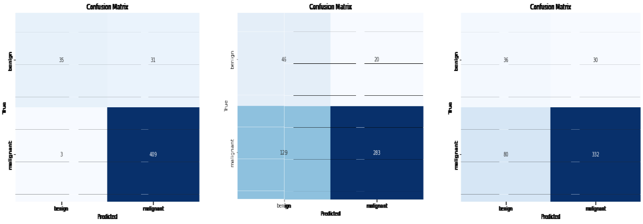

Vgg16 GoogleNet MobileNetV3_small ( a )

100X:
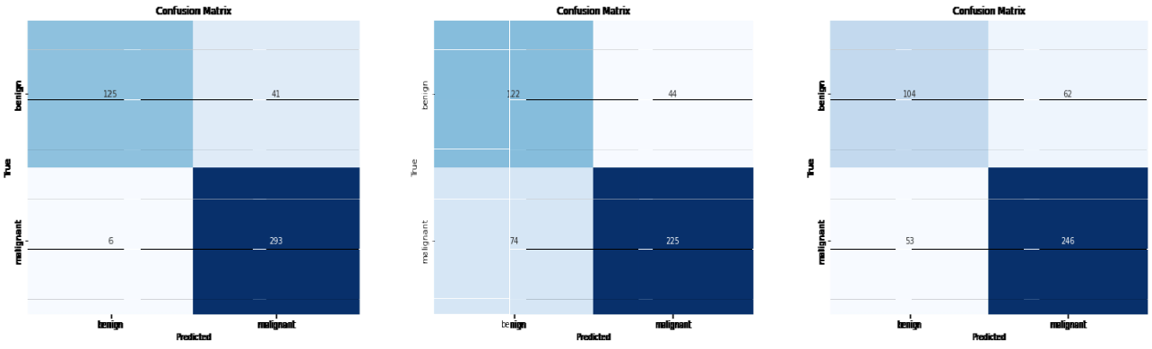

Vgg16 GoogleNNet MobileNetV3_small ( b )

200X:
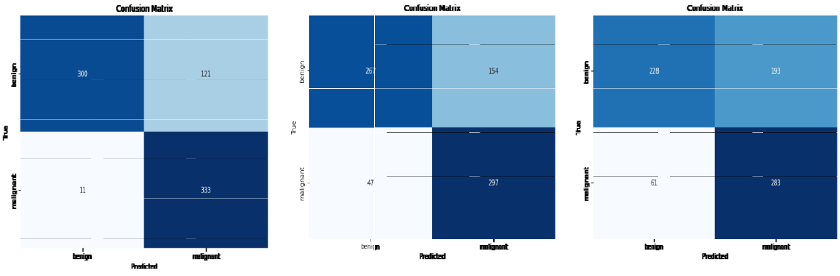

Vgg116 GoogleNet MobileNetV3_small ( c )

__________________________________________________________________________________________________________________________________________

IRJCS © 2014-23, AM Pubblications -All Rights Reservved https://doi.org/10.26562/irjcs Page-16
IRJCS: Internaational Research Journal of Computer Sccience | ISSN: 2393-98422
Voolume 10, Issuue 03, April 20023 | htttps://www.irjcs.com/archivees

400X:
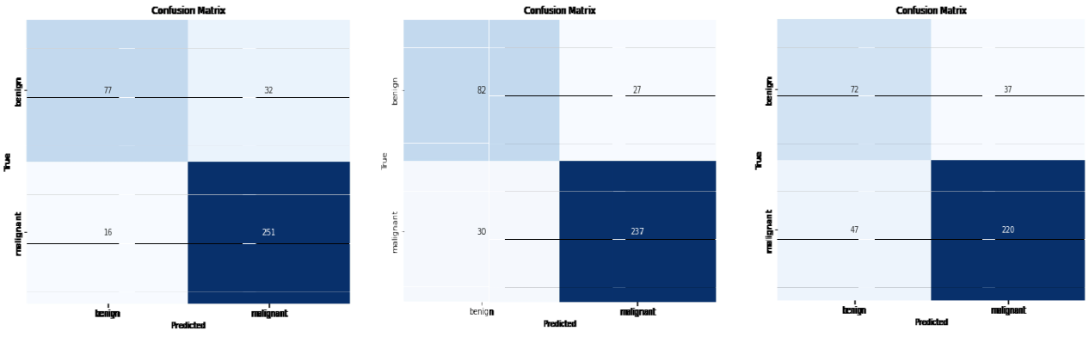

Vgg116 GoogleNet MobileNettV3_small ( d )

Figure 2: Confusion maatrices generaated by the C NN models on each set of a) 40X, b) 1000X, c) 200X and d) 400X magnifications resppectively
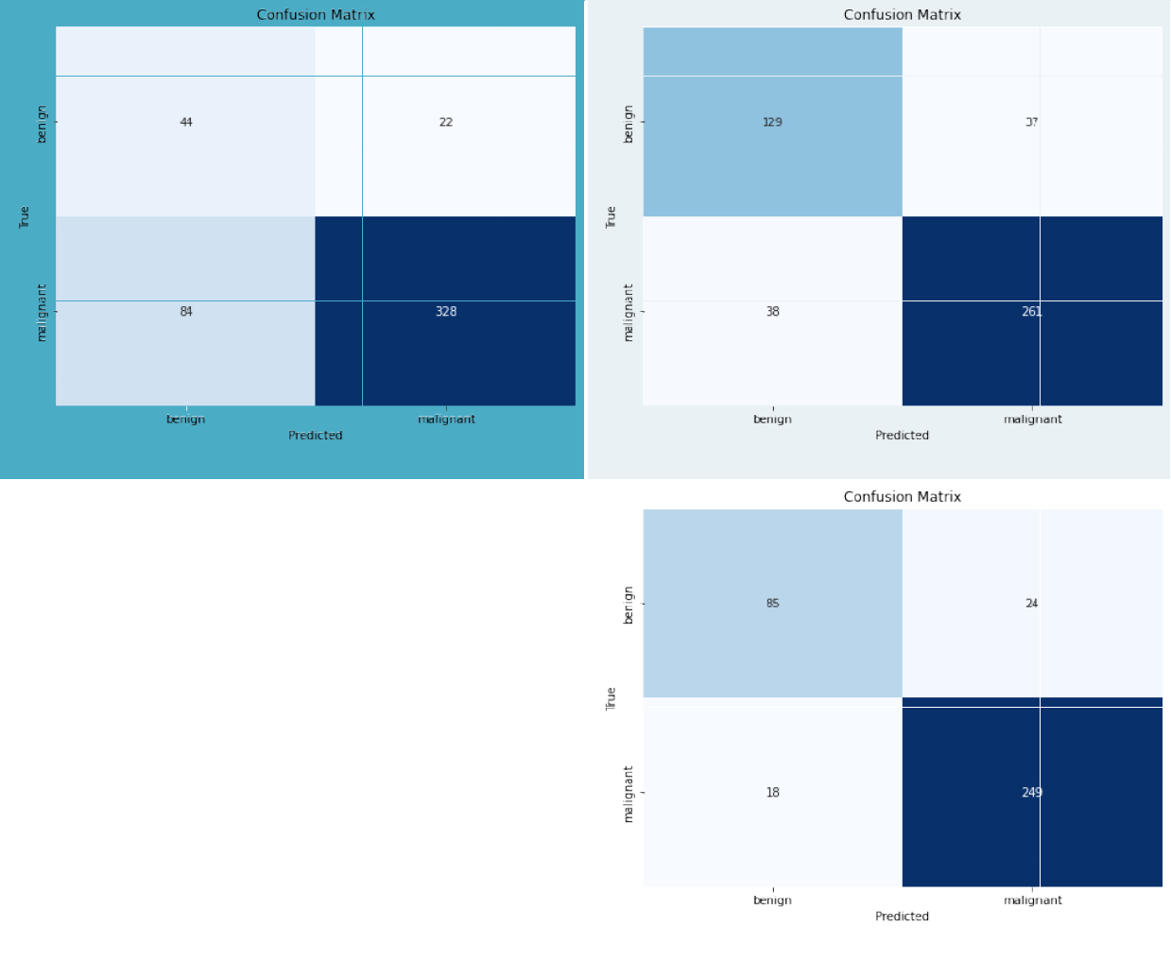

( a )

( b )

 | ( c ) |  | ( d )
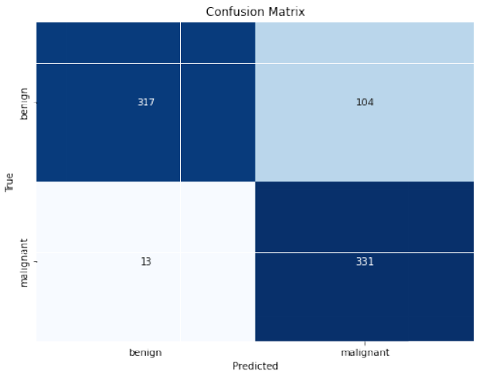
Figure 3: Coonfusion matrrices generateed by the propposed ensembble model on each set of a) 40X, b) 100XX, c) 200X and d) 400X magnifications respectively

The Receiver Operating Characteristic (ROC) curvees obtained byy our proposed ensemble model on all the four sets of magnification is shown in Figure 4. In all curves, thhe AUC (Area Under the Curve) valuee is maintaineed. Under 400X magnification,, the AUC value is 94% whhich is the higghest among all, whereas inn 40X magnification the AUUC value is 833%. In a ROC curve, higher thhe value on thhe X axis indicates the highher value of false positive instances thann the number of true negative instances. If the curve iss more inclined towards Y axis it indicates the higher number of true posittive instances thann the numberr of false negaatives. The moore ROC curve is inclined towards the top-left corner of the Y axis, greater is the ability of thee classifier to distinguish beetween positivve and negative instances. Here in Figure 4 under 400X magnification,, the ROC curve is most inclined towards the Y axis, whereas in 40X magnificattion the curvee is least inclinned than the otheer sets of magnification.

__________________________________________________________________________________________________________________________________________

IRJCS © 2014-23, AM Pubblications -All Rights Reservved https://doi.org/10.26562/irjcs Page-17

IRJCS: International Research Journal of Computer Science | ISSN: 2393-9842
Volume 10, Issue 03, April 2023 | https://www.irjcs.com/archives
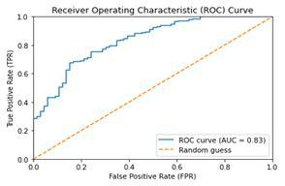

( a ) 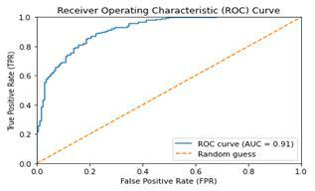 ( b )
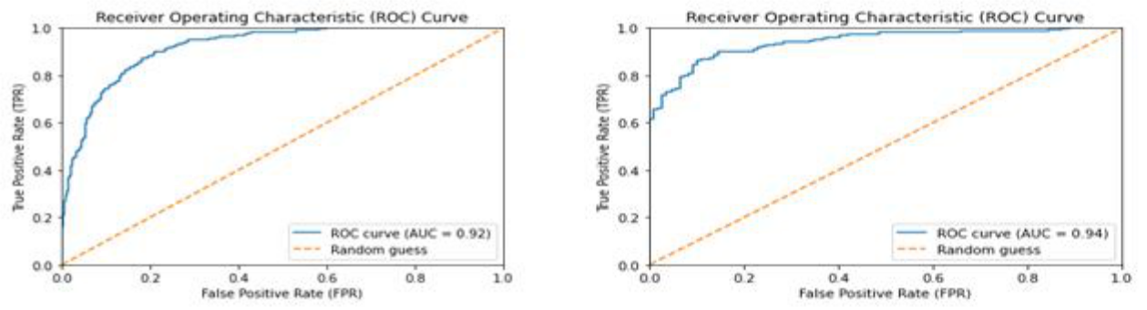

( c ) ( d )

Figure 4: ROC curves obtained by the proposed ensemble model from the four sets of magnification i.e., a) 40X, b) 100X, c) 200X and d) 400X

VI. CONCLUSION

In today's generation, Breast cancer is one of the serious concerns among women worldwide. Breast histopathology is a method of microscopic inspection as well as evaluation of a biopsy sample performed by a medical expert to determine cancer growth in the breast. Advancements in digital imaging along with the success of deep learning models in complex image classification tasks motivate many researchers to develop more accurate CAD systems. In this work, we have proposed an ensemble model for classifying breast histopathology images by combining the decision scores of three standard CNN models, namely GoogleNet, VGG16, and MobileNetV3 Small. We utilized the Gompertz function for score combination and evaluated our proposed model on the BreakHis dataset, which is a publicly available dataset. Our experimental results demonstrated that the ensemble model outperformed individual CNN models and achieved satisfactory outcomes across various magnification levels of BreakHis images. Therefore, the proposed ensemble model can be a promising approach for accurate and robust classification of breast histopathology images. Future work could involve further experimentation and optimization of these models using different techniques and datasets to improve their performance and enhance their applicability in real-world scenarios.

ACKNOWLEDGEMENT

We express our gratitude to Mangalore Institute of Technology & Engineering for their motivation and support for research work publication and department of CSE for providing the laboratory facility to develop this proposed idea and special thanks to our faculty and colleagues who have supported with valuable and timely suggestion. We are also immensely grateful to all those references listed which provided us insight and great assistance for this work.

REFERENCES

[1] Purushottam, K. Gamma Function Based Ensemble of CNN Models for Breast Cancer Detection in Histopathology Images, Samriddha Majumdar, Payel Pramanik, Ram Sarkar, Expert Systems with Applications, Volume 213, Part B, 2022, 119022, ISSN 0957-4174, doi: https://doi.org/10.1016/j.eswa.2022.119022.

[2] DeepBreastNet: A novel and robust approach for automated breast cancer detection from histopathological images, Fatih Demir, Nalecz Institute of Biocybernetics and Biomedical Engineering of the Polish Academy of Sciences, Biocybernetics and Biomedical Engineering, Volume 41, Issue 3, 2021.
- “Breast Cancer Detection in Mammography Images Using Deep Convolutional Neural Networks and Fuzzy Ensemble Modeling Techniques.” Altameem, A.; Mahanty, C.; Poonia, R.C.; Saudagar, A.K.J.; Kumar, R. Diagnostics (Basel,

Switzerland) vol.12, 8 1812. 28 Jul. 2022, doi:10.3390/diagnostics1208181.

[4] Transfer learning from synthetic labels for histopathological images classification. Nassima Dif, Mohammed Oualid Attaoui, Zakaria Elberrichi, Mustapha Lebbah, and Hanene Azzag. 2022. Applied Intelligence 52, 1 (Jan 2022), 358– 377. https://doi.org/10.1007/s10489-021-02425-z.
[5] Arjun C, Anusha, Meghana B Kamath, Nireeksha S Amin, Pradeep BS Predicting Cancer and Heart Disease at Early Stages using Machine Learning-International Journal of Innovative Research in Advanced Engineering (IJIRAE), ISSN: 2349-2163, Vol 9, Issue 5, May 2022, DOI: https://doi.org /10.26562/ijirae.2022.v0905.001, https://www.ijirae.com/volumes/Vol9/iss-05/01.MYAE10081.pdf

_____________________________________________________________________________________________________________________________________

IRJCS © 2014-23, AM Publications -All Rights Reserved https://doi.org/10.26562/irjcs Page-18

