# TLEN SECURE EMBEDDED PROGRAMMING – ASSIGNMENT 3

PART1:

SERIAL SCREEN:

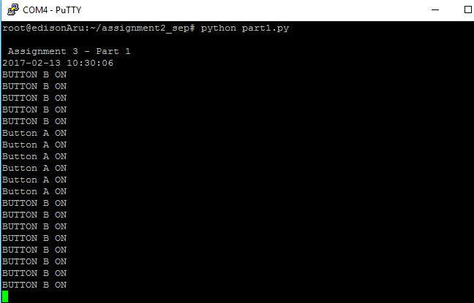

FILE :

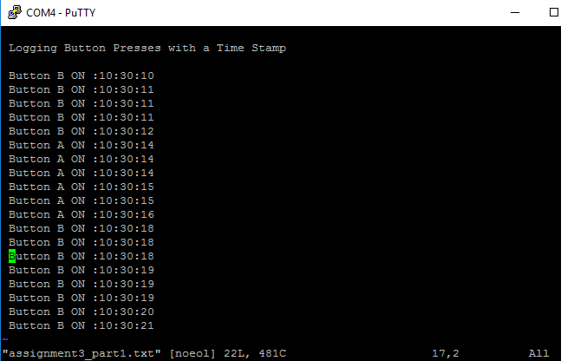

PART2:

SERIAL SCREEN:

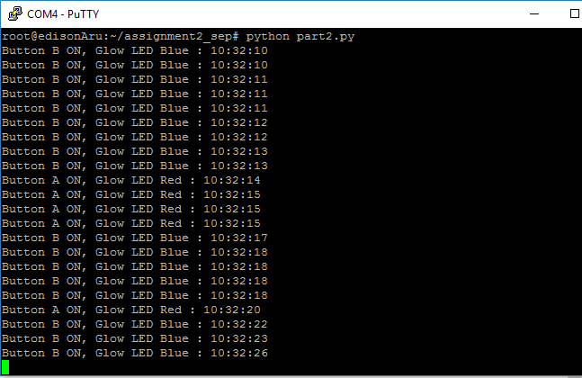

FILE:

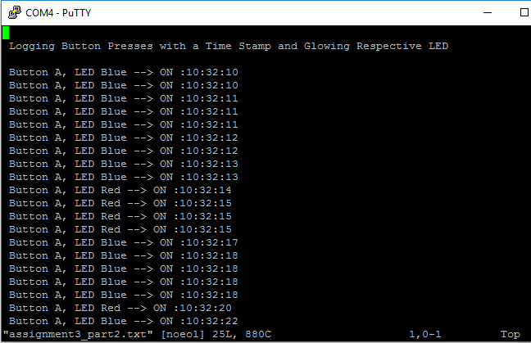

PART3:

* INCORRECT PASSWORD ENTERED ONCE FOLLOWED BY THE RGHT PASSWORD

SERIAL SCREEN

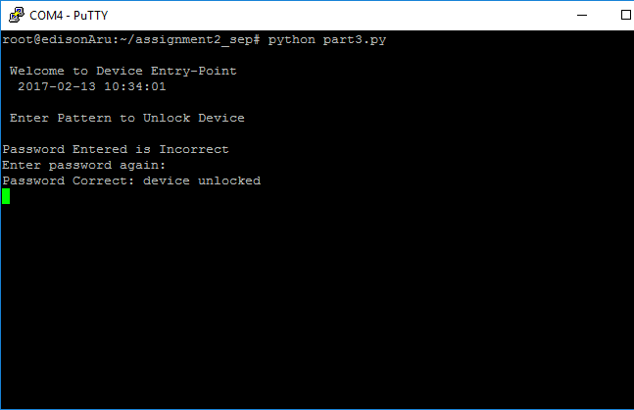

FILE:

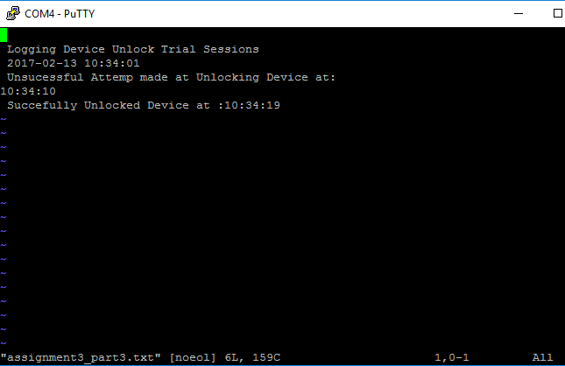

PART3: FOR THREE CONSECUTIVE WRONG ENTRIES

SERIAL SCRREN:

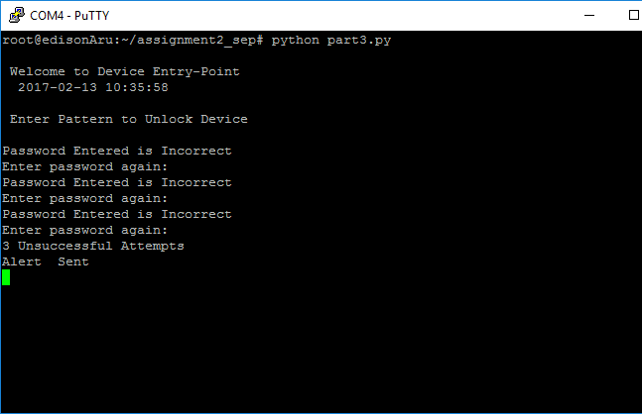

FILE:

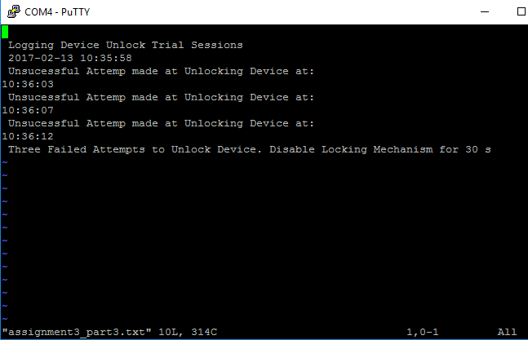

EMAIL:

