**Topics: Normal distribution, Functions of Random Variables**

1. The time required for servicing transmissions is normally distributed with *μ* = 45 minutes and *σ* = 8 minutes. The service manager plans to have work begin on the transmission of a customer’s car 10 minutes after the car is dropped off and the customer is told that the car will be ready within 1 hour from drop-off. What is the probability that the service manager cannot meet his commitment?
2. 0.3875
3. 0.2676
4. 0.5
5. 0.6987

Answer :

Since work begins 10 mins after the car is dropped , the time left to complete work is 50 mins .

Probability that service manager can’t meet his commitment =P(X>50)=1-Pr(x<=50) (X is the time taken to complete work ) .Convert 50 to Z-score .

Standard normal variable Z=(x- μ)/σ =(x-45)/8

P=(X<50)=P(Z<=(50-45)/8)=PR(Z<=0.625) = 0.73237=73.737% (The number in z-table)

Probability that service manager will not meet his commitment is : 100-73.237=26.763%=0.2676.

Hence, option B. 0.2676 is correct.

1. The current age (in years) of 400 clerical employees at an insurance claims processing center is normally distributed with mean *μ* = 38 and Standard deviation *σ* =6. For each statement below, please specify True/False. If false, briefly explain why.
2. More employees at the processing center are older than 44 than between 38 and 44.
3. A training program for employees under the age of 30 at the center would be expected to attract about 36 employees.

Answer :

1. False 🡺

μ ==38 & σ=6

Probability if employees > 44=P(x>44) =1-P(x<44)

Z=(X- μ)/σ =(x-38)/6

P(x<=44)=P(z<(44-38)/6) = P(Z<=1)=0.84134= 84.134%

Probability that employees will be greater than 44=100-84.134 = 15.866%

Probability if employees between 38 & 44 = Pr(x<=44) – Pr(x<=38)

Here, P(x<=44) = 0.84134

P(x<=38)=P(z<=(38-38)/6) = P(z<=0) = 0.5

Therefore, P(x<=44) – P(x<=38) = 0.84134 – 0.5 = 0.34134 = 34.134% = 137 Out of 400

So, the statement more employees at the processing center are older than 44 than between 38 and 44 is FALSE

1. True 🡺

Z-score for 30 = (30-38)/6 = -1.33 = 9.15% = 36 out of 400 employees

1. If *X1* ~ *N*(μ, σ2) and *X*2 ~ *N*(μ, σ2) are *iid* normal random variables, then what is the difference between 2 *X*1 and *X*1 + *X*2? Discuss both their distributions and parameters.

Answer :

As we know that if X~ N(μ, σ2) , and Y ~ N(μ, σ2) are two independent random variables than X+Y ~ N(µ1 + µ2, σ1^2 + σ2^2 ), and X-Y ∼ N(µ1 − µ2, σ1^2 + σ2^2 ) .

Similarly if Z = aX + bY , where X and Y are as defined above , i.e Z is linear combination of X and Y , then Z ∼ N(aµ1 + bµ2, a^2σ1^2 + b^2σ2^2 ).

Therefore in the question

2X1~ N(2 u,4 σ^2) and

X1+X2 ~ N(µ + µ, σ^2 + σ^2 ) ~ N(2 u, 2σ^2 )

2X1-(X1+X2) = N( 4µ,6 σ^2)

1. Let X ~ N(100, 202). Find two values, *a* and *b*, symmetric about the mean, such that the probability of the random variable taking a value between them is 0.99.
2. 90.5, 105.9
3. 80.2, 119.8
4. 22, 78
5. 48.5, 151.5
6. 90.1, 109.9

Answer :

Since we need to find the values, a and b, which are symmetric about mean such that the probability of random variable taking a value between then is 0.99, we have to work in reverse order.

The probability of going wrong, or the probability outside the a and b area is 0.01

The probability towards left from a =0.01/2 = - 0.005

The probability towards right from b = 0.005

Finding the standard normal variable Z (z value)

Z = (X- µ) /σ

The probability 0.005 the z value is -2.57 (from z table)

Z*σ + µ = X

Z (-0.005) *20 + 100 = -(-2.57) * 20+100 = 151.4

Z (0.005) *20 + 100 = (-2.57)* 20+100 = 48.6

So ‘**D**’ is the correct option

1. Consider a company that has two different divisions. The annual profits from the two divisions are independent and have distributions Profit1 ~ N(5, 32) and Profit2 ~ N(7, 42) respectively. Both the profits are in $ Million. Answer the following questions about the total profit of the company in Rupees. Assume that $1 = Rs. 45
2. Specify a Rupee range (centered on the mean) such that it contains 95% probability for the annual profit of the company.
3. Specify the 5th percentile of profit (in Rupees) for the company
4. Which of the two divisions has a larger probability of making a loss in a given year?

Answer :

A.

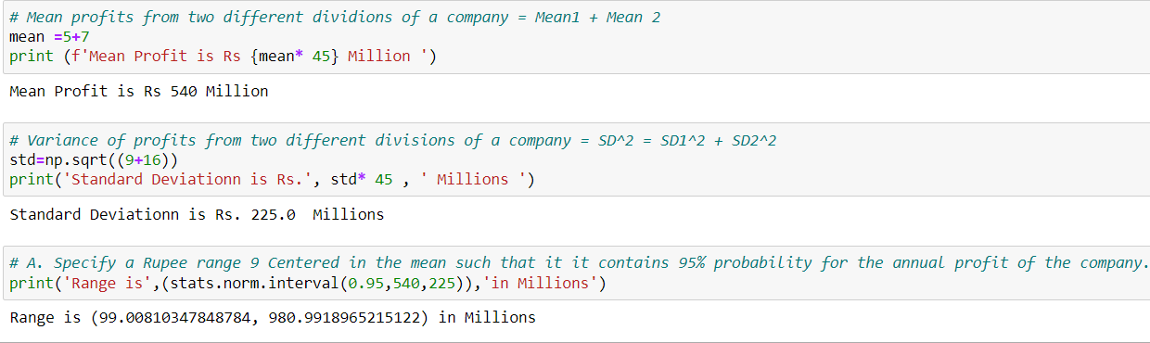

B.

C.

