Predicting Sediment Particle Size Distributions with Machine Learning
UE24CS352A – Machine Learning | Mini-Project Write-up
Problem Statement No. 62 | Arnav Chaudhary - PES1UG24CS081 | Arundhathi K - PES1UG24CS082
GitHub: https://github.com/ArundhathiK29/ml-sediment-mini-project
1. Problem Statement
Suspended marine sediment (mud) controls carbon sequestration, contaminant transport and coastal erosion, and sediment-transport models need the particle settling velocity as a key input. Settling velocity depends on particle size, but size changes within seconds as particles aggregate and break up (flocculation), and existing semi-empirical flocculation models are tuned to specific sites and do not generalise. Following Egan, “Machine learning for predicting sediment particle size distributions”, we ask: can a data-driven regression model predict the median particle diameter d50 (µm) and the particle-size-distribution variance σ² (µm²) from measured water-quality, biological and hydrodynamic variables? Success is measured by R² between predicted and true values (supported by MAE and RMSE).
2. Dataset
The paper’s field data (1648 hourly samples from South San Francisco Bay, measured with LISST, ECO-FL and ac-9 instruments) is not available, so we use a synthetic dataset of 5000 samples (seed 42, no missing values) with the same 8 inputs and 2 targets. Inputs are drawn independently and uniformly. The targets are illustrative functions of the inputs (linear terms, S×T and u_{b}×S interactions, and a u_{b}² term) plus Gaussian noise (σ = 12 µm for d50, 8 µm² for variance); they are not validated sediment physics. Targets: d50 mean 174.4 µm (std 46.5, range 48.7–370.9); σ² mean 143.0 µm² (std 38.2, range 44.6–272.9). Because the noise is known we can compute the noise ceiling, the best R² any model can reach: 0.930 for d50 and 0.958 for σ².
Feature (symbol) | Range | Corr. with d50 | Corr. with σ² | Role in model
Salinity (S, ppt) | 5 – 35 | +0.51 | +0.74 | Selected
Temperature (T, °C) | 5 – 30 | +0.56 | +0.47 | Selected
Wave-induced velocity (u_{b}, m/s) | 0.01 – 0.50 | −0.43 | +0.39 | Selected
Particle refractive index (n_{p}) | 1.05 – 1.25 | +0.23 | +0.14 | Selected
Mean tidal velocity (ū, m/s) | 0.01 – 1.00 | +0.02 | +0.09 | Dropped
Chlorophyll-a (chl-a) | 0.1 – 20 | +0.07 | +0.03 | Dropped
Algal peak ratio (a676/a650) | 0.70 – 1.50 | 0.00 | +0.01 | Dropped
Detrital peak ratio (a450/a676) | 0.50 – 2.00 | +0.01 | −0.02 | Dropped
Table 1: input features, ranges, Pearson correlation with each target (full dataset) and whether the feature was kept after selection.
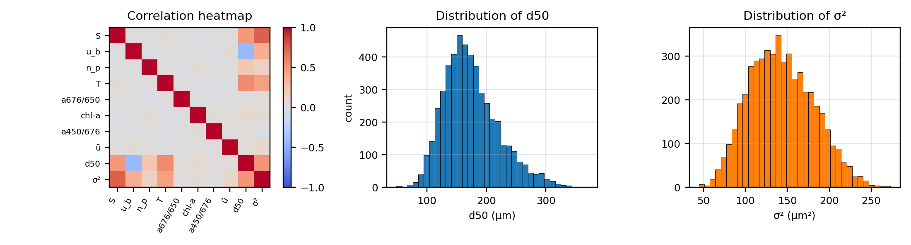
Fig. 1: correlation heatmap and target distributions. Targets are unimodal and mildly right-skewed; d50 and σ² correlate at +0.52.
EDA observations. Salinity and temperature correlate positively with both targets. Wave velocity correlates negatively with d50 (−0.43) but positively with σ² (+0.39), because the u_{b}×S interaction outweighs its direct term for d50. The four biological/optical and tidal features are essentially uncorrelated with the targets, and features are mutually independent by construction.
3. Approach
- Split. Hold out a 20 % test set (1000 samples), used once at the end. All feature selection and tuning use only the remaining 4000 training samples.
- Feature selection. Fit a separate Random Forest (RF) per target on 10 random 70/30 splits of the training set and average two importance measures: impurity (mean decrease in impurity) and permutation importance. Keep the top 4 features by mean importance, as in the paper.
- RF tuning. Choose the number of trees from the out-of-bag (OOB) R², an internal validation estimate that needs no extra validation set.
- SVR tuning. RBF-kernel Support Vector Regression with a grid search over C ∈ {1, 10, 100}, ε ∈ {0.1, 0.3}, γ ∈ {scale, 0.1} using 3-fold CV. Inputs and target are standardised inside the pipeline (no leakage, and ε is unit-free).
- Evaluation. Report R², MAE and RMSE on the test set, confirm with 5-fold CV on all 5000 samples, and compare against the noise ceiling and the all-8-feature RF.
4. Implementation Overview
Python 3 with NumPy, pandas, scikit-learn and matplotlib, in one notebook (ml_mini_project.ipynb) that runs top to bottom with no external uploads: data generation → EDA → split → importance → tuning → evaluation → saved results (results/: CSV tables, test predictions, trained models; data/: dataset). Models: RandomForestRegressor (one per target) and SVR wrapped in TransformedTargetRegressor + StandardScaler; tuning with GridSearchCV and the OOB score. All random states are fixed to 42 (reproducible).
Model | Target | Tuned setting | How chosen | Tuning score
Random Forest | d50 | 100 trees | OOB R² flat from ≈20 trees; 100 = smallest within 0.002 of best | OOB R² = 0.903
Random Forest | σ² | 100 trees | same rule | OOB R² = 0.933
SVR (RBF) | d50 | C = 10, ε = 0.1, γ = 0.1 | 3-fold grid search (18 combinations) | CV R² = 0.9196
SVR (RBF) | σ² | C = 1, ε = 0.1, γ = 0.1 | 3-fold grid search (18 combinations) | CV R² = 0.9453
Table 2: final hyper-parameters. The σ² SVR optimum C = 1 lies at the lower edge of the grid; its score is almost unchanged for larger C.
5. Results
Target | Model | Features | Test R² | MAE | RMSE | 5-fold CV R² (mean ± std) | Noise ceiling
d50 (µm) | Random Forest | all 8 | 0.914 | 10.89 | 13.55 | – | 0.930
d50 (µm) | Random Forest (tuned) | top 4 | 0.909 | 11.24 | 13.95 | 0.905 ± 0.005 | 0.930
d50 (µm) | SVR (tuned) | top 4 | 0.921 | 10.49 | 12.97 | 0.920 ± 0.002 | 0.930
σ² (µm²) | Random Forest | all 8 | 0.939 | 7.65 | 9.57 | – | 0.958
σ² (µm²) | Random Forest (tuned) | top 4 | 0.936 | 7.98 | 9.86 | 0.934 ± 0.004 | 0.958
σ² (µm²) | SVR (tuned) | top 4 | 0.948 | 7.11 | 8.86 | 0.946 ± 0.004 | 0.958
Table 3: held-out test-set performance (1000 samples; MAE/RMSE in µm for d50, µm² for σ²) and 5-fold CV on all 5000 samples (a stability check; CV mean MAE/RMSE: d50 RF 11.41/14.29, SVR 10.46/13.13; σ² RF 7.90/9.81, SVR 7.08/8.84).
Feature | Impurity d50 | Impurity σ² | Permutation d50 | Permutation σ² | Mean importance | Rank
Salinity | 0.318 | 0.560 | 0.355 | 0.596 | 0.457 | 1
Temperature | 0.336 | 0.225 | 0.329 | 0.228 | 0.280 | 2
Wave velocity | 0.248 | 0.158 | 0.270 | 0.155 | 0.208 | 3
Refractive index | 0.056 | 0.025 | 0.042 | 0.016 | 0.035 | 4
Tidal velocity | 0.011 | 0.011 | 0.001 | 0.004 | 0.007 | 5
Chlorophyll-a | 0.013 | 0.008 | 0.003 | 0.001 | 0.006 | 6
Detrital peak ratio | 0.009 | 0.007 | 0.000 | 0.000 | 0.004 | 7
Algal peak ratio | 0.009 | 0.006 | 0.000 | 0.000 | 0.004 | 8
Table 4: Random Forest feature importance, averaged over 10 random 70/30 splits of the training set (permutation scores normalised to sum to 1).
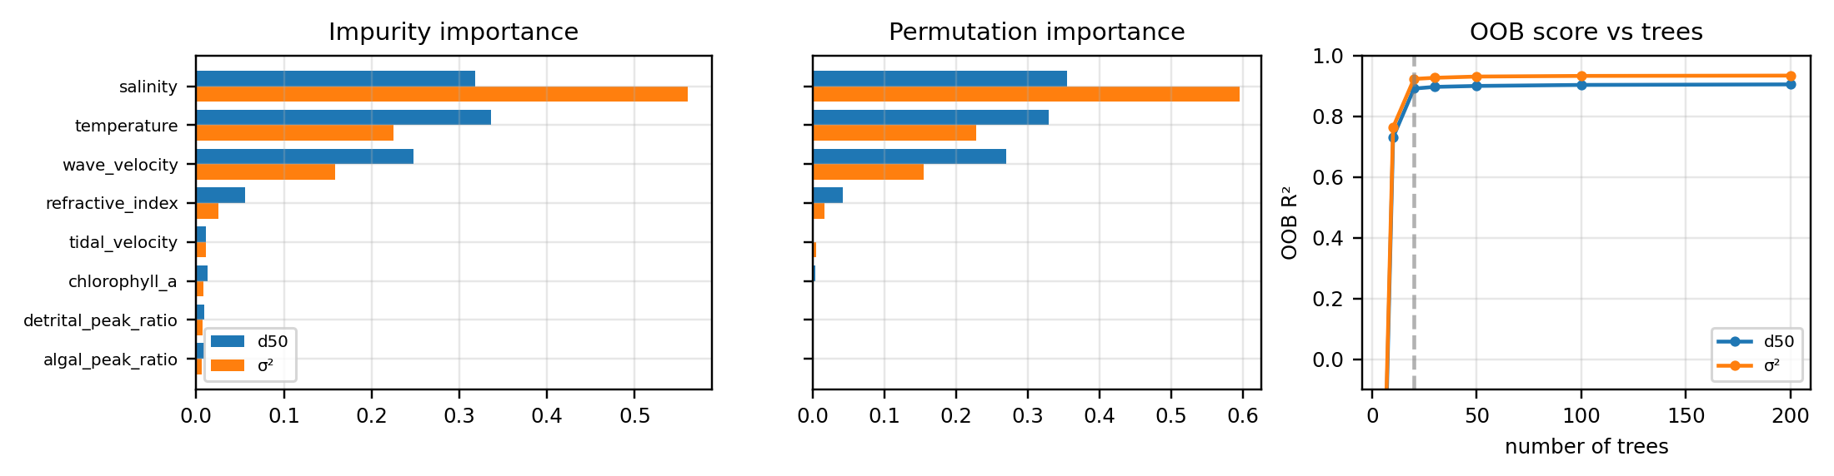
Fig. 2: “dashed line: 20 trees, where OOB R² levels off; the final model uses 100 trees
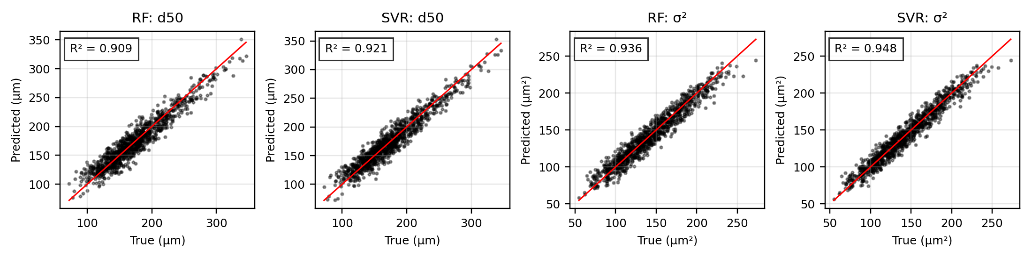
Fig. 3: test-set predictions vs ground truth (red line = perfect fit) for the tuned top-4 RF and SVR models.
6. Interpretation
- Both models predict well; SVR is slightly better (test R² 0.921 vs 0.909 for d50, 0.948 vs 0.936 for σ², with lower MAE and RMSE). The 5-fold CV agrees (std ≤ 0.005), so this is not an artefact of one split. The targets are smooth functions, which an RBF kernel fits more naturally than piecewise-constant trees; RF flattens at the extremes in Fig. 3 because trees cannot extrapolate.
- Feature importance. Salinity, temperature, wave velocity and refractive index carry almost all the signal; the other four score below 0.015 (permutation ≈ 0). For σ² salinity dominates (impurity 0.56); for d50 salinity (0.32), temperature (0.34) and wave velocity (0.25) are comparable. Impurity and permutation rankings agree. Since this mirrors the coefficients we chose, it shows the method recovers a known structure rather than a physical finding.
- Feature selection costs almost nothing: dropping the four weak features lowers RF test R² by only 0.005 (d50) and 0.004 (σ²). On real data this would mean expensive optical or chlorophyll sensors could be left out of a campaign if equally uninformative.
- Near the noise ceiling. SVR is within about 0.01 R² of the ceiling (0.921 vs 0.930; 0.948 vs 0.958) and RF within about 0.02: both have learned most of the structure and the remaining error is the injected noise (typical error ≈10 µm on d50, ≈6 % of its mean; ≈7 µm² on σ², ≈5 %).
- Versus the paper. Egan reports real-data test R² of 0.81 (d50) and 0.75 (σ²) for RF, and 0.76 for SVR. Our higher scores come from low noise and a known relationship, so the numbers are not comparable; the qualitative picture (RF ≈ SVR, a few dominant features) matches.
7. Conclusions and Limitations
Random Forest and SVR both predict median particle diameter and PSD variance accurately (test R² 0.91–0.95), top-4 feature selection loses almost nothing, and tuned SVR is marginally best. The full pipeline (held-out test set, importance-based selection, OOB and CV tuning, CV confirmation, noise-ceiling check) works as intended and is reproducible. Limitations: (i) the data is synthetic, so these scores show the pipeline works but do not prove the models predict real flocculation; (ii) inputs are independent and uniform, whereas field data is correlated and time-dependent; (iii) importance rankings reflect our chosen coefficients; (iv) the σ² SVR optimum lies at the edge of the C grid; (v) cross-site generalisation was not tested. Future work: apply the pipeline to real field data, add correlated inputs and heavier noise, extend the SVR grid, and test other sites, as the paper proposes.

