#include SoftwareSerial mySerial(3, 2);

SoftwareSerial ss(12, 13);

#define sensorDigital A0

#define buzzer 8 int flag;

void setup()

{

pinMode(sensorDigital, INPUT);

pinMode(buzzer, OUTPUT);

Serial.begin(9600);

mySerial.begin(9600);

ss.begin(9600);

pinMode(4,OUTPUT);

pinMode(5,OUTPUT);

pinMode(6,OUTPUT);

pinMode(7,OUTPUT);

Serial.println("Initializing...");

delay(1000);

mySerial.println("AT"); //Once the handshake test is successful, it will back to OK

updateSerial();

mySerial.println("AT+CSQ");

updateSerial();

mySerial.println("AT+CMGS=\"+919539041141\"");

updateSerial();

mySerial.println("ALCOHOL DETECTED");

updateSerial();

mySerial.write(26);

}

void loop()

{

int alcohollevel= analogRead(sensorDigital);

if (alcohollevel> 900) { updateSerial();

Serial.print("Alcohol value :");

Serial.println(alcohollevel);

digitalWrite(buzzer, HIGH);

flag=1;

digitalWrite(4,LOW);

digitalWrite(5,LOW);

digitalWrite(6,LOW);

digitalWrite(7,LOW);

while (ss.available() > 0)

{

byte gpsData = ss.read();

Serial.write(gpsData);

}

}

else

{

digitalWrite(4,HIGH);

digitalWrite(5,LOW);

digitalWrite(6,HIGH);

digitalWrite(7,LOW);

digitalWrite(buzzer, LOW);

}

}

void updateSerial()

{

delay(500);

while (Serial.available())

{

mySerial.write(Serial.read()); //Forward what Serial received to Software Serial Port

}

while(mySerial.available())

{

Serial.write(mySerial.read()); //Forward what Software Serial received to Serial Port

}

}

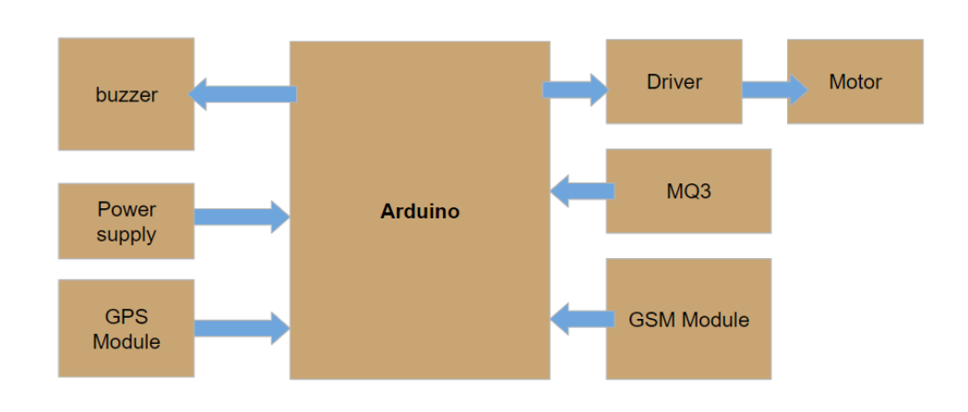

BLOCK DIAGRAM

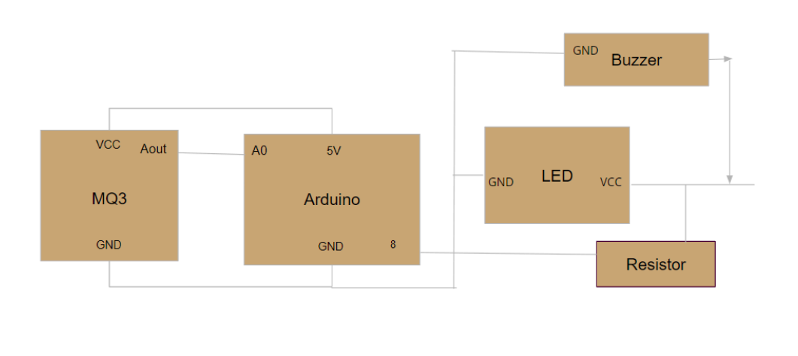

ALCOHOL DETECTION DIAGRAM

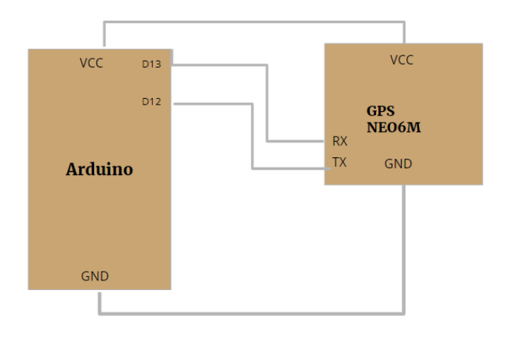

GPS TRACKING

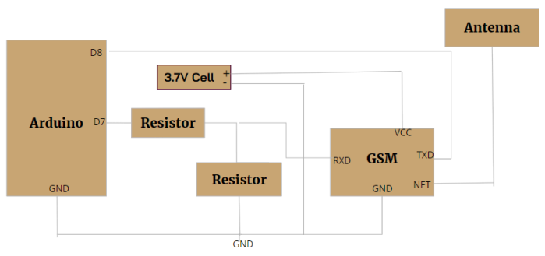

GSM MODULE

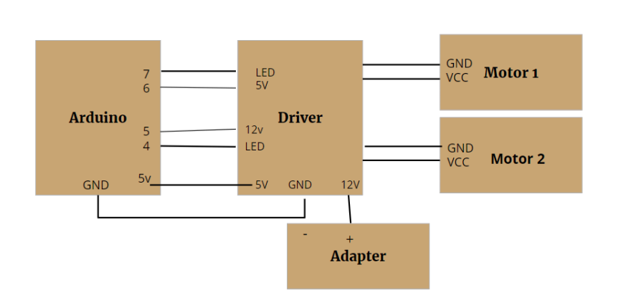

ENGINE LOCKING SYSTEM

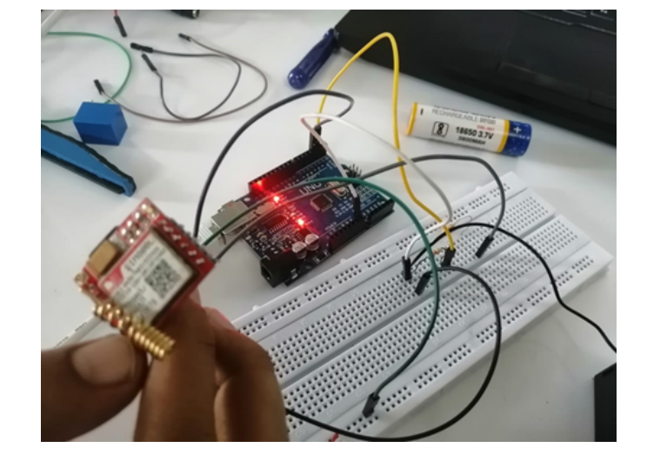

WORKING OF GSM

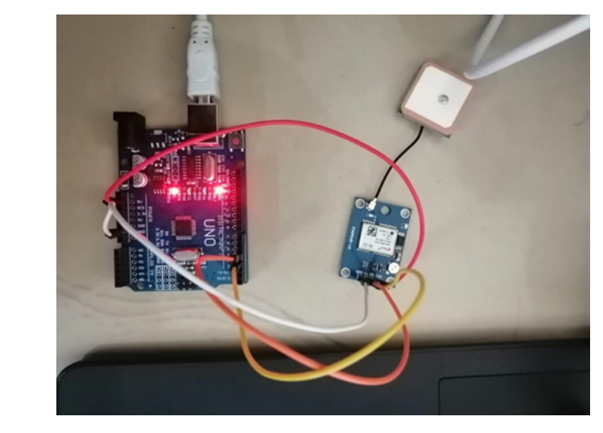

WORKING OF GSM

