**MealMate Delivery**

As a dedicated frontend developer, I embarked on a journey to enhance my React.js skills, resulting in my latest project, MealMate. This innovative online food ordering platform streamlines the process of discovering and ordering meals from a variety of options. Utilizing React.js for dynamic and interactive user interfaces, custom CSS for a visually appealing design, and backend integration to fetch meal data and manage order details, MealMate allows users to explore diverse meal choices, add them to their carts, and complete their orders seamlessly. This project highlights my ability to create intuitive, user-friendly web applications and showcases my commitment to mastering frontend development and delivering impactful solutions.

**How to Install and Run the Project**

To run MealMate locally, follow these steps:

1. **Clone the repository:** git clone https://github.com/yourusername/mealmate.git
2. **Navigate to the project directory:** cd mealmate
3. **Install dependencies:** npm install
4. **Start the development server:** npm start

The application should now be running on **http://localhost:3000**.

**How to Use the Project**

1. **Browse Meals:**
   * Navigate through the different meal categories and explore a variety of meal options.
2. **Add to Cart:**
   * Click on a meal to view its details and add it to your cart.
3. **Place an Order:**
   * View your cart and proceed to checkout to complete your order.

**Screenshots**

* **Homepage:**

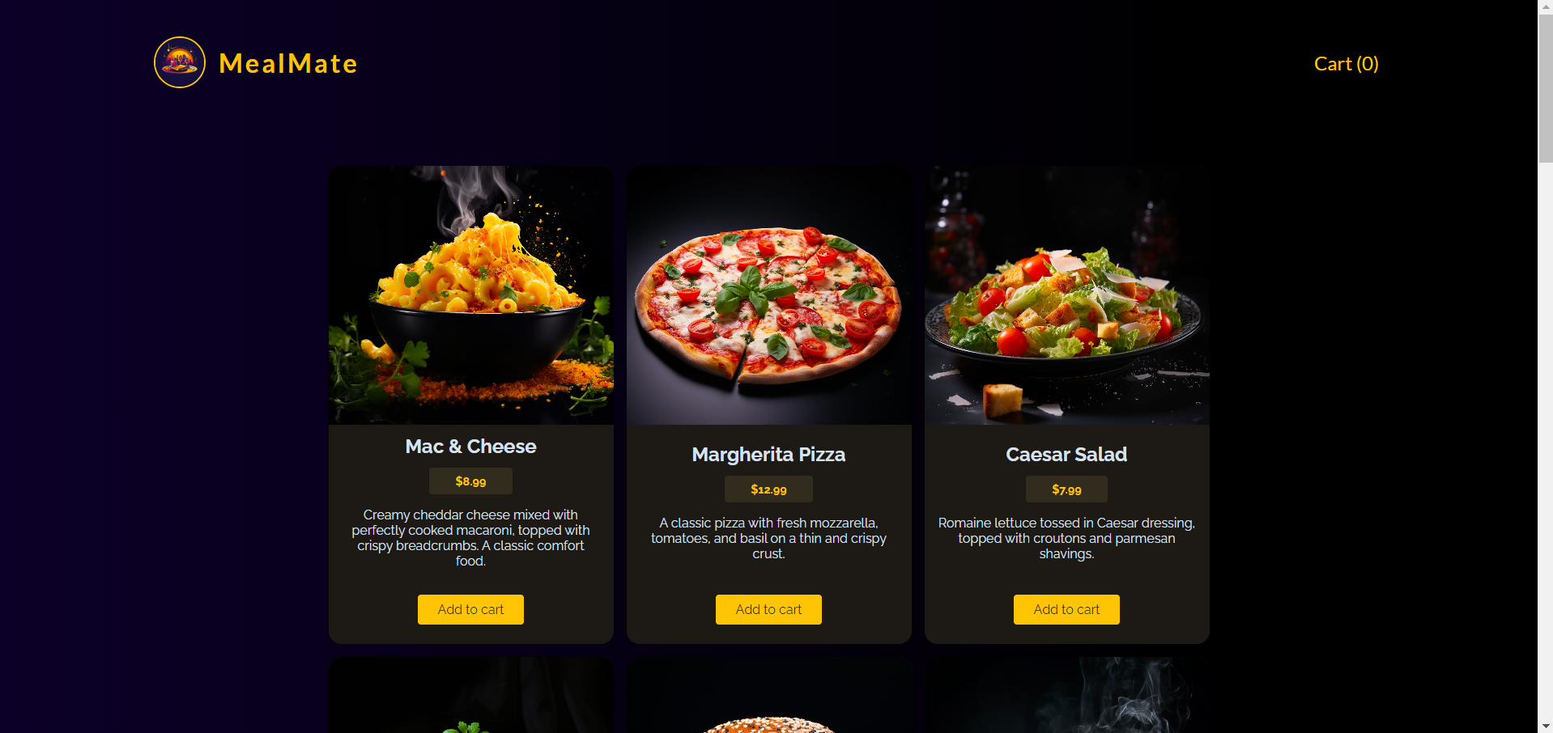

* **Cart:**

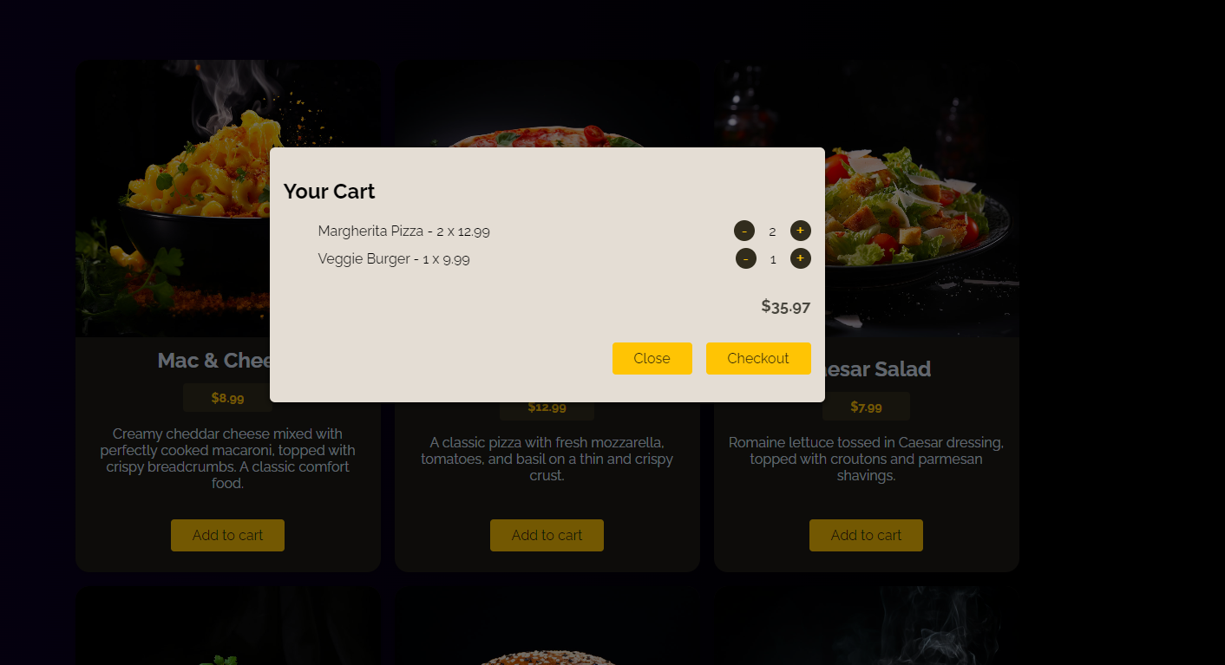

* **CheckOut:**

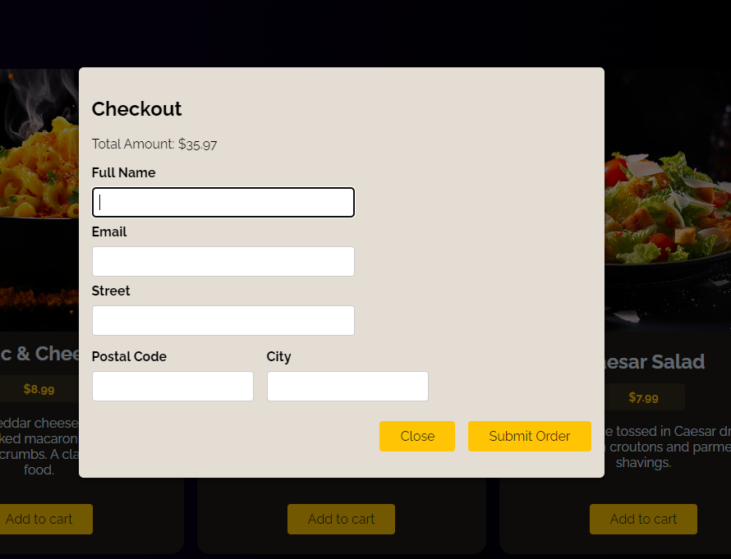

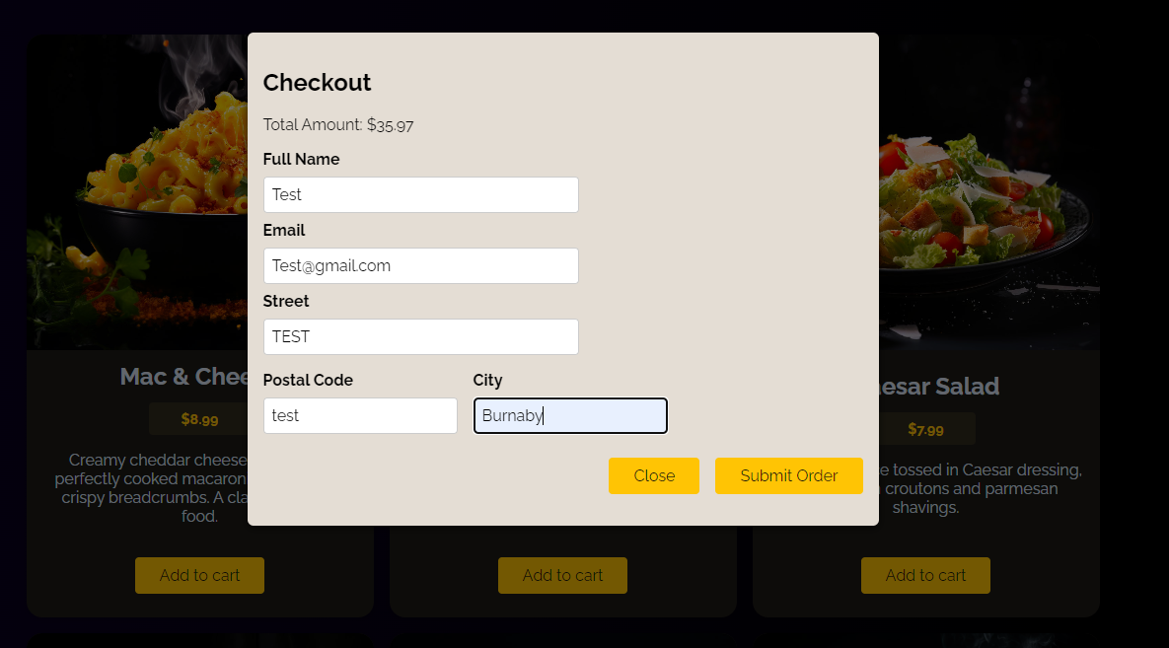

* **Order Confirmed:**

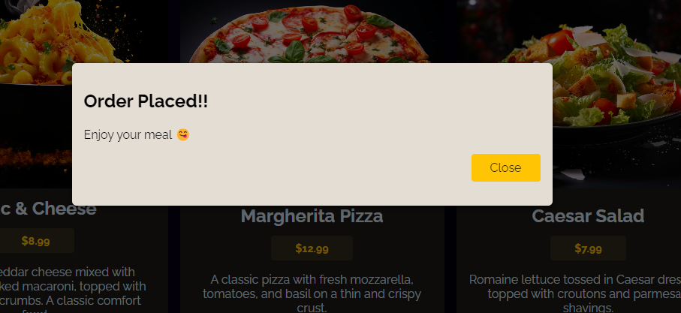

Data added:

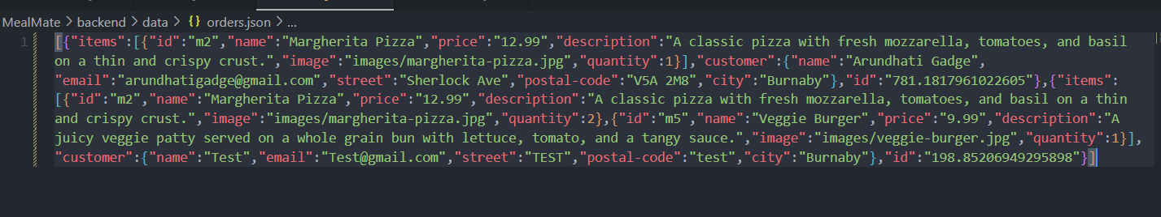

**Include Credits**

Backend taken from a tutorial online.

**Contributors**

* **Arundhati Gadge** - linkedin.com/in/arundhati-gadge/