**Home Automation using Arduino**

**Arundhati Bandopadhyaya**

**PRN: 18070123023**

**ENTC A (18-22)**

**Apparatus Required:**

* Arduino UNO
* Relay module
* HC-05 Bluetooth module
* LEDs
* Wires
* Android device with Controller app

**Video**: **https://www.youtube.com/watch?v=NxpuLLVqBeE&feature=youtu.be**

**Circuit Diagram:**

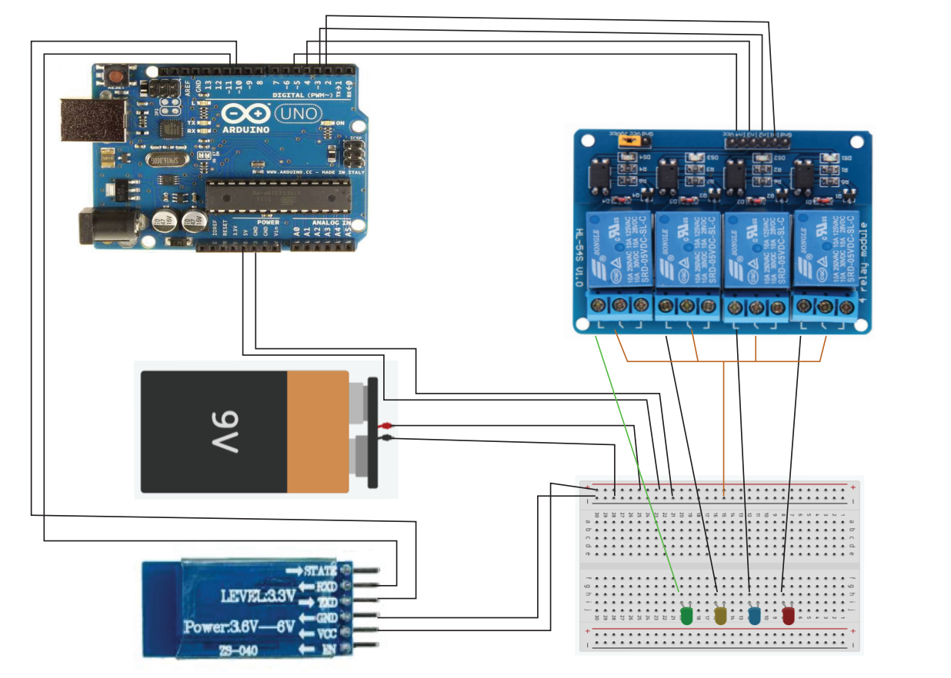

**Arduino Code:**

#include <SoftwareSerial.h>

SoftwareSerial mySerial(10, 11); //Pin10 RX , Pin 11 TX

#define relay1 2

#define relay2 3

#define relay3 4

#define relay4 5

char val;

void setup() {

pinMode(relay1,OUTPUT);

pinMode(relay2,OUTPUT);

pinMode(relay3,OUTPUT);

pinMode(relay4,OUTPUT);

digitalWrite(relay1,HIGH);

digitalWrite(relay2,HIGH);

digitalWrite(relay3,HIGH);

digitalWrite(relay4,HIGH);

mySerial.begin(9600);

Serial.begin(9600);

}

void loop() {

//check data serial from bluetooth android App

if( mySerial.available() >0 ) {

val = mySerial.read();

Serial.println(val);}

//Relay is on

if( val == '1' ) {

digitalWrite(relay1,LOW);

}

else if( val =='2' ) {

digitalWrite(relay2,LOW);

}

else if( val == '3' ) {

digitalWrite(relay3,LOW);

}

else if( val == '4' ) {

digitalWrite(relay4,LOW);

}

//relay all on

else if( val == '9' ) {

digitalWrite(relay1,LOW);

digitalWrite(relay2,LOW);

digitalWrite(relay3,LOW);

digitalWrite(relay4,LOW);

}

//relay is off

else if( val == 'A' ) {

digitalWrite(relay1,HIGH);

}

else if( val == 'B' ) {

digitalWrite(relay2,HIGH);

}

else if( val == 'C' ) {

digitalWrite(relay3,HIGH);

}

else if( val == 'D' ) {

digitalWrite(relay4,HIGH);

}

//relay all off

else {

digitalWrite(relay1,HIGH);

digitalWrite(relay2,HIGH);

digitalWrite(relay3,HIGH);

digitalWrite(relay4,HIGH);

}

};

**Project Timeline:**

|  |  |
| --- | --- |
| Date | Description |
| 18/1 | Project Selected**: Home Automation using Arduino**. Timeline document created. |
| 19 / 1 | Ordered basic equipment: Arduino UNO, Jumper Cables, Electronic Component kit.  Total expense: 1100 |
| 23 / 1 | Received equipment |
| 24/1 | Project Research |
| 25/1 | Project Research |
| 26/1 | Project Research |
| 27/1 | Project Research |
| 28/1 | Project Research |
| 29/1 | Circuit Drawing. Tried simulating on Proteus 8 but laptop did not support. |
| 30/1 | Built the circuit on breadboard. Wrote .ino code for project. |
| 2/2 | Bluetooth module not getting sniffed by android device. |
| 3/2 | Started building android app. |
| 7/2 | Basic app complete, will try using it tmrw |
| 8/2 | Bluetooth module still not getting sniffed by android. Tried all android devices at home but still not getting detected. |
| 9/2 | Went into AT-command mode of HC-05 and changed its baud rate from 9600 to 13800. Still not getting sniffed. Dry ran .ino code, seems fine. |
| 10/2 | Used a playstore app for the project. Redid circuitry. HC-05 still not getting sniffed. |
| 14/2 | Borrowed ammeter and checked the Bluetooth module. Soldering was faulty so borrowed soldering iron and solder lead and corrected it. Bluetooth module now getting sniffed by Samsung A30 but not by Mi A2. |
| 15/2 | Project is now up and running. Using playstore app for the project. Don’t have budget to use actual bulbs and cabling. Will work with these basic components only. |
| 18/2 | Made circuit diagram using Adobe Illustrator. Made Report. Uploaded everything to GitHub. |

**Time Taken:** 1 month

**Total Expenses:** Rs. 1100/-

**App Used:**

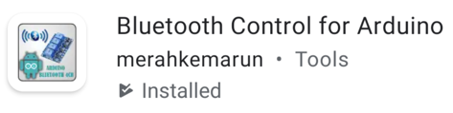

**Project Summary:**

Using this project, the electrical equipment in a room can be controlled from an android device, given that it is in the range of detection. I designed the project as shown in the circuit diagram using the equipment mentioned above. One relay module can support up to 4 electrical appliances. The app used to control the appliances is available to download from playstore.