## 

Arundhati Sharma

Computer Science - Project Report



Contents

1.0 Introduction

2.0 System Requirements

2.1 Software Requirements

2.2 Hardware Requirements

2 Source Code

3 Output/ScreenShots

4 Conclusion

***Acknowledgement***

*Authors would like to thank Shri Surendar P. Sachdeva,Principal DPS Bopal to provide the opportunity to learn the best in excellent environment. Authors would like to thank Ms. Malvika Sharma to make us learn C ++ and enriching us with basic concepts used to develop this project. Authors also extend their gratitude to Ms. Sumita Arora, Authorof our course book “Computer Science with C++” where programming concepts are explained in a very simple manner. Last but not the least we thank our batch mates for useful discussions for knowledge sharing during classroom sessions*

# Introduction

This project maintains the Menu and Billing System of “***Kake Da Dhaba.com***” a Punjabi restaurant which takes online orders from the customers. Project has two parts ; Part 1 allow customers to order the Food items in form of Snacks, Main course and Beverages whereas part 2 is used to produce bill amount for the option selected.It’s a take away dhaba with special facility for home delivery. To support these requirements all options are taken care during development of software application.

This document describes System requirements in terms of hardware and software in section 2.0. Source code is included in section 3.0. Output and Screen shots are given in section 4.0. Section 5.0 discusses the Results and concluding remarks.

# System Requirements

System requirements for this project are classified into two parts; Software Requirement and Hardware requirements;

## Software Requirements

Project requirement is to maintain the item ordering and billing system of “Kake da Dhaba.com” restaurant where Punjabi food can be ordered online. Based on the discussion with Dhaba owner, requirements are identified and implemented as a separate function. Following are the core requirements of the Software:

**Req1:** Welcome screen to select the option for order; To support home delivery and take away option

**Req2:** Option to add or delete item or show already selected items

**Req3:**Display List of Items if item to be added or deleted in order list

**Req4:** Add or delete item

**Req5 :** Select mode of Payment; Cash , Card, Paytm etc.

**Req6:** Calculate total bill amount based on mode of payment

**Req7:** Get Address from customer if Home delivery option is selected

**Req8:** Display of Rules and Norms and Thanks message with final amount to be paid

## Hardware Requirements

Intel Pentium® CPU @1.60GHz

Installed Memory: Minimum 1GB RAM

System Type: 64 bit OS x64 based processor

C++ Compiler installed

Laser jet Printer to print the bill

# Source Code

#include<string.h>

#include<ctype.h>

#include<iostream.h>

#include<conio.h>

#include<stdio.h>

#include<math.h>

/*Created by:

Arundhati Sharma(R. no. 9)*/

struct item

{ short no;

char name[30];

float price;

int type;

int quantity;

int c;

};

//declarations!

const int startersLength = 10;

const int mainsLength = 5;

const int sidesLength = 6;

float total = 0;

float net = 0;

item starters[startersLength] = { { 101, "Masala rava Idli", 80, 1, 0,0},

{ 102, "Cheese Pakoras", 35, 1, 0,0},

{ 103, "Chilli Paneer", 85, 1, 0,0},

{ 104, "Paneer Pakoras", 50, 1, 0,0},

{ 105, "Chinise Samosas", 40, 1, 0,0},

{ 106, "Vegetable Salad", 35, 1, 0,0},

{ 107, "Roasted Papad", 20, 1, 0,0},

{ 108, "Hara Bhara Kabab" , 60, 1, 0,0},

{ 109, "Mexican tacos", 50, 1, 0,0},

{ 110, "Aloo mutter Samosas", 15, 1, 0,0}

};

item mains[mainsLength] = { { 201, "Kadhai Paneer", 120,2,0,0},

{ 202, "Paneer Balti Me", 120,2,0,0},

{ 203, "Bhindi Di Subzi", 80,2,0,0},

{ 204, "Mix vegetable", 130,2,0,0},

{ 205, "Dum Bhara Aaloo", 100,2,0,0}

};

item sides[sidesLength] = { { 301, "Butter Roti", 15, 3,0,0},

{ 302, "Plain Roti", 10, 3,0,0},

{ 303, "Sweet Lassi", 40, 3,0,0},

{ 304, "Soft Drink", 40, 3,0,0},

{ 305, "Water Bottle", 20, 3,0,0},

{ 306, "Salt Chaas" , 25, 3,0,0}

};

void generateBill(); //prototype

void additem(int index) //adds items to main cart.

{ if( index > 100 && index < 200) //for starters.

{ for(int x = 0; x < startersLength; x++)

{ if (starters[x].no == index) starters[x].quantity++;

}

}

else if (index > 200 && index < 300)

{ for(int x = 0; x < mainsLength; x++)

{ if (mains[x].no == index) mains[x].quantity++;

}

}

else if (index > 300 && index < 400)

{ for(int x = 0; x < sidesLength; x++)

{ if (sides[x].no == index) sides[x].quantity++;

}

}

cout<<"Your item list is:";

generateBill();

}

void removeitem(int x)

{ int flag = 1;

for(int i = 0; i<startersLength; i++)

{ if((starters[i].c == x) && (starters[i].quantity != 0))

{starters[i].quantity--; flag = 0;}

}

if(flag)

{ for(int j = 0; j < mainsLength; j++)

{ if(mains[j].c == x && mains[j].quantity != 0)

{mains[j].quantity--; flag = 0;}

}

}

if(flag)

{ for(int k = 0; k<sidesLength; k++)

{ if(sides[k].c == x && sides[k].quantity != 0)

{sides[k].quantity--;}

}

}

cout<<"You renewed item list is: ";

generateBill();

}

void adjustCounter(){

for(int i = 0; i<startersLength; i++)

{starters[i].c = 0;}

for(int j = 0; j<mainsLength; j++)

{mains[j].c = 0;}

for(int k = 0; k<sidesLength; k++)

{sides[k].c = 0;}

}

void generateBill(){

adjustCounter();

clrscr();

int counter = 1;

total = 0;

cout<<"========KAKE DA DHABA.com Bill=========\n\n";

//for starters

for(int x = 0; x<startersLength; x++)

{ if(starters[x].quantity != 0)

{ cout<<"\t"<<counter<<". "<<starters[x].name<<"("<<starters[x].quantity<<") \t\t "<<starters[x].quantity<<" x "<<starters[x].price<<" = "<<(starters[x].price)*(starters[x].quantity)<<"\n";

starters[x].c = counter++;

total = total + (starters[x].price)*(starters[x].quantity);

}

}

//for mains

for(int y = 0; y<mainsLength; y++)

{ if(mains[y].quantity != 0)

{ cout<<"\t"<<counter<<". "<<mains[y].name<<"("<<mains[y].quantity<<") \t\t "<<mains[y].quantity<<" x "<<mains[y].price<<" = "<<(mains[y].price)*(mains[y].quantity)<<"\n";

mains[y].c = counter++;

total = total + (mains[y].price)*(mains[y].quantity);

}

}

//for sides.

for(int z = 0; z<sidesLength; z++)

{ if(sides[z].quantity != 0)

{ cout<<"\t"<<counter<<". "<<sides[z].name<<"("<<sides[z].quantity<<") \t\t "<<sides[z].quantity<<" x "<<sides[z].price<<" = "<<(sides[z].price)*(sides[z].quantity)<<"\n";

sides[z].c = counter++;

total = total + (sides[z].price)*(sides[z].quantity);

}

}

cout<<"\n\nTOTAL PRICE = "<<total;

}

void finalBill()

{ clrscr();

generateBill();

float tax = total * 0.1;

float service_charge = total * 0.001;

float sbc = total * 0.005;

net = tax + service_charge + sbc + total;

cout<<"\n\nTax(10%): "<<tax<<"\nService Charge(1%): "<<service_charge<<"\nSwachh Bharat Cess(5%): "<<sbc;

cout<<"\nNET PAYABLE AMOUNT: "<<floor(net);

getch();

}

int menu(int n)

{ int x,ord;

clrscr();

if(n==1)

{ cout<<"OUR STARTERS ARE-\n\n";

for(int i=0;i<startersLength;i++)

{cout<<"\t"<<i+1<<". "<<starters[i].name<<"\t\t\t"<<starters[i].price<<endl;}

cout<<"\n\nPlease enter the number you would like to order.";

cin>>x;

ord=x+100;

}

if(n==2)

{ cout<<"OUR MAIN DISHES ARE-\n\n";

for(int i=0;i<mainsLength;i++)

{cout<<"\t"<<i+1<<". "<<mains[i].name<<"\t\t\t"<<mains[i].price<<endl;}

cout<<"\n\nPlease enter the number you would like to order.";

cin>>x;

ord=x+200;

}

if(n==3)

{ cout<<"OUR SIDES ARE-\n\n";

for(int i=0;i<sidesLength;i++)

{cout<<"\t"<<i+1<<". "<<sides[i].name<<"\t\t\t"<<sides[i].price<<endl;}

cout<<"\n\nPlease enter the number you would like to order.";

cin>>x;

ord=x + 300;

}

return ord;

}

void payment()

{ int n ;

float tot ;

cout<<"\n\n\n";

cout<<"\t\t\t*********PAYMENT**********\n";

cout<<"\t\t\t+---------------------------------+\n";

cout<<"\t\t\t| PAYMENT OPTIONS |"<<endl ;

cout<<"\t\t\t| 1.CASH |"<<endl;

cout<<"\t\t\t| 2.CARD |"<<endl;

cout<<"\t\t\t| 3.CHEQUE |"<<endl;

cout<<"\t\t\t| 4.PAYTM |"<<endl;

cout<<"\t\t\t+--------------------------------+\n";

label :

cout<<"\t\t\t Enter option for Payment: ";

cin >> n;

cout<<endl;

if(n==1)

{ cout <<"\t\t\tTotal Amount is (NO DISCOUNT) : Rs."<< floor(net) ;

}

else if (n==2)

{ tot = net - (0.1)*net ;

cout <<"\t\t\tTotal amount is (AFTER 10% DISCOUNT) : Rs."<< floor(tot) ;

}

else if (n==3)

{ tot = net+(0.1)*net ;

cout <<"\t\t\tTotal amount is(AFTER 10% TAX) : Rs."<< floor(tot);

}

else if (n==4)

{ tot = net - (0.15)*net ;

cout <<"\t\t\tTotal amount is(AFTER 15% SPECIAL DISCOUNT) : Rs."<< floor(tot) ;

}

else

{ cout <<"\n"<<" WRONG OPTION ";

goto label ;

}

getch();

cout<<endl<<endl;

}

int main()

{ int choice[5];

go:

cout<<"\n\n\n\t\t\t*******Welcome to KAKE KA DHABA.com********\n";

cout<<"\t\t\t+---------------------------------------+\n";

cout<<"\t\t\t| Select yout Option :(1 or 2) |"<<endl;

cout<<"\t\t\t| 1.Home Delivery |"<<endl;

cout<<"\t\t\t| 2.Take Away |"<<endl;

cout<<"\t\t\t+---------------------------------------+\n";

cout<<"\t\t\tEnter Choice: ";

cin>>choice[1];

while(1){

clrscr();

cout<<"\n\n\n";

cout<<"\t\t\t+------------------------------------------+\n";

cout<<"\t\t\t| Select Option to Order/Cancel |"<<endl;

cout<<"\t\t\t| 1.Add Item |"<<endl;

cout<<"\t\t\t| 2.Remove Item |"<<endl;

cout<<"\t\t\t| 3.View Item List |"<<endl;

cout<<"\t\t\t+-----------------------------------------+\n";

cout<<"\t\t\tEnter Choice: ";

cin>>choice[2];

switch(choice[2]){

case 1:

cout<<"\t\t\t+-----------------------------------------------+"<<endl;

cout<<"\t\t\t| Select Category from the List |"<<endl;

cout<<"\t\t\t| 1.Starters |"<<endl;

cout<<"\t\t\t| 2.Mains |"<<endl;

cout<<"\t\t\t| 3.Sides |"<<endl;

cout<<"\t\t\t+---------------------------------------------+"<<endl;

cout<<"\t\t\tEnter Choice: ";

cin>>choice[3];

additem(menu(choice[3]));

break;

case 2: generateBill();

cout<<"\nEnter s.no of the item you want removed.";

cin>>choice[4];

removeitem(choice[4]);

break;

case 3: generateBill();

break;

}

cout<<"\nDo you want to order something more?Enter 1 for yes ; 0 for No (0/1)";

cin>>choice[2]; if(!(choice[2])) break;

}

finalBill();

payment();

if(choice[1] == 1){

cout<<"\t\t+-----------------------------------------------------+"<<endl;

cout<<"\t\t| Enter your address for Home Delivery: |"<<endl;

cout<<"\t\t+----------------------------------------------------+"<<endl;

char ch;

cout<<"\t\t\tEnter Address :";

cin>>ch;

clrscr();

cout<<"\n\n\n";

cout<<"\t\t+----------------------------------------------------------------------+"<<endl;

cout<<"\t\t| Thank you for choosing KAKE KA DHABA.com |"<<endl;

cout<<"\t\t| Your order will be deleivered within 45 minutes |"<<endl;

cout<<"\t\t| Kindly don't pay in denominations of 500 and 1000.|"<<endl;

cout<<"\t\t| Thank You... Have a great day and Visit Again |"<<endl;

cout<<"\t\t+----------------------------------------------------------------------+"<<endl;

cout<<"\t\t Total Bill amount is: Rs "<<total<<""<<endl;

}

else if(choice[1] == 2){

cout<<"\n\n\n";

cout<<"\t\t+-------------------------------------------------------------------+"<<endl;

cout<<"\t\t| Please reach Dhaba within 100 minutes |"<<endl;

cout<<"\t\t| Otherwise your order will be cancelled |"<<endl;

cout<<"\t\t| 80% money will be refunded in case of cancellation|"<<endl;

cout<<"\t\t| Thank you for choosing KAKE KA DHABA.com |"<<endl;

cout<<"\t\t| Thank You... Have a great day and Visit Again |"<<endl;

cout<<"\t\t+-------------------------------------------------------------------+"<<endl;

cout<<"\t\t Total Bill amount is: Rs "<<total<<""<<endl;

}

getch();

clrscr();

return 0;

}

# Output/ScreenShots

On running this application, Main Menu as shown in Fig.1 appears. This is the welcome screen where option for type of delivery/order is to be selected.

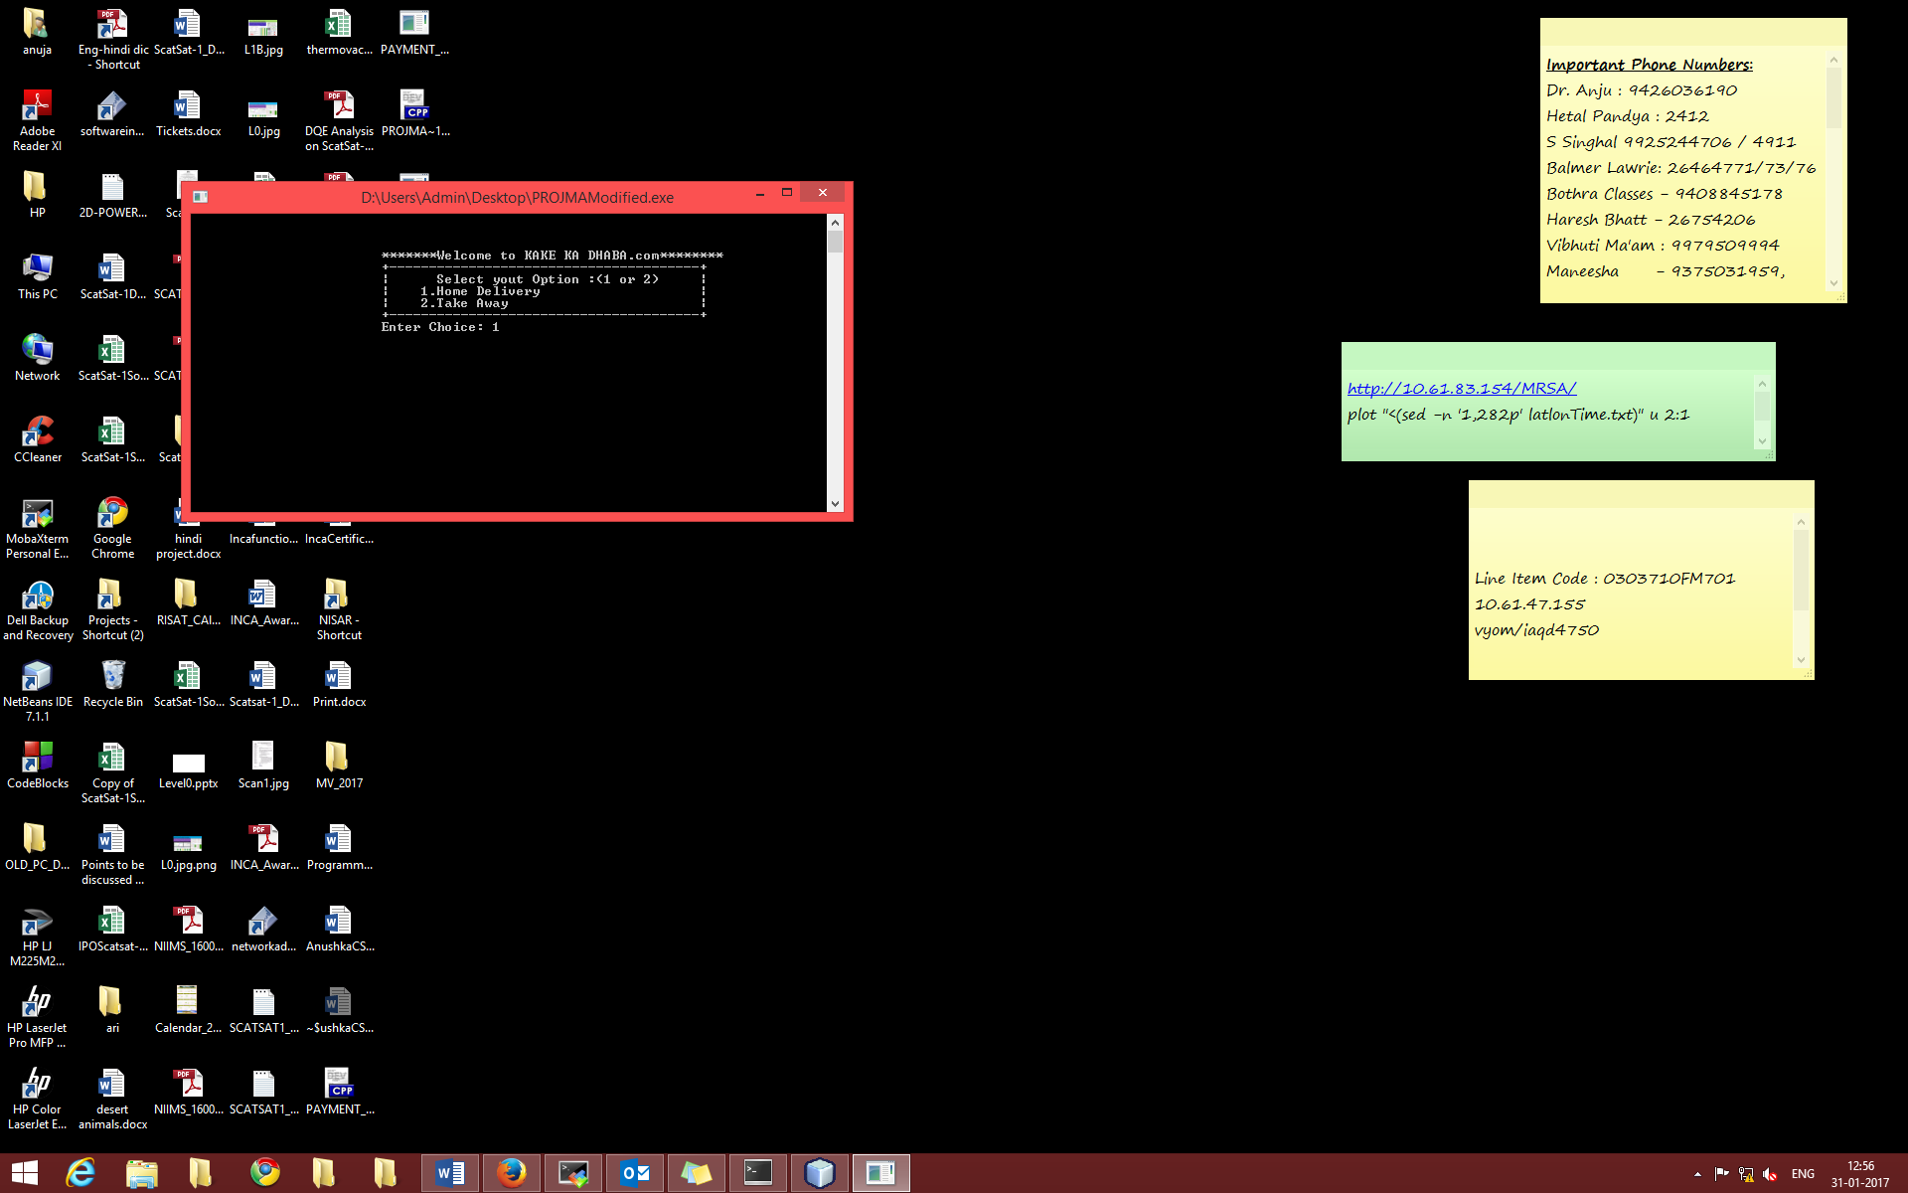

**Fig.1 Main Menu**

Upon the selection of option, second Menu as shown in Fig.2 appears. It allows user to order item or cancel the ordered item. Next Menu offer to select kind of food i.e. Starters or Mains or Sides. On selection of suitable option, list of items available in dhaba in the category will be displayed as shown in Fig.3. Next menu will ask user to continue selecting more items or to end the selection (Fig.4). Once all required items are selected, it will ask for payment option (Fig. 6). Application presents the discounted bills based on payment option selected by user. Generally, discounts are offered for e-payments. Address where food to be delivered is taken as input if home delivery option was selected. Final screen shows the rules and norms for money refund, final amount to be paid and thanks giving message (Fig. 7).

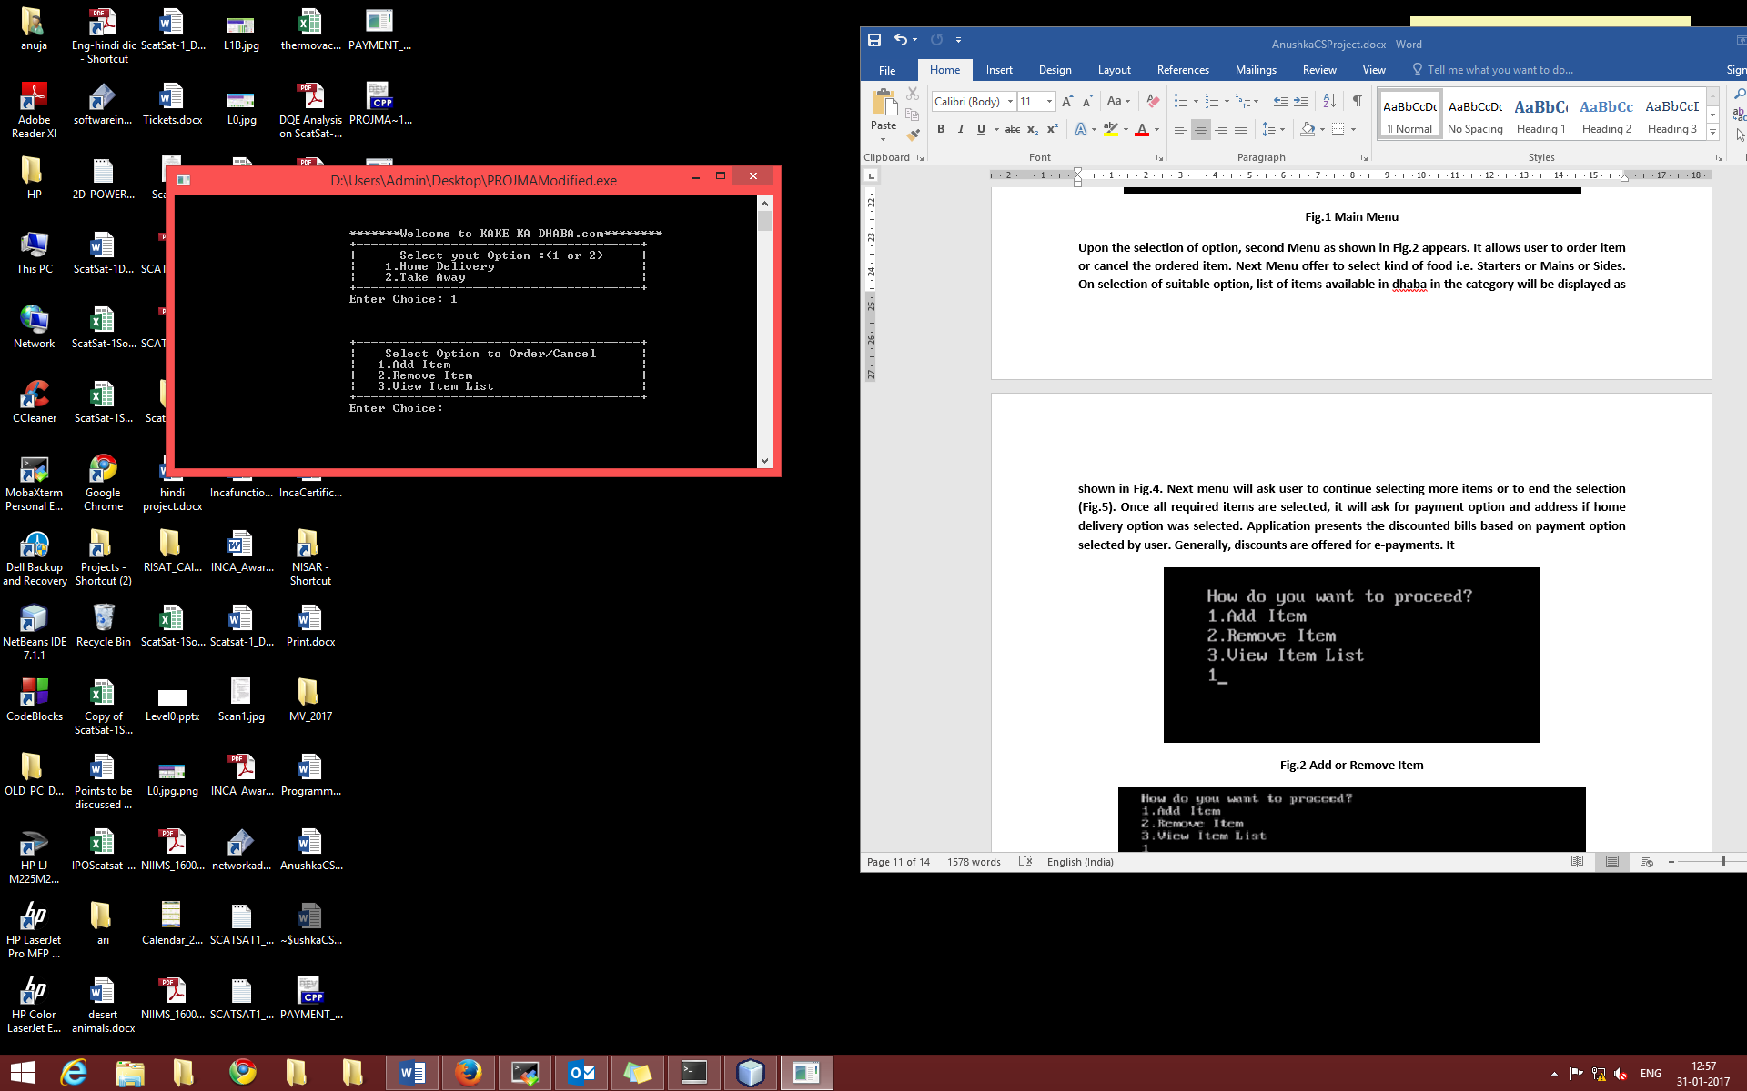

**Fig.2 Add or Remove Item**

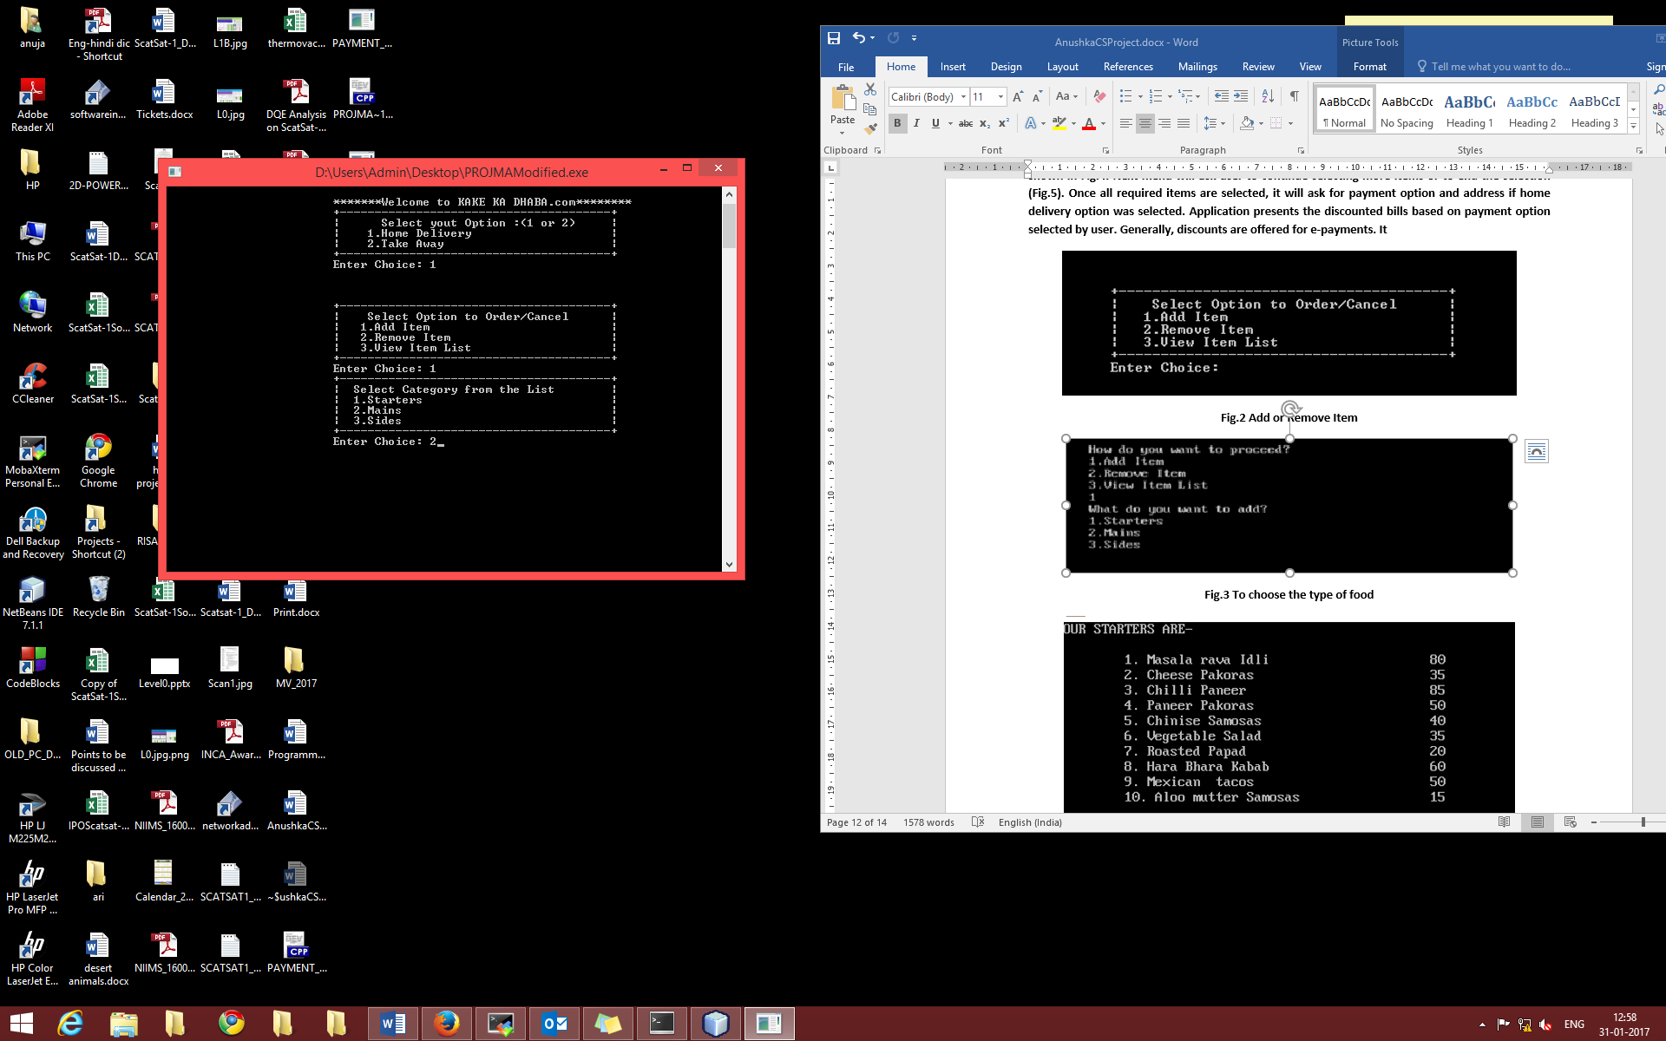

**Fig.3 To choose the type of food**

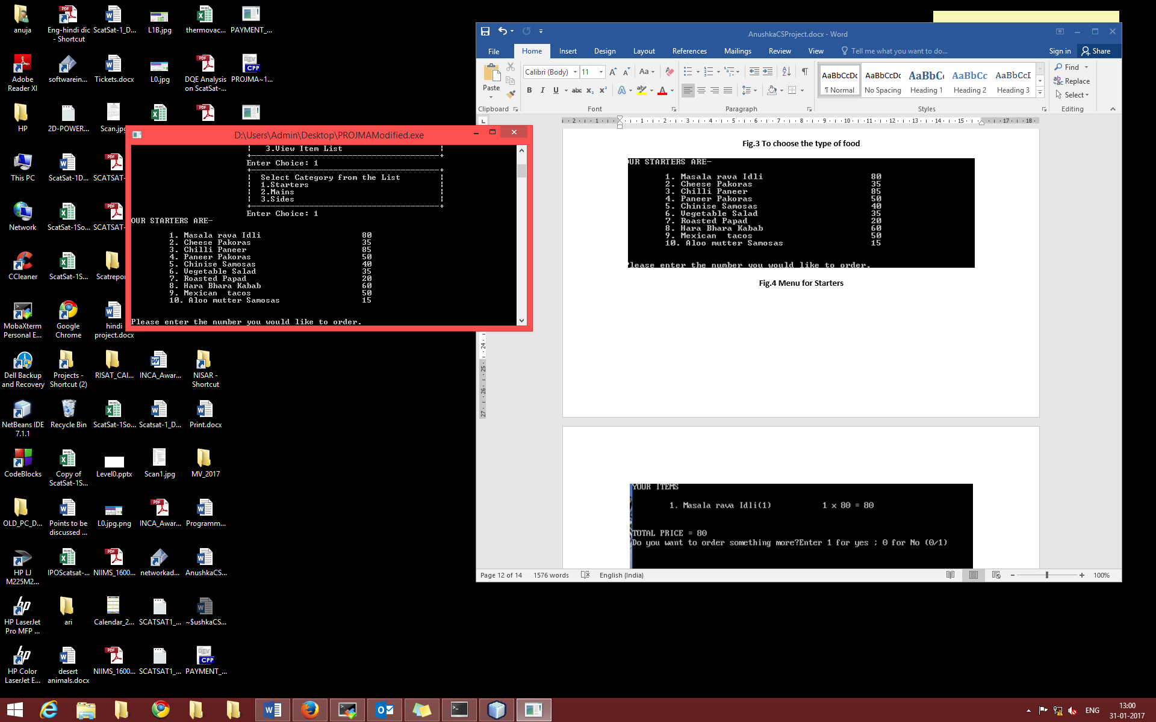

**Fig.4 Menu for Starters with Price**

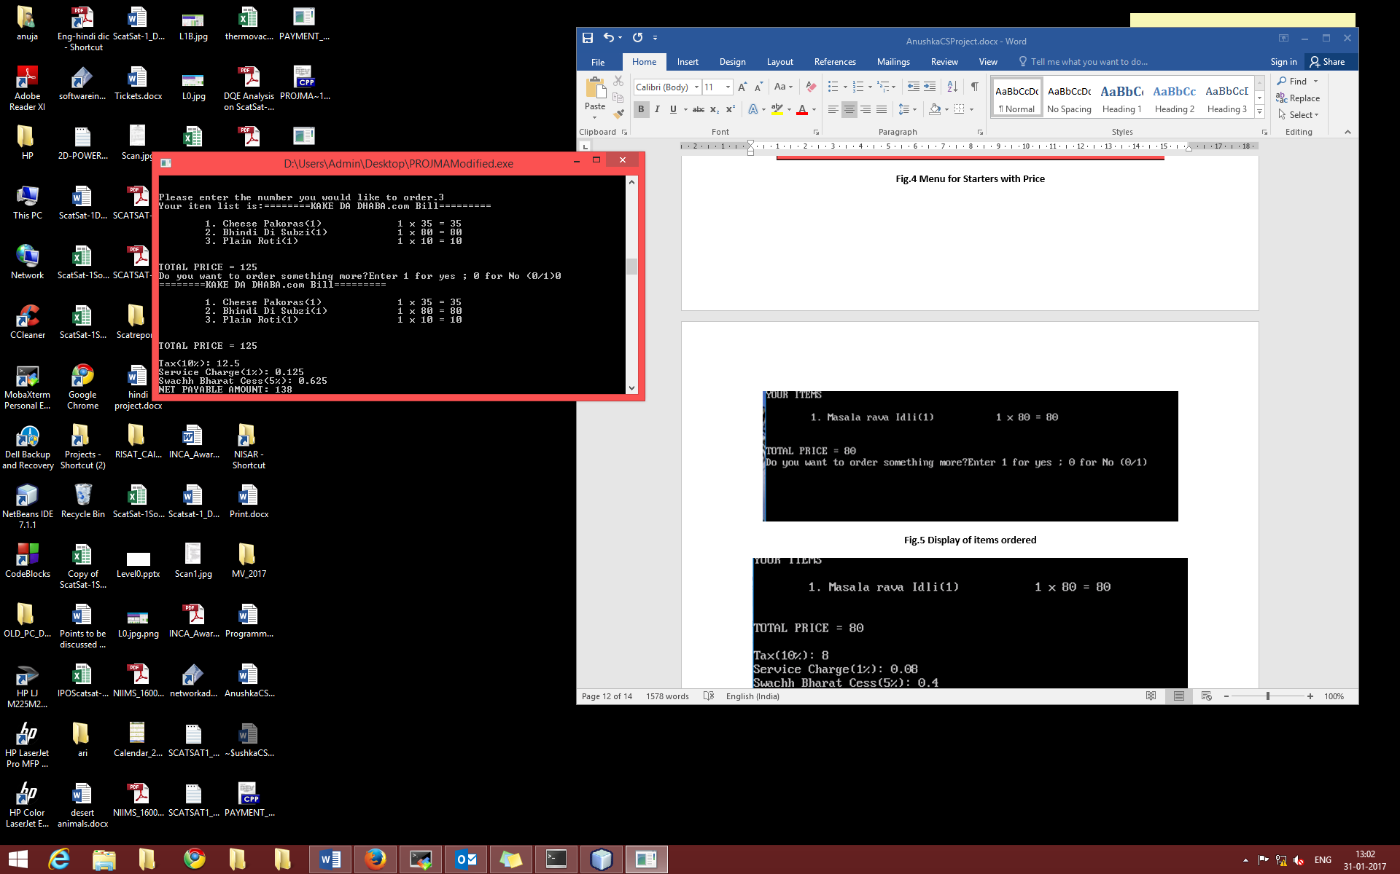

**Fig.5 Display of items ordered and bill without Discount**

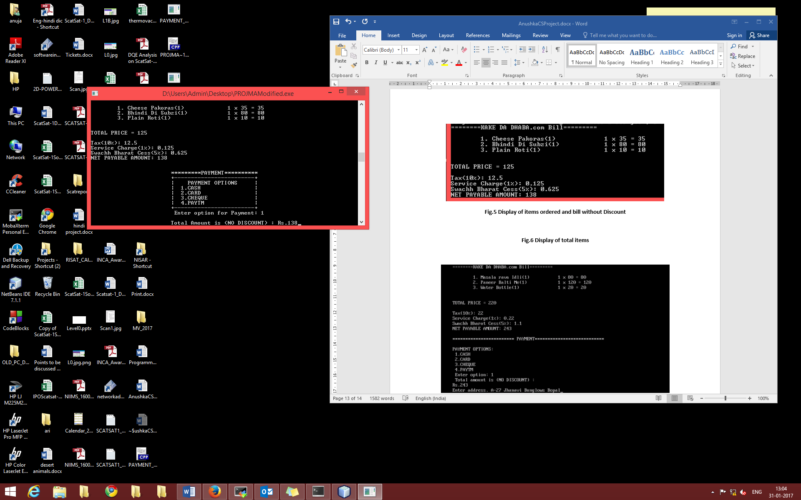

**Fig.6 Select mode of Payment**

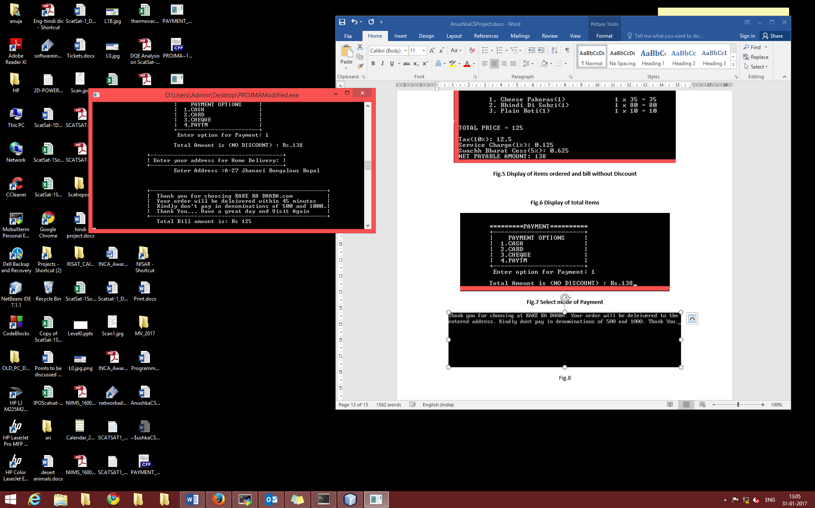

**Fig.7 Final Bill with Discount**

# Conclusion

Software executed successfully in the defined environment without any error. All expected errors are handled properly and during run-time error conditions or wrong inputs, software comes out gracefully with proper error message.