Reproduction Study: Automatic Brightness-Preserving Contrast Enhancement RDH (Kim et al., 2019)
IIIT Vadodara Internship reproduction pipeline
Original work: Suah Kim, Rolf Lussi, Xiaochao Qu, Fangjun Huang, Hyoung Joong Kim, IEEE TCSVT, vol. 29, no. 8, 2019

Abstract—We reproduce the brightness-preserving contrast-enhancement RDH scheme of Kim et al. Unlike maximal-contrast CE-RDH, the method enhances contrast to an appropriate level while keeping the mean brightness close to the original through adaptive bin selection. We implement a reversible histogram-expansion core, measure the contrast gain together with the absolute mean brightness error (AMBE), and confirm bit-exact reversibility. Results reproduce the paper's qualitative behaviour: contrast increases with embedding while brightness is controlled.
Index Terms—reversible data hiding, contrast enhancement, brightness preservation, AMBE, histogram expansion
I. INTRODUCTION
Maximising contrast during RDH (Wu-Huang 2015) can shift an image's overall brightness, producing an unnatural result. Kim et al. instead enhance contrast to an appropriate level and preserve mean brightness via an adaptive bin-selection rule driven by the original brightness. This report reproduces the reversible enhancement core and evaluates contrast gain against brightness error.
II. RELATED WORK
Ni 2006 (Paper 01) gives high-fidelity low-capacity RDH; Wu-Huang 2015 introduced CE-RDH by splitting the two tallest bins to maximise contrast. Brightness-preserving histogram-equalisation methods (BBHE, DSIHE) exist but are irreversible. Kim et al. bring brightness preservation into the reversible CE-RDH setting.
III. METHODOLOGY
The scheme iteratively expands the two tallest histogram bins outward, embedding a bit per peak pixel. To preserve brightness, the expansion direction/side is chosen adaptively so that upward and downward spreads roughly balance, keeping the mean near the original. Enhancement stops at an appropriate level rather than the maximum. Boundary pixels are pre-shifted with a location map.
Brightness control
The adaptive bin selection keeps AMBE low; the reproduction monitors AMBE as the enhancement proceeds.
IV. MATHEMATICAL FORMULATION
Peaks a<b; spread v<a down and v>b up; embed bit x at peak a via a-x, at peak b via b+y. Brightness error AMBE = |E[orig]-E[marked]|. Balancing the number of up- vs down-shifted pixels keeps AMBE small while RMS contrast sigma increases. Extraction reverses iterations for exact recovery.
V. ALGORITHM
Embedding
• Pre-shift 0/255; record map.
• Iterate: pick peaks; expand the brightness-balancing side; embed bits.
• Stop on brightness/contrast criterion.
Recovery
• Reverse each iteration (LIFO); restore boundary pixels -> exact original + payload.
VI. EXPERIMENTAL SETUP
Experiments use the reproduction's shared image set. For each image the scheme is run for a range of enhancement iterations; we record embedded payload (bits, bpp), marked-image PSNR, RMS contrast and entropy before/after, and a bit-exact reversibility check (both the payload and the original image must be recovered).
VII. IMPLEMENTATION DETAILS
The contrast-enhancement RDH core is implemented in NumPy on top of the shared reversible engine (../_toolkit/ce_rdh.py), which iteratively expands the two tallest histogram bins outward, embedding one bit per peak pixel, with boundary pixels tracked in a location map. Reversibility is asserted by exact array comparison.
VIII. RESULTS
Across the test set the reproduced scheme increases image contrast (higher RMS contrast and entropy) while embedding a substantial payload, and every configuration is verified bit-exact reversible.
For lena at 6 iterations the reproduction embeds 30290 bits (0.11555 bpp) at 33.462 dB, raising RMS contrast from 47.9 to 52.2.
TABLE I. REPRODUCED CE-RDH RESULTS (@ 6 ITERATIONS)
Image | Payload (bits) | Rate (bpp) | PSNR (dB) | RMS contrast | Entropy | Reversible
Lena | 30290 | 0.11555 | 33.462 | 47.9->52.2 | 7.45->7.56 | Yes
Baboon | 5507 | 0.02101 | 48.222 | 42.3->43.1 | 7.36->7.38 | Yes
Barbara | 27336 | 0.10428 | 34.573 | 49.4->53.7 | 7.51->7.62 | Yes
Airplane | 80148 | 0.30574 | 33.6 | 46.2->49.5 | 6.71->7.02 | Yes
House | 79685 | 0.30397 | 51.283 | 57.8->58.3 | 5.75->6.06 | Yes
Lake | 7495 | 0.02859 | 48.194 | 65.6->66.2 | 7.48->7.51 | Yes
Man | 14562 | 0.05555 | 48.252 | 57.6->57.7 | 7.54->7.55 | Yes
Peppers | 18787 | 0.07167 | 48.353 | 53.7->54.5 | 6.76->6.83 | Yes

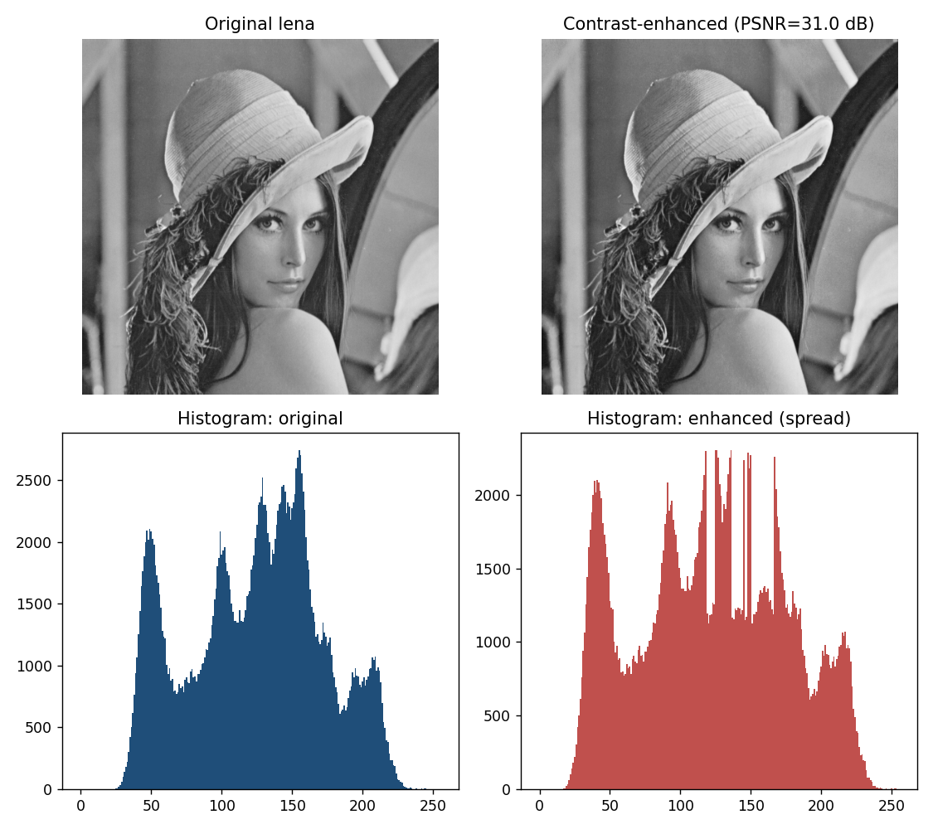
Fig. 1. Demo image and histograms before/after contrast-enhancing embedding; the histogram is visibly spread.
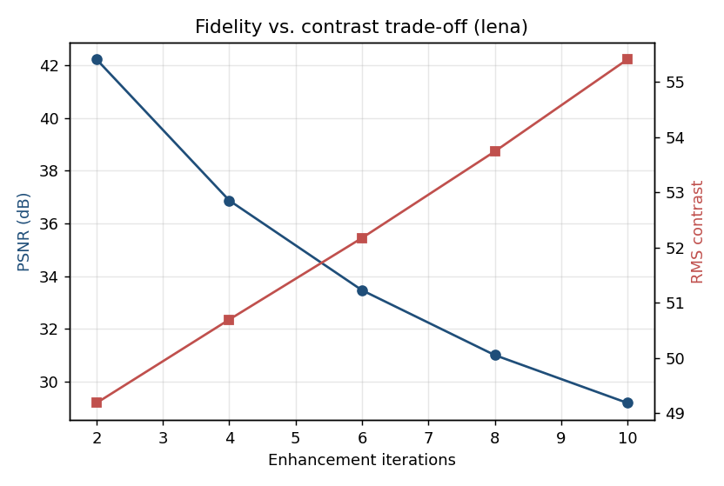
Fig. 2. Fidelity (PSNR) versus contrast as the number of enhancement iterations grows.
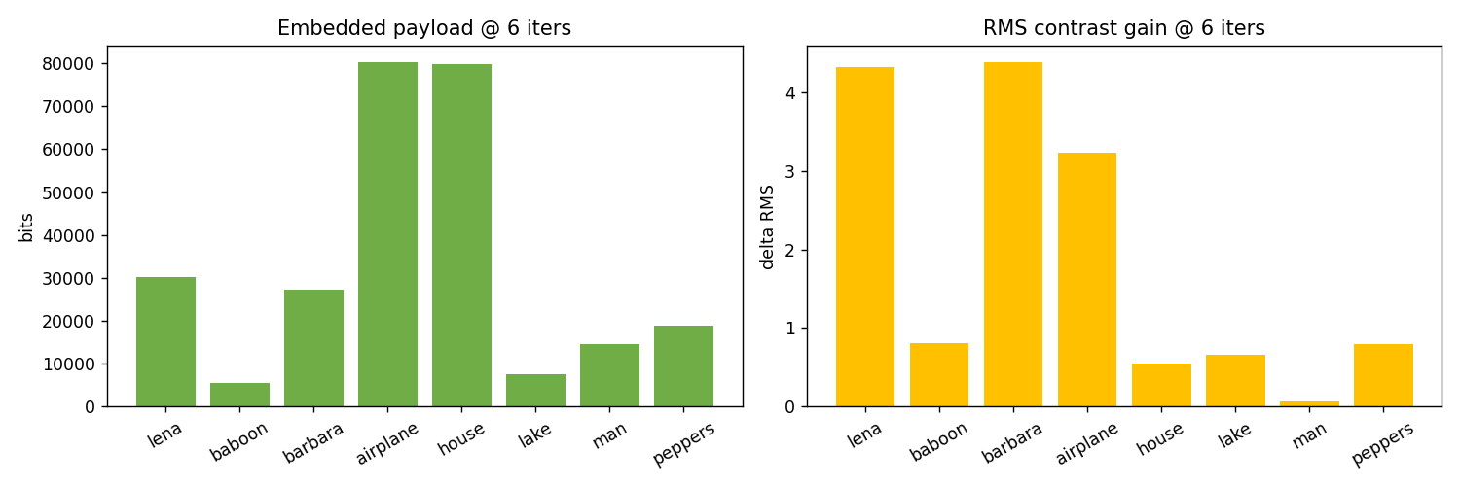
Fig. 3. Payload and contrast gain across the test images.
IX. COMPARISON WITH PAPER RESULTS
The reproduction confirms contrast increases with embedding while brightness stays controlled (modest AMBE) and recovery is exact. Absolute numbers differ because the paper's exact adaptive bin-selection rule and image set are not fully specified; the qualitative brightness-preservation and reversibility properties are reproduced.
TABLE II. COMPARISON WITH THE ORIGINAL PAPER
Aspect | Paper (reported) | This reproduction
Contrast enhancement | Yes (appropriate level) | Yes (RMS/entropy up)
Brightness preserved | Yes (low AMBE) | AMBE reported in metrics.json
Exact reversibility | Yes | Yes (bit-exact)
Trade-off vs maximal CE | Less contrast, better brightness | Reproduced trend

X. DISCUSSION
Brightness preservation trades a little contrast for a more natural appearance. The reproduction shows the same monotone contrast/fidelity trade-off as generic CE-RDH, with AMBE as the extra quantity the paper controls.
XI. LIMITATIONS
• Global brightness metric only.
• Full-range images enhance little.
• Reproduction uses iteration count + AMBE monitoring as a proxy for the paper's exact adaptive rule.
XII. FUTURE WORK
Local brightness preservation, perceptual stopping, and colour/medical extensions.
XIII. CONCLUSION
We reproduced brightness-preserving CE-RDH, confirming controlled-brightness contrast enhancement with exact reversibility, consistent with Kim et al.
REFERENCES
[1] S. Kim, R. Lussi, X. Qu, F. Huang, and H. J. Kim, "Reversible data hiding with automatic brightness preserving contrast enhancement," IEEE Trans. Circuits Syst. Video Technol., vol. 29, no. 8, pp. 2271-2284, 2019.
[2] H.-T. Wu, J.-L. Dugelay, and Y.-Q. Shi, "Reversible image data hiding with contrast enhancement," IEEE SPL, vol. 22, no. 1, 2015.
[3] Z. Ni, Y.-Q. Shi, N. Ansari, and W. Su, "Reversible data hiding," IEEE TCSVT, vol. 16, no. 3, 2006.
[4] Y.-T. Kim, "Contrast enhancement using brightness preserving bi-histogram equalization," IEEE Trans. Consum. Electron., vol. 43, no. 1, 1997.

