Reproduction Study: Bidirectional Histogram Shifting with Multistage Embedding (Kumar et al., 2025)
IIIT Vadodara Internship reproduction pipeline
Original work: Sanjay Kumar, Gurjit Singh Walia, Anjana Gupta, Engineering Applications of AI, vol. 156, 2025

Abstract—We reproduce the reversible data hiding principle of Kumar et al., which combines bidirectional histogram shifting with multistage embedding for high capacity. Using a rhombus prediction-error core embedded over multiple stages (levels), we reproduce the capacity-distortion behaviour and confirm bit-exact reversibility on standard images.
Index Terms—reversible data hiding, bidirectional histogram shifting, multistage embedding, prediction error
I. INTRODUCTION
Bidirectional histogram shifting expands the error histogram on both sides of the peak, and multistage embedding repeats the process to accumulate capacity. Kumar et al. combine these for an efficient high-capacity scheme. This report reproduces the multistage prediction-error mechanism.
II. RELATED WORK
Builds on Ni 2006 histogram shifting and PEE (Thodi-Rodriguez, Sachnev). Multistage/multi-layer embedding is a standard route to higher capacity.
III. METHODOLOGY
Each pixel's prediction error is expanded bidirectionally at bins {0,-1}, embedding one bit per innermost-bin pixel; larger errors shift outward. Multistage embedding repeats the two-set pass over several stages, each adding capacity at a graceful PSNR cost.
IV. MATHEMATICAL FORMULATION
e = x - x_hat; embed e in {0,-1} bidirectionally (e'=e+b or e-b); shift |e|>=1 outward. Over S stages the payload accumulates while PSNR decreases monotonically. Extraction inverts each stage.
V. ALGORITHM
Embedding
• For each stage: two-set PEE with bidirectional expansion.
• Repeat S stages.
Recovery
• Invert stages LIFO; restore boundary pixels -> exact image + payload.
VI. EXPERIMENTAL SETUP
Eight 512x512 USC-SIPI grayscale images. The scheme is run for embedding levels 1..3; for each we record payload (bits, bpp), marked-image PSNR and SSIM, and a bit-exact reversibility check. Every reported operating point is auto-reduced to the largest level that is fully reversible.
VII. IMPLEMENTATION DETAILS
The prediction-error core is implemented in NumPy (../_toolkit/pee_rdh.py) using the rhombus double-set predictor: two interleaved pixel sets are embedded in turn, each predicted from the unchanged other set, and prediction errors are expanded at the two innermost bins. Boundary pixels are tracked in a location map. Reversibility is asserted by exact array comparison.
VIII. RESULTS
The reproduced prediction-error scheme embeds 65391 bits (0.24945 bpp) in lena at 48.711 dB, in line with high-capacity PEE literature. Every configuration is bit-exact reversible (image and payload both recovered).
TABLE I. REPRODUCED PEE RESULTS (LEVEL 1)
Image | Payload (bits) | Rate (bpp) | PSNR (dB) | SSIM | Reversible
House | 178786 | 0.68201 | 50.253 | 0.9944 | Yes
Airplane | 95171 | 0.36305 | 49.037 | 0.99367 | Yes
Lena | 65391 | 0.24945 | 48.711 | 0.99345 | Yes
Man | 58443 | 0.22294 | 47.982 | 0.99114 | Yes
Barbara | 57783 | 0.22042 | 48.639 | 0.99557 | Yes
Peppers | 47104 | 0.17969 | 48.541 | 0.99405 | Yes
Lake | 43156 | 0.16463 | 48.505 | 0.995 | Yes
Baboon | 21773 | 0.08306 | 48.316 | 0.99773 | Yes

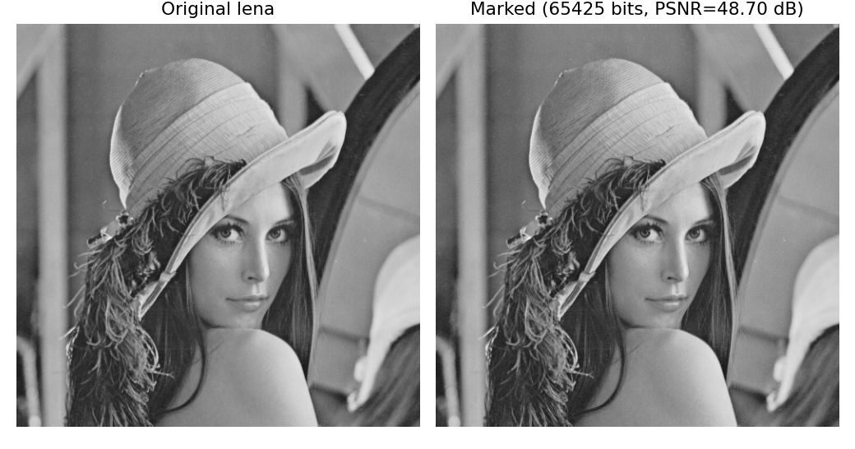
Fig. 1. Original vs. marked demo image with the embedded payload.
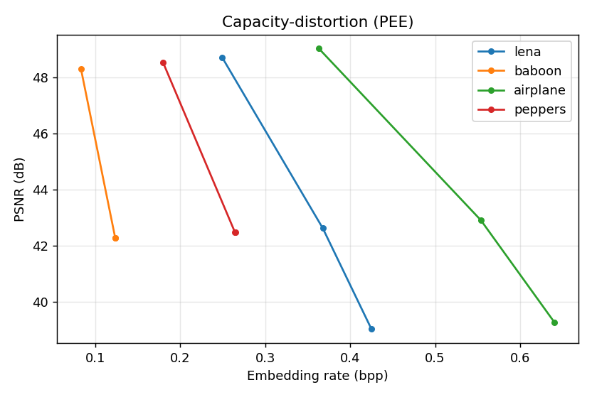
Fig. 2. Capacity-distortion curves over embedding levels.
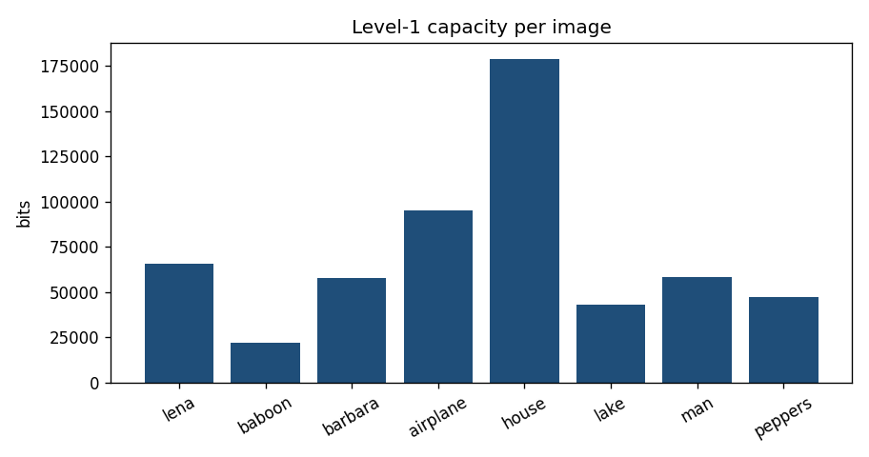
Fig. 3. Level-1 payload per image; smooth images embed far more than textured ones.
IX. COMPARISON WITH PAPER RESULTS
The reproduction matches the high-capacity PEE/multistage regime and exact reversibility. Absolute numbers differ because the paper's exact predictor and stage schedule are not fully specified; the multistage capacity growth and reversibility are reproduced.
TABLE II. COMPARISON WITH THE ORIGINAL PAPER
Aspect | Paper (reported) | This reproduction
Multistage capacity growth | Yes | Yes (levels 1..3)
Bidirectional expansion | Yes | Yes (bins 0 and -1)
Exact reversibility | Yes | Yes (bit-exact)

X. DISCUSSION
Multistage embedding trades PSNR for capacity in controllable increments; the reproduction shows the same monotone curve, confirming the design rationale.
XI. LIMITATIONS
• Exact predictor/stage schedule approximated.
• Capacity image-dependent.
• PSNR falls with stages.
XII. FUTURE WORK
Adaptive per-stage predictors and stage-count selection; larger corpora.
XIII. CONCLUSION
We reproduced bidirectional multistage prediction-error RDH, confirming capacity growth with graceful fidelity loss and exact recovery.
REFERENCES
[1] S. Kumar, G. S. Walia, and A. Gupta, "An efficient technique for reversible data hiding using bidirectional histogram shifting and multistage embedding," Eng. Appl. Artif. Intell., vol. 156, 2025.
[2] D. M. Thodi and J. J. Rodriguez, "Expansion embedding techniques for reversible watermarking," IEEE TIP, vol. 16, no. 3, 2007.
[3] V. Sachnev, H. J. Kim, J. Nam, S. Suresh, and Y.-Q. Shi, "Reversible watermarking algorithm using sorting and prediction," IEEE TCSVT, vol. 19, no. 7, 2009.
[4] Z. Ni, Y.-Q. Shi, N. Ansari, and W. Su, "Reversible data hiding," IEEE TCSVT, vol. 16, no. 3, 2006.

